Methods
Participants
In total, 161 right-handed participants took part in this study, including 50 AD patients (28 females), 52 aMCI patients (31 females), and 59 normal healthy controls (HCs, 36 females). Demographic baseline information is summarized in Table S1. The AD and aMCI patients were recruited from the Memory Disorders Clinic of the First Affiliated Hospital of Anhui Medical University, Anhui Province, China, while HCs were recruited from the local community or were spouses or family members of study patients. All experimental procedures were approved by the Medical Research Ethics Committee of the First Affiliated Hospital of Anhui Medical University and all subjects gave written informed consent in accordance with the Declaration of Helsinki.
Alzheimer’s disease was diagnosed according to the Diagnostic and Statistical Manual of Mental Disorders 4th Edition criteria for dementia and the revised National Institute of Neurological and Communicative Disorders and Stroke/Alzheimer Disease and Related Disorders Association (NINCDS-ADRDA) criteria for possible or probable AD. The inclusion criteria included Mini-Mental State Examination (MMSE) score less than 24 and Clinical Dementia Rating (CDR) score from 0.5 to 2. Exclusion criteria were history of sudden onset dementia, other types of dementia, other comorbid mental disorders or drug/alcohol dependence, early occurrence of gait disturbances, seizures, sudden behavioral changes, focal neurological features including hemiparesis, sensory loss, and visual field deficits, early extra-pyramidal signs, and other severe disorders such as trauma, major depression, severe cerebrovascular disease, and toxic and metabolic abnormalities(Dubois, et al. 2007; Li, et al. 2021).
Diagnosis of aMCI was based on the criteria proposed by Petersen(Petersen, et al. 1999): memory loss reported by the patient and an informant, objective evidence of memory loss, normal cognitive function in other domains, diminished memory not meeting DSM-VI criteria for dementia, MMSE score > 24, and CDR score of 0.5. Exclusion criteria were the same as for the AD group(Li, et al. 2021).
Inclusion criteria for the HC group included no previous history of neurological, cognitive, and executive dysfunction, no family history of mental illness, no serious physical illness, and no history of traumatic brain injury, stroke, long-term drug use, or heavy and chronic alcohol consumption. All HCs had a MMSE score of 28 or higher and a CDR score of 0(Li, et al. 2021).
Cognitive Assessment
All subjects underwent a standardized clinical and neuropsychological evaluation including Mini Mental State Examination (MMSE)(Folstein, et al. 1975), Clinical Dementia Rating (CDR)(Morris 1993), Auditory Verbal Learning Test (AVLT), Verbal Fluency Test (VFT), and Activity of Daily Living test (ADL)(Leandrou, et al. 2018). The MMSE includes a series of clinical and psychometric items assessing general cognitive abilities(Folstein, et al. 1975), while the CDR(Morris 1993) was used to evaluate memory, orientation, judgment, problem solving, home and hobbies, and personal care. The AVLT(Lyu, et al. 2018) was used to evaluate the participants’ short-term and long-term memory by scoring performance on immediate recall and delayed recall, respectively(Stricker, et al. 2020). The VFT was used to assess semantic memory ability. It required the participants to verbally provide as many animal names as possible within 60 seconds(Lyu, et al. 2018).
MRI Data Acquisition
Magnetic resonance imaging scans were acquired using a General Electric 750 w 3.0 T MRI scanner with 24-channel head coil (General Electric, Waukesha, WI, USA). The imaging protocol included a T1-weighted three-dimensional structure sequence, resting-state blood oxygen level dependent (BOLD) functional sequence, axial T2-weighted sequence, fluid-attenuated inversion recovery sequence, and ASL sequence(Li, et al. 2021). T1-weighted three-dimensional structural data were collected using the brain volume (BRAVO) sequence [repetition time (TR)/echo time (TE)/inversion time = 8.5/3.2/450ms; matrix = 256 × 256; field of view (FOV) = 256 mm × 256 mm; slice thickness = 1.0 mm without intervals] with an acquisition time of 4 min 56 s(Zhu, et al. 2021). Resting-state fMRI scans were performed using an echo planar imaging sequence [TR/TE/flip angle = 2,000 ms/30 ms/90º; matrix = 64 × 64; FOV = 220 mm × 220 mm; 185 volumes 35 interleaved axial slices with slice thickness of 3 mm and interval space of 1 mm] with an acquisition time of 6 min 10 s. Resting-state perfusion imaging was performed using a pseudo-continuous ASL (pcASL) sequence with 3D fast spin-echo acquisition and background suppression [TR/TE = 5070/11 ms; post-label delay = 2025 ms; spiral in readout of 8 arms with 512 sample points; FA = 111°; FOV = 240 mm × 240 mm; reconstruction matrix = 128 × 128; slice thickness = 3 mm, no gap; 50 axial slices; number of excitations = 3]. Acquisition time was 4 min 54 s. All subjects were instructed to keep their eyes closed, relax, move as little as possible, think of nothing in particular, and stay awake during the scans.
CBF Calculation
CBF images were processed in the following steps: (1) Spatial normalization, (2) Standardization, and (3) Smoothing. First, SPM8 software was used to register all subjects’ native CBF images to the corresponding T1 structural image in Montreal Neurological Institute (MNI) space, ensuring that all images had the same coordinates. All images were then standardized by the Mean Division method using DPABI software to reduce variability from individual differences in ASL efficiency and hemodynamics. Finally, standardized images were spatially smoothed with a Gaussian kernel of 8 mm×8mm×8 mm full width at half maximum (FWHM). FCS Calculation
BOLD data were preprocessed using Data Processing Assistant for Resting-state fMRI (DPARSF) software v.3.21 (http://rfmri.org/DPARSF(Chao-Gan and Yu-Feng 2010)). The processing pipeline included slice timing, realignment, normalization, smoothing, detrending, nuisance covariate regression, and band-pass filtering. The covariates included signals from white matter and cerebrospinal fluid as well as the mean global brain signal. Then, the Seed-based Connectivity Analysis Toolbox (SeeCAT) (NITRC: SeeCAT: Tool/Resource Info) was used to calculate the voxel-wised FCS. Since the meaning of negative connectivity is ambiguous, only positive connectivity was calculated with a threshold of 0.2. To further explore the influence of physical distance on the FCS–CBF relationship, we also computed the short-range and long-range FCS maps for a given voxel x₀. The former was computed as the average correlation between x₀ and a set of voxels for which the physical distance was less than 75 mm from voxel x_{0,} while the latter was computed as the average correlation between x₀ and another set of voxels more than 75 mm from x₀(Liang, et al. 2013).
Validation Analysis
It is still controversial whether it is appropriate or necessary to regress out the global signal during image preprocessing(Li, et al. 2021). Therefore, we repeated the entire analysis without regression of whole-brain signals for validation analysis.
Results
Long-range Coupling
Interaction effects of group and sex
We also found significant group × sex interaction effects on CBF/lFCS ratios of the left precuneus (PCu-L), left posterior cingulate (PCC-L), left angular gyrus (ANG-L), and right middle temporal gyrus (MTG-R) (all p < 0.05, FDR corrected, Fig S1). In females, CBF/lFCS ratios of the PCC-L, ANG-L, and MTG-R increased with disease progression. Conversely, the CBF/lFCS ratio of the PCu-L was lower in female aMCI patients than female HCs, but was still higher in female AD patients than aMCI patients and HCs. In males, however, CBF/lFCS ratios of the PCC-L, ANG-L, and MTG-R gradually decreased with disease progression, while the CBF/lFCS ratio of the PCu-L was higher among male aMCI patients compared to HCs and AD patients. In conclusion, the coupling ratios of all four brain regions differed significantly between female HCs and AD patients and between female aMCI and AD patients (all p < 0.05, Fig S1A-D), while in males, the only significant difference in CBF/lFCS ratio was that of the MTG-R between HCs and AD patients (p = 0.03, Figure S1C).
These analyses notably revealed significant group × sex interaction effects on both CBF/sFCS and CBF/lFCS ratios of the MTG-R and the ANG-L, suggesting that altered network information transmission and communication with these regions may contribute to the progressive deficits of AD.
Main effects of group
The CBF/lFCS ratios of the bilateral calcarine fissure and surrounding cortex, right precuneus, right occipital gyrus, left median cingulate, and left paracingulate gyri were significantly higher in the entire AD group compared to all HCs (all p < 0.05, Fig S2B, Table S1), and the CBF/lFCS ratio of the left precuneus was also significantly higher in AD patients compared to aMCI patients (all p < 0.05, Fig S2C, Table S1). No significant changes were found between the aMCI group and HCs.
Correlation Analysis
Correlation results for long-range coupling were similar. The CBF/lFCS ratios of PCu-L, PCC-L, ANG-L, and MTG-R showed strong negative correlations with MMSE scores in female patients (all p < 0.05, Fig 3A-D, Table S2), while the CBF/lFCS ratios of the PCu-L, ANG-L, and MTG-R were positively correlated with MMSE in male patients (all p < 0.05, Fig S3A, C, D, Table S2).
Verification Analysis
Interaction effects of group and sex
Given the uncertainty over whether it is appropriate to regress out the global mean signal in image analysis, we recalculated all CBF/FCS values without the regression of the global mean. In accord with the original analyses, we still found significant group × sex interaction effects on CBF/sFCS ratios of the ORBIFG-L, SFG-L, ANG-L, and MTG-R (all p < 0.05, FDR corrected, Fig S4). Significant group × sex interaction effects were also found for CBF/lFCS ratios of the PCu-L, PCC-L, and ANG-L, consistent with the original analyses, although interactions were also significant for left medial orbital superior frontal gyrus and bilateral precuneus (all p < 0.05, FDR corrected, Fig S5). Thus, most short- and long-range coupling results were consistent.
Main effects of group
The CBF/sFCS ratios of left supplementary motor area, bilateral precuneus, and right superior frontal gyrus were significantly higher in the entire AD group compared to the entire aMCI group (all p < 0.05, Fig S6B, Table S3), while there were no significant differences between HC and aMCI or between HC and AD groups. The CBF/lFCS ratios of the right calcarine fissure and surrounding cortex, bilateral precuneus, and right cuneus gyrus were significantly higher in the AD group compared to the HC group (all p < 0.05, Fig S7B, Table S4). The CBF/lFCS ratios of the right calcarine fissure and surrounding cortex, bilateral precuneus, and left superior parietal gyrus were higher in the AD group than the aMCI group (all p < 0.05, Fig S7C, Table S4), while there were no significant differences between aMCI and HC groups.
Correlation analysis
Also consistent with the original regression analyses, CBF/sFCS ratios of the ORBIFG-L, SFG-L, MTG-R, and ANG-L were negatively correlated with MMSE scores in female patients (all p < 0.05, Fig S8A-D, Table S5), whereas the CBF/sFCS ratios of the ORBIFG-L, MTG-R, and ANG-L were positively correlated with MMSE scores in male patients (all p < 0.05, Fig S8A, C, D, Table S5). Also, the CBF/lFCS ratios of the PCC-L, PCu-L, ANG-L, bilateral precuneus, and left medial orbital superior frontal gyrus were negatively correlated with MMSE scores in female patients (all p < 0.05, Fig S9A-D, Table S5), whereas the CBF/lFCS ratios of the PCu-L, bilateral precuneus, and ANG-L were positively correlated with MMSE score in male patients (all p < 0.05, Fig S9C-E, Table S5).

References
Chao-Gan, Y., and Z. Yu-Feng
2010 DPARSF: A MATLAB Toolbox for "Pipeline" Data Analysis of Resting-State fMRI. Front Syst Neurosci 4:13.
Dubois, B., et al.
2007 Research criteria for the diagnosis of Alzheimer's disease: revising the NINCDS-ADRDA criteria. Lancet Neurol 6(8):734-46.
Folstein, M. F., S. E. Folstein, and P. R. McHugh
1975 "Mini-mental state". A practical method for grading the cognitive state of patients for the clinician. J Psychiatr Res 12(3):189-98.
Leandrou, S., et al.
2018 Quantitative MRI Brain Studies in Mild Cognitive Impairment and Alzheimer's Disease: A Methodological Review. IEEE Rev Biomed Eng 11:97-111.
Li, X., et al.
2021 Sex Difference in Network Topology and Education Correlated With Sex Difference in Cognition During the Disease Process of Alzheimer. Front Aging Neurosci 13:639529.
Liang, X., et al.
2013 Coupling of functional connectivity and regional cerebral blood flow reveals a physiological basis for network hubs of the human brain. Proc Natl Acad Sci U S A 110(5):1929-34.
Lyu, J., et al.
2018 The Effects of Music Therapy on Cognition, Psychiatric Symptoms, and Activities of Daily Living in Patients with Alzheimer's Disease. J Alzheimers Dis 64(4):1347-1358.
Morris, J. C.
1993 The Clinical Dementia Rating (CDR): current version and scoring rules. Neurology 43(11):2412-4.
Petersen, R. C., et al.
1999 Mild cognitive impairment: clinical characterization and outcome. Arch Neurol 56(3):303-8.
Stricker, N. H., et al.
2020 Diagnostic and Prognostic Accuracy of the Cogstate Brief Battery and Auditory Verbal Learning Test in Preclinical Alzheimer's Disease and Incident Mild Cognitive Impairment: Implications for Defining Subtle Objective Cognitive Impairment. J Alzheimers Dis 76(1):261-274.
Zhu, W., et al.
2021 The protective impact of education on brain structure and function in Alzheimer's disease. BMC Neurol 21(1):423.

Figures
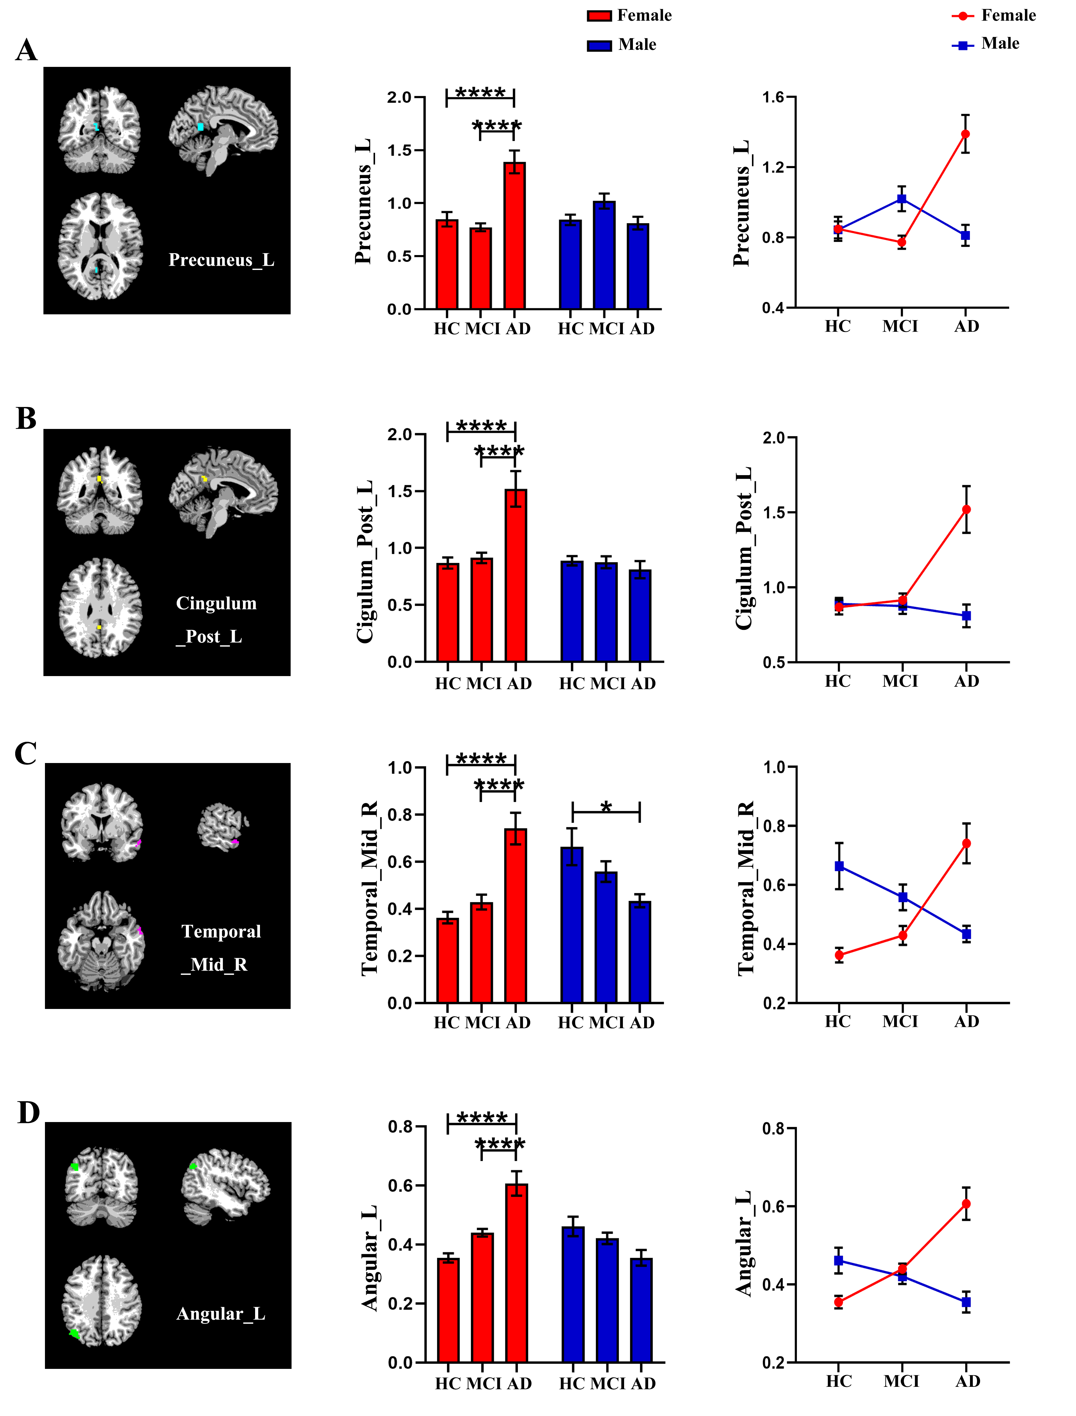Fig S1 Group × sex interaction effects on CBF/lFCS ratios of the left precuneus, left posterior cingulate, right middle temporal gyrus and left angular gyrus (P < 0.05). (A-D) The CBF/lFCS ratios of left precuneus, left posterior cingulate, right middle temporal gyrus and left angular gyrus were higher in female AD patients compared to female HCs and aMCI patients. (C) Male AD patients exhibited lower CBF/lFCS ratios of right middle temporal gyrus than male HCs. *p < 0.05; **p < 0.01; ***p < 0.001; ****p < 0.0001.
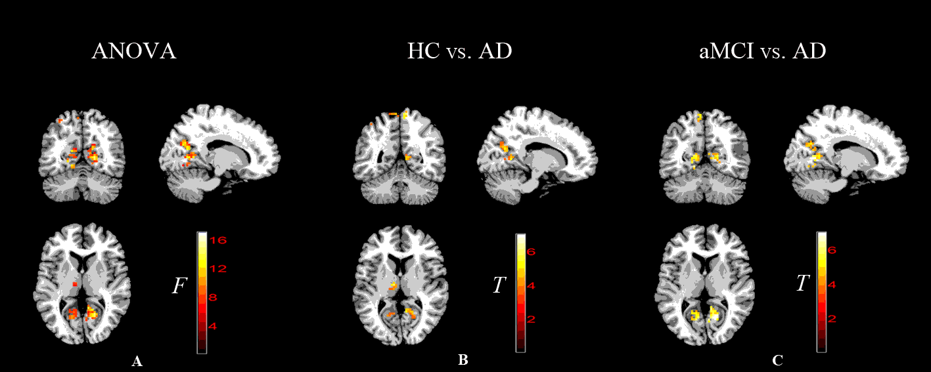
Fig S2 Main effects of group on CBF/lFCS ratios. (A) Brain areas with differences in CBF/lFCS ratio among clinical groups. (B, C) Brain areas with greater CBF/lFCS ratios in the AD group than HC and aMCI groups (cluster level FDR corrected, p < 0.05). There were no significant differences between HC and aMCI groups.
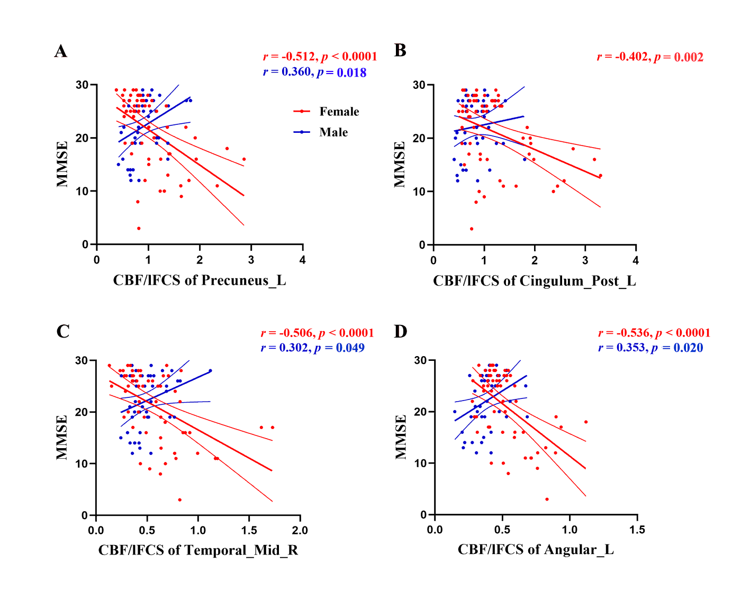
Fig S3 Scatter plots of correlations between CBF/lFCS ratios and patient MMSE scores for brain regions with sex × group interaction effects. (A-D) Negative correlations between MMSE scores and CBF/lFCS ratios of the left precuneus, left posterior cingulate, right middle temporal gyrus and left angular gyrus, respectively, in female patients. (A, C, D) Positive correlations between MMSE scores and CBF/lFCS ratios of left precuneus, right middle temporal gyrus, and left angular gyrus, respectively, in male patients.
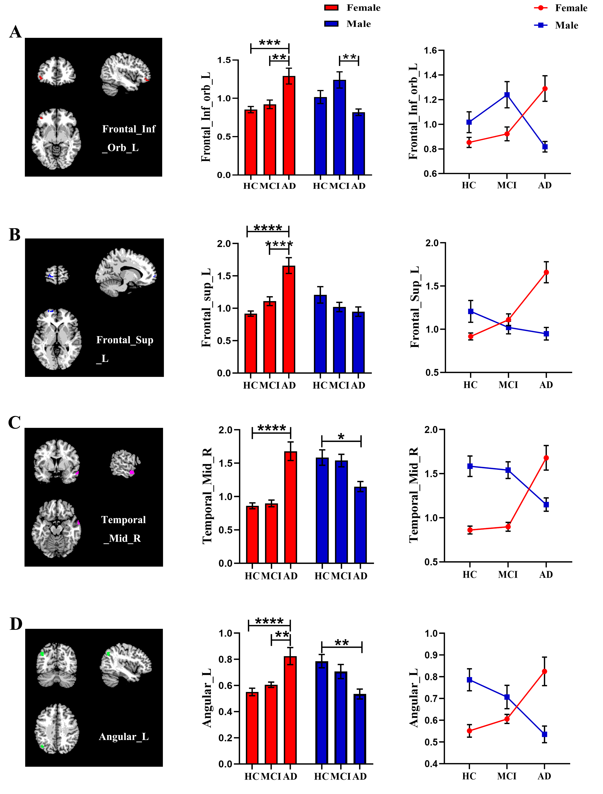
Fig S4 Group × sex interaction effects on CBF/sFCS ratios of the left inferior orbital frontal gyrus, left superior frontal gyrus, right middle temporal gyrus and left angular gyrus (P < 0.05). (A-D) The CBF/sFCS ratios of left inferior orbital frontal gyrus, left superior frontal gyrus, right middle temporal gyrus and left angular gyrus were higher in female AD patients compared to female HCs. (A, B, D) The CBF/sFCS ratios of left inferior orbital frontal gyrus, left superior frontal gyrus, and left angular gyrus were also higher in female AD patients than female aMCI patients. (C, D) Male AD patients exhibited lower CBF/sFCS ratios of right middle temporal gyrus and left angular gyrus than male HCs. (A) The CBF/sFCS ratios of left inferior orbital frontal gyrus were also lower in male AD patients than male aMCI patients. *p < 0.05; **p < 0.01; ***p < 0.001; ****p < 0.0001.
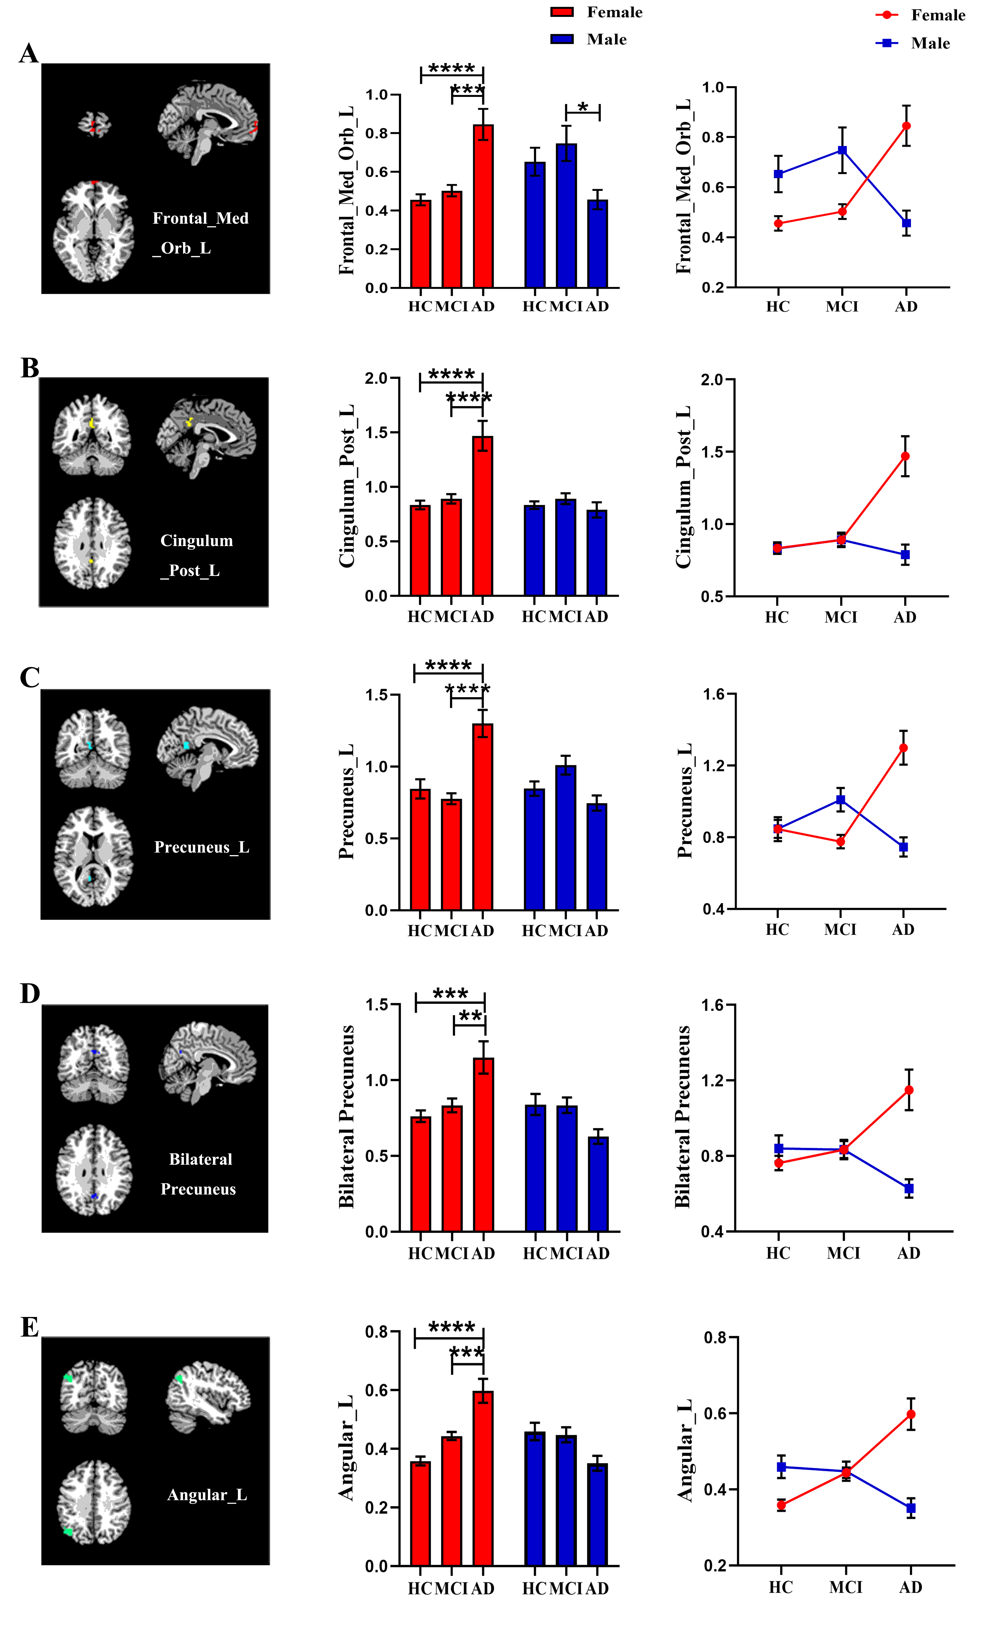
Fig S5 Group × sex interaction effects on CBF/lFCS ratios of the left medial orbital superior frontal gyrus, left posterior cingulate, left precuneus, bilateral precuneus and left angular gyrus (P < 0.05). (A-E) The CBF/lFCS ratios of left medial orbital superior frontal gyrus, left posterior cingulate, left precuneus, bilateral precuneus and left angular gyrus were higher in female AD patients compared to female HCs and aMCI patients. (A) Male AD patients exhibited lower CBF/sFCS ratios of left medial orbital superior frontal gyrus than male aMCI patients. *p < 0.05; **p < 0.01; ***p < 0.001; ****p < 0.0001.
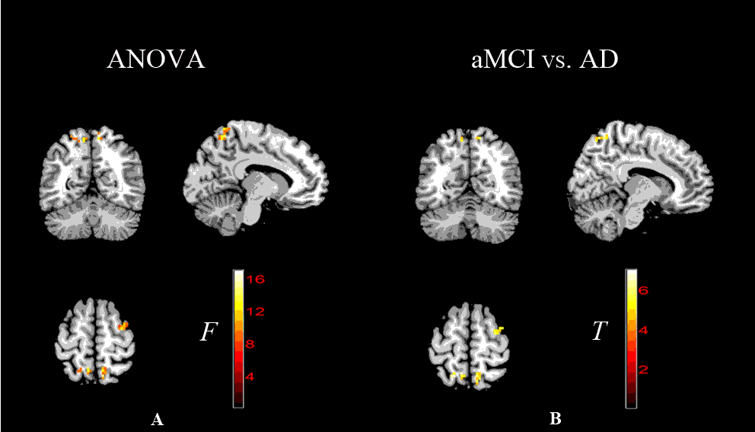
Fig S6 Main effects of group on CBF/sFCS ratios. (A) Brain areas with differences in CBF/sFCS ratio among clinical groups. (B,) Brain areas with greater CBF/sFCS ratios in the AD group than aMCI groups (cluster level FDR corrected, p < 0.05). There were no significant differences between HC and aMCI groups, HC and AD groups.
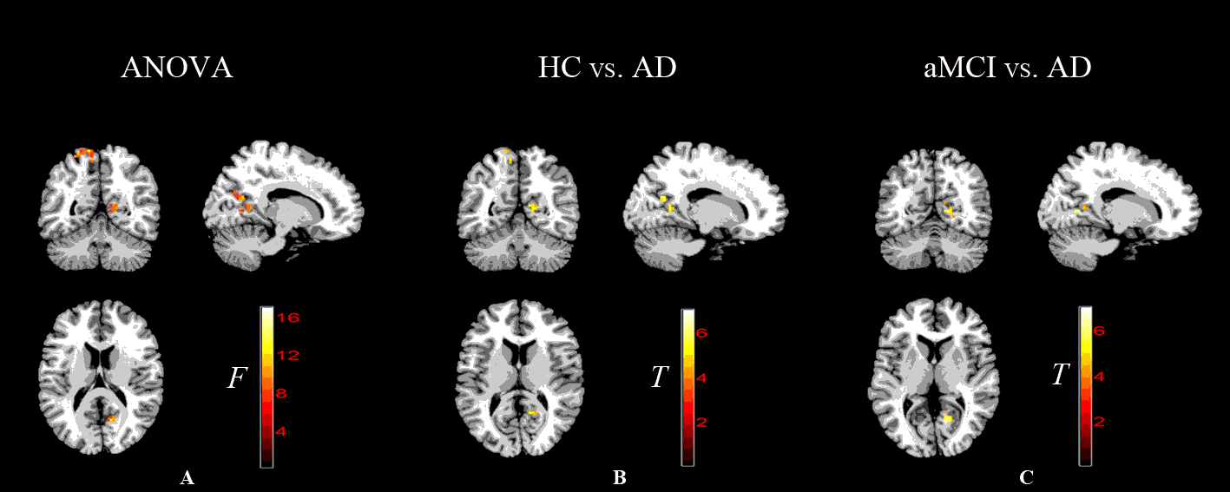
Fig S7 Main effects of group on CBF/lFCS ratios. (A) Brain areas with differences in CBF/lFCS ratio among clinical groups. (B, C) Brain areas with greater CBF/lFCS ratios in the AD group than HC and aMCI groups (cluster level FDR corrected, p < 0.05). No significant differences between the HC and aMCI groups.
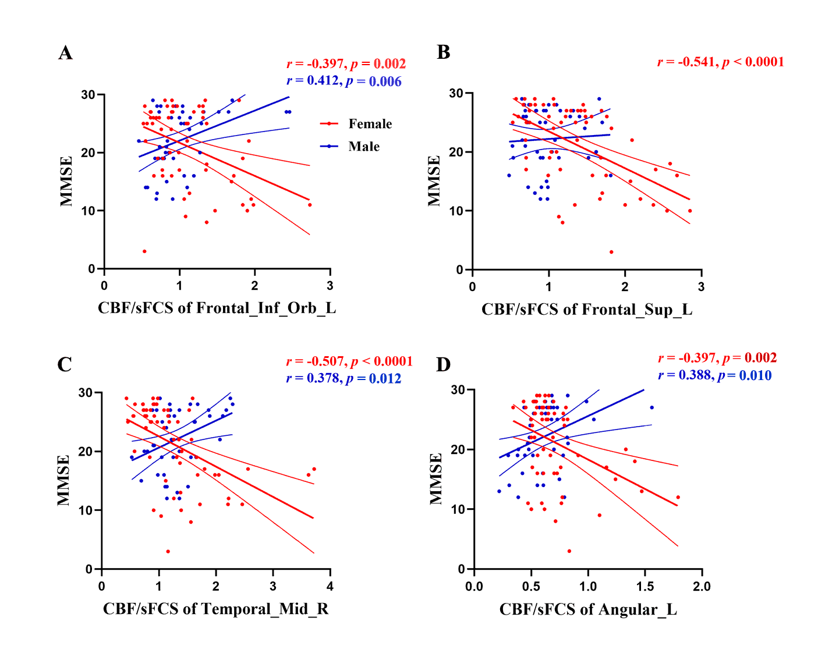
Fig S8 Scatter plots of correlations between CBF/sFCS ratios and patient MMSE scores for brain regions with sex × group interaction effects. (A-D) Negative correlations between MMSE scores and CBF/sFCS ratios of the left inferior orbital frontal gyrus, left superior frontal gyrus, right middle temporal gyrus, and left angular gyrus, respectively, in female patients. (A, C, D) Positive correlations between MMSE scores and CBF/sFCS ratios of left inferior orbital frontal gyrus, right middle temporal gyrus, and left angular gyrus, respectively, in male patients.
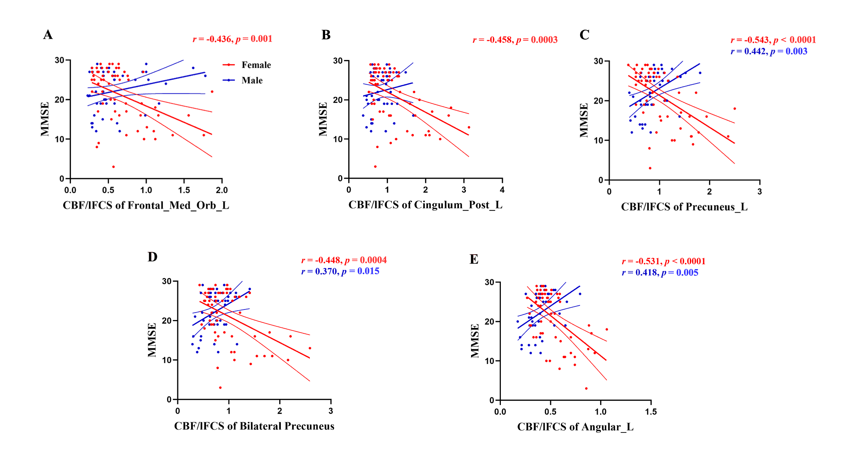
Fig S9 Scatter plots of correlations between CBF/lFCS ratios and patient MMSE scores for brain regions with sex × group interaction effects. (A-E) Negative correlations between MMSE scores and CBF/lFCS ratios of the left medial orbital superior frontal gyrus, left posterior cingulate, left precuneus, bilateral precuneus and left angular gyrus, respectively, in female patients. (C-E) Positive correlations between MMSE scores and CBF/lFCS ratios of left precuneus, bilateral precuneus, and left angular gyrus, respectively, in male patients.

Tables
Table S1 Brain regions with differences in CBF/lFCS ratios among clinical groups.
 | Regions | voxel | MNI coordinates
 | Regions | voxel | X | Y | Z
Compared  With HC  group | Calcarine_L | 21 | -9 | -57 | 3
Compared  With HC  group | Calcarine_R | 38 | 9 | -54 | 9
Compared  With HC  group | Precuneus_R | 32 | 15 | -63 | 21
Compared  With HC  group | Occipital_Sup_R | 25 | 30 | -69 | 48
Compared  With HC  group | Cingulum_Mid_L | 66 | -3 | -30 | 51
Compared  With HC  group | Precuneus_R | 44 | 9 | -51 | 72
Compared  With HC  group | Calcarine_L | 59 | -15 | -75 | 0
Compared  With HC  group | Calcarine_R | 66 | 15 | -63 | 6
Compared  With aMCI  group | Precuneus_R | 18 | 15 | -66 | 27
Compared  With aMCI  group | Occipital_Sup_R | 37 | 30 | -72 | 45
Compared  With aMCI  group | Cingulum_Mid_L | 45 | 66 | -27 | 51
Compared  With aMCI  group | Precuneus_L | 38 | -9 | -54 | 63
Compared  With aMCI  group | Precuneus_R | 32 | 15 | -63 | 21
Compared  With aMCI  group | Occipital_Sup_R | 25 | 30 | -69 | 48
Compared  With aMCI  group | Cingulum_Mid_L | 45 | 66 | -27 | 51
Compared  With aMCI  group | Precuneus_L | 38 | -9 | -54 | 63

Table S2 Results of the correlation between coupling ratios and MMSE scores for brain regions with sex × group interaction effects.
 | Brain regions | Female |  | Male
 | Brain regions | r | p | r | p
Long-range  coupling | Precuneus_L | -0.512 | <0.0001 | 0.360 | 0.018
Long-range  coupling | Cingulum_Post_L | -0.402 | 0.002
Long-range  coupling | Temporal_Mid_R | -0.505 | <0.0001 | 0.302 | 0.049
Long-range  coupling | Angular_L | -0.356 | <0.0001 | 0.353 | 0.020

Table S3 Brain regions with differences in CBF/sFCS ratios among clinical groups.
 | Regions | Voxel | MNI coordinates
 | Regions | Voxel | X | Y | Z
Compared  with aMCI  group | Supp_Motor_Area_L | 9 | 3 | 0 | 51
Compared  with aMCI  group | Precuneus_R | 13 | 9 | -57 | 63
Compared  with aMCI  group | Precuneus_L | 45 | -9 | -51 | 69
Compared  with aMCI  group | Frontal_Sup_R | 16 | 33 | -3 | 60

Table S4 Brain regions with differences in CBF/lFCS ratios among clinical groups.
 | Regions | Voxel | MNI coordinates
 | Regions | Voxel | X | Y | Z
Compared  with HC  group | Calcarine_R | 8 | 12 | -54 | 12
Compared  with HC  group | Precuneus_R | 8 | 15 | -60 | 21
Compared  with HC  group | Cuneus_R | 2 | 18 | -66 | 27
Compared  with HC  group | Precuneus_L | 4 | -9 | -57 | 63
Compared  with HC  group | Precuneus_L | 3 | -12 | -51 | 72
Compared  with HC  group | Precuneus_L | 1 | -6 | -48 | 72
Compared  with aMCI  group | Calcarine_R | 18 | 15 | -63 | 6
Compared  with aMCI  group | Calcarine_R | 2 | 12 | -63 | 18
Compared  with aMCI  group | Precuneus_R | 1 | 9 | -66 | 21
Compared  with aMCI  group | Precuneus_L | 15 | -9 | -54 | 63
Compared  with aMCI  group | Parietal_Sup_L | 1 | -24 | -57 | 66

Table S5 Results of the correlation between coupling ratios and MMSE scores for brain regions with sex × group interaction effects.
 | Brain regions | Female |  | Male
 | Brain regions | r | p | r | p
Short-range  coupling | Frontal_Inf_Orb_L | -0.397 | 0.002 | 0.412 | 0.006
Short-range  coupling | Frontal_Sup_L | -0.541 | <0.0001
Short-range  coupling | Temporal_Mid_R | -0.507 | <0.0001 | 0.378 | 0.012
Short-range  coupling | Angular_L | -0.397 | 0.002 | 0.388 | 0.010
Long-range  coupling | Frontal_Med_Orb_L | -0.436 | 0.001
Long-range  coupling | Cingulum_Post_L | -0.458 | 0.0003
Long-range  coupling | Precuneus_L | -0.543 | <0.0001 | 0.442 | 0.003
Long-range  coupling | Bilateral Precuneus | -0.448 | 0.0004 | 0.370 | 0.015
 | Angular_L | -0.531 | <0.0001 | 0.418 | 0.005

