Landscape drivers and spatial scale predicting epiphyte biodiversity across human-modified landscapes

Landscape ecology

Edicson PARRA-SANCHEZ and David P. EDWARDS
¹ University of Sheffield, United Kingdom
Author for correspondence: edicsonparras@gmail.com

Supplementary material
Table S1. Evaluation of forest/non-forest map´s forest cover thresholds.
Forest cover | Forest | Non-forests | Matching percentage
40% | 133 | 122 | 76,3
50% | 160 | 144 | 91,0
60% | 161 | 117 | 83,2
70% | 164 | 84 | 74,3
90% | 167 | 72 | 71,6

Fig. S1. Location of study forests (n= 23) along the eastern cordillera, Colombia. Maps depict forest cover (black), matrix (white), points represent (orange dots) the centre of each survey plot, and buffers around each point represent the radii analysed in our study (100-2400 m).

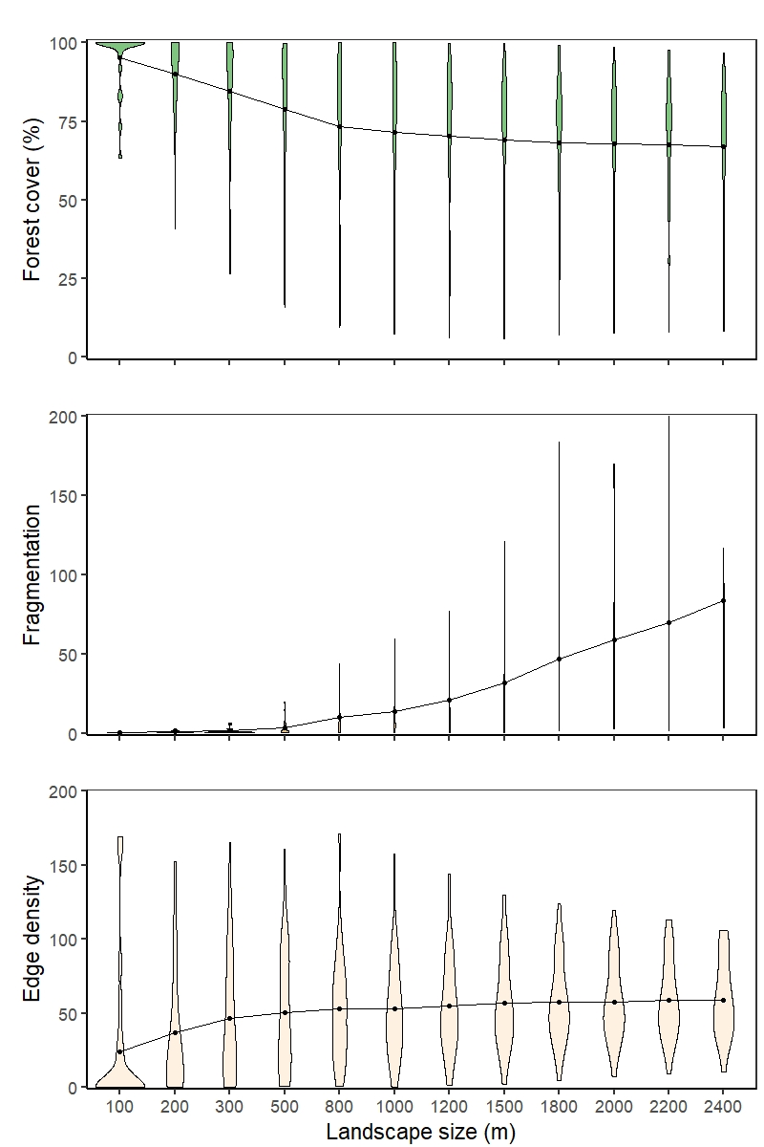

Fig. S2. Landscape predictors across 12 spatial scales (landscape size m). Violin plot area represents the probability density of the sample values.
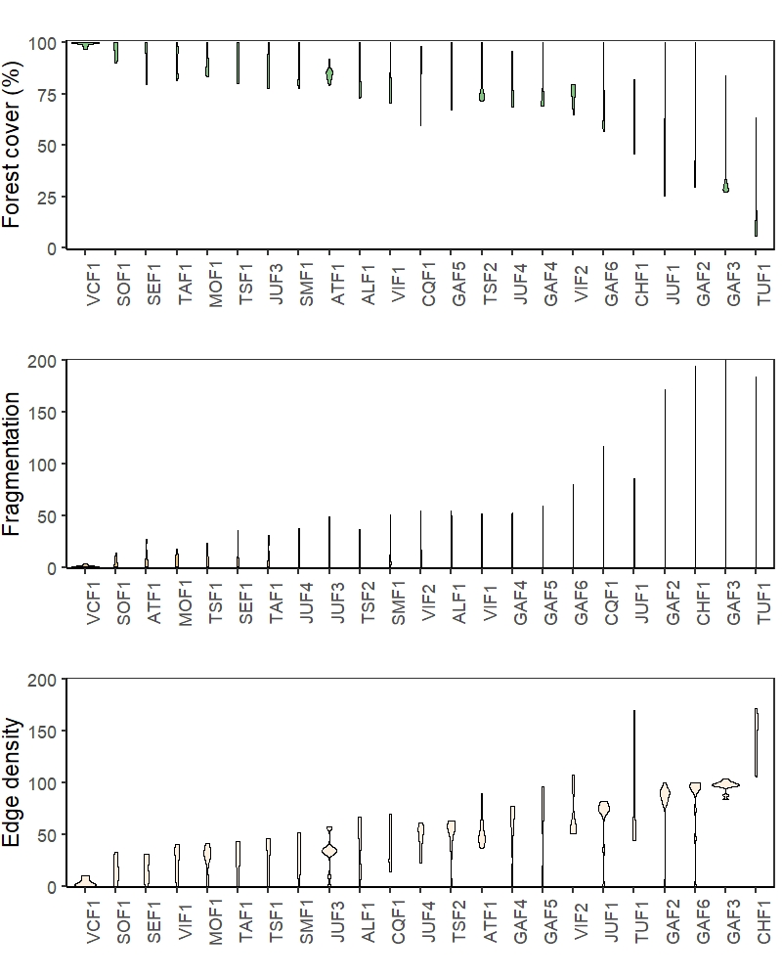
Fig. S3. Habitat loss, fragmentation, and edge density metrics in the sampling sites across 12 radii (100-2400 m radii). Violin plot area represents the probability density of the sample values.

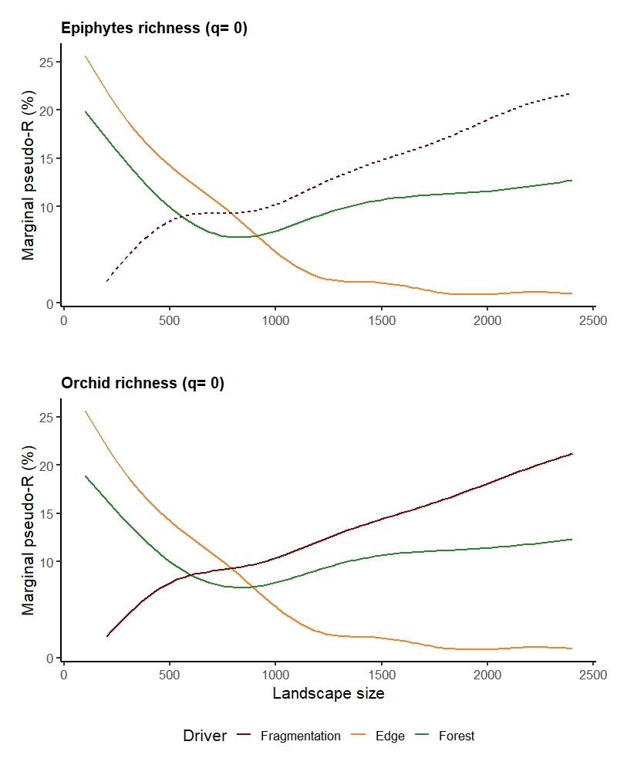
Fig. S5. Effect of forest cover (green), fragmentation (red), and edge density (yellow) across twelve spatial scales on the species richness (q= 0) of epiphytes (a) and orchid communities (b) in the Colombian eastern cordillera. The strength of landscapes effects is measured with the marginal r² (%) of each linear mixed model. Dashed line indicates the cases in which the model showed no effects.
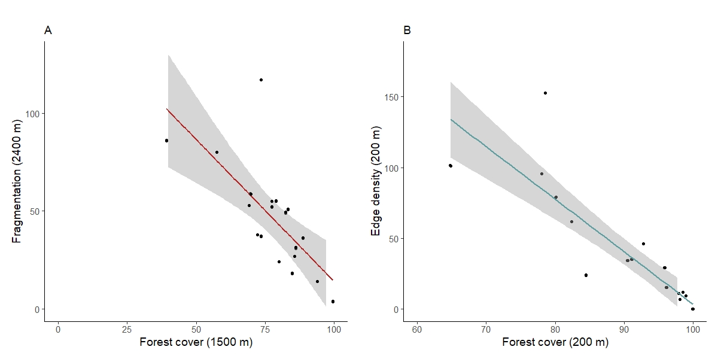
Fig. S6. Correlations among forest cover and (A) fragmentation (i.e. number of patches) at the scale of effect of 1500 m radius; and (B) edge density at the scale of effect of 100 m radius. Straight line depicts the linear regression between predictors (red for fragmentation and blue for edge density), shaded-area represents the confident intervals at 95% of the sample values.

