Supplementary Figures

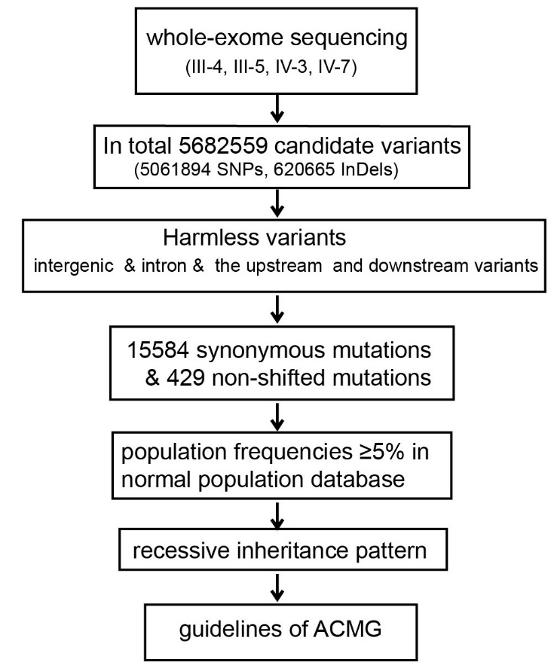
Supplementary Figure 1. Workflow of whole-exome sequencing analysis for the consanguineous family with dilated cardiomyopathy.

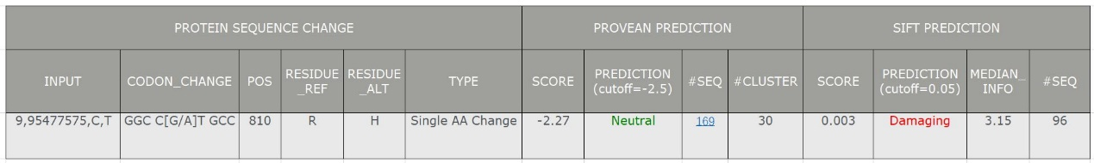
Supplementary Figure 2. Algorithm prediction for the BICD2 missense variant (c.2429G>A:p.Arg810His) identified in DCM patients from the consanguineous family.

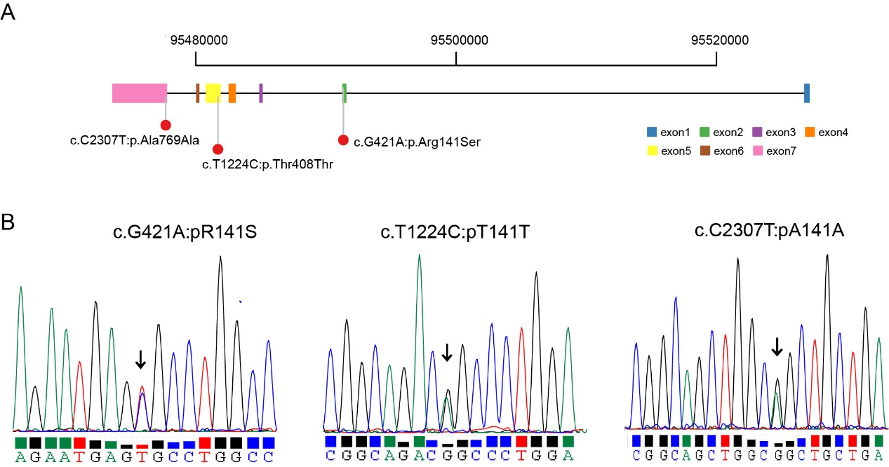
Supplementary Figure 3. Validation of BICD2 in 210 sporadic DCM patients.
- Three BICD2 variants were identified in 210 sporadic DCM patients.
- Sanger sequencing results of the missense variant.

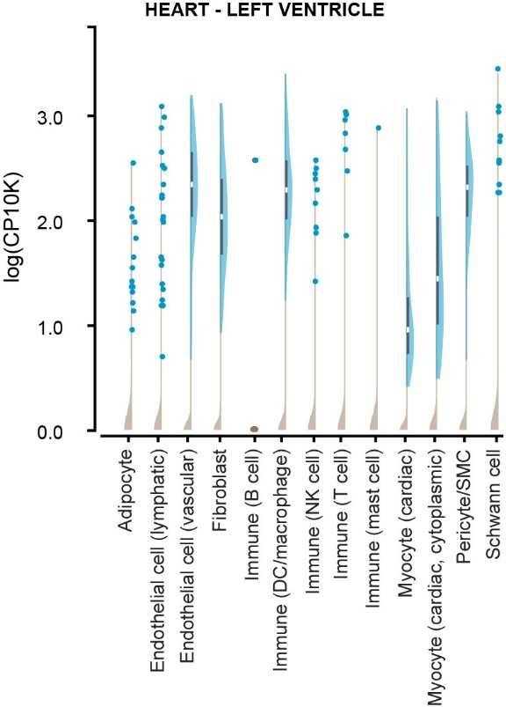
Supplementary Figure 4. scRNA-seq of the human heart unraveled BICD2 mRNA expression in different cell types.

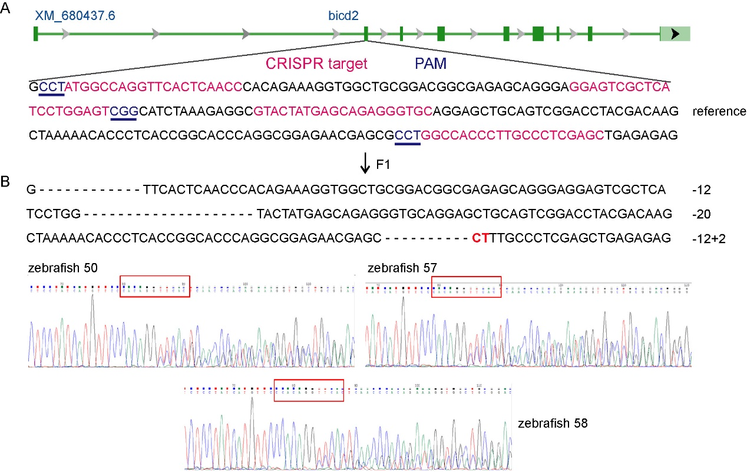
Supplementary Figure 5. Generation of bicd2 knockout zebrafish.
A. The target site of the CRISPR/Cas9 system, which was designed at the exon 2 of the bicd2 gene, consists of the red colored CRISPR target sequence and the CCT/CGG/CCT protospacer-adjacent sequence. We identified 3 heterozygous mutant adult zebrafish.
B. Sequencing validation of the F1 heterozygous mutant adult zebrafish (3 fish with the same mutant genotype).

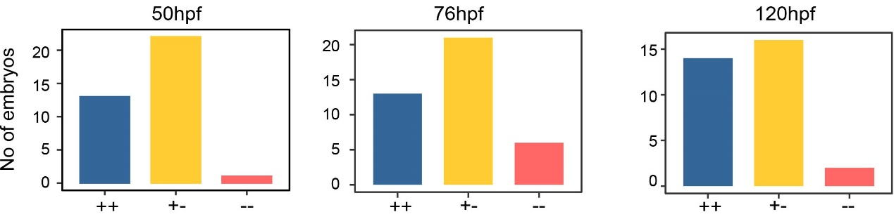
Supplementary Figure 6. Number of embryos in three different zebrafish groups with genotype of wild-type, heterozygous and homozygous

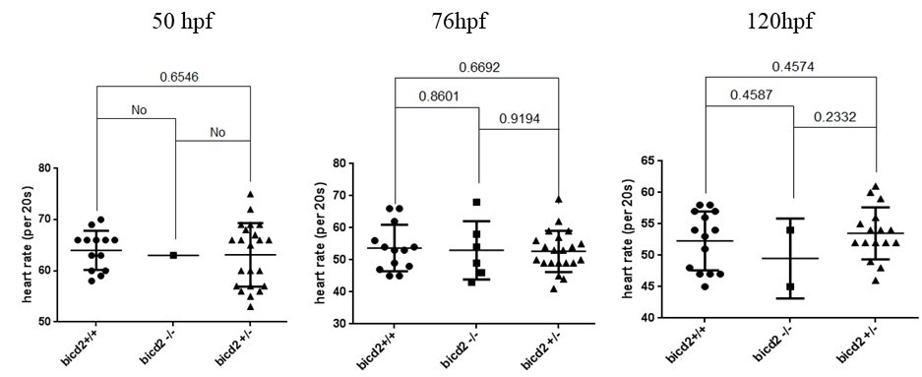
Supplementary Figure 7. Heart rate of embryo zebrafish in three different zebrafish groups with genotype of wild-type, heterozygous and homozygous

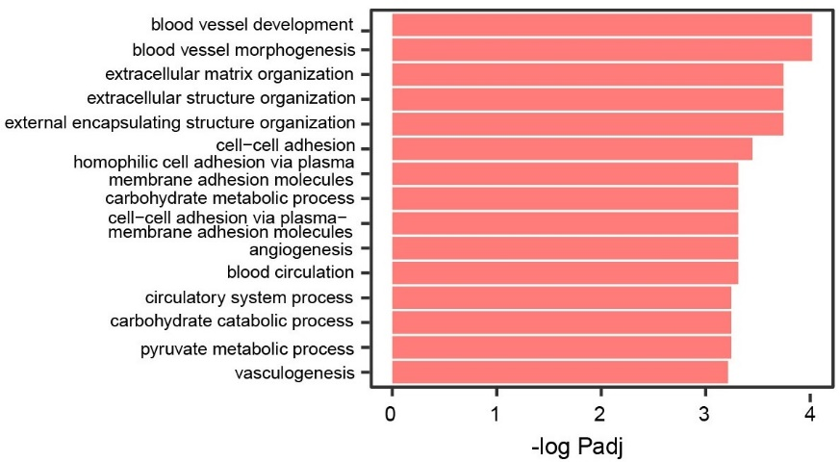
Supplementary Figure 8. The top 15 GO biological pathway increased in bicd2 homozygous group.

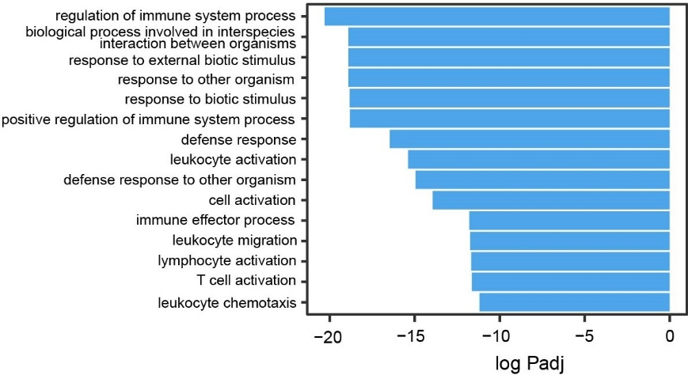
Supplementary Figure 9. The top 15 GO biological pathway decreased in bicd2 homozygous group.

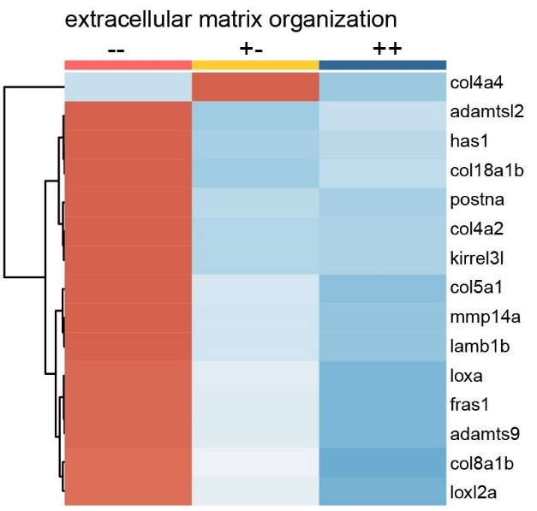
Supplementary Figure 10. Differential expressed genes in extracellular matrix organization.

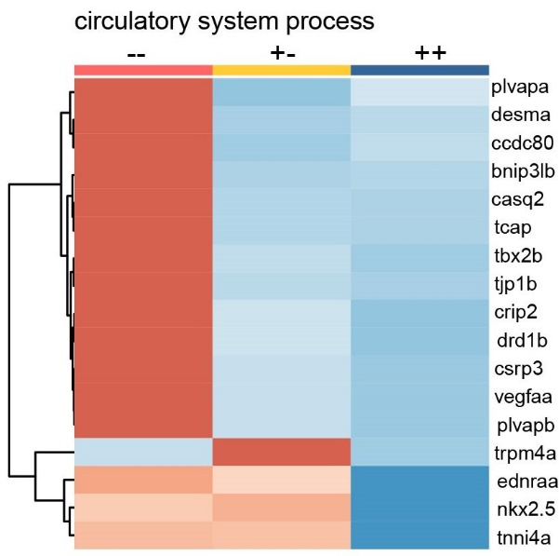
Supplementary Figure 11. Differential expressed genes in circulatory system process
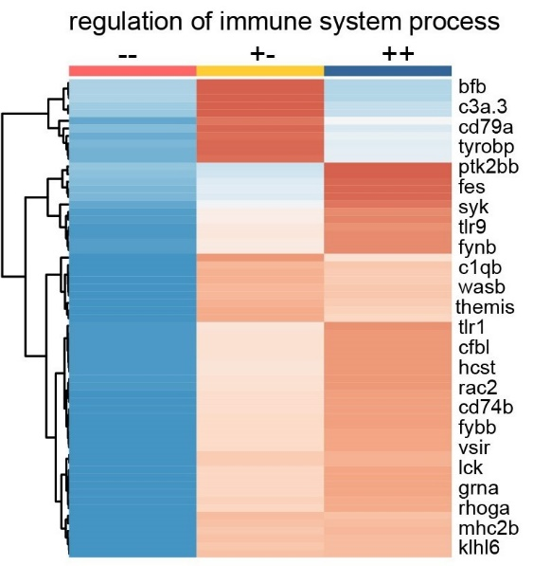
Supplementary Figure 12. Differential expressed genes in regulation of immune system process.

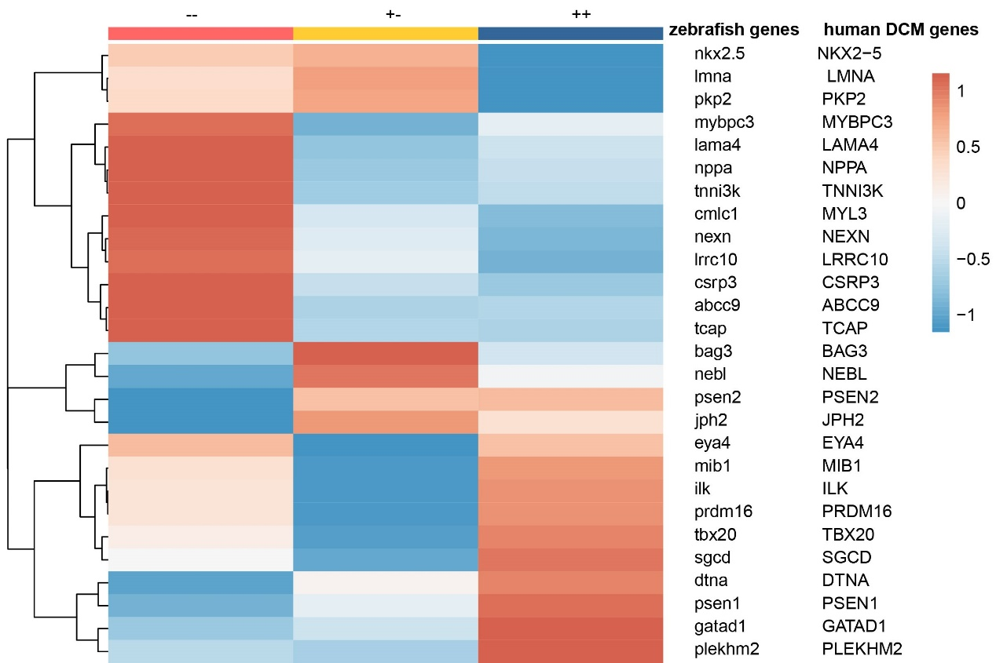

Supplementary Figure 13. Expression of zebrafish homologues of 20 human DCM associated genes with unique homologues in bicd2-deficiency zebrafish.
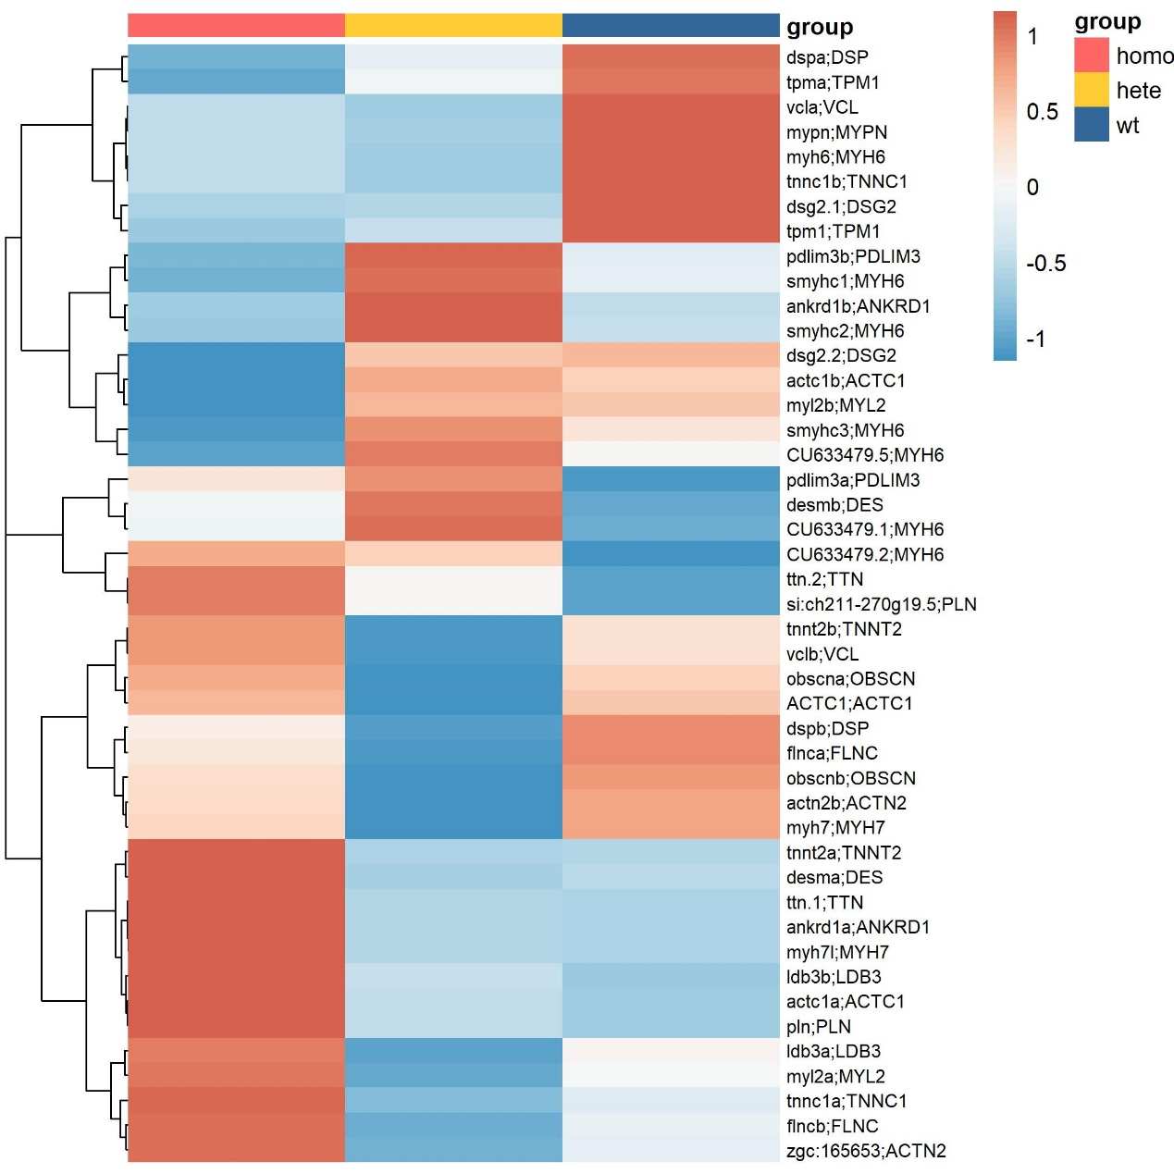
Supplementary Figure 14. Expression of zebrafish homologues of 20 human DCM associated genes with multiple homologues in bicd2-deficiency zebrafish.

CHR | POS | REF | ALT | Impact_score | Gene_symbol | High_effect | Hgv.p | Hgv.c | Annotation_Impact
6 | 105573356 | CA | C | 0.823213843 | BVES | frameshift_variant | p.Cys150fs | c.448delT | HIGH
6 | 122773161 | C | T | 0.737171748 | SERINC1 | missense_variant | p.Val211Ile | c.631G>A | MODERATE
7 | 45717651 | C | T | 0.82589953 | ADCY1 | missense_variant | p.Arg597Trp | c.1789C>T | MODERATE
9 | 95477575 | C | T | 0.853430607 | BICD2 | missense_variant | p.Arg810His | c.2429G>A | MODERATE
9 | 118997457 | G | A | 0.83169857 | PAPPA | missense_variant | p.Arg758His | c.2273G>A | MODERATE
Supplementary Table 1. Five candidate BICD2 variants for the consanguineous family with DCM

Supplementary Table 2. Three BICD2 variants identified in 210 sporadic DCM cases
Markers | Exon | Amino acid change | Polyphen2_HDIV_ score | Polyphen2_HDIV_ pred
NM_001003800.1:c.421C>A | exon2 | p.Arg141Ser | 0.959 | D
NM_001003800.1:c.1224A>C | exon5 | p.Thr408Thr | - | -
NM_001003800.1:c2307G>T | exon7 | p.Ala769Ala | - | -

Supplementary Table 3. CRISPR target sequence
ID | sequence
Guide #1 | GGTTGAGTGAACCTGGCCATAGG
Guide #2 | GGAGTCGCTCATCCTGGAGTCGG
Guide #3 | GTACTATGAGCAGAGGGTGCAGG
Guide #4 | GCTCGAGGGCAAGGGTGGCCAGG

Supplementary Table 4. PCR primer for F1 mutant identification
ID | sequence
F1-bicd2 | TAAACTTCAAACCTCCACCCCC
R1-bicd2 | AGCTTAACATTTCATTGGAGGAGC
F2-bicd2 | TCCTCCACCCTACAAGACAAG
R2-bicd2 | CGATCCACTGGCTTTAGTTTG

Supplementary Table 5. Number of zebrafish embryos in three genotypes groups
 | 50hpf | 76hpf | 120hpf
bicd2+/- | 22 | 21 | 16
bicd2+/+ | 13 | 13 | 14
bicd2-/- | 1 | 6 | 2

Supplementary Table 6. Heart rate of zebrafish with three different genotypes at embryo stage
50hpf |  |  |  | 76hpf |  |  |  | 120hdf
ID | bicd2  ++ | bicd2  -- | bicd2  +- | ID | bicd  ++ | bicd2  -- | bicd2  +- | ID | bicd2  ++ | bicd2  -- | bicd2  +-
1 | 70 | 63 | 56 | 1 | 45 | 46 | 49 | 1 | 47 | 54 | 46
2 | 66 | 57 | - | 2 | 45 | 43 | 54 | 2 | 48 | 45 | 52
3 | 60 | 69 | - | 3 | 49 | 58 | 49 | 3 | 54 | 52 | -
4 | 59 | 66 | - | 4 | 53 | 49 | 45 | 4 | 47 | 48 | -
5 | 69 | 75 | - | 5 | 48 | 54 | 41 | 5 | 58 | 56 | -
6 | 63 | 57 | - | 6 | 54 | 68 | 50 | 6 | 47 | 52 | -
7 | 66 | 65 | - | 7 | 56 | 49 | - | 7 | 56 | 52 | -
8 | 58 | 66 | - | 8 | 62 | 44 | - | 8 | 45 | 59 | -
9 | 63 | 60 | - | 9 | 53 | 54 | - | 9 | 51 | 60 | -
10 | 66 | 67 | - | 10 | 54 | 55 | - | 10 | 57 | 54 | -
11 | 60 | 66 | - | 11 | 47 | 49 | - | 11 | 54 | 52 | -
12 | 66 | 69 | - | 12 | 66 | 50 | - | 12 | 53 | 49 | -
13 | 66 | 56 | - | 13 | 66 | 56 | - | 13 | 57 | 61 | -
14 | 69 | - | - | 14 | 49 | - | - | 14 | 58 | 55 | -
15 | 53 | - | - | 15 | 59 | - | - | 15 | 54 | - | -
16 | 55 | - | - | 16 | 53 | - | - | 16 | 54 | - | -
17 | 60 | - | - | 17 | 53 | - | -
18 | 68 | - | - | 18 | 57 | - | -
19 | 57 | - | - | 19 | 69 | - | -
20 | 66 | - | -
21 | 60 | - | -
22 | 72 | - | -

Supplementary Table 7. Metrics of cardiac function and cardiac size in zebrafish groups
 | Homo1 | Homo2 | Homo3 | Homo4 | Homo5 | WT1 | WT2 | WT3 | WT4
Area | 1.1201 | 1.4286 | 0.8070 | 1.2610 | 1.5397 | 0.9706 | 1.3079 | 1.1502 | 1.0556
Area;s | 1.1201 | 1.4286 | 0.8070 | 1.2610 | 1.5397 | 0.9706 | 1.3079 | 1.1502 | 1.0556
Area;d | 1.5488 | 1.7202 | 1.1557 | 1.5917 | 1.8398 | 1.4308 | 1.7386 | 1.5010 | 1.4161
Volume | 0.8153 | 1.1094 | 0.4857 | 0.9418 | 1.2233 | 0.6637 | 1.0667 | 0.6690 | 0.7015
Volume;s | 0.8153 | 1.1094 | 0.4857 | 0.9418 | 1.2233 | 0.6637 | 1.0667 | 0.6690 | 0.7015
Volume;d | 1.3071 | 1.5346 | 0.8416 | 1.3304 | 1.5187 | 1.1730 | 1.6444 | 1.2477 | 1.3011
Stroke Volume | 0.4917 | 0.4253 | 0.3559 | 0.3886 | 0.2953 | 0.5093 | 0.5778 | 0.5787 | 0.5996
Ejection Fraction | 37.6203 | 27.7109 | 42.2908 | 29.2090 | 19.4459 | 43.4167 | 35.1350 | 46.3777 | 46.0841
Fractional Shortening | 14.7300 | 3.9495 | 18.7594 | 13.8289 | 13.5571 | 15.5385 | 13.4224 | -2.7793 | 10.1920
Cardiac Output | 0.5069 | 0.2833 | 0.3687 | 0.3758 | 0.3066 | 0.4979 | 0.5560 | 0.6009 | 0.6031

Supplementary Table 8. Mean FPKM of bicd2 in three zebrafish groups
 | homo | hete | wt
bicd2 | 3.271738 | 3.949286 | 5.322773

Supplementary Table 9. KEGG pathways enriched in bicd2-- zebrafish
NAME | SIZE | ES | NES | NOM  p-val | FDR  q-val | FWER  p-val | RANK  AT MAX | LEADING EDGE
KEGG_PARKINSONS_DISEASE | 106.000 | 0.948 | 1.720 | 0.016 | 0.168 | 0.170 | 404.000 | tags=58%, list=3%, signal=60%
KEGG_HUNTINGTONS_DISEASE | 156.000 | 0.943 | 1.703 | 0.014 | 0.225 | 0.389 | 404.000 | tags=39%, list=3%, signal=40%
KEGG_GLYCOLYSIS_GLUCONEOGENESIS | 53.000 | 0.970 | 1.677 | 0.016 | 0.373 | 0.707 | 204.000 | tags=32%, list=1%, signal=32%
KEGG_ALZHEIMERS_DISEASE | 135.000 | 0.915 | 1.643 | 0.042 | 0.532 | 0.901 | 404.000 | tags=44%, list=3%, signal=45%
KEGG_OXIDATIVE_PHOSPHORYLATION | 104.000 | 0.906 | 1.628 | 0.055 | 0.520 | 0.939 | 404.000 | tags=57%, list=3%, signal=58%
KEGG_CARDIAC_MUSCLE_CONTRACTION | 66.000 | 0.910 | 1.610 | 0.065 | 0.524 | 0.966 | 343.000 | tags=32%, list=2%, signal=32%
KEGG_CALCIUM_SIGNALING_PATHWAY | 154.000 | 0.878 | 1.576 | 0.082 | 0.573 | 0.986 | 274.000 | tags=4%, list=2%, signal=4%
KEGG_FRUCTOSE_AND_MANNOSE_METABOLISM | 31.000 | 0.925 | 1.571 | 0.056 | 0.514 | 0.987 | 248.000 | tags=13%, list=2%, signal=13%
KEGG_PYRUVATE_METABOLISM | 34.000 | 0.925 | 1.563 | 0.055 | 0.477 | 0.990 | 486.000 | tags=38%, list=3%, signal=39%
KEGG_CITRATE_CYCLE_TCA_CYCLE | 29.000 | 0.914 | 1.545 | 0.061 | 0.471 | 0.994 | 277.000 | tags=31%, list=2%, signal=32%
KEGG_RNA_DEGRADATION | 54.000 | 0.871 | 1.513 | 0.085 | 0.499 | 0.998 | 10.000 | tags=2%, list=0%, signal=2%
KEGG_RIBOSOME | 76.000 | 0.838 | 1.498 | 0.096 | 0.489 | 0.998 | 494.000 | tags=70%, list=3%, signal=72%
KEGG_PENTOSE_PHOSPHATE_PATHWAY | 23.000 | 0.893 | 1.473 | 0.085 | 0.503 | 1.000 | 248.000 | tags=17%, list=2%, signal=18%
KEGG_PROPANOATE_METABOLISM | 28.000 | 0.872 | 1.464 | 0.088 | 0.487 | 1.000 | 575.000 | tags=29%, list=4%, signal=30%

