Extended Data Table 1: Unsolicited AEs, AESIs, and SAEs until day 56, classified according to CTCAE V5.0.
CTCAE | Severity | All participants (n = 54) |  | Phase I (n = 14) |  | Phase II (n = 40)
CTCAE | Severity | Not related to vaccine | Related to vaccine | Not related to vaccine | Related to vaccine | Not related to vaccine | Related to vaccine
Any event | Mild | 50 | 3 | 14 | - | 36 | 3
Any event | Moderate | 8 | - | 3 | - | 5 | -
Any event | Severe | 5 | - | 1 | - | 4 | -
Any event | Life-threatening | 1 | - | - | - | 1 | -
Arthralgia | Mild | 1 | - | - | - | 1 | -
Arthralgia | Moderate | - | - | - | - | - | -
Atrial fibrillation | Mild | 1 | - | - | - | 1 | -
Atrial fibrillation | Moderate | - | - | - | - | - | -
Blister | Mild | - | 1 | - | - | - | 1
Blister | Moderate | - | - | - | - | - | -
Bloating | Mild | 1 | - | 1 | - | - | -
Bloating | Moderate | - | - | - | - | - | -
Bone pain | Mild | 1 | - | - | - | 1 | -
Bone pain | Moderate | - | - | - | - | - | -
Chills | Mild | 1 | - | 1 | - | - | -
Chills | Moderate | - | - | - | - | - | -
Chough | Mild | 1 | - | - | - | 1 | -
Chough | Moderate | 1 | - | - | - | 1 | -
Diarrhea | Mild | 2 | - | 1 | - | 1 | -
Diarrhea | Moderate | - | - | - | - | - | -
Dizziness | Mild | 2 | - | 1 | - | 1 | -
Dizziness | Moderate | 1 | - | - | - | 1 | -
Dyspnea | Mild | 2 | - | 1 | - | 1 | -
Dyspnea | Moderate | - | - | - | - | - | -
Ear pain | Mild | 1 | - | - | - | 1 | -
Ear pain | Moderate | - | - | - | - | - | -
Edema limbs | Mild | 1 | - | - | - | 1 | -
Edema limbs | Moderate | - | - | - | - | - | -
Edema of both legs | Mild | 1 | - | - | - | 1 | -
Edema of both legs | Moderate | - | - | - | - | - | -
Epistaxis | Mild | 1 | - | - | - | 1 | -
Epistaxis | Moderate | - | - | - | - | - | -
Fatigue | Mild | 1 | - | 1 | - | - | -
Fatigue | Moderate | - | - | - | - | - | -
Flu like symptoms | Mild | 4 | - | 1 | - | 3 | -
Flu like symptoms | Moderate | - | - | - | - | - | -
Fracture | Mild | - | - | - | - | - | -
Fracture | Moderate | - | - | - | - | - | -
Fracture | Severe | 1 | - | 1 | - | - | -
Headache | Mild | 2 | - | 1 | - | 1 | -
Headache | Moderate | - | - | - | - | - | -
Hearing impaired | Mild | - | - | - | - | - | -
Hearing impaired | Moderate | 1 | - | 1 | - | - | -
Herpes simplex reactivation | Mild | - | 1 | - | - | - | 1
Herpes simplex reactivation | Moderate | - | - | - | - | - | -
Hot flashes | Mild | 2 | - | - | - | 2 | -
Hot flashes | Moderate | - | - | - | - | - | -
Hypertension | Mild | - | - | - | - | - | -
Hypertension | Moderate | 1 | - | 1 | - | - | -
Hypertension | Severe | 1 | - | - | - | 1 | -
Infections and infestations, other -novel proven SARS-CoV-2 infection | Mild | 2*, ** | - | - | - | 2*, ** | -
 | Moderate | - | - | - | - | - | -
Insomnia | Mild | 1 | - | - | - | 1 | -
Insomnia | Moderate | - | - | - | - | - | -
Lyme borreliosis | Mild | 1 | - | 1 | - | - | -
Lyme borreliosis | Moderate | - | - | - | - | - | -
Lymphadenopathy | Mild | 1 | - | 1 | - | - | -
Lymphadenopathy | Moderate | - | - | - | - | - | -
Menorrhagia | Mild | - | - | - | - | - | -
Menorrhagia | Moderate | 1 | - | - | - | 1 | -
Muscle cramp | Mild | 1 | - | - | - | 1 | -
Muscle cramp | Moderate | - | - | - | - | - | -
Nausea | Mild | 6 | - | 1 | - | 5 | -
Nausea | Moderate | - | - | - | - | - | -
Neoplasms benign, malignant and unspecified (incl. cysts and polyps) - others, prostate | Mild | - | - | - | - | - | -
 | Moderate | - | - | - | - | - | -
 | Severe | 1* | - | - | - | 1* | -
Neutrophile count decreased | Mild | - | - | - | - | - | -
Neutrophile count decreased | Moderate | - | - | - | - | - | -
Neutrophile count decreased | Severe | - | - | - | - | - | -
Neutrophile count decreased | Life-threatening | 1 | - | - | - | 1 | -
Pain in extremity – left knee | Mild | 1 | - | - | - | 1 | -
Pain in extremity – left knee | Moderate | - | - | - | - | - | -
Pain in extremity – right upper arm | Mild | 1 | - | - | - | 1 | -
Pain in extremity – right upper arm | Moderate | - | - | - | - | - | -
Periodontal disease | Mild | 1 | - | - | - | 1 | -
Periodontal disease | Moderate | - | - | - | - | - | -
Presyncope | Mild | - | - | - | - | - | -
Presyncope | Moderate | 1 | - | 1 | - | - | -
Renal calculi | Mild | - | - | - | - | - | -
Renal calculi | Moderate | - | - | - | - | - | -
Renal calculi | Severe | 1 | - | - | - | 1 | -
Shingles | Mild | - | 1 | - | - | - | 1
Shingles | Moderate | - | - | - | - | - | -
Sinusitis | Mild | 1 | - | 1 | - | - | -
Sinusitis | Moderate | 1 | - | - | - | 1 | -
Sore throat | Mild | 2 | - | - | - | 2 | -
Sore throat | Moderate | - | - | - | - | - | -
Stomach pain | Mild | 2 | - | 1 | - | 1 | -
Stomach pain | Moderate | - | - | - | - | - | -
Suspicious skin lesion | Mild | - | - | - | - | - | -
Suspicious skin lesion | Moderate | 1 | - | - | - | 1 | -
Vaginal infection | Mild | 1 | - | - | - | 1 | -
Vaginal infection | Moderate | - | - | - | - | - | -
Vasovagal reaction | Mild | - | - | - | - | - | -
Vasovagal reaction | Moderate | - | - | - | - | - | -
Vasovagal reaction | Severe | 1 | - | - | - | 1 | -
Vertigo | Mild | 2 | - | 1 | - | 1 | -
Vertigo | Moderate | - | - | - | - | - | -
Vomiting | Mild | 2 | - | - | - | 2 | -
Vomiting | Moderate | - | - | - | - | - | -
Severity and relationship were judged by the investigator until day 56. *termed as SAE, **termed as AESI. Abbreviations: AE, adverse event; AESI, adverse event of special interest; SAE, serious adverse event; CTCAE, common terminology criteria for adverse events; n, number.

Extended Data Figures
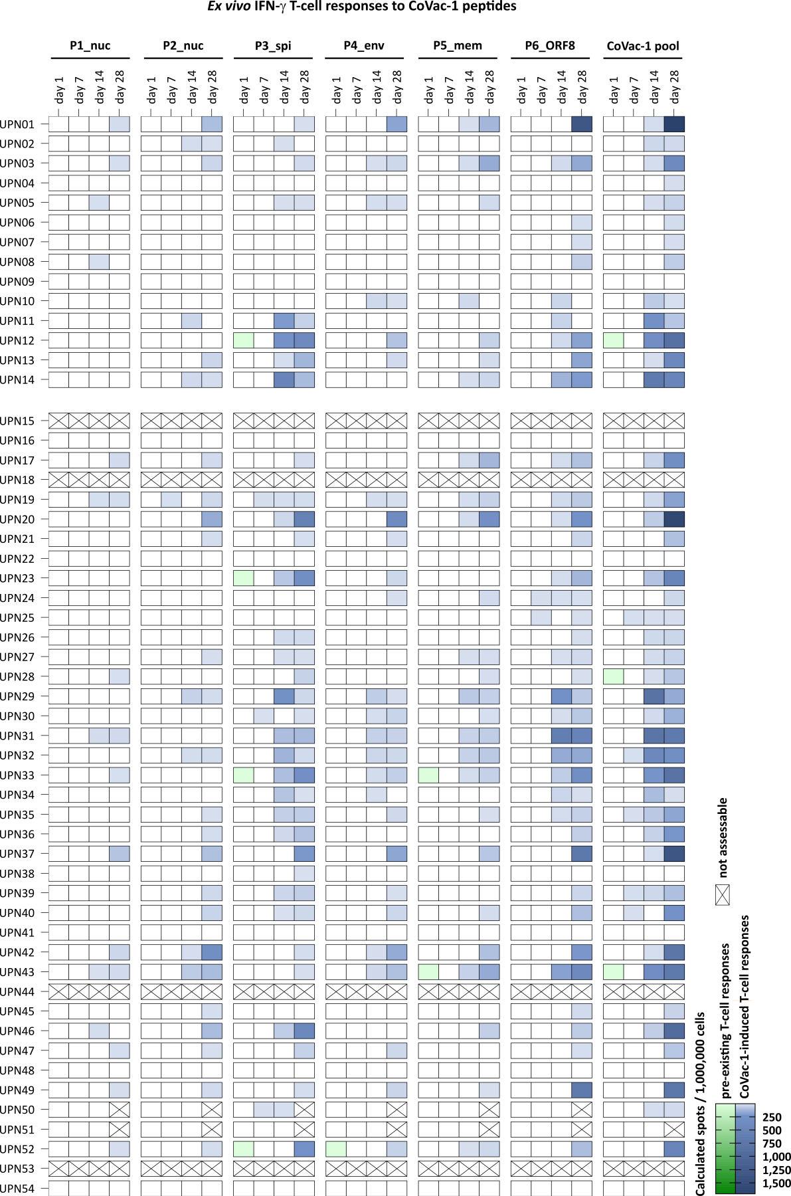
Extended Data Figure 1: Intensities of CoVac-1-induced T-cell responses ex vivo assessed in IFN-γ ELISPOT assays. Heatmap of pre-existing (color gradient green) or CoVac-1-induced (color gradient blue) T-cell response intensities to single CoVac-1 peptides (nuc, nucleocapsid; spi, spike; env, envelope; mem, membrane; ORF, open reading frame) and CoVac-1 peptide pool in ex vivo IFN-γ ELISPOT assays using PBMCs from study patients (uniform patient number, UPN) before CoVac-1 application (day 1) and at different time points after vaccination (day 7, day 14, day 28). The first 14 study patients were included in the Phase I part of the trial. Ticked boxes display not assessable T-cell responses due to e.g. insufficient sample material or inability to mount antigen-specific T-cell responses (absence of CoVac-1-induced T-cell responses and no T-cell responses to HLA-DR T-cell epitope control panel including viral peptides from Epstein-Barr virus (EBV), cytomegalovirus (CMV) and adenovirus (ADV) assessed by IFN-γ ELISPOT assays).

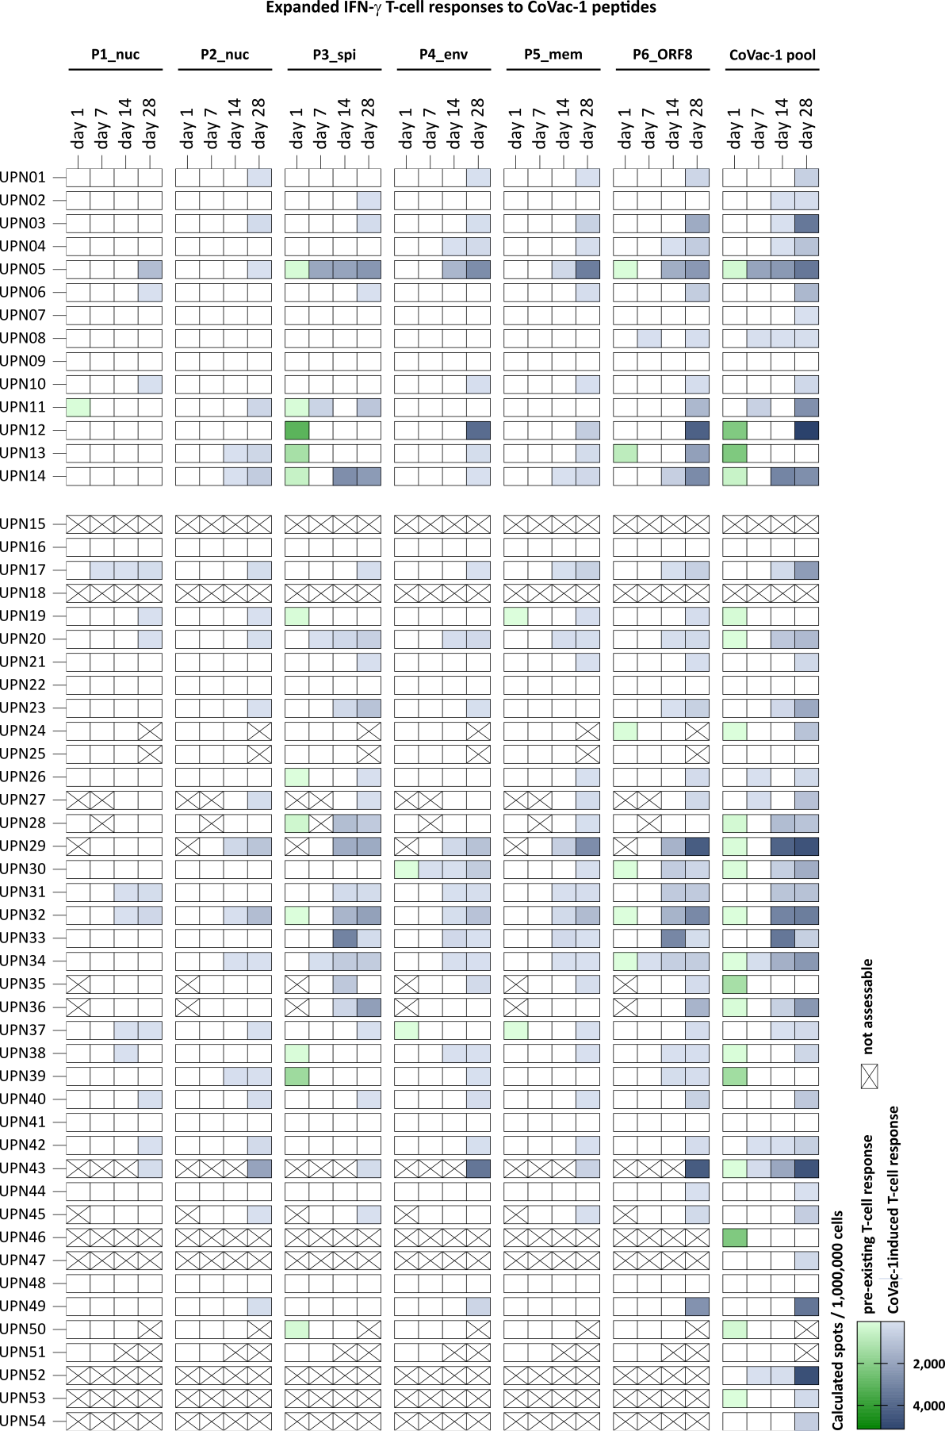
Extended Data Figure 2: Intensities of CoVac-1-induced T-cell responses assessed in IFN-γ ELISPOT assays after 12-day in vitro expansion. Heatmap of pre-existing (color gradient green) or CoVac-1-induced (color gradient blue) T-cell response intensities to single CoVac-1 peptides (nuc, nucleocapsid; spi, spike; env, envelope; mem, membrane; ORF, open reading frame) and CoVac-1 peptide pool in IFN-γ ELISPOT assays after 12-day in vitro expansion of PBMCs from study patients (uniform patient number, UPN) before (day 1) and at different time points after CoVac-1 application (day 7, day 14, day 28). The first 14 study patients were included in the Phase I part of the trial. Ticked boxes display not assessable T-cell responses due to e.g. insufficient sample material or inability to mount antigen-specific T-cell responses (absence of CoVac-1 induced T-cell responses and no T-cell responses to HLA-DR T-cell epitope control panel including viral peptides from Epstein-Barr virus (EBV), cytomegalovirus (CMV) and adenovirus (ADV) assessed by IFN-γ ELISPOT assays).

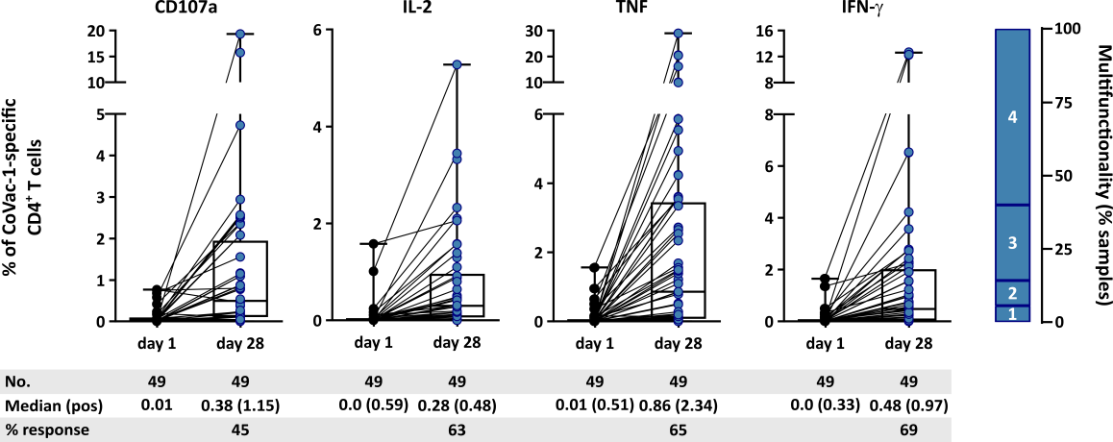
Extended Data Figure 3: CoVac-1-induced CD4⁺ T-cell responses in study participants. Frequencies of CoVac-1‐specific CD4⁺ T cells in study participants (n = as indicated) prior to (day 1) or on day 28 following CoVac-1 administration after 12-day in vitro expansion. Functionality of CD4⁺ T cells was assessed for upregulation of the degranulation marker CD107a and production of the T-helper 1 (Th1) cytokines (IFN‐γ, TNF, IL-2). The right graph displays the proportion of samples revealing bifunctional (2), trifunctional (3), or tetrafunctional (4) CD4⁺ T cells. Combined box-line plots display median with 25th or 75th percentiles, and min/max whiskers. no, number; pos, positive.

Supplementary Tables and Figures
Supplementary Table S1: Toxicity grading scale modified according to CTCAE V5.0.
This table depicts the toxicity grading for local solicited AEs.
Supplementary Table S2: Potential immune-mediated medical conditions.
This table depicts potential immune-mediated medical conditions after CoVac-1 administration.
Supplementary Table S3: Adverse events of special interest (AESI).
This table depicts the predefined AESIs.
Supplementary Table S4: HLA-DR viral control peptide panel (ADV, CMV, EBV).
This table depicts the peptides derived from ADV, CMV and EBV which were used as HLA-DR viral control peptide panel.
Supplementary Table S5: Characteristics of immunocompetent convalescents after SARS-CoV-2 infection.
This table depicts the characteristics of immunocompetent convalescents after SARS-CoV-2 infection.
Supplementary Table S6: Additional information on patients` prior vaccination.
This table depicts additional information on patients` prior COVID-19 vaccination.
Supplementary Table S7: Hematological malignancies and therapies of patients included in the study.
This table contains information about the hematological malignancies and therapies of patients included in the study.
Supplementary Table S8: Mutations of SARS-CoV-2 omicron variants.
This table depicts a list of mutations of SARS-CoV-2 omicron variants.

Supplementary Figure S1: Gating strategy for flow cytometry-based evaluation of surface marker and intracellular cytokine staining. Representative example showing the gating strategy for the evaluation of flow cytometry-acquired surface marker and intracellular cytokine staining data. The first gate identifies the lymphocytes (FSC-A vs. SSC-A), which are further gated for single cells (FSC-A vs. FSC-H and SSC-A vs. SSC-H) and viable cells (FSC-A vs. Aqua live/dead). CD4⁺ T cells (CD4-APC/Cy7 vs. CD8-PE/Cy7) are analyzed for different cytokines (FSC-A vs. IFN-γ-PE; FSC-A vs. TNF-Pacific Blue; FSC-A vs. IL-2-APC; IFN-γ-PE vs. TNF-Pacific Blue; IL-2-APC vs. TNF-Pacific Blue) and the degranulation marker CD107a (FSC-A vs. CD107a-FITC). This gating strategy was applied for the data presented in Figure 3c and Extended Figure 3.

