Table S1. Primer pairs used in the qRT-PCR.
Gene | Forward primer (5’-3’) | Reverse primer (5’-3’)
COL2A1 | CAACCAGGACCAAAGGGACA | ACCTTTGTCACCACGATCCC
SOX9 | GAAGGACCACCCGGATTACA | GCCTTGAAGATGGCGTTGG
ACAN | GAAGGGCGAGTGGAATGATGT | CGTTTGTAGGTGGTGGCTGTG
GADPH | GTCTTCACCACCATGGAGAAG | GTTGTCATGGATGACCTTGGC

Table S2. Components of various concentrations of dECM pre-hydrogel mixture
Concentration | SDCM (50 mg/ml) | 10× PBS | distilled water | 1 M NaOH
10 mg/ml | 200 µl | 100 µl | 680 µl | 20 µl
20 mg/ml | 400 µl | 100 µl | 460 µl | 40 µl
30 mg/ml | 600 µl | 100 µl | 240 µl | 60 µl
40 mg/ml | 800 µl | 100 µl | 20 | 80 µl

Table S3. Primer pairs used in the qRT-PCR.
Gene | Forward primer (5’-3’) | Reverse primer (5’-3’)
iNOS | CAAGCACCTTGGAAGAGGAG | CAAGCACCTTGGAAGAGGAG
CD206 | AGACGAAATCCCTGCTACTG | CACCCATTCGAAGGCATTC
TNF-α | AGCCCACGTCGTAGCAAACCAC | AGGTACAACCCATCGGCTGGCA
ARG-1 | AGGTACAACCCATCGGCTGGCA | GGAATCTGCATGGGCAACCTGTGT
GADPH | CTCCACTCACGGCAAATTCA | GCCTCACCCCATTTGATGTT

Fig. S1. The cartilage defect animal model and hydrogel injection. The full-thickness cartilage defect model was made(A). The USCs-laden dECM hydrogel was injected into the cartilage defect in the patellar groove of distal femur(B). The hydrogel in situ gelatinization after injection(C).

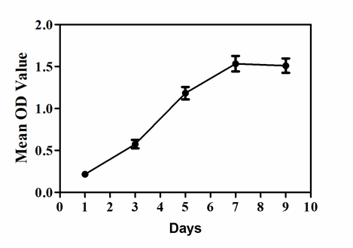

Fig. S2 Proliferation activity of the USCs as determined by a CCK-8 assay after 1, 3, 5, 7 and 9 days’ incubation.

Fig. S3 Swelling behavior of the dECM hydrogels soaked in PBS.

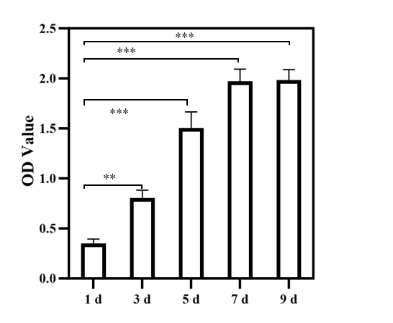

Fig. S4. Proliferation of the USCs cultured in dECM hydrogels as determined by CCK-8 assay after 1, 3-, 5-, 7- and 9-days’ incubation.
Fig. S5 Histological analysis of the dECM hydrogels and surrounding tissues at various time points following subcutaneous injection in rats. (A) Gross appearance of the dECM hydrogels at 7 and 14 days. (B) Representative images of H&E staining of the dECM hydrogels at 7 and 14 days after the injection. (C-D) Immunofluorescence of CD86 and CD206 expression in the hydrogels at 7 and 14 days after injection (Scale bar = 200 μm). ns, not significant; *P < 0.05, **P < 0.01, ***P < 0.001. Each data point represented average ± standard deviation.

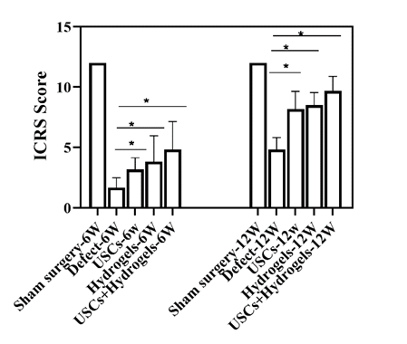
Fig. S6 ICRS score grading of the cartilage defects. Data were presented as mean ± SD

