Supplementary data:
Targeted transcriptomics of the Mexican prickly poppy (Argemone mexicana L.) reveals diverse proteins related to benzylisoquinoline alkaloid biosynthesis
Serrano-Gamboa JG^{1,§}, Xool-Tamayo JF^{1,2,§}, Loza-Muller¹ L, Tamayo-Ordóñez YJ^{1,3} and Vázquez-Flota F^{1,} *
¹Unidad de Bioquímica y Biología Molecular de Plantas, Centro de Investigación Científica de Yucatán, Calle 43 No. 130 Chuburná 97205, Mérida Yucatán México.
²Current address: División de Biología Experimental y Aplicada, Centro de Investigación Científica y de Educación Superior de Ensenada, Carretera Ensenada-Tijuana No. 3918 Zona Playitas 22860, Ensenada BC México.
³Current address: Facultad de Ciencias Químicas, Universidad Autónoma de Coahuila, Ing J. Cárdenas Valdez S/N República 25280, Saltillo Coahuila México.
§These authors contributed equally
*Corresponding author: Unidad de Bioquímica y Biología Molecular de Plantas, Centro de Investigación Científica de Yucatán, A.C. Calle 43 No. 130 Chuburná 97205, Mérida Yucatán México, +52 999942-8330 (151); e-mail address: felipe@cicy.mx, ORCID ID: 0000-0002-3171-137X
JGS-G; 0000-0002-1386-8306; JFX-T; 0000-0002-5146-6260; LL-M; 0000-0002-4842-7586; YJT-O; 0000-0001-8265-5382

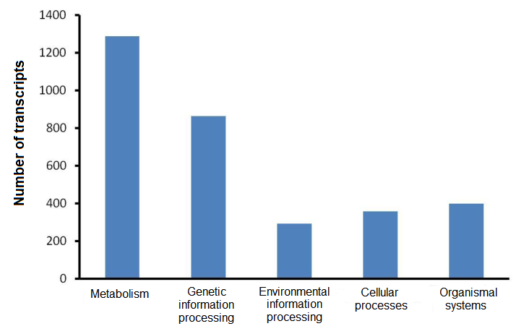
Fig. S1 Distribution of XT1 transcripts in metabolic categories and cellular functions according to KEGG annotation.

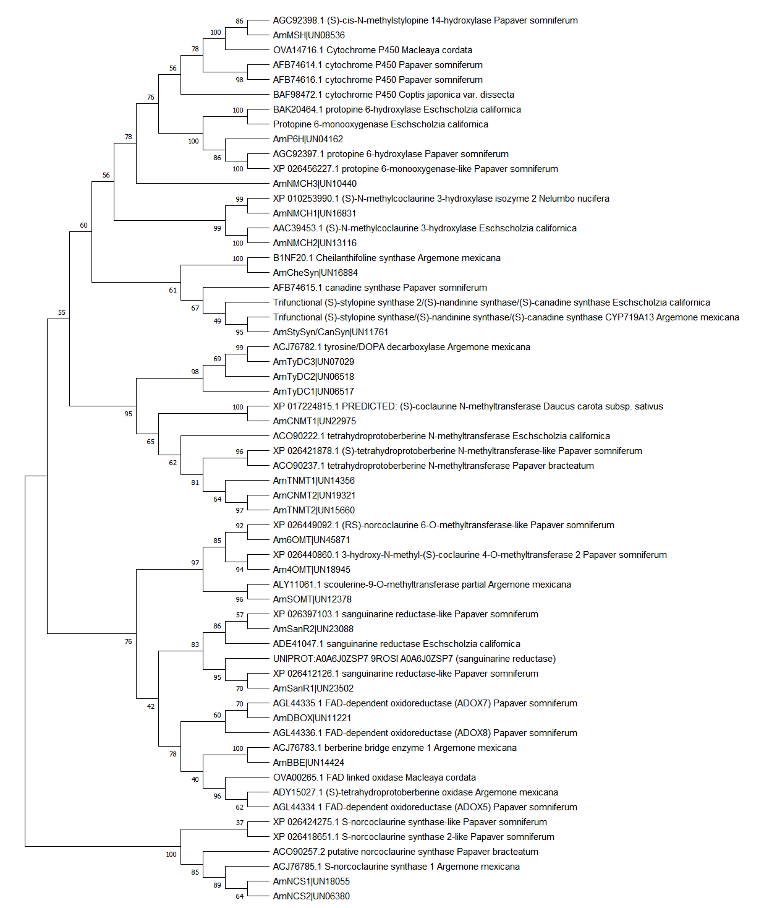
Fig. S2 Phylogenetic analysis of identified A. mexicana proteins involved in all steps of berberine and sanguinarine biosynthesis clustered with previously characterized enzymes in related species. The phylogenetic tree was constructed with the maximum likelihood method with 100 bootstrap replications using MEGA X.

