Low lipoprotein(a) concentration is associated with higher atrial fibrillation risk: A large retrospective cohort study
Short title: Lp(a) levels and atrial fibrillation risk
Junjie Tao^{1,2#}, Qingkai Qiu ^{1,2#}, Feng Gao ^{1,2}, Wenchong Chen ^{1,2}, Lijuan Hu ³, Yuan Xu ⁴, Yingping Yi ⁴, Xinlei Yang ^{5*}, Long Jiang ^{2*}
¹ Department of Cardiovascular Medicine, the Second Affiliated Hospital of Nanchang University, Nanchang, Jiangxi, China
² The Second Clinical Medical College of Nanchang University, The Second Affiliated Hospital of Nanchang University，Jiangxi, Nanchang 330006, China
³Department of Nursing, Nanchang Medical College, Nanchang, Jiangxi, China
⁴Department of Medical Big Data Center, the Second Affiliated Hospital of Nanchang University, Nanchang, Jiangxi, China
⁵Biobank center, the Second Affiliated Hospital of Nanchang University
*Correspondence to: Long Jiang, Department of Cardiovascular Medicine, the Second Affiliated Hospital of Nanchang University, Nanchang, Jiangxi, China; e-mail: skyiadx@hotmail.com; Tel: +86-13767026990. Xinlei Yang, Biobank center, the Second Affiliated Hospital of Nanchang University; email: yxl2251259@163.com; Tel: +86-13767026990.

Supplements
Supplemental Table S1 The correlation between Lp(a) and the variables.
Supplemental Figure S1 The distribution of Lp(a) in all study population.
Figure S2 Odd ratios (95% confidence intervals) for AF of Lp(a) quartiles stratified by hypertension status. This Model was adjusted for BMI, Blood glucose, CRP, HCY, statin status, SBP, and TG.

Table S1. The correlation indices between Lp(a) and the variables.
Characteristics | r | P-value
Demographic data
Sex | -0.020 | 0.015
Ages | 0.042 | <0.001
BMI | -0.0408 | <0.001
Smoker | -0.0209 | 0.014
Alcohol taking status | -0.0191 | 0.928
SBP | <0.0001 | 0.985
DBP | -0.0109 | 0.204
Medical history
Atrial fibrillation | -0.030 | <0.001
Ischemic stroke | 0.023 | 0.007
Type 2 diabetes mellitus | -0.013 | 0.113
Coronary heart disease | 0.037 | <0.001
Hypertension | 0.009 | 0.286
Medication on admission
β-receptor antagonists | 0.008 | 0.305
Statin | 0.066 | <0.001
Laboratory values
LDL-C | 0.136 | <0.001
Apo(a) | 0.022 | 0.007
Apo(b) | 0.133 | <0.001
HDL-C | 0.113 | <0.001
TC | 0.120 | <0.001
TG | -0.037 | <0.001
HCY | -0.010 | 0.241
Albumin | -0.033 | <0.001
CRP | 0.030 | <0.001
Blood glucose | -0.008 | 0.349
Uric acid | -0.015 | 0.071
Serum creatine | 0.034 | <0.001
Continuous variables exhibited as median [25, 75%]. Apo(a), apolipoprotein A; Apo(b), apolipoprotein B; BMI, body mass index; CRP, C-reactive protein; DBP, diastolic blood pressure; HDL-C, high-density lipoprotein cholesterol; HCY, homocysteine; LDL-C, low-density lipoprotein cholesterol; SBP, systolic blood pressure; TC, total cholesterol; TG, triglyceride.

Figure S1. The distribution of Lp(a) concentration in all study population.

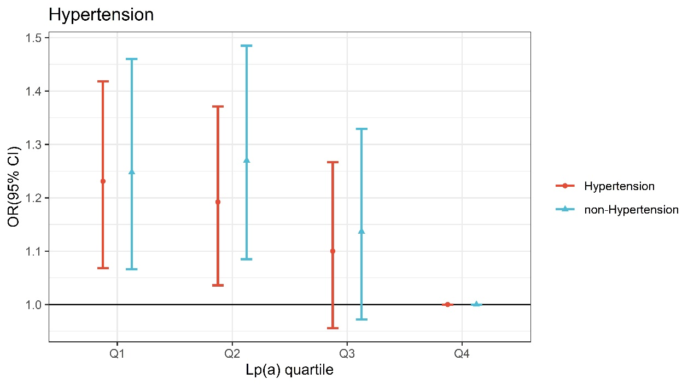
Figure S2. Odd ratios (95% confidence intervals) for AF of Lp(a) quartiles stratified by hypertension status. This Model was adjusted for BMI, Blood glucose, CRP, HCY, statin status, SBP, and TG.

