Supplementary information

Title
Keystone phylotypes determine soil functions and nutrient cycling processes in a 33-year field fertilization experiment
Running title
Soil keystone microbes determines soil functions
Authors
Guopeng Zhouª, Songjuan Gao^{b}, Danna Changª, Kunkun Fan^{c}, Ting Liangª, Hai Liang^{b}, Shun Li^{b}, Jiudong Zhang^{d}, Zongxian Che^{d*}, Weidong Cao^{a*}
Affiliations
ª Key Laboratory of Plant Nutrition and Fertilizer, Ministry of Agriculture and Rural Affairs / Institute of Agricultural Resources and Regional Planning, Chinese Academy of Agricultural Sciences, Beijing, 100081, PR China.
^{b} College of Resources and Environmental Sciences, Nanjing Agricultural University, Nanjing, 210095, PR China.
^{c}State Key Laboratory of Soil and Sustainable Agriculture, Institute of Soil Science, Chinese Academy of Sciences, 71 East Beijing Road, Nanjing 210008, China.
^{d}Institute of Soil and Fertilizer and Water-saving Agriculture, Gansu Academy of Agriculture Science, Lanzhou, 730070, China
*Corresponding author
Weidong Cao (caoweidong@caas.cn; Tel: +86 10 82109622; Fax: +86 10 82106733); Zongxian Che (chezongxian@163.com)
This file includes:
Appendix 1 to 4
Figure S1 to S22
Table S1 to S15
Supplementary materials and methods
Appendix S1: Soil properties
Soil organic C (SOC) and total N (TN) were determined by a CHN elemental analyser (Elementar Analysensysteme GmbH, Hanau, Germany). Soil total phosphorous (TP) and total potassium (TK) were extracted by HF-HClO₄ digestion and measured via the molybdenum blue colorimetry and flame spectrophotometry methods, respectively. Soil dissolved organic C (DOC) and total dissolved N (TDN) were extracted by double distilled water (soil/water, 1:2, w/vol) and passed through 0.45-μm filter paper, and then the DOC, TDN, and inorganic N concentrations in the extracts were measured using a TOC/N analyzer (Aanalytikjena, Multi N/C 2100, Germany) and an autoanalyzer (SEAL AutoAnalyzer3, Germany), respectively. Dissolved organic N (DON) was calculated as the difference between TDN and inorganic N. Ammonium (NH₄⁺-N) and nitrate (NO₃⁻-N) were extracted with 2 M KCl and measured using a continuous flow analyser (AA3, SEAL, Germany). The available phosphorus (AP) and potassium (AK) were extracted by 0.5 M NaHCO₃ and 1 M ammonium acetate, and then were determined using molybdenum blue colorimetry and flame spectrophotometry method, respectively. Soil pH was determined by a compound electrode (LE438, Mettler-Toledo Instruments, Shanghai, China) at a soil-to-water ratio of 1:2.5.

Supplementary results
Appendix S2: Soil properties and enzyme activity in long-term different fertilizations
The long-term application of inorganic fertilizer (CF), cow manure (CM), straw (S) and green manure (GM) significantly increased the TN, TP, AP, AK, and moisture contents in 0-to-100 cm soil layer (Table S2, Table S3). Meanwhile the CM, S and GM treatments further increased the contents of SOC and NO₃⁻-N. In contrast, the soil pH was significantly lower in the CF, S, and GM treatments than the control (CK), with the lowest soil pH being generated by the CF treatment. The contents of TP, TK, NO₃⁻-N, and AK declined sharply across the soil depths, whereas the SOC, TN, DOC, DON, and moisture contents exhibited a valley pattern throughout the soil layers, bottoming in the 20-to-80 cm depth. Two-way analysis of variance (ANOVA) revealed that soil depth had a stronger effect on the soil properties (apart from NH₄⁺-N, AK, and C/N ratio) than the fertilization treatments. Coefficients of variation for most soil properties were higher in the 0-to-20 and 80-to-100 cm depths than in the other depths. Furthermore, almost three decades of organic fertilization had a greater influence on topsoil (0-to-20 cm) properties than on the other depths’, such as SOC, TN, TP, NO₃⁻-N, AP, AK, and moisture contents significantly increased by 3.5~9.9 g kg⁻¹, 0.35~0.80 g kg⁻¹, 0.69~1.23 g kg⁻¹, 7.8~15.2 mg kg⁻¹, 62.3~167.7 mg kg⁻¹, 166.0~474.7 mg kg⁻¹, and 5.5~9.5%, and pH decreased by 0.11~0.17 than the CK, respectively, with the greatest influence being generated by the CM treatment (Table S2). Long-term applying inorganic fertilizer significantly increased the topsoil TP, NH₄⁺-N, AP, AK, and moisture contents by 0.6 g kg⁻¹, 10.6 mg kg⁻¹, 22.1 mg kg⁻¹, 49.7 mg kg⁻¹, and 7.4%, decreased the topsoil pH by 0.08 compared with the CK, respectively. In the other soil depths (20-to-100 cm), the fertilization treatments showed a similar influence as described above for soil properties, whereas the influence gradually weaken as the soil layer deepens in general.
Almost three decades of organic fertilization significantly increased the activities of most soil enzymes (such as α-glucosidase, β-glucosidase, β-cellobiosidase, β-xylosidase, N-acetyl-glucosaminidase, and nitrate reductase), showing a general trend of GM>S>CM (apart from nitrate reductase) (Table S4). However, long-term applying inorganic fertilizer had a lower influence on the activities of soil enzyme than the organic fertilization, only significantly enhanced the activities of α-glucosidase and β-glucosidase in 0-100 cm soil layer. Two-way ANOVA revealed that soil depth had a stronger effect on the activities of soil enzyme than the fertilization treatments, and with the enzyme activities sharply declining as the soil layer deepens (Table S3, Figure S3). More specifically, the fertilization treatments exhibited inconsistent effects on soil enzymes, such as the GM and CM with the greatest enhancements on activities of C-related enzymes (α-glucosidase, β-glucosidase, β-cellobiosidase, β-xylosidase, and N-acetyl-glucosaminidase) and N-related enzymes (urease, nitrate and nitrite reductases), respectively. And organic fertilization treatments showed varying degrees of enhancement of subsoil (20-to-100 cm) enzyme activities, whereas the CF only enhanced some enzyme activities (e.g., α-glucosidase, β-glucosidase, β-cellobiosidase, and β-xylosidase, nitrate and nitrite reductases) in the topsoil (0-to-20 cm) (Figure S3).

Appendix S3: Microbial traits and their contribution to soil functions and nutrient cycling processes
The 16S rRNA gene was enriched in the CM and GM treatments, and the ITS1 gene was enriched in the GM treatment, particularly in the topsoil (0-to-20 cm), indicating the long-term of applying cow manure increased bacterial abundance while the long-term of green manuring increased both bacterial and fungal abundances (Table S6, Figure S4). Both 16S rRNA and ITS1 genes abundance decreased sharply across the soil depths, but the CM treatment still significantly increased the abundance of 16S rRNA gene in subsoil (20-to-40 cm and 40-to-60 cm). The Spearman correlation analysis showed that the abundance of 16S rRNA and ITS1 genes were significantly and positively correlated with the soil multifunctionality, functionality of C/N/P cycling, C mineralization, and also correlated positively with most of the activity of soil enzymes (Figure S5), indicating the enrichments of bacteria and fungi in some organic fertilization treatments were associated with upward shifts in soil ecosystem functions. Interestingly, ITS1 gene rather than 16S rRNA gene was correlated well with the soil N fixation potential (Figure S5), which implied the enhancement of fungal abundance in the GM treatment was an important factor facilitating soil free-living N fixation.
For the functional genes, the long-term application of inorganic fertilizer significantly decreased the abundance of cbhI and phoD genes associated with C degradation and P cycle but increased the abundance of BamoA gene associated with N cycle in the topsoil (Table S6, Figure S4). The abundance of most functional genes associated with C (e.g., cbhI, GH48), N (e.g., nifH, ArchamoA, narG, nirK, nirS, nosZ), and P (e.g., phoD) cycling increased in the CM and GM treatments, and the CM treatment with a greater effect on the abundance of functional genes (e.g., cbhI, ArchamoA, narG, nirS, nosZ) in the subsoil than the GM treatment. Apart from sdimo and BamoA genes, most functional genes were significantly and positively correlated with soil multifunctionality and their corresponding functionality of C/N/P cycling and enzyme activity, respectiverly (Figure S5). The GH48 and nifH genes correlated significantly with the C mineralization and soil N fixation potential respectively, indicating the enrichments of cellulolytic bacteria and N-fixing microorganisms in organic fertilization treatments contributed to their corresponding functions of soil ecosystem. Significantly, the functional genes involved in denitrification (e.g., narG, nirS, nirK, nosZ) were not correlated with or negatively correlated with the N₂O release potential (NRP); however, the BamoA gene associated with a function of nitrification was significantly and positively with the NRP, which indicated the ammonia-oxidizing bacteria (AOB) playing an important role in the generation of N₂O, particularly in the inorganic fertilizer treatment.

Appendix S4: Microbial community composition in long-term different fertilizations
The bacterial communities were predominated by phylum Actinobacteria (30.1%), Proteobacteria (27.3%), Acidobacteria (13.2%), and Chloroflexi (13.0%), Rokubacteria (4.0%), Gemmatimonadetes (3.6%), and Bacteroidetes (2.2%), etc., across all samples (Table S8, Table S9). Two-way analysis of variance (ANOVA) revealed that the relative abundance of dominant bacterial taxa (except Actinobacteria) was more pronouncedly impacted by soil depth than by fertilization treatments. The long-term application inorganic fertilizer decreased the relative abundance of Actinobacteria and Firmicutes (especially in the subsoils) but increased Proteobacteria, Gemmatimonadetes, and Nitrospirae (especially in the topsoil). Meanwhile the long-term organic fertilizations decreased Actinobacteria and Chloroflexi but increased Proteobacteria, Acidobacteria, and Bacteroidetes abundance. Furthermore, Actinobacteria, Proteobacteria, Acidobacteria, and Bacteroidetes abundance generally declined as the soil layer deepens, while Chloroflexi and Rokubacteria exhibited the opposite trend. For the fungal community, its composition was predominated by class Sordariomycetes (32.9%), Dothideomycetes (26.1%), Mortierellomycetes (8.6%), Tremellomycetes (7.6%), Pezizomycetes (6.3%), and Leotiomycetes (2.7%), etc. (Table S8, Table S9). Two-way ANOVA showed that soil depth had greater effects on the relative abundance of Sordariomycetes, Dothideomycetes, and Mortierellomycetes than fertilization treatment, and vice versa for other dominant fungal taxa. The long-term feralization treatments increased the relative abundance of Sordariomycetes (except the GM treatment) but decreased Mortierellomycetes abundance (except the S treatment). The long-term GM having the lowest Dothideomycetes abundance and the largest Tremellomycetes, Pezizomycetes, and Leotiomycetes abundances. Additionally, while the relative abundance of Dothideomycetes generally declined across the soil depths, Sordariomycetes and Mortierellomycetes exhibited the opposite trend.
For bacterial community, the Mantel test analyses indicated that most of edaphic variables were significantly correlated with bacterial communities (Figure S11B). Among the measured edaphic variables, soil TP and nitrate N concentrations had the strongest influence on the bacterial communities, followed by TK, N/P ratio, SOC, and AP, etc. Random forest modeling was further performed to separate and assess the important predictors of the alpha- and beta-diversities of bacterial community (Figure S11A). The models for the alpha- and beta-diversities were significant at the 0.001 level (R² = 0.69 and 0.77). We observed that soil depth and edaphic variables (including nitrate N, TP, AP, SOC, and N/P ratio) were the most important predictors of alpha- and beta-diversities at the same time. The findings indicates that the soil depth, nitrate N, TP, AP, SOC, and N/P ratio are key factors shaping bacterial communities. For fungal community, Mantel test showed that fungal communities were significantly correlated with the concentrations of soil AK, nitrate N, TP, AP, SOC, TN, and DON (Figure S11B). In addition, random forest analysis revealed that the fertilization treatments and edaphic variables (i.e., AK, AP, and nitrate N) were the most important variables for predicting the alpha- and beta-diversities of fungal community (Figure S11A). The results show that fertilization treatments, soil AK, AP, and nitrate N concentrations play a substantial role in shaping fungal community.

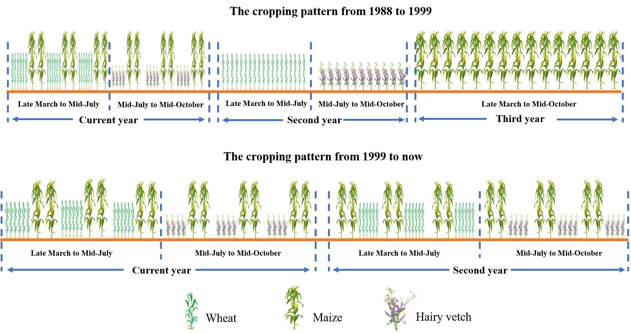
Figure S1 The cropping pattern of the long-term fertilization treatment. Apart from green manure (hairy vetch) treatment, there is fallow after wheat harvest in other treatments.

Figure S2 Variation in the soil organic carbon mineralization (per unite soil carbon) soil denitrification (per unite soil nitrogen) after almost three decades of fertilization across soil depths. Bars with different letters reveal the values that differ significantly among treatments at P < 0.05 (LSD test) in the same soil depth.

Figure S3 Variation in the soil enzyme activity after almost three decades of fertilization across soil depths. Bars with different letters in the same soil depth indicate significant differences within the soil enzyme activity among fertilization treatments at P < 0.05 (LSD test).

Figure S4 Variation in the copy numbers of 16S rRNA gene (representing bacteria abundance), ITS1 (representing fungi abundance), and functional genes associated with the C (cbhI, GH48, and sdimo), N (nifH, amoA, amoB, narG, nirK, nirS, and nosZ), and P (phoD) cycles after almost three decades of fertilization across soil depths. Bars with different letters in the same soil depth indicate significant differences within the soil enzyme activity among fertilization treatments at P < 0.05 (LSD test).

Figure S5 Spearman correlation analysis between soil functions, and nutrient cycling processes, 16S rRNA, ITS1, and functional genes, and enzymes. Red and blue circles represent positive and negative correlations, respectively. Oval from fat to thin indicates low to high correlation. A “×” in the ovals reveals no significant correlation (P > 0.05). NFP, nitrogen fixation potential; CMP, C mineralization potential; NRP, N₂O release potential; MF, multifunctionality; FC, functionality of C cycling; FN, functionality of N cycling; FP, functionality of P cycling; AG, α-glucosidase; BG, β-glucosidase, CB, β-cellobiosidase; XYL, β-xylosidase; NAG, N-acetyl-glucosaminidase; NR, nitrate reductases; NiR, nitrite reductases; PHOS, alkaline phosphatase.

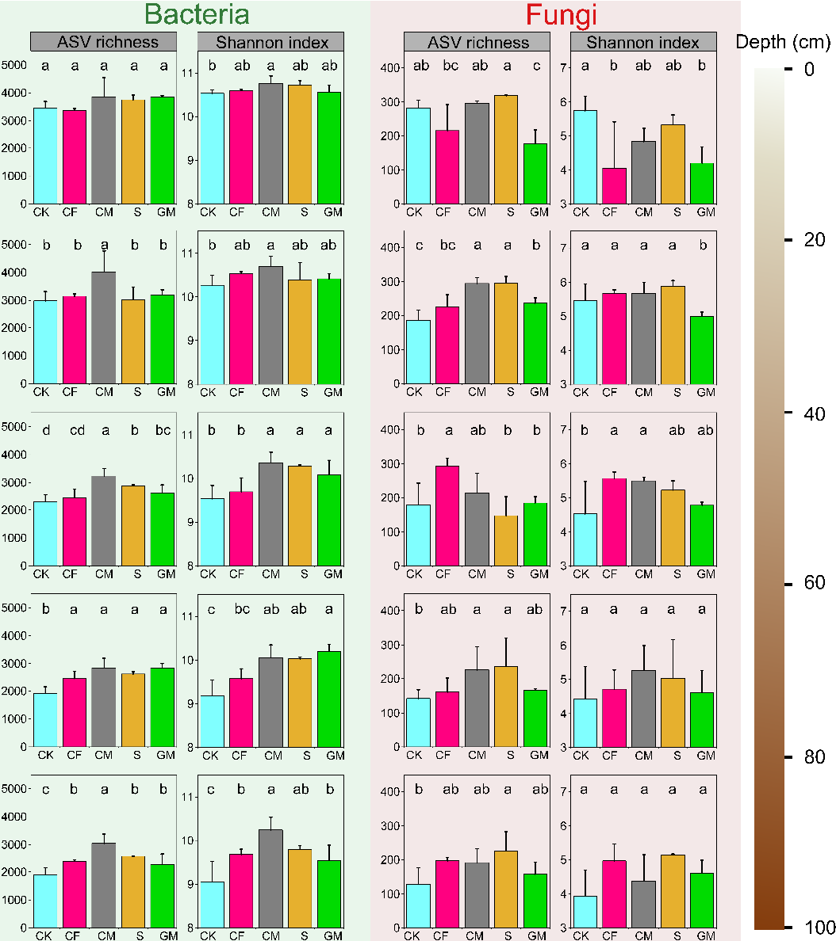
Figure S6 Alpha diversity of soil bacteria and fungi as affected by almost three decades of fertilization across soil depths. Bars with different letters indicate significant differences within the alpha diversity among fertilization treatments at P < 0.05 (LSD test).

Figure S7 General patterns of soil microbial alpha diversity after almost three decades of fertilization. Box plot showing the overall variation in the microbial alpha diversity in the whole depth (0-to-100 cm) (A). Bars with different letters indicate significant differences within the alpha diversity among fertilization treatments at P < 0.05 (LSD test). Variation in alpha diversity of soil bacteria and fungi between soil depths (B). The adjust R² was used to determine whether the models were fitted well. The lines denote the least-squares linear regressions across soil depth, with their 95% confidence intervals (gray-shaded areas).

Figure S8 Linear least-squares regression relationships between alpha diversity and soil functions, and nutrient cycling processes, respectively. The adjust R² was used to determine whether the models were fitted well. Plots only showed the significant regression models.

Figure S9 Bray-Curtis distance among the soil depths were estimated. Boxes with different letters reveal the values that differ significantly among soil depths at P < 0.05 (multiple comparison with Kruskal-Wallis tests).

Figure S10 Linear least-squares regression relationships between beta diversity and soil functions, and nutrient cycling processes, respectively. The adjust R² was used to determine whether the models were fitted well. Plots only showed the significant regression models.

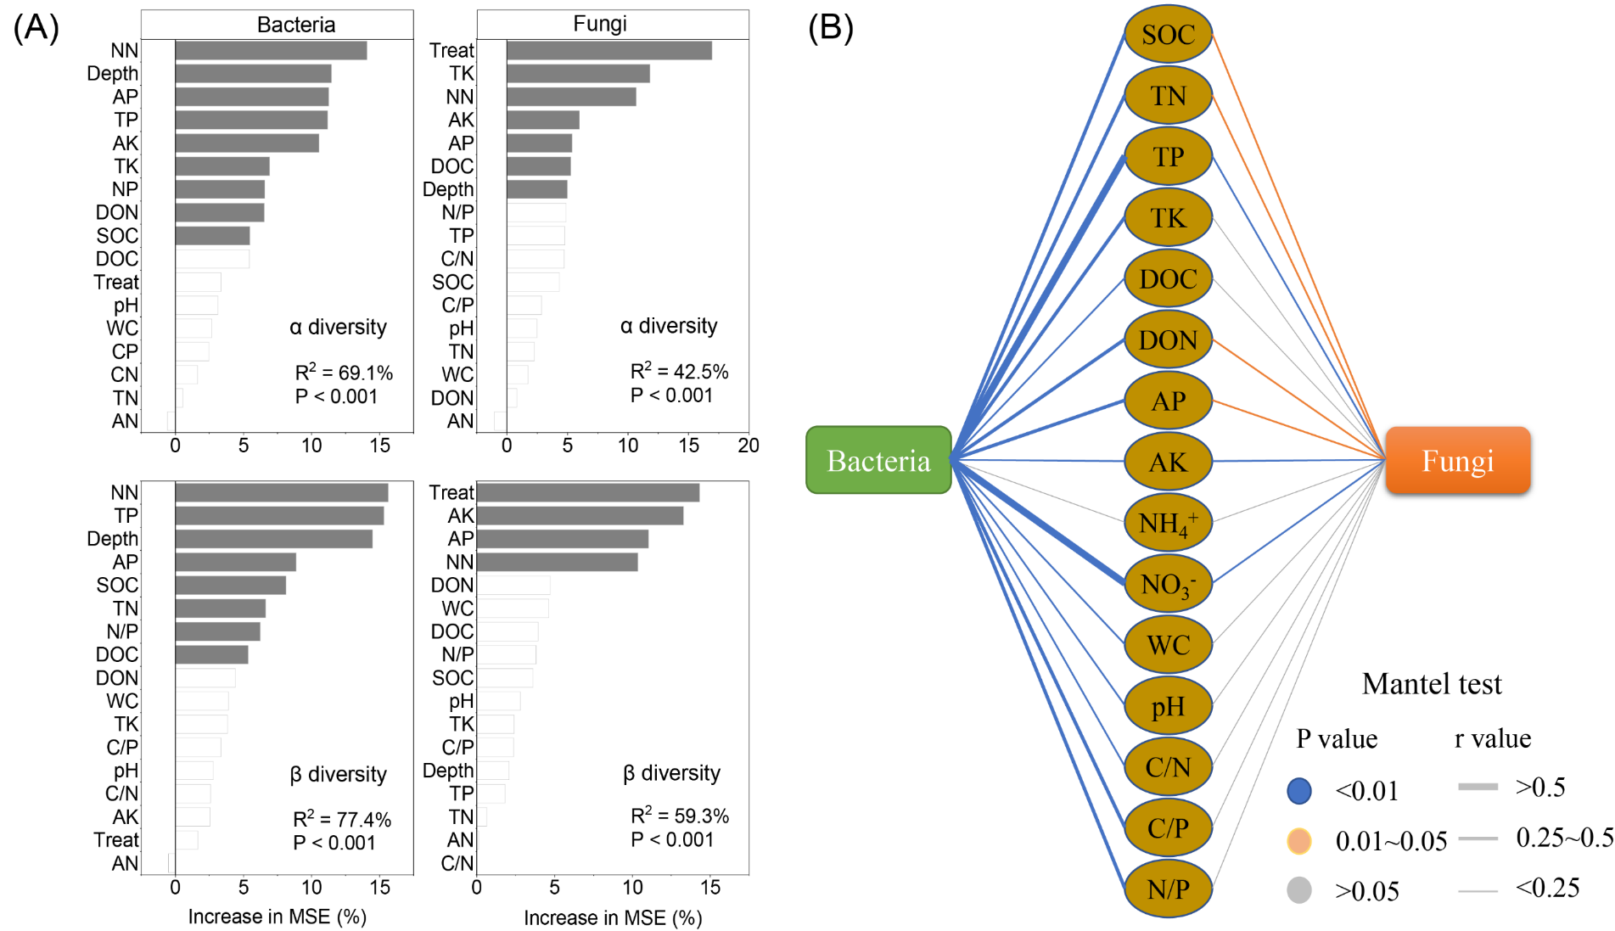

Figure S11 Potential drivers of variation in soil microbial alpha and beta diversity, and community after long-term different fertilization. Random forest mean predictor importance (percentage of increase of mean square error) of treatment, soil depth and edaphic variables as drivers for the microbial alpha-, beta-diversity separately (A). Percentage increases in the MSE (mean squared error) of variables were used to estimate the importance of these predictors, and higher MSE% values imply more important predictors. Significance levels (P < 0.05) of predictors are colored with grey. Mantel tests are performed to reveal the relationship between soil bacterial and fungal community structures and edaphic variables, respectively (B). SOC, soil organic carbon; TN, total nitrogen; TP, total phosphorus; TK, total potassium; AN, ammonium nitrogen; NN, nitrate nitrogen; AP, available phosphorus; AK, available potassium; DOC, dissolved organic carbon; DON, dissolved organic nitrogen; WC, water content; C/N, carbon to nitrogen ratio; C/P, carbon to phosphorus ratio; N/P, nitrogen to phosphorus ratio.

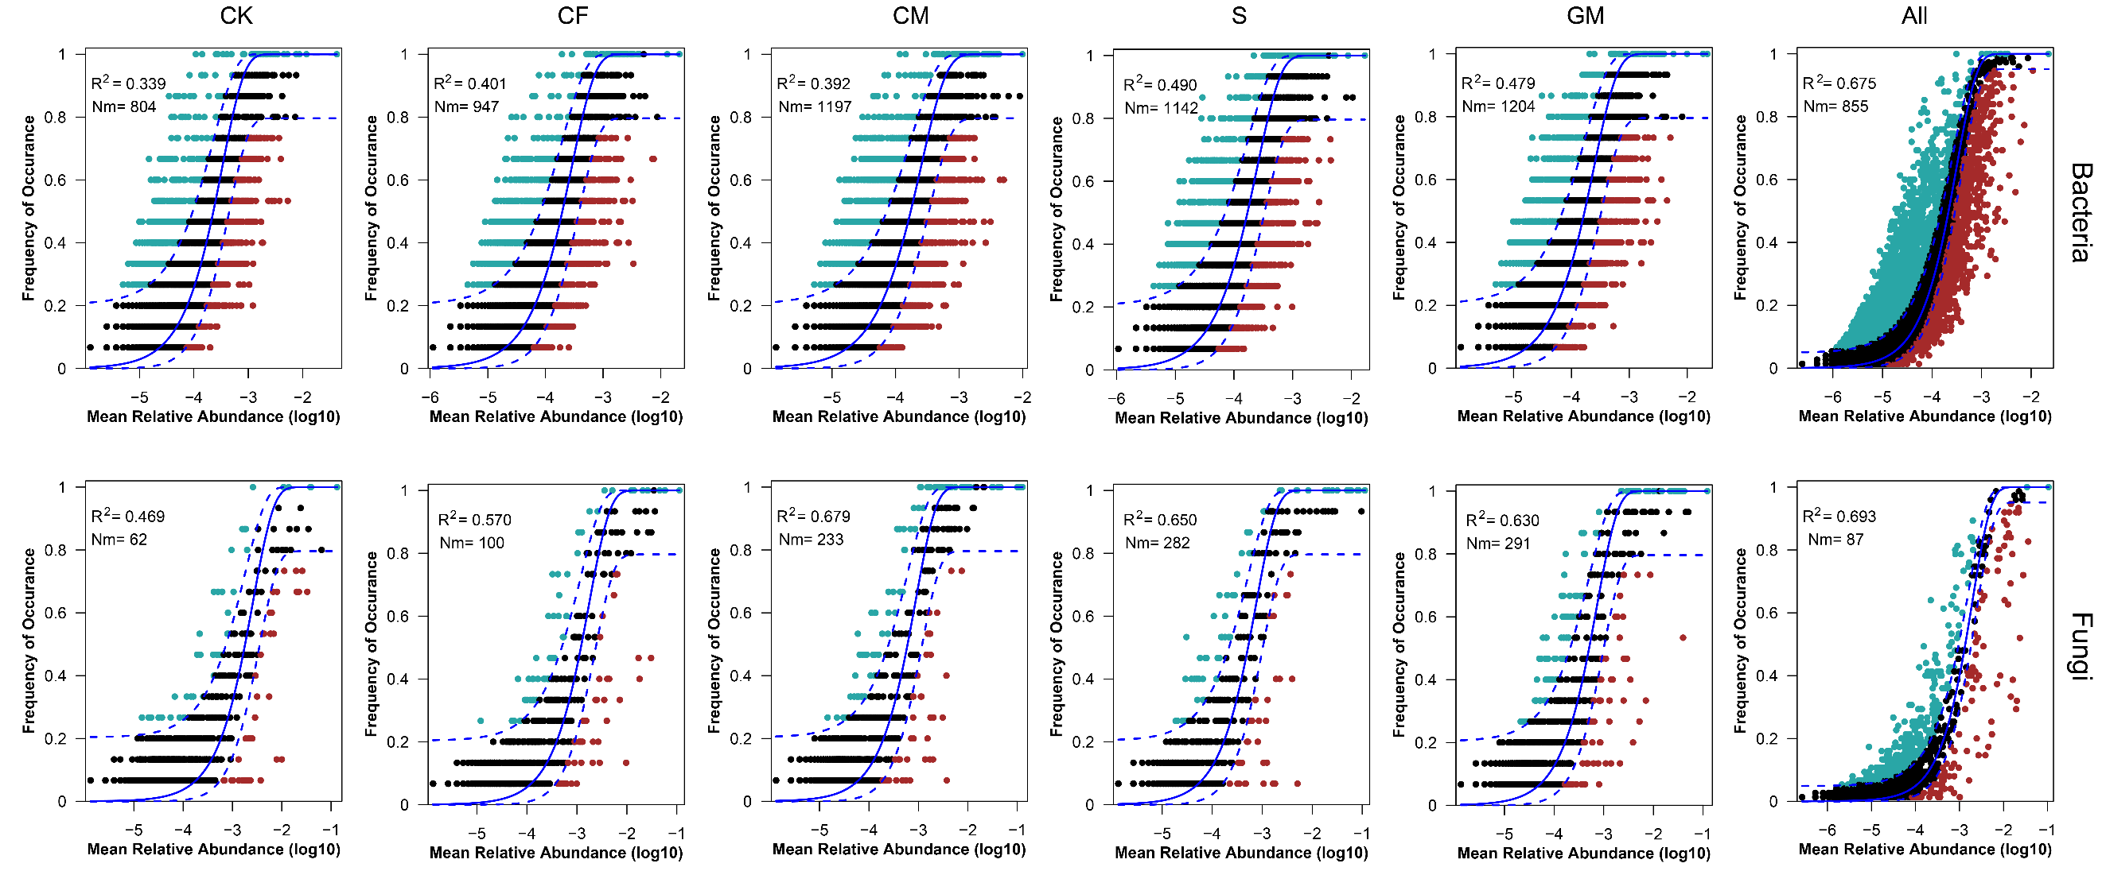
Figure S12 Fit of the neutral community model (NCM) of community assembly. The predicted occurrence frequencies for different treatments and all representing bacterial and fungal communities from different treatments and all samples, respectively. The solid blue lines indicate the best fit to the NCM as in Sloan et al. (2006), and the dashed blue lines represent 95% confidence intervals around the model prediction. ASVs that occur more or less frequently than predicted by the NCM were shown in different colors. Nm indicate the metacommunity size times immigration, R² determine the fit to this model.

Figure S13 The network degree distribution patterns of microbes (including bacteria and fungi) in different treatments and soil depth.

Figure S14 The robustness of microbial network for different treatments and soil depth.

Figure S15 Linear least-squares regression relationships between sub-network characteristic (network size and network connectivity) and soil functions, and nutrient cycling processes, respectively. (A) The sub-network characteristics originate from meta-network based on fertilization treatments. (B) The sub-network characteristics originate from meta-network based on soil depth. The adjust R² was used to determine whether the models were fitted well. Plots only showed the significant regression models.

Figure S16 Soil biodiversity in main ecological clusters (Modules #0–3). Bars with different letters indicate significant differences within the soil biodiversity among different fertilization treatments at P < 0.05 (LSD test).

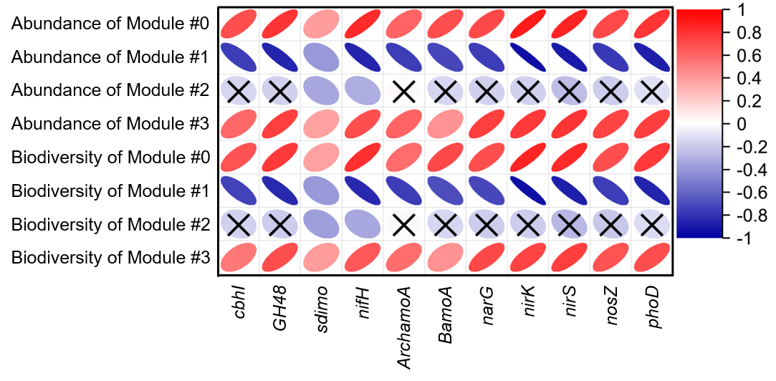Figure S17 Spearman correlations between the abundance of functional genes and the relative abundance and diversity of main ecological clusters (Modules #0–3). Red and blue ellipses represent positive and negative correlations, respectively. A “×” in the ellipses reveals no significant correlation (P > 0.05).

Figure S18 Linear least-squares regression relationships between relative abundance and diversity of main ecological clusters (Modules #0–3) and soil functions, and nutrient cycling processes, respectively. The adjust R² was used to determine whether the models were fitted well. Plots only showed the significant regression models.

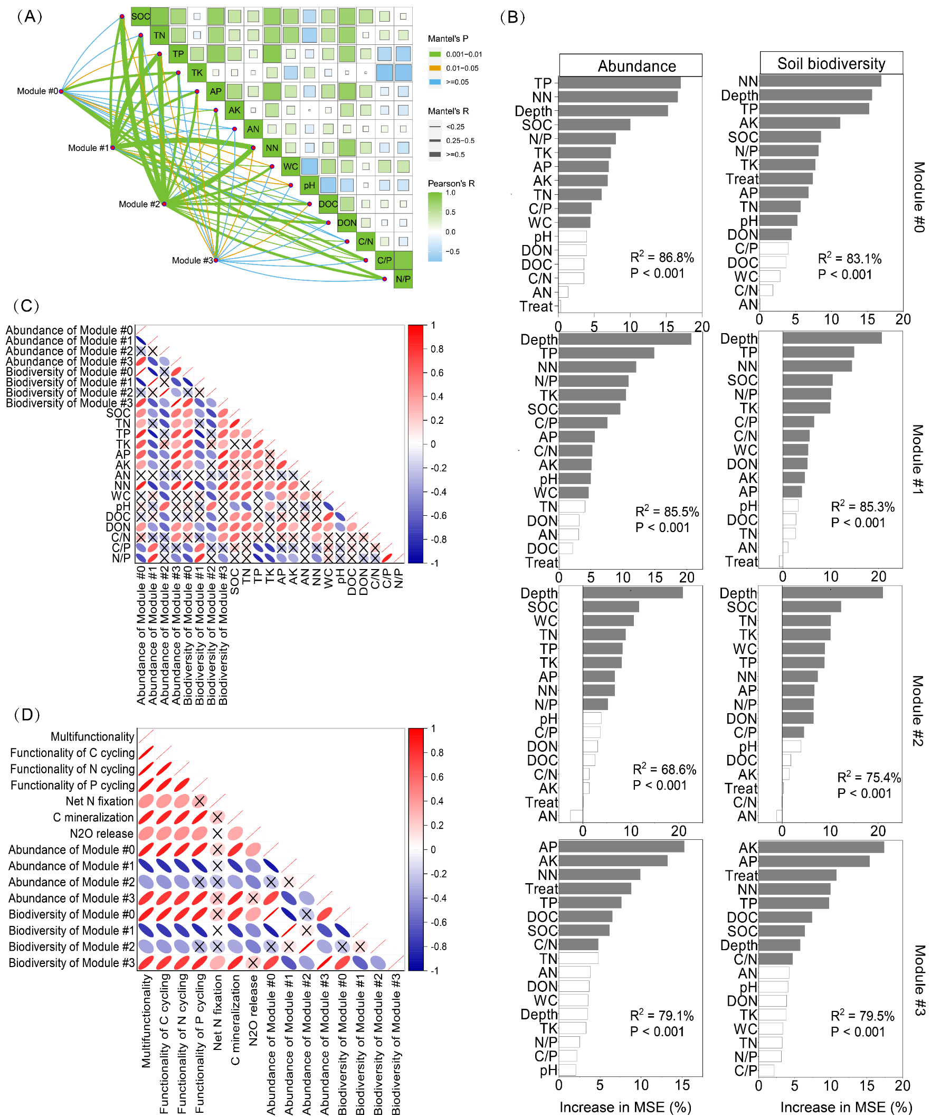
Figure S19 The relationships between the main ecological clusters, edaphic variables, and soil functions, and nutrient cycling processes. Pairwise comparisons of environmental factors are shown, with a color gradient denoting Spearman’s correlation coefficients. Taxonomic community composition of main ecological clusters was related to each environmental factor by partial (geographic distance–corrected) Mantel tests. Edge width corresponds to the Mantel’s r statistic for the corresponding distance correlations, and edge color denotes the statistical significance based on 9,999 permutations (A). Random forest mean predictor importance (percentage of increase of mean square error) of treatment, soil depth and edaphic variables as drivers for the relative abundance and diversity of phylotypes within main ecological clusters. Percentage increases in the MSE (mean squared error) of variables were used to estimate the importance of these predictors, and higher MSE% values imply more important predictors. Significance levels (P < 0.05) of predictors are colored with grey (B). Spearman correlation analysis between the relative abundance and diversity of phylotypes within main ecological clusters and edaphic variables (C). Spearman correlation analysis between the relative abundance and diversity of phylotypes within main ecological clusters and soil functions, and nutrient cycling processes (D). Red and blue circles represent positive and negative correlations, respectively. Oval from fat to thin indicates low to high correlation. A “×” in the ovals reveals no significant correlation (P > 0.05). SOC, soil organic carbon; TN, total nitrogen; TP, total phosphorus; TK, total potassium; AN, ammonium nitrogen; NN, nitrate nitrogen; AP, available phosphorus; AK, available potassium; DOC, dissolved organic carbon; DON, dissolved organic nitrogen; WC, water content; C/N, carbon to nitrogen ratio; C/P, carbon to phosphorus ratio; N/P, nitrogen to phosphorus ratio.

Figure S20 Standardized total effects (STE) from the PLS-PM. This is the sum of direct and indirect effects from each variable on soil functions, nutrient cycling processes, and crop production.

Figure S21 Crossing loading values from the PLS-PM. This is the contribution of from each variable on soil functions and nutrient cycling processes.

Figure S22 Ecological relationships between abundance of key-stone phylotypes, functional genes, and nutrient cycling processes. Selected examples for the links between relative abundance of key-stone phylotypes (e.g., Azospirillaceae, Nitrosomonadaceae, Sphingomonadaceae in Module #0) and the abundance of functional genes (e.g., nifH, BamoA, GH48) on key soil process in the long-term different fertilizations.

Table S1 Primers used for quantification of targeted genes through quantitative real-time PCR.
Target | Primer | Sequence (5’-3’) | Reference
16S rRNA | 338F  518R | ACTCCTACGGGAGGCAGCAG  ATTACCGCGGCTGCTG | Fierer et al., 2005
ITS1 | ITS5  ITS2 | GGAAGTAAAAGTCGTAACAAGG GCTGCGTTCTTCATCGATGC | White, 1990
cbh I | fungcbh IF  fungcbh IR | ACCAAYTGCTAYACIRGYAA  GCYTCCCAIATRTCCATC | Guo et al., 2018
GH48 | GH48_F8  GH48_R5 | GCCADGHTBGGCGACTACCT  CGCCCCABGMSWWGTACCA | Guo et al., 2018
sdimo | NVC66  NVC57 | CCANCCNGGRTAYTTRTTYTCRAACCA  CAGTCNGAYGARKCSCGNCAYAT | Coleman et al., 2006
nifH | nifH-F  nifH-R | AAAGGYGGWATCGGYAARTCCACCAC  TTGTTSGCSGCRTACATSGCCATCAT | Levy-Booth et al., 2014
amoA | Arch-amoA26F  Arch-amoA417R | GACTACATMTTCTAYACWGAYTGGGC  GGKGTCATRTATGGWGGYAAYGTTGG | Meinhardt et al., 2015
amoB | amoB-1F  amoB-2R | GGGGTTTCTACTGGTGGT  CCCCTCKGSAAAGCCTTCTTC | Rotthauwe et al., 1997
narG | narG-1960m2F  narG-2050m2R | TAYGTSGGGCAGGARAAACTG  CGTAGAAGAAGCTGGTGCTGTT | López-Gutiérrez et al., 2004
nirS | cd3aF  R3cdR | GTSAACGTSAAGGARACSGG  GASTTCGGRTGSGTCTTGA | Throbäck et al., 2004
nirK | nirKF1aCuF  nirKR3CuR | ATCATGGTSCTGCCGCG  GCCTCGATCAGRTTGTGGTT | Hallin and Lindgren 1999
nosZ | nosZ-1126F  nosZ-1381R | GGGCTBGGGCCRTTGCA  GAAGCGRTCCTTSGARAACTTG | Chen et al., 2012
phoD | ALPS-F730  ALPS-1101 | CAGTGGGACGACCACGAGGT  GAGGCCGATCGGCATGTCG | Zeng et al., 2022

Table S2. Comparison of wheat yield and soil physicochemical properties among different treatments within each soil depth in 2020.
Please see the excel file (SI_Table S2.xlsx).

Table S3. Two-way analysis of variance for the influences of the soil depth and treatment on soil physicochemical properties as dependent variables.
Please see the excel file (SI_Table S3.xlsx).

Table S4. Two-way analysis of variance for the influences of the soil depth and treatment on soil enzyme activity as dependent variables.
Please see the excel file (SI_Table S4.xlsx).

Table S5. Two-way analysis of variance for the influences of the soil depth and treatment on potentials of C mineralization, N₂O emission, and net N fixation as dependent variables.
Please see the excel file (SI_Table S5.xlsx).

Table S6. Two-way analysis of variance for the influences of the soil depth and treatment on the copy numbers of 16S rRNA gene, ITS1, and functional genes associated with the C (cbhI, GH48, and sdimo), N (nifH, ArchamoA, BamoA, narG, nirK, nirS, and nosZ), and P (phoD) cycles after as dependent variables.
Please see the excel file (SI_Table S6.xlsx).

Table S7. The differences of bacterial and fungal community structures among different treatments and soil depth assessed by PERMANOVA based on Bray-Curtis distance
 | Bacterial community |  | Fungal community
 | F value | P value | F value | P value
Differences of microbial community structure among different treatments
all | 1.59 | 0.001 | 9.30 | 0.001
CK vs. CF | 1.43 | 0.041 | 2.01 | 0.016
CK vs. CM | 2.13 | 0.003 | 7.41 | 0.001
CK vs. S | 1.84 | 0.011 | 4.18 | 0.001
CK vs. GM | 1.73 | 0.026 | 13.63 | 0.001
CF vs. CM | 1.75 | 0.012 | 7.92 | 0.001
CF vs. S | 1.33 | 0.079 | 3.55 | 0.001
CF vs. GM | 1.26 | 0.112 | 15.24 | 0.001
CM vs. S | 1.74 | 0.009 | 9.38 | 0.001
CM vs. GM | 1.48 | 0.039 | 22.87 | 0.001
S vs. GM | 1.10 | 0.235 | 16.31 | 0.001
Differences of microbial community structure among different soil depth
all | 12.96 | 0.001 | 2.11 | 0.001
0~20 vs. 20~40 | 7.70 | 0.001 | 1.51 | 0.100
0~20 vs. 40~60 | 17.09 | 0.001 | 2.94 | 0.001
0~20 vs. 60~80 | 22.14 | 0.001 | 3.42 | 0.003
0~20 vs. 80~100 | 25.05 | 0.001 | 4.16 | 0.001
20~40 vs. 40~60 | 5.64 | 0.001 | 1.25 | 0.200
20~40 vs. 60~80 | 13.06 | 0.001 | 2.07 | 0.024
20~40 vs. 80~100 | 19.78 | 0.001 | 2.88 | 0.002
40~60 vs. 60~80 | 4.15 | 0.001 | 0.72 | 0.778
40~60 vs. 80~100 | 11.70 | 0.001 | 1.50 | 0.108
60~80 vs. 80~100 | 3.92 | 0.001 | 0.60 | 0.915

Table S8. Comparison of the relative abundance of the dominant bacterial and fungal taxa among different treatments.
Please see the excel file (SI_Table S8.xlsx).

Table S9. Two-way analysis of variance for the influences of the soil depth and treatment on dominant bacterial and fungal taxa as dependent variables
Please see the excel file (SI_Table S9.xlsx).

Table S10. Proportions of amplicon sequence variants (ASVs) numbers of soil dominant taxa at the class level within each bacterial-fungal meta-network.
Please see the excel file (SI_Table S10.xlsx).

Table S11. Relative abundance of soil dominant taxa at the class level within each bacterial-fungal meta-network.
Please see the excel file (SI_Table S11.xlsx).

Table S12. Co-occurrence meta-network topological features statistics in different treatment and soil depth gradients.
Index | Treatment
Index | CK | CF | CM | S | GM
Nodes | 339 | 404 | 393 | 446 | 352
Edges | 5568 | 6565 | 3939 | 4436 | 4492
Average clustering coefficient | 0.537 | 0.541 | 0.474 | 0.442 | 0.543
Average path distance | 2.945 | 3.281 | 3.486 | 3.519 | 3.514
Density | 0.097 | 0.081 | 0.051 | 0.045 | 0.073
Degree (Average) | 32.85 | 32.50 | 20.05 | 19.89 | 25.52
Node betweenness centrality | 0.0050 | 0.0045 | 0.0056 | 0.0045 | 0.0058
Closeness centrality | 0.405 | 0.386 | 0.342 | 0.359 | 0.365
Eigenvector centrality | 0.248 | 0.249 | 0.183 | 0.175 | 0.214
Modularity | 0.678 | 0.892 | 1.224 | 1.440 | 1.112
Positive | 69.74% | 66.76% | 64.00% | 62.74% | 64.63%
Negative | 30.26% | 33.24% | 36.00% | 37.26% | 35.37%
 | Soil Depth (cm)
 | Depth 0-20 | Depth 20-40 | Depth 40-60 | Depth 60-80 | Depth 80-100
Nodes | 354 | 305 | 288 | 314 | 288
Edges | 850 | 515 | 1225 | 780 | 591
Average clustering coefficient | 0.403 | 0.232 | 0.397 | 0.342 | 0.378
Average path distance | 4.965 | 5.796 | 4.029 | 4.370 | 5.228
Density | 0.014 | 0.011 | 0.030 | 0.016 | 0.014
Degree (Average) | 4.802 | 3.377 | 8.507 | 4.968 | 4.104
Node betweenness centrality | 0.0061 | 0.0094 | 0.008 | 0.0055 | 0.0072
Closeness centrality | 0.389 | 0.333 | 0.353 | 0.377 | 0.394
Eigenvector centrality | 0.114 | 0.093 | 0.137 | 0.087 | 0.086
Modularity | 1.529 | 2.260 | 0.751 | 0.733 | 0.786
Positive | 66.94% | 61.36% | 73.31% | 82.18% | 82.91%
Negative | 33.06% | 38.64% | 26.69% | 17.82% | 17.09%

Table S13. Random forest mean predictor importance (percentage of increase of mean square error) of microbial communities as drivers for the key functional microbes associating soil nutrient cycling processes. Percentage increases in the MSE (mean squared error) of variables were used to estimate the importance of these predictors, and higher MSE% values imply more important predictors.
Please see the excel file (SI_Table S13.xlsx).

Table S14. The characteristics of main ecological clusters (module) and links between the main ecological clusters
 | Module #0 | Module #1 | Module #2 | Module #3
nodes | 1158 | 780 | 532 | 225
Edges | 62965 | 47264 | 11287 | 1051
Density | 0.094 | 0.156 | 0.335 | 0.042
Positive edges | 62960 | 47264 | 11287 | 1050
Negative edges | 5 | 0 | 0 | 0
Links between the main ecological clusters |  |  | Positive link | Negative link
Module #0 to Module #1 |  |  | 0 | 18997
Module #0 to Module #2 |  |  | 1200 | 593
Module #0 to Module #3 |  |  | 400 | 4
Module #1 to Module #2 |  |  | 1200 | 593
Module #1 to Module #3 |  |  | 0 | 1
Module #2 to Module #3 |  |  | 0 | 0

Table S15. The relative abundance of dominant taxa in main ecological clusters
Please see the excel file (SI_Table S15.xlsx).

Inference
Chen, Z., Liu, J., Wu, M., Xie, X., Wu, J., Wei, W. (2012). Differentiated response of denitrifying communities to fertilization regime in paddy soil. Microbial Ecology, 63(2), 446-459.
Coleman, N. V., Bui, N. B., Holmes, A. J. (2006). Soluble di‐iron monooxygenase gene diversity in soils, sediments and ethene enrichments. Environmental Microbiology, 8(7), 1228-1239.
Fierer, N., Jackson, J. A., Vilgalys, R., Jackson, R. B. (2005). Assessment of soil microbial community structure by use of taxon-specific quantitative PCR assays. Applied and environmental microbiology, 71(7), 4117-4120.
Guo, T., Zhang, Q., Ai, C., Liang, G., He, P., Zhou, W. (2018). Nitrogen enrichment regulates straw decomposition and its associated microbial community in a double-rice cropping system. Scientific reports, 8(1), 1-12.
Hallin, S., & Lindgren, P. E. (1999). PCR detection of genes encoding nitrite reductase in denitrifying bacteria. Applied and environmental microbiology, 65(4), 1652-1657.
Levy-Booth, D. J., Prescott, C. E., Grayston, S. J. (2014). Microbial functional genes involved in nitrogen fixation, nitrification and denitrification in forest ecosystems. Soil Biology and Biochemistry, 75, 11-25.
López-Gutiérrez, J. C., Henry, S., Hallet, S., Martin-Laurent, F., Catroux, G., Philippot, L. (2004) Quantification of a novel group of nitrate-reducing bacteria in the environment by realtime PCR. J Microbiol Methods 57, 399–407.
Meinhardt, K. A., Bertagnolli, A., Pannu, M. W., Strand, S. E., Brown, S. L., Stahl, D. A. (2015). Evaluation of revised polymerase chain reaction primers for more inclusive quantification of ammonia‐oxidizing archaea and bacteria. Environmental microbiology reports, 7(2), 354-363.
Rotthauwe, J. H., Witzel, K. P., Liesack, W. (1997). The ammonia monooxygenase structural gene amoA as a functional marker: molecular fine-scale analysis of natural ammonia-oxidizing populations. Applied and environmental microbiology, 63(12), 4704-4712.
Sloan, W. T., Lunn, M., Woodcock, S., Head, I. M., Nee, S., & Curtis, T. P. (2006). Quantifying the roles of immigration and chance in shaping prokaryote community structure. Environmental microbiology, 8(4), 732-740.
Throbäck, I. N., Enwall, K., Jarvis, Å., & Hallin, S. (2004). Reassessing PCR primers targeting nirS, nirK and nosZ genes for community surveys of denitrifying bacteria with DGGE. FEMS microbiology ecology, 49(3), 401-417.
White, T. J., Bruns, T., Lee, S. J. W. T., Taylor, J. (1990). Amplification and direct sequencing of fungal ribosomal RNA genes for phylogenetics. PCR protocols: a guide to methods and applications, 18(1), 315-322.
Zeng, Q., Mei, T., Delgado-Baquerizo, M., Wang, M., & Tan, W. (2022). Suppressed phosphorus-mineralizing bacteria after three decades of fertilization. Agriculture, Ecosystems & Environment, 323, 107679.

