Using the COM-B to understand intervention need in the development of a paediatric clinical weight management intervention targeted at those young people who are not experiencing weight change from attending the clinic.

Fig 1. The behaviour change wheel with sources, intervention functions and policy categories
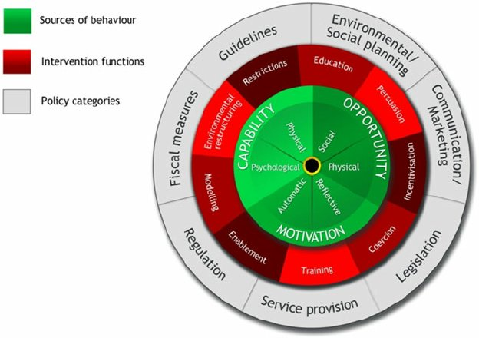

Fig 2. The process of completing the behaviour change wheel guide to designing an intervention.
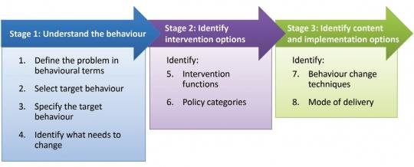

NB As the intervention aim has been established via qualitative interviews and literature searching, the COM-B process for this intervention begins at Stage 1. Step 4.

Stage 1. Step 4. Understanding the behaviour: Identify what needs to change.

Worksheet 4
Using the COM-B model to identify what needs to change to enable young people to increase their intrinsic motivation.

COM-B Component | What needs to happen for the target behaviour to occur? | Is there a need for change?
Physical capability: our physical strength, skill or stamina | N/A | No
Psychological capability: our knowledge/ psychological strength, skills or stamina | Perseverance and stamina will be required for these patients as it’s possible they will need to manage and monitor changes for a long period.  Psychological strength to make decisions based on long-term not short-term reward.  Increase in self-efficacy.  Psychological skills in identifying what their values and goals are.  Skills to appraise their environment and to understand how to operationalise this to their benefit (environmental restricting, cueing etc).  Skills to negotiate conflict.  Skills to negotiate sabotage by friends/family/etc. | Yes  Yes  Yes  Yes  Yes  Yes  Yes
Physical Opportunity: opportunities provided by the environment, such as time, location and resource | N/A | No
Social Opportunity: opportunities as a result of social factors, such as cultural norms and social cues | Young people need to be supported by an ‘autonomy-supportive’ environment and support style from parents and clinicians. Patients will need this form of support from their close family and friends to allow them the autonomy to take responsibility for their own behaviour. This will be a change in the power-balance for many families, where parents usually have the greater control over their child’s eating.  Engaging peer support.  Parental modelling of intrinsic motivation and behaviour change driven from intrinsic means.  Challenging stigma and external drivers for change. | Yes  Yes  Yes  Yes
Reflective Motivation: reflective processes, such as making plans and evaluating things that have already happened | Patients will need to be prepared to evaluate their values and goals for this approach to work. They will need to develop skills in reflecting on their behaviour (both past and current) as the course goes on and making plans to take forward ideas from the clinic into their everyday behaviour.  Improved self-knowledge of what motivates oneself.  Reflection on past experiences and what helps/hinders in own life. | Yes  Yes  Yes
Automatic Motivation: automatic processes, such as our desires, impulses and inhibitions | Learning skills to inhibit automatic behaviours that allow short-term rewards and to favour a longer-term view, for example targeting the automatic processes that result in emotional/comfort eating.  Developing new behaviours as habits. This will support self-regulation as actions are less focused around conscious decisions. Healthy behaviours become embedded. | Yes  Yes
Behavioural diagnosis of the relevant COM-B components | Psychological capability; Social Opportunity; Reflective Motivation; Automatic Motivation

Stage 2: Identifying intervention content and implementation options.

Step 5. Identify intervention functions.
This stage involves using the results of the behavioural diagnosis carried out in Stage 1 to guide decisions regarding the content and delivery of the intervention. This involves first selecting suitable intervention functions (e.g. education, incentivisation) and policy categories (e.g. guidelines, legislation). (Fig. 1) Based upon these decisions, suitable BCTs are identified for inclusion in the intervention before finally deciding upon a suitable mode of delivery.
First, the intervention functions most suited to target the domains identified in the COM-B behavioural analysis carried out in stage 1 were selected using established links between COM-B and intervention functions (Table 1). The identified intervention functions suitable in the context of the target behaviours are then considered using APEASE criteria (affordability, practicability, effectiveness/cost-effectiveness, acceptability, side-effects/safety, equity) which allowed for evaluation of the appropriateness of the identified functions for incorporation into the intervention.

Table 1. Links between COM-b & intervention functions
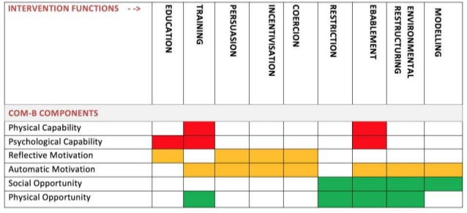

Table 2. examples of intervention functions
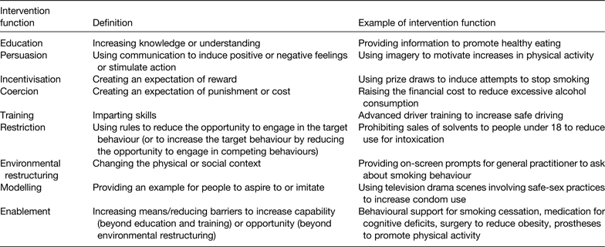

Worksheet 5
Candidate intervention function | How would the intervention work in the context of improving a paediatric patient’s intrinsic motivation? | Does the intervention function meet the APEASE criteria (affordability, practicability, effectiveness/cost-effectiveness, acceptability, side-effects/safety, equity) in the context of improving a paediatric patient’s intrinsic motivation?  Consider this on the basis of this being an individual level intervention (not a population level intervention)  Explain whether or not each function is appropriate, including your rationale.
Education | This function is appropriate as linked to ‘Psychological Capability’ – patients will need educating in psychological techniques and behaviours to increase their strength and stamina.  Psycho-education could be used to help support understanding of motivation and psychological pathways to success, self-understanding and evaluation, and planning for the future. | Affordability could be questioned given we’re planning a 1:1 therapy, one hour a week for 7 weeks.  However, the intention is that this would reduce overall duration of time the patient is in the clinic.  Targeted at current non-responders to the current treatment, so would likely go on to having complex health conditions/ NHS expense.  Using online platform (e.g. zoom) reduces cost. No clinic space required.  The feasibility trial is designed to determine if it is acceptable.
Persuasion | No – this approach is too ‘top-down’ to be fitting with generating intrinsic motivation | N/A
Incentivisation | No - this approach is in contrast with generating intrinsic motivation (instead generating extrinsic motivation) | N/A
Coercion | No – this approach is too ‘top-down’ to be fitting with generating intrinsic motivation | N/A
Training | Yes – would be a fitting approach to impart skills for self-motivation and management, and for parents in creating an autonomy-supportive environment. | Affordability could be questioned given we’re planning a 1:1 therapy, one hour a week for 7 weeks.  However, the intention is that this would reduce overall duration of time the patient is in the clinic.  Targeted at current non-responders to the current treatment, so would likely go on to having complex health conditions/ NHS expense.  Using online platform (e.g. zoom) reduces cost. No clinic space required.  The feasibility trial is designed to determine if it is acceptable.
Restriction | No – this approach is too ‘top-down’ to be fitting with generating intrinsic motivation however the restriction of patients' exposure to interventions that engage extrinsic motivation would be beneficial.
Environmental Restructuring | N/A | No
Modelling | Parents and therapists will be encouraged to model behaviours driven by intrinsic motivation, which will support the young person to learn vicariously. | Yes
Enablement | Using ACT to increase self-determination will hopefully help reduce barriers patients have so far found in their weight management. | Yes
Selected intervention functions:

Modelling, enablement, training & education

Step 6: Identify policy categories
Of the seven policy categories, as listed below in Table 2, use APEASE criteria to identify the categories best suited to deliver the identified intervention functions within the resource constraints of the work.

Table 3. Matrix of links between intervention functions and policy categories
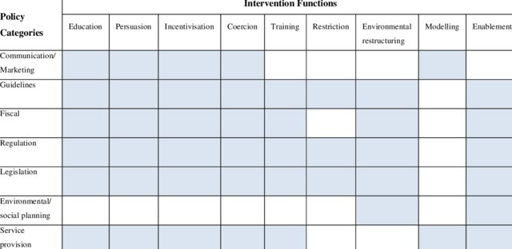

Table 4. examples of the policy categories
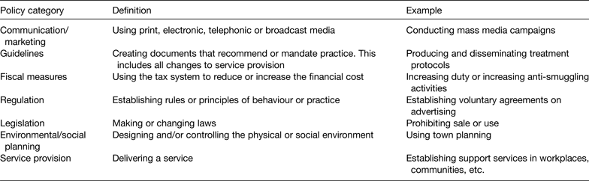

Worksheet 6.
Intervention function | COM-B component | Potentially useful policy categories | Does the policy category meet the APEASE criteria in the context of improving paediatric patients' intrinsic motivation?
Education | Psychological Capability | Communication/marketing | No
Education | Psychological Capability | Guidelines | Yes
Education | Psychological Capability | Regulation | No
Education | Psychological Capability | Legislation | No
Education | Psychological Capability | Service provision | Yes
Training | Psychological Capability | Guidelines | Yes
Training | Psychological Capability | Fiscal measures | No
Training | Psychological Capability | Regulation | No
Training | Psychological Capability | Legislation | No
Training | Psychological Capability | Service provision | Yes
Modelling | Social Opportunity | Communication/marketing | No
Modelling | Social Opportunity | Service provision | Yes
Enablement | Reflective motivation | Guidelines | Yes
Enablement | Reflective motivation | Fiscal measures | No
Enablement | Reflective motivation | Regulation | No
Enablement | Reflective motivation | Legislation | No
Enablement | Reflective motivation | Environmental / Social planning | No
Enablement | Reflective motivation | Service provision | Yes
Policy Category selected: Guidelines & Service Provision

Stage 3: Identify content and implementation options.
Step 7: Identify behaviour change techniques.
Whilst the COM-B model traditionally leads us to utilise the behaviour change taxonomy of 93 individual behaviour change techniques (BCT’s) covering all areas of COM-B (capability, opportunity and motivation), in this case the behaviour we are seeking to change is that of intrinsic motivation. For this, a specific set of 21 behaviour change techniques has been devised based on expert consensus (Teixera et al., 2020). As this tailored resource exists, we will continue the COM-B process but with reference to these behaviour change techniques instead, referred to as MBCT’s (Motivational behaviour change techniques).
The suitability and potential efficacy of each identified BCT will be considered, guided by APEASE, to produce a final set of BCT’s for inclusion in the intervention.
We have also considered the BCT’s needed to run the wider intervention, based on the area raised in the earlier stages of this behavioural analysis.

Worksheet 7a
Intervention Function | COM-B Component | Most Recently used BCT’s | Does the BCT meet the APEASE criteria (affordability, practicability, effectiveness/cost-effectiveness, acceptability, side-effects/safety, equity) in the context of raising patients' intrinsic motivation?
Education | Psychological capability  Reflective motivation | Information about social and environmental consequences | Yes - about the benefits of intrinsic motivation not weight loss
Education | Psychological capability  Reflective motivation | Information about health consequences | Yes - about the benefits of intrinsic motivation not weight loss
Education | Psychological capability  Reflective motivation | Feedback on behaviour | Yes
Education | Psychological capability  Reflective motivation | Feedback on outcome of the behaviour | Yes
Education | Psychological capability  Reflective motivation | Prompts/cues | Yes
Education | Psychological capability  Reflective motivation | Self-monitoring of behaviour | Yes
Education | Psychological capability  Reflective motivation | Biofeedback | Not practical to deliver
Education | Psychological capability  Reflective motivation | Self-Monitoring of the outcomes of behaviour | Not relevant in this context
Education | Psychological capability  Reflective motivation | Cue signally reward | Not relevant in this context
Education | Psychological capability  Reflective motivation | Satiation | Yes
Education | Psychological capability  Reflective motivation | Information about antecedents | Yes
Education | Psychological capability  Reflective motivation | Reattribution | Yes
Education | Psychological capability  Reflective motivation | Behavioural experiments | Yes
Education | Psychological capability  Reflective motivation | Information about emotional consequences | Yes - about the benefits of intrinsic motivation not weight loss.
Education | Psychological capability  Reflective motivation | Information about others’ approval | Unlikely to be effective in this context
Training | Physical capability  Psychological Capability  Automatic motivation  Physical opportunity | Demonstration of the behaviour | Yes
Training |  | Instruction on how to perform a behaviour | Yes
Training |  | Feedback on the behaviour | Yes
Training |  | Feedback on outcomes of behaviour | Yes
Training |  | Self-monitoring of behaviour | Yes
Training |  | Behavioural practice/rehearsal | Yes
Training |  | Biofeedback | Not practical to deliver.
Training |  | Self-monitoring of outcomes of behaviour | Yes
Training |  | Habit formation | Yes
Training |  | Habit reversal | Yes
Training |  | Graded tasks | Yes if set collaboratively.
Training |  | Behavioural experiments | Not relevant in this context,
Training |  | Mental rehearsals of successful performance | Yes
Training |  | Self-talk | Yes
Training |  | Self-reward | Yes
Modelling | Automatic motivation  Social opportunity | Demonstration of the behaviour | Yes
Enablement | Psychological capability  Automatic motivation  Social opportunity | Social support (unspecified) | Yes – if in line with autonomy support
Enablement |  | Social support (practical) | Not likely to effective in this context
Enablement |  | Goal setting (behaviour) | yes
Enablement |  | Goal setting (outcome) | yes
Enablement |  | Adding objects to the environment | Not relevant
Enablement |  | Problem solving | Yes – promoting the person to problem solve, not problem solving for them
Enablement |  | Action planning | Yes
Enablement |  | Self-monitoring of behaviour | Yes
Enablement |  | Restructuring the physical environment | Not relevant
Enablement |  | Review behavioural goals | yes
Enablement |  | Review outcome goals | Yes –
Enablement |  | Social support (emotional) | Yes – if in line with autonomy support
Enablement |  | Reduce negative emotions | Not likely to be effective
Enablement |  | Conserve mental resources | Not likely to be effective
Enablement |  | Pharmacological support | Not relevant
Enablement |  | Self-monitoring of outcomes of behaviour | yes
Enablement |  | Behavioural substitution | Not likely to be effective
Enablement |  | Overcorrection | Not likely to be effective
Enablement |  | Generalisation of a target behaviour | Not likely to be effective
Enablement |  | Graded tasks | Yes – if self-set
Enablement |  | Avoidance/reducing exposure to cues for the behaviour | Not likely to be effective
Enablement |  | Restructuring the environment | Not relevant
Enablement |  | Distraction | Not likely to be effective
Enablement |  | Body changes | Not relevant
Enablement |  | Behavioural experiments | Yes
Enablement |  | Mental rehearsal of the successful performance | Yes
Enablement |  | Focus on past success | Yes
Enablement |  | Self-talk | Yes
Enablement |  | Verbal persuasion about capability | Not likely to be effective
Enablement |  | Self-reward | Yes
Enablement |  | Behavioural contract | Not likely to be effective
Enablement |  | Commitments | Not likely to be effective
Enablement |  | Discrepancy between current behaviour and goal | Collaboratively
Enablement |  | Pros and cons | Yes
Enablement |  | Comparative imagining of future outcomes | Yes
Enablement |  | Valued self-identity | yes
Enablement |  | Framing / reframing | Yes - collaboratively
Enablement |  | Incompatible beliefs | Yes – but manner of delivery is important
Enablement |  | Identity associated with changed behaviour | Yes
Enablement |  | Identification of self as a role model | Yes
Enablement |  | Salience of consequences | Not likely to be effective
Enablement |  | Monitoring of emotional consequences | Yes
Enablement |  | Anticipated regret | Not likely to be effective
Enablement |  | Imaginary punishment | Not likely to be effective
Enablement |  | Imaginary reward | Not likely to be effective
Enablement |  | Vicarious consequences | Not likely to be effective.

Worksheet 7b: Additional MBCT’s applicable to this intervention
Label | Definition | Function | Description | Does the MBCT meet the APEASE criteria?
Autonomy-Support Techniques |  |  |  | Code:  Yes,  Not relevant in this context,  Unlikely to be effective in this context or  Not practical to deliver
MBCT1. | Elicit perspectives on condition or behaviour | Encourage exploration and sharing of  perspectives on current behaviour (e.g.  causes, perpetuating factors etc.). | Allows exploration of behaviour in more depth (self-knowledge), which can inform the programme and personal choices. | Yes
MBCT2. | Prompt identification of sources of pressure for behaviour change | Prompt identification of possible sources of external (or partially internalized) pressures and expectations and explore how they may relate to client’s desired goals and outcomes. | Explores locus of causality and potential sources of external/introjected regulation and its consequences | Yes
MBCT 3. | Use noncontrolling, informational language | Use informational, non-judgmental language that conveys freedom of choice, collaboration, and possibility when communicating (avoiding constraining, pressuring, or guilt-inducing language). For example, use "might" or “could” instead of "should” and “must”. | Avoids being a source of pressure or creating internal pressure, countering external locus of causality for actions. | Yes
MBCT 4. | Explore life aspirations and values | Prompt identification and listing of important life aspirations, values, and/or long-term interests and explore how changes in behaviour (or maintaining the status quo) could be linked to them. | Explores integrity and internal coherence between aspirations, values, and goals/behaviours, which can sustain autonomous regulation. | Yes
MBCT 5. | Provide a meaningful rationale | Prompt client to identify rationale for behaviour change and its maintenance that is tailored, explanatory, and personally meaningful or valuable. | Highlights and reinforces motives/reasons that could form the basis of autonomous motivation. | Yes
MBCT 6. | Provide choice | Provide opportunities to make choices from a collaboratively devised menu of behavioural options and autonomous goals. It includes the decision not to change, delay change, select focus/intensity of change, personally endorsed intrinsic goals and standards for success, including the timing or pace for certain outcomes. | Promotes personal input and ownership over behaviour change and responsibility through choice | Yes
MBCT 7. | Encourage the person to experiment and self-initiate the behaviour | Prompt the person to experiment and self-initiate (new) target behaviour that could be fun and enjoyable, is experienced as positive challenge, opportunity for learning or personal expression, and/or is associated with skill development, all of which provide experiential / immediate positive reinforcement”. | Supports autonomous action via intrinsic motivation. | Yes
Relatedness-support techniques
MBCT 8. | Acknowledge and respect perspectives and feelings | Provide statements of empathy and acknowledgment of the person’s perspective, conflicts/ambivalence, distress, and negative affect (fear, confusion, etc.) and also expression of positive feelings when communicating with client (concerning the target behaviour, treatment, or other related matters). | Indicates attention and respect for the person’s attitudes, thoughts, perceptions, and feelings, which creates an accepting and warm social environment. | Yes
MBCT 9. | Encourage asking of questions | Prompt the client to pose questions regarding their goals/behavioural progress. | Creates an open and collaborative relation that promotes trust. | Yes
MBCT 10. | Show unconditional regard | Express positive support regardless of success or failure. | Demonstrates unconditional respect, care and support and promotes warm social environment. | Yes
MBCT 11. | Demonstrate/show interest in the person | Provide statements of interest and curiosity about the person’s thoughts and perceptions, personal history and background, social context, life events, etc. when communicating. | Displays involvement, indicates to the person that their experiences and input are valued. | Yes
MBCT 12. | Use empathic listening | Demonstrate attentiveness to the client’s responses (e.g. stay silent to allow the person to complete sentences), and provide reflective and summary statements when appropriate (directed at affect or content) when communicating. Prompt permission to provide new information, guidance or advice | Creates open, collaborative relation; promotes trust; Displays respect for the person. | Yes
MBCT 13. | Providing opportunities for ongoing support | Offer the person an appropriate venue and means to contact you in the event of difficulties or questions during the behaviour change process. | Shows care and personal involvement. | Not practical to deliver
MBCT 14. | Prompt identification and seek available social  support | Prompt identification of sources of support for behaviour change (if relevant), acknowledge challenges in recruiting adequate support (autonomous vs  controlled), and promote effective ways of  seeking positive support. | Includes strategies that will help in feeling confident to overcome potential challenges and meet behavioural goal (e.g. information about available programmes, active involvement of others such as family members). | Yes
Competence-support techniques
MBCT 15. | Address obstacles for change | Prompt identification of likely barriers to behaviour change, based on previous attempts, and explore how to overcome them (e.g. what may have worked in the past). | Increases confidence and reinforces existing skills. | Yes
MBCT 16. | Clarify expectations | Prompt statements of client’s own expectations in terms of behaviour change (e.g. identify a clear goal or learning objective), both its experiential elements (process) as well as outcomes. | Provides structure and minimizes future failure (and perceived incompetence). | Yes
MBCT 17. | Assist in setting optimal challenge | Assist in identification of goals that are realistic, meaningful challenging, and achievable. | Provides structure and minimizes future failure (and perceived incompetence) | Yes
MBCT 18. | Offer constructive, clear, and relevant feedback | Provide relevant, tailored, non-evaluative feedback on goal/behavioural progress. This can include specific, process-focused feedback. | Provides encouragement and information to guide future behaviour. | Yes
MBCT 19. | Help develop a clear and concrete plan of action | Develop and provide summary of action plan to work toward a behavioural goal. | Provides structure, increases confidence, and minimizes future failure (and perceived incompetence). | Yes
MBCT 20. | Promote self-monitoring | Prompt monitoring of progress, skill level, or performance such as suggesting options for monitoring tools/means and metrics for success, including steps in the direction of behaviour change. | Provides structuring information that reinforces success and self-awareness. | Yes
MBCT 21. | Explore ways of dealing with pressure | Provide information to manage and limit effects of pressuring contingencies that would undermine competence such as extrinsic rewards, criticism, negative feedback. | Increase confidence to deal with sources of controlling pressure from others and themselves. | Yes

Step 7: Identify mode of delivery.
The final step involves considering the following in relation to intervention delivery: content, provider, recipients, intensity, duration and fidelity. The various potential modes of intervention delivery were considered using the APEASE criteria to assess the options that would be suitable within the constraints and resources of the feasibility trial.
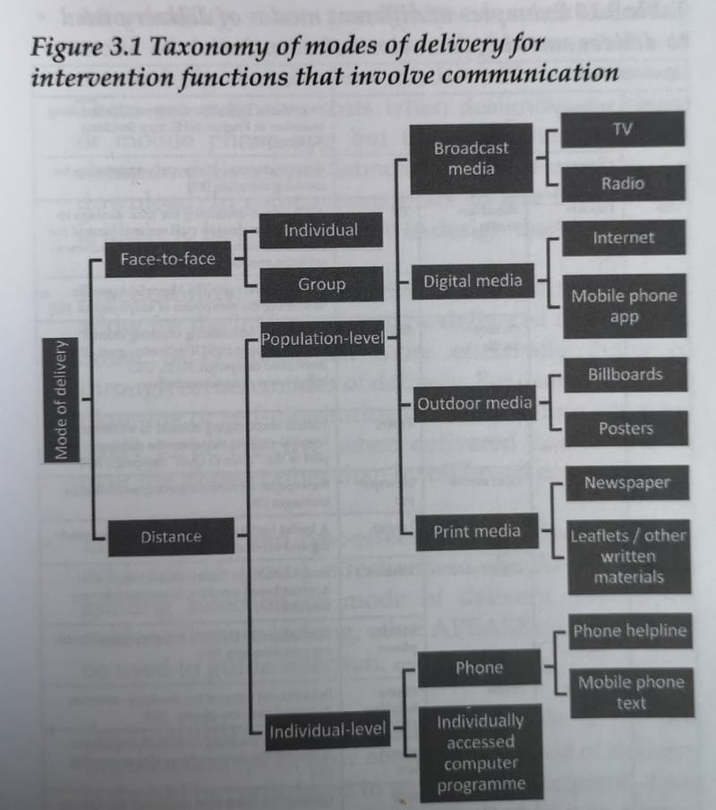

Worksheet 8.
Mode of delivery |  |  |  | Does the mode of delivery meet the APEASE criteria in the context of increasing paediatric patients’ intrinsic motivation?
Face-to-face | Individual |  |  | Yes – will need to consider the costing / cost-effectiveness as face-to-face is expensive
Face-to-face | Group |  |  | Yes
Distance | Population level | Broadcast media | TV | Not applicable
Distance | Population level | Broadcast media | Radio | Not applicable
Distance | Population level | Outdoor media | Billboard | Not applicable
Distance | Population level | Outdoor media | Poster | Not applicable
Distance | Population level | Print media | Newspaper | Not applicable
Distance | Population level | Print media | Leaflet | Not applicable
Distance | Population level | Digital media | Internet | Not applicable
Distance | Population level | Digital media | Mobile phone app | Not applicable
Distance | Individual level | Phone | Phone helpline | Yes – partially if video calling. Calls could be used if preferred by patient, although much easier to share materials and build rapport using a platform such as zoom (or equivalent).
Distance | Individual level | Phone | Mobile phone text | The intervention is too complex to be delivered over text. Needs discussion between therapist and patient
Distance | Individual level | Individually accessed computer programme |  | Yes – could be delivered as a remote programme, but patients would potentially lose out through not working with a clinician. Cost-benefit analysis required.

