SUPPLEMENTARY INFORMATION

Table S1. Main effects (F value) of waterlogging (water) and salinity and their interactive effects on plant biomass, δ¹³C (including soil), ¹³C-assimilation, and percentage of ¹³C allocation (¹³C %) in the leaves, stems and roots at the early stage and later periods, respectively. Significance: *P < 0.05; **P < 0.01.
Variables | Treatment | Early stage |  |  | Later stage
Variables | Treatment | Leaf | Stem | Root | Leaf | Stem | Root
Biomass | water | 0.281 | 2.074 | 0.000 | 0.079 | 0.169 | 0.348
 | salinity | 21.319** | 27.225** | 12.613** | 59.455** | 56.682** | 15.695**
 | water×salinity | 1.205 | 1.156 | 2.521 | 4.162* | 0.706 | 3.967*
Root:shoot ratio | water | - | 8.587* | - | - | 0.039 | -
 | salinity | - | 20.354** | - | - | 9.945** | -
 | water×salinity | - | 2.480 | - | - | 0.172 | -
δ¹³C | water | 7.393* | 0.246 | 0.436 | 16.051** | 32.028** | 2.866
 | salinity | 32.247** | 13.927** | 19.047** | 14.503** | 17.359** | 20.72**
 | water×salinity | 0.629 | 0.295 | 1.957 | 18.911** | 2.678 | 3.909*
¹³C-assimilation | water | 5.08* | 0.927 | 0.005 | 23.136** | 14.703** | 2.406
 | salinity | 60.529** | 61.481** | 15.222** | 35.621** | 38.15** | 38.172**
 | water×salinity | 0.037 | 0.864 | 0.934 | 14.816** | 2.758 | 4.78*
¹³C_{organ}% | water | 2.552 | 0.208 | 5.683* | 0.055 | 12.196** | 10.265**
 | salinity | 2.033 | 0.787 | 10.326** | 1.531 | 12.592** | 11.713**
 | water×salinity | 0.122 | 0.612 | 0.612 | 6.742** | 0.742 | 0.122
δ13Csoil | water | - | 0.018 | - | - | 39.108** | -
 | salinity | - | 25.833** | - | - | 4.448* | -
 | water×salinity | - | 1.519 | - | - | 7.796** | -

Table S2. Effects (F-value) among increased waterlogging (water), salinity, and their interactive effects together with chase period on biomass, δ¹³C (including soil), ¹³C-assimilation, and the ¹³C_{organ}% allocation in leaf, stem and root over the whole observation period, respectively. Significance values: *P < 0.05; **P < 0.01.
Variables | Water | Salinity | Water×Salinity | Chase period
Leaf biomass | 0.869 | 79.875** | 3.129* | 34.252**
Stem biomass | 3.651 | 65.697** | 2.933* | 52.71**
Root biomass | 6.198* | 38.918** | 9.819** | 97.794**
Root:shoot ratio | 7.728** | 58.185** | 2.690 | 2.481
δ¹³C_{L} | 2.926 | 22.083** | 0.29 | 96.739**
δ¹³C_{S} | 2.591 | 36.006** | 0.796 | 52.177**
δ¹³C_{R} | 7.923** | 60.325** | 1.204 | 39.114**
δ¹³C_{soil} | 6.968** | 23.625** | 0.907 | 29.341**
¹³C_{L} | 2.611 | 31.581** | 0.085 | 41.374**
¹³C_{S} | 5.997* | 97.303** | 0.808 | 20.91**
¹³C_{R} | 10.487** | 79.694** | 0.733 | 7.331**
¹³C_{L}% | 0.341 | 2.085 | 0.69 | 227.876**
¹³C_{S}% | 2.121 | 6.12** | 1.603 | 14.435**
¹³C_{R}% | 5.005* | 15.409** | 1.116 | 97.524**

Fig. S1. Amounts of labeled ¹³C (mean ± SD, n = 3) in P. australis leaves, stems, and roots under different waterlogging (non-waterlogging vs. waterlogging) and salinity (0‒30 ppt) conditions, at 0 hours, 1 day, 3 days, 96 days, 150 days after ¹³C labeling. The x-axis is in the logarithmic scale.

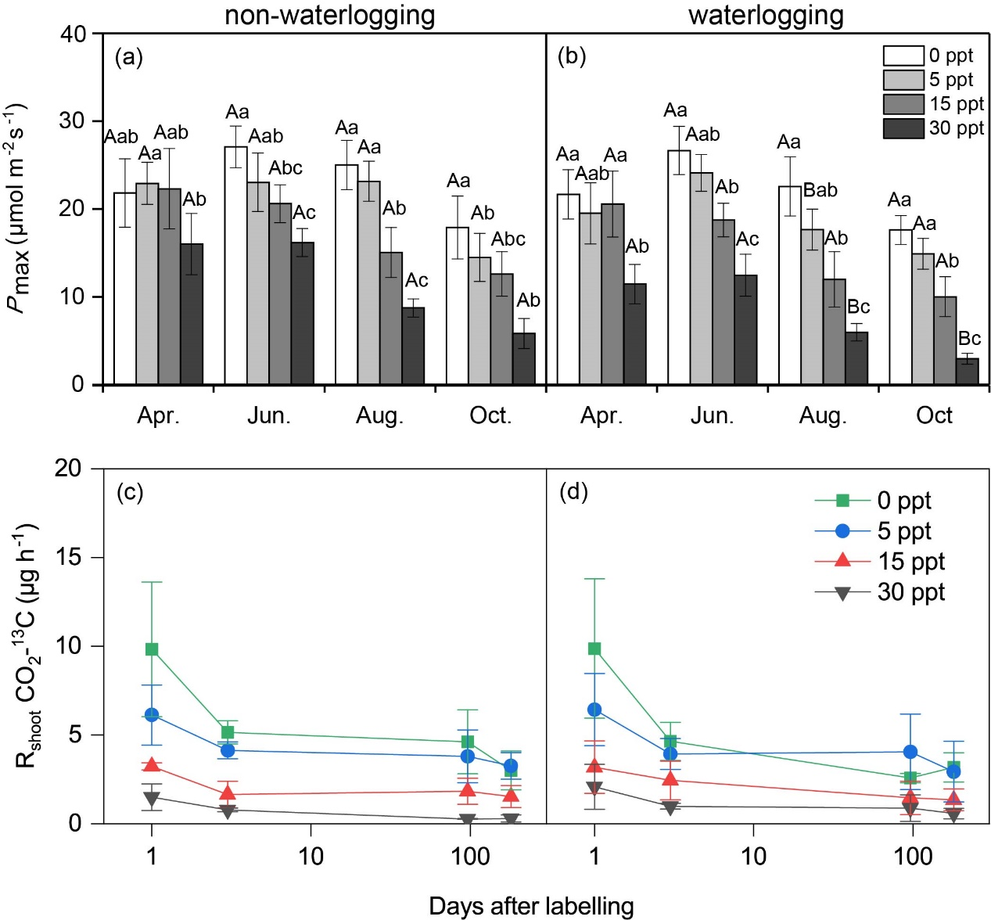 Fig. S2. The maximum rate of photosynthesis (P_{max}, mean± SD, a, b) and respired CO₂-¹³C by shoot (R_{shoot}) of P. australis during the growing season (c, d) under different waterlogging and salinity conditions. Different capital letters indicate significant differences (P < 0.05) between non-waterlogging and waterlogging treatments at the same salinity levels, and different lowercase letters indicate significant differences (P < 0.05) among salinity treatments at the same water levels. The data of P_{max} are modified from Li et al. (2020).

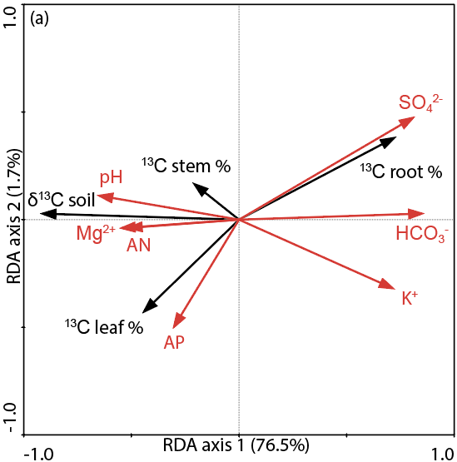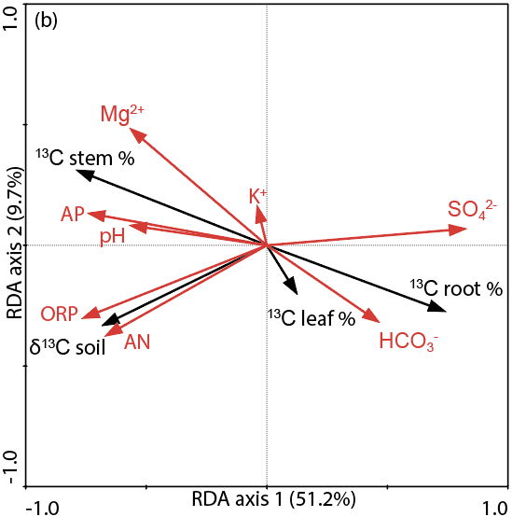
Fig. S3. Ordination diagram based on redundancy analysis (RDA) of the percentage ¹³C allocation within plant and soil δ¹³C (black arrows) with respect to edaphic variables (red arrows) at early (a) and later growing periods (b). AN: available nitrogen; AP: available phosphorus; ORP: oxidation-reduction potential; HCO₃⁻: bicarbonate ion; SO₄²⁻: sulfate ion; K⁺: potassium ion; Mg²⁺: magnesium ion; MBC: microbial biomass carbon; MBN: microbial biomass nitrogen.

Table S3. Explained variance and relative contributions of the edaphic variables to the percentage of ¹³C allocation (¹³C %) in leaf, stem, root and soil δ¹³C at early and later growing periods, respectively, tested with redundancy analysis (RDA).
Explanatory variable | Dependent variable | Explained variance | Relative contribution | F-value | P-value
AN | Allocation at | 20.1% | 8.5% | 5.518 | 0.014
AP | early stage | 7.4% | 3.1% | 1.755 | 0.178
ORP |  | 9.2% | 3.9% | 2.226 | 0.138
pH |  | 32.2% | 13.6% | 10.466 | <0.01
HCO₃⁻ |  | 55.2% | 23.4% | 27.124 | <0.01
SO₄²⁻ |  | 50.3% | 21.3% | 22.298 | <0.01
K⁺ |  | 39.1% | 16.6% | 14.141 | <0.01
Mg²⁺ |  | 22.6% | 9.6% | 6.44 | 0.012
AN | Allocation at | 23.8% | 14.6% | 6.886 | <0.01
AP | later stage | 27.7% | 17.0% | 8.449 | <0.01
ORP |  | 30.2% | 18.6% | 9.539 | <0.01
pH |  | 16.2% | 10.0% | 4.239 | 0.032
HCO₃⁻ |  | 11.8% | 7.2% | 2.938 | 0.068
SO₄²⁻ |  | 34.3% | 21.1% | 11.479 | <0.01
K⁺ |  | 0.4% | 0.2% | 0.088 | 0.930
Mg²⁺ |  | 18.4% | 11.3% | 4.95 | 0.012

Fig. S4. Relationships between the soil microbial biomass carbon (MBC) and nitrogen (MBN) and δ¹³C in soils at the late growing season (including Day 96 to Day 150), under waterlogging and salinity treatments.

