Supplementary Information

Sub-optical-cycle light-matter energy transfer in molecular vibrational spectroscopy

Martin T. Peschel^{1,*}, Maximilian Högner^{2,*}, Theresa Buberl^{2,*}, Daniel Keefer^{1,4},
Regina de Vivie-Riedle^{1✉}, Ioachim Pupeza^{2,3✉}
1. Ludwig-Maximilians-Universität München, Butenandtstraße 5-13, 81377 Munich, Germany
2. Max-Planck-Institut für Quantenoptik, Hans-Kopfermann-Straße 1,85748 Garching, Germany
3. Ludwig-Maximilians-Universität München, Am Coulombwall 1, 85748 Garching, Germany
4. Department of Chemistry, University of California, Irvine, CA 92697, USA
* these authors contributed equally
^{✉ corresponding authors}

Contents
Field-resolved spectroscopy 2
Quantum chemical calculations 4
Calculations of vibrational frequencies and transition dipole moments in the polarizable continuum 6
Calculations of vibrational frequencies and transition dipole moments in an explicit solvent environment 7
Estimation of dephasing rates using ab initio molecular dynamics 8
Analytical model 9
Propagation through the medium 9
Role of the reference measurement 9
Absorbed and reemitted energy in the limit of an impulsive excitation 10
Scaling behaviour of CET(t) with concentration 11
Connection between CET(t) and vibrational coherence 11
Simulation of vibrational coherences 12

Field-resolved spectroscopy
The setup used for field-resolved spectroscopy (see also Fig S1) is similar to the one previously reported.¹ In short, all-solid-state spectral broadening via self-phase modulation in a two-stage multi-pass cell and subsequent compression driven by an Yb:YAG thin-disk oscillator operating at a repetition rate of 28 MHz serves as a high peak and average power source for the experiments. The resulting 15-fs output pulses centred at a wavelength of 1030 nm, and with an average power of 66 W generated by frequency-down-converting phase-stable mid-infrared (MIR) waveforms via intrapulse difference frequency mixing in a 1-mm thick LiGaS₂ crystal. After transmission of the super-octave MIR waveforms covering the 850-to-1670-cm⁻¹ spectral range with an average power of 52 mW, through a 30-µm thick liquid cuvette, a set of six customized dispersive mirrors is utilized to temporally compress their duration. The liquid cuvette is connected to a robotic liquid-handling system to automatically exchange the purified-water reference and the 10-mg/ml DMSO₂ solution.
The electric field of the MIR waveform emerging after the liquid cuvette is detected via electro-optic sampling using a variably-delayed copy of the 15-fs, near-infrared driving pulse with an average power of 350 mW for gating. An 85-µm thick GaSe crystal was used for EOS.¹ The mutual delay between the MIR wave and sampling pulse was measured with interferometric delay tracking.² To avoid molecular background signal due to water vapor the system was operated at a pressure of 10⁻³ mbar from the MIR generation down-stream.

Figure S1: Experimental setup. For details see Supplementary Information, subsection “Field-resolved spectroscopy”. FS: fused silica, QWP: quarter-wave plate, HWP: half-wave plate, CW: continuous wave laser, LGS: LiGS2 crystal, ZnSe: dichroic mirror on ZnSe substrate, DM: dispersive mirror, ADC: analog-to-digital converter, CaF: CaF₂ window, BSC: beam splitter cube, LPF: long-pass filter, GaSe: GaSe crystal, SPF: short-pass filer, WP: Wollaston prism.

Quantum chemical calculations
The ground state geometry of DMSO₂ was obtained by optimization with the M06-2X functional³ and the 6-31+g** basis set in the program package Gaussian16.⁴ Default convergence parameters were used. Subsequent harmonic frequency analysis showed no imaginary vibrational modes, thus confirming that the minimum energy structure had been found. Modes 14 and 15 were identified as the symmetric and asymmetric O-S-O stretching vibrations observed in the experiment.
Table S1: Optimized reference geometry of DMSO₂ in PCM(water).
Element | X(Å) | Y(Å) | Z(Å)
S | 0.000001 | 0.170163 | 0.000013
O | -0.000147 | 0.931109 | 1.259878
O | 0.000072 | 0.931253 | -1.259795
C | 1.411790 | -0.914460 | 0.000040
H | 1.383754 | -1.527002 | 0.901244
H | 1.383567 | -1.527199 | -0.901025
H | 2.291847 | -0.269406 | -0.000140
C | -1.411730 | -0.914541 | -0.000128
H | -1.383587 | -1.527033 | -0.901362
H | -1.383519 | -1.527324 | 0.900908
H | -2.291831 | -0.269545 | 0.000028

Table S2: normalized displacement vectors of selected vibrational modes of DMSO₂ in PCM(water).
Element | Mode 14 (symmetric stretch) |  |  | Mode 15 (asymmetric stretch)
 | X | Y | Z | X | Y | Z
S | -0.00 | 0.25 | -0.00 | -0.00 | 0.00 | 0.43
O | 0.00 | -0.18 | -0.27 | 0.00 | -0.23 | -0.40
O | -0.00 | -0.18 | 0.27 | 0.00 | 0.23 | -0.40
C | -0.03 | -0.09 | 0.00 | -0.00 | -0.00 | -0.07
H | 0.37 | -0.04 | 0.05 | -0.06 | 0.20 | 0.08
H | 0.37 | -0.04 | -0.05 | 0.06 | -0.20 | 0.08
H | -0.21 | 0.18 | 0.00 | 0.00 | -0.00 | 0.29
C | 0.03 | -0.09 | 0.00 | 0.00 | -0.00 | -0.07
H | -0.37 | -0.04 | -0.05 | -0.06 | -0.20 | 0.08
H | -0.37 | -0.04 | 0.05 | 0.06 | 0.20 | 0.08
H | 0.21 | 0.18 | -0.00 | 0.00 | -0.00 | 0.29

Table S3: harmonic vibrational frequencies and IR intensities of DMSO₂ in PCM(water).
Mode # | Wavenumber (cm⁻¹) | IR Intensity (km mol⁻¹)
1 | 170.5 | 0.00
2 | 249.8 | 1.21
3 | 284.5 | 4.73
4 | 290.8 | 0.00
5 | 358.5 | 2.95
6 | 439.0 | 83.23
7 | 474.9 | 63.58
8 | 701.2 | 7.62
9 | 775.9 | 50.31
10 | 951.7 | 0.00
11 | 967.0 | 94.31
12 | 1018.2 | 1.61
13 | 1033.8 | 1.45
14 | 1135.5 | 326.63
15 | 1272.0 | 537.71
16 | 1353.4 | 19.14
17 | 1378.2 | 21.33
18 | 1440.9 | 11.36
19 | 1441.9 | 0.00
20 | 1453.4 | 11.35
21 | 1467.7 | 16.78
22 | 3097.1 | 1.08
23 | 3103.1 | 0.08
24 | 3210.1 | 2.10
25 | 3213.3 | 1.15
26 | 3215.9 | 0.00
27 | 3225.3 | 1.21

Calculations of vibrational frequencies and transition dipole moments in the polarizable continuum
To include anharmonicities in the description, an approach that explicitly calculates the potential energy surface for the vibrational modes 14 and 15 was chosen. Thus, single point calculations were performed on DMSO₂ geometries that were displaced by different amounts along the two most relevant gas phase normal modes (see Table S2) using M06-2X/6-31g* and a polarizable continuum model as implemented in the program package Gaussian16. The vibrational eigenfrequencies $ω_{k}$ and vibrational eigenstates $ψ_{k}$ were determined numerically using the Fourier-grid Hamiltonian method.⁵ This also yielded transition dipole moments by numerically evaluating the integral $<ψ_{0}\left|μ\right|ψ_{k}>.$ The grids on which dipole moment and energies were evaluated were built from the singlepoint values by interpolation using cubic splines. For the other normal modes, the values the harmonic vibrational frequencies and MIR intensities (Table S3) were scaled such that the mean frequencies/MIR intensities for modes 14 and 15 match the mean frequencies/IR intensities calculated by the procedure described above and reported in the main text.
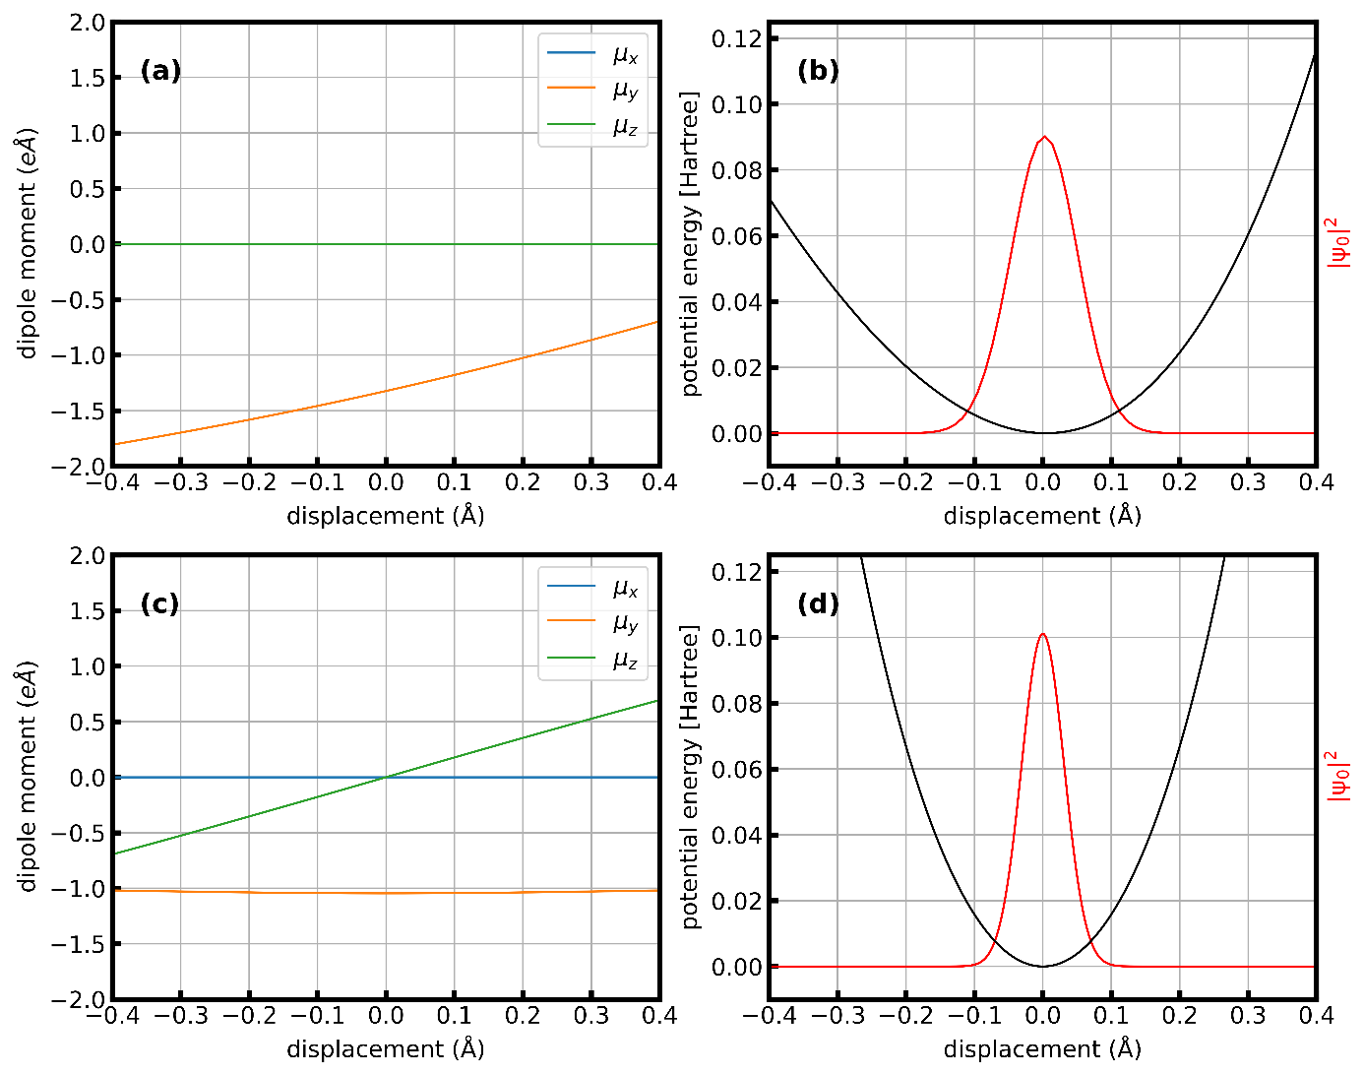
Figure S2: (a) Dipole Moments of DMSO₂ when displaced along normal mode 14 (asymmetric stretch). (b) Potential energy and ground state wavefunction in normal mode 14 (asymmetric stretch). (c) Dipole Moments of DMSO₂ when displaced along normal mode 15 (symmetric stretch). (d) Potential energy and ground state wavefunction in normal mode 15 (symmetric stretch).

Calculations of vibrational frequencies and transition dipole moments in an explicit solvent environment
The transition frequencies and transition dipole moments in solution were also obtained by studying static snapshots of DMSO₂ in water obtained via classical molecular dynamics simulations. The GROMACS package⁶ was used with the OPLSAA forcefield⁷ for DMSO₂ and TP3P⁸ for water. The optimized geometry of DMSO₂ (see Table S1) was placed at the centre of a 30-Å box with 879 molecules of water and was equilibrated at a temperature of 298.15 K. During all MD runs, the coordinates of the central solute were kept frozen. From NVT trajectories with a total duration of 30 ns, snapshots of the solvent shell were extracted at a random time point in every second 5 ps interval. All solvent molecules not within 7.5 Å of the solute molecule were removed. Into these solvent shells, DMSO₂ geometries were inserted in place of the central DMSO₂ molecule, where the atoms were displaced along the two relevant gas-phase normal modes (see Table S2). Vibrational frequencies and vibrational transition dipole moments were then evaluated as described in the Section “Calculations of vibrational frequencies and transition dipole moments in the polarizable continuum” and atoms in the solvent shell were explicitly included in the DFT calculation. The obtained frequency distributions for the modes 14 and 15 are shown in Figure S3. The ensemble average over these distributions then yielded the central frequencies and transition dipole moments referred to in the main text.
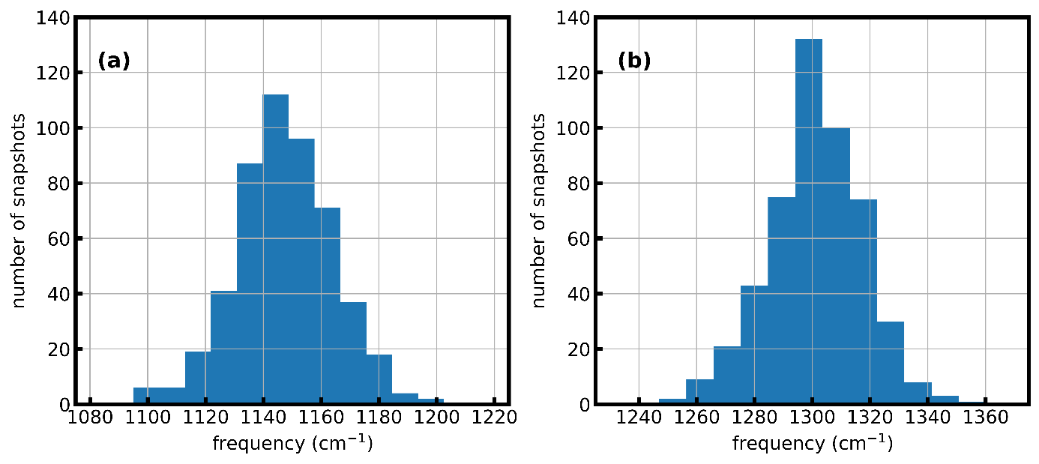
Figure S3: Frequency distributions obtained from MD snapshots for (a) mode 14 (symmetric stretch) and (b) mode 15 (asymmetric stretch).

Estimation of dephasing rates using ab initio molecular dynamics
To estimate the dephasing rate $Γ_{k}$ we conducted on-the-fly semiclassical dynamics simulations of DMSO₂ in water. A box was prepared containing one DMSO₂ molecule and 46 water molecules and was pre-equilibrated using classical molecular dynamics as described previously. The chosen forcefield was OPLSAA for DMSO₂ and TIP4P2005f⁹ for water. The pressure equilibration to 1 bar yielded a box size of 11.7302 Å side length, corresponding to a density of 0.95 g/cm³. Then, on-the-fly semiclassical dynamics simulations using the BLYP-D3 functional and GTH pseudopotentials as implemented in the program package cp2k (version 6.1) were performed.^{10,11} All calculations used 4 multigrids, a CUTOFF of 350 Ry and a REL_CUTOFF of 40 Ry. After a temperature equilibration at 300 K for 11 ps, a 30 ps trajectory was run with a timestep of 0.5 fs. The obtained geometries and electron densities were used to calculated the classical dipole autocorrelation function using the tessellation method by Thomas et al.^{12,13} as implemented in TRAVIS.¹⁴ An estimate of $Γ_{k}$ was obtained by fitting Lorentz functions to the Fourier transformed dipole autocorrelation function (Figure S4).
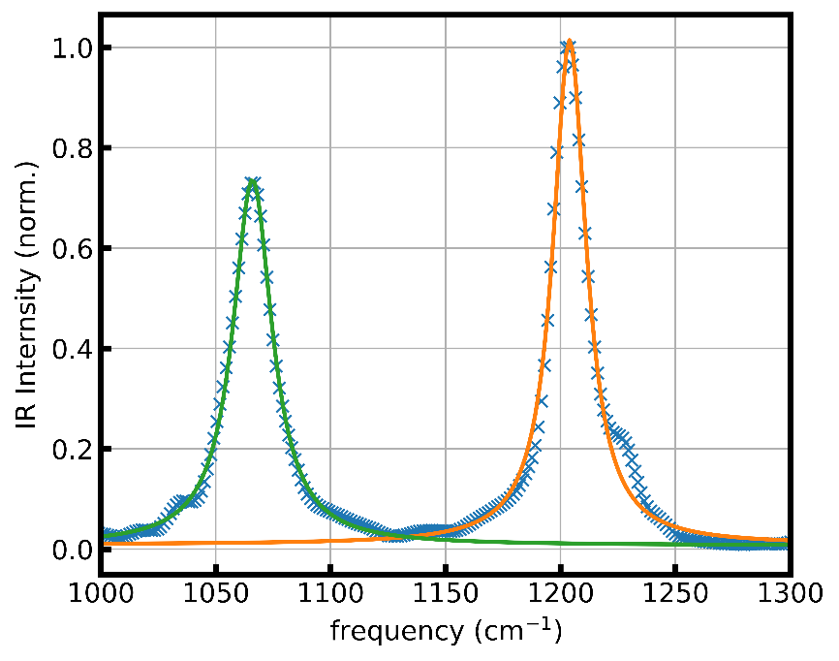
Figure S4: Fourier-transformed dipole autocorrelation function from ab initio molecular dynamics (blue crosses), fit of Lorentzian line shape to the absorption band corresponding to the symmetric stretch (green) and the asymmetric stretch (orange). From the fit, a dephasing parameter $Γ$ was determined as 10.44 cm⁻¹ (1.97 ps⁻¹) for the symmetric stretch and 8.81 cm⁻¹ (1.66 ps⁻¹) for the asymmetric stretch.

Analytical model

Propagation through the medium
1D Propagation of the electric field $E\left(ω,z\right)$ in a linear dielectric medium is described by the electromagnetic wave equation
$$\left(μ_{0}^{-1}ϵ_{0}^{-1}n^{-2}\left(ω\right){ ∂}_{z}^{2}+ω^{2}\right)E\left(ω,z\right)=0,$$
which follows without approximations from the Maxwell equations in linear media. Its solution is
$$E\left(ω,z\right)=E\left(ω,0\right)\exp\left(-in\left(ω\right)\frac{ω}{c}z \right),$$
with the complex refractive index $n\left(ω\right)=\sqrt{1+χ^{\left(1\right)}\left(ω\right)}$, where the complex susceptibility $χ^{\left(1\right)}\left(ω\right)$ follows from the complex molecular polarizabilities $α\left(ω\right)$ and number densities $ρ_{N}$ of the constituents of the water-DMSO₂ mixture via the low-concentration approximation of the Clausius-Mosotti relation:¹⁵
$$χ^{(1)}\left(ω\right)=\sum_{i∈\{H_{2}O,{DMSO}_{2}\}}{ρ_{N,i}α_{i}\left(ω\right)}$$
The complex molecular polarizability of DMSO₂, in turn, follows from the Lorentz parameters of the vibrational transitions:
$$α_{{DMSO}_{2}}\left(ω\right)=\frac{2}{3}\frac{ϵ_{0}}{ℏ}\sum_{k}{\frac{{\left|μ_{k}\right|}^{2}ω_{k}}{ω_{k}^{2}-{\left(ω+iΓ\right)}^{2}}},$$
where $k$ enumerates the transitions, and $μ_{k}$, $ω_{k}$ and $Γ$ are the transition dipole moments, transition angular frequencies, and relaxation constant, respectively.

Role of the reference measurement
For small concentrations, one may approximate $n\left(ω\right)≈1+χ^{\left(1\right)}\left(ω\right)/2$ and therefore
$$E\left(ω,z\right)≈E\left(ω,0\right)\exp\left(-i\left(1+χ^{\left(1\right)}\left(ω\right)/2\right)\frac{ω}{c}z \right)=$$
$$=E\left(ω,0\right)\exp\left(-i\frac{ω}{c}z \right)H_{H_{2}0}\left(ω\right)H_{{DMSO}_{2}}\left(ω\right),$$
with the transfer functions
$$H_{{DMSO}_{2}}\left(ω\right)=\exp\left(-i{ ρ}_{N,{DMSO}_{2}}α_{{DMSO}_{2}}(ω)/2 \frac{ω}{c}z \right)$$
and
$$H_{H_{2}0}\left(ω\right)=\exp\left(-i{ ρ}_{N,H_{2}0}α_{H_{2}0}(ω)/2 \frac{ω}{c}z \right).$$
We can rearrange like
$$E\left(ω,z\right)≈\underset{=: E'(ω,0) }{\underbrace{E\left(ω,0\right)H_{H_{2}0}\left(ω\right)\exp\left(-i\frac{ω}{c}z \right)}}×\exp\left(-i\frac{ω}{c}0 \right)H_{{DMSO}_{2}}\left(ω\right),$$
which is formally equivalent to the propagation through an infinitesimally thin slice of DMSO₂ molecules (with the number of molecules per cm² kept constant as compared to the mixed DMSO₂ and water sample), with an initial field $E'\left(ω,0\right)$ in place of $E\left(ω,0\right)$. This initial field is exactly what is measured in the reference measurement, and the field at the end of the DMSO₂ sample $E\left(ω,z\right)$ is identical to the sample measurement:
$$E^{'}(ω,0)=E_{ref}\left(ω\right)$$
$$E\left(ω,z\right)=E_{sam}\left(ω\right)$$
Consequently, the quantity defined in Eq. (1),
$$CET\left(t\right)=cϵ_{0}\int_{t_{0}}^{t}{\left(E_{ref}^{2}\left(t'\right)-E_{sam}^{2}\left(t'\right)\right)dt'},$$
describes the coherent energy transfer between this hypothetical, infinitesimally thin DMSO₂ sample and the pulse measured in the reference measurement.

Absorbed and reemitted energy in the limit of an impulsive excitation
The final level of the CET, i.e., the energy that remains in the DMSO₂ sample (see Role of the reference measurement) is the difference between the energy in the sample and the reference pulse:
$$E_{final}=\int{[{\overline{S}}_{ref}\left(ω\right)-{\overline{S}}_{sam}(ω)]}dω,$$
where ${\overline{S}}_{ref}\left(ω\right)∝{\left|E_{ref}\left(ω\right)\right|}^{2}$, ${\overline{S}}_{sam}\left(ω\right)∝{\left|E_{sam}\left(ω\right)\right|}^{2}$ are the energy spectral densities of the reference and sample pulse, respectively.
The reemitted energy, i.e., the energy that is emitted by the DMSO₂ sample after the impulsive excitation, can be obtained as follows:
$$E_{sam}\left(ω\right)=E_{ref}\left(ω\right)H_{{DMSO}_{2}}\left(ω\right)$$
$$⇒E_{sam}\left(t\right)=E_{ref}\left(t\right)*H_{{DMSO}_{2}}\left(t\right)=E_{ref}\left(t\right)*\left(H_{{DMSO}_{2}}\left(t\right)-δ\left(t\right)\right)+E_{ref}\left(t\right).$$
The second term is non-zero only during the time window of the exciting pulse. Therefore, we conclude that in the limit of a short pulse, the first term describes the reemitted radiation:
$$E_{reem.}\left(t\right):=E_{ref}\left(t\right)*\left(H_{{DMSO}_{2}}\left(t\right)-δ\left(t\right)\right)$$
Using the Plancherel theorem, we get the reemitted energy
$$E_{reem.}=∫C{\left|E_{reem.}\left(t\right)\right|}^{2} dt=∫C{\left|E_{ref}\left(t\right)*\left(H_{{DMSO}_{2}}\left(t\right)-δ\left(t\right)\right)\right|}^{2} dt=$$
$$=∫C{\left|E_{ref}\left(ω\right)\left(H_{{DMSO}_{2}}\left(ω\right)-1\right)\right|}^{2} dω=∫{\overline{S}}_{ref}\left(ω\right){\left|H_{{DMSO}_{2}}\left(ω\right)-1\right|}^{2} dω.$$
The energy that is temporally absorbed by the DMSO₂ sample (corresponding to the value of the CET just after the impulsive excitation) is just the sum of between the energy that remains in the sample and the reemitted energy:
$$E_{abs.}=E_{final}+E_{reem.}$$

Scaling behaviour of CET(t) with concentration
For small concentrations, the maximum absorbed energy scales linearly with the concentration (Fig. 4e). In contrast, the coherent re-emission scales quadratically with the concentration. This can be explained by a simple examination of the terms contributing to the electric field: For small concentration, the change of the electric field is proportional to the mass concentration $β$ of the DMSO₂ molecules:
$$E_{sam}\left(ω\right)-E_{ref}\left(ω\right)=E\left(ω,z\right)-E^{'}\left(ω,0\right)=E^{'}\left(ω,0\right)\left(H_{{DMSO}_{2}}\left(ω\right)-1\right)≈$$
$$≈E^{'}\left(ω,0\right) \frac{-i{ ρ}_{N,{DMSO}_{2}}α_{{DMSO}_{2}}\left(ω\right)}{2}\frac{ω}{c}z∝{ ρ}_{N,{DMSO}_{2}}∝β$$
This proportionality can be written in the time domain, where the proportionality constant C(t) contains the molecular response:
$$E_{sam}\left(t\right)-E_{ref}\left(t\right)=β·C\left(t\right) ⇒ E_{sam}\left(t\right)=E_{ref}\left(t\right)+β·C\left(t\right)$$
Therefore, the integrand of the CET reads:
$$I_{ref}^{inst}\left(t\right)-I_{sam}^{inst}\left(t\right)=E_{ref}^{2}\left(t\right)-{\left(E_{ref}\left(t\right)+β·C\left(t\right)\right)}^{2}=-β^{2}·C^{2}\left(t\right)-2β·E_{ref}\left(t\right)C\left(t\right).$$
Because $∆E\left(t\right)$ is much smaller than $E_{ref}\left(t\right)$, the second term containing $E_{ref}\left(t\right)$ is dominant during the FCE, which explains the linear scaling of the maximum absorbed energy. After the FCE, $E_{ref}\left(t\right)$ and therefore the entire second term is zero so that the first term, containing a quadratic scaling factor with concentration, becomes dominant. In other words, the electric field of the molecular response after the FCE scales linearly with the concentration and the emitted energy therefore scales quadratically. In contrast, interference with the impinging pulse during the FCE leads to a predominantly linear concentration scaling of the energy absorbed during the FCE.

Connection between CET(t) and vibrational coherence
When incoherent processes are neglected, our system is in a pure state characterized by a wavefunction $Ψ(t)$, with coefficients $\left\{c_{l}(t)\right\}$ for the first vibrational eigenstate of each vibrational mode $l$. The square of the absolute value of the coherence $ρ_{0k}\left(t\right)$ in one specific mode $k$ can then be expressed as
${|ρ_{0k}\left(t\right)|}^{2}{=|{c_{0}\left(t\right)}^{*}c_{k}\left(t\right)|}^{2}= {{|c}_{k}\left(t\right)|}^{2}\left(1-\sum_{l>0}{{{|c}_{l}\left(t\right)|}^{2}}\right)=$ ${{|c}_{k}\left(t\right)|}^{2}- \sum_{l>0}{{{{{|c}_{k}\left(t\right)|}^{2}|c}_{l}\left(t\right)|}^{2}}$
With weak excitation, ${{|c}_{l}\left(t\right)|}^{2}≪1$ for all $l>0$ and the first term dominates
${|ρ_{0k}\left(t\right)|}^{2}≈{{|c}_{k}\left(t\right)|}^{2}$.
$CET(t$) directly measures how much energy is removed from the excitation field at each point in time. By energy conservation, and when only a single vibrational transition per molecule is excited, $CET(t$) is proportional to the change in energy expectation value of one molecule undergoing that transition
$$CET(t)∝ ℏω_{k}ρ_{kk}(t)=ℏω_{k}{{|c}_{k}\left(t\right)|}^{2}$$
with the energy associated with the vibrational transition $ℏω_{k}$. This shows the proportionality of $CET(t)$ and ${|ρ_{0k}\left(t\right)|}^{2}$ under the given assumptions.

Simulation of vibrational coherences
As described in the main text, the vibrational coherences can be calculated using first-order perturbation theory as
$ρ_{0k}^{\left(1\right)}\left(t\right)=\frac{i}{ℏ}µ_{0k}\int_{0}^{∞}{E\left(t-t_{1}\right)e^{iω_{k}t_{1}}e^{-Γ_{k}t_{1}}dt_{1}}$.
To generate the plots in figures 4a-d, the above equation was integrated numerically using MATLAB. We used the experimentally measured electric field of the reference pulses $E\left(t\right)$and the Lorentzian parameters $µ_{0k}, ω_{k}$ and $Γ_{k}$ that were fit to the experimental data for the asymmetric stretching vibration and are given in the main text. The resulting coherences $ρ_{0k}^{\left(1\right)}\left(t\right)$ transformed to a rotating frame by multiplying by $e^{iω_{k}t}$. For figures 4b-d, prior to the procedure described above, we Fourier-transformed $E\left(t\right),$ removed all negative frequency components and reversed the transformation. This is equivalent to the rotating wave approximation.

References
1. Pupeza, I. et al. Field-resolved infrared spectroscopy of biological systems. Nature 577, 52–59 (2020).
2. Schweinberger, W. et al. Interferometric delay tracking for low-noise Mach-Zehnder-type scanning measurements. Opt. Express 27, 4789 (2019).
3. Zhao, Y. & Truhlar, D. G. The M06 suite of density functionals for main group thermochemistry, thermochemical kinetics, noncovalent interactions, excited states, and transition elements: Two new functionals and systematic testing of four M06-class functionals and 12 other function. Theor. Chem. Acc. 120, 215–241 (2008).
4. Frisch, M. J. et al. Gaussian 16 Revision C.01. (2016).
5. Clay Marston, C. & Balint-Kurti, G. G. The Fourier grid Hamiltonian method for bound state eigenvalues and eigenfunctions. J. Chem. Phys. 91, 3571–3576 (1989).
6. Abraham, M. J. et al. Gromacs: High performance molecular simulations through multi-level parallelism from laptops to supercomputers. SoftwareX 1–2, 19–25 (2015).
7. Jorgensen, W. L., Chandrasekhar, J., Madura, J. D., Impey, R. W. & Klein, M. L. Comparison of simple potential functions for simulating liquid water. J. Chem. Phys. 79, 926–935 (1983).
8. Jorgensen, W. L. Transferable Intermolecular Potential Functions for Water, Alcohols, and Ethers. Application to Liquid Water. J. Am. Chem. Soc. 103, 335–340 (1981).
9. González, M. A. & Abascal, J. L. F. A flexible model for water based on TIP4P/2005. J. Chem. Phys. 135, (2011).
10. Goedecker, S. & Teter, M. Separable dual-space Gaussian pseudopotentials. Phys. Rev. B - Condens. Matter Mater. Phys. 54, 1703–1710 (1996).
11. Hutter, J., Iannuzzi, M., Schiffmann, F. & Vandevondele, J. Cp2k: Atomistic simulations of condensed matter systems. Wiley Interdiscip. Rev. Comput. Mol. Sci. 4, 15–25 (2014).
12. Thomas, M., Brehm, M., Fligg, R., Vöhringer, P. & Kirchner, B. Computing vibrational spectra from ab initio molecular dynamics. Phys. Chem. Chem. Phys. 15, 6608–6622 (2013).
13. Thomas, M., Brehm, M. & Kirchner, B. Voronoi dipole moments for the simulation of bulk phase vibrational spectra. Phys. Chem. Chem. Phys. 17, 3207–3213 (2015).
14. Brehm, M. & Kirchner, B. TRAVIS - A free analyzer and visualizer for monte carlo and molecular dynamics trajectories. J. Chem. Inf. Model. 51, 2007–2023 (2011).
15. Van Rysselberghe, P. Remarks concerning the clausius-mossotti law. J. Phys. Chem. 36, 1152–1155 (1932).

