Supplementary notes

PGS method selection and validation
While we aimed to use the most optimal methods to predict PGS, we originally noticed different papers inconsistently report varying optimal PGS strategies. These methods vary from simple yet effective clumping and thresholding using PRSice-2 ¹, stacked clumping and thresholding (SCT) ², to other methods such as, Lassosum ³, Ldpred-2 ⁴, SbayesR ⁵, PRS-CS and more ⁶, all predicting Type-2 diabetes (T2D) using UK Biobank (UKB) data. Furthermore, it was shown the optimal method can also vary on environment of the population on which the GWAS input files were generated as well as the target population in which the PGS are predicted ⁷. In an independent extensive comparison, it was shown that the best model varies per phenotype ⁶.
As such, we originally set out to first calculate PGS using a simple computationally less intensive method (ldpred-inf) using a limited set of SNPs. We compared two analyses to compare how the inclusion of more or less SNPs would affects the predictive performance. These two analyses varied only in that they included a different set of input SNPs based on two arbitrarily selected different Genome Wide Association Study (GWAS) significance cutoffs: 10⁻⁶ and 0.01. We found that both translate into relatively similar biologically meaningful results in terms of identifying individuals at higher risk (Supplementary figure 5). Early reported PGS performance however was slightly worse than reported in current literature, reporting a 2.5 and 2.9 fold increased risk, fold increased risk for the individuals in the highest decile as compared to the rest, for T2D and CAD ⁸ as opposed to 2.3 and 2.4 fold in our exploratory analysis (Supplementary figure 5).
In addition to the performance of our PGS predictions on an overall level, we also assessed the robustness of these two different PGS on a per user level. We compared the risk percentiles each individual is part of based on the 2 PGS calculated using the 2 different GWAS significance thresholds. We found that the results on a per person level can greatly differ, while AUROCs using these different cutoffs only differed marginally (Supplementary figure 5, Supplementary table 2). We found that the Pearson correlation between the predicted risk percentiles of these two PGS was 0.36 for T2D and 0.37 for CAD in the UKB.
We concluded that, if the predictive power of PGS at both cutoffs is similar but the individual results differ, that both PGS lists harbor different information. As such, a combined model based on both PGS scores should result in more accurate predictions. Indeed, we observe that a model based on both PGS combined finds has an increased AUROC compared to the best performing one of either separate. The AUROC increases from 0.626 (95 CI: 0.62-0.632) to 0.644 (95 CI: 0.638-0.650) and 0.623 (95 CI: 0.618-0.628) to 0.633 (95 CI: 0.627-0.638) (Supplementary table 1) and the outcome odds ratios for individuals in the highest risk decile are 2.5 and 2.5 (supplementary figure 6, supplementary table 1), for T2D and CAD respectively, compared to the approximate 2.5 and 2.9 fold reported earlier in literature ^{8,9}. We initially chose our approach as a quick and simple test but found that after combining the results for 2 different thresholds, the performance was similar to that of far more computationally intense methods ⁸ and decided to use our approach, but acknowledge that there is likely room for further minor improvements trying different strategies, albeit at the cost of introducing some bias due to multiple testing.
As reported previously^{8,9}, we found that individuals in the highest decile have a substantially higher risk of the respective disease and see these are consistent across different ages in the UK Biobank (Figure2, supplementary figure 6, supplementary table 1). Risk estimated based on PGS calculated on the Lifelines cohort similarly reveal a risk increase for the highest decile (Figure 2, supplementary table 1). However, the confidence interval is larger in Lifelines, likely due to the much smaller sample size and larger age range. Additionally, AUROCs were computed (Figure 2, supplementary table 1).

PGS computed from better/larger GWAS predict significantly better
Although this was not the main objective in this paper, we also attempted to obtain the best predicting PGS. Due to our access to both the UK Biobank and the Lifelines data, we were able to investigate how well PGS calculated using GWAS summary statistic files from the UK Biobank to predict T2D and CAD in Lifelines.
There is a large amount of literature proving different methods to calculate PGS outperform each other or perform similarly ^{1–6}. While different methods appear to have mixing effectiveness, it is clear that GWAS summary statistic files can greatly benefit the predictive power of PGS ¹⁰. In accordance, we show that GWAS files computed on a much larger cohort (the UKB) result in an AUROC of 0.68 rather than 0.65 for T2D in Lifelines and higher than reported anywhere else (supplementary table //). This translates into a risk increase of the top decile against the rest of the population of 3.4-fold (Table 2) compared to 3-fold. This is significantly higher than earlier reports that only identify the top decile at a 2.5 fold increased risk, albeit in a different cohort ^{8,9}. Therefore, we encourage any future efforts to create large consortia combining large datasets, to obtain allow for even better GWAS, ultimately leading to, among others, better PGS predictions.
Additionally, running this same analysis on the UK Biobank, allowed us to investigate the magnitude to which overfitting forms a problem when calculating a PGS score using a GWAS summary statistic file derived from the respective cohort. We find that at a more stringent GWAS p-value significance threshold of 10⁻⁶ for inclusion of variants in the PGS calculation, the observed predictive power in the two cohorts is similar. However, at a less stringent p-value cutoff for inclusion of GWAS variants to calculate PGS, the effects of circular bias become clear with exceedingly high artificial AUROCs of 0.73 for T2D and 0.75 for CAD based on PGS alone (0.77 and 0.85 when age and sex are also included as covariates), while only being 0.68 and 0.63 in Lifelines. These large AUROC differences are not observed when PGS are calculated based on summary statistic files based on a GWAS external to both the UKB and Lifelines, similar AUCs were found in both cohorts.
The models were first trained and tested for the prediction of prevalence. When calculating the coefficients for prediction components for the prevalence, we corrected the data for the following variables: genetic sex, weight, physical activity and smoking status, parental disease status, age PC_{1,2,3,4} and genotyping measurement batch. When testing, the same covariates were included, provided they were not already included as a predictor in the model under question. AUROCs were calculated based on the test data using the disease annotation as listed below.
The following models were used:

Model $Outcome \sim PGS$
$$logit(p_{i})=β_{0}+β_{pgs}PGS_{i}+\sum_{covariate=1}^{n}{β_{covariate}Covariate_{i}}$$

Model $Outcome \sim PGS+Age+Sex$
$$logit(p_{i})=β_{0}+β_{pgs}PGS_{i}+β_{age}Age_{i}+β_{sex}Sex_{i}+\sum_{covariate=1}^{n}{β_{covariate}Covariate_{i}}$$

Model $Outcome \sim BMI$
$$logit(p_{i})=β_{0}+β_{bmi}BMI_{i}+\sum_{covariate=1}^{n}{β_{covariate}Covariate_{i}}$$

Model $Outcome \sim BMI+Smoker$
$$logit(p_{i})=β_{0}+β_{bmi}BMI_{i}+β_{smokerPast}SmokerPast_{i}+β_{smokerCurrent}SmokerCurrent_{i}+{\sum_{covariate=1}^{n}{β_{covariate}Covariate}}_{i}$$

Model $Outcome \sim BMI+Smoker+PA$
$$logit(p_{i})=β_{0}+β_{bmi}BMI_{i}+β_{smokerPast}SmokerPast_{i}+β_{smokerCurrent}SmokerCurrent_{i}+β_{physicalActivityModerate}PhysicalActivityModerate_{i}+β_{physicalActivityVigorous}PhysicalActivityVigorous_{i}+\sum_{covariate=1}^{n}{β_{covariate}Covariate_{i}}$$
Model $Outcome \sim BMI+Smoker+PA+Sex$
$$logit(p_{i})=β_{0}+β_{bmi}BMI_{i}+β_{smokerPast}SmokerPast_{i}+β_{smokerCurrent}SmokerCurrent_{i}+β_{physicalActivityModerate}PhysicalActivityModerate_{i}+β_{physicalActivityVigorous}PhysicalActivityVigorous_{i}+β_{sex}Sex_{i}+\sum_{covariate=1}^{n}{β_{covariate}Covariate_{i}}$$

Model $Outcome \sim BMI+Smoker+PA+Sex+Parent$
$$logit(p_{i})=β_{0}+β_{bmi}BMI_{i}+β_{smokerPast}SmokerPast_{i}+β_{smokerCurrent}SmokerCurrent_{i}+β_{physicalActivityModerate}PhysicalActivityModerate_{i}+β_{physicalActivityVigorous}PhysicalActivityVigorous_{i}+β_{sex}Sex_{i}+β_{fatherDiseaseStatus}FatherDiseaseStatus_{i}+β_{motherDiseaseStatus}MotherDiseaseStatus_{i}+\sum_{covariate=1}^{n}{β_{covariate}Covariate_{i}}$$
Model $Outcome \sim BMI+Smoker+PA+Sex+Parent+PGS$
$$logit(p_{i})=β_{0}+β_{bmi}BMI_{i}+β_{smokerPast}SmokerPast_{i}+β_{smokerCurrent}SmokerCurrent_{i}+β_{physicalActivityModerate}PhysicalActivityModerate_{i}+β_{physicalActivityVigorous}PhysicalActivityVigorous_{i}+β_{sex}Sex_{i}+β_{fatherDiseaseStatus}FatherDiseaseStatus_{i}+β_{motherDiseaseStatus}MotherDiseaseStatus_i+\sum_{covariate=1}^{n}{β_{covariate}Covariate_{i}}$$
Model $Outcome \sim BMI+Smoker+PA+Sex+Parent+PGS+Age$
$$logit(p_{i})=β_{0}+β_{bmi}BMI_{i}+β_{smokerPast}SmokerPast_{i}+β_{smokerCurrent}SmokerCurrent_{i}+β_{physicalActivityModerate}PhysicalActivityModerate_{i}+β_{physicalActivityVigorous}PhysicalActivityVigorous_{i}+β_{sex}Sex_{i}+β_{fatherDiseaseStatus}FatherDiseaseStatus_{i}+β_{motherDiseaseStatus}MotherDiseaseStatus_{i}+β_{pgs}PGS_{i}+β_{age}Age_{i}+\sum_{covariate=1}^{n}{β_{covariate}Covariate_{i}}$$

Full model:
Model $Outcome \sim BMI+Smoker+PA+Sex+Parent+PGS+Age+PGS*BMI$
$$logit(p_{i})=β_{0}+β_{bmi}BMI_{i}+β_{smokerPast}SmokerPast_{i}+β_{smokerCurrent}SmokerCurrent_{i}+β_{physicalActivityModerate}PhysicalActivityModerate_{i}+β_{physicalActivityVigorous}PhysicalActivityVigorous_{i}+β_{sex}Sex_{i}+β_{fatherDiseaseStatus}FatherDiseaseStatus_{i}+β_{motherDiseaseStatus}MotherDiseaseStatus_{i}+β_{pgs}PGS_{i}+β_{age}Age_{i}+β_{PgsBmi}PGS_{i}*BMI_{i}+\sum_{pc=1}^{4}{β_{pc} PC_{i}}+\sum_{batch=1}^{95}{β_{batch} batch_{i}}$$

Where β₀ is the intercept, and β_{pgs}, β_{sex}, β_{age}, β_{bmi}, β_{smoker}, β_{pa}, β_{sex}, β_{parent} the regression coefficient for the respective variables and β_{PgsBmi} the regression coefficient for the multiplicative term. β_{pc} is the regression coefficient for the respective PC and β_{batch} the regression component for the respective batch. β_{covariates} details the regression coefficients for the included respective covariate. In all cases, variables not included as predictors are included as covariates.
Outcome is the diagnosis status for either T2D or CAD, described in more detail below (section "Disease annotation").

Disease annotation
The models were built to predict either T2D or CAD. These annotations were defined depending on the biobank's available information as described below.
UKBiobank
Disease annotations were based on self-report in an interview with a trained nurse (Data-Fields 20002 and 20004) or via ACE touchscreen questions (Data-Fields 2443 and 6150), hospital reports coded according to the International Classification of Disease version 9 (ICD-9, Data-Fields 41271, 41203 and 41205) and version 10 (ICD-10, UKB Data-Fields 41270, 41202, 41204), and reported operative procedures coded according to the Office of Population Censuses and Surveys Classification of Interventions and Procedures version 4 (OPCS-4, UKB Data-Field 41272, 41200). Supplemental Table // lists all the Data-Fields used to calculate disease incidence and the Data-Fields of the associated ages or dates of diagnosis that were used to determine if participants developed the disease before or after their first UKB center visit.

For CAD, diagnosis was based on self-reported heart attack (Data-Fields 20,002 Data-Field 6,150), self-reported operation (PTCA, CABG or triple heart bypass, Data-Field 20,004), hospital admission for myocardial infarction (ICD-9 codes 410.X, 411.0, 412.X and 429.79, Data-Fields 41,271, 41,203 and 41,205), reported coronary artery bypass grafting (OPCS-4 codes K40.1–40.4, K41.1–41.4, or K45.1–45.5, Data-Fields 41272 and 41,200) and reported coronary angioplasty (OPCS-4 codes K49.1–49.2, K49.8–49.9, K50.2, K75.1–75.4, and K75.8–75.9, Data-Fields 41,272 and 41,200).

T2D diagnoses were based on self-reported answer whether a doctor had ever given the diagnosis diabetes (Data-Field 2,443) and self-reported type 2 diabetes in an interview with a trained nurse (Data-Field 20,002). Individuals with self-reported T1D were annotated as not having T2D.

Lifelines

Disease annotations for Lifelines were based on questionnaires the participants filled in on paper. Questionnaire data from assessment 1A was used to determine if participants were diagnosed with the disease before the first measurement. All other assessment questionnaires (1B, 1C, 2A, 2B, 2C, 3A) were used to annotate if participants developed the disease after the first measurement.

CAD diagnosis was based on self-reported heart attack (code heartattack_presence_adu_q_1 for 1A and code infarction_followup_adu_q_1 for 1B, 1C, 2A and 3A) and self-reported angioplasty and/or bypass surgery (code angioplasty_bypass_adu_q_1 for 1A and 3A).

T2D diagnosis was based on self-reported type 2 diabetes (codes diabetes_type_adu_q_1 and diabetes_type_adu_q_2 for 1A and code t2d_followup_adu_q_1 for 2A and 3A)

Additional risk factors improve PGS models that identify groups with high disease prevalence
In addition to the models we have built to predict incidence, we have built a model that predict prevalence. These models include the same known risk factors, including only those that can be acquired through questionnaire data. We observed that the prevalence odds ratios for T2D for individuals in the highest decile based on PGS is 3.4 (95-CI: 2.8-4.1) and increases to 6.5 (95-CI: 5.5-7.7) when BMI, physical activity, sex, parental disease and smoking status are added to the model (Fisher exact test p-value: 2.8*10⁻⁶). When age is also included in the model, the odds ratios increase further (Fisher exact test p-value: 2.1*10⁻⁹) to 16.1 (95-CI: 13.8-18.9) (Figure 2, Supplementary table //).
Similarly, for CAD, we observe that the prevalence odds ratios for individuals in the highest decile based on PGS is 2.8 (95-CI: 2.2-3.5) and increases (Fisher exact test p-value: 1.0*10⁻⁵) to 5.3 (95-CI: 4.4-6.4), with an AUROC increase from 0.64 (95-CI: 0.61-0.66) to 0.76 (95-CI: 0.74-0.77). This increases (Fisher exact test p-value: 8.9*10⁻⁹) further to 15.7 (95-CI: 13.2-18.6) and an AUROC of 0.87 (95-CI: 0.86-0.89) when age is also added to the model (Figure 2, Supplementary table //).

PGS improves risk models based on regular risk factors to identify groups with high disease prevalence
Vice versa, we also observed that the prevalence odds ratios for T2D for individuals in the highest risk decile based on BMI, physical activity, sex, parental disease and smoking status is 4.9 (95-CI: 4.2-5.8) and increases (Fisher exact test p-value: 4.9*10⁻²) to 6.5 (95-CI: 5.5-7.7) when PGS are added to the model (age excluded in both models). (Figure 2). For T2D the AUROC of the regular risk factor model is 0.79 (95-CI: 0.77-0.80) compared to an AUROC of 0.81 (95-CI: 0.8-0.83) when PGS are added (not corrected for sex and age).
Similarly, for CAD, odds ratios for individuals in the highest risk decile were 2.8 (95-CI: 2.2-3.5) without PGS and increased (Fisher exact test p-value: 4.8*10⁻⁵) to 5.3 (95-CI: 4.4-6.4) with PGS included in the model (age excluded in both models) . The corresponding AUROC is 0.75 (95-CI: 0.73-0.77) based only the set of regular risk factors and 0.76 (95-CI: 0.74-0.78) when PGS are added to the model. While this AUROC has not significantly improved by adding PGS to the model, the model does appear to be able to better identify individuals that are at high risk as apparent from the higher odds ratios for those in the top decile (Figure 2B), while performing worse at classifying those at in the lower risk categories correctly. The lack of a statistically significant effect on the AUROC of adding PGS to the model, may also be attributable to the smaller sample size of this cohort. Indeed, in the UKB test set, we do observe a statistically significant improvement, also at the level of the AUC when PGS are added to the model. The AUROC of a model without PGS is 0.76 (95-CI: 0.75-0.76) and with PGS 0.78 (95-CI: 0.78-0.78), in the UKB test dataset with an increased prevalence odds ratio from 4.5 (95-CI: 4.3-4.7) to 5.9 (95-CI: 5.6-6.1) when PGS are in or excluded from the model (Fisher exact test p-value: 1.8*10⁻¹⁷) (Supplementary table //). This indicates that PGS still have added value when BMI, smoking status, physical activity and parental disease status are already included in a prediction model to predict prevalence.

SaaS platform to estimate risk for single genotyping chips
To support implementation of the scientific methods described in this paper for use in practice, we have constructed a SaaS platform that allows translation of genotyping files into risk scores for chronic diseases, such as T2D and CAD.
The SaaS platform requires either a VCF, bgen or pgen file as input and performs the following steps to finally arrive at risk estimates for a particular individual based on their genetic profile (Age, sex and gender information can be added to arrive at vastly more accurate predictions).
- Where necessary SNPs are flipped to match the reference genome (1000g)
- Poor quality samples are removed (>2.5% missing genotype calls)
- Poorly genotyped SNPs are removed (>2.5% missing genotype calls)
- Genotypes with a Hardy Weinberg Equilibrium p-value below 10⁻⁶ are removed
- Samples with a high heterozygosity rate (4 standard deviations of the mean of the reference panel) are removed
- Samples are imputed against the Haplotype Reference Consortium (r1.1) panel, using the Sanger imputation service ¹¹
- Sex is determined based on genotyping data.
- PGS scores are calculated as described in the method section of the paper.
To allow for calculation of PGS, it is possible to conduct a GWAS on the UK Biobank data for any trait that is available in both the UK Biobank and Lifelines data. PGS will be calculated on the UK Biobank cohort and the predictive power is computed on the Lifelines data.

PGS can only be translated into risk scores by comparing to a reference cohort using the same genotyping SNPs
Although PGS can be calculated for any individual, they are nothing more than an arbitrary number on their own. To assign a risk to a PGS of an individual the score is normally compared to a reference distribution of PGS ⁸. With such analyses it is important that the reference PGS are calculated in the same manner using the same list of input SNPs. Here, we are faced with a challenge that the single genetic profile is not necessarily based on the same genotyping chip as the reference cohort.
Since different genotyping chips often contain different SNPs, this can lead to issues, especially when there is a need to calculate a risk score for a single genotyping sample that is based on a different genotyping chip compared to any reference cohort available. For example, the overlap between genetic variants measured by the Global Screen Array (GSA) chip used in Lifelines and the UK Biobank (UKB) Axiom Array chip is only 34%. The raw PGS scores calculated based on these two different chips clearly follow different distributions, where both the diabetes, as well as the other PGS scores for the Lifelines diabetics are greatly differing from both the diabetics, as well as the other PGS scores in the UK Biobank (Supplementary figure 7)(p-value < 10⁻³²³, Mann-Whitney U test) and would normally incorrectly suggest most of the, in this example, Lifelines individuals are at high risk for diabetes if they were compared to the UK Biobank PGS distributions. To allow assigning a risk to a single genotyping SNP, for which only a reference cohort based on a different genotyping chip is available, we have therefore devised a method that allows a score based on this chip to be placed in the perspective of any cohort.
To be able to compare results from a different type of genotyping chip, we used an intermediary cohort for which WGS data is available. This WGS data will contain SNP data from both genotyping chips. To do this we used the European individuals in the 1000genomes (1000g) data. This is a dataset containing WGS data for 2500 individuals of which 503 of European descent. Unfortunately, for the 1000g data not all phenotype information is available, making it impossible to assess for each phenotype what risk is associated to the different scores identified. However, we can determine the percentile the individual ranks in compared to the 1000g data. We observed that the distributions for diabetics between both cohorts largely overlap using this method (p-value: 0.76, two sided Mann-Whitney U test t-test) (Supplementary figure 7, left). For the non-diabetics this is also the case albeit there still is a small, yet statistically significant difference between the two distributions (p-value: 1.6 x 10⁻³⁵, two sided Mann-Whitney U test t-test).
Then we can assess the corresponding incidence based on the incidence of individuals in the reference cohort, which in this case could be either the UK Biobank non-diabetics, or the Lifelines non-diabetics. Doing so, we observe similar risk increases in both cohorts (Table 1).
In terms of predicted absolute risk, we did observe a difference, which we can attribute to the overall lower incidence of diabetes in the Lifelines cohort, due to its much lower average age. Correcting for this, yields also similar absolute risk predictions. Using this method, we find that relative risk is comparable in both cohorts and in line with earlier findings ^{10,11}, showing that this method is robust. As such this method can be used to assess the risk of single individuals, without the need for the use of the same genotyping chip.
This is particularly of interest since PGS currently suffer from a bias toward Europeans ¹². Although new biobanks for different ethnicities will resolve the accessibility of reference genotyping chips of the appropriate ethnicity, these will likely contain different genotypes. One drawback that will remain is that for subjects with a complex history of admixture, there will likely be additional challenges, but deconvolution, based on the ethnicity of origin, of such genomes suggests that also for these individuals it will be possible to calculate accurate PGS provided references for the deconvoluted genomes are available ¹³. Therefore, our method will allow any individual chip to be compared against the dataset with most appropriate for that ethnicity when such database become available in the future.

Supplementary figures
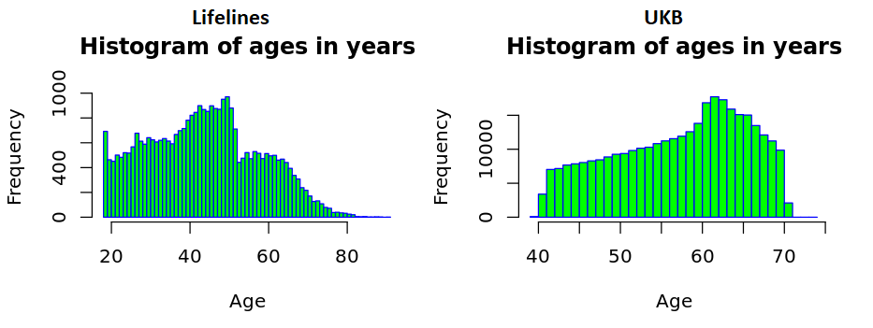
Supplementary figure 1: Ages of individuals in the biobanks. Left Lifelines, right UK Biobank.

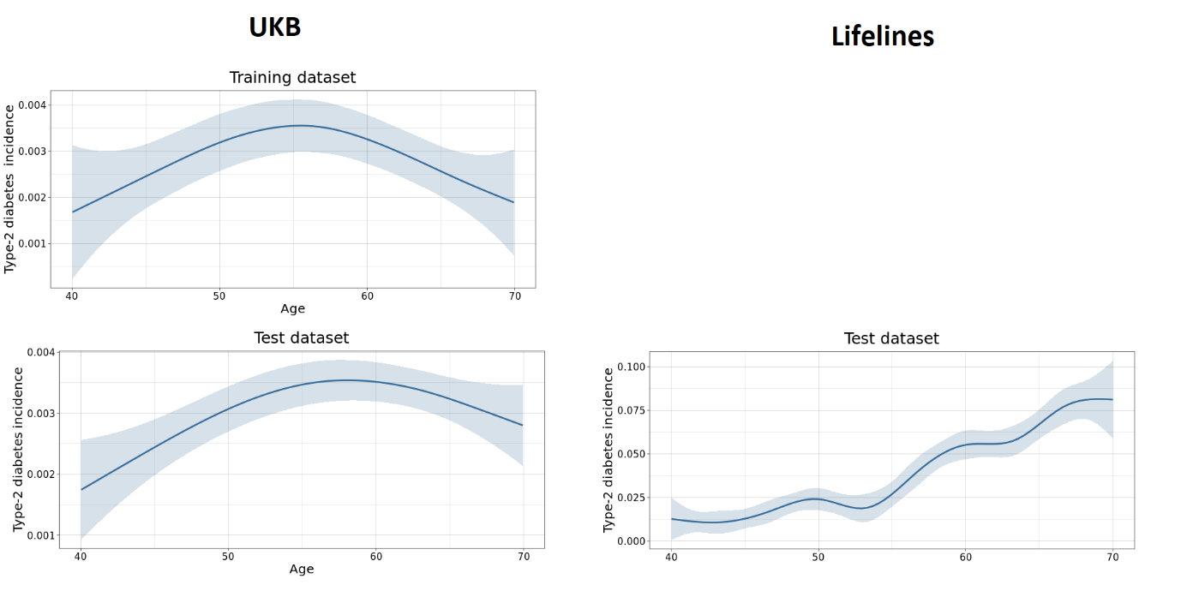
Supplementary figure 2: Type-2 diabetes (T2D) incidence does not increase in the training dataset, but does in the data sets used for validation. We note, that no corrections were made for mortality. As a result of the failed observation of increase T2D incidence in the UKB training set, this variable does not aid in T2D incidence predictions in the datasets used for validation either.
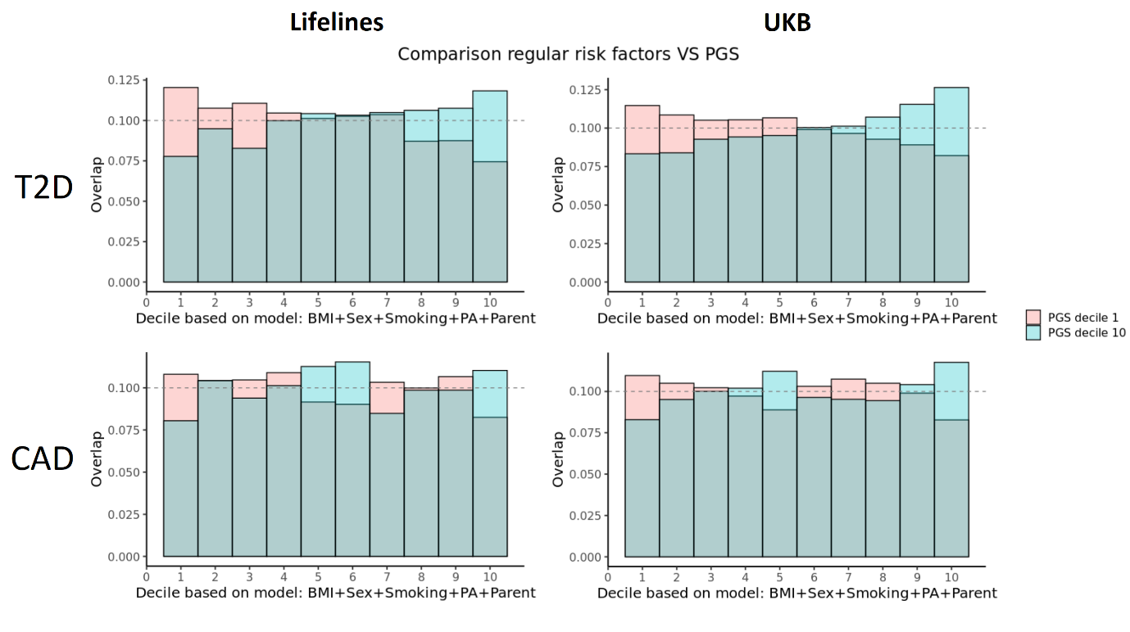
Supplementary figure 3: Comparison outcome prevalence predictions based on a model based on PGS and a model based on Sex, BMI, physical activity, parental T2D disease and Smoking status in both Lifelines (figure 2) and the UK Biobank. Correlation in the UKB is 0.07 (p-value: 3.3 *10⁻²²⁴) and 0.03 (p-value: 9.0 *10⁻⁵⁶) with 46 and 48 % of the individuals being predicted at least 3 deciles apart from each other, for CAD and T2D respectively.//

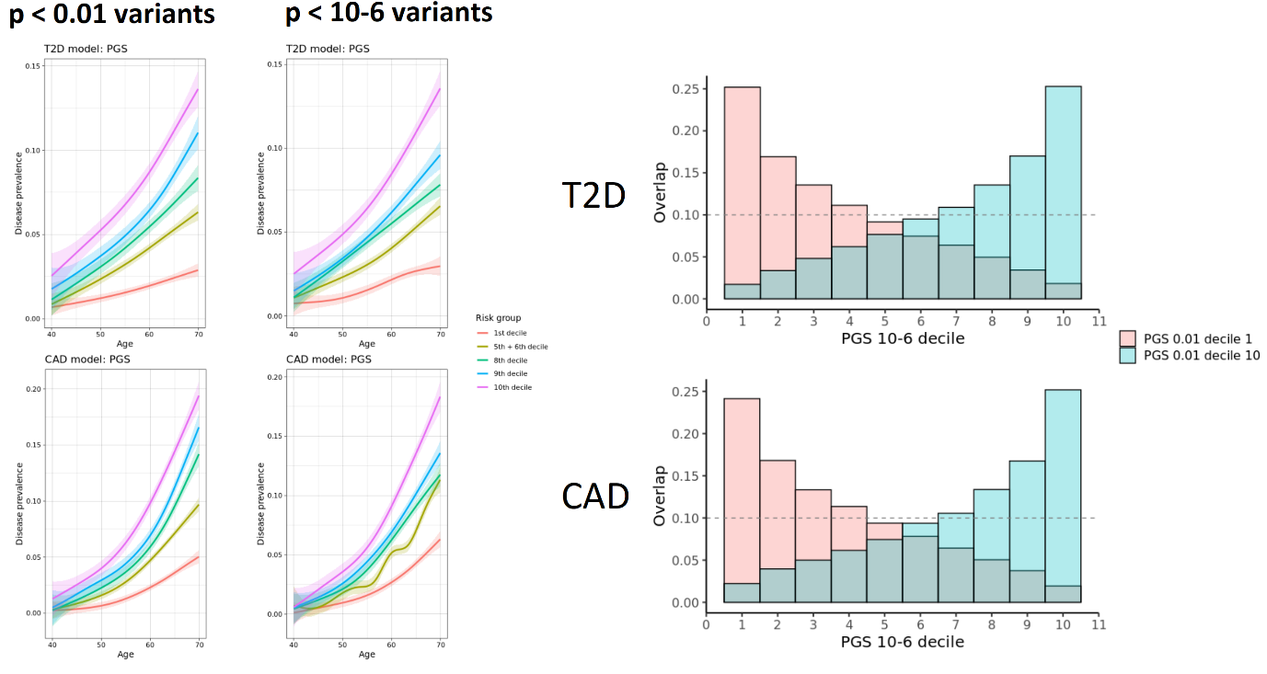
Supplementary figure 5. Comparison of predictions of top and bottom decile from PGS analyses calculated using different prediction models.
Left: Prevalence in different risk deciles based on scores calculated using 2 different sets of input SNPs. Either all variants with GWAS significance < 0.01 or all variants with GWAS significance p-value < 10⁻⁶ were included. Both scores perform relatively well. AUROC 0.01 cutoff statistics: 0.623 (95 CI: 0.618-0.628), Risk increase in highest decile compared to remainder of the population: 2.3. AUROC ¹⁰⁻⁶ cutoff statistics: 0.623 (95 CI: 0.618-0.628), Risk increase in highest decile compared to remainder of the population: 2.3.
Right: The overlap between the individuals predicted in the highest and lowest risk decile according to PGS calculated using a more limited list of SNPs and a more elaborate list based on GWAS significance cutoffs 0.01 and 10⁻⁶, is lower than we had expected, indicating that even this single different setting can have a great impact on the risk predictions on a personal level. Correlation between the 2 PGS calculation settings is 0.52 and 0.54 in Lifelines and 0.36 and 0.35. in the UKB for T2D and CAD respectively, with a quarter of the individuals being classed 3 deciles or more differently in Lifelines and 38% in the UKB.
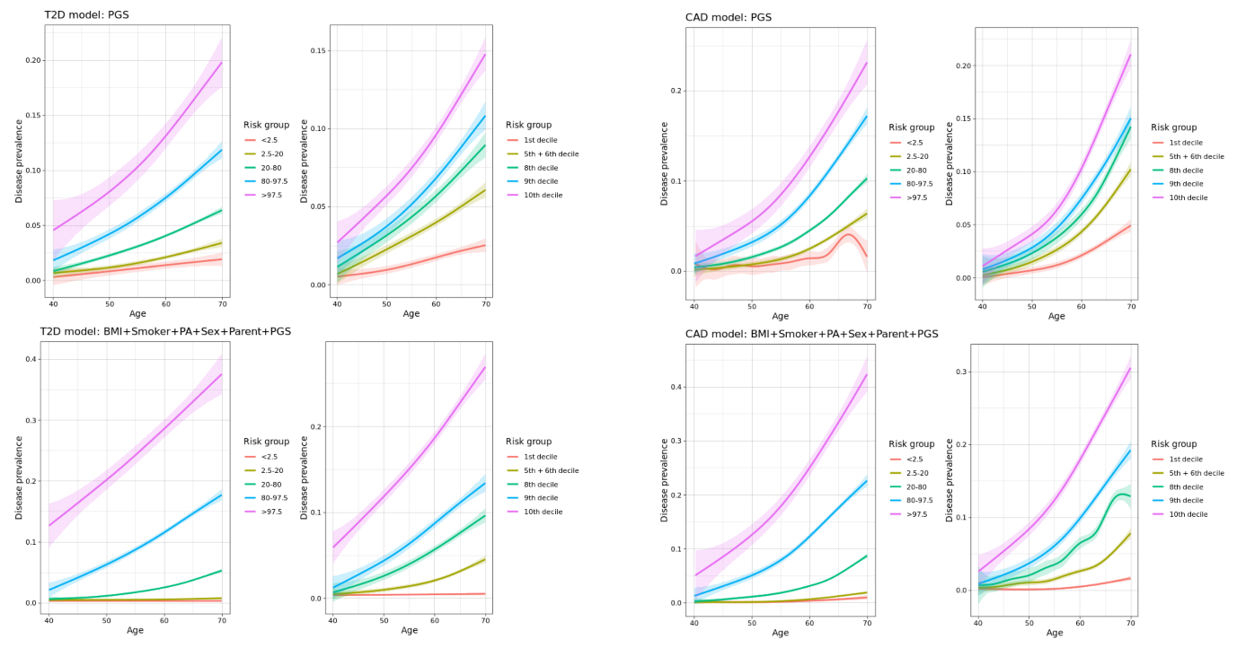
Supplementary figure 6. Disease incidence of different risk groups, in the UK Biobank. PGS calculated using GWAS variants from ^{14,15}. Individuals were grouped into risk groups based on their PGS. Data has been adjusted for first 4 genetic principal components and genotyping batch.

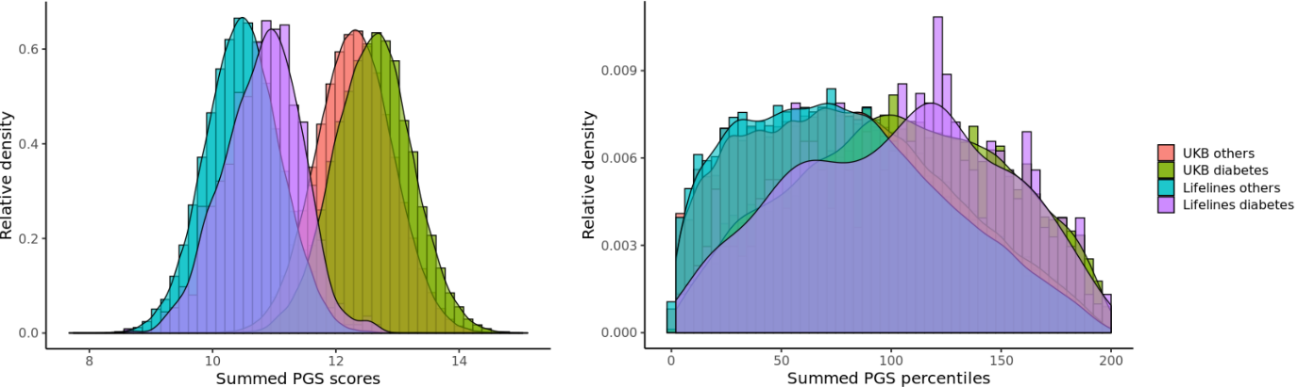
Figure 7. Absolute PGS scores based on different genotyping chips cannot be compared directly. Left: Raw summed PGS scores; Risk scores calculated based on different genotypes are largely different, making direct comparisons problematic. Right: Raw PGS scores were compared to raw PGS scores of the 500 European individuals of the 1000g cohort to translate them into percentiles. This was done for both PGS scores (based on GWAS summary statistic file including variants with p-value threshold 0.01 and 10⁻⁶). Then the percentiles where summed and the densities plotted. Raw PGS scores UKB diabetes versus Lifelines diabetes are statistically significantly different (p-value < 10⁻³²³, Mann-Whitney U test test), but summed PGS for UKB diabetes versus Lifelines diabetes are not (p-value: 0.51, two sided Mann-Whitney U test t-test).

Supplementary tables
Supplement tables 1: Comparison of models including only PGS or additional variables that can be attained through a questionnaire.
Lifelines: T2D model AUCs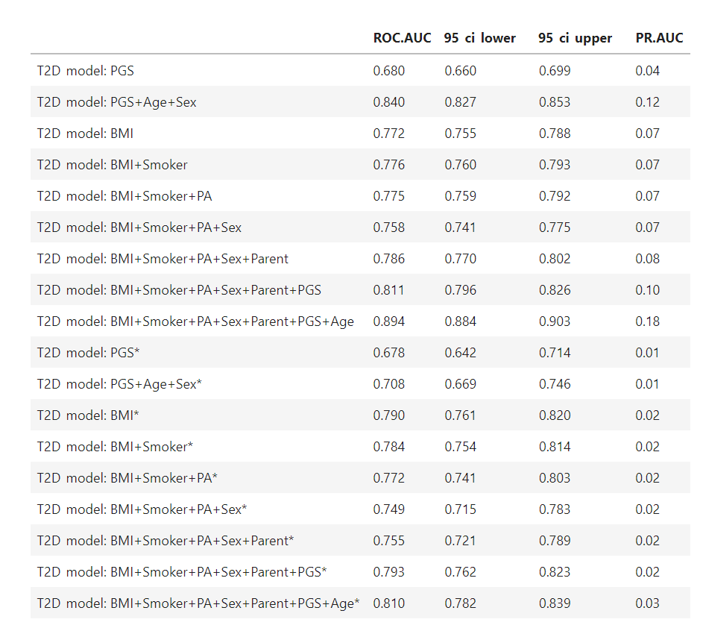

Lifelines: T2D prevalence and incidence
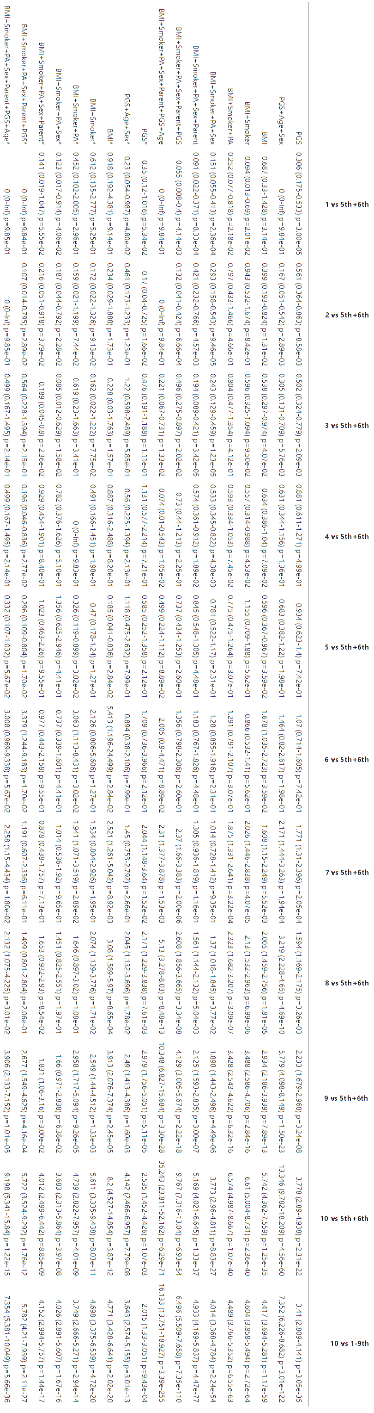
Lifelines: T2D absolute prevalence and incidence
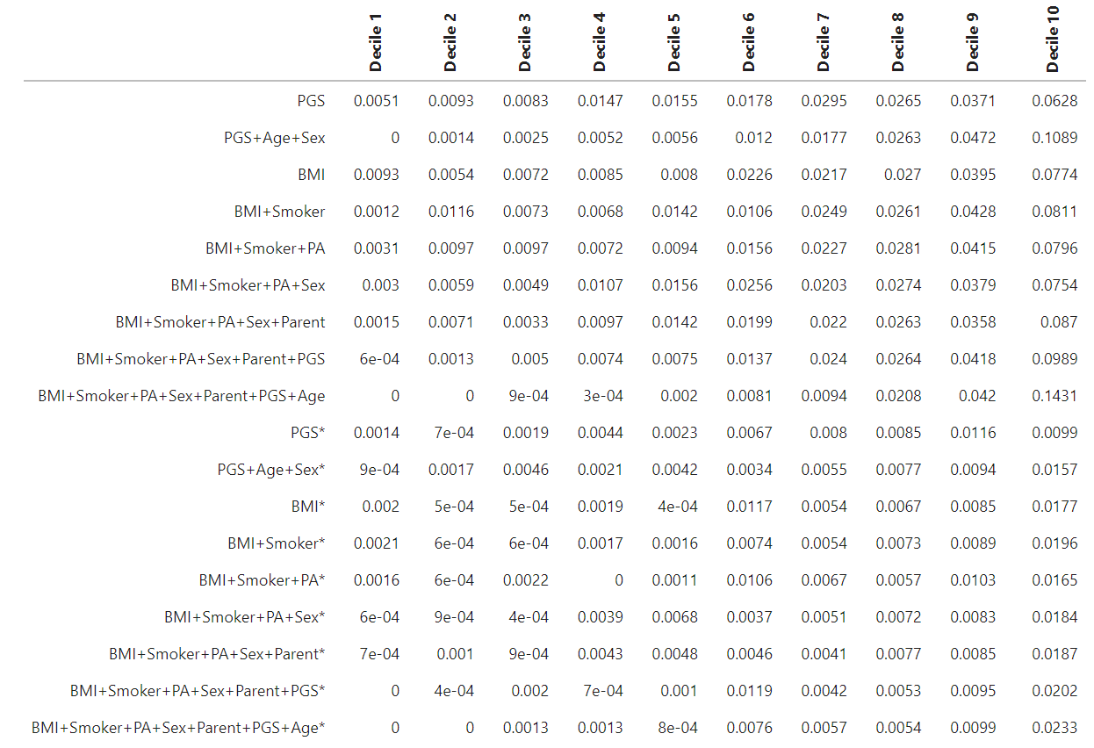

Lifelines: CAD model AUCs
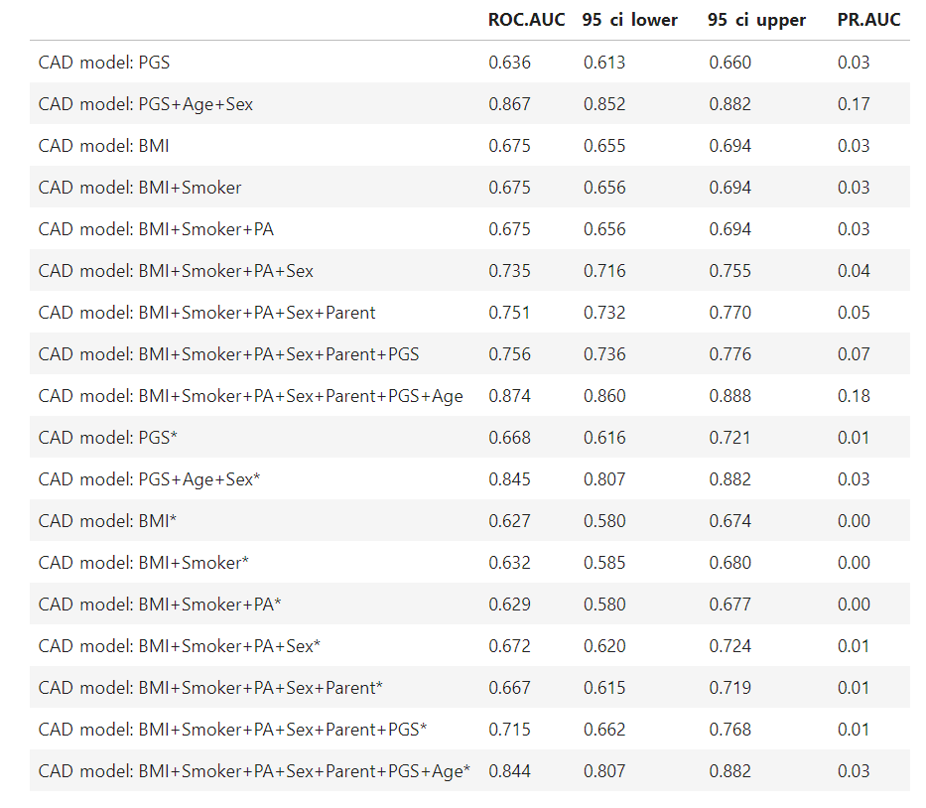

Lifelines: CAD prevalence and incidence
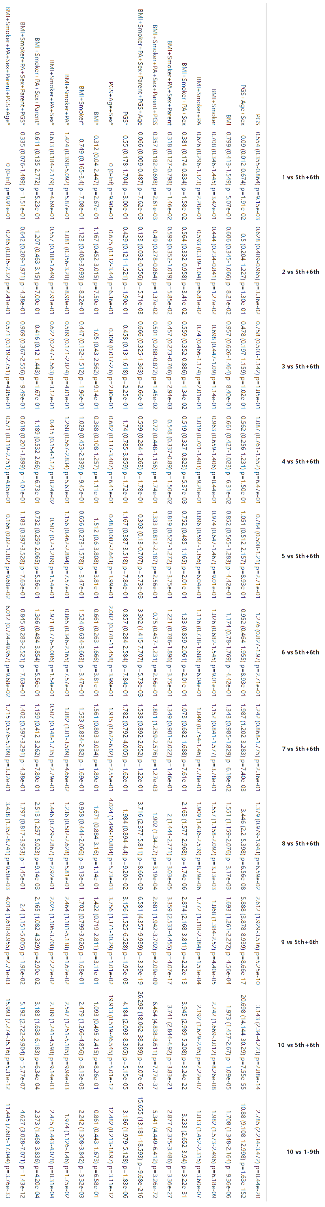
Lifelines: CAD absolute prevalence and incidence

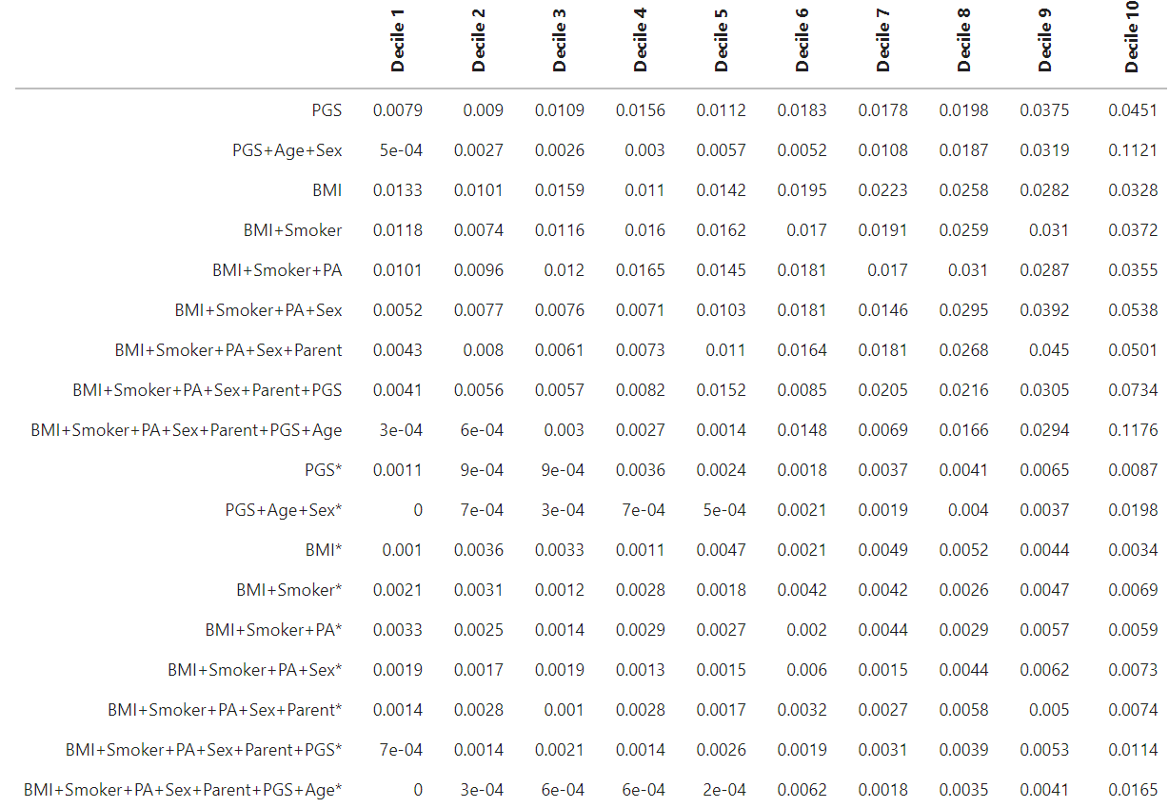

UKB: T2D model AUCs
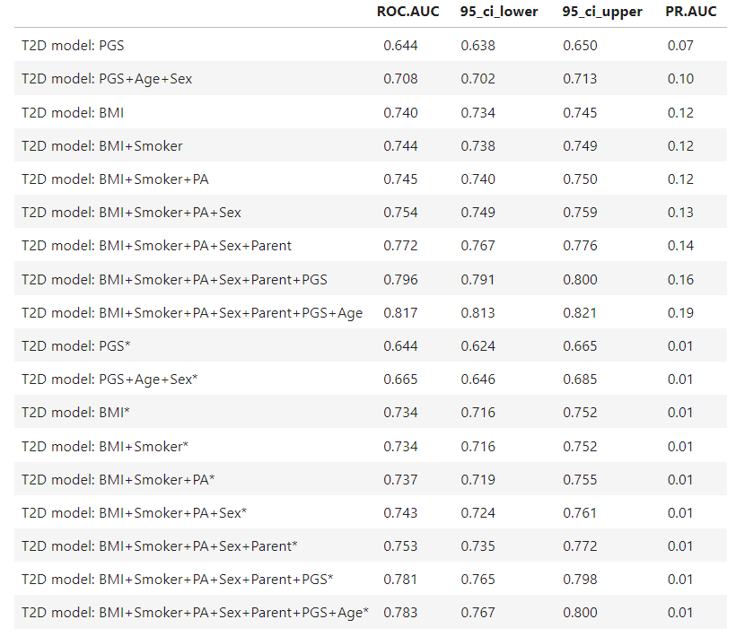

UKB: T2D prevalence and incidence

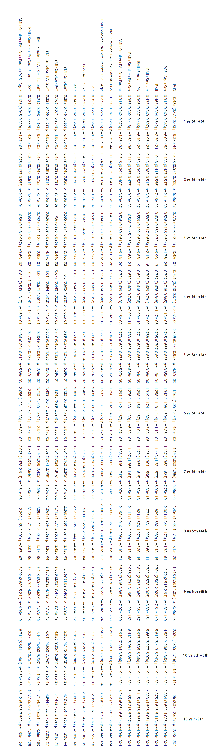
UKB: T2D absolute prevalence and incidence

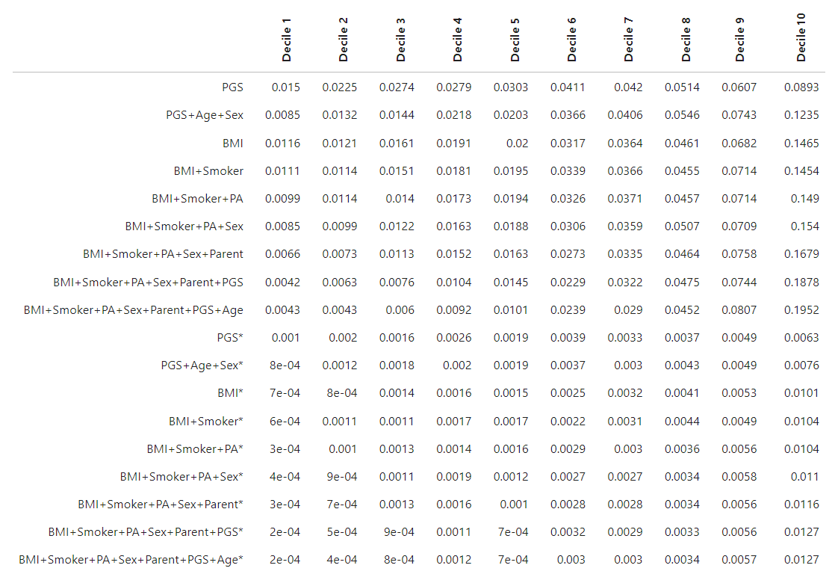

UKB: CAD model AUCs
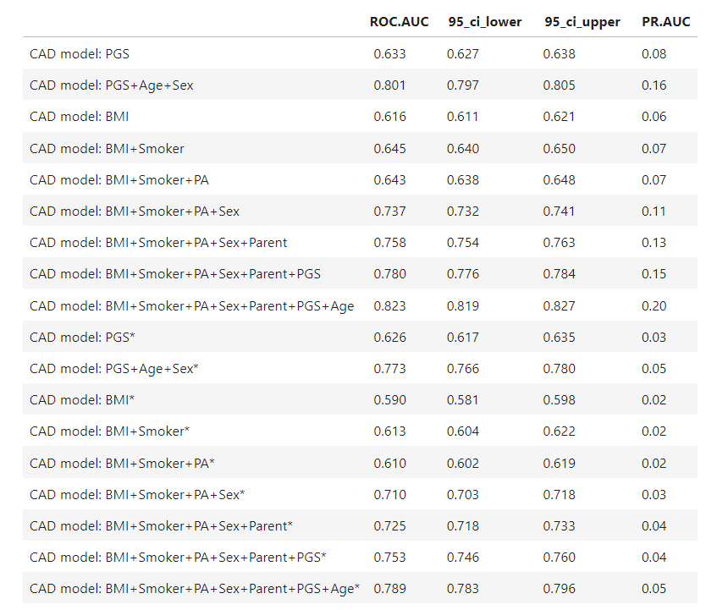

UKB: CAD prevalence and incidence
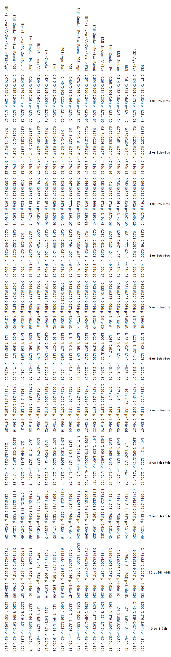
UKB: CAD absolute prevalence and incidence
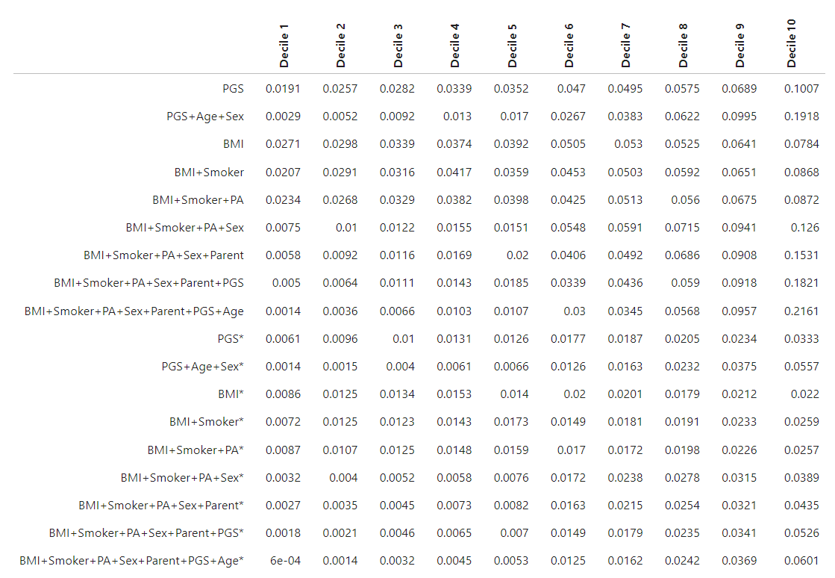

Supplemental Table 2. Data-Fields used for calculating disease incidence and the associated age or date of diagnosis Data-Fields.
Diagnosis |  | Age or date of diagnosis
Description | Data-Fields | Description | Data-Fields
Non-cancer illness code, self-reported | 20002 | Interpolated Age of participant when non-cancer illness first diagnosed | 20009
Operation code | 20004 | Interpolated Age of participant when operation took place | 20011
Vascular/heart problems diagnosed by doctor | 6150 | Age heart attack diagnosed | 3894
Diabetes diagnosed by doctor | 2443 | Age diabetes diagnosed | 2976
Diagnoses - ICD9 | 41271 | Date of first in-patient diagnosis - ICD9 | 41281
Diagnoses – main ICD9 | 41203 | Date of first in-patient diagnosis - main ICD9 | 41263
Diagnoses – secondary ICD9 | 41205 | - | -
Diagnoses - ICD10 | 41270 | Date of first in-patient diagnosis - ICD10 | 41280
Diagnoses - main ICD10 | 41202 | Date of first in-patient diagnosis - main ICD10 | 41262
Diagnoses - secondary ICD10 | 41204 | - | -
Underlying (primary) cause of death: ICD10 | 40001 | Date of death | 40000
Contributory (secondary) causes of death: ICD10 | 40002 | Date of death | 40000
Operative procedures - OPCS4 | 41272 | Date of first operative procedure - OPCS4 | 41282
Operative procedures - main OPCS4 | 41200 | Date of first operative procedure - main OPCS4 | 41260
Operative procedures - secondary OPCS4 | 41210 | - | -
References
1. Liu, W., Zhuang, Z., Wang, W., Huang, T. & Liu, Z. An Improved Genome-Wide Polygenic Score Model for Predicting the Risk of Type 2 Diabetes. Front. Genet. 0, 63 (2021).
2. Privé, F., Vilhjálmsson, B. J., Aschard, H. & Blum, M. G. B. Making the Most of Clumping and Thresholding for Polygenic Scores. Am. J. Hum. Genet. 105, 1213–1221 (2019).
3. Shin Heng Mak, T. et al. Polygenic scores via penalized regression on summary statistics. (2017) doi:10.1002/gepi.22050.
4. Privé, F., Arbel, J. & Vilhjálmsson, B. J. LDpred2: better, faster, stronger. Bioinformatics 36, 5424–5431 (2021).
5. Lloyd-Jones, L. R. et al. Improved polygenic prediction by Bayesian multiple regression on summary statistics. Nat. Commun. 2019 101 10, 1–11 (2019).
6. Kulm, S., Marderstein, A., Mezey, J. & Elemento, O. A Systematic Framework for Assessing the Clinical Impact of Polygenic Risk Scores. SSRN Electron. J. (2021) doi:10.2139/SSRN.3808292.
7. Mostafavi, H. et al. Variable prediction accuracy of polygenic scores within an ancestry group. Elife 9, (2020).
8. Khera, A. V. et al. Genome-wide polygenic scores for common diseases identify individuals with risk equivalent to monogenic mutations. Nature Genetics vol. 50 1219–1224 (2018).
9. Mars, N. J. et al. Polygenic and clinical risk scores and their impact on age at onset of cardiometabolic diseases and common cancers. bioRxiv 727057 (2019) doi:10.1101/727057.
10. Dudbridge, F. Power and Predictive Accuracy of Polygenic Risk Scores. PLOS Genet. 9, e1003348 (2013).
11. McCarthy, S. et al. A reference panel of 64,976 haplotypes for genotype imputation. Nat. Genet. 48, 1279–1283 (2016).
12. Duncan, L. et al. Analysis of polygenic risk score usage and performance in diverse human populations. Nat. Commun. 10, 1–9 (2019).
13. Marnetto, D. et al. Ancestry deconvolution and partial polygenic score can improve susceptibility predictions in recently admixed individuals. Nat. Commun. 2020 111 11, 1–9 (2020).
14. Scott, R. A. et al. An Expanded Genome-Wide Association Study of Type 2 Diabetes in Europeans. Diabetes 66, 2888–2902 (2017).
15. Nikpay, M. et al. A comprehensive 1000 Genomes-based genome-wide association meta-analysis of coronary artery disease. Nat. Genet. 47, 1121–1130 (2015).

