Supplementary Information for
Ubiquitous and Increasing Ferric Iron on Lunar Surface Revealed by Chang’E-5 samples

Haiyang Xian^{1,2, †}, Jianxi Zhu^{1,2,5, †}, Yiping Yang^{1,2}, Shan Li^{1,2}, Xiaoju Lin^{1,2}, Jiaxin Xi^{1,2,5}, Jieqi Xing^{1,2,5}, Xiao Wu^{1,2}, Hongmei Yang^{1,2}, Qin Zhou^{2,4}, Akira Tsuchiyama^{1,2}, Hongping He^{1,2,5*}, Yigang Xu^{2,3} *

* Yigang Xu & Hongping He.
Email: yigangxu@gig.ac.cn; hehp@gig.ac.cn

This PDF file includes:

Supplementary text
Figures S1 to S6
Table S1
Legend for Movie S1
Legend for Dataset S1
SI References

Other supplementary materials for this manuscript include the following:

Movie S1
Dataset S1

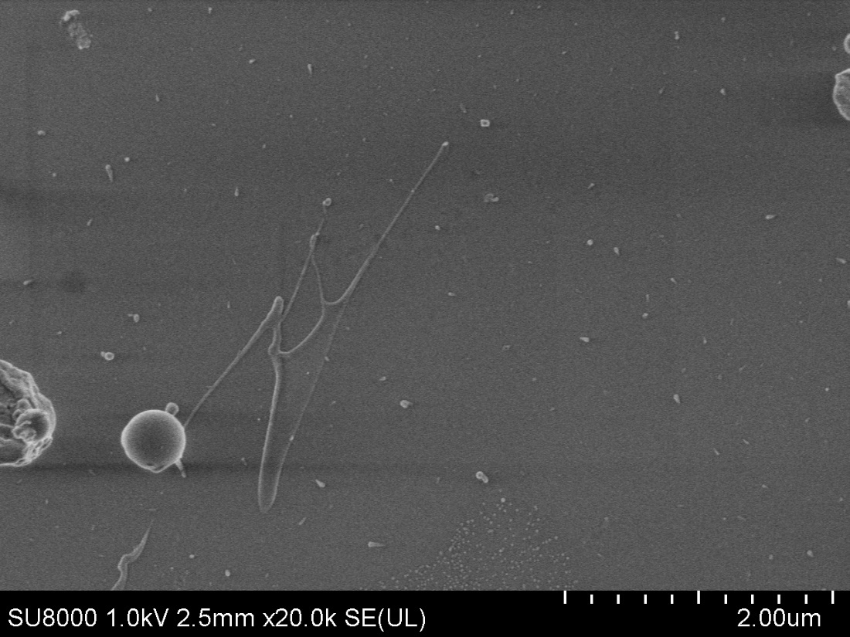

Fig. S1. Melt splashes on the surface of a CE5 agglutinate particle.

Fig. S2. HAADF-STEM image (a), elemental EDS maps (b−h), and selected area EDS spectra (i) of the same area shown in Figs.1c-1d of the main text.

Fig. S3. Peak position and shape comparation of intensity normalized Fe L_{2,3} EELS spectra of metallic Fe⁰, olivine, and hematite. The Fe⁰ and Fe²⁺ have a typical Fe L₃ peak positions at 708.1−708.9 eV while the Fe³⁺ has a typical Fe L₃ peak position at 709.9 eV. The normalized intensity of the peak tail of Fe⁰ at 730 eV is 2 times higher than those of Fe²⁺ and Fe³⁺. The full width at half maximum (FWHM) of Fe⁰ L₃ peak (3.9 eV) is larger than those of Fe²⁺ and Fe³⁺ L₃ peaks (~3.4 eV).

Fig. S4. HAADF-STEM image (a), EELS Fe valent map (b), Fe³⁺/∑Fe ratios map (c), and the frequency and cumulative distributions (d) of the Fe³⁺/∑Fe ratios of a randomly chosen zone in the CE5 agglutinate.

Fig. S5. HAADF-STEM image (a), EELS Fe valent map (b), Fe³⁺/∑Fe ratios map (c), and the frequency and cumulative distributions (d) of the Fe³⁺/∑Fe ratios of another randomly chosen zone in the CE5 agglutinate.

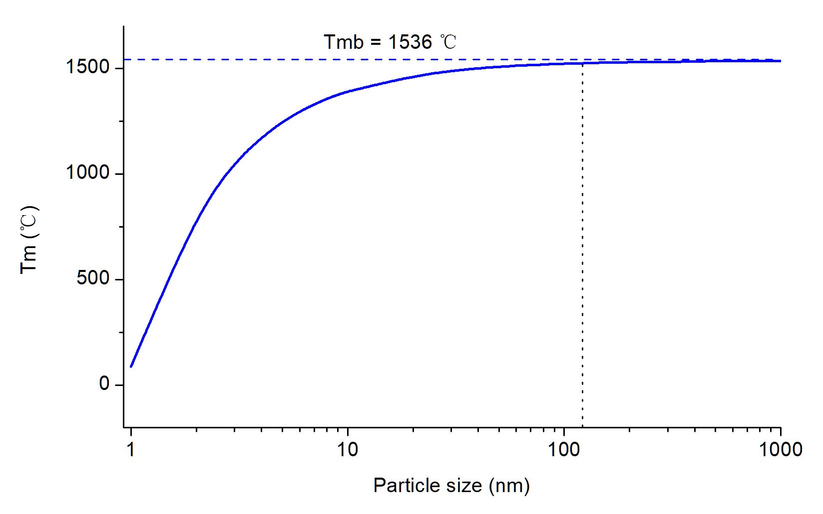

Fig. S6. The relationship between the particle size and melting temperature (T_{m}) of iron nanospheres.

Table S1. CIPW norm calculation results from the EDS data (shown in Table 1 in the main text) of three randomly selected pure zones in an EDS mapping area (wt%).
Mineral | Quartz | Plagioclase | Diopside | Hypersthene | Ilmenite | Magnetite
No. 1 | 4.11 | 52.05 | 9.03 | 21.73 | 10.69 | 2.39
No. 2 | 1.40 | 52.51 | 5.81 | 27.42 | 10.43 | 2.45
No. 3 | 2.46 | 51.19 | 10.74 | 24.07 | 9.29 | 2.25

Movie S1 (separate file). 3D view movie of Fe valence state dispersion in agglutinate glass.

Dataset S1 (separate file). Abundance calculation details of various valent iron species in agglutinate glass.

