Supplementary materials

Supplementary figures and figure legends
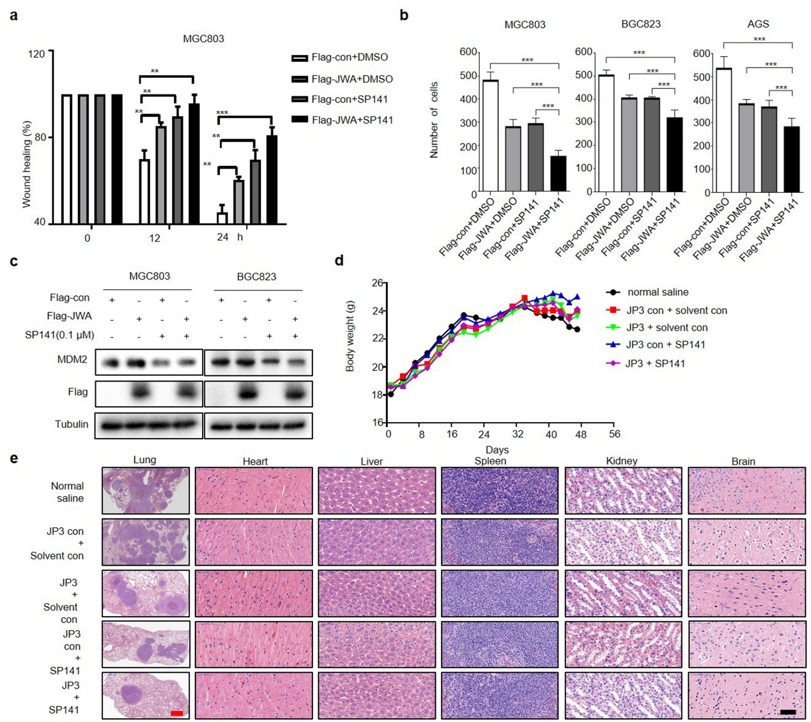
Fig. S1 JWA combined with MDM2 inhibits cells migration and the lung metastasis of GC. (a) Quantitative data of scratch wound healing assays for different treatment groups in MGC803 cells. (b) Quantitative data of Transwell assays for different treatment groups in MGC803, BGC823 and AGS cells, respectively. (c) The protein expression levels of Flag-JWA and MDM2 in MGC803 and BGC823 cells after transfected with Flag-JWA or treated with SP141. ** P < 0.01, ***P < 0.001. (d) Body weight curves of mice in different treatment groups in the GC metastasis model (n=8). (e) In the GC metastasis model, the H&E staining images of lung (scare bar=1 mm), heart, liver, spleen, kidney and brain (scare bar=50 μm) in different treatment groups.
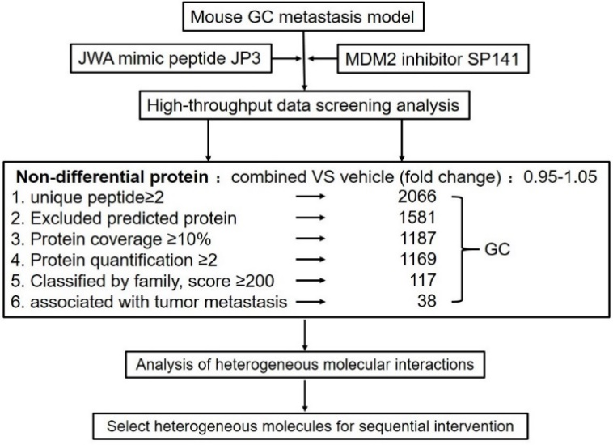
Fig. S2 Identification strategy of heterogeneity molecules drive metastasis in GC. The high-throughput data screening analysis for metastatic lesions after peptide JP3 combined with SP141 intervention in GC mouse model.
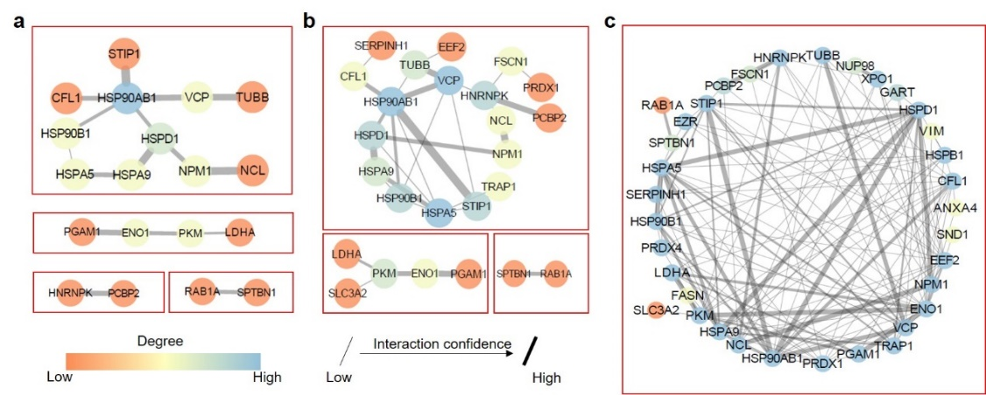
Fig. S3 Heterogeneity molecular interaction networks associated with cancer metastasis for GC. (a) The reliable interaction relationships among heterogeneous molecules for GC (known interactions; interaction score > 0.7). (b) The enlarged and modified interaction relationships among heterogeneous molecules for GC (known interactions; interaction score > 0.4). (c) All potential interaction relationships among heterogeneous molecules for GC (all potential interactions, interaction score > 0.4).
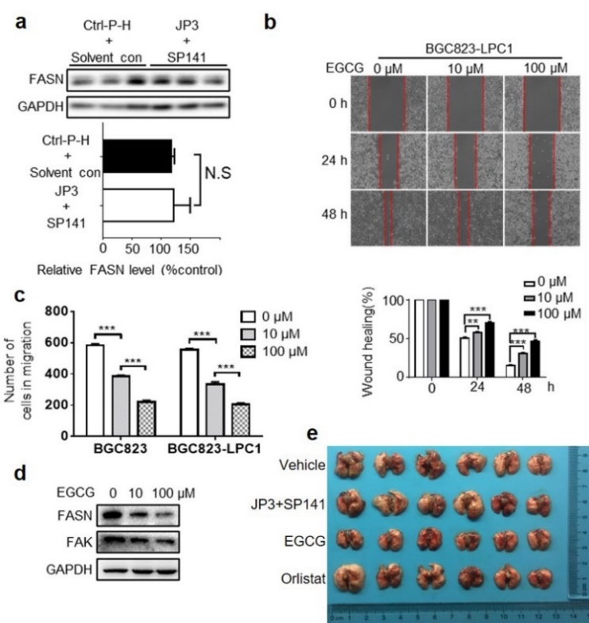
Fig. S4 FASN is the third target molecules of GC. (a) FASN expression level in different treatment groups (control and JP3 + SP141 groups). No significance different between two treatment groups. (b) The representative images and quantitative data of wound healing assays in different time points after injected different dose EGCG (FASN inhibitor) for BGC823-LPC1 cells, respectively. (c) Quantitative data of Transwell assays after injected different dose EGCG for BGC823 and BGC823-LPC1 cells, respectively. (d) Protein expressions for FASN and FAK (cell transfer related protein) after injected different dose EGCG 24 hours for BGC823-LPC1 cells. (e) The extent of lung metastasis for different treatment groups in the GC metastasis model (n=7).
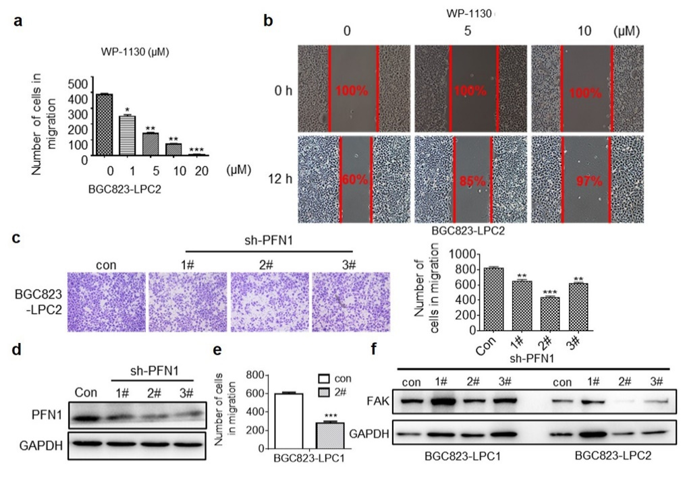
Fig. S5 USP9X and PFN1 are the targets in sequential therapy process for GC. (a) The quantitative data of Transwell assays after injected different dose WP-1130 (USP9X inhibitor) for BGC823-LPC2 cells, respectively. (b) The representative images of wound healing assays in different time points after injected different dose WP-1130 (USP9X inhibitor) for BGC823-LPC2 cells, respectively. (c) Construct sh-PFN1. The representative images and quantitative data of Transwell assays after injected different sh-PFN1 for BGC823-LPC2 cells. Results of Transwell analysis indicated that 2# is the best. (d) Protein expression of PFN1 after transferred sh-PFN1 48 hours for BGC823-PCL2 cells. (e) The quantitative data of Transwell analysis after transferred sh-PFN1 (2#) for BGC823-PCL1 cells. (f) Protein expression of FAK after transferred sh-PFN1 48 hours for BGC823-PCL1 cells and BGC823-PCL2 cells. These results shown that sh-PFN1 (2#) was utilized to do following animal experiments in this study.
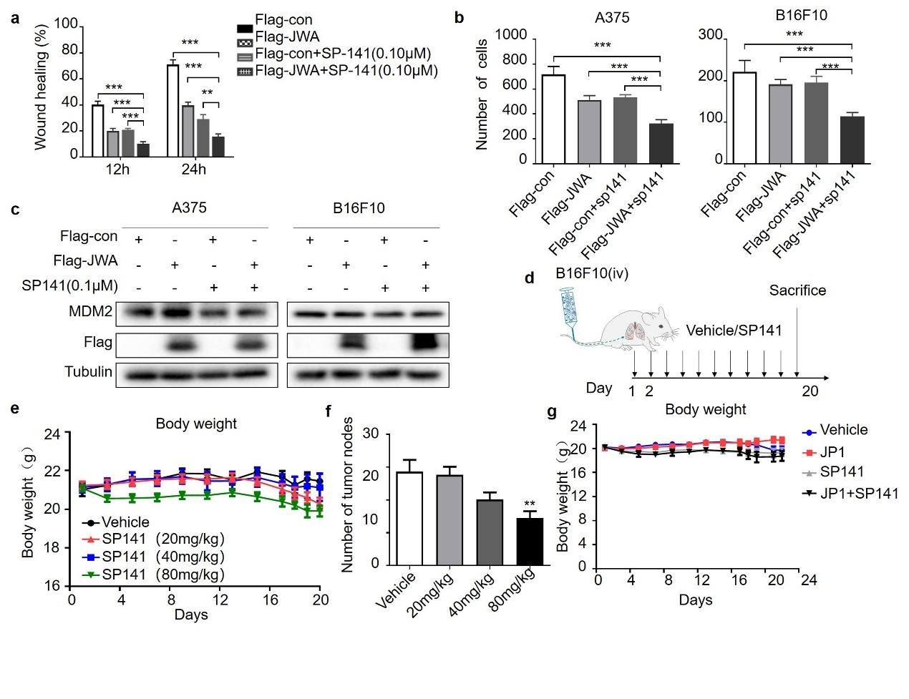
Fig. S6 Combined intervention of JWA and MDM2 enhances the inhibitory effects on metastasis of melanoma. (a) Quantitative data of scratch wound healing assays for different treatment groups in B16F10 cells. (b) Quantitative data of Transwell assays for different treatment groups in A375 and B16F10 cells, respectively. (c) The protein expression levels of Flag-JWA and MDM2 in A375 and B16F10 cells after transfected with Flag-JWA or treated with SP141. (d) A schematic diagram of SP141 treatment protocol for the melanoma abdominal metastasis mouse model. (e) Body weight curves of mice in different SP141 experimental groups for melanoma model. (f) Number of metastasis nodes for different SP141 treatment groups. These results shown that 80mg/kg sp141 was utilized to do following animal experiments for melanoma in this study. (g) Body weight curves for JWA and MDM2 combined experiment groups. The ** represents P < 0.01, *** represents P < 0.001.
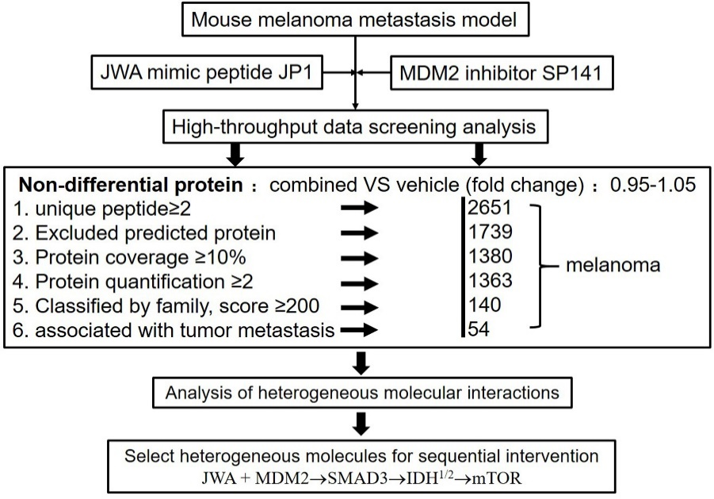
Fig. S7 Identification strategy of heterogeneity molecules drive metastasis in melanoma. The high-throughput data screening analysis for metastatic lesions after peptide JP1 combined with SP141 intervention in melanoma mouse model.
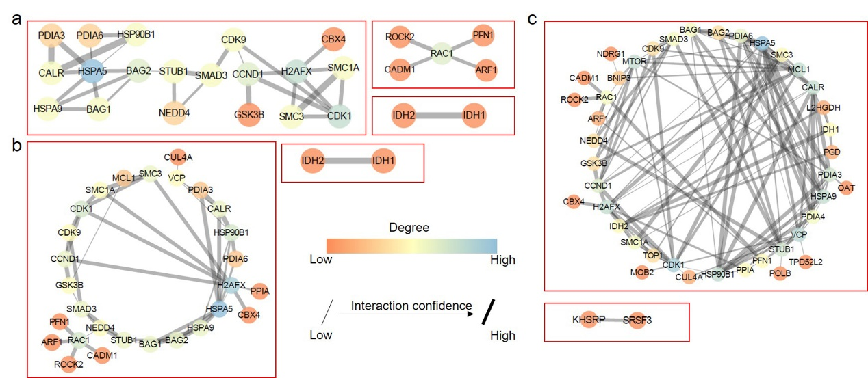
Fig. S8 Heterogeneity molecular interaction networks associated with melanoma metastasis. (a) The reliable interaction relationships among heterogeneous molecules for melanoma (known interactions; interaction score > 0.7). (b) The enlarged and modified interaction relationships among heterogeneous molecules for melanoma (known interactions; interaction score > 0.4). (c) All potential interaction relationships among heterogeneous molecules for melanoma (all potential interactions, interaction score > 0.4).
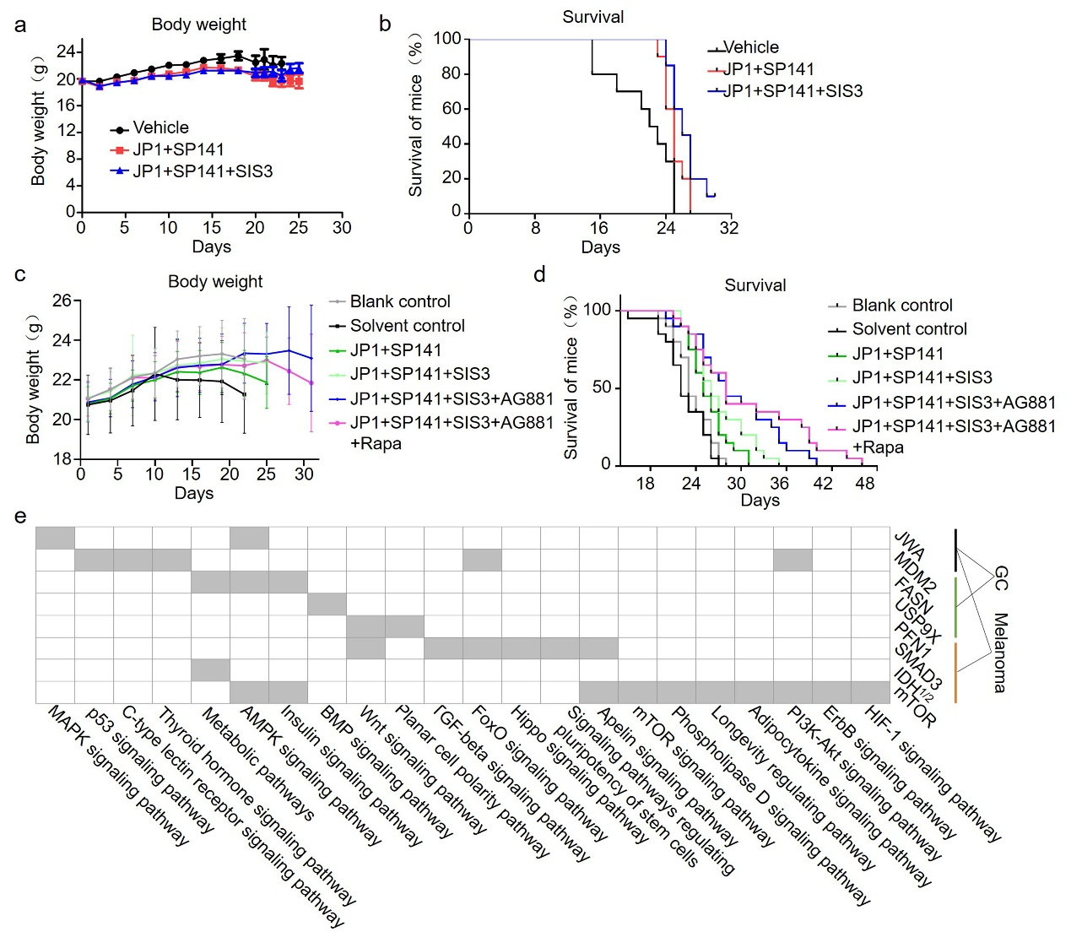
Fig. S9 The outcomes and signaling of heterogeneity-based sequential therapy for melanoma metastasis. (a) Body weight curves of mice in treatment groups (second and third phases) for melanoma metastasis model (n=8). (b) The Kaplan-Meier survival curves after the second and third interventions (P<0.05). (c) Body weight curves of mice in treatment groups for whole process for melanoma metastasis model (n=8). (d) The Kaplan-Meier survival curves for five rounds of interventions (P<0.05). (f) The signal networks of target molecules in GC and melanoma.

Supplementary tables and table legends
Table S1. Protein sequencing data in the 3 stages for GC
 |  | Stage 1 |  | Stage 2 |  | Stage 3
 | Gene Symbol | Score | Fold change | Score | Fold change | Score | Fold change
1 | AGRN | 307.31 | 0.98 | 67.98 | 0.81 | 68.7 | 1.11
2 | ANXA4 | 251.75 | 0.99 | 202.52 | 1.12 | 138.23 | 0.98
3 | NUP98 | 205.67 | 1.04 | 186.60 | 1.01 | 153.12 | 1.01
4 | PFN1 | 250.00 | 1.05 | 431.97 | 0.99 | 90.88 | 0.90
5 | RAB1A | 239.87 | 0.96 | 383.62 | 1.14 | 26.79 | 0.99
6 | SLC3A2 | 302.87 | 1.02 | 331.14 | 0.99 | 211.23 | 0.91
7 | USP9X | 248.96 | 0.95 | undetermined (0.98?) |  | 181.81 | 1.07
8 | VIM | 1040.3 | 1.05 | 439.21 | 0.88 | 648.51 | 1.10
9 | FASN | 525.48 | 1.05 | 665.80 | 0.78 | 630.81 | 0.84
10 | CFL1 | 400.60 | 0.98 | 495.64 | 1.19 | 165.56 | 0.88
11 | EEF2 | 712.43 | 1.02 | 1172.8 | 0.94 | 435.67 | 0.93
12 | ENO1 | 891.76 | 1.03 | 1113.2 | 1.17 | 488.84 | 0.96
13 | EZR | 366.28 | 1.03 | 684.84 | 1.09 | 255.07 | 1.01
14 | FSCN1 | 264.43 | 0.96 | 301.02 | 1.02 | 268.51 | 0.99
15 | GART | 214.75 | 1.02 | 230.46 | 0.96 | 140.85 | 0.98
16 | GRP78 | 1141.7 | 0.95 | undetermined |  | undetermined
17 | HNRNPK | 398.66 | 1.04 | 465.10 | 0.92 | 404.23 | 1.04
18 | HSP90AB1 | 1608.7 | 0.99 | 1777.5 | 0.94 | 914.91 | 0.95
19 | HSP90B1 | 716.21 | 1.03 | 789.01 | 0.98 | 326.58 | 1.01
20 | HSPA9 | 556.21 | 0.97 | 748.54 | 0.99 | 367.4 | 1.04
21 | HSPB1 | 254.42 | 0.99 | 165.69 | 1.04 | 121.03 | 1.00
22 | HSPD1 | 476.79 | 1.05 | 639.49 | 1.01 | 318.55 | 1.01
23 | LDHA | 751.53 | 1.04 | 661.92 | 0.78 | 405.54 | 0.92
24 | NCL | 484.68 | 1.04 | 327.84 | 0.62 | 277.19 | 0.93
25 | NPM1 | 465.84 | 1.03 | 370.17 | 0.46 | 426.9 | 1.05
26 | PCBP2 | 206.12 | 1.00 | 246.57 | 0.97 | 161.44 | 0.97
27 | PGAM1 | 268.61 | 0.96 | 468.26 | 0.99 | 158.83 | 0.97
28 | PKM | 856.30 | 1.01 | 1003.3 | 1.07 | 622.38 | 0.99
29 | PRDX1 | 535.73 | 1.03 | 894.52 | 1.12 | 195.75 | 0.90
30 | PRDX4 | 263.07 | 1.02 | 353.15 | 1.01 | 158.52 | 1.05
31 | SERPINH1 | 276.59 | 0.96 | 309.52 | 0.93 | 138.97 | 0.94
32 | SND1 | 276.18 | 1.00 | 398.64 | 0.89 | 235.02 | 0.98
33 | SPTBN1 | 1152.9 | 1.03 | 1058.8 | 0.93 | 813.01 | 1.00
34 | STIP1 | 384.44 | 1.03 | 463.21 | 1.18 | 252.95 | 0.99
35 | TRAP1 | 346.89 | 1.02 | 260.37 | 0.87 | 242.5 | 1.05
36 | TUBB | 1111.6 | 1.03 | 1218.1 | 0.90 | 642.8 | 1.01
37 | VCP | 371.76 | 1.02 | 640.07 | 1.23 | 204.22 | 0.99
38 | XPO1 | 220.65 | 1.02 | 304.25 | 1.02 | 246.91 | 0.99
Table S2. Stress values in corresponding networks of supplementary Fig. S3
NO. | Name a | Stress a | Name b | Stress b | Name c | Stress c
1 | HSP90AB1 | 64 | HSP90AB1 | 148 | ENO1 | 700
2 | HSPD1 | 42 | VCP | 138 | EEF2 | 502
3 | VCP | 18 | HNRNPK | 126 | PKM | 474
4 | NPM1 | 18 | HSPD1 | 50 | GRP78 | 404
5 | HSP90B1 | 10 | TUBB | 46 | CFL1 | 296
6 | HSPA9 | 6 | GRP78 | 42 | HSPD1 | 294
7 | PKM | 4 | CFL1 | 40 | HSP90AB1 | 266
8 | ENO1 | 4 | FSCN1 | 38 | HSPA9 | 220
9 | GRP78 | 2 | STIP1 | 36 | SPTBN1 | 206
10 | TUBB | 0 | HSP90B1 | 34 | PRDX1 | 198
11 | STIP1 | 0 | NPM1 | 22 | NPM1 | 168
12 | SPTBN1 | 0 | NCL | 18 | EZR | 162
13 | RAB1A | 0 | PKM | 10 | NCL | 156
14 | PGAM1 | 0 | ENO1 | 6 | HSPB1 | 142
15 | PCBP2 | 0 | HSPA9 | 4 | LDHA | 142
16 | NCL | 0 | SERPINH1 | 0 | HNRNPK | 140
17 | LDHA | 0 | SLC3A2 | 0 | STIP1 | 136
18 | HNRNPK | 0 | EEF2 | 0 | TUBB | 84
19 | CFL1 | 0 | TRAP1 | 0 | HSP90B1 | 76
20 | AGRN | 0 | PRDX1 | 0 | TRAP1 | 72
21 | ANXA4 | 0 | LDHA | 0 | XPO1 | 72
22 | EEF2 | 0 | SPTBN1 | 0 | VCP | 58
23 | EZR | 0 | RAB1A | 0 | PRDX4 | 44
24 | FASN | 0 | PCBP2 | 0 | GART | 16
25 | PRDX1 | 0 | PGAM1 | 0 | FSCN1 | 12
26 | SERPINH1 | 0 | AGRN | 0 | PCBP2 | 12
27 | SND1 | 0 | ANXA4 | 0 | SND1 | 8
28 | TRAP1 | 0 | EZR | 0 | SERPINH1 | 6
29 | USP9X | 0 | FASN | 0 | PGAM1 | 4
30 | VIM | 0 | SND1 | 0 | ANXA4 | 0
31 | FSCN1 | 0 | USP9X | 0 | VIM | 0
32 | GART | 0 | VIM | 0 | SLC3A2 | 0
33 | HSPB1 | 0 | GART | 0 | FASN | 0
34 | NUP98 | 0 | HSPB1 | 0 | RAB1A | 0
35 | PFN1 | 0 | NUP98 | 0 | NUP98 | 0
36 | PRDX4 | 0 | PFN1 | 0 | AGRN | 0
37 | SLC3A2 | 0 | PRDX4 | 0 | USP9X | 0
38 | XPO1 | 0 | XPO1 | 0 | PFN1 | 0
Black 0 represents stress is 0. Red 0 represents its corresponding molecule is an isolated molecule. Black represents the node is in a network. However, this node could be also independent with other isolated molecules.
Table S3. Stress values in corresponding networks of supplementary Fig. S8
NO. | Name A | Stress A | Name B | Stress B | Name C | Stress C
1 | SMAD3 | 200 | HSPA5 | 622 | MTOR | 934
2 | CDK9 | 198 | NEDD4 | 540 | CALR | 932
3 | STUB1 | 192 | STUB1 | 484 | HSPA5 | 814
4 | BAG2 | 182 | RAC1 | 452 | CDK1 | 810
5 | HSPA5 | 134 | H2AFX | 416 | H2AFX | 596
6 | CDK1 | 104 | BAG1 | 258 | MCL1 | 554
7 | CCND1 | 86 | BAG2 | 258 | VCP | 546
8 | H2AFX | 66 | SMAD3 | 258 | IDH1 | 450
9 | RAC1 | 12 | HSP90B1 | 206 | IDH2 | 450
10 | HSP90B1 | 2 | VCP | 166 | SMC1A | 444
11 | CALR | 2 | CDK9 | 148 | STUB1 | 444
12 | CBX4 | 0 | CCND1 | 146 | RAC1 | 436
13 | ARF1 | 0 | CALR | 126 | PDIA3 | 418
14 | NEDD4 | 0 | CDK1 | 112 | CCND1 | 256
15 | CADM1 | 0 | HSPA9 | 108 | BNIP3 | 256
16 | HSPA9 | 0 | GSK3B | 100 | PFN1 | 234
17 | BAG1 | 0 | SMC3 | 38 | HSPA9 | 174
18 | PDIA6 | 0 | MCL1 | 20 | HSP90B1 | 168
19 | PFN1 | 0 | CUL4A | 0 | PPIA | 98
20 | ROCK2 | 0 | PPIA | 0 | SMAD3 | 78
21 | GSK3B | 0 | CADM1 | 0 | SMC3 | 68
22 | IDH2 | 0 | ARF1 | 0 | BAG1 | 68
23 | IDH1 | 0 | CBX4 | 0 | NEDD4 | 58
24 | PDIA3 | 0 | PDIA6 | 0 | CDK9 | 30
25 | SMC1A | 0 | PFN1 | 0 | PDIA6 | 10
26 | SMC3 | 0 | ROCK2 | 0 | PDIA4 | 6
27 | BNIP3 | 0 | IDH2 | 0 | GSK3B | 4
28 | CD2AP | 0 | IDH1 | 0 | BAG2 | 0
29 | CUL4A | 0 | PDIA3 | 0 | ROCK2 | 0
30 | FADS1 | 0 | SMC1A | 0 | ARF1 | 0
31 | PGP | 0 | BNIP3 | 0 | CBX4 | 0
32 | GSTP1 | 0 | CD2AP | 0 | CADM1 | 0
33 | KHSRP | 0 | FADS1 | 0 | KHSRP | 0
34 | MAPAK3 | 0 | PGP | 0 | SRSF3 | 0
35 | MAPAK4 | 0 | GSTP1 | 0 | PGD | 0
36 | MEAF6 | 0 | KHSRP | 0 | L2HGDH | 0
37 | PGD | 0 | MAPAK3 | 0 | TOP1 | 0
38 | POLB | 0 | MAPAK4 | 0 | OAT | 0
39 | RNF181 | 0 | MEAF6 | 0 | MOB2 | 0
40 | TOP1 | 0 | PGD | 0 | CUL4A | 0
41 | D54 | 0 | POLB | 0 | POLB | 0
42 | ITGA4 | 0 | RNF181 | 0 | NDRG1 | 0
43 | L2HGDH | 0 | TOP1 | 0 | CD2AP | 0
44 | MCL1 | 0 | D54 | 0 | FADS1 | 0
45 | MOB2 | 0 | ITGA4 | 0 | PGP | 0
46 | MTOR | 0 | L2HGDH | 0 | GSTP1 | 0
47 | NDRG1 | 0 | MOB2 | 0 | MAPAK3 | 0
48 | OAT | 0 | MTOR | 0 | MAPAK4 | 0
49 | PDIA4 | 0 | NDRG1 | 0 | MEAF6 | 0
50 | PPIA | 0 | OAT | 0 | RNF181 | 0
51 | SRSF3 | 0 | PDIA4 | 0 | D54 | 0
52 | TYR | 0 | SRSF3 | 0 | ITGA4 | 0
53 | UFC1 | 0 | TYR | 0 | TYR | 0
54 | VCP | 0 | UFC1 | 0 | UFC1 | 0
Black 0 represents stress is 0. Red 0 represents its corresponding molecule is an isolated molecule. Black represents the node is in a network. However, this node could be also independent with other isolated molecules.

