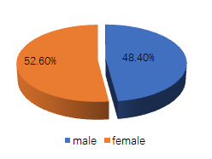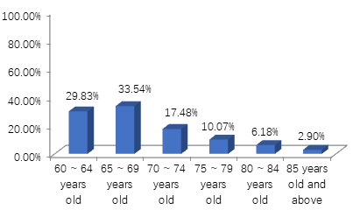
Figure S2. Age composition of the sample
Figure S1. Gender composition of the sample

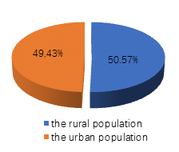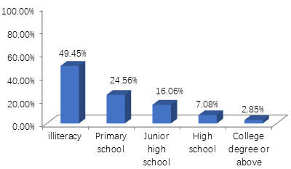
Figure S3. Regional composition of the sample
Figure S4. Education level of the sample

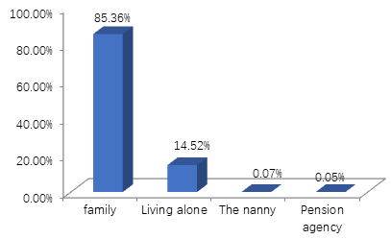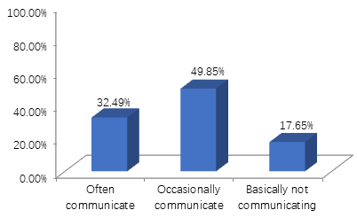
Figure S6. Communication between the participants and their children

Figure S5. Residential situation of the sample

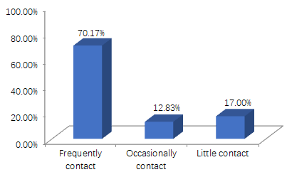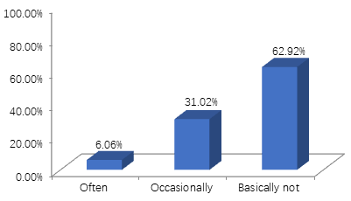
Figure S7. The interaction between the participants
and their neighbours
Figure S8. Participants’ participation in social activities

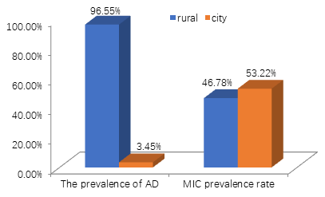
Figure S9. The proportion of patients with AD and MCI in different regions

