Supplementary Figures

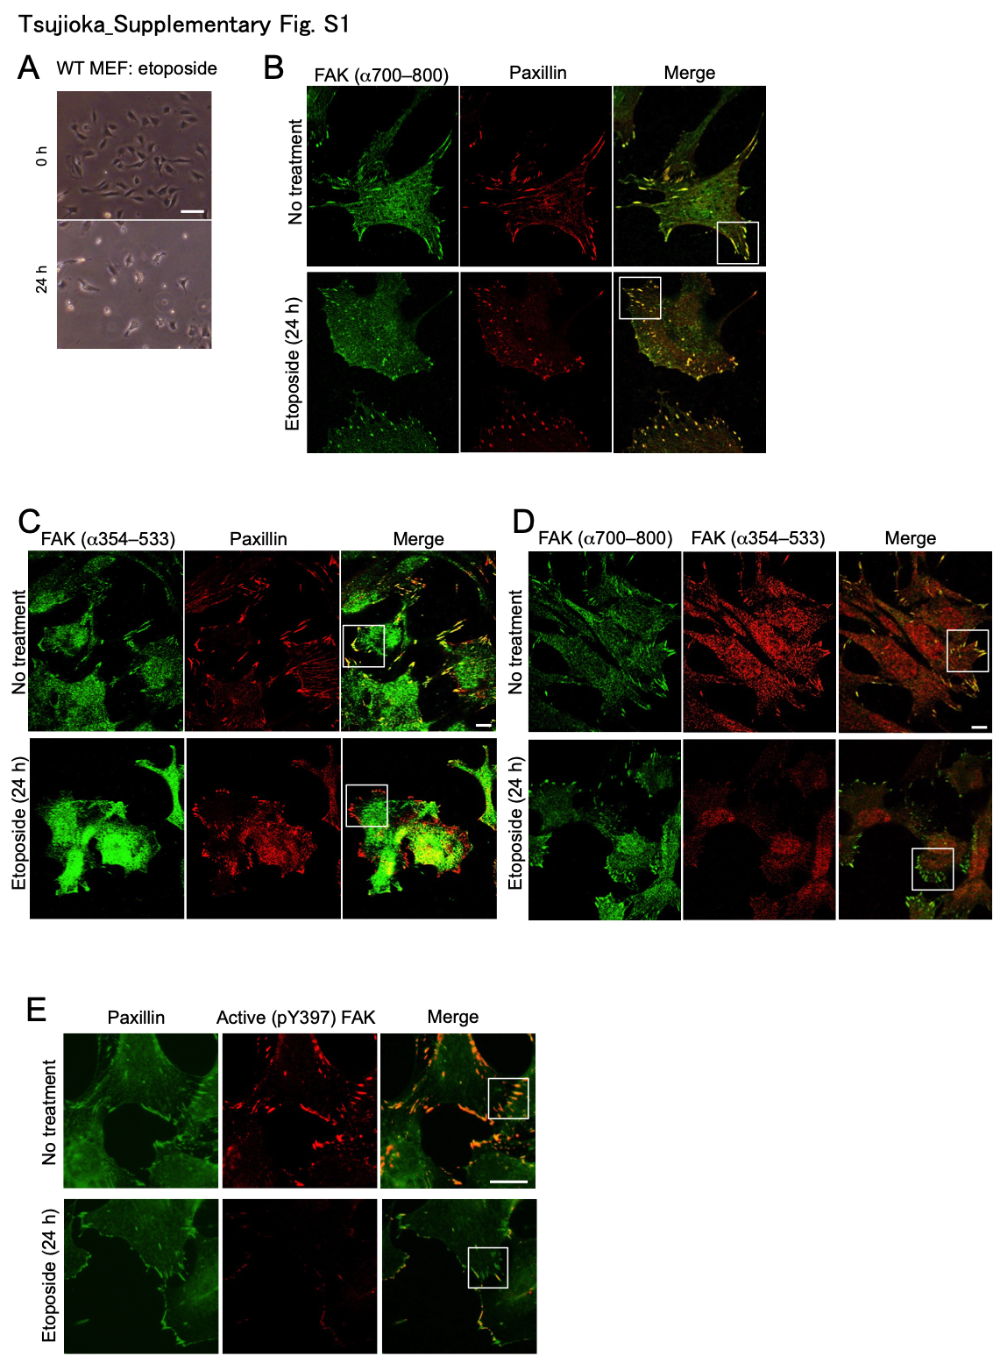

Supplementary Fig. S1. Formation of unusual focal adhesions upon genotoxic stress.
WT MEFs were treated with etoposide (20 µM) for 24 h. A Phase-contrast images showing morphological changes of WT MEFs upon genotoxic stress. Scale bar, 100 µm. B–E Full images of the fluorescence images shown in Fig. 1B–E, which were magnified images of the boxed regions. Scale bars, 20 µm.
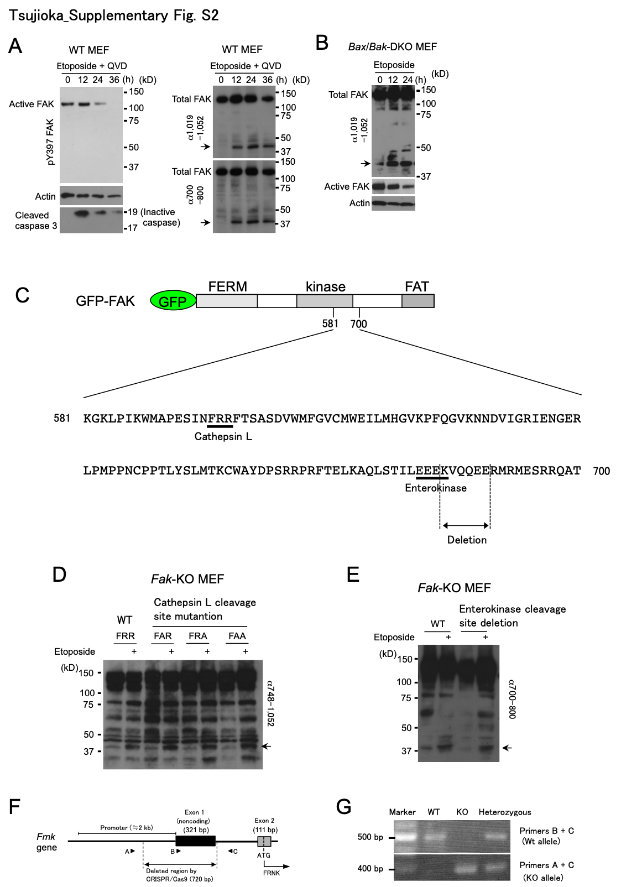

Supplementary Fig. S2. Expression of FRNK in response to genotoxic stress.
A, B Indicated MEFs were treated with etoposide (20 µM). (A) Immunoblot analysis showing that the inhibition of caspases by QVD-OPh (100 µM) does not affect the generation of the 40-kDa band (arrows) after etoposide treatment. Caspase-3 was cleaved but only the inactive (19 kDa) form was generated. (B) Immunoblot analysis showing generation of the FAK-associated 40-kDa band (arrow) in Bax/Bak-DKO MEFs. Actin was used as a loading control. C Schematic diagram showing potential cleavage sequences of cathepsin L and enterokinase (underlined). ‘Deletion’ indicates the deleted region of the FAK mutant used in (E). D The cathepsin L target site is not cleaved in etoposide-treated cells. Fak-KO MEFs were transiently transfected with 3 µg of plasmids encoding FAK, or its three individual mutants in which the cathepsin L target site was disrupted (‘FAR’, ‘FRA’, and ‘FAA’). Cells were then exposed to 20 µM etoposide for 26 h, and the generation of the 40-kDa product was analysed by immunoblotting using the indicated FAK antibody. The arrow indicates the 40-kDa product. E The enterokinase target site was not cleaved in etoposide-treated cells. A similar experiment to (D) was performed by introducing a different Fak mutant gene, in which the enterokinase target site was disrupted. Fak-KO MEFs expressing this Fak mutant still yielded the 40-kDa product, as indicated by the arrow. F A schematic diagram illustrating the genomic region including the promotor region, and exons 1 and 2 of the Frnk gene. The sizes of each exon are indicated in parentheses. The diagram also shows the deleted region of the Frnk gene in Frnk-KO mice. Black arrowheads indicate the locations of the primers used for genotyping. G Genotyping by genomic PCR showing the generation of heterologous and homologous mice for KO of the Frnk gene. As illustrated in (F), a 495-bp DNA fragment is amplified from the WT allele by genomic PCR using primers B and C, whereas a 396-bp fragment is amplified from the mutant allele using primers A and C.

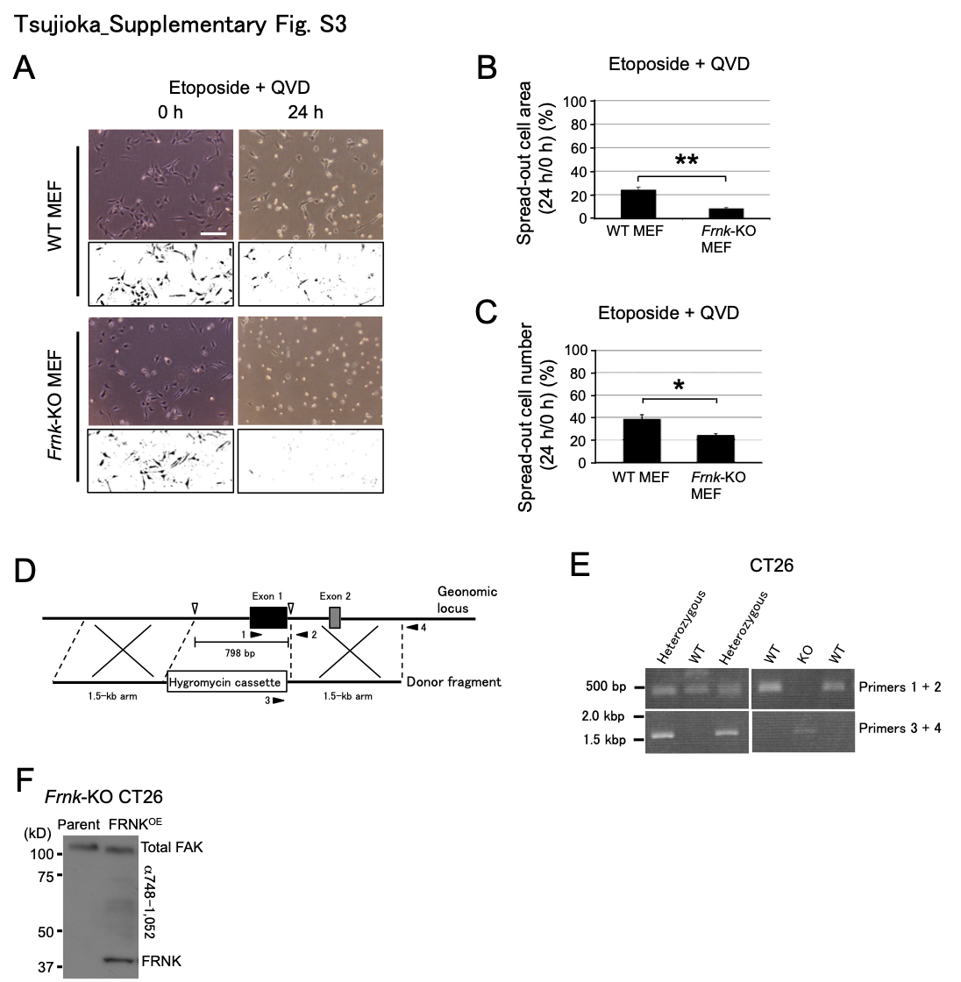
Supplementary Fig. S3. Significance and generality of FAK/FRNK replacement in cells upon genotoxic stress.
A–C Indicated MEFs were treated with etoposide (20 µM) in the presence of QVD-OPh (100 µM). (A) Representative images showing that QVD-OPh does not inhibit the accelerated cell rounding of Frnk-KO MEFs upon etoposide treatment. Phase-contrast images were binarised as in Fig. 3A. Scale bar, 200 µm. (B, C) Graphs showing the ratios of the spread-out cell areas (B) and numbers (C) at 24 h with respect to those at 0 h. All data in the graphs are shown as means ± SD (n = 3). The two-sided Student t-test was used for statistical analysis. *: p < 0.05, **: p < 0.01. D A schematic diagram showing the Frnk gene KO strategy using the CRISPR/Cas9 system in cultured cells. The genomic locus around the target region and the donor fragment for homologous recombination are shown. The black and grey boxes indicate exons 1 and 2 of the Frnk gene, respectively. White arrowheads indicate the sites where double stranded breaks are expected to occur. As illustrated, the donor fragment is comprised of the hygromycin resistance gene cassette and genomic fragment arms, and the hygromycin cassette is expected to replace a 798-bp genomic region. Black arrowheads indicate the locations of the primers used for genotyping. E Genotyping by genomic PCR in CT26 cells. As illustrated in (D), genomic PCR using primers 1 and 2 amplified a 495-bp fragment almost covering exon 1, whereas primers 3 and 4 were used to amplify an approximately 1.5-kbp fragment that is produced only when the desired replacement occurs. WT and KO derivatives only showed the band amplified by primers 1 and 2 and primers 3 and 4, respectively. The heterozygous derivative showed both bands. F Immunoblot analysis showing the re-expression of FRNK in FRNK^{OE}/Frnk-KO CT26 cells.

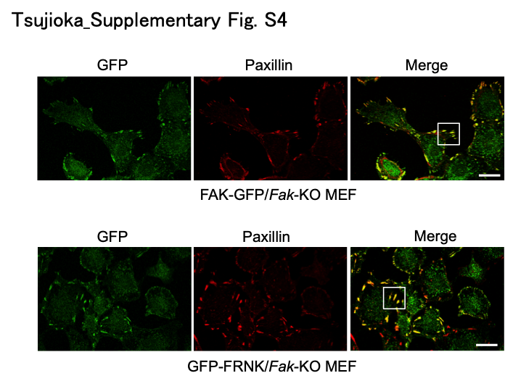

Supplementary Fig. S4. Localization of FAK and FRNK in focal adhesions.
Full images of the fluorescence images shown in Fig. 4A, which were magnified images of the boxed regions. Scale bar, 30 µm

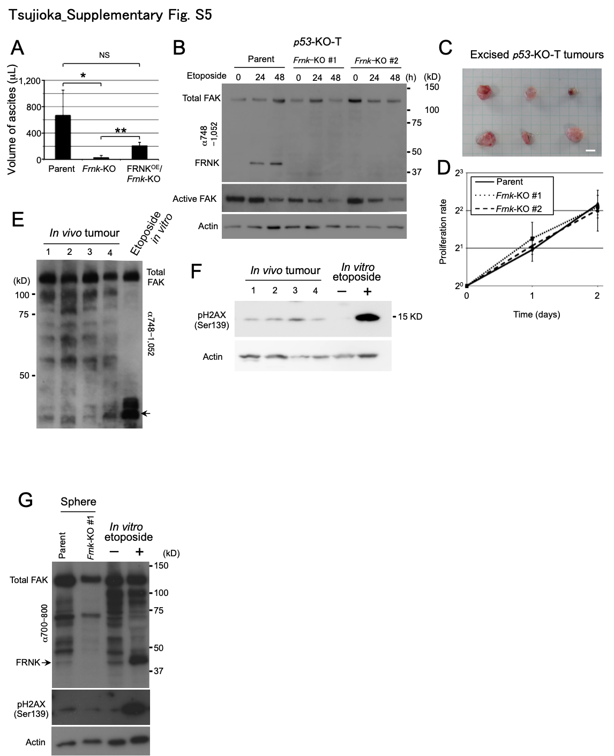

Supplementary Fig. S5. Effects of FRNK in cancer progression.
A A graph showing the volume of bloody ascites taken from the peritoneal cavities of mice in which parental, Frnk-KO, and FRNK^{OE}/Frnk-KO CT26 cells were injected. All data in the graph are shown as means ± SD (n = 3). The two-sided Student t-test was used for statistical analysis. *: p < 0.05, **: p < 0.01, NS: no significance. B Immunoblot analysis showing the expression of FRNK in p53-KO-T but not its Frnk-KO cell lines during etoposide (100 µM) treatment. All the cell lines showed a reduction in the level of active FAK during etoposide treatment. C Macroscopic image of the excised p53-KO-T cell tumours at 16 days after intraperitoneal injection. Scale bar, 5 mm. D A graph showing equivalent proliferation rates among the parental and two Frnk-deficient p53-KO-T cell lines. Statistical analysis demonstrated no significant differences among the cell lines (n = 2). E, F P53-KO-T cells (3 × 10⁵ cells) were intraperitoneally injected, and tumours were excised after 16 days. Immunoblot analysis showing the expression levels of FRNK (arrow), total FAK (E), and pH2AX (F) in in vivo in four tumour masses. Cultured p53-KO-T cells treated with and without etoposide were used as positive and negative controls, respectively. G P53-KO-T cell derivatives (5 × 10⁴ cells) were 3D-cultured for 8 days to generate spheres. Immunoblot analysis showing the expression levels of FRNK (arrow) and pH2AX in in vitro tumour spheres of parental and Frnk-deficient p53-KO-T cells. Cultured p53-KO-T cells treated with and without etoposide were used as positive and negative controls, respectively.

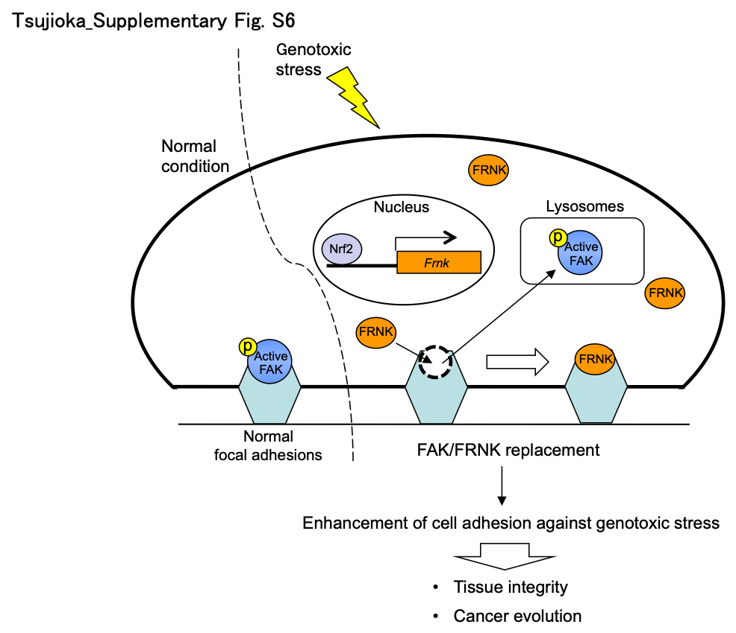

Supplementary Fig. S6. Model showing the responses of focal adhesions to genotoxic stress.
In normal conditions, active FAK acts as a component of focal adhesions. Upon genotoxic stress, however, Nrf2 drives the expression of the Frnk gene, whereas active FAK is reduced via lysosomal degradation. This results in FAK/FRNK replacement in focal adhesions, and this remodelling counteracts genotoxic stress in normal as well as pathological tissues by enhancing cell adhesion.
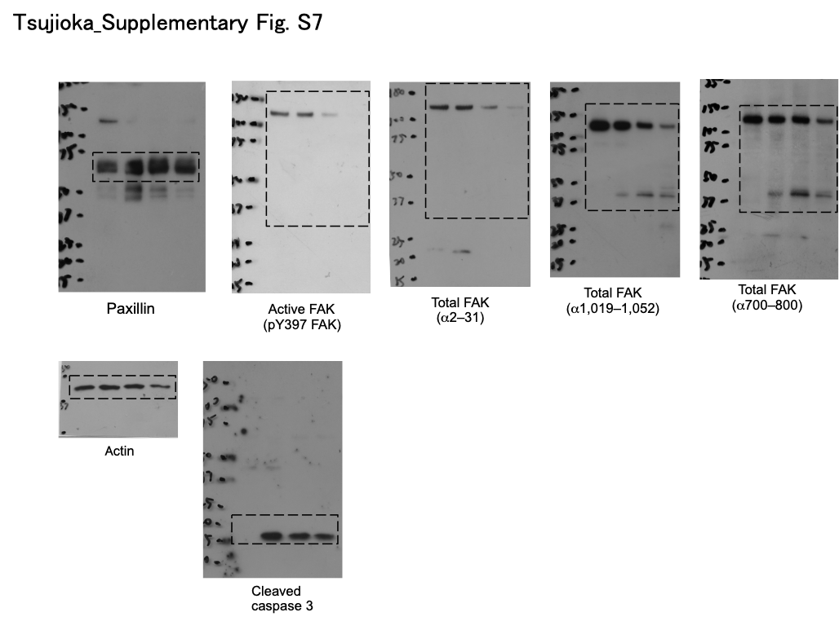

Supplementary Fig. S7. Original immunoblots for Fig. 1F.

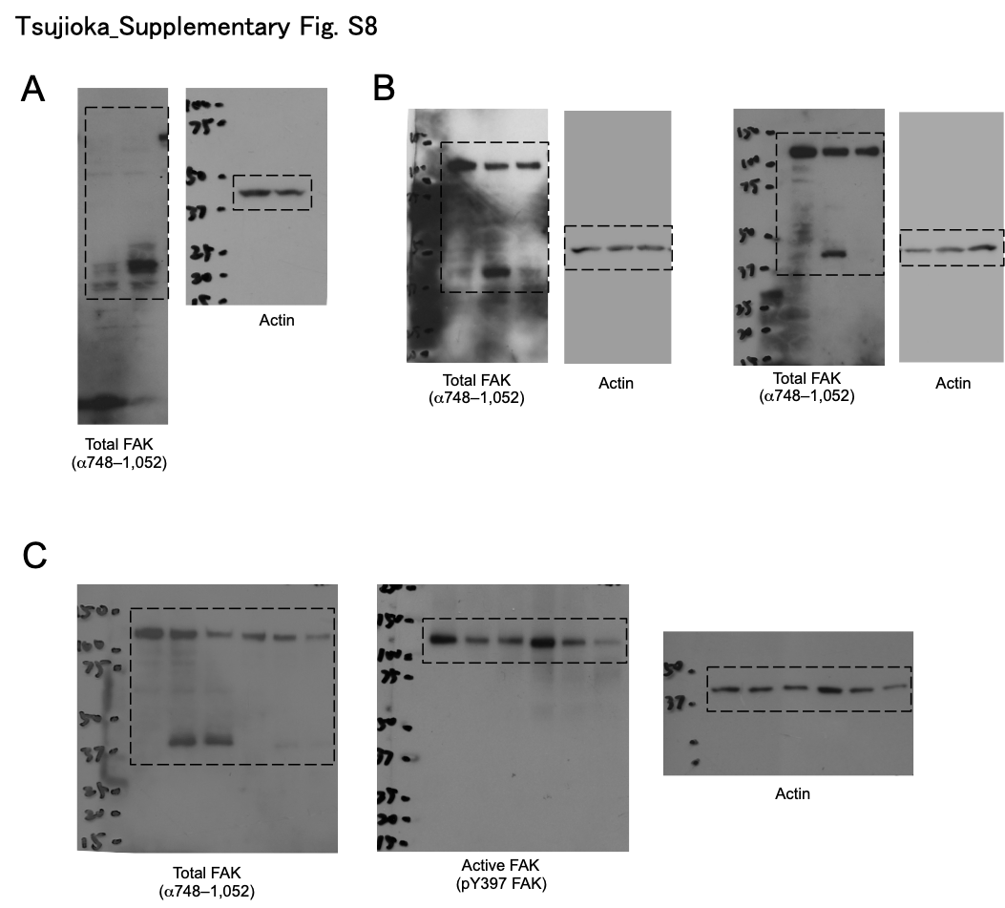

Supplementary Fig. S8. Original immunoblots for Fig. 2.
A is for Fig. 2A. B is for Fig. 2D. C is for Fig. 2G.

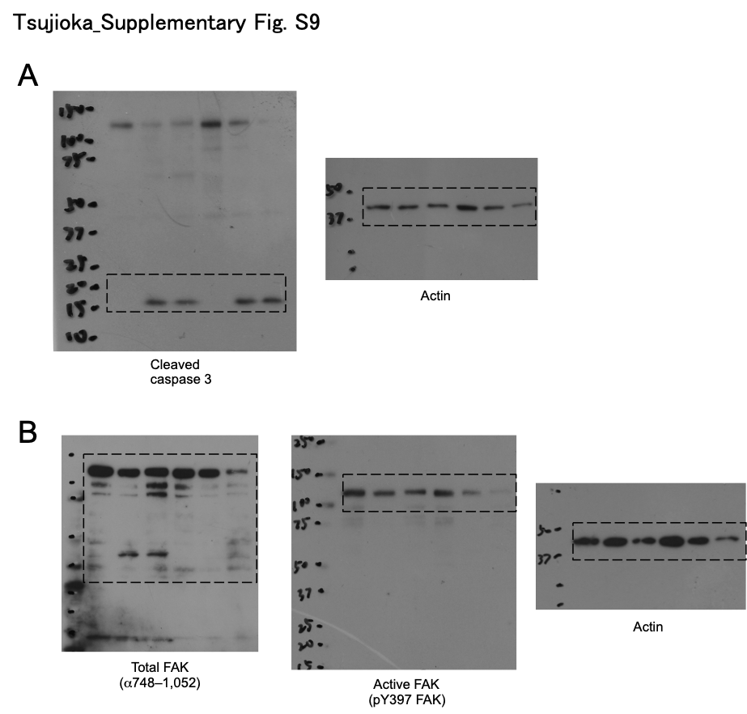

Supplementary Fig. S9. Original immunoblots for Fig. 3.
A is for Fig. 3D. B is for Fig. 3E.

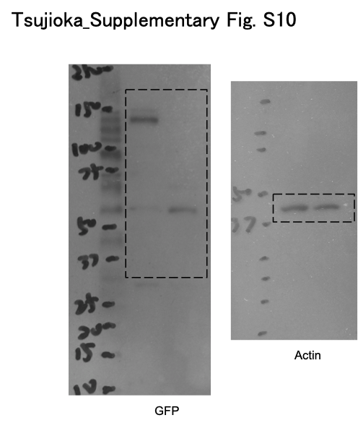

Supplementary Fig. S10. Original immunoblots for Fig. 4B.

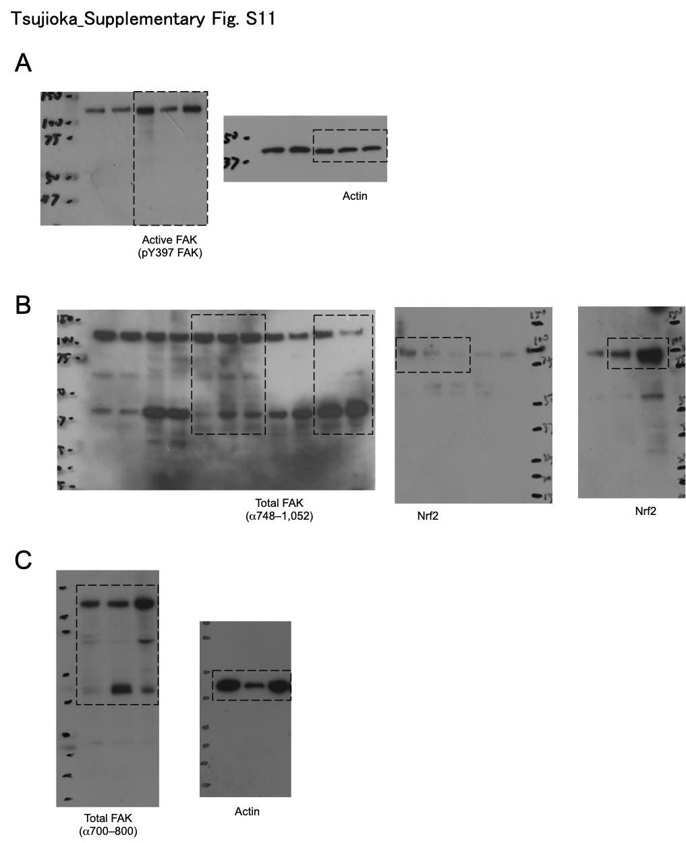

Supplementary Fig. S11. Original immunoblots for Fig. 5.
A is for Fig. 5A. B is for Fig. 5E. C is for Fig. 5F.

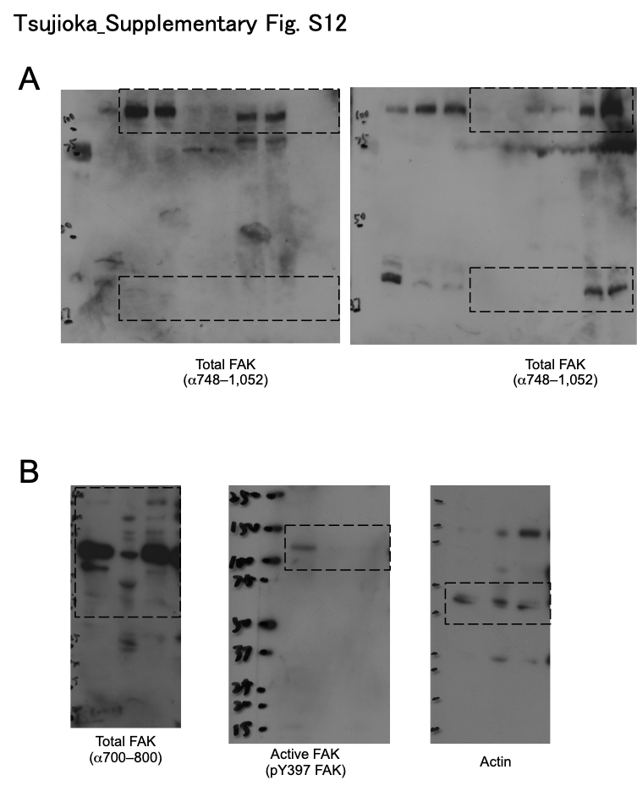

Supplementary Fig. S12. Original immunoblots for Fig. 6.
A is for Fig. 6A. B is for Fig. 6B.

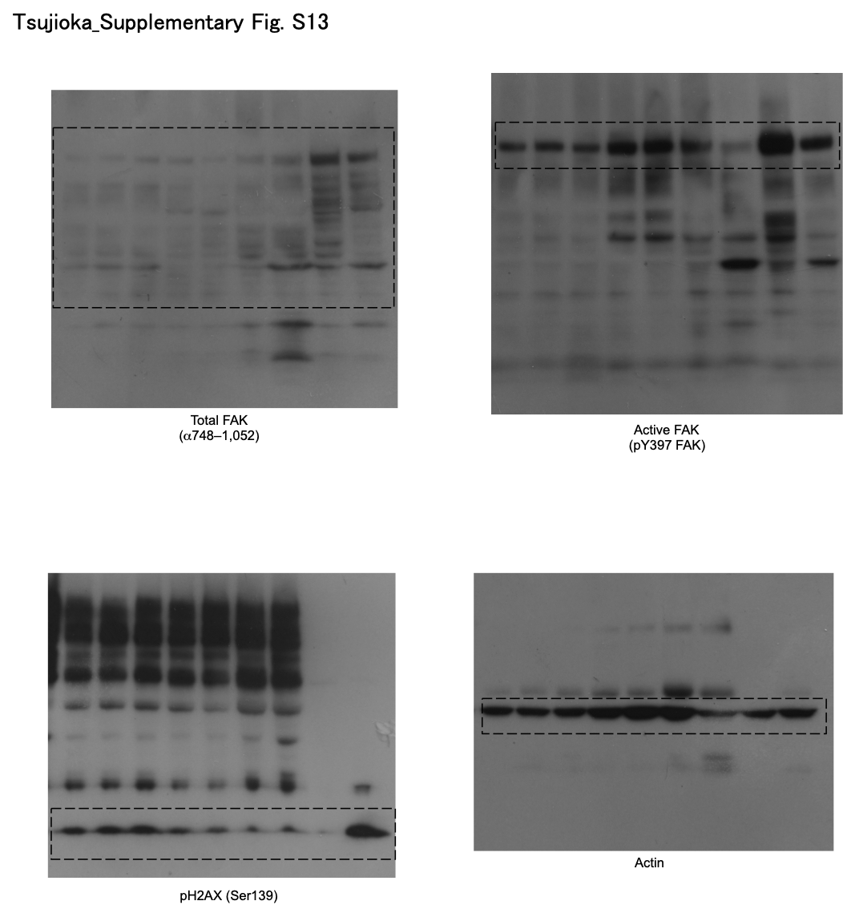

Supplementary Fig. S13. Original immunoblots for Fig. 7A.

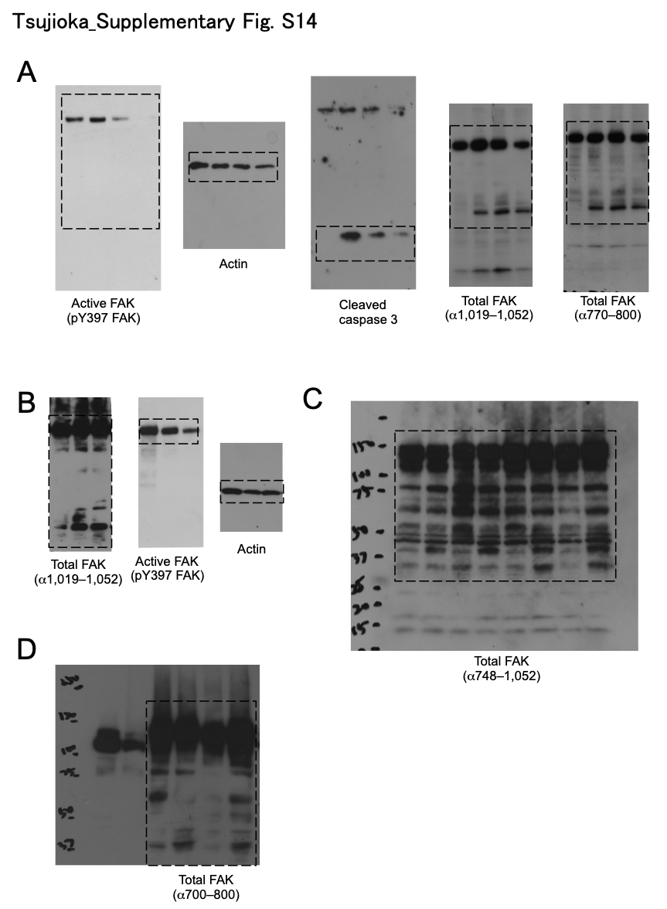

Supplementary Fig. S14. Original immunoblots for Supplementary Fig. S2.
A is for Supplementary Fig. S2A. B is for Supplementary Fig. S2B. C is for Supplementary Fig. S2D. D is for Supplementary Fig. S2E.
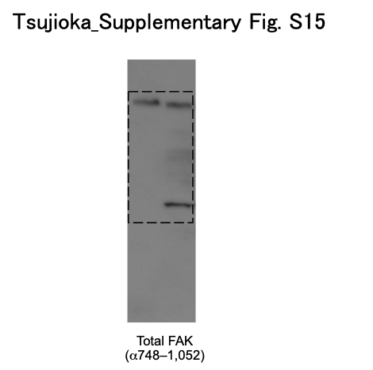

Supplementary Fig. S15. Original immunoblots for Supplementary Fig. S3F.

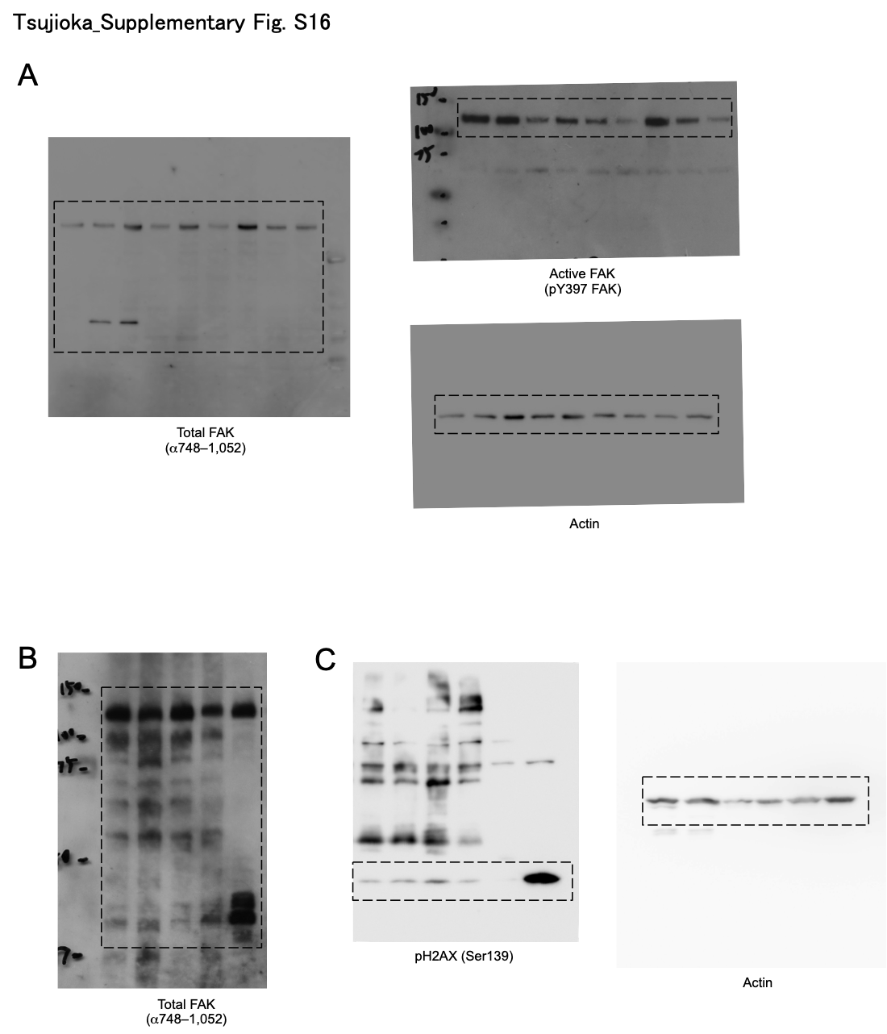

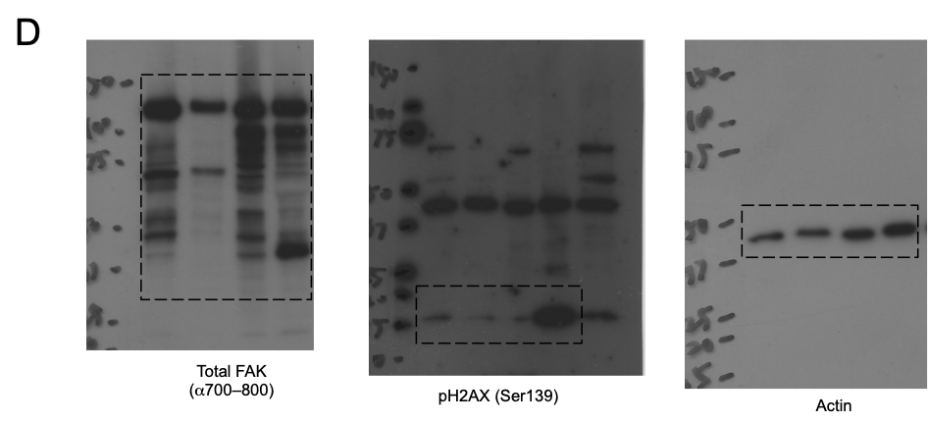

Supplementary Fig. S16. Original immunoblots for Supplementary Fig. S5.
A is for Supplementary Fig. S5B. B is for Supplementary Fig. S5E. C is for Supplementary Fig. S5F. D is for Supplementary Fig. S5G.

Supplementary Table S1. List of antibodies used in this study.

Supplementary Table S2. List of reagents used in this study.

Supplementary Table S3. List of cell lines in which FRNK expression was analysed.
“+” indicates the detection of FRNK after etoposide treatment.

Supplementary Table S4. Table showing information regarding the biopsy samples.
“+” indicates the detection of the FRNK gene expression.

