Title: Potential role of rhizosphere microbiome on root exudations and phosphorus uptake of rice under flooded soil culture
Journal of name: Plant and Soil
Author names: Mana Mukai, Kei Hiruma, Tomohiro Nishigaki, Yuniar Devi Utami, Junnosuke Otaka, Tadashi Yoshihashi, Papa Saliou Sarr, Aung Zaw Oo, Toshiyuki Takai, Yasuhiro Tujimoto
Correspondence:
Yasuhiro Tujimoto
Japan International Research Center for Agricultural Sciences, 1-1 Ohwashi, Tsukuba, Ibaraki 305-8686, Japan
Kei Hiruma
Department of Life Science, Graduate School of Arts and Sciences, The University of Tokyo, 3-8-1 Komaba, Meguro-ku, Tokyo 153-8902 Japan

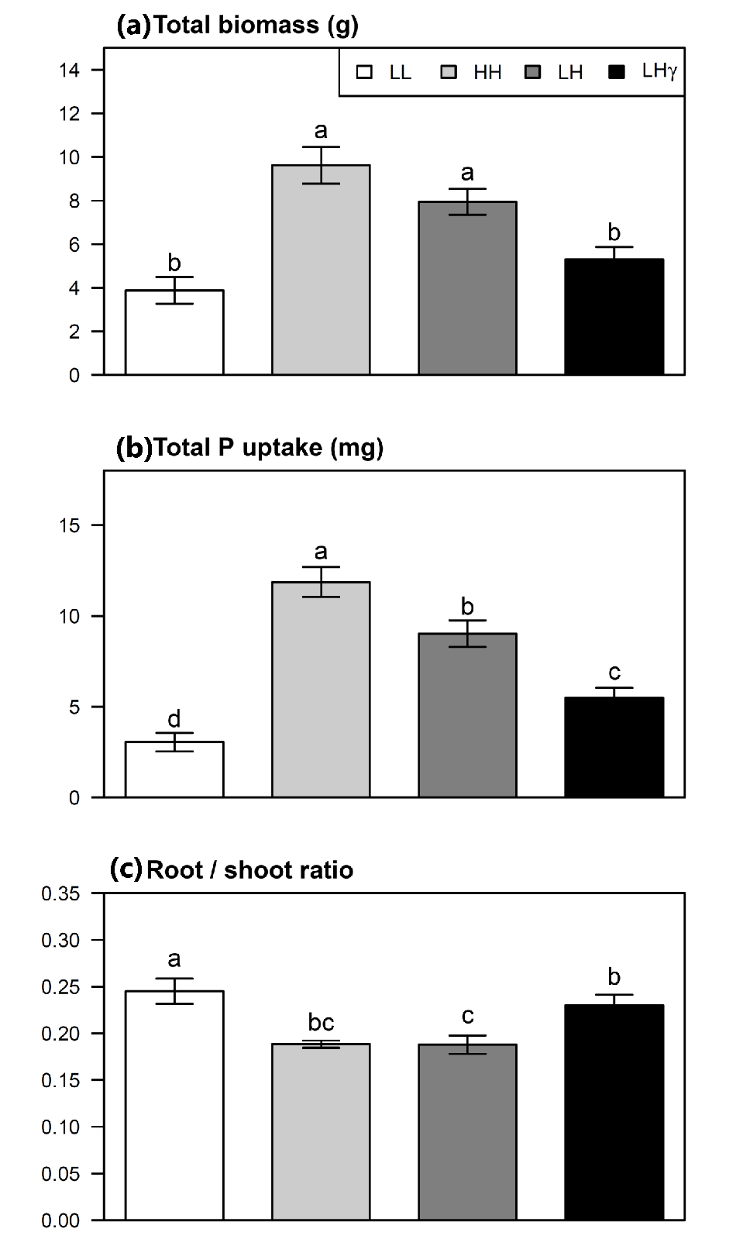
Fig. S1 Total biomass (a), total P uptake (b) and root/shoot ratio (c) at 41 to 42 DAT as affected by P-application and γ-irradiation treatments when two varieties (IR64 and AZ97) were pooled. Different letters indicate significant differences in the means at 5% using Tukey's HSD test. Error bars represent the standard error of replications.

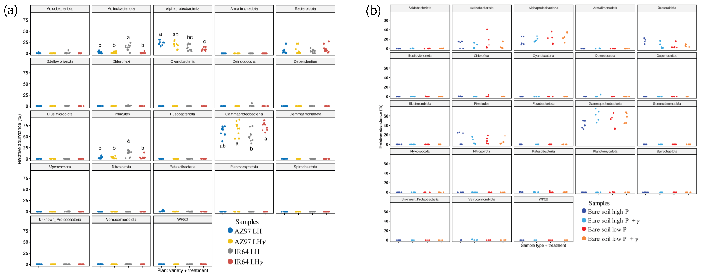 Fig. S2 Microbial relative abundance in the rhizosphere of AZ-97 and IR64 as affected by γ-irradiation (a) and those in the bare soil as affected by γ-irradiation (b). Taxonomic groupings are on the phylum level and the class level for phylum Proteobacteria. Each sample has 10 replicates for the rhizosphere and 5 replicates for the bare soil. Statistical significance with different letters was determined at 5% using Tukey's HSD test.
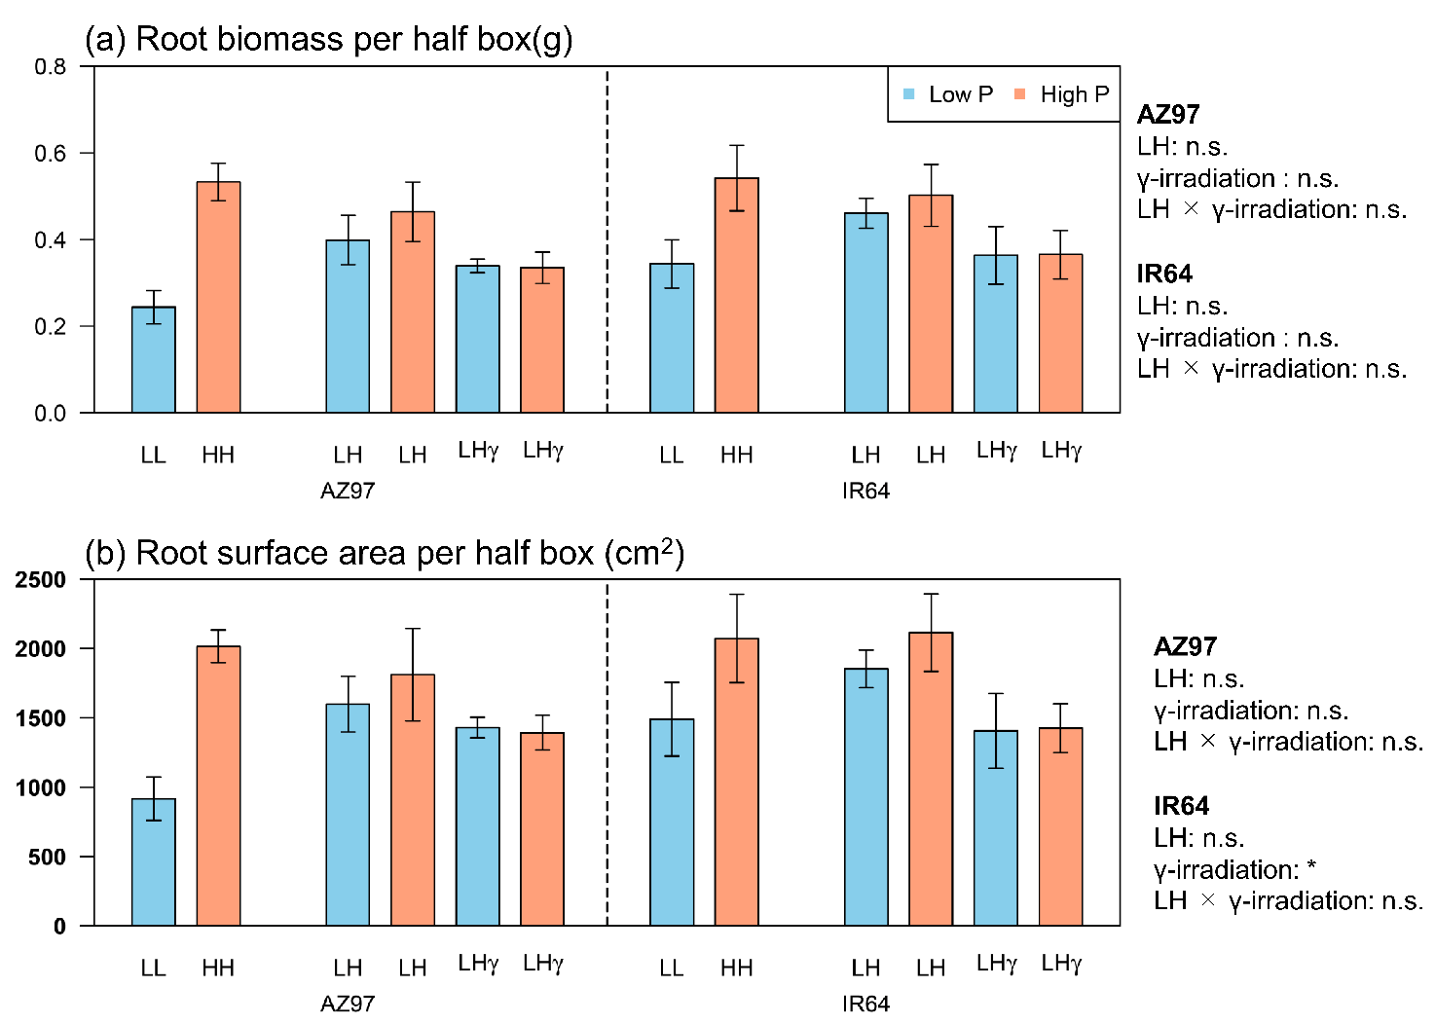 Fig. S3 Root biomass (a) and root surface area (b) per half root box of AZ97 and IR64 at 41 to 42 DAT as affected by P-application and γ-irradiation treatments. Orange and blue bars indicate P-applied (High P) and non-P-applied (Low P) compartments of the root box or the means of two compartments for LL and HH, respectively. Error bars represent the standard error of replications. The letters outside of the box represent the results of three-way ANOVA (Variety × soil P concentration; LH × γ-irradiation treatment; γ-irradiation) for LH and LHγ for each variety. The significant levels were shown: **, P < 0.01; *, P < 0.05; n.s., not significant.
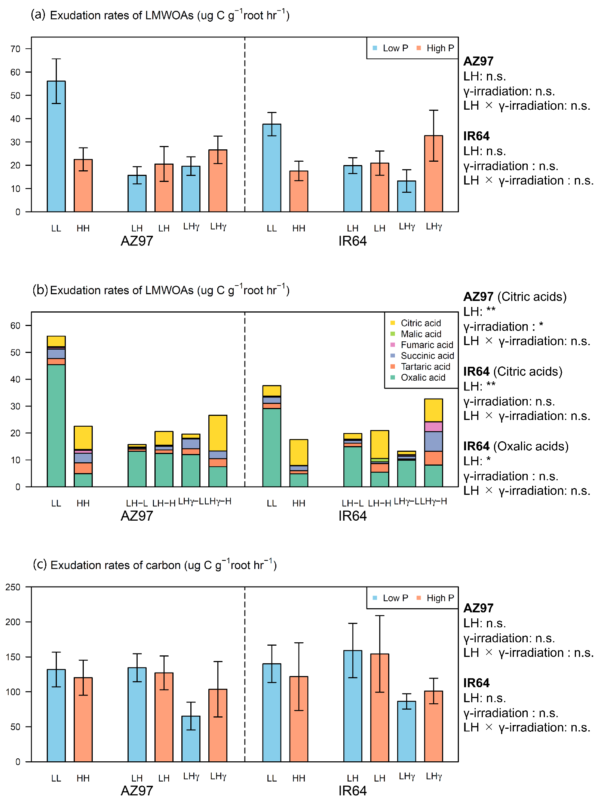
Fig. S4 Root exudation rates of LMWOAs (a) and its classification (b) and the exudation rates of total carbon from roots (c) of AZ97 and IR64 at 41 to 42 DAT as affected by P-application and γ-irradiation treatments. Orange and blue bars in (a) and (c) indicate P-applied (High P) and non-P-applied (Low P) compartments of the root box or the means of two compartments for LL and HH, respectively. Yellow, light green pink, purple, orange, and green bars in (b) indicate the exudation rates of Citric, Malic, Fumaric, Succinic, Tartaric, Oxalic acids, respectively. Error bars represent the standard error of replications. The letters written outside of the box represent the results of three-way ANOVA (Variety × soil P concentration; LH × γ-irradiation treatment; γ-irradiation) for LH and LHγ for each variety. The significant levels were shown: **, P < 0.01; *, P < 0.05; n.s., not significant.

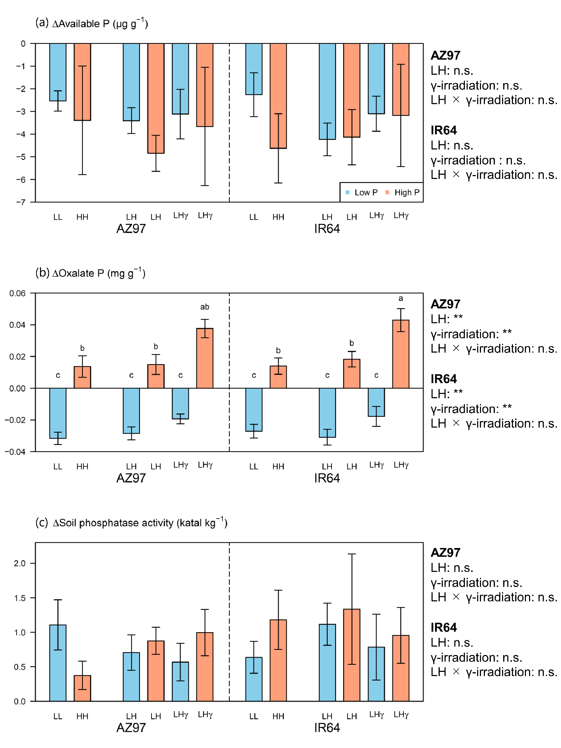
Fig. S5 The rhizosphere effects on soil chemical properties (a, available P; b, oxalate-P; c, phosphatase activity) of AZ97 and IR64 at 41 to 42 DAT as affected by P-application and γ-irradiation treatments. The values were subtraction of the values in bare soils from those of the rhizosphere soils. Orange and blue bars indicate P-applied (High P) and non-P-applied (Low P) compartments of the root box or the means of two compartments for LL and HH, respectively. Error bars represent the standard error of replications. Different letters indicate significant differences at 5% using Tukey's HSD test. The letters written outside of the box represent the results of three-way ANOVA (Variety × soil P concentration; LH × γ-irradiation treatment; γ-irradiation) for LH and LHγ for each variety. The significant levels were shown: **, P<0.01; *, P<0.05; n.s., not significant.

