Mobilization of hematopoietic stem cells with lenograstim in multiple myeloma patients: prospective multicenter observational study (KMM122)
Eun Hee Jung MD, Ja Min Byun MD PhD, Dong-Yeop Shin MD PhD, Young Rok Do MD PhD, Jae-Cheol Jo MD PhD, Sang Min Lee MD PhD, Sung-Soo Yoon MD PhD

Supplementary Materials

Index

Supplementary Table S1 ---------------------------------------------------------------------- Page 2-3
Supplementary Table S2 ------------------------------------------------------------------------ Page 4
Supplementary Table S3 ------------------------------------------------------------------------ Page 5
Supplementary Table S4 ---------------------------------------------------------------------- Page 6-8
Supplementary Figure S1 ----------------------------------------------------------------------- Page 9
Supplementary Figure S2 ---------------------------------------------------------------------- Page 10

Supplementary Table S1. Details of mobilization failure patients
 | 1 | 2 | 3 | 4 | 5 | 6 | 7 | 8
Baseline Characteristics
Age at diagnosis / Sex | 57 / F | 50 / F | 58 / F | 62 / F | 50 / F | 49 / M | 46 / M | 57 / F
International Scoring System stage | 3 | 2 | 2 | 2 | N/A | 2 | 2 | 2
Revised International Scoring System stage | 3 | 2 | 2 | 2 | N/A | 2 | 2 | 2
Heavy chain type | Light chain disease | Light chain disease | Light chain disease | IgG | Light chain disease | IgA | Light chain disease | IgG
Light chain type | Lambda | Lambda | Kappa | Lambda | Kappa | Lambda | Lambda | Lambda
Lytic bone lesion > 3 | No | Yes | No | Yes | No | No | No | No
Presence of plasmacytoma at diagnosis | No | No | No | No | No | No | No | No
Laboratory finding at diagnosis
Hemoglobin (median, range, g/dL) | 11.3 | 6.2 | 11.3 | 9.2 | Unknown | 5.5 | 9.4 | 5.7
WBC (median, range, 10³/μL) | 4.04 | 9.62 | 4.49 | 3.9 | Unknown | 5.7 | 6.88 | 3.83
Platelet (median, range, 10³/μL) | 170 | 186 | 365 | 198 | Unknown | 64 | 188 | 140
Cytogenetic abnormalities | Standard | Standard | Unknown | Standard | High | High | Standard | Standard
Lenalidomide exposure before mobilization | No | No | No | No | Yes | No | No | No
Alkylator exposure before mobilization | No | No | Yes | No | No | No | No | No
Radiotherapy before mobilization | No | No | No | No | No | No | No | No
Lines of therapy before mobilization, median | 1 | 1 | 2 | 1 | 2 | 1 | 1 | 1
Mobilization & Apheresis
BSA at mobilization, m² | 1.41 | 1.39 | 1.65 | 1.75 | 1.22 | 1.88 | 2.04 | 1.54
Body weight at mobilization, kg | 46.80 | 49.45 | 65.65 | 69.40 | 40.25 | 75.90 | 89.20 | 53.70
Time from diagnosis to ASCT, months | 8.79 | 6.00 | 11.11 | 5.50 | 16.00 | 4.96 | before ASCT | 7.18
Time from diagnosis to mobilization, months | 5.89 | 4.57 | 9.89 | 4.57 | 9.46 | 3.61 | 6.21 | 6.57
Time from mobilization to ASCT, days | 81.00 | 40.00 | 34.00 | 26.00 | 183.00 | 38.00 | before ASCT | 17.00
Disease status at mobilization | CR | VGPR | PR | PR | PR | PR | PR | PR
No. of apheresis procedures (median, range) | 4 | 3 | 2 | 3 | 3 | 3 | 3 | 6
Total collected PB CD34+ cells using G-CSF only, x 10⁶/kg (median, range) | 1.86 | 0.72 | 0.9 | 0.59 | 0.49 | 1.99 | 1.61 | 1.65
Additional modes of mobilization | Plerixafor | Plerixafor | Cyclophosphamide | Plerixafor | Plerixafor | Plerixafor | Plerixafor | Plerixafor
Total collected PB CD34+ cells with additional modes of mobilization | 3.51 | 4.15 | 4.43 | 2.16 | 2.18 | 4.69 | 3.31 | 2.64
No. of patients with transfusion during apheresis
RBC | No | No | No | No | Yes | No | Yes | No
PLT | Yes | Yes | No | Yes | Yes | Yes | No | No
ASCT
Conditioning Regimen | Busulfan/Etoposide/  Cyclophosphamide | High-dose  melphalan | High-dose  melphalan | High-dose  melphalan | High-dose  melphalan | Busulfan/Melphalan | before ASCT | High-dose  melphalan
Infused CD34 cell, ×10⁶/kg (median) | 2.717 | 4.15 | 4.43 | 2.16 | 2.069 | 2.32 |  | 2.64
Neutrophil engraftment, days | Yes (9) | Yes (9) | Yes (9) | Yes (13) | Yes (11) | Yes (11) |  | Yes (12)
Platelet recovery | Yes (11) | Yes (8) | Yes (8) | Yes (11) | Yes (12) | Yes (6) |  | Yes (20)
Post ASCT response | CR | CR | CR | CR | CR | CR |  | CR
Relapse after ASCT | No | No | No | No | Yes | Yes |  | No
Median relapse free survival |  |  |  |  | 5.68 | 17.00
Median overall survival (from ASCT) | 43.93 | 42.36 | 28.79 | 32.36 | 14 | 17 |  | 51.21
F, female; M, male; WBC, white blood cell; ASCT, autologous stem cell transplantation; BSA, body surface area; G-CSF, granulocyte colony stimulating factor; RBC; red blood cell; PLT, platelet

Supplementary Table S2. Hematologic recovery within 12 months after autologous stem cell transplantation
 | 3 months | 6 months | 9 months | 12 months
WBC (median, range, 10³/μL) | 4.60 (1.79-38.31) | 4.86 (2.09-28.47) | 5.00 (1.03-29.55) | 5.10 (1.83-34.37)
ANC (median, range, 10³/μL) | 2.01 (0.35-7.90) | 2.29 (0.37-7.42) | 2.27 (0.40-7.77) | 2.46 (0.45-13.08)
Hb (median, range, g/dL) | 11.6 (7.0-14.9) | 12.1 (8.2-15.1) | 12.4 (8.7-15.5) | 12.6 (8.7-15.8)
PLT (median, range, 10³/μL) | 147 (14-269) | 168 (35-320) | 162 (13-564) | 168 (21-278)
WBC, white blood cell; ANC, absolute neutrophil count; Hb, hemoglobin; PLT, platelet

Supplementary Table S3. Multiple linear regression model of variables affecting collected PB CD34+ cells with G-CSF only
 |  | Coefficient | Standard Error | t | P-value
BSA at mobilization |  | 3.336 | 1.603 | 2.080 | 0.040
PLT TF during PBSCM |  | -1.472 | 0.593 | -2.483 | 0.015
PB, peripheral blood; G-CSF, granulocyte colony stimulating factor; BSA, body surface area; PLT, platelet; TF, transfusion; PBSCM, peripheral blood stem cell mobilization

Supplementary Table S4. Details of patients according to age at ASCT
 | Age ≤ 60 (N = 67) | Age > 60 (N = 27) | p-value
Baseline characteristics
Age at diagnosis (median, years) | 53.5 (33-59) | 62.0 (58-69) | <0.001
Male of patients, n (%) | 31 (46.3%) | 12 (44.4%) | 0.873
International Scoring System stage |  |  | 0.898
1 / 2 / 3 / Unknown | 23 (34.3%) / 26 (38.8%) / 11 (16.4%) / 7 (10.4%) | 9 (33.3%) / 11 (40.7%) / 6 (22.2%) / 1 (3.7%)
Revised International Scoring System stage |  |  | 0.881
1 / 2 / 3 / Unknown | 12 (17.9%) / 33 (49.3%) / 8 (11.9%) / 14 (20.9%) | 3 (11.1%) / 16 (59.3%) / 3 (11.5%) / 5 (18.5%)
Heavy chain type, n (%) |  |  | 0.679
IgG/A/D | 33 (49.3%) / 13 (19.4%) / 2 (3.0%) | 15 (55.6%) / 6 (22.2%) / 0 (0.0%)
Light chain disease | 17 (25.4%) | 5 (18.5%)
Unknown | 2 (3.0%) | 1 (3.7%)
Light chain type, n (%) |  |  | 0.201
Kappa / Lambda / Unknown | 36 (53.7%) / 29 (43.3%) / 2 (3.0%) | 19 (70.4%) / 8 (29.6%) / 0 (0.0%)
Lytic bone lesion > 3 | 17 (25.4%) | 7 (25.9%) | 0.896
Presence of plasmacytoma | 11 (16.4%) | 2 (7.4%) | 0.194
Laboratory finding at diagnosis, median, range
Hb (g/dL) | 9.8 (3.4-15.2) | 9.5 (6.9-16.3) | 0.974
WBC (10³/μL) | 5.41 (2.62-23.10) | 5.24 (2.69-12.20) | 0.630
PLT (10³/μL) | 217 (58-532) | 205 (84-358) | 0.329
Serum β2-microglobulin (mg/dL) | 2.76 (1.55-16.73) | 3.49 (1.85-19.47) | 0.069
BM plasma cell count (%) | 24.3 (0.2-85.8) | 31.8 (1.5-73.9) | 0.880
Cytogenetic abnormalities | N = 53 | N = 21 | 0.881
High risk / Standard risk | 20 (37.7%) / 33 (62.3%) | 9 (42.9%) / 12 (87.1%)
Exposure before mobilization, N (%)
Thalidomide | 62 (92.5%) | 21 (77.8%) | 0.045
Lenalidomide | 3 (4.5%) | 3 (11.1%) | 0.236
Previous lines of treatment before ASCT |  |  | 0.183
1 / 2 / ≥ 3 | 58 (86.6%) / 7 (10.4%) / 2 (3.0%) | 21 (77.8%) / 4 (14.8%) / 2 (7.4%)
Previous radiation therapy before ASCT | 5 (7.5%) | 1 (3.7%) | 0.502
Time from diagnosis to mobilization, months (median, range) | 5.11 (2.5-36.82) | 4.81 (2.93-31.36) | 0.515
Mobilization
D-4
WBC (median, range, 10³/μL) | 5.74 (2.33-46.40) | 6.50 (3.72-61.00) | 0.235
Hb (median, range, g/dL) | 12.3 (7.3-14.9) | 11.4 (9.2-15.1) | 0.209
PLT (median, range, 10³/μL) | 268 (93-473) | 258 (126-357) | 0.107
D-3
WBC (median, range, 10³/μL) | 18.15 (3.97-44.43) | 20.05 (6.90-41.70) | 0.323
Hb (median, range, g/dL) | 12.2 (8.6-14.8) | 11.8 (8.6-15.8) | 0.912
PLT (median, range, 10³/μL) | 234 (67-445) | 233 (160-290) | 0.808
D-2
WBC (median, range, 10³/μL) | 24.78 (4.09-49.47) | 26.12 (17.17-74.95) | 0.215
Hb (median, range, g/dL) | 12.3 (8.8-14.6) | 11.7 (9.1-14.6) | 0.310
PLT (median, range, 10³/μL) | 229 (79-385) | 231 (92-302) | 0.643
D-1
WBC (median, range, 10³/μL) | 30.91 (3.92-75.71) | 31.83 (11.19-74.71) | 0.680
Hb (median, range, g/dL) | 12.2 (8.6-14.2) | 11.7 (8.3-15.3) | 0.442
PLT (median, range, 10³/μL) | 202 (59-370) | 229 (75-277) | 0.753
Apheresis
Median no. of apheresis procedures | 3 (1-6) | 3 (2-5) | 0.217
Median of total collected PB CD34+ cells using G-CSF only (x 10⁶/kg) | 5.58 (0.49-13.13) | 5.18 (0.59-13.47) | 0.247
No. of patients collected PB CD34+ cells ≥ 2 x 10⁶/kg | 62 (92.5%) | 26 (96.3%) | 0.383
No. of patients collected PB CD34+ cell ≥ 5 x 10⁶/kg | 42 (62.7%) | 15 (55.6%) | 0.524
Median no. of apheresis required for minimal collection | 1 (1-5) | 2 (1-5) | 0.383
Median no. of apheresis required for optimal collection | 2 (1-5) | 3 (2-5) | 0.524
No. of patients with transfusion during apheresis
RBC | 3 (4.5%) | 1 (3.7%) | 0.867
PLT | 36 (53.7%) | 14 (51.9%) | 0.869
Use of other drugs for mobilization, n (%) |  |  | 0.720
Cyclophosphamide | 1 (1.5%) | 0 (0.0%)
plerixafor | 6 (9.0%) | 1 (3.7%)
PBSC product ; CD34+ cell /kg (x 10⁶/kg)
D1 | N = 67 | N = 27
D1 | 2.08 (0.11-9.9) | 1.87 (0.00-4.31) | 0.018
D2 | N = 61 | N = 27
D2 | 1.81 (0.08-6.55) | 1.67 (0.04-13.41) | 0.832
D3 | N = 43 | N = 21
D3 | 0.96 (023-4.54) | 0.74 (0.10-3.70) | 0.529
D4 | N = 19 | N = 10
D4 | 0.47 (0.16-1.2) | 0.71 (0.18-4.0) | 0.073
D5 | N = 8 | N = 4
D5 | 0.55 (0.20-0.75) | 0.72 (0.53-1.04) | 0.062
ASCT
Time from diagnosis to ASCT, months (median, range) | 6.32 (3.57-38.21) | 6.02 (3.64-32.43) | 0.381
Time from mobilization to ASCT, days (median, range) | 35.00 (12.0-183.0) | 30.00 (11.0-88.0) | 0.211
Infused CD34 cell, ×10⁶/kg (median) | 3.38 (1.80-9.90) | 3.54 (2.00-11.00) | 0.938
Neutrophil engraftment | 67 (100.0%) | 26 (96.3%) | 0.115
Time to neutrophil engraftment, days (median, range) | 10 (1-21) | 10 (3-13)
Platelet engraftment | 64 (95.5%) | 25 (92.6%) | 0.348
Time to platelet recovery, days (median, range) | 10 (1-32) | 10 (8-37)
Relapse after ASCT | 23 (34.3%) | 13 (48.1%) | 0.208
Median relapse free survival | 18.91 (4.25-72.35) | 12.75 (6.57-52.67) | 0.220
Median overall survival (from ASCT) | 30.04 (1.25-107.18) | 33.11 (0.50-85.07) | 0.514
Hb, hemoglobin; WBC, white blood cell; PLT, platelet; BM, bone marrow; ASCT, autologous stem cell transplantation; PB; peripheral blood; G-CSF, granulocyte colony stimulating factor

Supplementary Figure S1. Study design
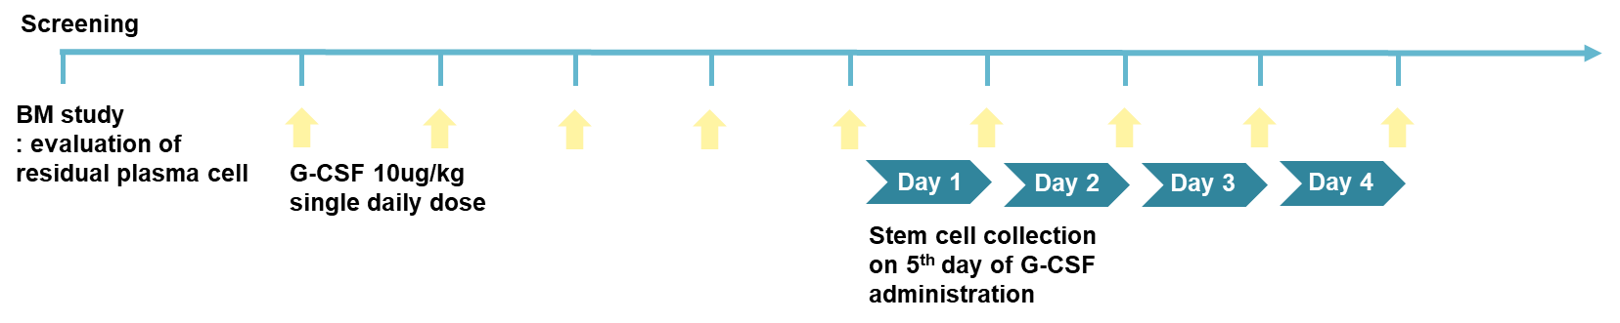
BM, bone marrow; G-CSF, granulocyte colony stimulating factor

Supplementary Figure S2. Consort diagram
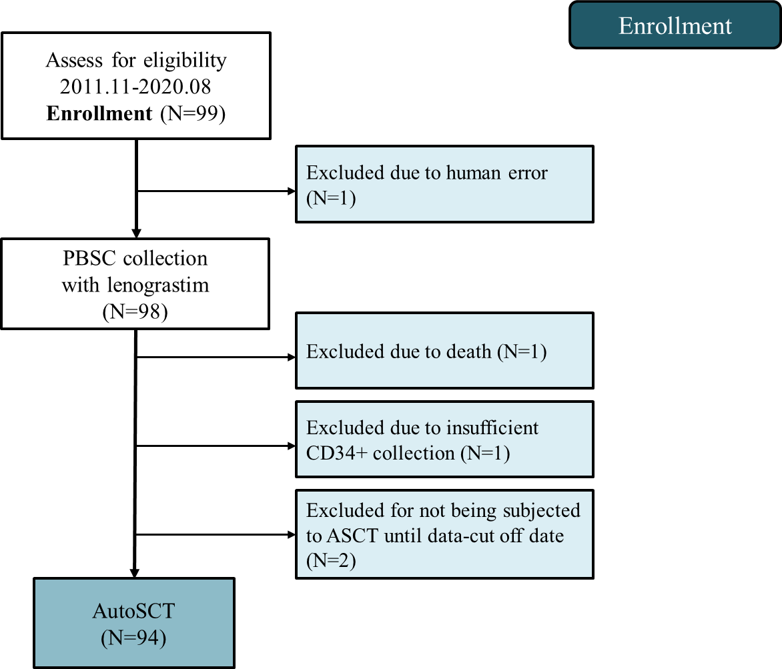
PBSC, peripheral blood stem cells; ASCT, autologous stem cell transplantation

