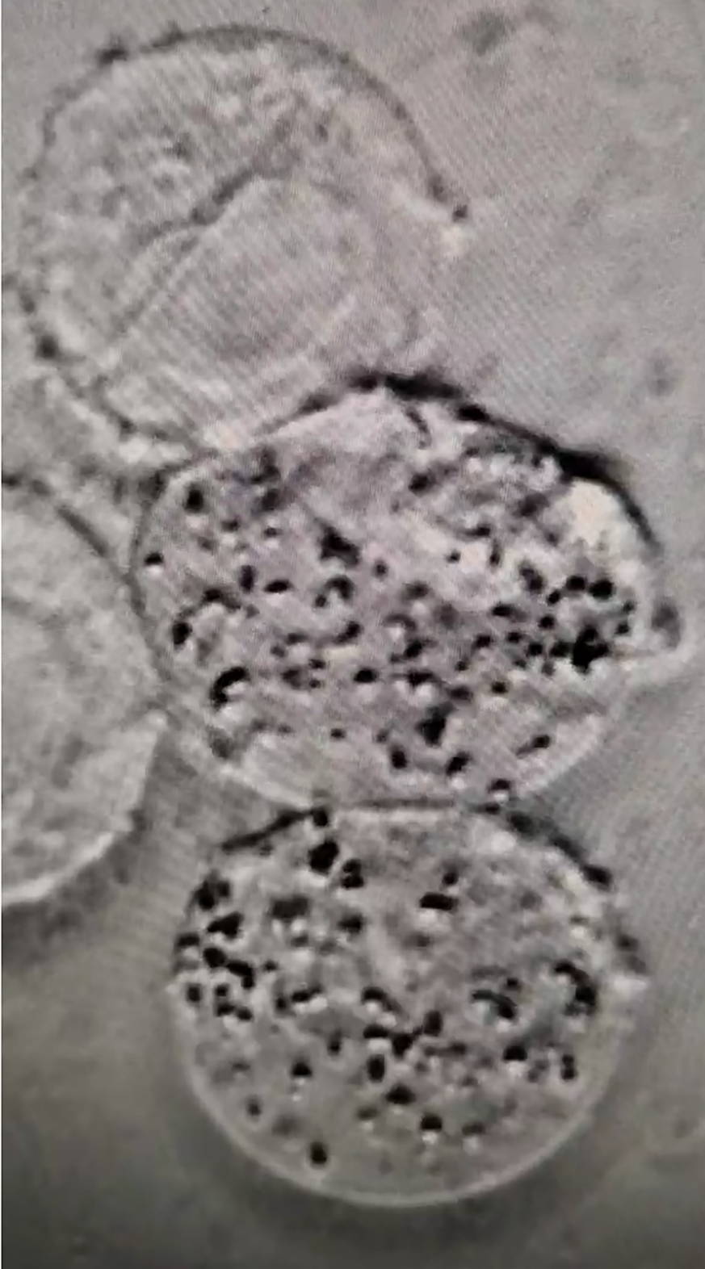
4
3
5
2
1

The legends of supplementary files

1. The E.coli-BSA in the cytoplasm does not fully enter the nucleus.
2. A well-defined tumor nucleus
3. Partial entry of E.coli-BSA into tumor cells
4. Tumor cells with nuclear fragmentation caused by E.coli-BSA
5. Surviving E.coli-BSA

