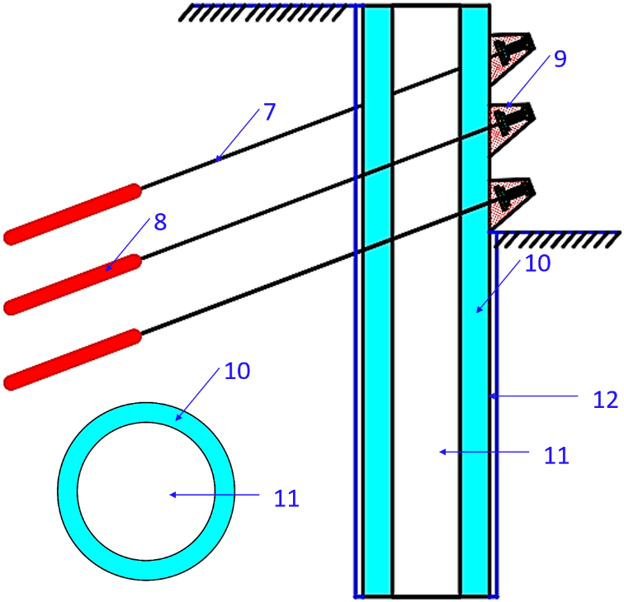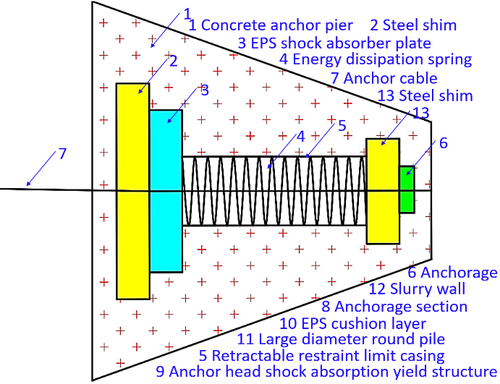
Fig. 1. New type of multi-anchor cable round pile.
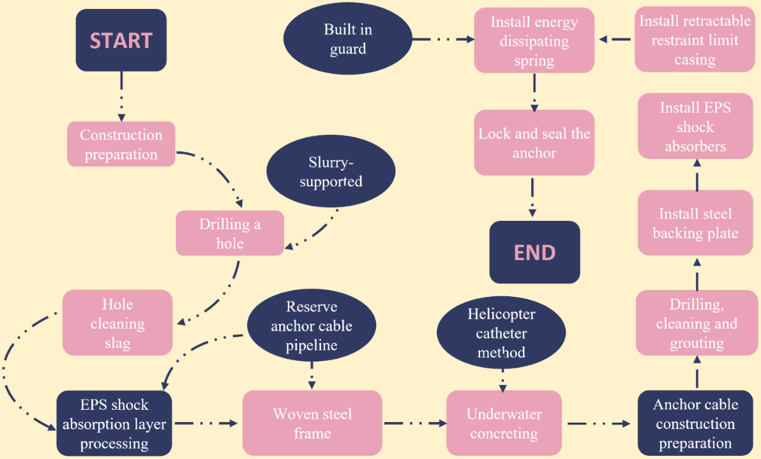
Fig. 2. Construction process flow chart of new type of multi-anchor cable round pile.
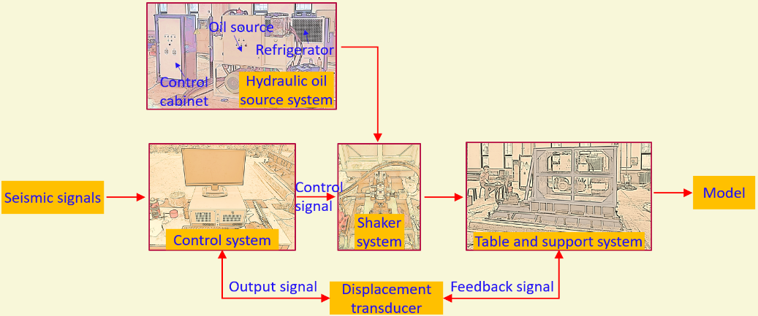
Fig. 3. Composition of electro-hydraulic servo seismic simulator system.
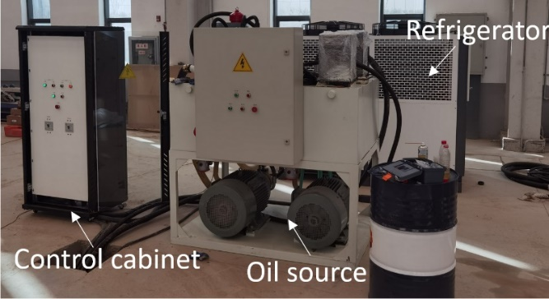
Fig. 4. Servo actuation control system.
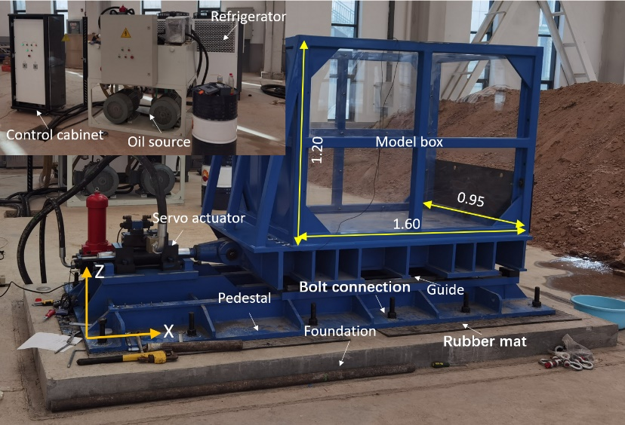
Fig. 5. Photos of shaking table test equipment (unit: cm).
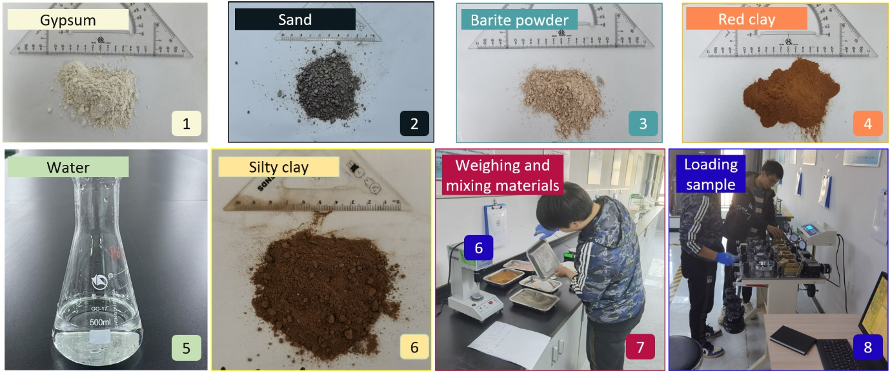
Fig. 6. Model similar material and sample test.
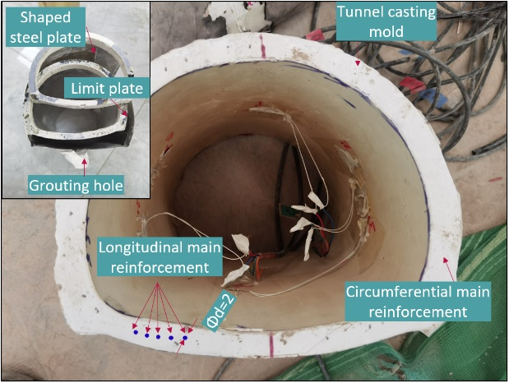
Fig. 7. Tunnel lining models and molds.
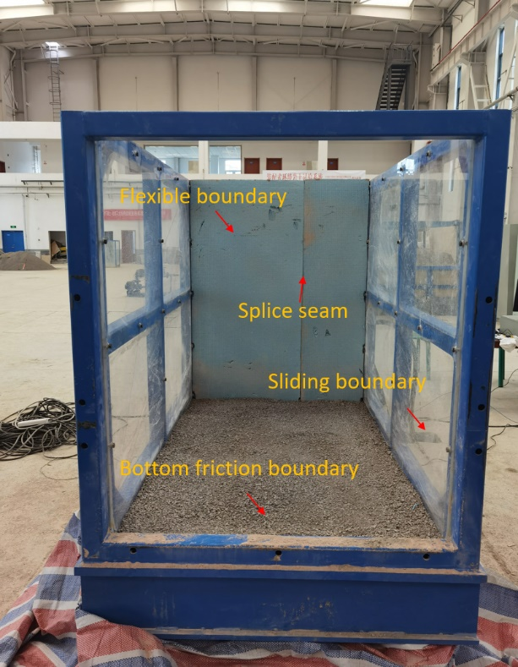
Fig. 8. Shake table model boundary processing.
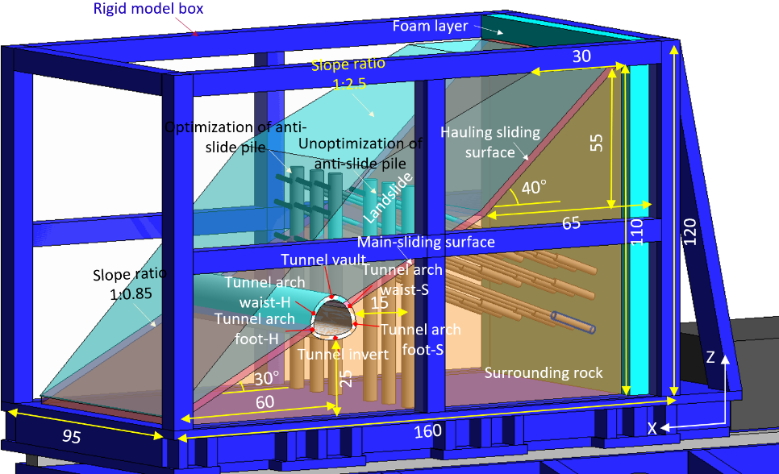
(a)
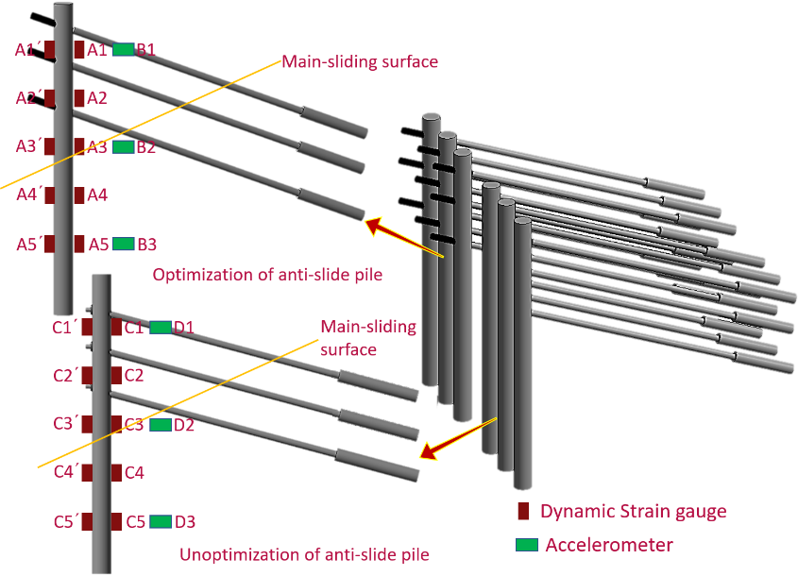
(b)
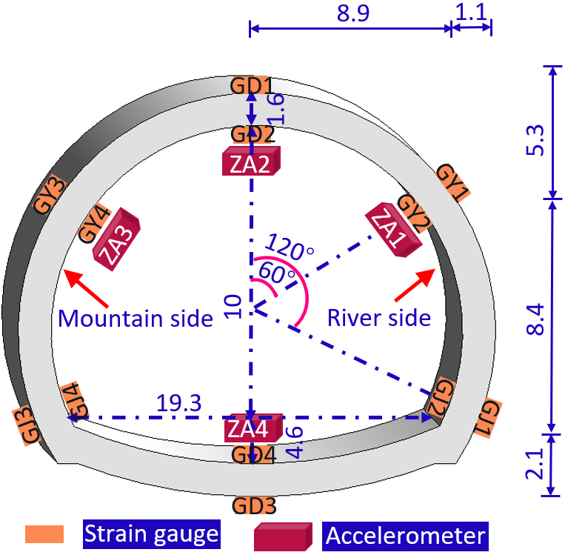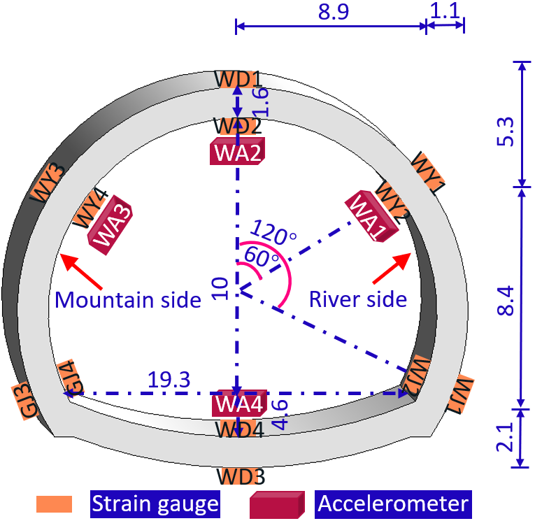
(c) (d)
Fig. 9. Shaking table test model design drawing. (a) Three-dimensional diagram of seismic optimization design for tunnel crossing the main sliding surface model. (b) Three-dimensional sensor layout of multi-anchor round piles model. Accelerometers B1 and D1 are located in landslide, B2 and D2 are located at main-sliding surface, B3 and D3 are located in bedrock. (c) Design drawing of tunnel lining section reinforced by optimized multi-anchor round piles. (c) Design drawing of tunnel lining section reinforced by unoptimized multi-anchor round piles.
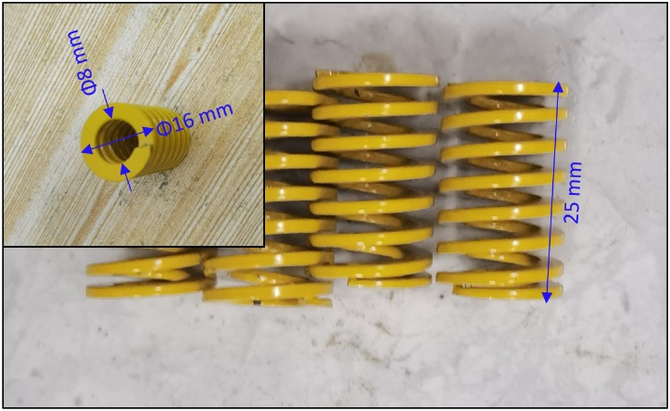
Fig. 10. Shock absorption spring mold.
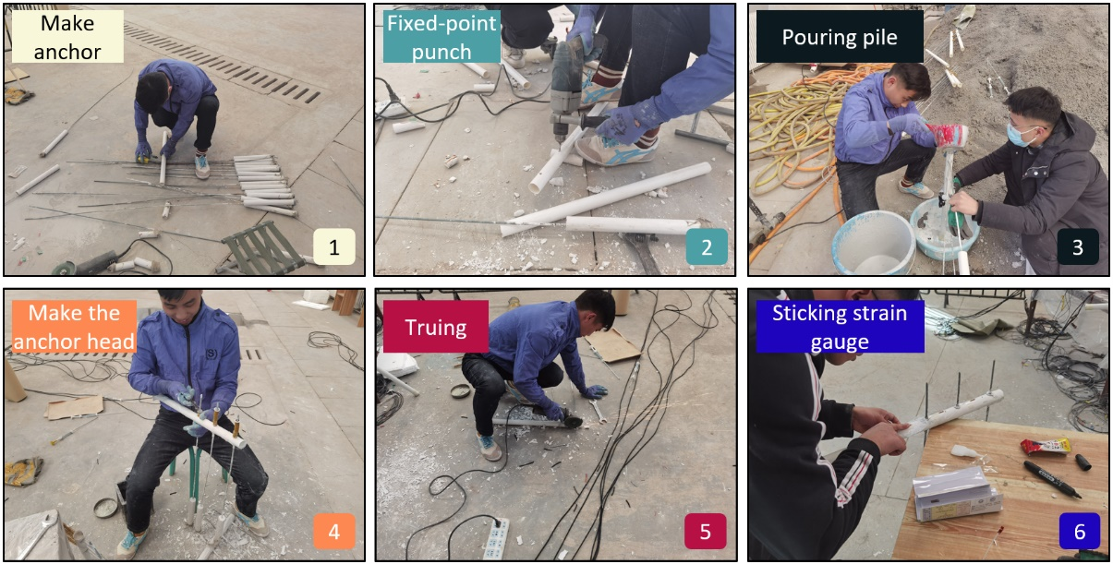
Fig. 11. Multi-anchor round piles model processing.
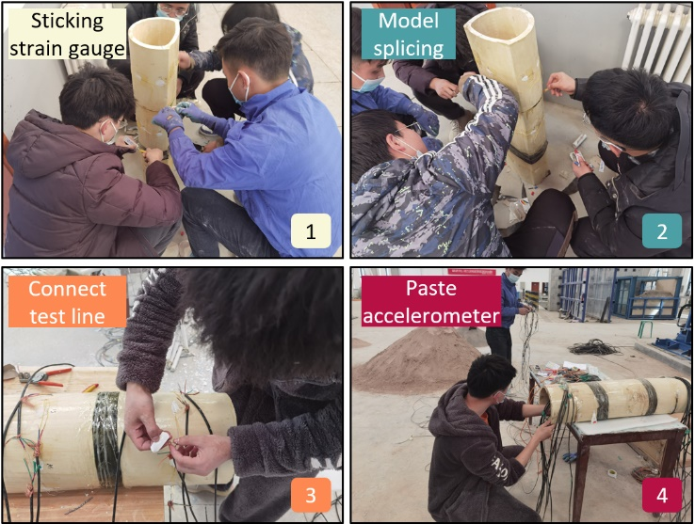
Fig. 12. Tunnel model processing.
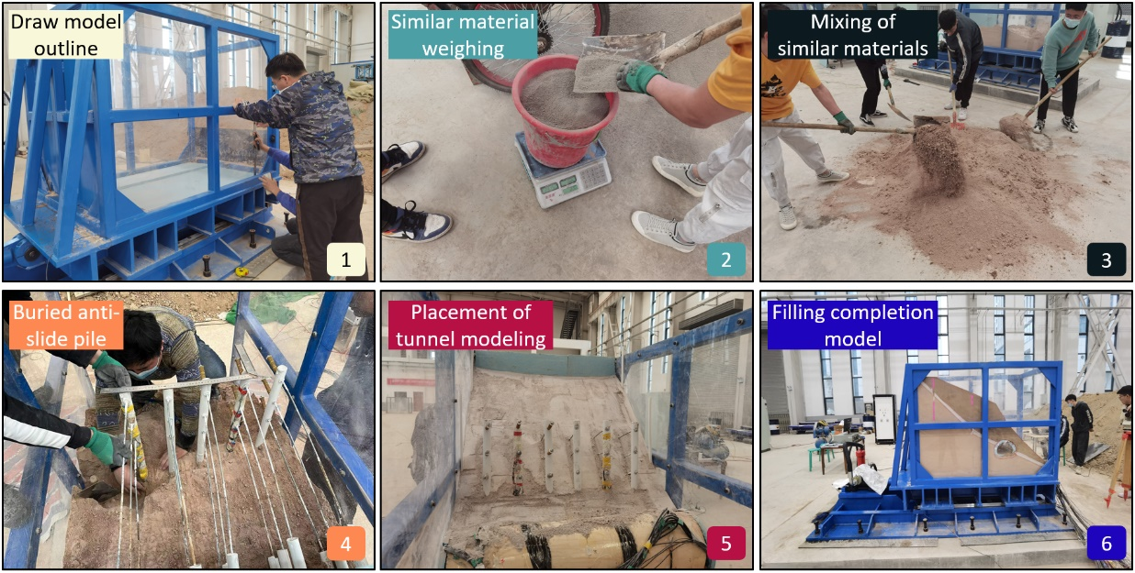
Fig. 13. Shaking table model filling process.
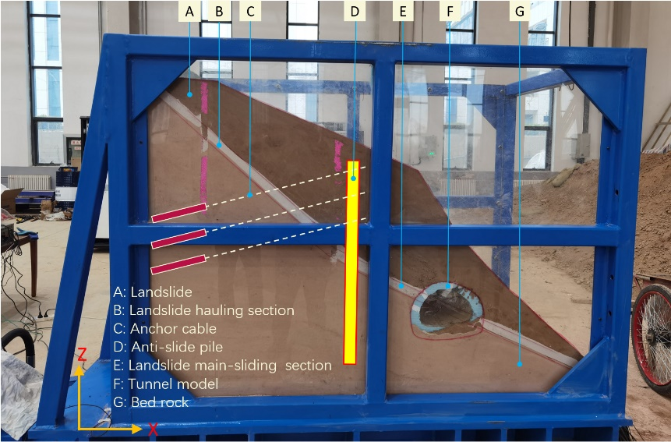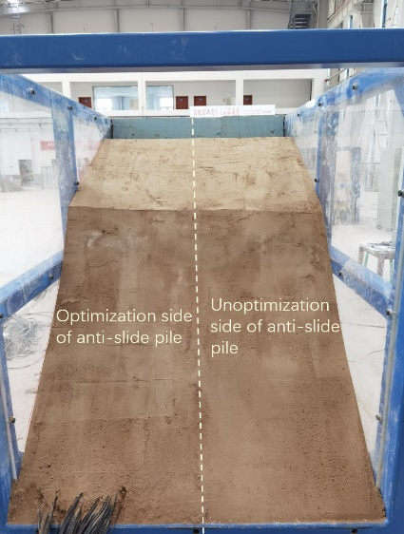
(a) (b)
Fig. 14. Model drawing of multi-anchor point circular pile reinforced tunnel crossing the main sliding surface. (a) Physical side view of the model. (b) Side physical view of slope model.
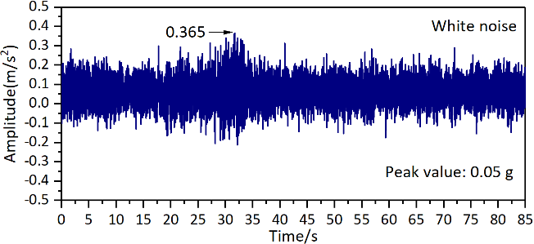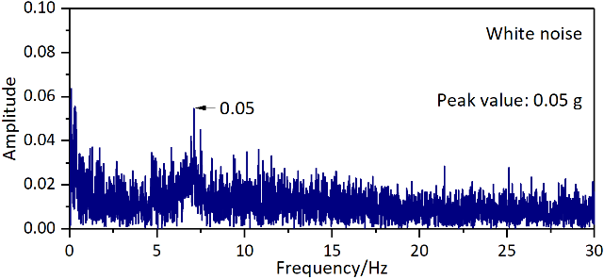
(a) (b)
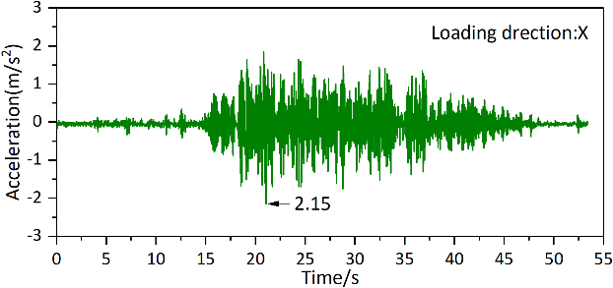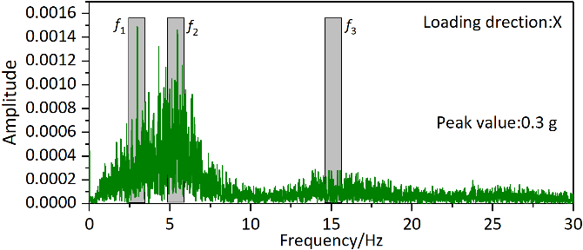
(c) (d)
Fig. 15. Loading wave time-history curve and Fourier spectrum. (a) Sine wave acceleration time-history curve and (b) Fourier spectrum. (c) EL Centro wave acceleration time-history curve and (d) Fourier spectrum.
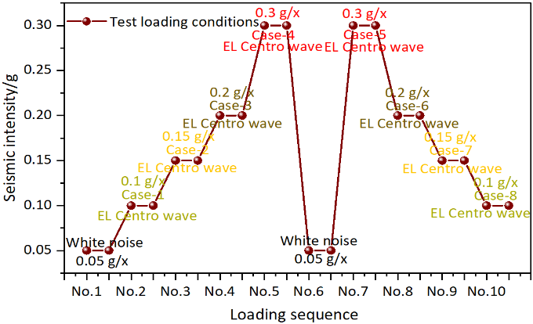
Fig. 16. Loading sequence of seismic waves in shaking table test.
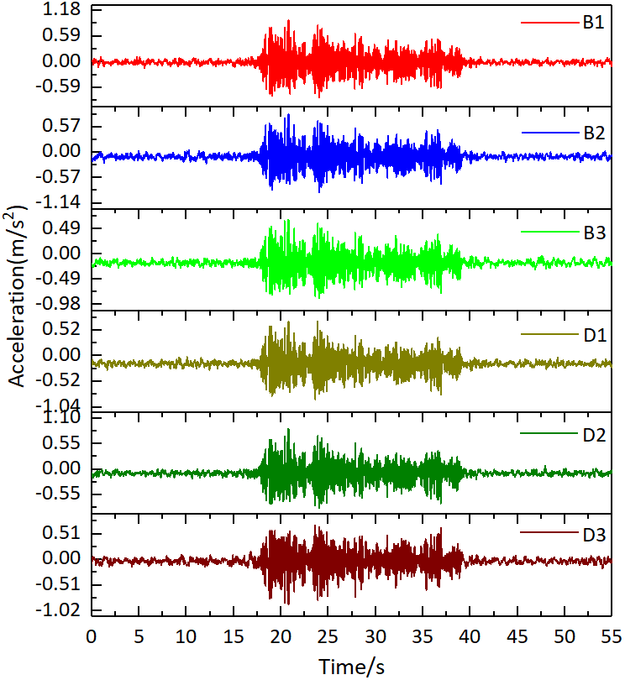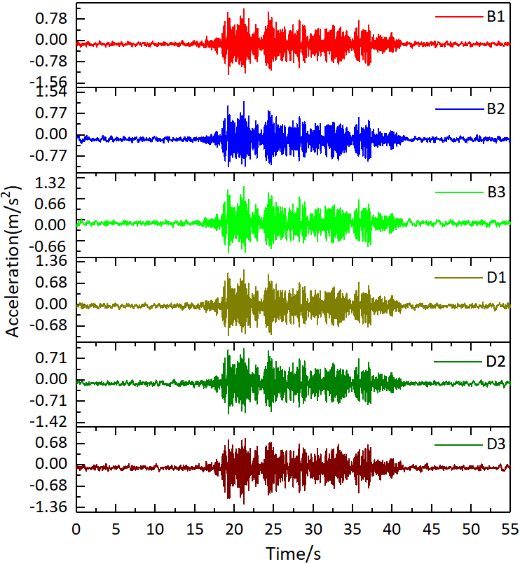
(a) (b)
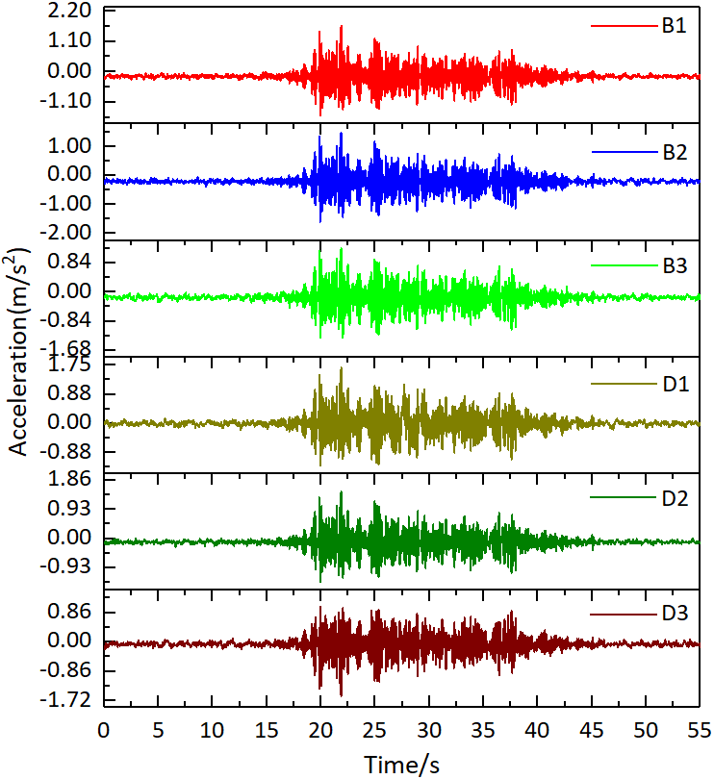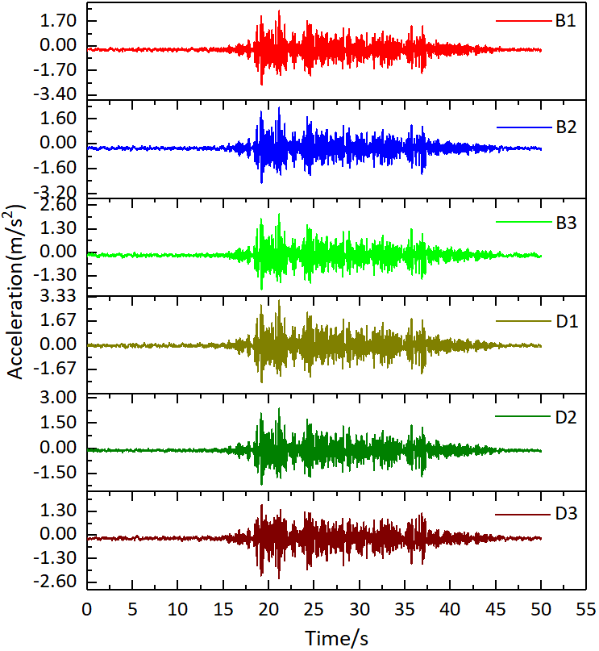
(c) (d)
Fig. 17. Acceleration response time-history curve of multi-anchor round piles in foreshock-main shock sequence. (a) 0.1 g seismic intensity. (b) 0.15 g seismic intensity. (c) 0.2 g seismic intensity. (d) 0.4 g seismic intensity.
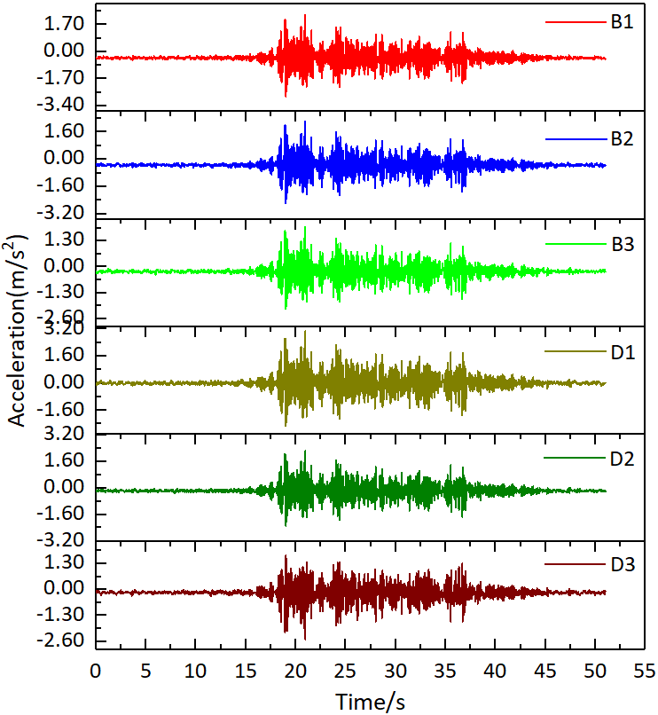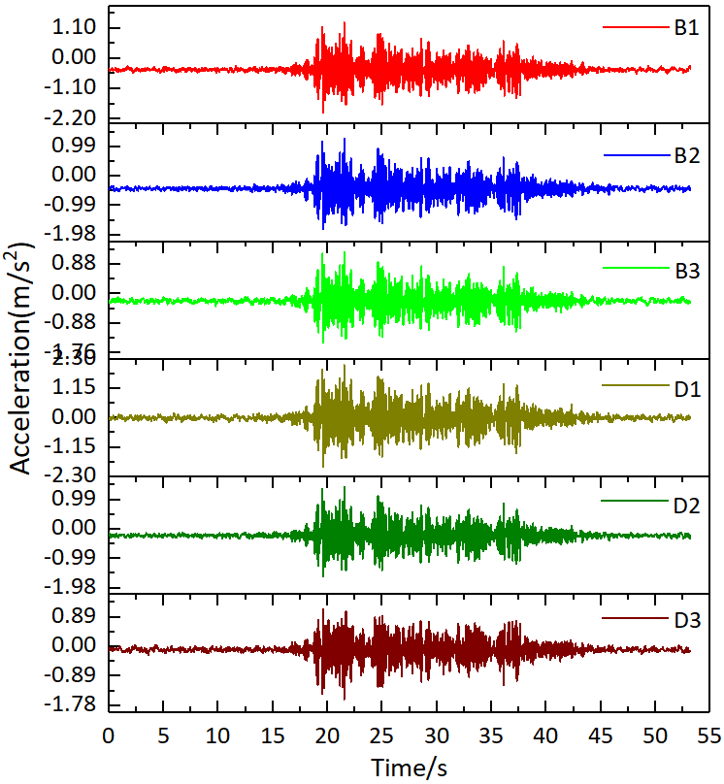
(a) (b)
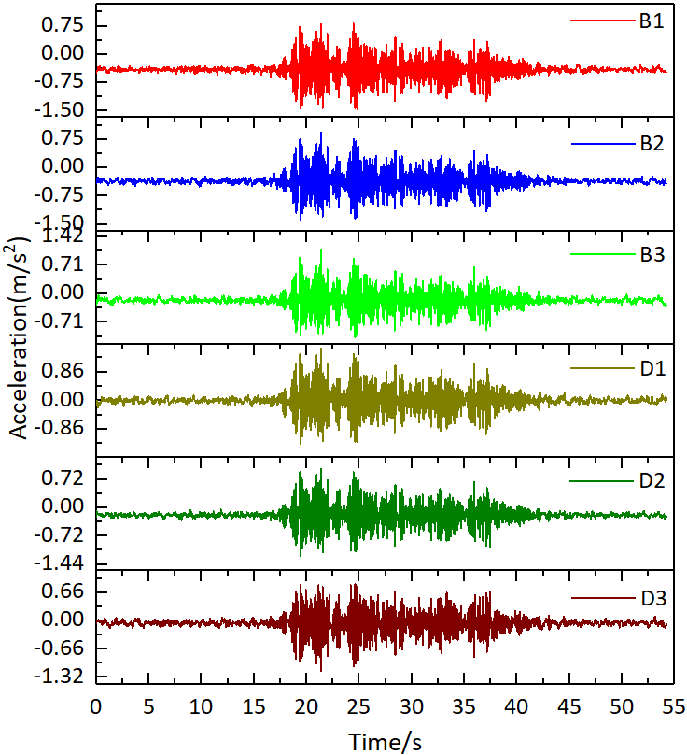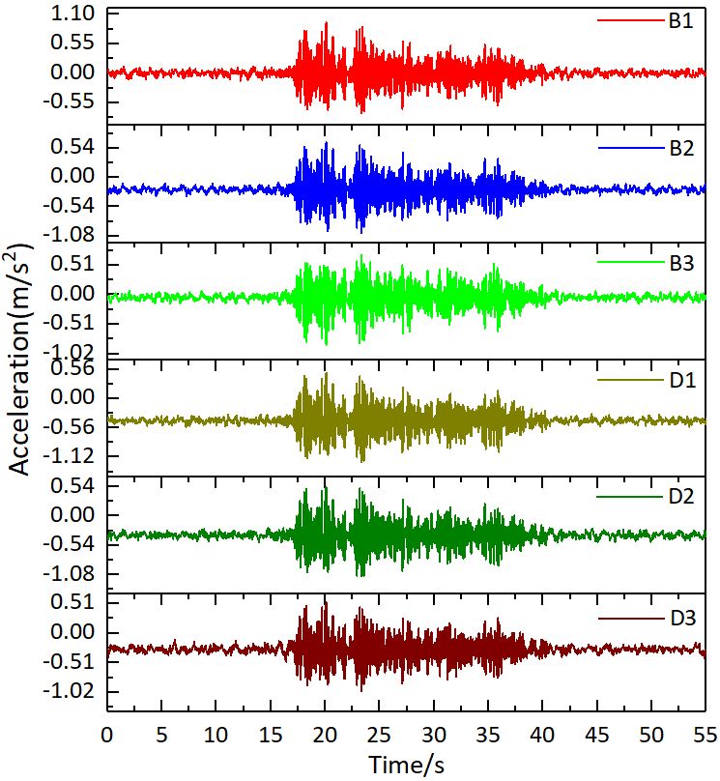
(c) (d)
Fig. 18. Acceleration response time-history curve of multi-anchor round piles in main shock-aftershock sequence. (a) 0.3 g seismic intensity. (b) 0.2 g seismic intensity. (c) 0.15 g seismic intensity. (d) 0.1 g seismic intensity.
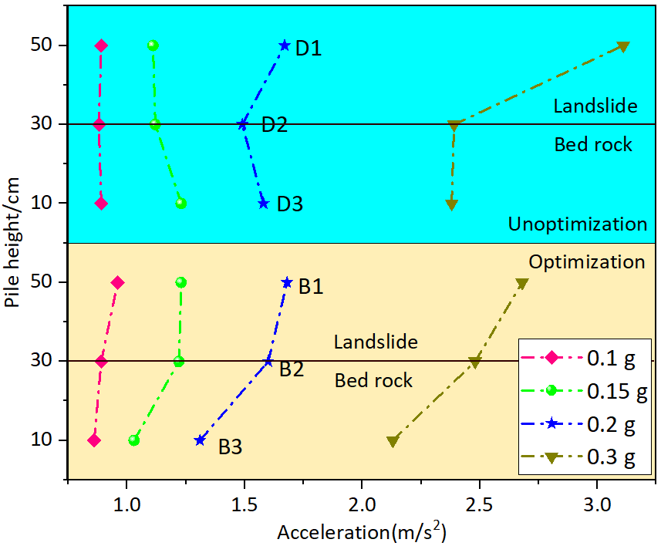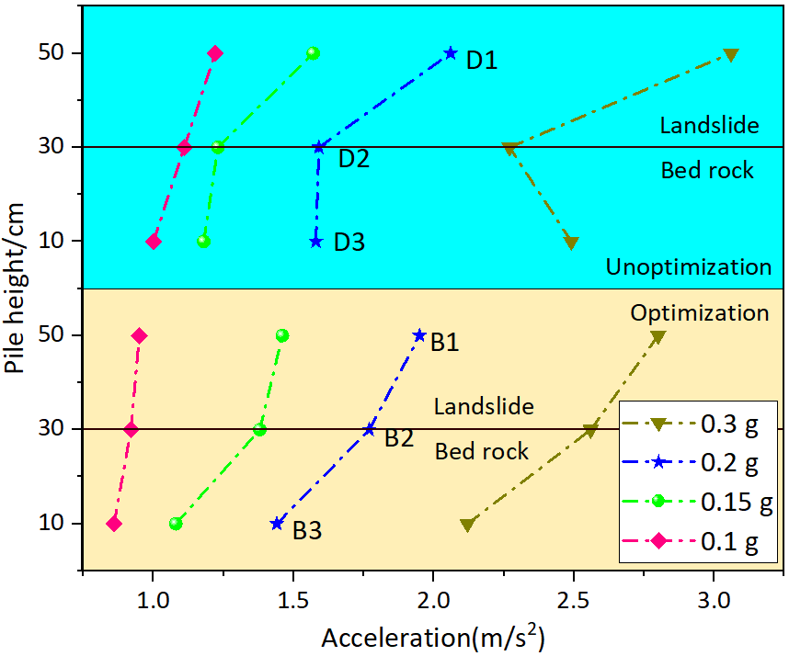
(a) (b)
Fig. 19. Peak acceleration response of round piles with different loading sequences.
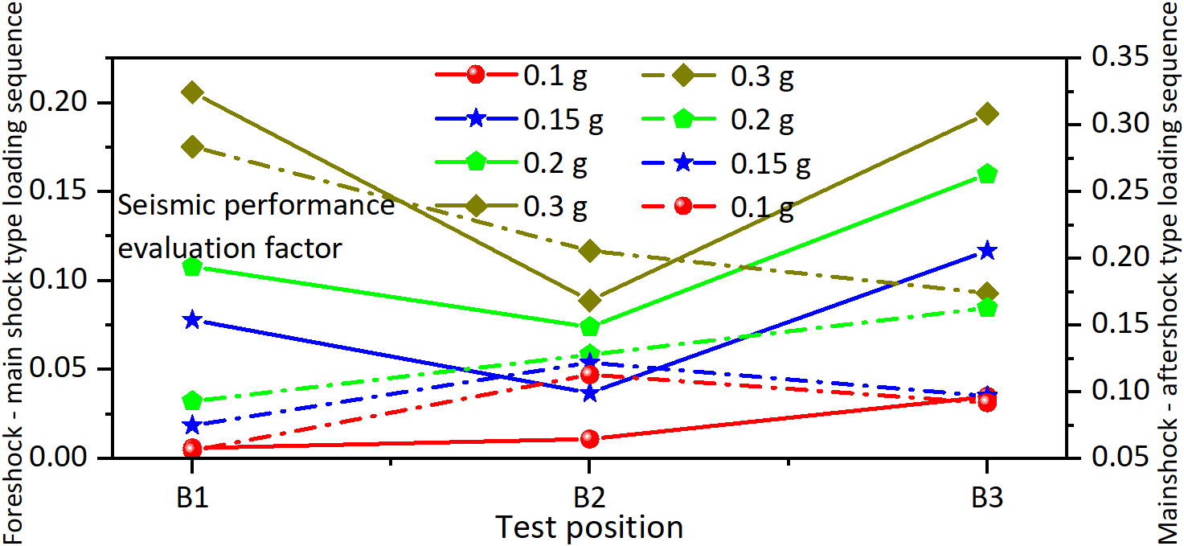
Fig. 20. Seismic performance evaluation factor of multi-anchor round piles with different seismic sequences.
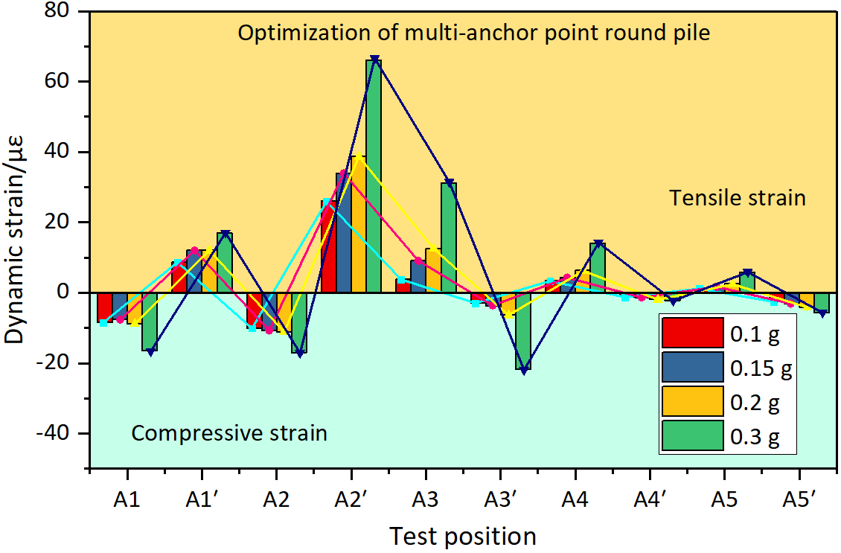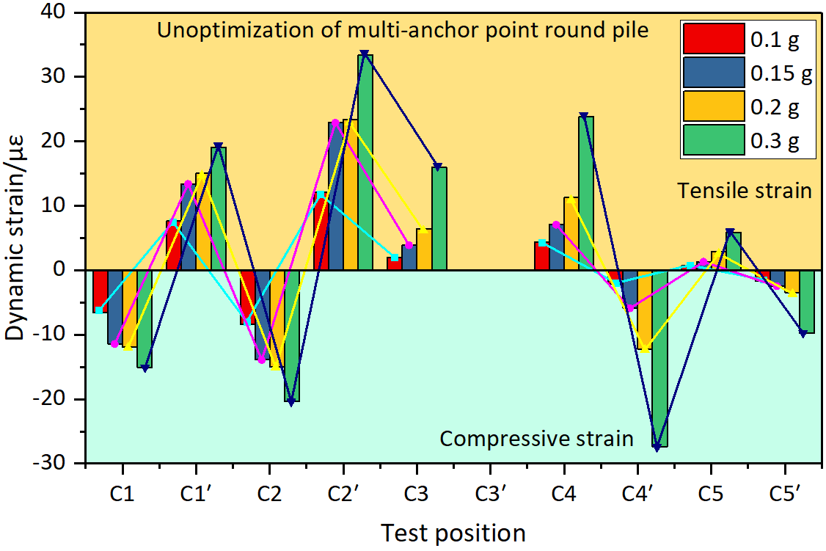
(a) (b)
Fig. 21. Dynamic strain response time-history curve of multi-anchor round piles in foreshock-main shock sequence. (a) Optimization of multi-anchor round piles. (b) Unoptimization of multi-anchor round pile. The dynamic strain gauge at C3´ position of multi-anchor round pile was damaged in the process of embedding, and no test data was obtained, so no special analysis was made for this position.
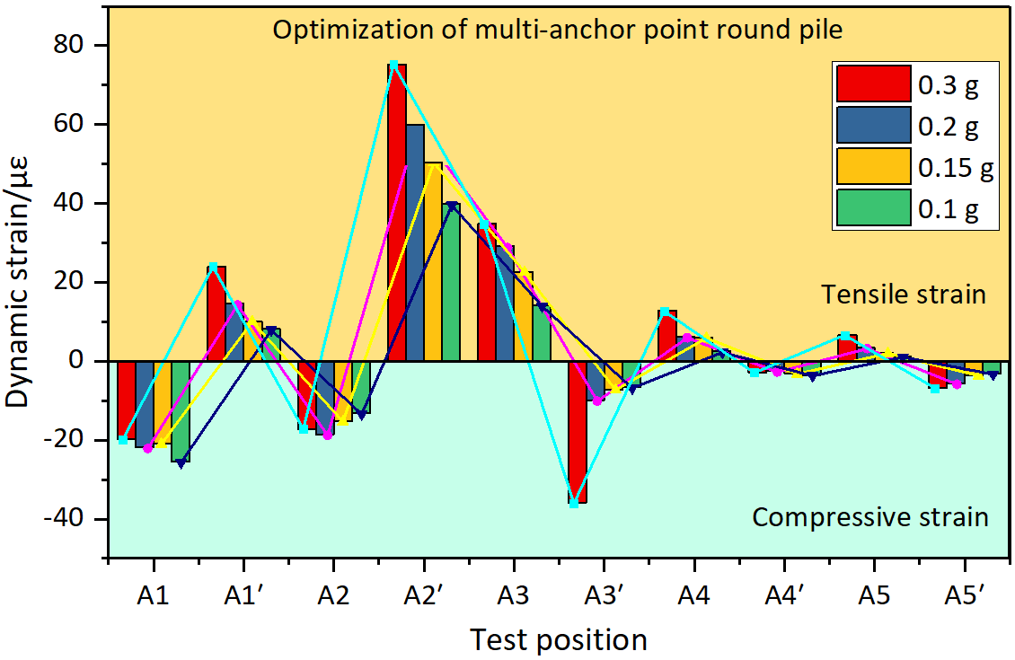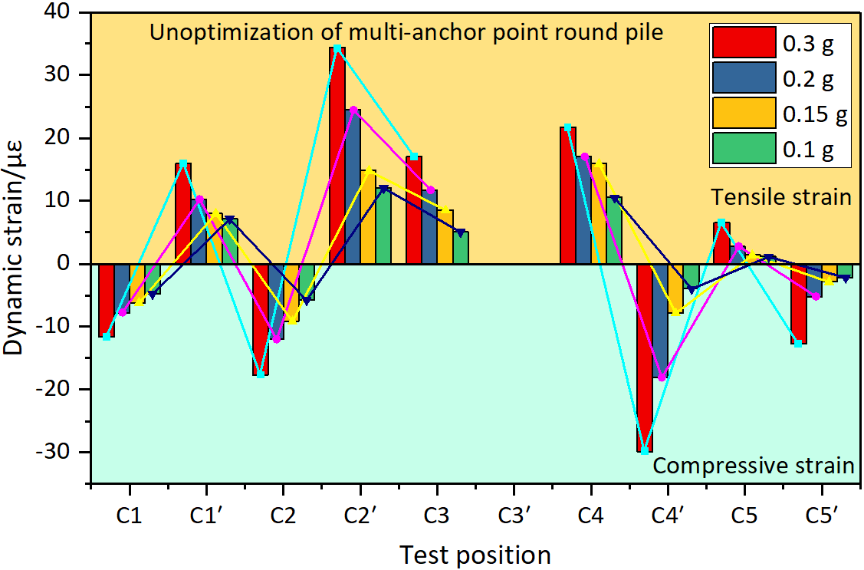
(a) (b)
Fig. 22. Dynamic strain response time-history curve of multi-anchor round piles in main shock - aftershock sequence. (a) Optimization of multi-anchor round piles. (b) Unoptimization of multi-anchor round pile.
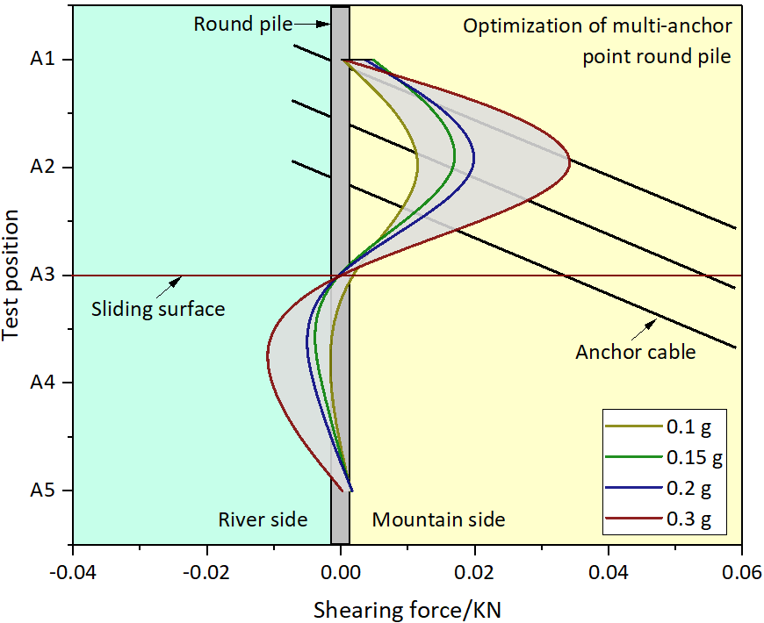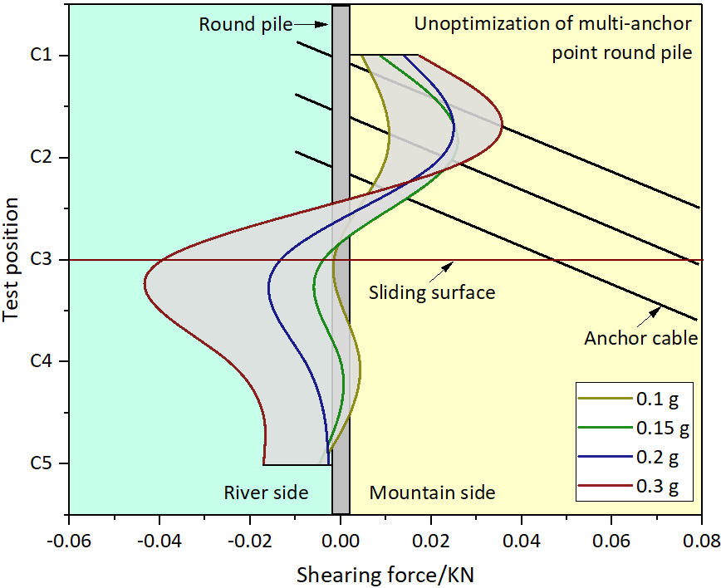
(a) (b)
Fig. 23. Shear force of multi-anchor round piles in foreshock-main shock sequence. (a) Optimization of multi-anchor round piles. (b) Unoptimization of multi-anchor round pile.
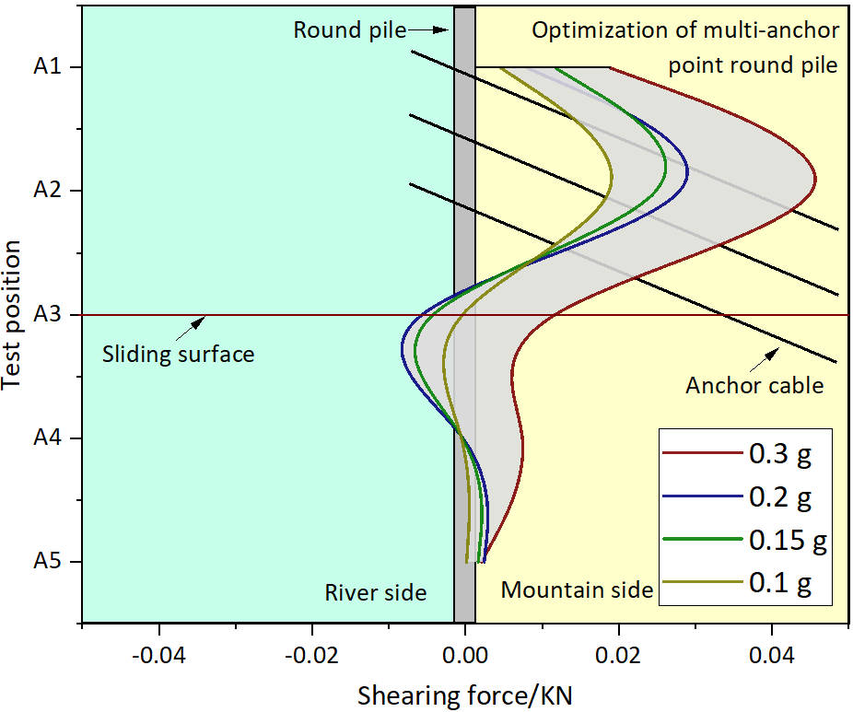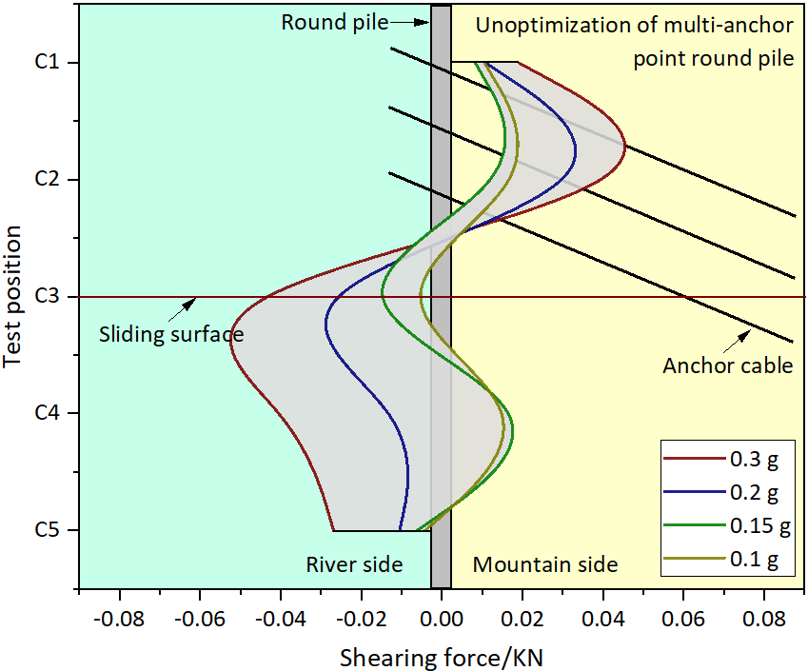
(a) (b)
Fig. 24. Shear force of multi-anchor round piles in main shock - aftershock sequence. (a) Optimization of multi-anchor round piles. (b) Unoptimization of multi-anchor round pile.
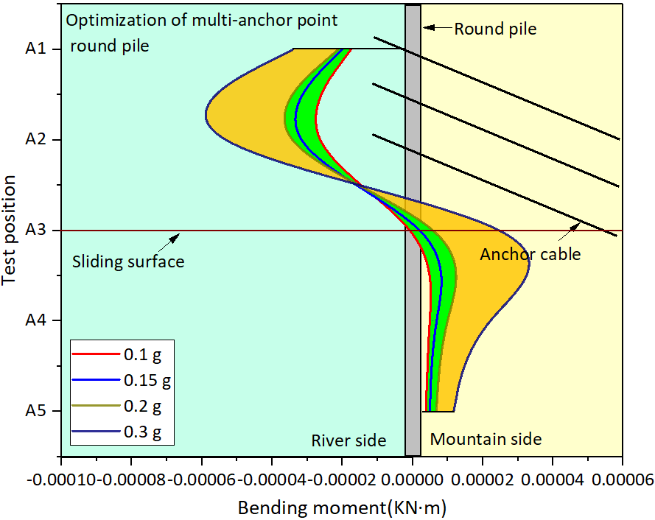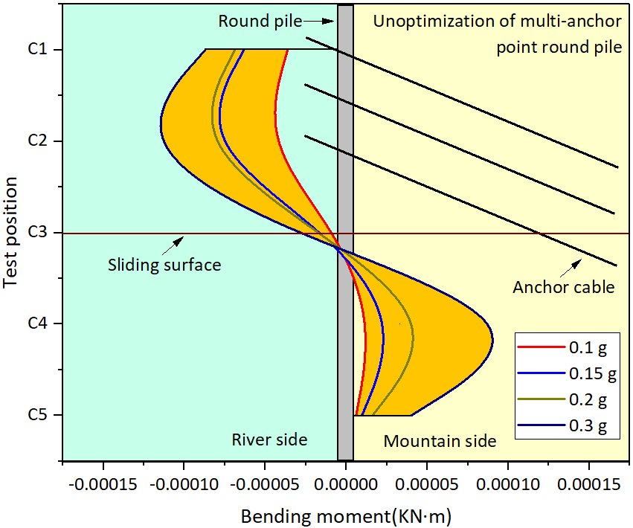
(a) (b)
Fig. 25. Bending moment of multi-anchor round piles in foreshock-main shock sequence. (a) Optimization of multi-anchor round piles. (b) Unoptimization of multi-anchor round pile.
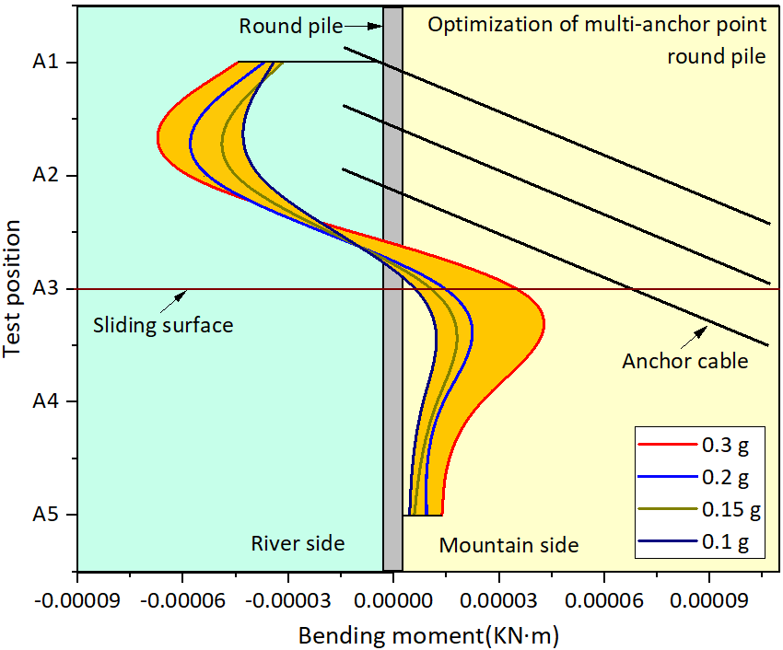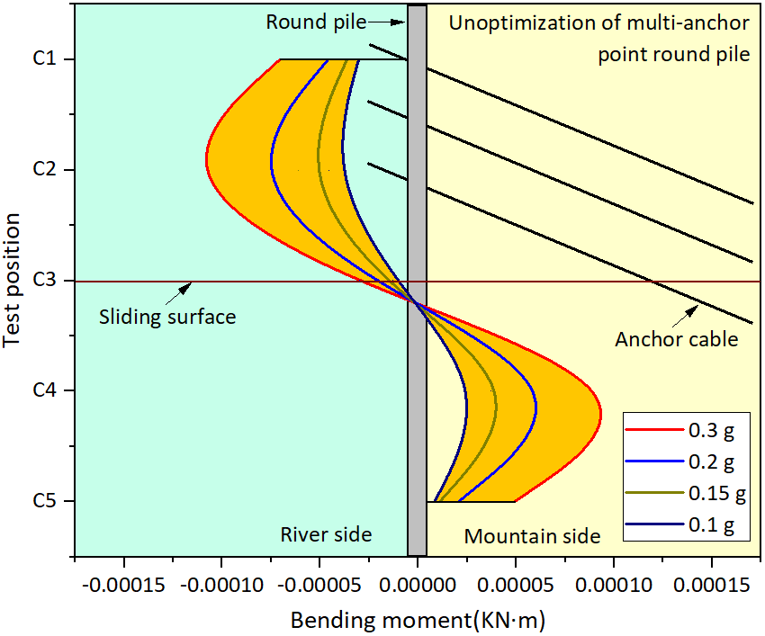
(a) (b)
Fig. 26. Bending moment of multi-anchor round piles in main shock-aftershock sequence. (a) Optimization of multi-anchor round piles. (b) Unoptimization of multi-anchor round pile.
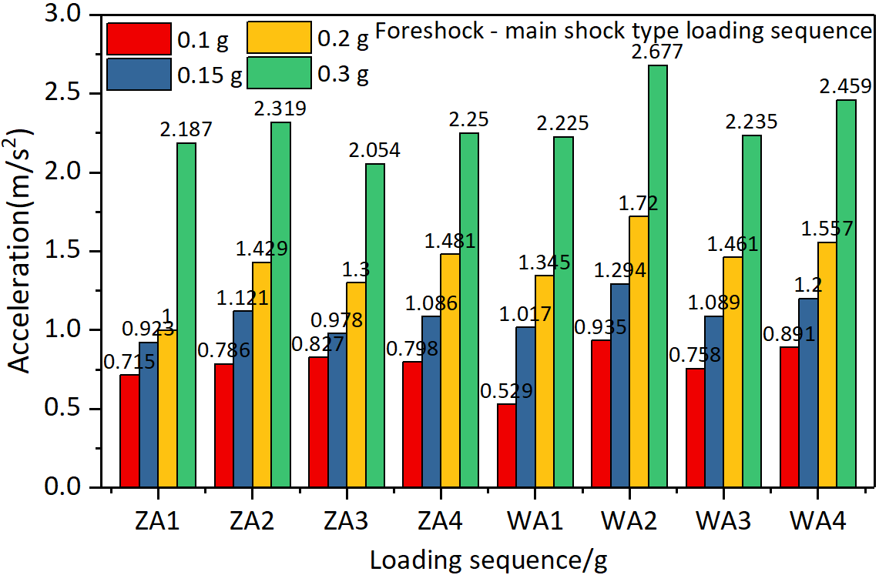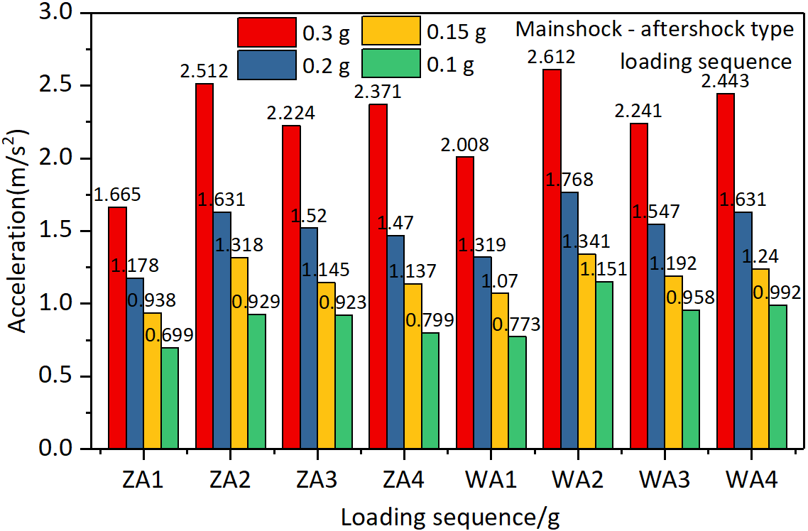
(a) (b)
Fig. 27. Peak acceleration response of tunnel lining with different loading sequences. (a) Foreshock-main shock loading sequence. (b) Mainshock-aftershock loading sequence.
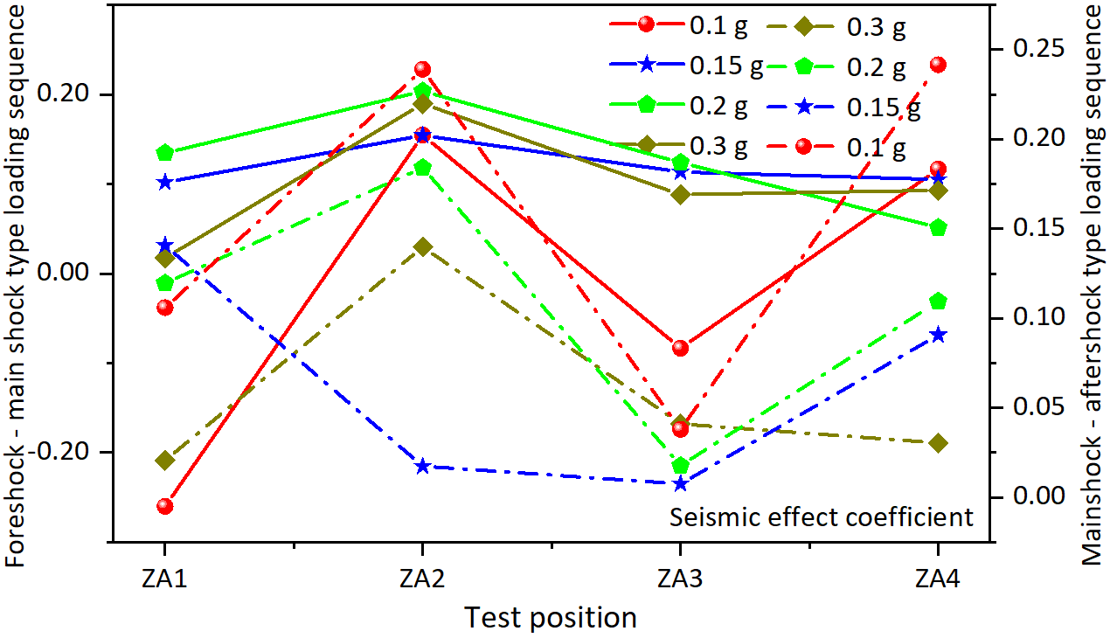
Fig. 28. Seismic effect coefficient of multi-anchor round piles reinforced lining with different seismic sequences.
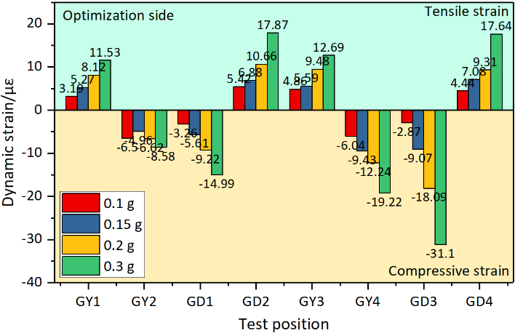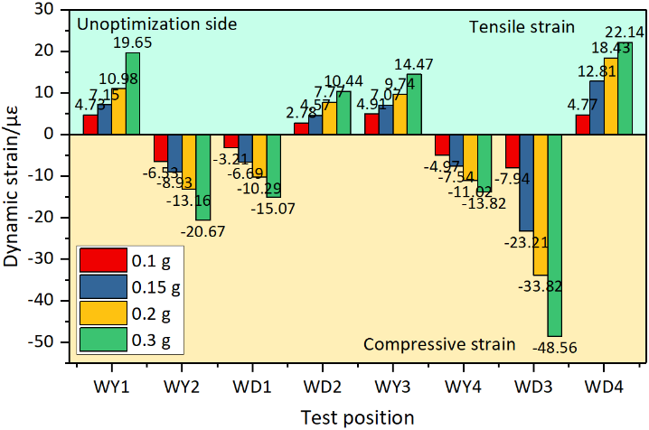
(a) (b)
Fig. 29. Dynamic strain of tunnel lining with foreshock-main shock loading sequence. (a) Dynamic strain of optimization multi-anchor round piles reinforced lining. (b) Dynamic strain of unoptimization multi-anchor round piles reinforced lining.
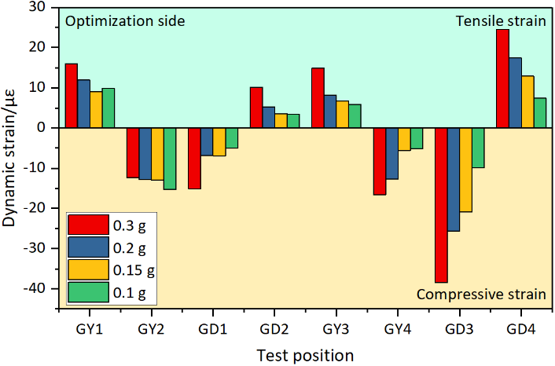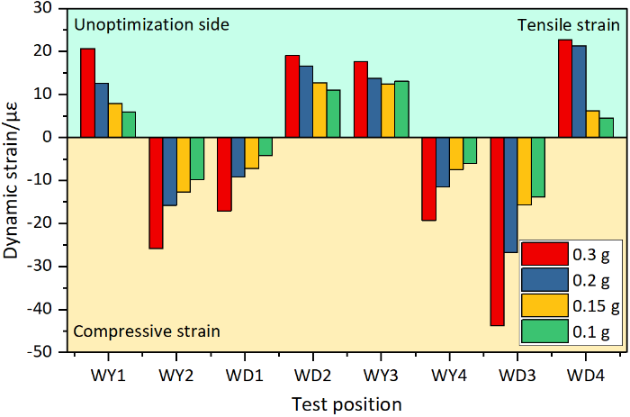
(a) (b)
Fig. 30. Dynamic strain of tunnel lining with main shock-aftershock loading sequence. (a) Dynamic strain of optimization multi-anchor round piles reinforced lining. (b) Dynamic strain of unoptimization multi-anchor round piles reinforced lining.
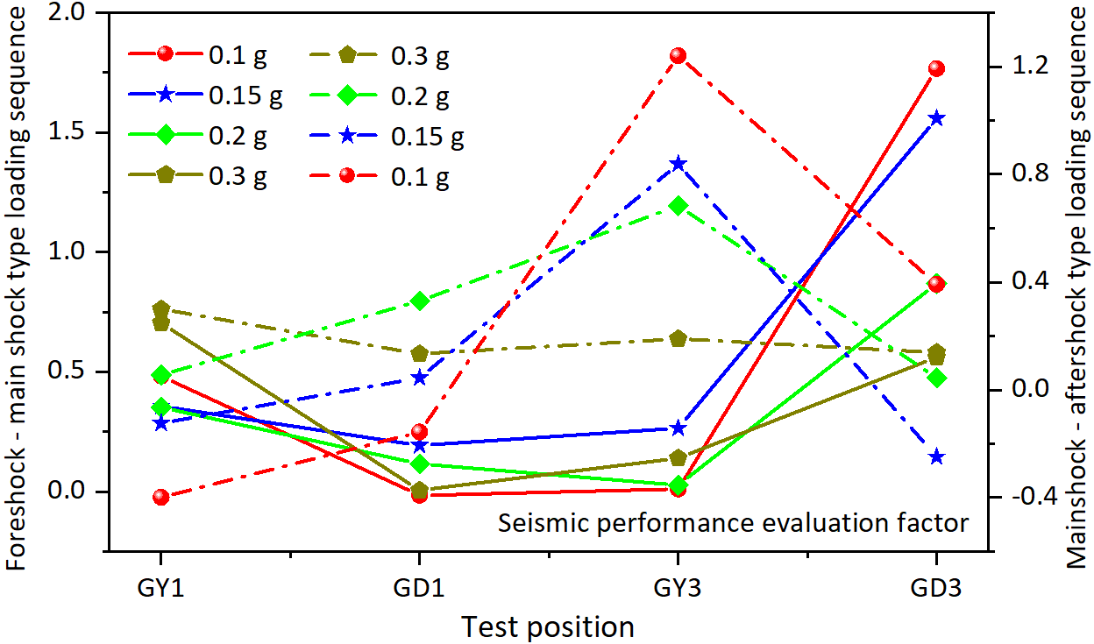
Fig. 31. Reinforcement effect evaluation coefficient of multi-anchor round piles reinforced tunnel lining with different seismic sequences

