Supporting Information
Enhanced photocatalytic properties of g-C₃N₄/ZnO/attapulgite (CNZATP) composite nano-mineral materials on methylene blue dye degradation
Most Munera Khatun ¹, Ashraful Islam ^{2,3}, Chunjie Yan ^{1*}, Most Jinnatun Nesa ⁴
¹ Engineering Research Center of Nano-Geomaterials of Ministry of Education, Faculty of Materials Science and Chemistry, China University of Geosciences, Wuhan 430074, China
² State Key Laboratory of Environmental Aquatic Chemistry, Research Center for Eco-Environmental Sciences, Chinese Academy of Sciences, Beijing, 100085, China
³ University of Chinese Academy of Sciences, Beijing, 100049, China
⁴ Department of Textile Engineering, Primeasia University, Dhaka 1213, Bangladesh

*Corresponding Author:
Name: Chunjie Yan, E-mail: chjyan@cug.edu.cn, Phone: +86-18971579917

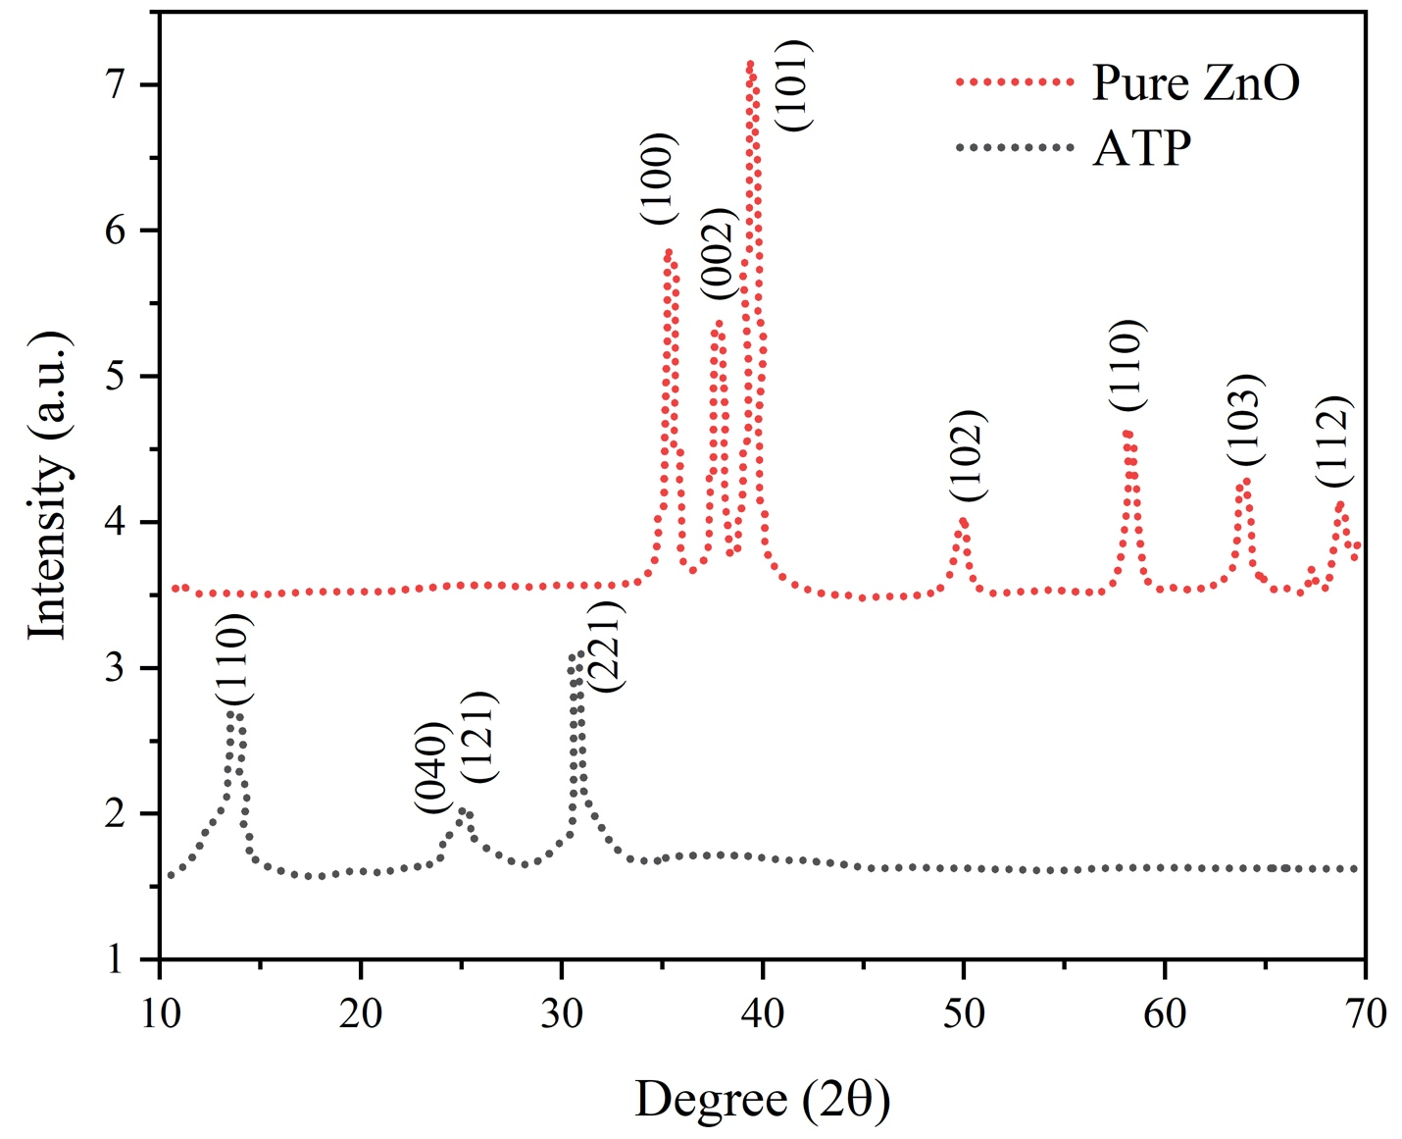
Fig. S1 X-ray diffraction patterns of pure ZnO and attapulgite (ATP).

