Supplementary information

Intelligent metasurface system for automatic tracking of moving targets and wireless communications based on computer vision

by Li et al.

Note S1. How does an Intel RealSense Depth Camera D435i (RS-camera) collect position information of the detected objects?
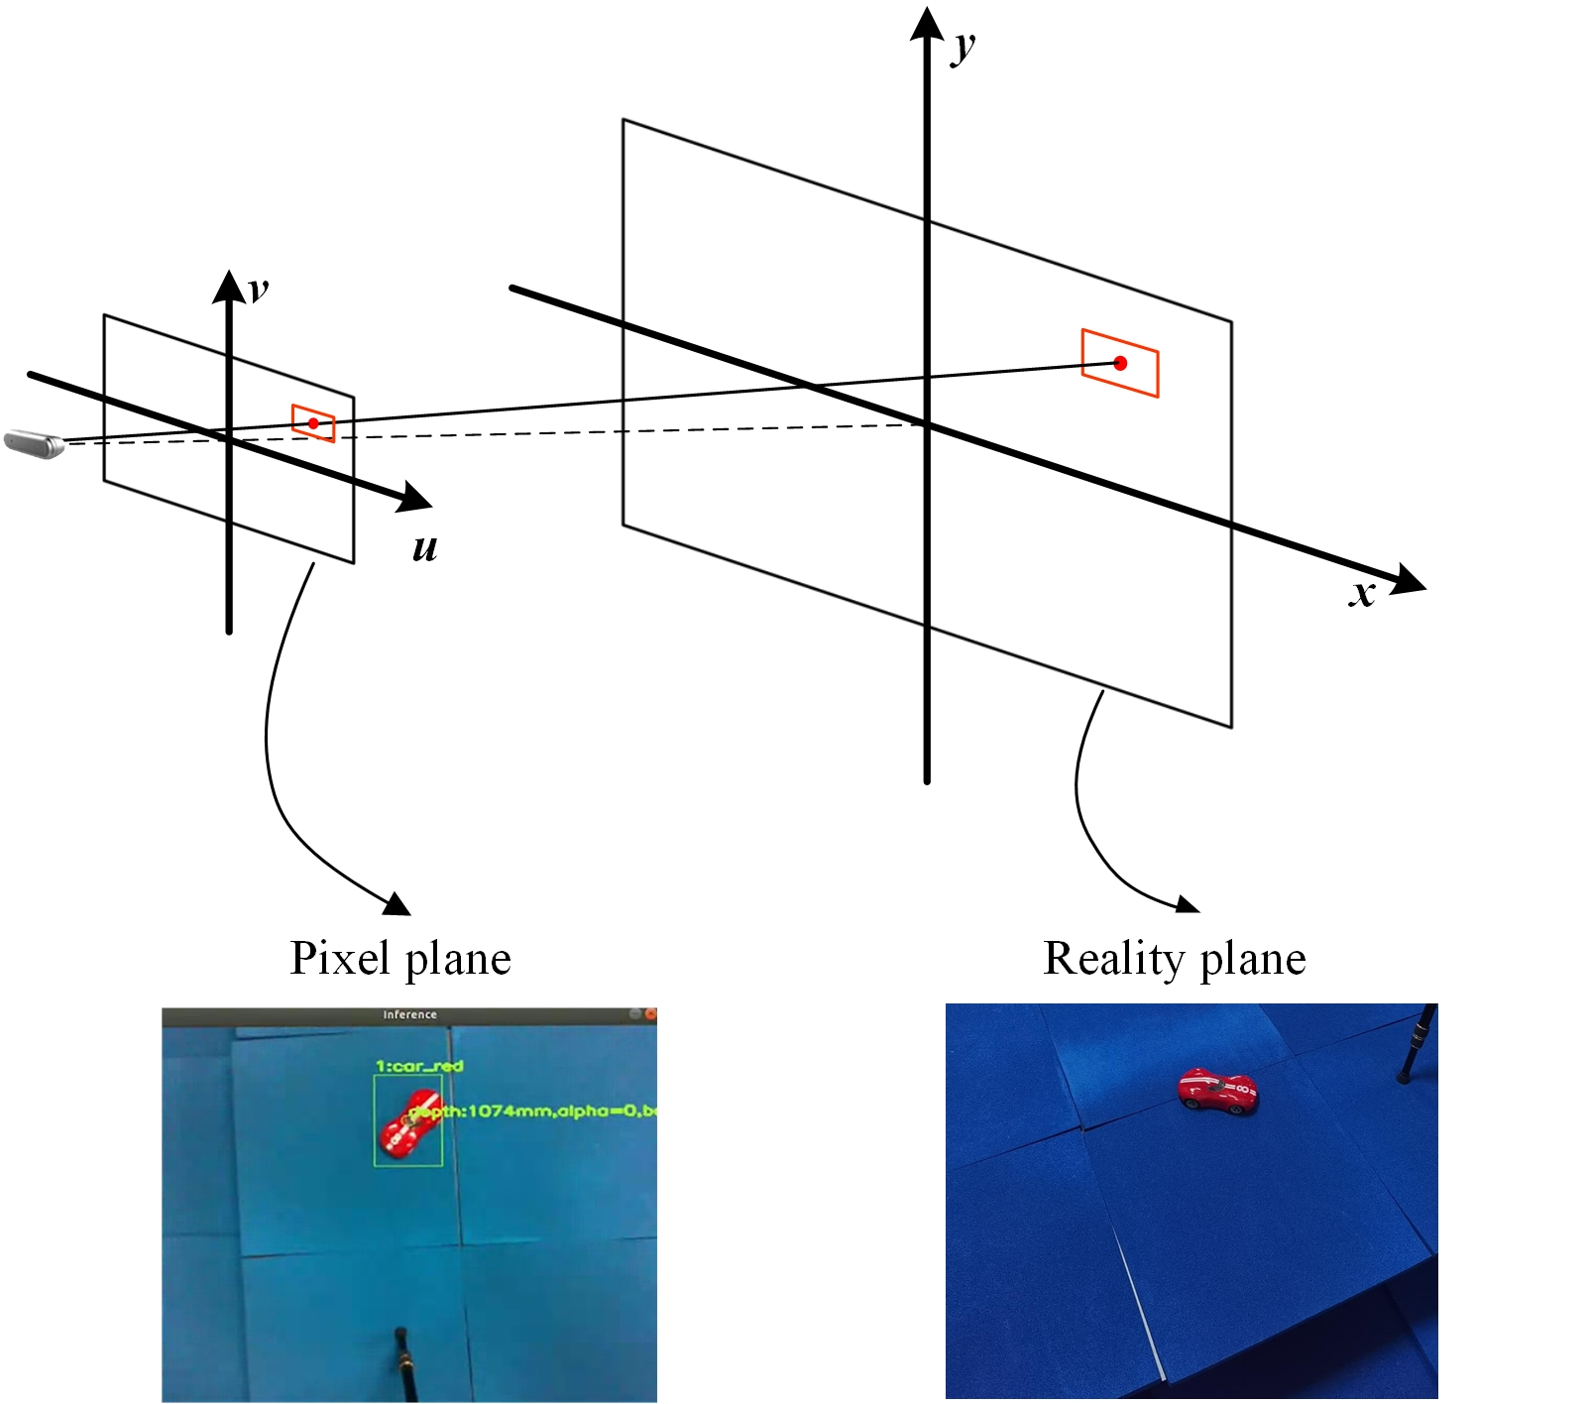
Supplementary Figure S1. Mapping diagram of pixel plane and reality plane.

Based on the pinhole imaging model, the corresponding relationship between the pixel plane and reality plane is established. Through the YOLO algorithm, the position of the target in the pixel coordinate system can be obtained. The azimuth angle of the target relative to the camera can be obtained by combining the field angle parameters of the camera. After obtaining the depth data of the target, one is able to multiply it with the sine values of yaw angle and pitch angle respectively to calculate the x and y position of the target in the three-dimensional reality coordinates, and multiply it with the cosine value of azimuth angle to calculate z position. The steps of calculation are as follows.
Input parameters: w, h, u, v, V, H, d.
w: the width of the image,
h: the height of the image,
(u, v): pixel coordinates of target in the image,
V: horizontal field angle of RS-camera,
H: vertical field angle of RS-camera,
d: distance from the RS-camera to the target center.
Output parameters: (x, y, z).
(x, y, z): 3D coordinates of the target in the coordinate system with the RS-camera as the origin.
Step 1:
Calculate the yaw angle $α$ and pitch angle $β$ of the target relative to the RS-camera,$α=\frac{u}{w}V, β=\frac{v}{h}H$.
Step 2:
Calculate the 3D coordinates of the target, $x=d sinα, y=d sinβ, z=d cosα cosβ$.

Note S2. Field calculation for the digital programmable metasurface (DPM)
The scattering-field calculation for conventional metasurfaces generally depends on the phase distribution on a 2D plane (see Supplementary Fig. S2(a). For a metasurface including N◊N elements, the related scattering field is calculated as ²²
$f\left(θ,φ\right)=\sum_{m=1}^{N}{\sum_{n=1}^{N}{exp\left\{-i\left\{φ\left(m,n\right)+kDsinθ\left[\left(m-\frac{1}{2}\right)cosφ+\left(n-\frac{1}{2}\right)sinφ\right]\right\}\right\}}}$ (S1)
where $θ$ and $φ$ are respectively the elevation and azimuth angles of an arbitrary direction. Relative to the metasurface, when the object is detected at a certain angle, the coding pattern on the metasurface has to be extended to a 3D version as shown in Fig. S2(b), and the related field is $f\left(θ+∆θ,φ+∆φ\right)$:
$f\left(θ+∆θ,φ+∆φ\right)=\sum_{m=1}^{N}{\sum_{n=1}^{N}{exp\left\{-i\left\{φ\left(m,n\right)+kDsin\left(θ+∆θ\right)\left[\left(m-\frac{1}{2}\right)cos\left(φ+ ∆φ\right)+\left(n-\frac{1}{2}\right)sin\left(φ+∆φ\right)\right]\right\}\right\}}}$ (S2)
where $θ$ and $φ$ respectively represent the elevation and azimuth angles of the moving target relative to the 2D version. The metasurface is able to automatically adjust the coding pattern according to the spatial displacement $(∆θ,∆φ)$. The Yolov4_tiny can exactly detect the displacement of the moving target and update the position information of it, and promptly instructs the FPGA to generate the corresponding coding pattern. Thus the problem can be simplified to calculate the coding pattern for the specific scattering direction $(∆θ,∆φ)$.
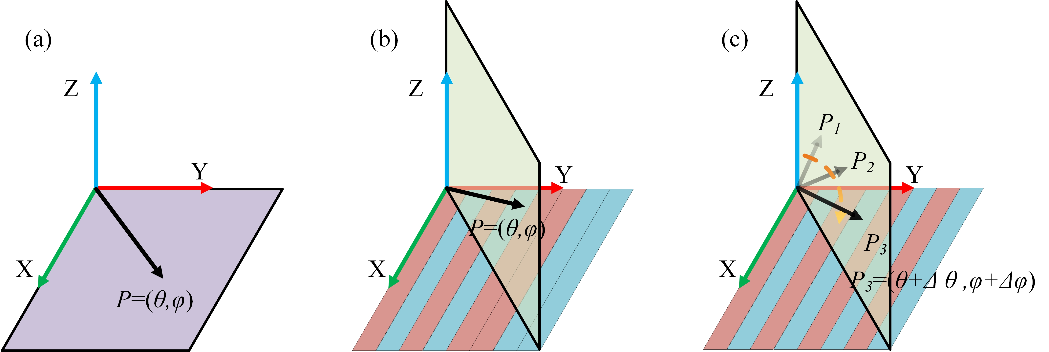
Supplementary Figure S2. The illustration of scattering-field calculation for rotated metasurface. (a) The coding patterns for 2D versions. (b-c) The 2D far-field scattering calculations for 3D versions. P₁, P₂ and P₃ are the positions of a moving target at different time points.

Note S3. Directional beam manipulations
A total of 324 (18 × 18) unit cells constitute the aperture of the DPMs, as shown in Fig. S3a. A y-polarized rectangular horn antenna is used to illuminate the DPMs. According to the superposition principle, reflection of the DPM is the superposition of reflections of all the unit cells. For simplicity, the unit cell with an ON-state diode is represented by digit “1” and the one with an OFF-state diode is represented by digit “0”. Distributions of these digits are referred as digital coding schemes of the DPMs. With adequate configuration of the digital coding schemes, DPMs can generate beams at different deflection angles. And steerable beams are available if the digital coding schemes are dynamically configured. Fig. S4 shows the digital coding schemes for DPMs with the beam varying from -40° to 40° and Fig. S5 gives the the photographs of the fabricated prototype.
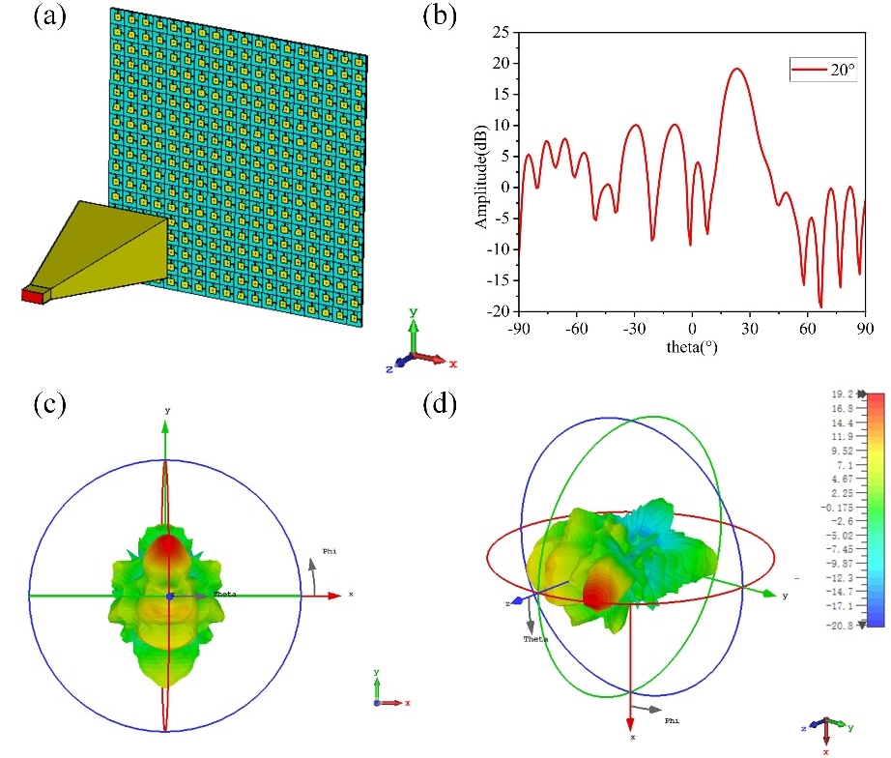
Supplementary Figure S3. Calculations of 20° beam at 5.8 GHz. (a) Simulation model of the proposed DPM. (b) Calculated 2D far-field results. The calculated 3D far-field results in perspective of (c) and (d) when the angle is 20°.
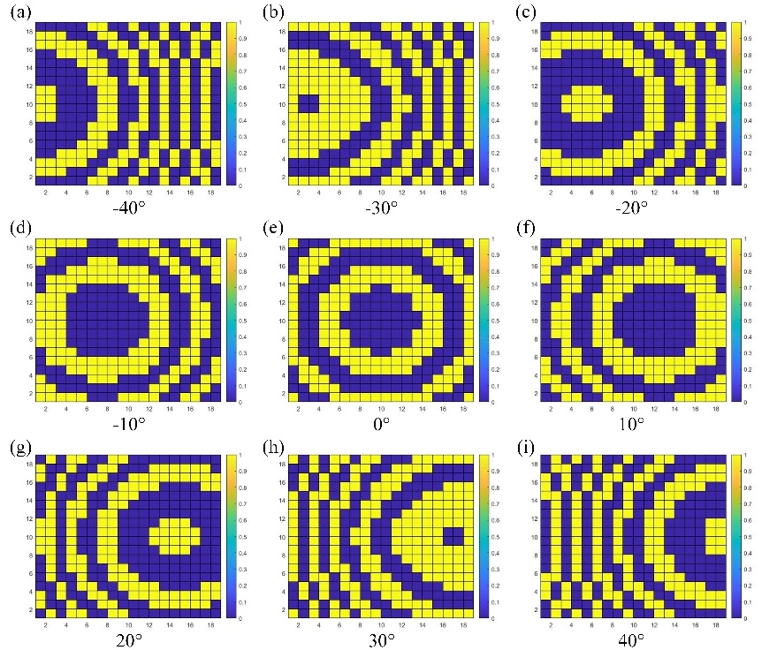
Supplementary Figure S4. (a-i) Digital coding schemes for beams varying from -40° to 40° in the E-plane. Blue patches denote OFF-state PIN diodes, and yellow patches denote ON-state PIN diodes.
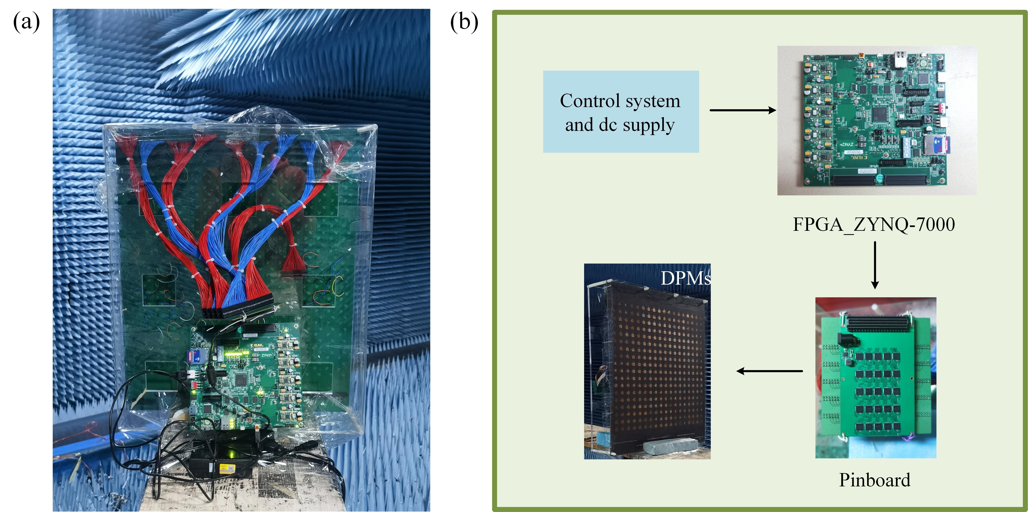
Supplementary Figure S5. (a) Photographs of the back side of the fabricated prototype. (b) The flow chart of DPMs and feeding network. The DPMs sample has a thickness of about 4.052 mm in total, FMC output on FPGA is connected to the DPMs through a pinboard.

Note S4. Fast inverse design algorithm of the coding pattern
For the part of vision detection and target tracking, we adopt the architecture based on YOLO -v4, and combine target tracking and coordinate transformation of the scene to realize the real scene.
Target detection is an overlay of classification and regression. Early visual detection used sliding windows of various sizes to slide on the image to select candidate regions, and manually designed the kinds of features extracted from the candidate regions to determine the presence or absence of targets and also the classes of targets in the candidate boxes. The traditional detection method is time-consuming and the manually designed features are poorly robust and difficult to cope with new scenes after transplantation. Along with the evolution of artificial intelligence and the development of high-performance computing resources, intelligent target recognition with deep learning as the core has emerged, showing unique features. Target detection algorithms based on deep learning are mainly divided into two categories: two-stage algorithms and one-stage algorithms. The typical model of two-stage algorithms is the RCNN series. The main idea is to generate multiple candidate boxes in the image based on the correlation algorithm, and extract the depth features of the candidate boxes. First, judge whether there are targets in the candidate boxes, and then classify the candidate boxes with targets. Judging the regression with the frame, the specific category of the object in the frame and the more accurate detection frame can be obtained. In contrast, a one-stage algorithm directly classifies and regresses the candidate box, and judges whether there are objects in the candidate box according to the confidence score of classification. Compared with the two-stage algorithm, it saves the step of judging whether there are objects in the candidate box. So, the one-stage algorithm is faster, but the accuracy is lower than that of the two-stage algorithm. YOLO series is a typical model in one-stage algorithm.
Visual tracking is the process of continuously locating a target in subsequent frames, given the position and size of the target in the initial frame. The process carries on continuous localization of the target in the subsequent frames. Compared with the visual detection task, the visual tracking task requires the initial position and size of the target to be determined in advance, and then use the temporal and spatial continuity and correlation of the images between frames to achieve continuous localization of the target.
The difference between the two-stage algorithm and Yolo-v4 for anchor frame position prediction and regression lies in that the two-stage algorithm uses the regional candidate network to get the filter box and then regression, while Yolo-v4 directly performs the border regression for all anchor frames. The process is shown in Fig. S6.
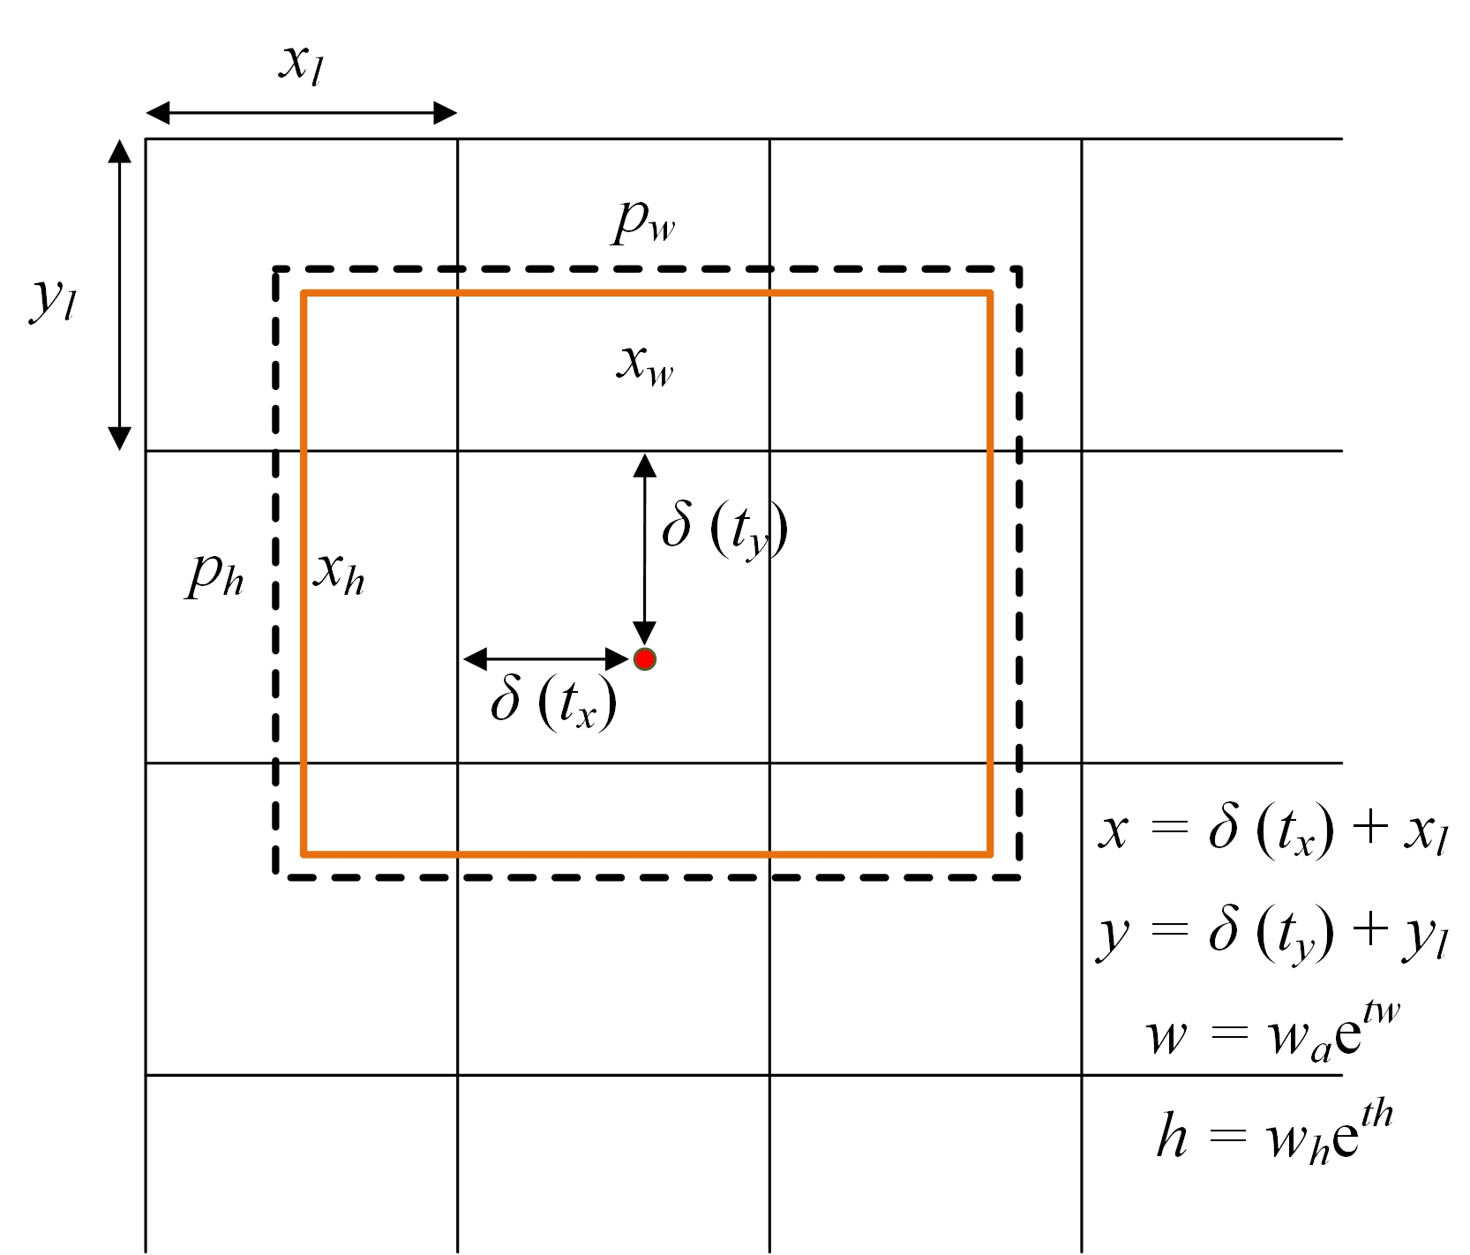
Supplementary Figure S6. YOLO border prediction.

YOLO-v4 divides the input image into S×S regions, and only detects the anchor frame of each region, in other words, only the target whose center falls in this region. Assume that the coordinates of the upper left corner of the area corresponding to [x_{l}, y_{l}], and the width and height are [w_{a}, h_{a}]; The center coordinate of the prediction box is [x, y], and the width and height are w and h. The real center coordinate of the real frame is t_{x}, and the width and height are t_{w} and t_{h}, respectively. Abscissa regression parameters of prediction frame and anchor frame t_{x}, ordinate regression parameter t_{y}, width regression parameter t_{w}* and height regression parameter t_{h}*. The confidence of the prediction box is t_{o}. The relationships between regression parameters and data are given below:
$δ\left(t_{x}\right)=x-x_{l},δ\left(t_{y}\right)=y-y_{l}$ (S4)
$t_{w}=log⁡\left(\frac{w}{w_{a}}\right),t_{y}=log⁡\left(\frac{h}{h_{a}}\right)$ (S5)
$δ\left(t_{x}^{*}\right)=x^{*}-x_{l},δ\left(t_{y}^{*}\right)=y^{*}-y_{l}$ (S6)
$t_{w}^{*}=log⁡\left(\frac{w^{*}}{w_{a}}\right),t_{h}^{*}=log⁡\left(\frac{h^{*}}{h_{a}}\right)$ (S7)
in which δ represents sigmoid normalization function, which is used to ensure that the target frame does not exceed the area where the initial anchor frame is located after regression, and is conducive to accelerating convergence. The model predicts and regresses the corresponding anchor frames in different feature maps, and finally obtains the detection results in the form of $\left(t_{x},t_{y},t_{w},t_{h},t_{o}\right)$, where $t_{o}$ represents the probability that the detection frame is a certain target. Tolov4-tiny target detection algorithm can classify multiple targets in the field of vision at the same time, and give the categories to which the targets belong. By judging the category, the position information of the specified target is extracted, and the beam is controlled to point to the specified target.

Note S5. Structure and operating process of the Yolov4-tiny network and pre-training ANN
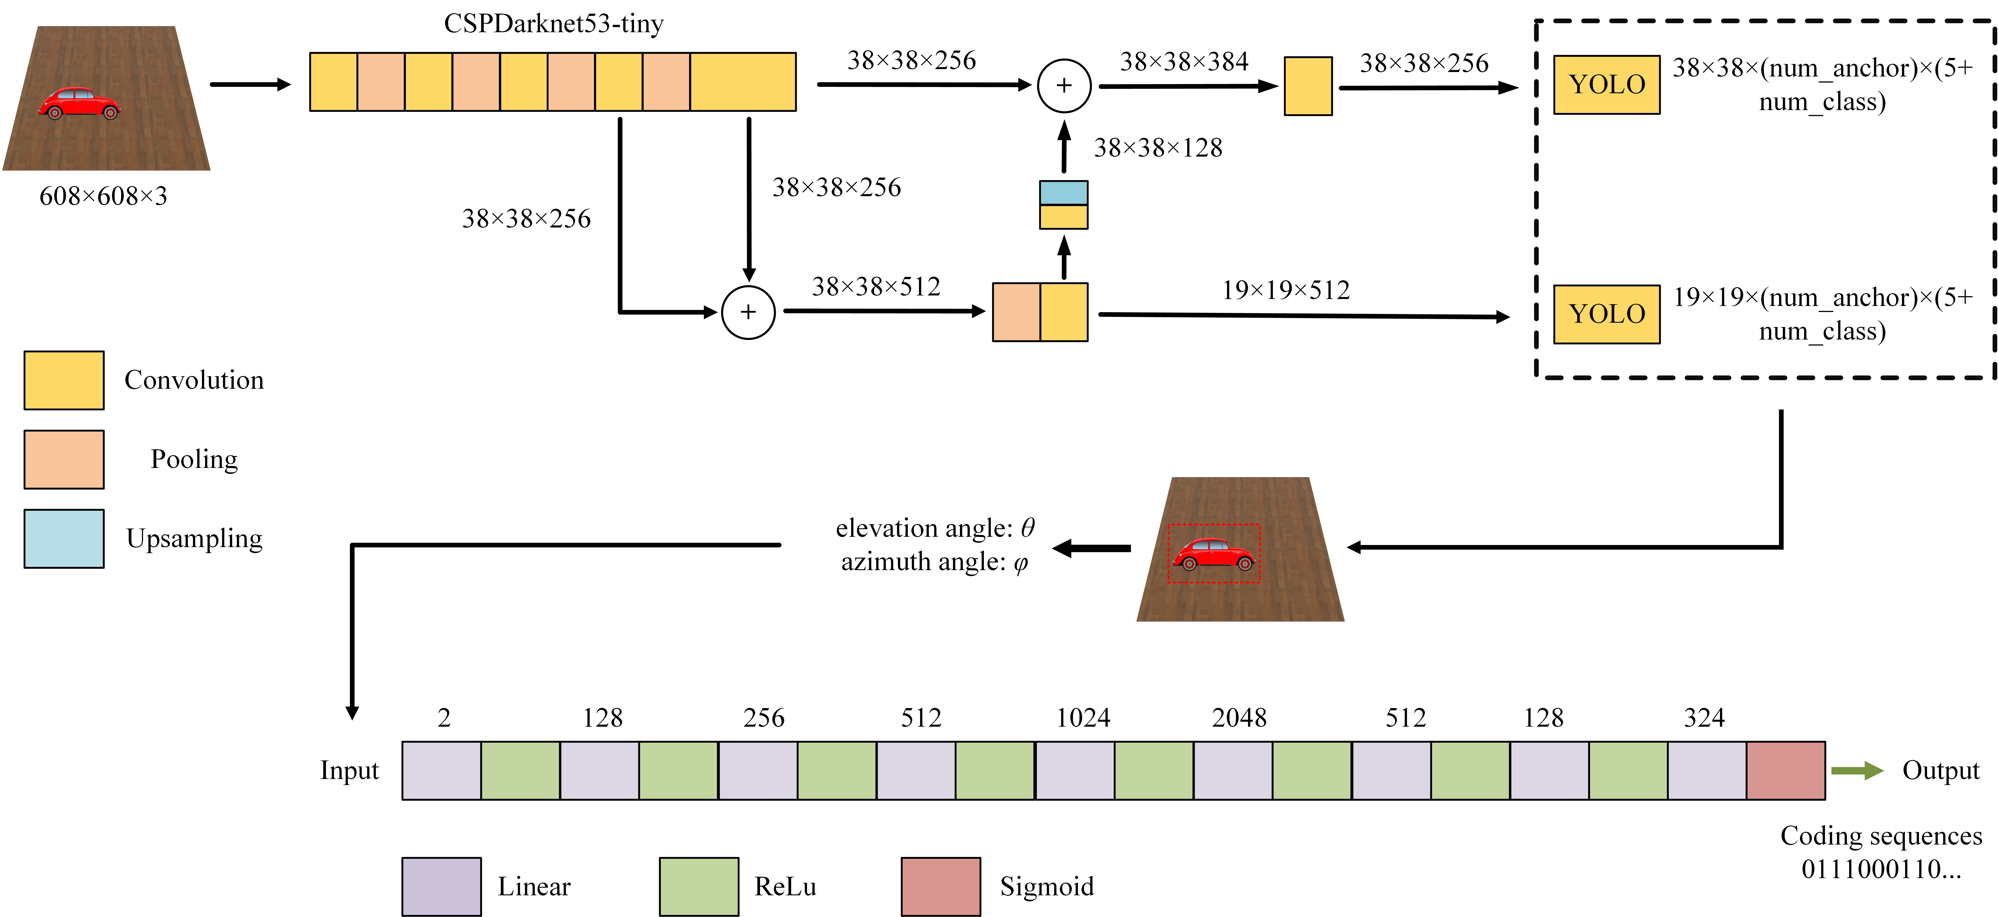
Supplementary Figure S7. Detailed structure of the Yolov4-tiny network and pre-training ANN.

Fig. S7 marks the intermediate result size of each level of the two networks, which is more helpful for analysis.

Note S6. Design of the receiver patch antenna
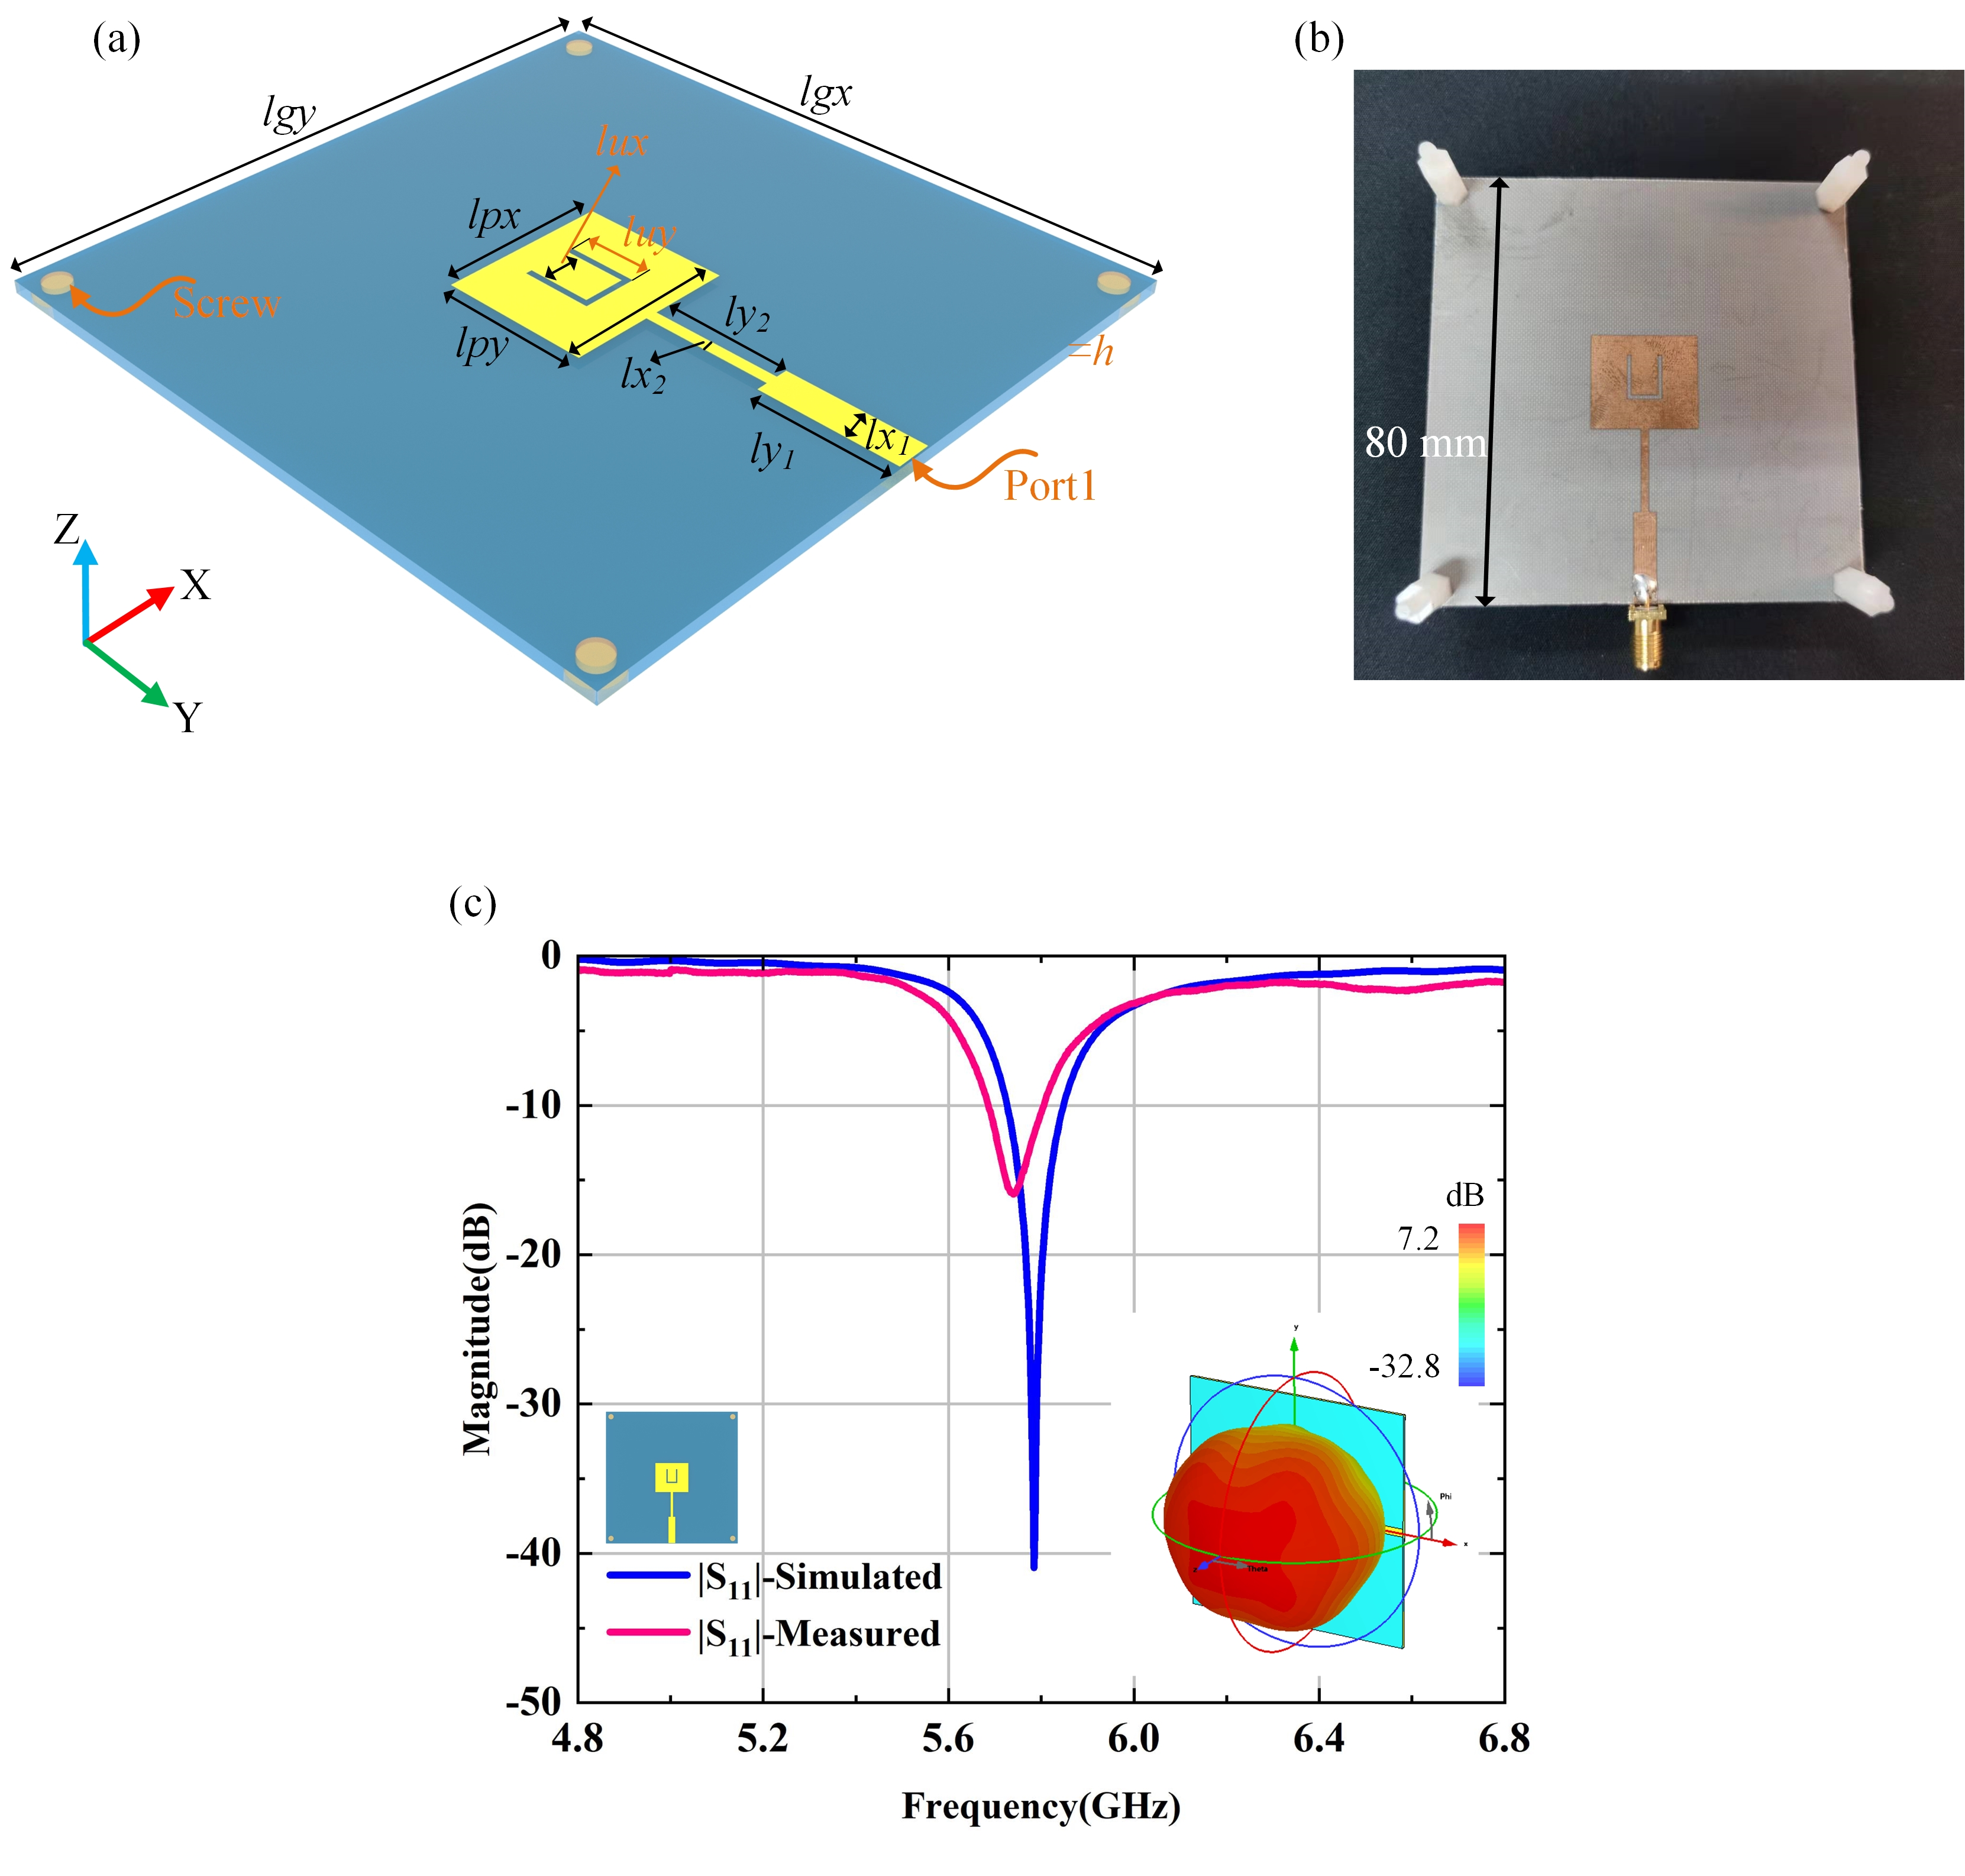
Supplementary Figure S8. The receiver patch antenna. (a) Perspective view of the antenna. (b) Photograph of the fabricated antenna. (c) The gain and reflection coefficient (S11) of the patch antenna.
Table S1. Dimensions of the patch antenna.
Parameters | lx₁ | ly₁ | lx₂ | ly₂ | lux | luy | lpx | lpy | lgx | lgy | h
Dimension (mm) | 4.1 | 15.95 | 1.4 | 15 | 5 | 8.4 | 20 | 17.6 | 80 | 80 | 1.5

Fig. S8(a-b) shows the basic structure of the proposed patch antenna that serves as the receiver. This U-shape patch antenna has a total size of 80×80 mm². The commercial dielectric F4B with a relative permittivity of 2.65, a thickness of 1.5 mm, and a loss tangent of 0.003 is adopted in this design. The dimensions of the patch are listed in Table S1. Fig. S8(c) gives the simulated and measured reflection coefficient (S11) for the patch antenna, showing that it works around 5.77 GHz. The simulated gain is also given in the inset, proving that the antenna has a very good radiation performance.
Note S7. Description of switching speed of system
We measured the switching speed of FPGA and the switching speed of the whole system, and got real-time data. As shown in Fig. S9(a), we use serial port tools and software to send sequences to FPGA at regular intervals. The pins of the FPGA are connected with the logic analyzer, and another computer is used to monitor the results of logic analyzer. We find that the FPGA can complete the voltage change on the pins with sequences at intervals of about 30ms, and the results are shown in Fig. S9(b). Similarly, we switched our system to the first serial port tool in the experiment. Through the previous analysis, we can track the moving target at a relatively fast speed, and each identification will send data. We can control the time interval of sending data. In the experiment, we set it to 0.2s, and the time interval between two samples obtained by testing with logic analyzer is about 0.2s, which is in line with the time domain change of the system.

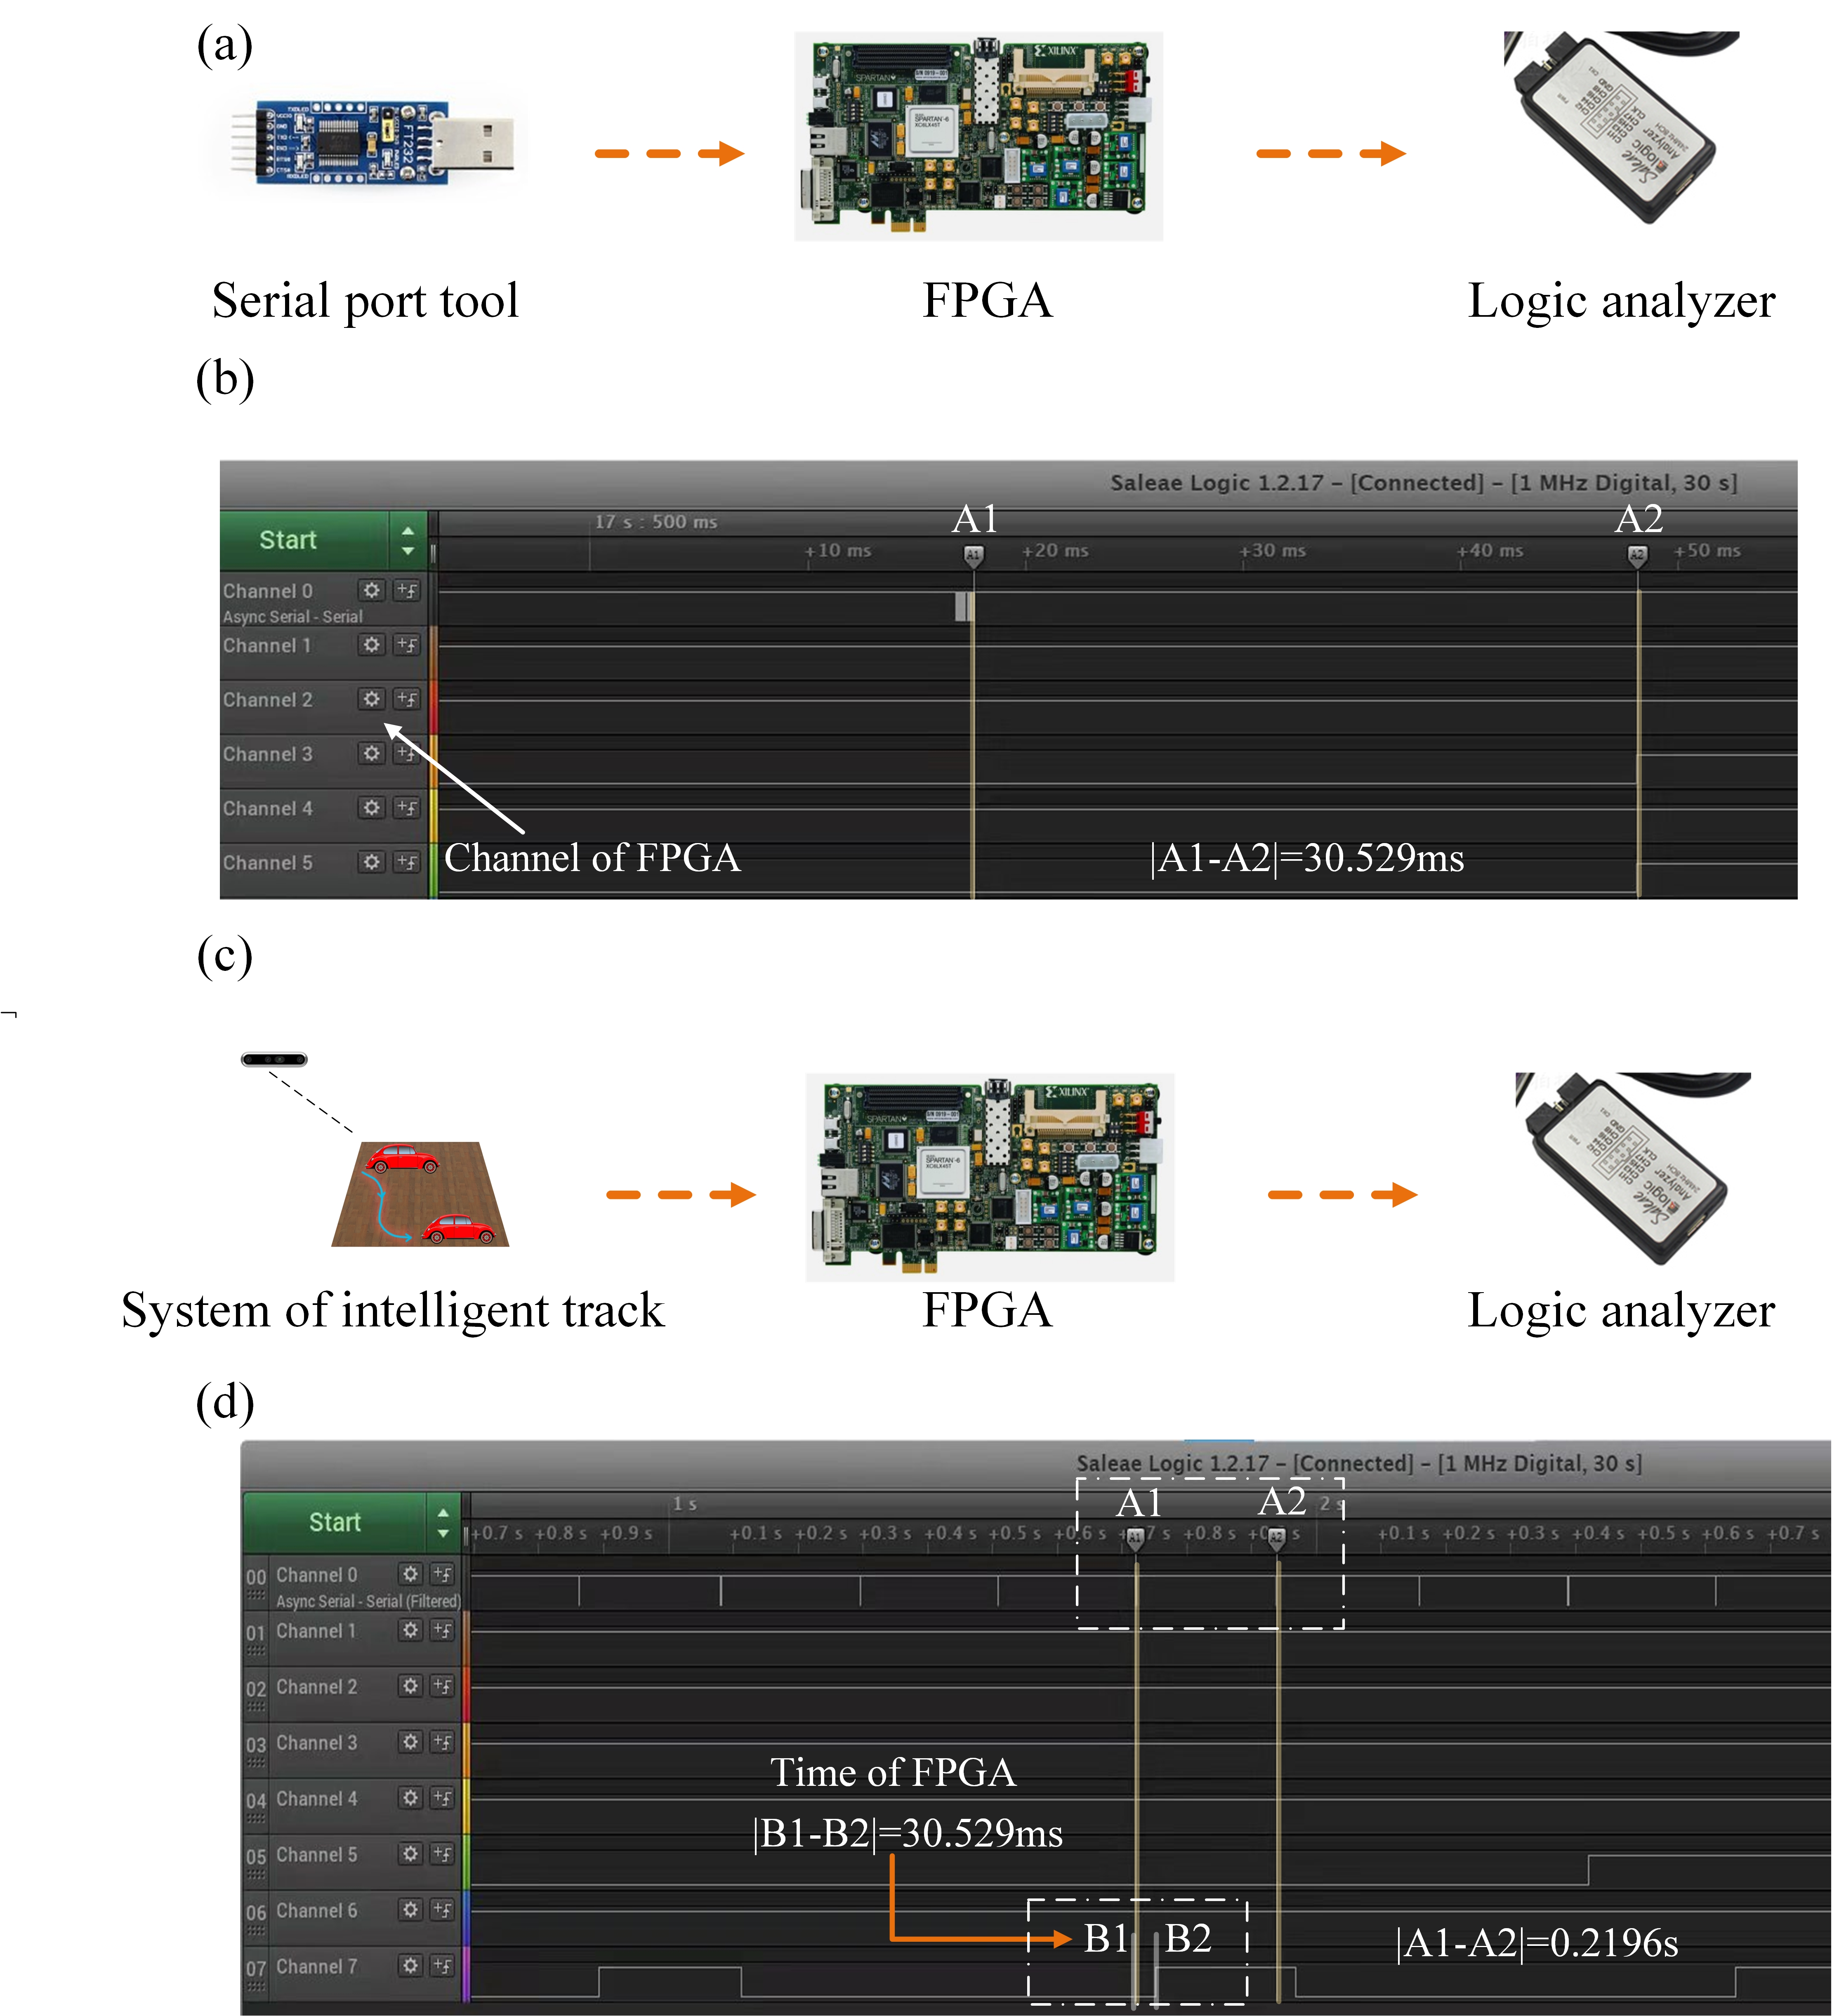
Supplementary Figure S9. Experimental test of switching speed and actual sampling results.

