Supplementary Information for

Liquid Water on Cold Exo-Earths via Basal Melting of Ice Sheets

Lujendra Ojha¹, Bryce Troncone¹, Jacob Buffo², Baptiste Journaux³, George McDonald¹

¹Department of Earth and Planetary Sciences, Rutgers University, Piscataway, NJ, USA
²Thayer School of Engineering, Dartmouth College, Hanover, NH 03755, USA.
³Department of Earth and Space Science, University of Washington, Seattle, WA, USA.

Corresponding Author: (luju.ojha@rutgers.edu)

Supplementary Figure 1. Estimated equilibrium temperature (T_{eq} ) and mass (relative to Earth) of various likely habitable exoplanets with colors showing the estimated surface gravity and dashed line marking the temperature of 273 K.

Supplementary Figure 2. Pressure and melting temperature at the base of ice sheets of various thicknesses on exo-Earths. The pressure at the bottom of the ice sheet increases with depth, but the melting temperature of ice decreases due to the presence of pressurized ice Ih.

Supplementary Figure 3. An example of initial steady-state profiles of temperature, density, specific heat, and ice-phase as a function of depth in a 75 km thick ice sheet on exo-Earth LHS 1140 b assuming a surface temperature of 235 K. The temperature is assumed to increase with depth in an adiabatic fashion. These initial profiles are coupled with a thermal evolution model to explore the feasibility of basal melting and the time-varying ice phase evolution of the thick ice cap.

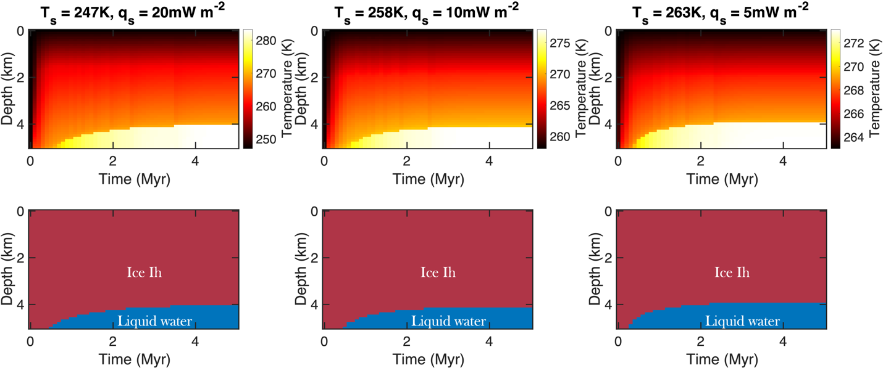
Supplementary Figure 4. An example of the temperature and phase evolution within a 5-km thick ice sheet on GJ 1061 d (left), Trappist 1e (center), and Kepler-442 b (right) over a 5-million-year period. The values of q on the title of the plots are the minimum q required for basal melting on these bodies.

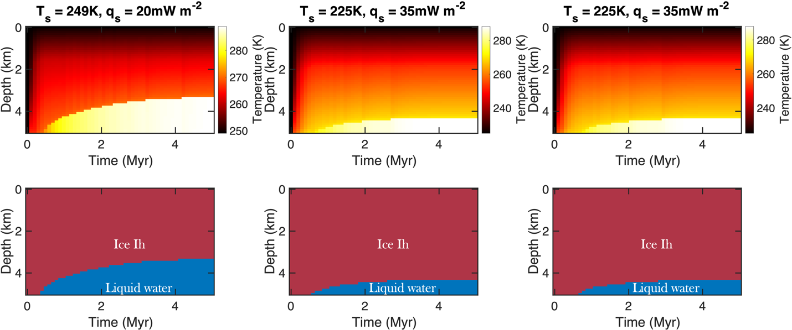
Supplementary Figure 5. An example of the temperature and phase evolution within a 5-km thick ice sheet on GJ 667 C f (left), TRAPPIST-1 f (center), and Teegarden's Star c (right) over a 5-million-year period. The values of q on the title of the plots are the minimum q required for basal melting on these bodies.

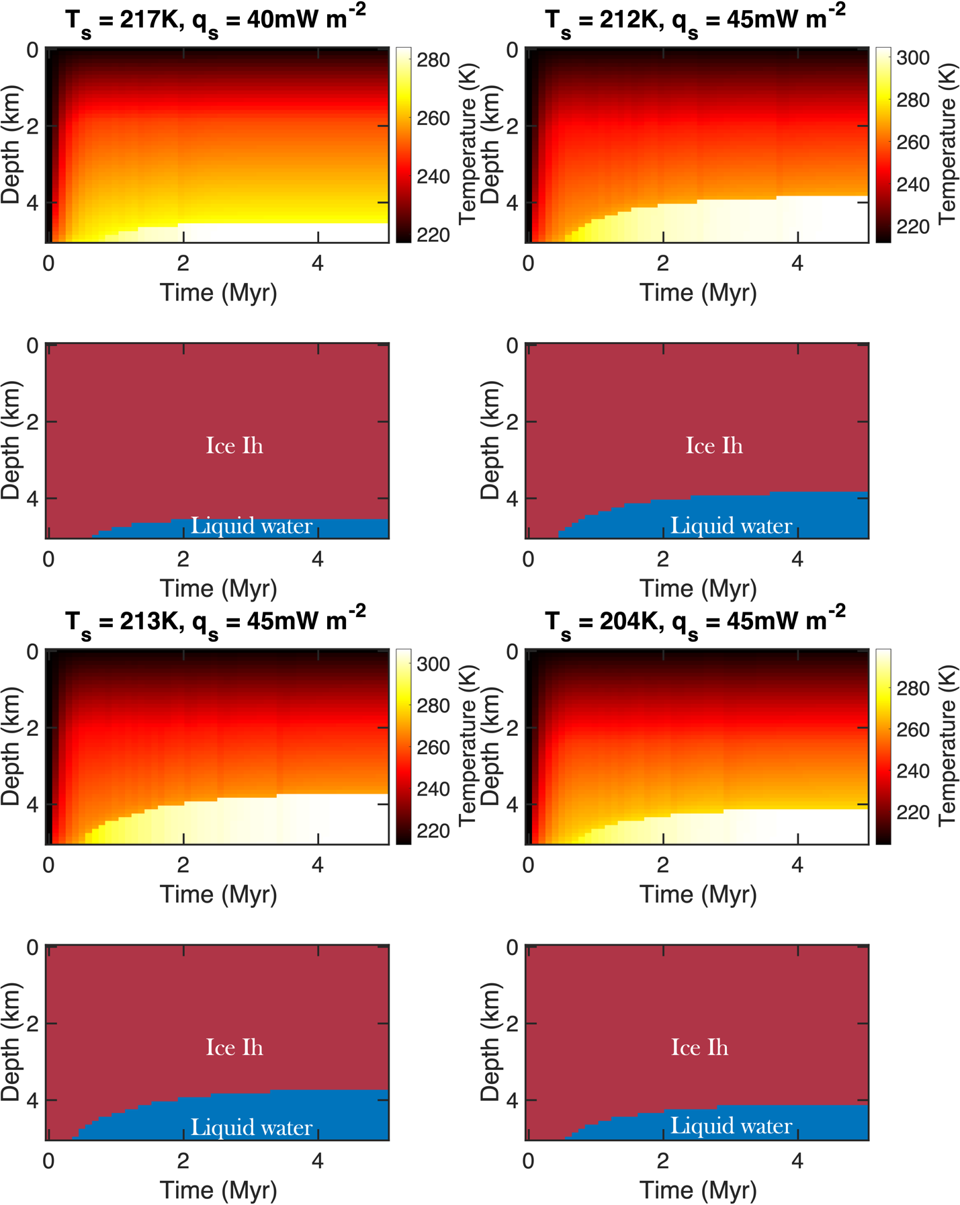
Supplementary Figure 6. An example of the temperature and phase evolution within a 5-km thick ice sheet on Kepler-1229 b (top-left), Kepler-186 f (top-right), GJ 667 C e (bottom left), TRAPPIST-1 g (bottom right) over a 5-million-year period. The values of q on the title of the plots are the minimum q required for basal melting on these bodies.
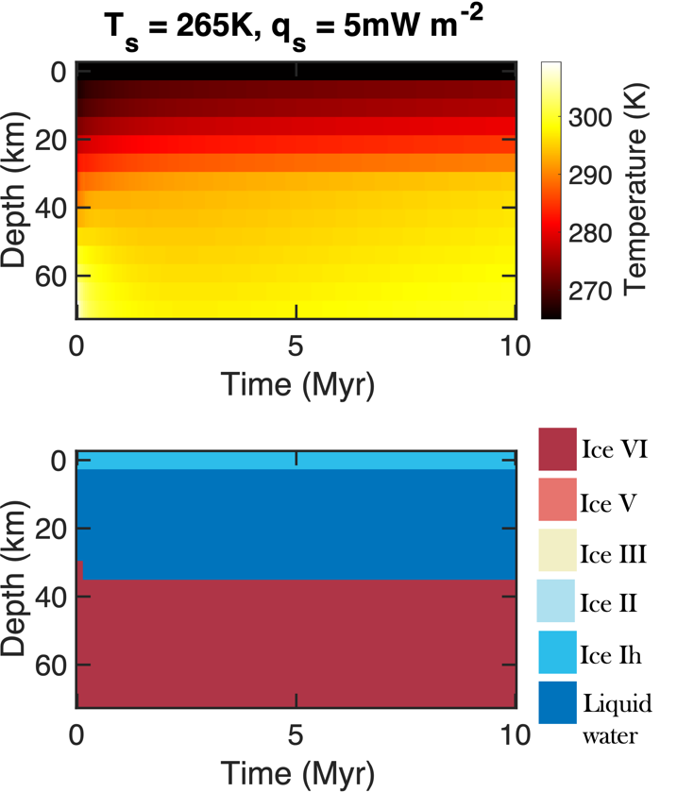
Supplementary Figure 7. An example of the temperature and phase evolution within a 70-km thick ice sheet on LHS 1140B over a 10-million-year period assuming a heat flow of 5 mW m⁻².

Exoplanet | T_{eq} (K) | Surface gravity (m s⁻²) | M_{Earth} | R_{Earth} | GEL of H₂O*
Earth | 255 | 9.81 | 1 | 1 | 4.5
Proxima Cen b | 257 | 7.9827 | 1.27 | 1.08 | 4.7619
GJ 1061 d | 247 | 9.4155 | 1.64 | 1.15 | 5.6167
TRAPPIST-1 e | 258 | 10.0492 | 0.69 | 0.92 | 5.9947
Kepler-442 b | 263 | 10.1226 | 2.36 | 1.35 | 6.0385
GJ 667 C f | 249 | 10.6619 | 2.54 | 1.45 | 6.3601
TRAPPIST-1 f | 225 | 11.8297 | 1.04 | 1.04 | 7.0568
Teegarden's Star c | 225 | 11.8297 | 1.11 | 1.04 | 7.0568
Kepler-1229 b | 217 | 12.143 | 2.54 | 1.4 | 7.2437
Kepler-186 f | 212 | 12.2321 | 1.71 | 1.17 | 7.2968
GJ 667 C e | 213 | 12.6801 | 2.54 | 1.45 | 7.5641
TRAPPIST-1 g | 204 | 12.6898 | 1.32 | 1.13 | 7.5699
LHS 1140 b | 235 | 23.2279 | 6.38 | 1.64 | 13.85

Table S1. M-dwarf orbiting, potentially habitable planets with T_{eq} < 273 K. *Global Equivalent Layer (GEL) of H₂O assuming Earth like WMF 0.05 %.

