Supplementary material: Influence of extreme events and local stressors on coral diversity in the Mesoamerican Reef during the last decade
Aarón Israel Muñiz-Castillo¹, Melanie McField^{2,3}, Jesús Ernesto Arias González¹
¹ Laboratorio de Ecología de Ecosistemas de Arrecifes Coralinos, Departamento de Recursos del Mar, Centro de Investigación y de Estudios Avanzados del I.P.N. Mérida, Yucatán 97310, Mexico.
² Smithsonian Marine Station, Smithsonian Institution, Fort Pierce 34949 Florida, USA.
³Healthy Reefs for Healthy People Initiative, Ft. Lauderdale, Florida 33312, USA.

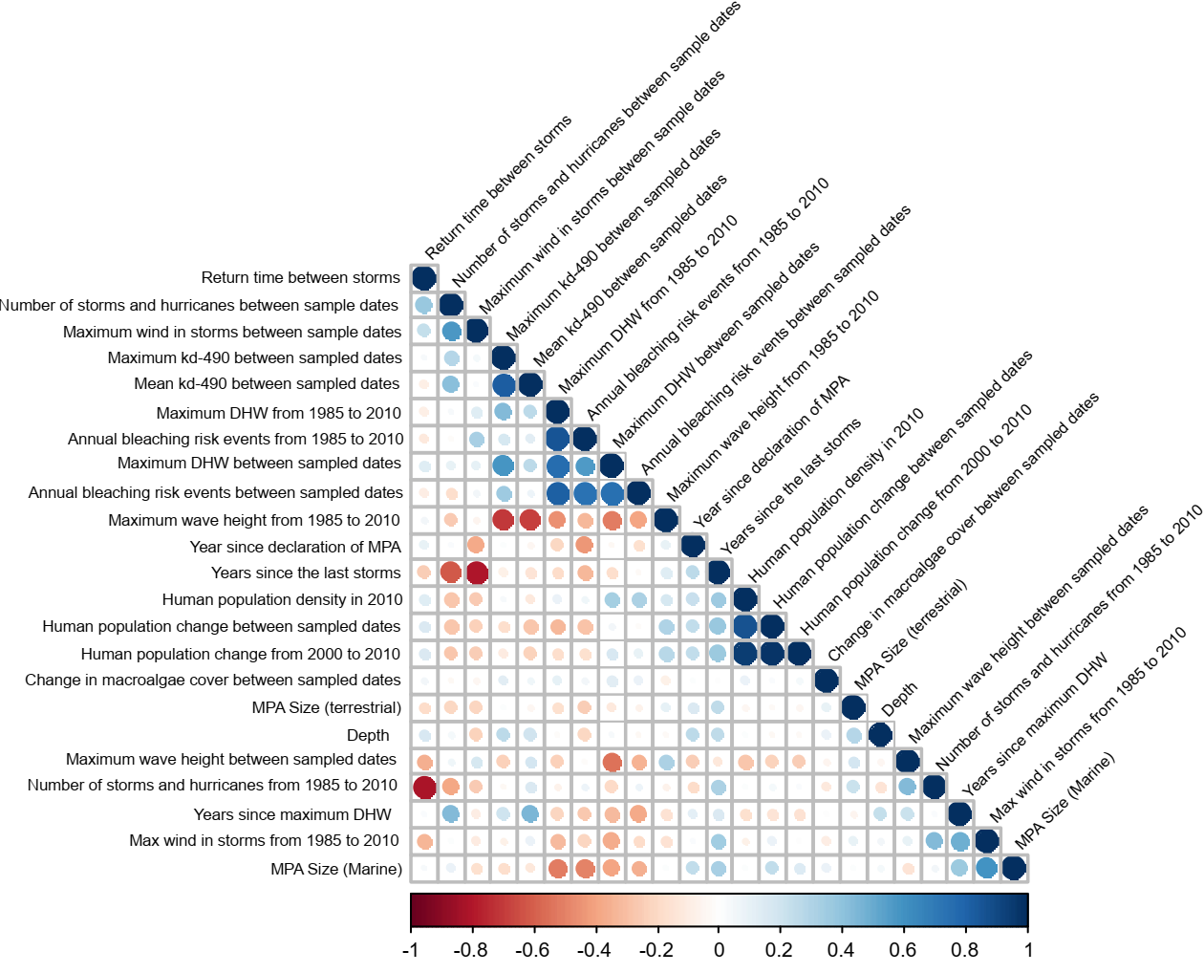
Supplementary Figure 1. Pearson's correlation of all explanatory variables used in linear regression models. The explanation of each of the metrics can be found in the methods section of the manuscript.
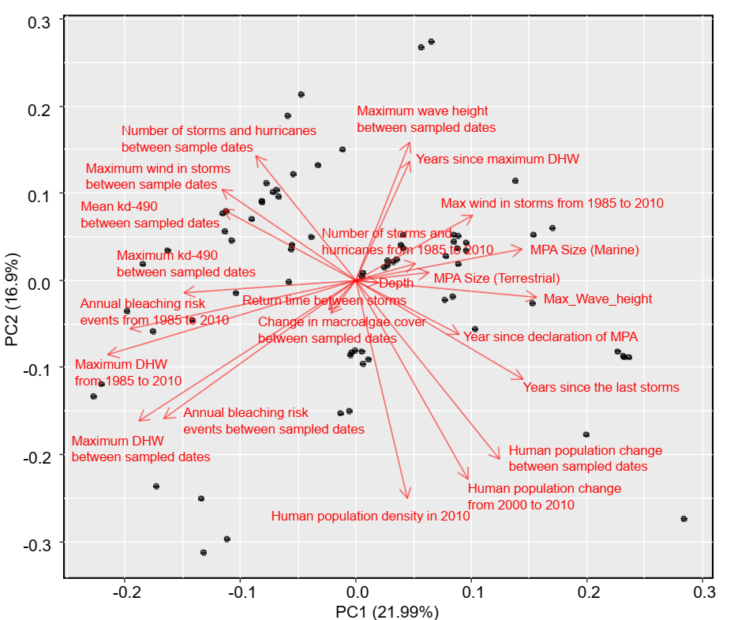
Supplementary Figure 2. Principal Components Analysis of all explanatory variables used in linear regression models. The explanation of each of the metrics can be found in the methods section of the manuscript.

Supplementary Table 1. List of identified species that were recorded on the Linear Point Intercept transects. Abbreviation expresses the code of the species which includes the first letter of the genus name and the first three letters of the species name. In addition, the frequency (N° of sites) and total relative cover (%) of the first and last periods considered are presented.
Name | Abbreviation | Frequency in 2010 -2012 | Total relative cover in 2010-2012 | Frequency in 2018 | Total relative cover in 2018
Acropora cervicornis | ACER | 14 | 0.89 | 11 | 0.79
Acropora palmata | APAL | 12 | 5.44 | 13 | 5.95
Acropora prolifera | APRO | 0 | 0.00 | 2 | 0.13
Agaricia agaricites | AAGA | 61 | 9.09 | 46 | 7.43
Agaricia fragilis | AFRA | 3 | 0.04 | 3 | 0.31
Agaricia grahamae* | AGRA | 0 | 0.00 | 0 | 0.00
Agaricia humilis | AHUM | 23 | 0.98 | 4 | 0.26
Agaricia lamarcki | ALAM | 7 | 0.32 | 1 | 0.03
Agaricia tenuifolia | ATEN | 41 | 15.27 | 41 | 14.78
Colpophyllia natans | CNAT | 30 | 2.69 | 18 | 1.42
Dendrogyra cylindrus | DCYL | 10 | 0.39 | 9 | 0.60
Dichocoenia stokesii | DSTO | 21 | 0.34 | 12 | 0.22
Diploria labyrinthiformis | DLAB | 27 | 1.16 | 30 | 2.70
Eusmilia fastigiata | EFAS | 9 | 0.34 | 5 | 0.19
Favia fragum | FFRA | 7 | 0.13 | 2 | 0.07
Helioseris cucullata | HCUC | 10 | 0.44 | 12 | 0.21
Isophyllia rigida | IRIG | 3 | 0.05 | 0 | 0.00
Isophyllia sinuosa | ISIN | 1 | 0.01 | 0 | 0.00
Madracis auretenra | MAUR | 3 | 0.08 | 6 | 0.43
Madracis decactis | MDEC | 7 | 0.14 | 4 | 0.14
Madracis formosa | MFOR | 1 | 0.01 | 0 | 0.00
Manicina areolata | MARE | 3 | 0.05 | 1 | 0.03
Meandrina jacksoni | MJAC | 0 | 0.00 | 1 | 0.03
Meandrina meandrites | MMEA | 12 | 0.49 | 14 | 0.73
Millepora alcicornis | MALC | 45 | 2.57 | 35 | 2.62
Millepora complanata | MCOM | 27 | 3.75 | 15 | 1.80
Millepora squarosa* | MSQU | 0 | 0.00 | 0 | 0.00
Millepora striata | MSTR | 0 | 0.00 | 3 | 0.33
Montastraea cavernosa | MCAV | 44 | 3.39 | 37 | 2.79
Mussa angulosa | MANG | 2 | 0.02 | 0 | 0.00
Mycetophyllia aliciae | MALI | 2 | 0.06 | 0 | 0.00
Mycetophyllia danaana | MDAN | 1 | 0.01 | 0 | 0.00
Mycetophyllia ferox | MFER | 2 | 0.06 | 2 | 0.15
Mycetophyllia lamarckiana | MLAM | 5 | 0.06 | 2 | 0.04
Oculina diffusa | ODIF | 1 | 0.05 | 0 | 0.00
Orbicella annularis | OANN | 40 | 6.59 | 33 | 8.02
Orbicella faveolata | OFAV | 38 | 7.10 | 38 | 4.99
Orbicella franksi | OFRA | 13 | 1.21 | 8 | 0.80
Porites astreoides | PAST | 70 | 13.74 | 65 | 13.40
Porites furcata | PFUR | 17 | 0.81 | 8 | 0.88
Porites porites | PPOR | 45 | 4.68 | 42 | 6.54
Porites divaricata | PDIV | 21 | 0.82 | 6 | 0.93
Pseudodiploria clivosa | PCLI | 18 | 1.09 | 8 | 0.42
Pseudodiploria strigosa | PSTR | 42 | 5.39 | 39 | 6.34
Scolymia cubensis | SCUB | 4 | 0.05 | 4 | 0.17
Scolymia lacera | SLAC | 2 | 0.02 | 1 | 0.02
Siderastrea radians | SRAD | 18 | 0.41 | 14 | 0.49
Siderastrea siderea | SSID | 58 | 8.83 | 59 | 11.82
Solenastrea bournoni | SBOU | 1 | 0.01 | 2 | 0.08
Stephanocoenia intersepta | SINT | 30 | 0.92 | 22 | 0.92

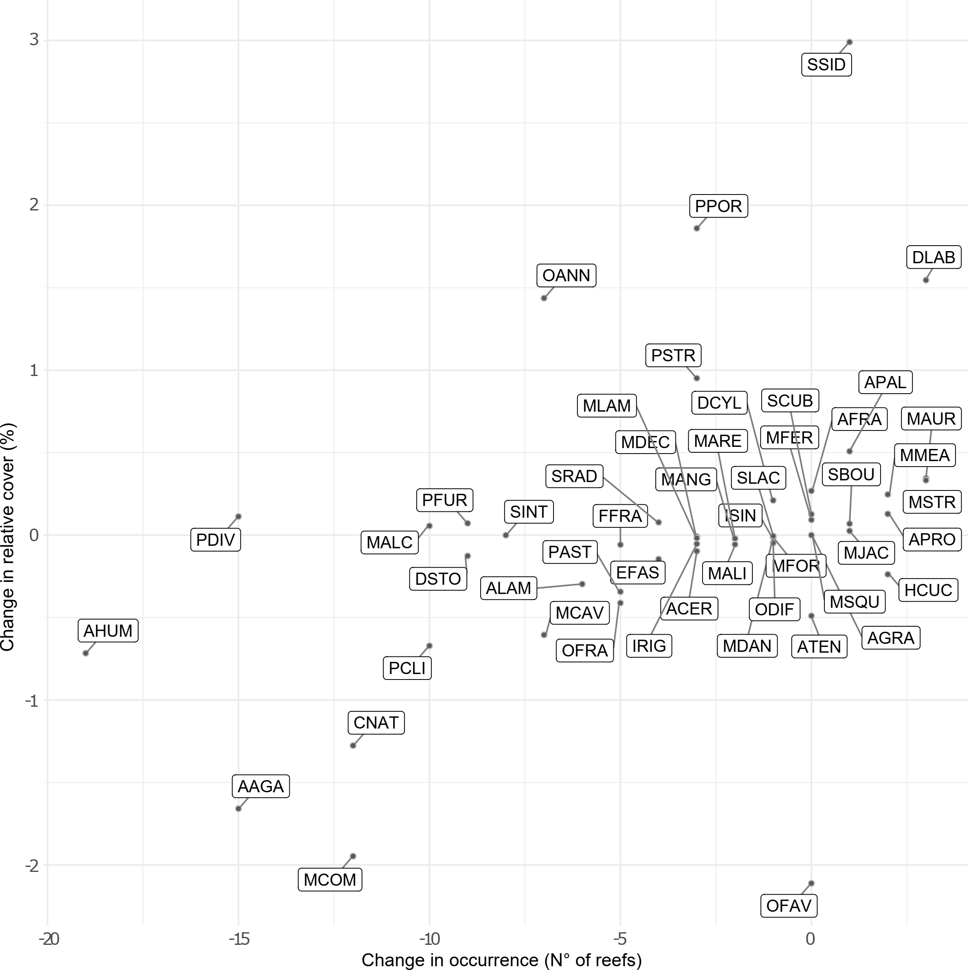
Supplementary Figure 3. Scatterplot of the relative change in frequency and abundance of each species. The difference in frequency and relative cover were calculated considering the global value of the first and last period for each of the species. Negative values on the axes of the graph express a loss in frequency or relative cover. We present the species in the codes shown in Supplementary table 1.

Supplementary Table 2. Results of the heteroscedasticity repeated measures ANOVA for trimming means applied to diversity metrics.
Diversity index | F-statistic | Degrees of freedom | p-value
Richness | 5.3381 | 3:147 | 0.00161
N1 Diversity | 5.5031 | 2.93: 143.5 | 0.00145
N2 Diversity | 5.9924 | 2.91: 142.75 | 0.00081

Supplementary Table 3. Results of post hoc tests for heteroscedasticity repeated measures ANOVA for species richness. CI = Confidence Interval. Periods: 1 = 2010 to 2012; 2 = 2013 to 2015; 3 = 2016; and 4 = 2018.
Periods | Difference | CI-lower | CI-upper | p-value | p-critical
1 VS 2 | 0.50007 | 0.06304 | 0.93711 | 0.00281 | 0.0102
1 VS 3 | 0.46324 | 0.00396 | 0.92252 | 0.00783 | 0.0127
1 VS 4 | 0.64417 | 0.09341 | 1.19492 | 0.0023 | 0.00851
2 VS 3 | 0.17955 | -0.30142 | 0.66051 | 0.30972 | 0.025
2 VS 4 | 0.2274 | -0.29202 | 0.74683 | 0.23446 | 0.0169
3 VS 4 | 0.09255 | -0.51615 | 0.70125 | 0.67773 | 0.05

Supplementary Table 4. Results of post hoc tests for heteroscedasticity repeated measures ANOVA for Diversity N1 of Hill numbers. CI = Confidence Interval. Periods: 1 = 2010 to 2012; 2 = 2013 to 2015; 3 = 2016; and 4 = 2018.
Periods | Difference | CI-lower | CI-upper | p-value | p-critical
1 VS 2 | 0.41183 | 0.02767 | 0.79599 | 0.00489 | 0.0102
1 VS 3 | 0.39884 | 0.05908 | 0.7386 | 0.00223 | 0.00851
1 VS 4 | 0.47226 | 0.01523 | 0.92928 | 0.00653 | 0.0127
2 VS 3 | 0.18745 | -0.20044 | 0.57535 | 0.19007 | 0.0169
2 VS 4 | 0.1992 | -0.21712 | 0.61552 | 0.19442 | 0.025
3 VS 4 | 0.04749 | -0.43112 | 0.5261 | 0.78612 | 0.05

Supplementary Table 5. Results of post hoc tests for heteroscedasticity repeated measures ANOVA for Diversity N1 of Hill numbers. CI = Confidence Interval. Periods: 1 = 2010 to 2012; 2 = 2013 to 2015; 3 = 2016; and 4 = 2018.
Periods | Difference | CI-lower | CI-upper | p-value | p-critical
1 VS 2 | 0.35075 | 0.00298 | 0.69851 | 0.00783 | 0.0127
1 VS 3 | 0.34098 | 0.04316 | 0.6388 | 0.0028 | 0.00851
1 VS 4 | 0.39793 | 0.00421 | 0.79166 | 0.00771 | 0.0102
2 VS 3 | 0.16524 | -0.16111 | 0.49159 | 0.17015 | 0.025
2 VS 4 | 0.18297 | -0.1738 | 0.53974 | 0.16481 | 0.0169
3 VS 4 | 0.03997 | -0.35747 | 0.4374 | 0.78333 | 0.05

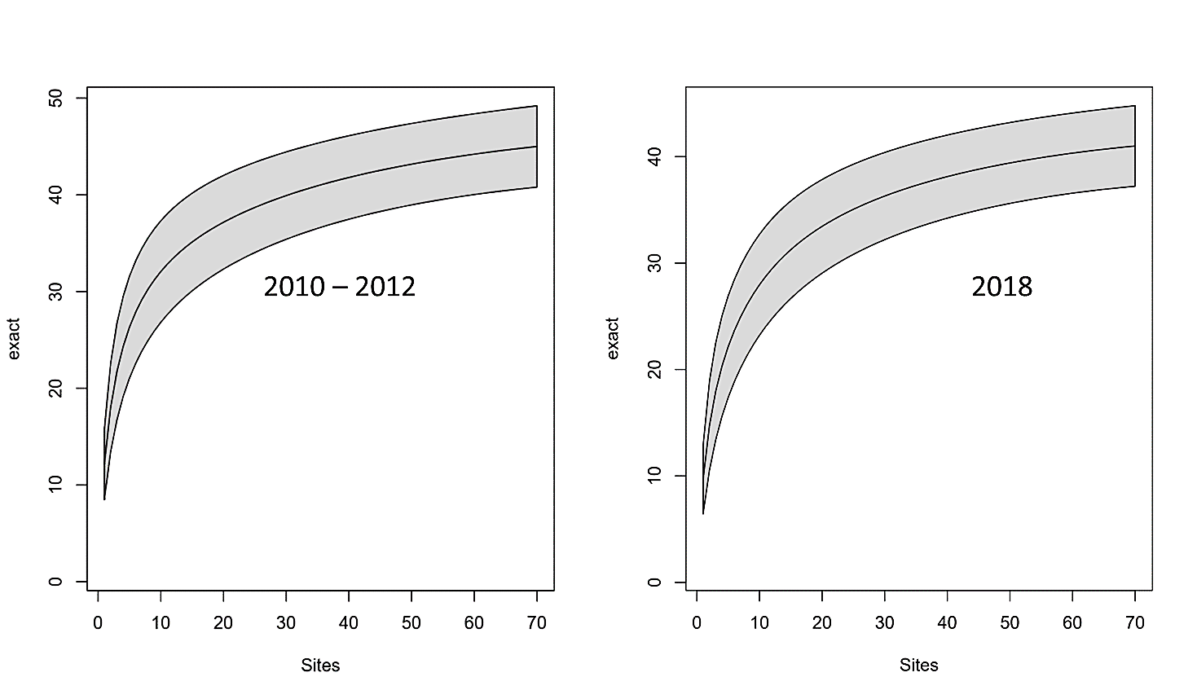
Supplementary Figure 4. Species accumulation curve for the first and last period. The bands show the 95% Confidence Interval.

