Supplementary Information for:

Network-specific metabolic and hemodynamic effects elicited by non-invasive brain stimulation

AUTHORS: Mark C. Eldaief, MD^{1,2,3,5} *, Stephanie McMains, PhD⁴, David Izquierdo-Garcia, PhD⁵, Rodrigo M. Braga, PhD⁶
¹Department of Neurology, Massachusetts General Hospital, Harvard Medical School, Boston MA 02114, USA.

²Department of Psychiatry, Massachusetts General Hospital, Harvard Medical School, Boston, MA 02114, USA.
³Center for Brain Science, Neuroimaging Facility, Harvard University, Cambridge, MA, 02138, USA.
⁴Cognitive Neuroimaging Center, Boston University, Boston, MA 02215, USA.
⁵Athinoula A. Martinos Center for Biomedical Imaging, Massachusetts General Hospital, Charlestown, MA 02129, USA
⁶Department of Neurology, Northwestern University, Feinberg School of Medicine, Chicago, IL, 60611, USA
*Indicates lead author, senior author, and corresponding author

Email: mark.eldaief@mgh.harvard.edu

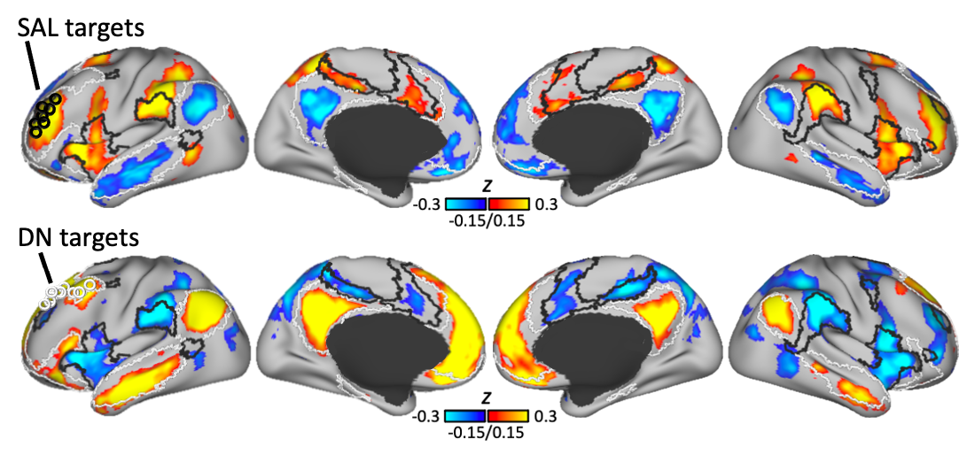

Fig. S1. Confirmation of network identity at target sites. Surface-rendered group-averaged seed-based functional connectivity (FC) maps defined using each subject’s salience network (SAL) targets (Top, black rings) and default network (DN) targets (Bottom, white rings) as seeds. The SAL targets showed positive correlation with regions of the salience network (black outlines) and negative correlations with regions of the default network (white outlines). In contrast, the DN targets showed positive correlation with the default network and negative correlation with the salience network.

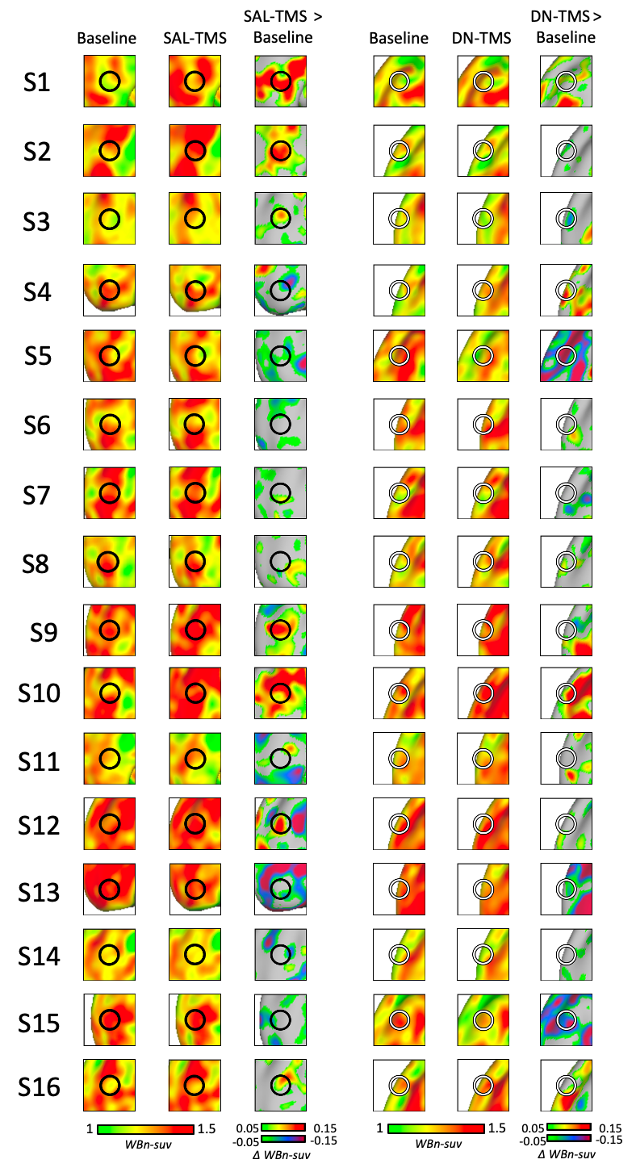

Fig. S2. Changes in target metabolism in each subject. Subjects are numbered in the order that data were acquired. For each subject, unthresholded images are shown displaying glucose metabolism at the target site during Baseline (left), following TMS (middle), and the subtraction of the two (right). Left panel shows effects of SAL-TMS, with black rings representing SAL targets. Right panel shows effects of DN-TMS, with white rings representing DN targets.
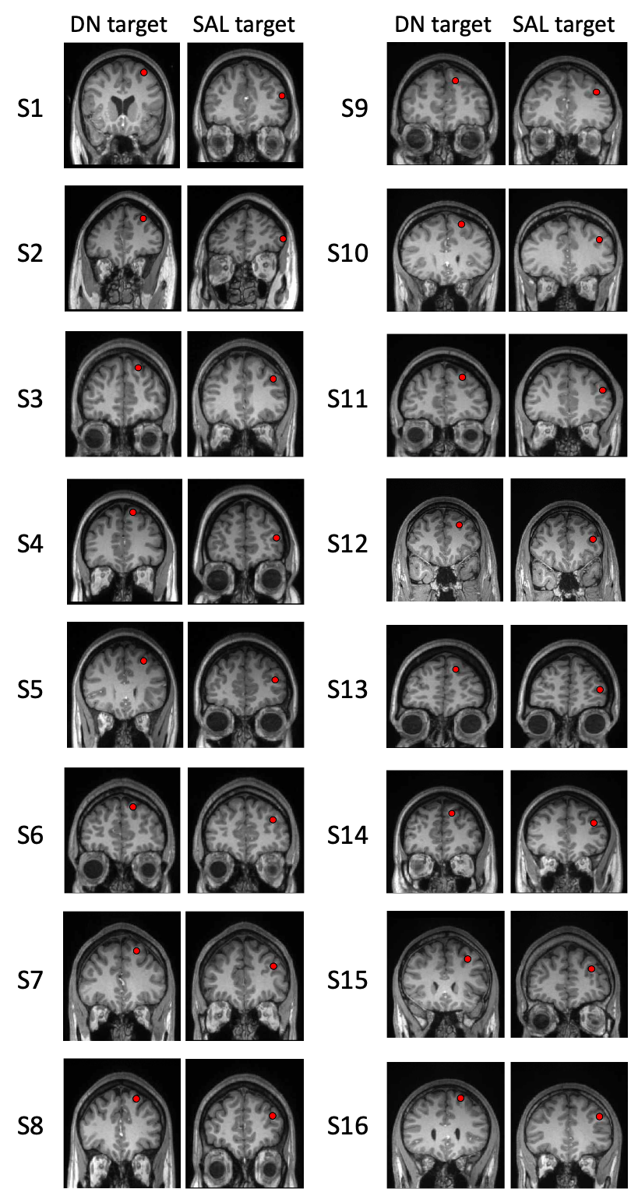

Fig. S3. Target locations as they relate to gyral morphology. Coronal T1 images of each subject are shown in standardized MNI space. Subjects were numbered in the order in which experimental procedures were performed. The red dots represent functionally derived target sites which were targeted using a neuronavigation system during administration of TMS. The targets in each subject were far apart, with a more dorsomedial site representing the default network (DN) target, while the more inferolateral site represents the salience network (SAL) target. We did not observe systematic differences between sites, such as in the depth or cortical orientation of the target in relation to the cranial surface, that might be relevant for understanding the different effects of stimulation.
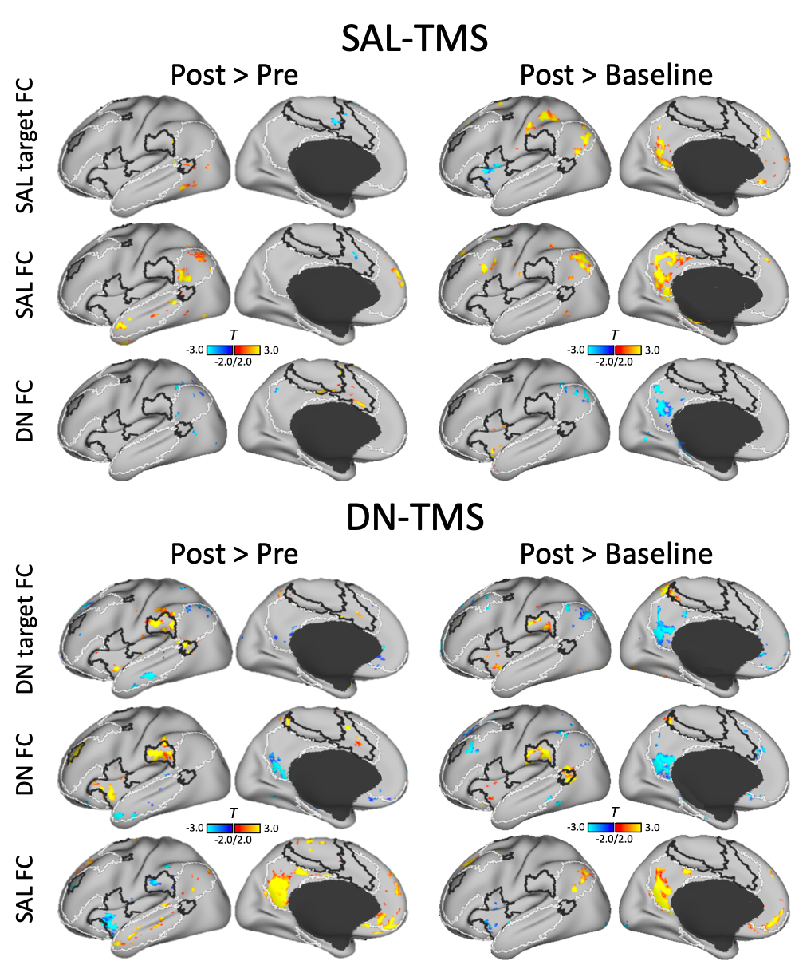

Fig. S4. Comparison of FC changes between Post-TMS > Pre-TMS and Post-TMS > Baseline. Surface rendered voxel-wise statistical T maps (p<0.05, FWE cluster corrected) showing Post-TMS > Pre-TMS FC changes (left) and Post-TMS > Baseline FC changes (right). Respective FC changes are shown from the target seeds (averaged across subjects), and ROIs encompassing the entire default and salience networks (DN and SAL ROIs). The top panel represents FC changes associated with SAL-TMS and the bottom panel represents changes associated with DN-TMS. For the SAL-TMS condition, between network changes were apparent more prominent in the Post-TMS > Baseline subtraction. For DN-TMS, the two comparisons differed in the magnitude of changes, but the topography and direction of FC changes were comparable, e.g., FC decreases within network and FC increases (i.e., reduced anticorrelations) between networks were observed in both comparisons.

