Supplementary material for: ‘A blood DNA methylation biomarker for predicting short-term risk of cardiovascular events’ by Andrea Cappozzo¹, Cathal McCrory², Oliver Robinson³, Anna Freni Sterrantino^{3,4}, Carlotta Sacerdote⁵, Vittorio Krogh⁶, Salvatore Panico⁷, Rosario Tumino⁸, Licia Iacoviello^{9,10}, Fulvio Ricceri^{11,12}, Sabina Sieri⁶, Paolo Chiodini¹³, Rose Anne Kenny², Aisling O’Halloran², Silvia Polidoro¹⁴, Giuliana Solinas¹⁵, Paolo Vineis³, Francesca Ieva^{1,16}, Giovanni Fiorito^{2,3,15, *}

Supplementary Results
Sensitivity leave-one-out analysis. We performed a sensitivity analysis to evaluate whether one of the ten DNAm surrogate biomarkers comprising the DNAmCVDscore drives the results described in the previous section. First, the DNAmCVDscore was re-computed ten times, excluding one DNAm surrogate each time. Then, AUC and 95% CI were calculated at different time points right censoring follow-up length as described previously. The results presented in Table S1 show that the AUC obtained using ten DNAm surrogates is generally higher than those obtained excluding one of them. However, none of the biomarkers significantly reduces the AUC when excluded (according to the DeLong test), suggesting that all the ten DNAm surrogates contribute predicting CVD events.

Correlation of DNAmCVDscore with epigenetic clocks. We computed the Pearson correlation coefficients (meta-analysis of the five studies) between DNAmCVDscore and previously developed epigenetic clocks. Although DNAmCVDscore was not explicitly trained on chronological age, it is highly correlated with age (R = 0.41) and four epigenetic clocks (R range from 0.35 to 0.56), DNAmGrimAge being the one with the highest correlation. In Supplementary Figure 1, we present the correlation heatmap.

DNAm surrogates and DNAmCVDscore vs COVID-19 case-control status and severity. In the GSE174818 dataset, BMI was not significantly different when comparing COVID-19 cases with matched controls whereas DNAm surrogate for BMI was significantly associated with COVID-19 case-control status: OR per one standard deviation increase = 2.64 (95% CI 1.56; 4.77, P = 0.0006, Table S2). Among COVID-19 cases, DNAmCRP outperforms blood measured CRP in predicting disease severity (GRAM score). The increase in the GRAM score were 17.1 (8.6; 25.6, P = 0.0002, Table S2) and 9.9 (1.1; 18.7, P = 0.03, Table S2) for DNAmCRP and blood measured CRP, respectively. Finally, DNAmCVDscore was (borderline significantly) associated with COVID-19 case-control status: OR per one standard deviation increase = 1.84 (95% CI 0.96; 3.65, P = 0.07, Table S2 and Supplementary Figure 2A), and GRAM score severity index. The estimate from the linear regression (interpretable as an increase in the GRAM score for one standard deviation increase in DNAmCVDscore) was 16.35 (95% CI 1.36; 31.04, P = 0.03, Table S2 and Supplementary Figure 2B).

Figure S1: Correlation heatmap with mutual Pearson correlation coefficients among DNAmCVDscore and epigenetic clocks
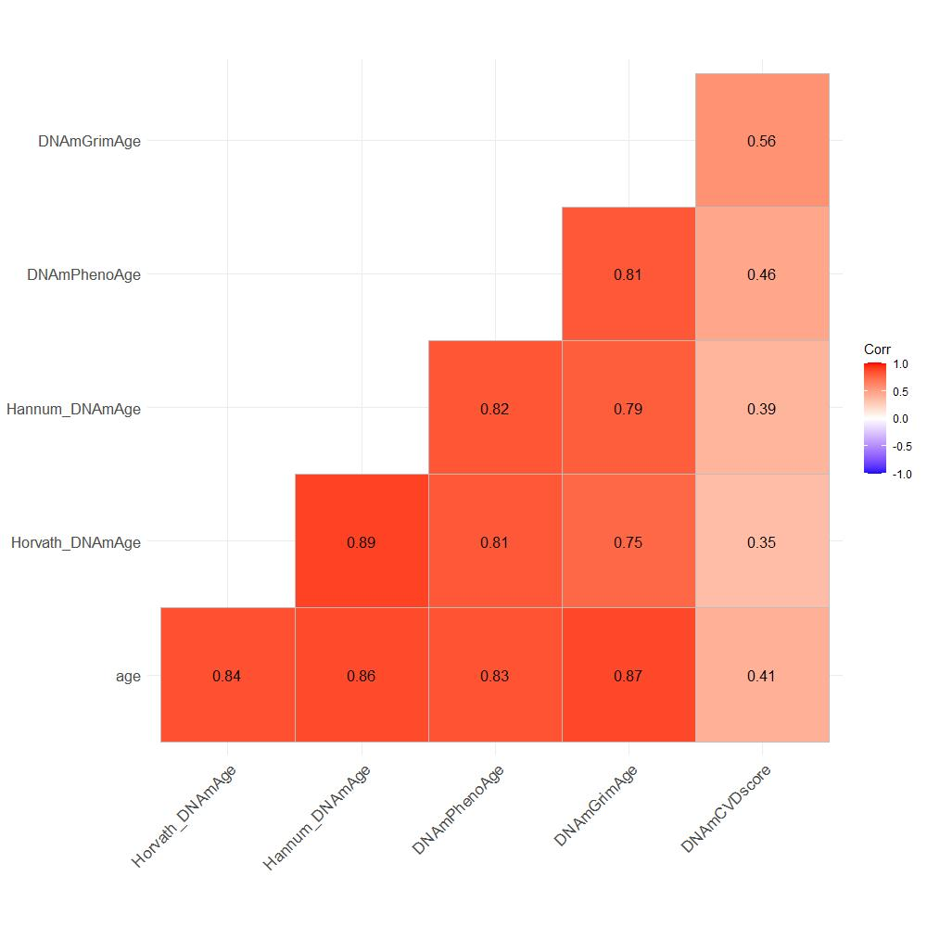
Figure S2: a) Violin plot of standardised DNAmCVDscore vs COVID-19 case-control status; b) scatterplot and regression line for DNAmCVDscore vs COVID-19 severity (GRAM score).
