Supplementary Information for paper Development of an insilico model of eccrine sweat

These plots are a result of various MD simulations carried out using LAMMPS and the values of self-diffusivity & bulk viscosity at various temperature and salt concentrations are presented. Validation with literature values and SEGWE from the Manchester NMR group tools is also presented.
https://nmr.chemistry.manchester.ac.uk/?q=node/432

Solution - Glucose + Salt + Water with water model TIP3P - post replicate 2x2x2

Glucose Salt Water – SPC/E – 35 A cube with SPC/E water model

Glucose Water TIP3P replicate

Salt Water spce

Glucose + Salt + Water TIP3P replicate rerun

Glucose Water Replicate – TIP3P

Glucose in water at 298K
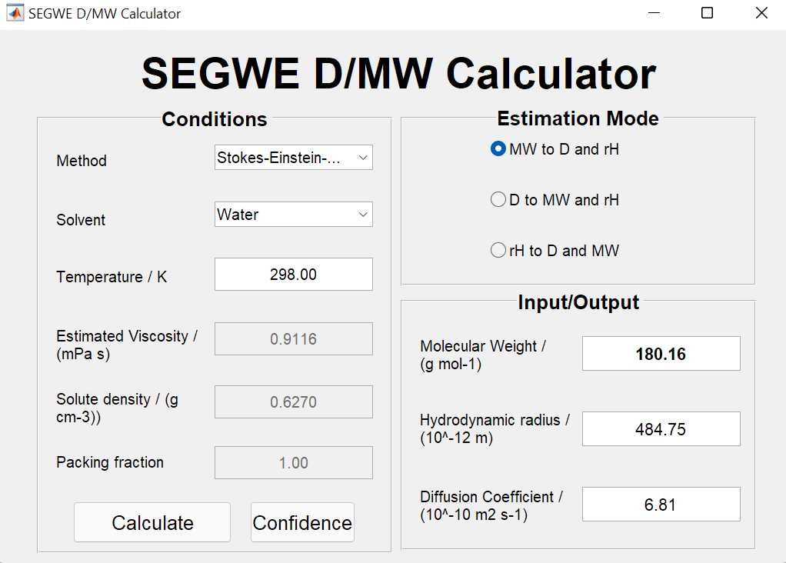
Glucose in water at 310K

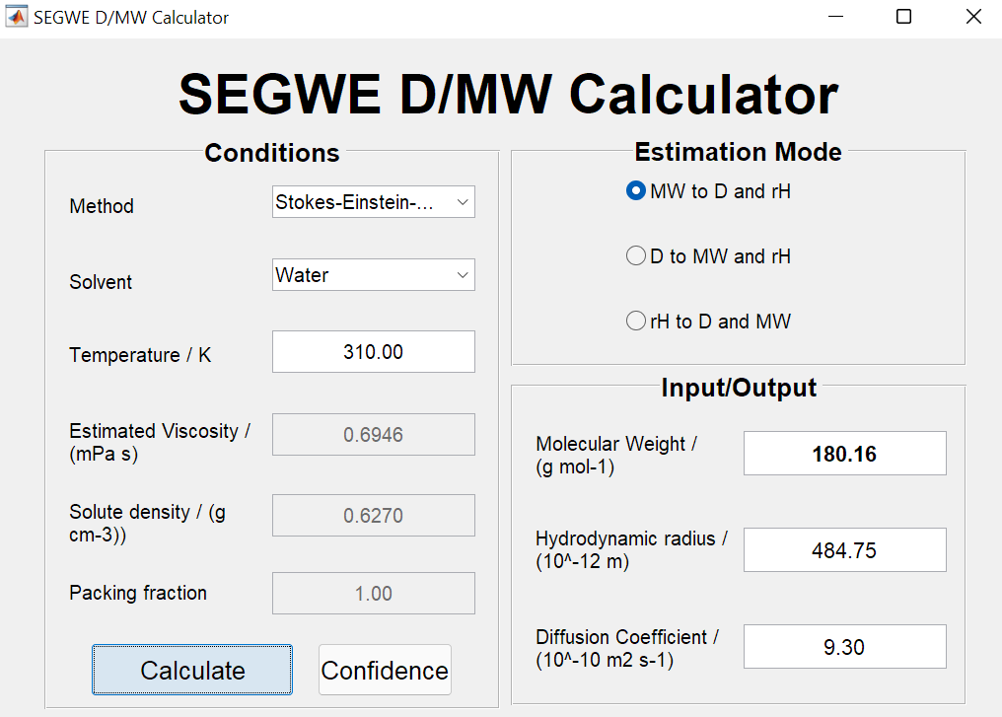

Na in water at 298K
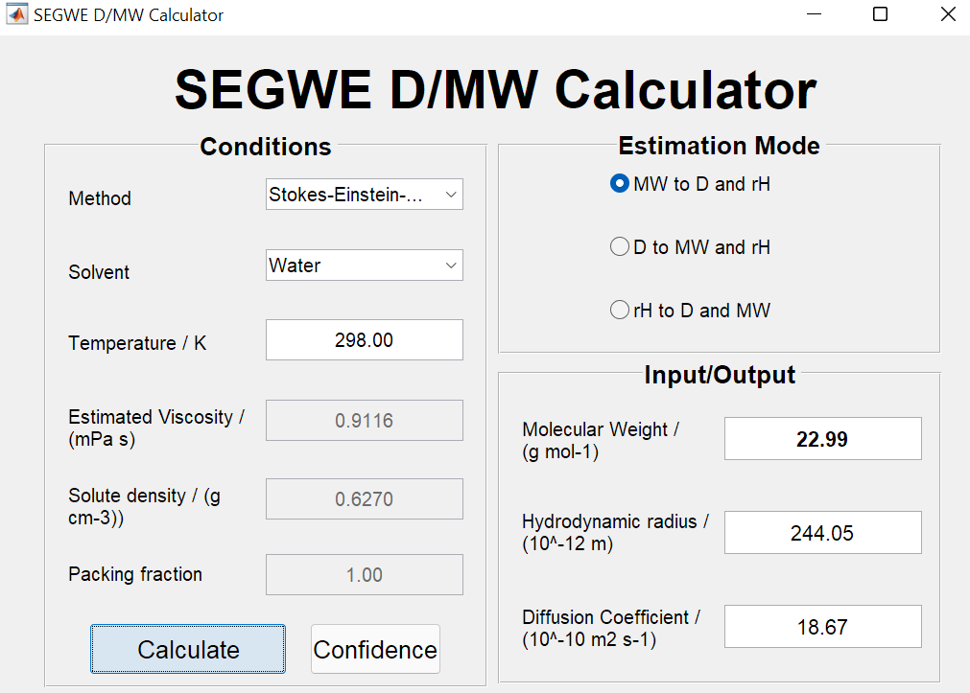

Na in water at 310K
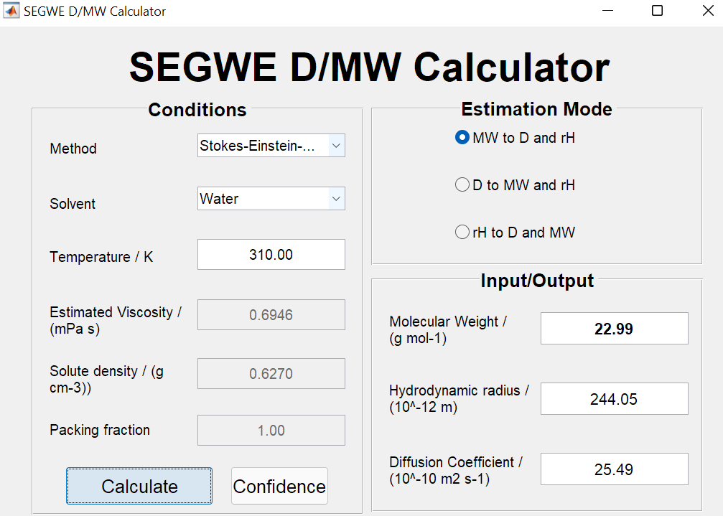

Cl in water at 298K
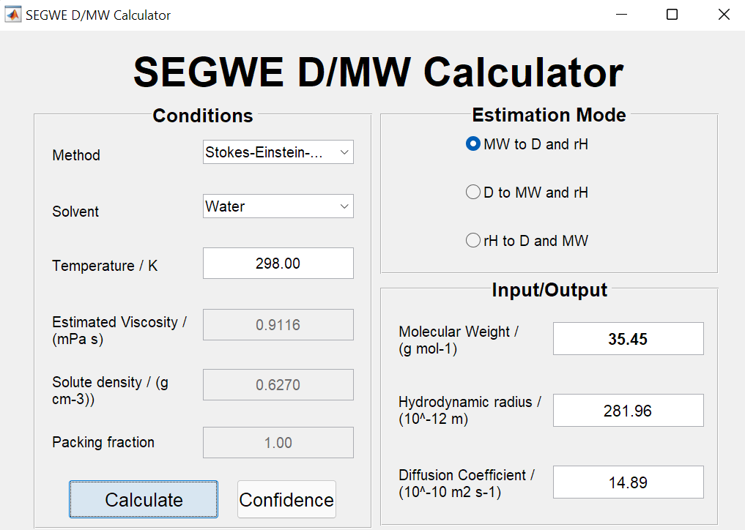

Cl in water at 310K
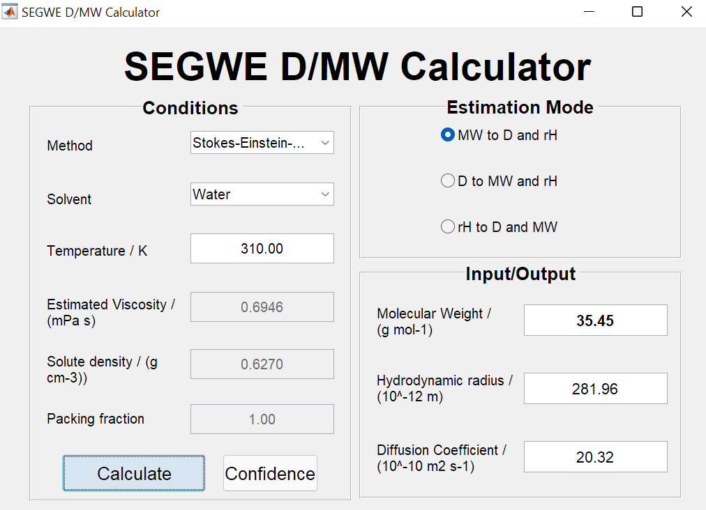

Water in water 298K
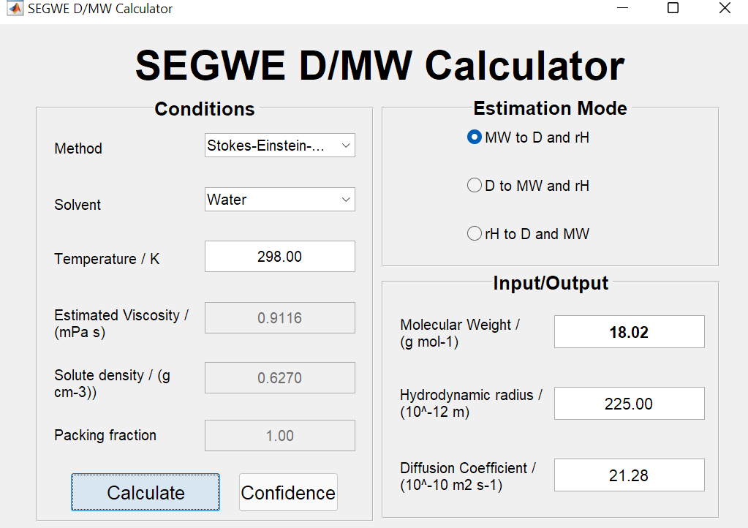

Water in water 310K
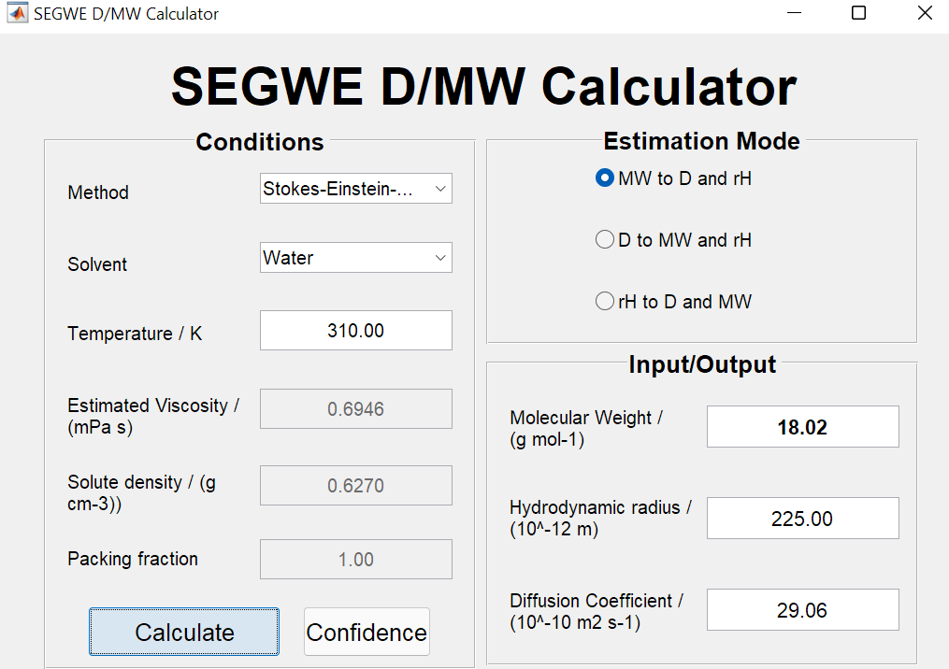

Viscosity of Water – TIP3P
Viscosity of Water – SPC/E

Water Salt Glucose Replicate 298K

Glucose Salt Water SPCE Replicate 310K

Glucose Salt Water Conc 3
Glucose Salt Water conc 4

