Additional Information for the paper
„Congregation Leaving the Reformed Church in Nuenen by Vincent van Gogh: a combined multi-instrumental approach to analyse the painting materials and support varnish removal”
by
Magdalena Iwanicka, Patrizia Moretti, Kathrin Pilz, Brenda Doherty, Laura Cartechini, Muriel Geldof, Suzan de Groot, Costanza Miliani, Piotr Targowski

Detailed results of XRF examination
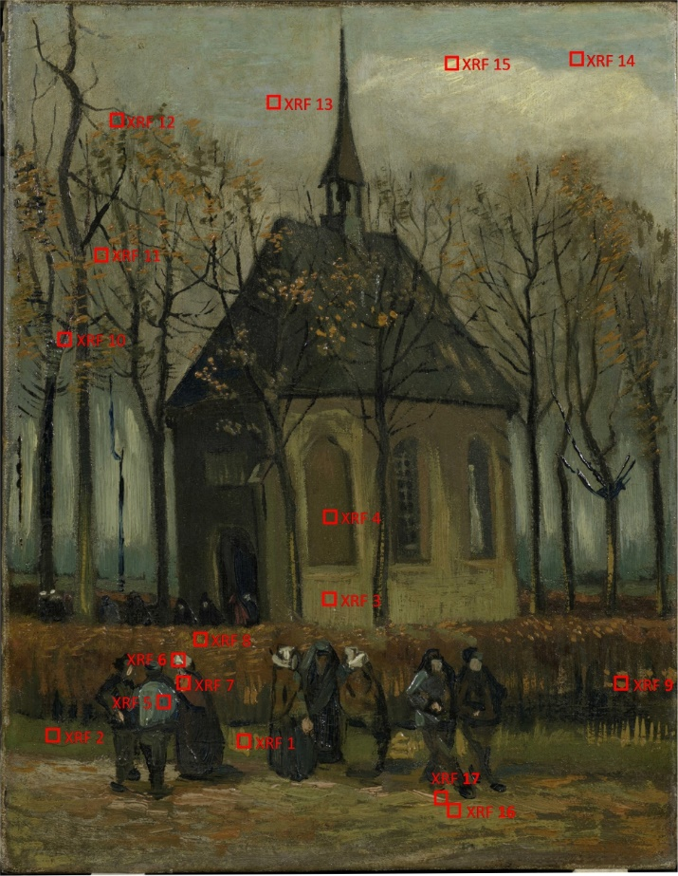
Fig. S1 Congregation Leaving the Reformed Church in Nuenen, spots of examination by portable X-ray fluorescence spectrometer.

Table 1. Identification of elements by means of X-ray fluorescence spectrometry.
Nr | Sample spot description | Elements detected | Possible pigments
1 | yellow brushstroke in the foreground | Pb (Hg) (Zn) (Fe) (Sb) (Cr) (Ba) | lead white, vermilion, zinc white, chrome yellow, ochre, Naples yellow, barium sulphate
2 | green stroke in the foreground | Pb (Hg) (Fe) (Zn) (Cr) (Ca) | lead white, vermilion, zinc white, ochre, chrome yellow/chromium oxide green
3 | light brown of the church | Pb Zn Hg Fe (Sb) (Cr) | lead white, zinc white, vermilion, ochre, Naples yellow, chrome yellow/chromium oxide green
4 | dark brown window | Pb (Hg) (Fe) (Zn) (Cr) (Ca) | lead white, vermilion, ochre, Prussian blue, zinc white, chrome yellow/ chromium oxide green
5 | blue jacket | Pb Zn Hg (Fe) (Sb) (Al) (Co?) (Cr) | lead white, zinc white, vermilion, ochre, Prussian blue, Naples yellow, cobalt blue?, chrome yellow/ chromium oxide green
6 | white bonnet | Zn Pb Hg (Fe) (Co?) (Ca) (Al) | zinc white, lead white, vermilion, ochre, cobalt blue?
7 | orange shawl | Pb Hg (Fe) (Zn) (Cr) (Sb) (Ca) (Ba) (Al) | lead white, red lead, vermilion, ochre, zinc white, chrome yellow/orange, Naples yellow, barium sulphate
8 | yellow in hedge | Pb Hg Fe (Cr) (Zn) (Ca) (Al) (Ba) | lead white, vermilion, ochre, chrome yellow, zinc white, barium sulphate
9 | orange in hedge | Pb Fe Hg (Zn) (Sb) (Al) | lead white, red lead, ochre, vermilion, Naples yellow, zinc white
10 | dark red tree branch | Pb (Hg) (Fe) (Zn) (Ca ) (Cr) (Al) | lead white, vermilion, ochre, zinc white, chrome yellow/ chromium oxide green
11 | orange leaves | Pb (Zn) (Fe) (Hg) (Sb) (Al) (Ba) (Cr) | lead white, zinc white, ochre, vermilion, Naples yellow, barium sulphate, chrome yellow/ chromium oxide green
12 | green blue in the tree | Pb (Hg) (Sb) (Zn) (Fe) (Al) (Cr) (Ba) | lead white, vermilion, Naples yellow, zinc white, Prussian blue, ochre, chrome yellow/ chromium oxide green
13 | blue sky | Pb (Hg) (Fe) (Ca) (Al) | lead white, vermilion, ochre, Prussian blue
14 | turquoise in the sky | Pb (Zn) (Ti) (Fe) (Ca) (Cr) (Al) | lead white, zinc white, titanium white?, ochre, Prussian blue, chrome yellow/ chromium oxide green
15 | white in the sky | Pb (Fe) (Ca) (Al) (Cr) | lead white, ochre, Prussian blue, chrome yellow/ chromium oxide green
16 | light green in the foreground, second campaign | Pb Zn Hg Fe (Sb) (Cr) (Co?) (Al) | lead white, zinc white, vermilion, ochre, Naples yellow, chrome yellow, / chromium oxide green  cobalt blue?
17 | pink in the foreground, second campaign | Pb Zn Hg Fe (Sb) (Cr) (Al) | lead white, vermilion, zinc white, ochre, Naples yellow, chrome yellow, / chromium oxide green

Numbers correspond to locations given in Fig. 3 – right panel. The major elements are indicated in bold, minor elements in regular font and trace elements in brackets.
The peak at 6.9 keV may correspond to the escape peak of the K_{α1} emission line of Zn instead (see main text).

