Supplementary Material For

Evaluation of the Performance of CMIP6 Model Simulations for the East Asia Region: Perspectives from Multiple Dimensions

Shuaifeng Song¹ · Xuezhen Zhang^{2,3} · Zhibo Gao¹ · Xiaodong Yan¹ .
¹ State Key Laboratory of Earth Surface Processes and Resource Ecology, Faculty of Geographical Science, Beijing Normal University, Beijing 100875, People's Republic of China
² Key Laboratory of Land Surface Pattern and Simulation, Institute of Geographic Sciences and Natural Resources Research, Chinese Academy of Sciences, Beijing 100101, People's Republic of China
³ University of Chinese Academy of Sciences, Beijing 100049, People's Republic of China

Corresponding author: Xiaodong Yan, yxd@bnu.edu.cn

Contents of this file
Tables S1
Figures S1 to S2

Table S1 Summary of Model configuration
Model | CMCC-CM2-SR5 | CMCC-ESM2-SR5 | MPI-ESM-1-2-HAM | MPI-ESM1-2-HR | MPI-ESM1-2-LR
Resolution | 288x192 | 288x192 | 192x96 | 384x192 | 192x96
Atmos_model | CAM5.3 | CAM5.3 | ECHAM6.3 | ECHAM6.3 | ECHAM6.3
Ocean_model | NEMO3.6 | NEMO3.6 | MPIOM1.63 | MPIOM1.63 | MPIOM1.63
Land_model | CLM4.5 | CLM4.5 | JSBACH 3.20 | JSBACH3.20 | JSBACH3.20
OcnBgchem_model | none | BFM5.1 | HAMOCC6 | HAMOCC6 | HAMOCC6
Aerosol_model | MAM3 | MAM3 | HAM2.3 | none | none
AtmosChem_model | none | none | sulfur chemistry (unnamed) | none | none
SeaIce_model | CICE4.0 | CICE4.0 | unnamed | unnamed | unnamed
LandIce_model | none | none | none | none | none

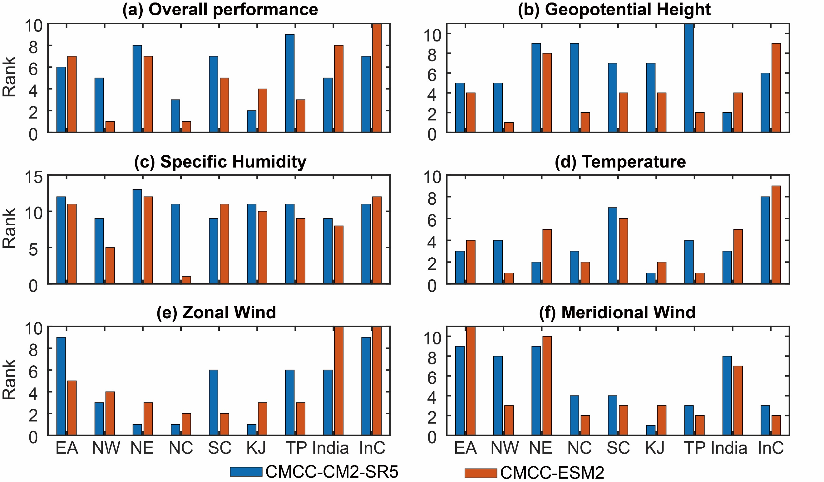
Fig. S1 Comparison of the performance of the CMCC-CM2-SR5 and CMCC-ESM2 models for different variables. The rank is among 13 models, and a smaller rank indicates better performance.

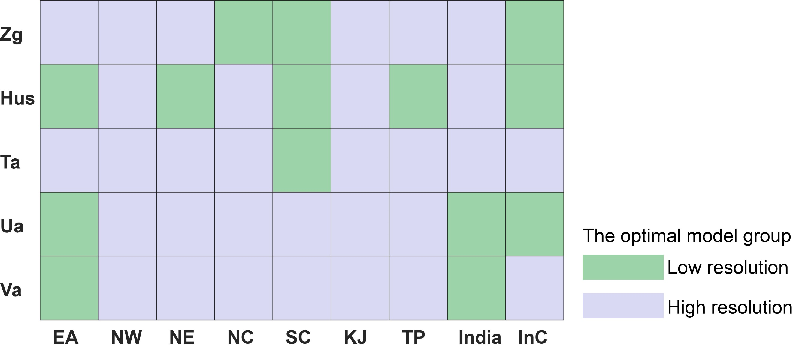
Fig. S2 Overall performance of high-resolution and low-resolution models for simulations in different variables and regions. The overall performance considers all evaluation indices, including spatial pattern, climatology, interannual variability, annual cycle, and diurnal variation. The blue grid indicates that the performance of high-resolution models is better. Conversely, the green colour is the low-resolution model.

