Supplementary material
Integrated assessment of volatile organic compounds from industrial biomass boilers in China: emission characteristics, influencing factors and ozone formation potential

Ruidan Shi¹, Zibing Yuan¹, Daojian Huang^{2,*}, Leifeng Yang², Hui Ma³

¹ School of Environment and Energy, South China University of Technology, Guangzhou 510006, China
² South China Institute of Environmental Sciences, Ministry of Ecology and Environment, Guangzhou 510655, China
³ Beijing Goldwind Smart Energy Technology Co. Ltd., Beijing 100176, China

⁎ Corresponding authors.
E-mail address: huangdaojian@scies.org (D. Huang)

This supporting information provides 5 tables and 3 figure.
Number of pages: 8
Number of tables: 5
Number of figures: 3

List of tables and figures in the supporting information:
Table S1. Detailed information of the five IBBs in this study
Table S2. Characteristics of biomass fuel on an air-dried basis
Table S3. VOCs species characterized in this study and their MIR values
Table S4. Correlation of VOCs EFs with the fuel properties, furnace temperature, operating load and excess air coefficient
Table S5. Oxygen content in the flue gas and excess air coefficient of the five IBBs

Figure S1. Sampling photos
Figure S2. Photos of the biomass fuels used in this study
Figure S3. Top 10 VOC species of OFP contribution (%) from the five IBBs

Table S1. Detailed information of the five IBBs in this study.
 | BB1 | BB2 | BB3 | BB4 | BB5
Fuel | Wood pellets | Wood pellets | Wood pellets | Wood residues | Wood residues
Rated evaporation (t/h) | 10 | 10 | 10 | 10 | 10
Height of sampling port (m) | 6 | 6 | 6 | 6 | 6
Rated vapor pressure (MPa) | 1.25 | 1.25 | 1.25 | 1.25 | 1.25
Rated vapor temperature | 194 | 194 | 194 | 194 | 194
Average operating load (%) | 52 | 59 | 77 | 35 | 71
Average furnace temperature (℃) | 581 | 678 | 833 | 527 | 763
Average oxygen content in flue gas (%) | 15.3 | 15.2 | 14.2 | 16.3 | 14.6
Fire grate | Chain grate | Chain grate | Chain grate | Chain grate | Chain grate
Precipitator | Bag filter | Bag filter | Bag filter | Bag filter | Bag filter

Table S2. Properties of biomass fuel on an air-dried basis.
 | BB1 | BB2 | BB3 | BB4 | BB5
Moisture (%) | 6.62 | 9.69 | 6.76 | 6.23 | 10.65
Volatile matter (%) | 76.73 | 75.78 | 74.61 | 78.28 | 75.23
Ash (%) | 1.49 | 1.65 | 2.14 | 3.52 | 4.49
Fixed carbon (%) | 16.25 | 16.57 | 17.45 | 15.25 | 16.78
Elemental Carbon (%) | 47.26 | 47.85 | 48.73 | 45.37 | 46.62
Hydrogen (%) | 5.53 | 5.58 | 5.75 | 5.76 | 5.24
Nitrogen (%) | 0.28 | 0.23 | 0.15 | 0.50 | 0.54
Sulfur (%) | 0.006 | 0.01 | 0.028 | 0.54 | 0.60
Oxygen (%) | 38.81 | 34.99 | 36.44 | 38.08 | 31.86
Heating value (MJ/kg) | 19.42 | 19.61 | 20.08 | 18.06 | 19.08

Table S3. VOCs species characterized in this study and their MIR values.
No. | Species | MIR | No. | Species | MIR | No. | Species | MIR | No. | Species | MIR | No. | Species | MIR
Alkanes (28) |  |  | 23 | 3-Methylheptane | 1.24 | 44 | Ethylbenzene | 3.04 | 66 | 1,2-Dichloroethane | 0.21 | 89 | Dibromochloromethane | -
1 | Ethane | 0.28 | 24 | n-Octane | 0.90 | 45 | m/p-Xylene | 5.84/9.75 | 67 | Vinyl Bromide | - | 90 | Bromoform | -
2 | Propane | 0.49 | 25 | n-Nonane | 0.78 | 46 | o-Xylene | 7.64 | 68 | Cis-1,3-dichloropropene | 3.70 | 91 | Hexachloro-1,3-butadiene | -
3 | i-Butane | 1.23 | 26 | n-Decane | 0.68 | 47 | i-Propylbenzene | 2.52 | 69 | Chlorobenzene | 0.32 | Oxygenated VOC (18)
4 | n-Butane | 1.15 | 27 | n-Un.a.ecane | 0.61 | 48 | n-Propylbenzene | 2.03 | 70 | 1,2-Dichloropropane | 0.29 | 92 | Formaldehyde | 9.46
5 | Cyclopentane | 2.39 | 28 | n-Dodecane | 0.55 | 49 | m-Ethyltoluene | 7.39 | 71 | Chloroform | 0.022 | 93 | Acetaldehyde | 6.54
6 | i-Pentane | 1.45 | Alkenes & Alkyne (12) |  |  | 50 | p-Ethyltoluene | 4.44 | 72 | Freon-12 | - | 94 | Acrolein | 7.45
7 | n-Pentane | 1.31 | 29 | Ethene | 9.00 | 51 | 1,3,5-Trimethylbenzene | 11.76 | 73 | Benzyl Chloride | - | 95 | Acetone | 0.36
8 | n-Heptane | 1.24 | 30 | Propene | 11.66 | 52 | o-Ethyltoluene | 5.59 | 74 | Trichloroethylene | 0.64 | 96 | Propionaldehyde | 7.08
9 | Methylcyclopentane | 2.19 | 31 | 1,3-butadiene | 12.61 | 53 | 1,2,4-Trimethylbenzene | 8.87 | 75 | 1,1,1-Trichloroethane | 0.0049 | 97 | Isopropanol | 0.61
10 | Cyclohexane | 1.25 | 32 | 1-Butene | 9.73 | 54 | 1,2,3-Trimethylbenzene | 11.97 | 76 | 1,1,2-Trichloroethane | 0.086 | 98 | Crotonaldehyde | 9.39
11 | 2,2-Dimethylbutane | 1.17 | 33 | trans-2-Butene | 15.16 | 55 | m-Diethylbenzene | 7.10 | 77 | Freon-11 | - | 99 | Butyraldehyde | 5.97
12 | 2,3-Dimethylbutane | 0.97 | 34 | cis-2-Butene | 14.24 | 56 | p-Diethylbenzene | 4.43 | 78 | 1,3-Dichlorobenzene | - | 100 | Methyl Ethyl Ketone | 1.48
13 | 2-Methylpentane | 1.50 | 35 | Isoprene | 10.61 | Halocarbons (35) |  |  | 79 | 1,4-Dichlorobenzene | 0.178 | 101 | Tetrahydrofuran | 4.31
14 | 3-Methylpentane | 1.80 | 36 | 1-Pentene | 7.21 | 57 | Chloromethane | 0.038 | 80 | 1,2-Dichlorobenzene | 0.178 | 102 | Vinyl Acetate | 3.20
15 | Methylcyclohexane | 1.70 | 37 | trans-2-Pentene | 10.56 | 58 | Vinyl chloride | 2.83 | 81 | Carbon Tetrachloride | 0 | 103 | Ethyl Acetate | 0.63
16 | 2,4-Dimethylpentane | 1.55 | 38 | cis-2-Pentene | 10.38 | 59 | Chloroethane | 0.29 | 82 | Bromodichloromethane | - | 104 | Methyl Tert Butyl Ether | 0.73
17 | 2-Methylhexane | 1.19 | 39 | 1-Hexene | 5.49 | 60 | Allyl Chloride | - | 83 | Tetrachloroethylene | 0.031 | 105 | Cyclohexanone | 1.35
18 | 2,3-DimethylPentane | 1.34 | 40 | Ethyne | 0.95 | 61 | Methylene-chloride | 0.041 | 84 | 1,1,2,2-Tetrachloroethane | - | 106 | Methyl Isobutyl Ketone | 3.88
19 | 3-Methylhexane | 1.61 | Aromatics (16) |  |  | 62 | Bromomethane | 0.0187 | 85 | Freon-114 | - | 107 | Benzaldehyde | -
20 | n-Heptane | 1.07 | 41 | Benzene | 0.72 | 63 | Cis-1,2-dichloroethylene | 1.70 | 86 | 1,2,4-Trichlorobenzene | - | 108 | Nonanal | -
21 | 2,2,4-Trimethylpentane | 1.26 | 42 | Toluene | 4.00 | 64 | 1,1-Dichloroethene | 1.79 | 87 | Freon-113 | - | 109 | Decanal | -
22 | 2-Methylheptane | 1.07 | 43 | Styrene | 1.73 | 65 | 1,1-Dichloroethane | 0.069 | 88 | 1,2-Dibromoethane | 0.102

Table S4. Correlation of VOCs EFs with the fuel properties, furnace temperature, operating load and excess air coefficient.
 | EFs | FT (℃) | OL (%) | α | Q (MJ/kg) | M (%) | V (%) | A (%) | FC (%) | C (%) | H (%) | N (%) | S (%)
EFs | 1
FT (℃) | -0.98** | 1
OL (%) | -0.99** | 0.98** | 1
α | 0.98** | -0.99** | -0.97** | 1
Q (MJ/kg) | -0.79** | 0.83** | 0.77** | -0.84** | 1
M (%) | -0.51 | 0.39 | 0.45 | -0.43 | 0.16 | 1
V (%) | 0.96** | -0.96** | -0.95** | 0.97** | -0.85** | -0.49 | 1
A (%) | 0.02 | -0.07 | 0.01 | 0.09 | -0.59 | 0.37 | 0.09 | 1
FC (%) | -0.94** | 0.97** | 0.94** | -0.97** | 0.91** | 0.34 | -0.99** | -0.20 | 1
C (%) | -0.73* | 0.78** | 0.73* | -0.79** | 0.99** | 0.08 | -0.81** | -0.63 | 0.88** | 1
H (%) | 0.40 | -0.34 | -0.35 | 0.38 | -0.04 | -0.79** | 0.33 | -0.45 | -0.22 | 0.11 | 1
N (%) | 0.37 | -0.44 | -0.37 | 0.44 | -0.83** | 0.27 | 0.46 | 0.88** | -0.57 | -0.89** | -0.47 | 1
S (%) | 0.26 | -0.32 | -0.23 | 0.33 | -0.78** | 0.25 | 0.33 | 0.97** | -0.44 | -0.81** | -0.36 | 0.96** | 1
ª FT denotes furnace temperature in ℃; ^{b} OL denotes operating load in %; ^{c} α denotes excess air coefficient; ^{d} Q denotes the heating value in MJ/kg; ^{e} M denotes moisture in %; ^{f} V denotes the volatile matter contents in %; ^{g} A denotes the ash content in %;
^{h} FC denotes the fixed carbon content in %; ^{i} C, H, N, S denotes elemental carbon, hydrogen, nitrogen and sulfur content in %, respectively.
** p＜0.01 represents the correlation was significant at the 0.01 level, * p＜0.05 represents the correlation was significant at the 0.05 level.

Table S5. Oxygen content in the flue gas and excess air coefficient of the five IBBs.
 | Oxygen content in flue gas (%) | Excess air coefficient
BB1 | 15.4 | 3.8
BB1 | 15.1 | 3.6
BB1 | 15.3 | 3.7
BB2 | 15.4 | 3.7
BB2 | 14.9 | 3.5
BB2 | 15.2 | 3.6
BB3 | 14.3 | 3.1
BB3 | 14.0 | 3.0
BB3 | 14.2 | 3.1
BB4 | 16.2 | 4.4
BB4 | 16.3 | 4.5
BB4 | 16.3 | 4.5
BB5 | 14.6 | 3.3
BB5 | 14.6 | 3.3
BB5 | 14.5 | 3.2

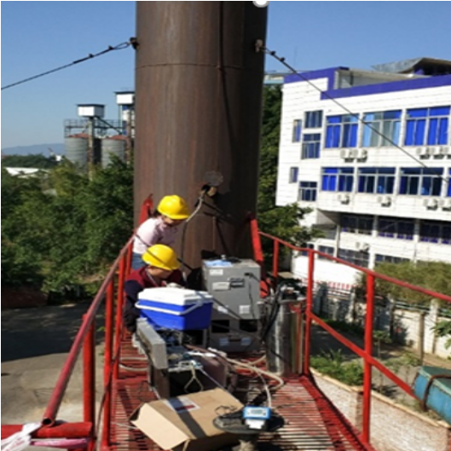
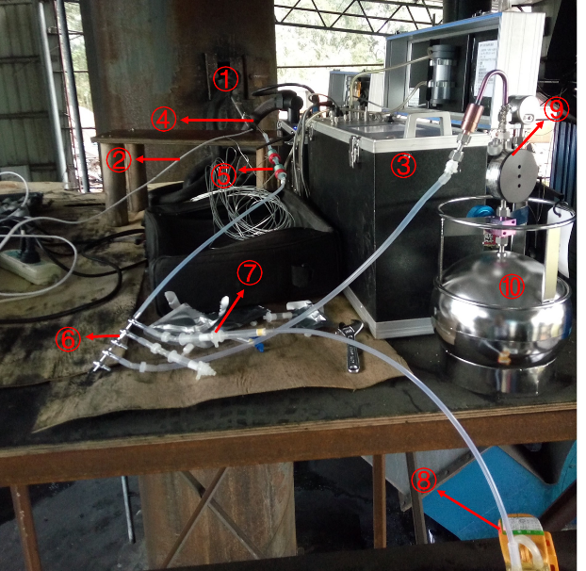
Figure S1. Sampling photos. ①Sampling outlet ②Flow meter ③Flue gas analyzer ④Heating tube ⑤Filter ⑥Flow divider valve ⑦DNPH+KI ⑧Pump ⑨Flow-limiting valve ⑩SUMMA canister.
1m
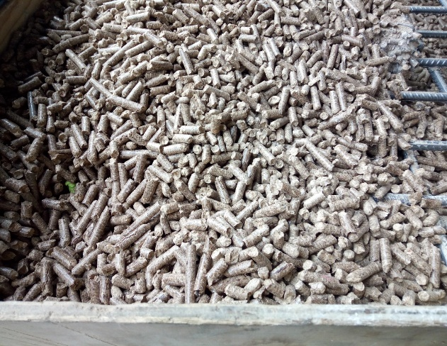
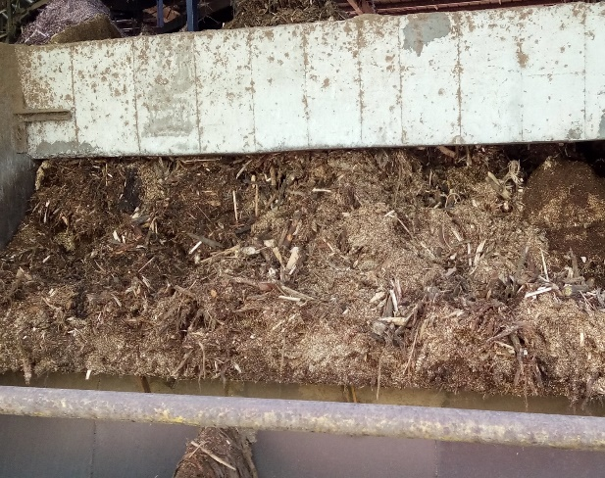
Figure S2. Photos of the biomass fuels used in this study. (a) wood pellets (mixed wood was compressed into cylinders with a diameter of 0.5–0.8 cm and a length of 3–5 cm), (b) wood residues (eucalyptus wood chips, bark, sawdust, and wood shavings).
(a)
(b)

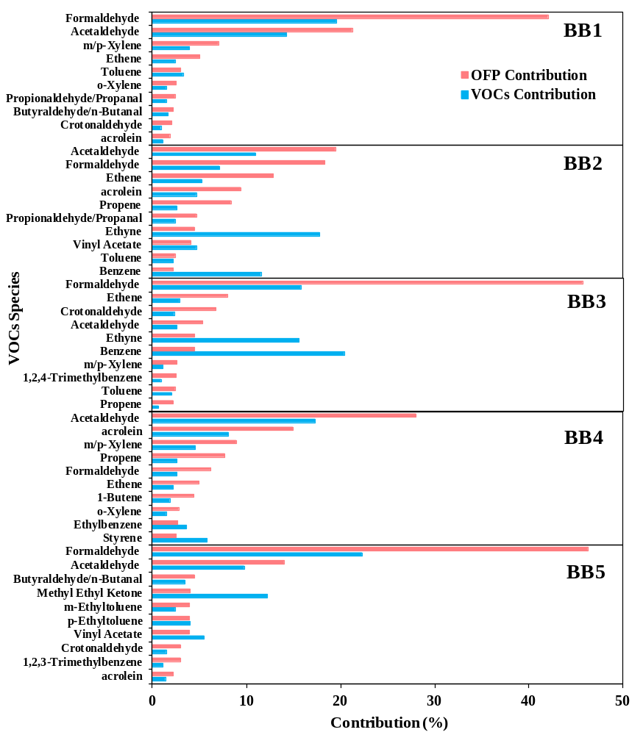
Figure S3. Top 10 VOC species of OFP contribution (%) from the five IBBs.

