Table. S1 Results of ADONIS tests comparing pair-wise fungal community difference derived in the matrix (Bray-Curtis distance) for each succession stage.
Diffs | Df | Sums Of Sqs | Mean Sqs | F-value | R2 | P-value | significant
AIM-STM | 1 | 0.9757 | 0.9757 | 4.8425 | 0.4466 | 0.021 | *
AIM-SWM | 1 | 0.9539 | 0.9539 | 5.5957 | 0.4826 | 0.031 | *
STM-SWM | 1 | 0.8706 | 0.8706 | 3.4926 | 0.3679 | 0.029 | *
AIM-STM-SWM | 2 | 1.8668 | 0.9334 | 4.5075 | 0.5004 | 0.001 | **
Note: *The level of significance of correlations is P < 0.05, ** The level of significance of correlations is P < 0.01. SWM, AIM, and STM indicate swamp meadow; Alpine meadow, and steppe meadow.

Table. S2 Results of ADONIS tests comparing pair-wise fungal community difference derived in the matrix (Bray-Curtis distance) for each succession stage.
Diffs | Df | Sums Of Sqs | Mean Sqs | F-value | R² | P-value | significant
AIM-STM | 1 | 0.9757 | 0.9757 | 4.8425 | 0.4466 | 0.021 | *
AIM-SWM | 1 | 0.9539 | 0.9539 | 5.5957 | 0.4826 | 0.031 | *
STM-SWM | 1 | 0.8706 | 0.8706 | 3.4926 | 0.3679 | 0.029 | *
AIM-STM-SWM | 2 | 1.8668 | 0.9334 | 4.5075 | 0.5004 | 0.001 | **
Note: *The level of significance of correlations is P < 0.05, ** The level of significance of correlations is P < 0.01. SWM, AIM, and STM indicate swamp meadow; Alpine meadow, and steppe meadow.

Table S3 Envfit test results of redundancy analysis (RDA).
Type | Constrain | Envfit_r2 | Envfit_P |  | RDA1
Fungi community | NH4N | 0.4491 | 0.044 | * | -0.53
Fungi community | SMC | 0.4332 | 0.048 | * | -0.58
Fungi community | VN | 0.3533 | 0.131 |  | -0.55
Fungi community | SOC | 0.3282 | 0.163 |  | -0.49
Fungi community | VOC | 0.3007 | 0.205 |  | -0.61
Fungi community | SIN | 0.1084 | 0.6 |  | 0.04
Fungi community | TN | 0.0863 | 0.688 |  | -0.31
Fungi community | NO3N | 0.0835 | 0.697 |  | -0.30
Fungi community | SMN | 0.031 | 0.884 |  | -0.17
Fungi community | URE | 0.013 | 0.94 |  | 0.02

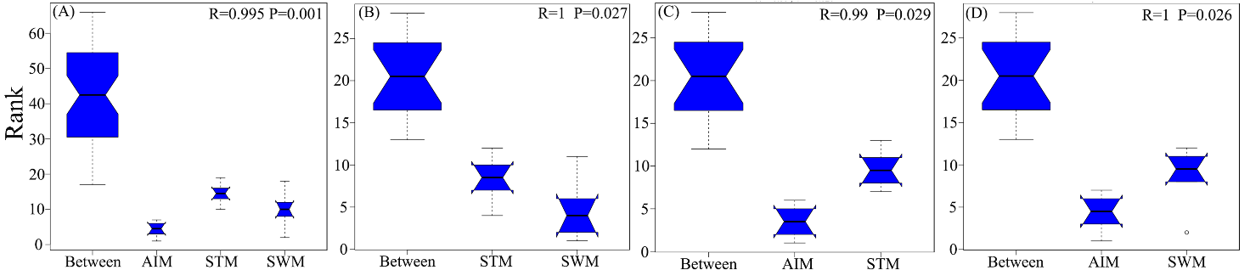
Figure S1 The ANOSIM test examined the significance of separation at different stages of succession. SWM, AIM, and STM indicate swamp meadow; Alpine meadow, and steppe meadow.
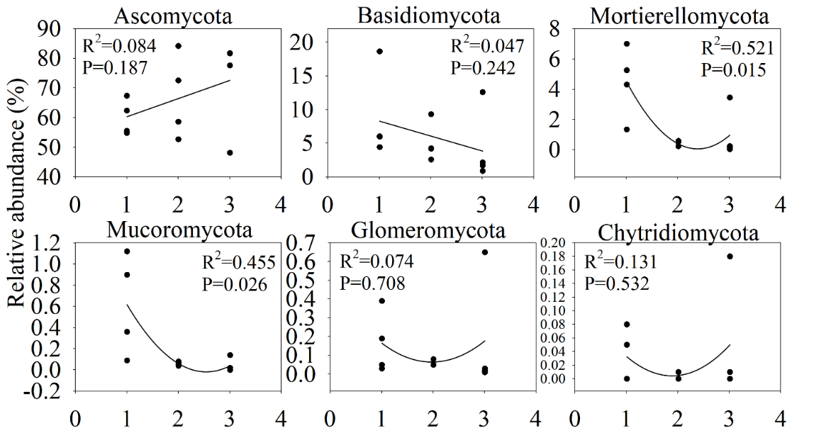
Figure S2 Linear changes of soil fungal communities in different succession stages. 1, 2, 3 represent the succession stages of swamp meadow; Alpine meadow, and steppe meadow, respectively.

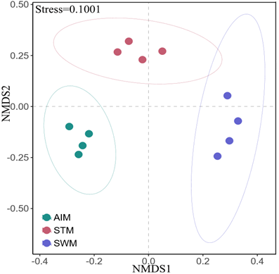

Figure S3 Nonmetric multidimensional scaling (NMDS) ordination plot based on the Bray distance of samples for the fungal functional group during succession. SWM, AIM, and STM indicate swamp meadow; Alpine meadow, and steppe meadow.

