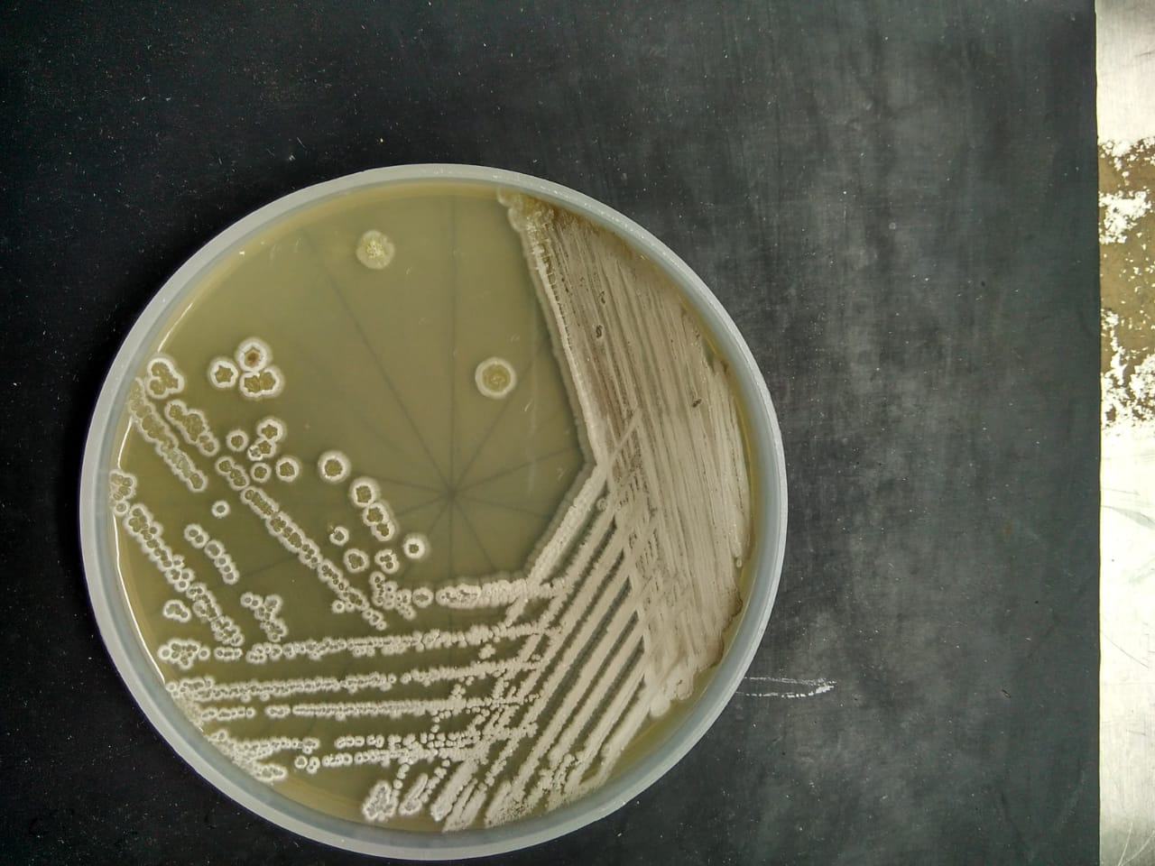
SupplementaryFig.(1) Morphological characteristics of the strains SAn01.Colony morphology and aerial mycelium of strain San01 after incubation on ISP4 on 7 days.
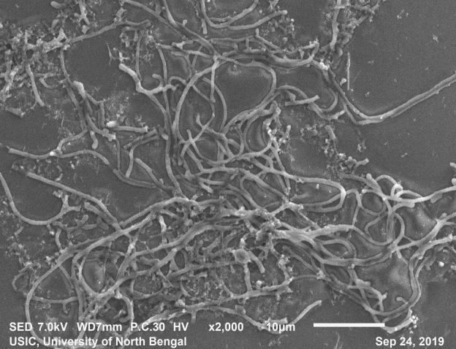
SupplementaryFig. (2): Scanning electron microscopy of San01 after 5 days of incubation in Bennet broth.

