Supplementary Information for
Reduction of pericyte coverage leads to blood-brain barrier dysfunction via endothelial transcytosis following chronic cerebral hypoperfusion
Zhengyu Sun^{1#}, Chenhao Gao^{1#}, Dandan Gao¹, Ruihua Sun¹, Wei Li¹, Fengyu Wang¹, Yanliang Wang², Huixia Cao², Guoyu Zhou³, Jiewen Zhang^{1*},Junkui Shang^{1*}

¹Department of Neurology, Henan Provincial People’s Hospital, Zhengzhou University People’s Hospital, Henan University People’s Hospital, Zhengzhou, Henan, 450003, China.
²Department of Nephrology, Henan Provincial Key Laboratory of Kidney Disease and Immunology, Henan Provincial People's Hospital, Zhengzhou University People’s Hospital, Henan University People’s Hospital, Zhengzhou, Henan, 450003, China.
³School of Public Health, Zhengzhou University, Zhengzhou, Henan, 450001, China.
*Corresponding author. E-mail: zhangjiewen9900@126.com (Jiewen Zhang), shangjunkui@yeah.net (Junkui Shang)
# These authors contributed equally to this work.
Supplementary Figures
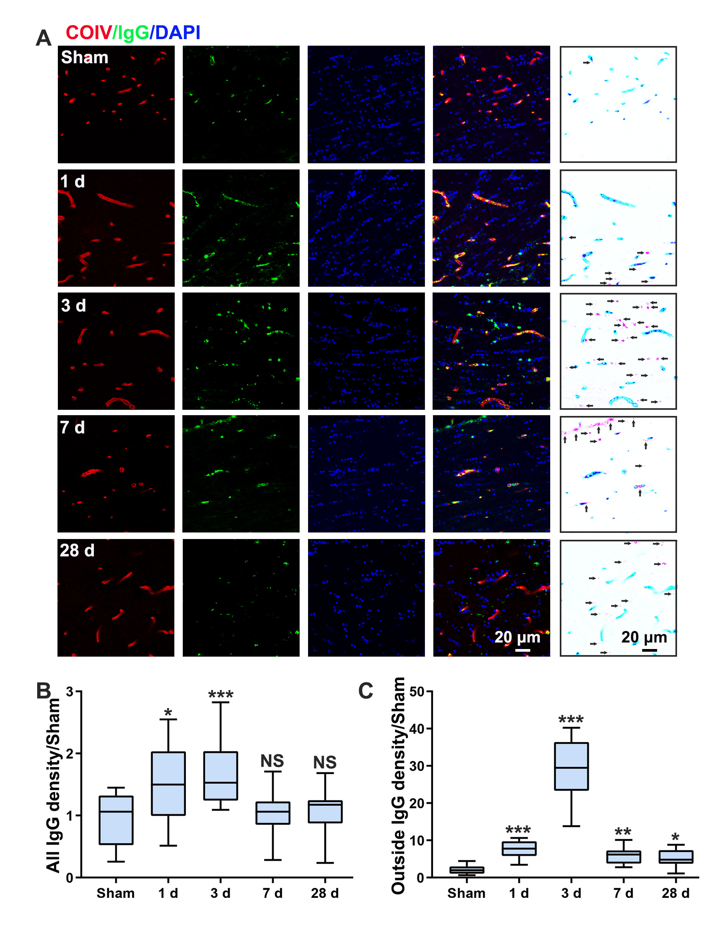
Supplementary Figure 1. Accumulation of plasma proteins in the CC following CCH. (A) Triple staining for COIV (red), IgG (green) and DAPI (blue) in order to observe IgG leakage in the CC. Schematic diagram of IgG in representative confocal microscopy image is shown in the right column. Black arrows indicate extravascular IgG deposits. (B and C) Quantification of total IgG and IgG leakage in the CC at various time points post operation. n=8 per group; NS not significant, *p < 0.05, **p < 0.01, ***p < 0.001; compared to sham group by one-way ANOVA with Dunnett post hoc test.
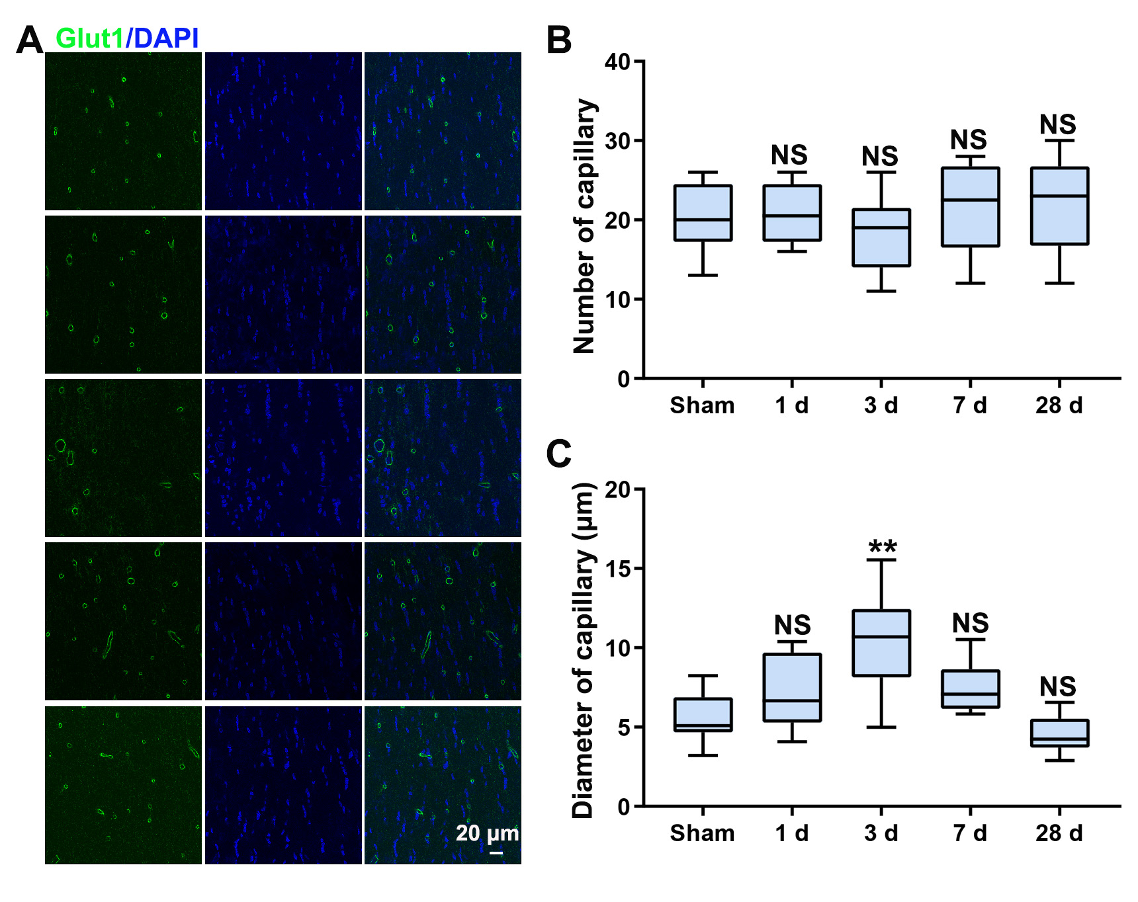
Supplementary Figure 2. Microvascular changes in the CC following CCH. (A) Immunofluorescence staining for Glut1 (green) in order to observe capillary changes following CCH. (B and C) Quantification of the number of capillaries and capillary diameter in the CC following CCH. n=8 per group; NS not significant, **p < 0.01; compared to sham group by one-way ANOVA with Dunnett post hoc test.
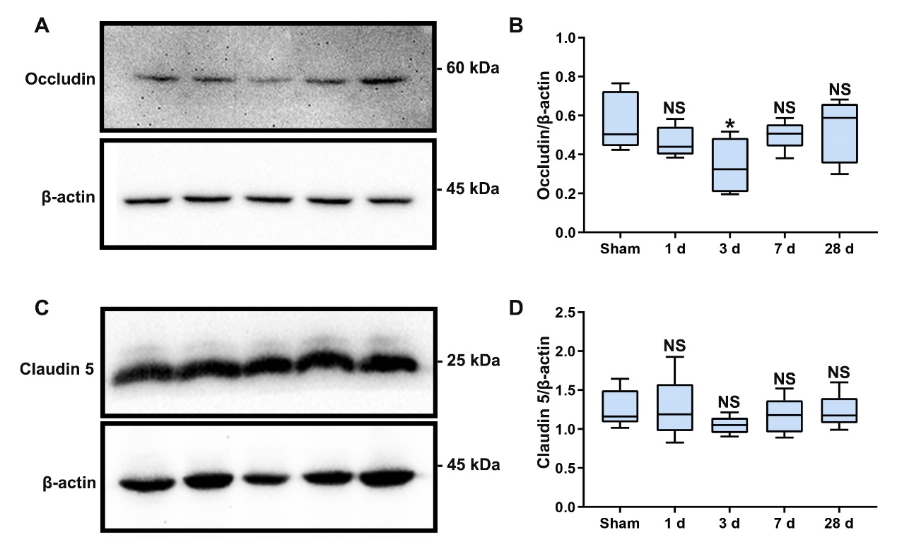
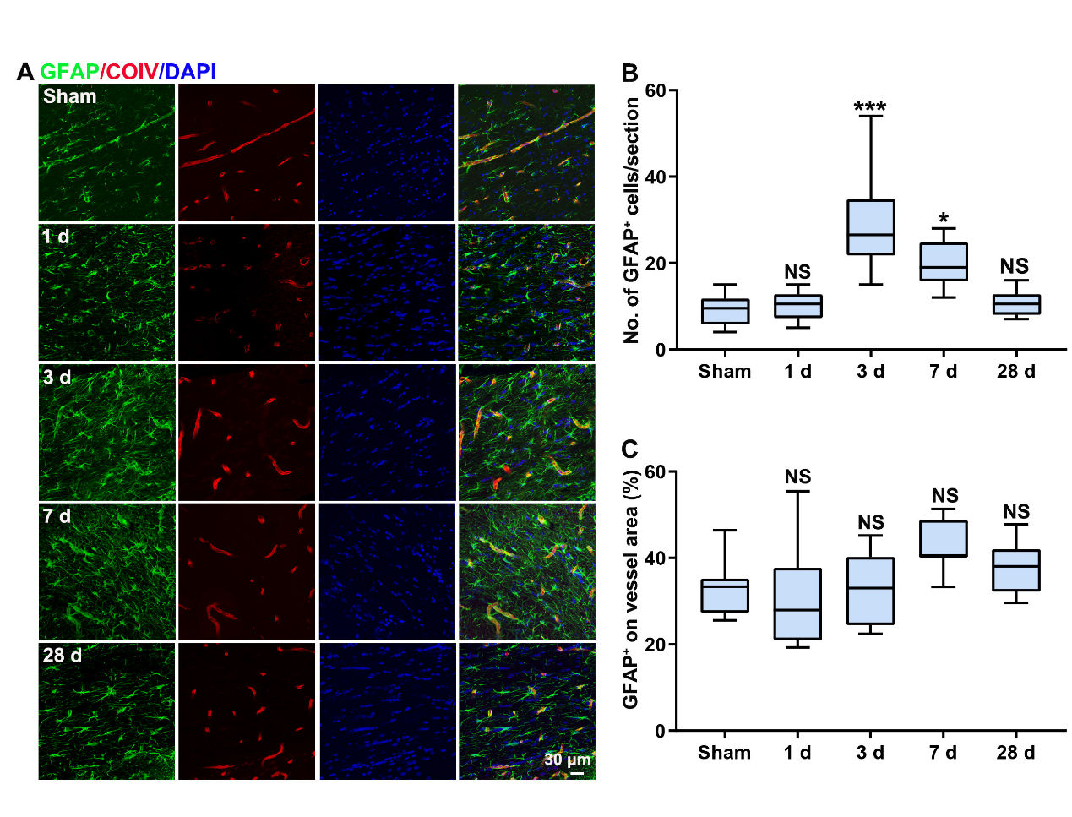
Supplementary Figure 3. BBB TJ changes in the CC following CCH. (A and B) Western blot and quantification of occludin expression in the CC at various time points post operation. (C and D) Western blot and quantification of claudin 5 expression in the CC at various time points post operation. n=5 per group; NS not significant, *p < 0.05; compared to sham group by one-way ANOVA with Dunnett post hoc test.
Supplementary Figure 4. Immunofluorescence assessment of vessels covered by astrocytes in the CC following CCH. (A) Confocal images of immunofluorescence staining for GFAP (green) and COIV (red) in CC. (B and C) Quantification of the number of astrocytes cells (GFAP⁺) and the percentage of vessels covered by astrocytes in the CC at various time points post operation. n=8 per group; NS not significant, *p < 0.05, ***p < 0.001; compared to sham group by one-way ANOVA with Dunnett post hoc test.
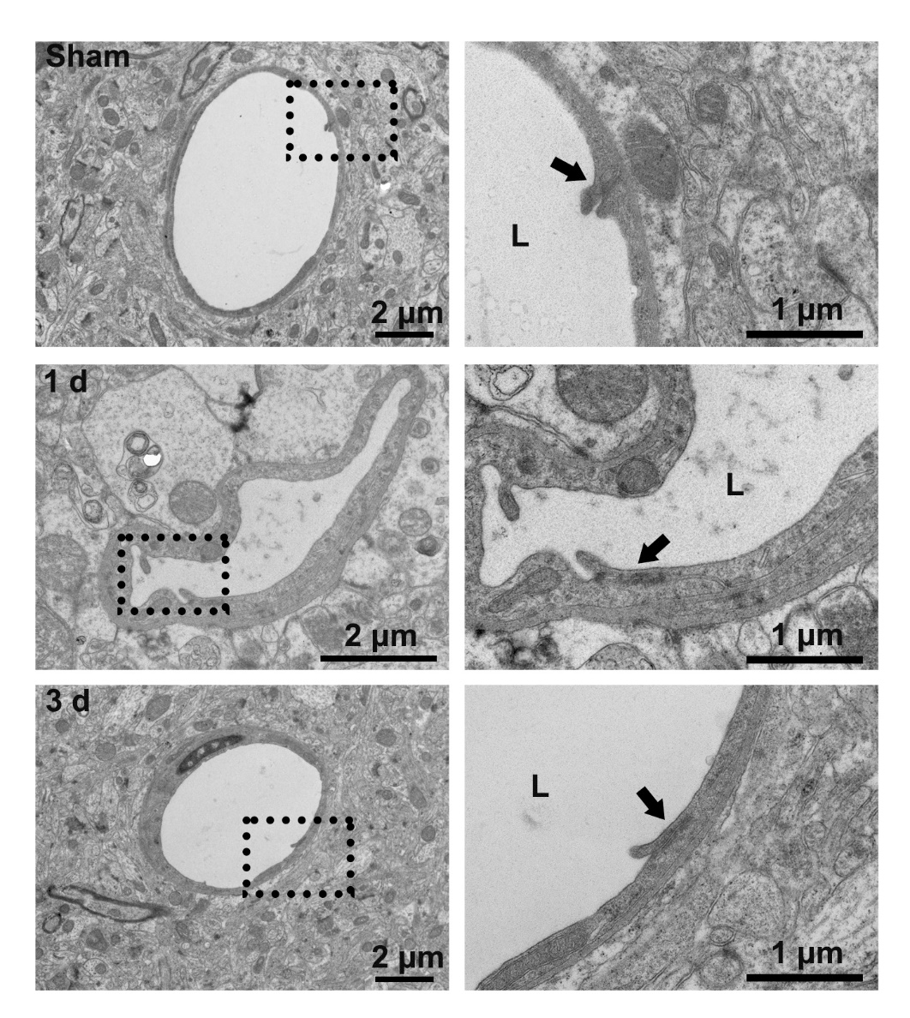
Supplementary Figure 5. Endothelial junctions changes following CCH. Representative images of the ultrastructure of endothelial junctions 1 and 3 days post operation. Black arrows indicate endothelial junctions.
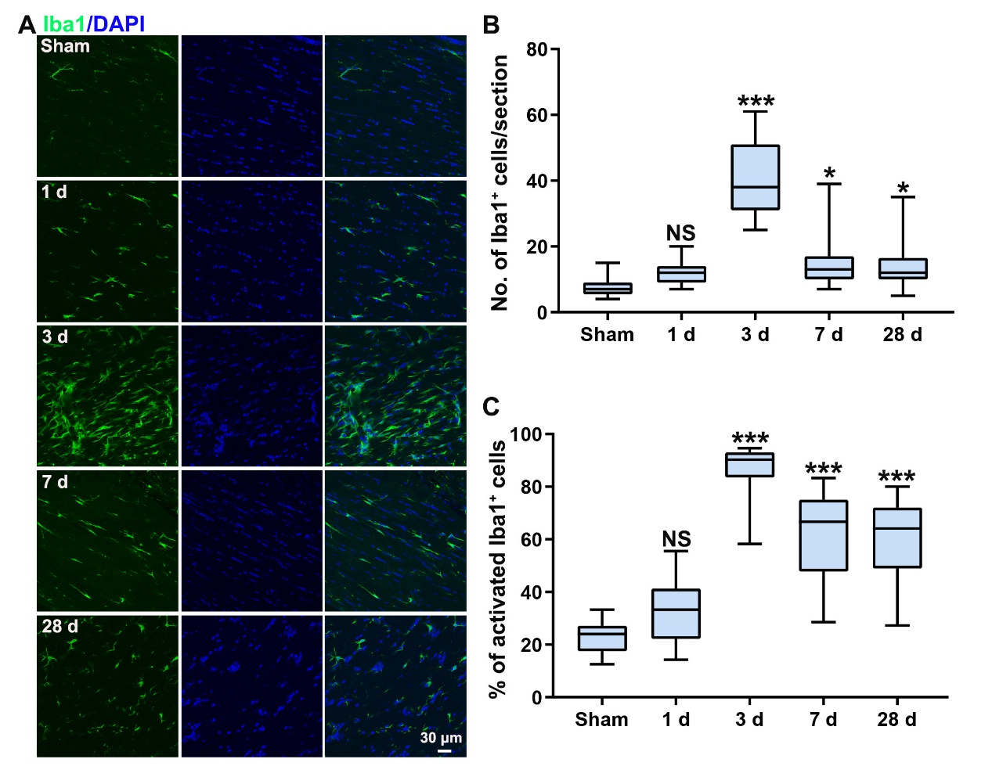
Supplementary Figure 6. Activation of microglia in the CC following CCH. (A) Immunofluorescence staining for Iba1 (green) in order to observe microglia activation following CCH. (B and C) Quantification of the total number of microglia cells (Iba1⁺) and the percentage of activated microglia in the CC at various time points post operation. n=8 per group; NS not significant, *p < 0.05, ***p < 0.001; compared to sham group by one-way ANOVA with Dunnett post hoc test.
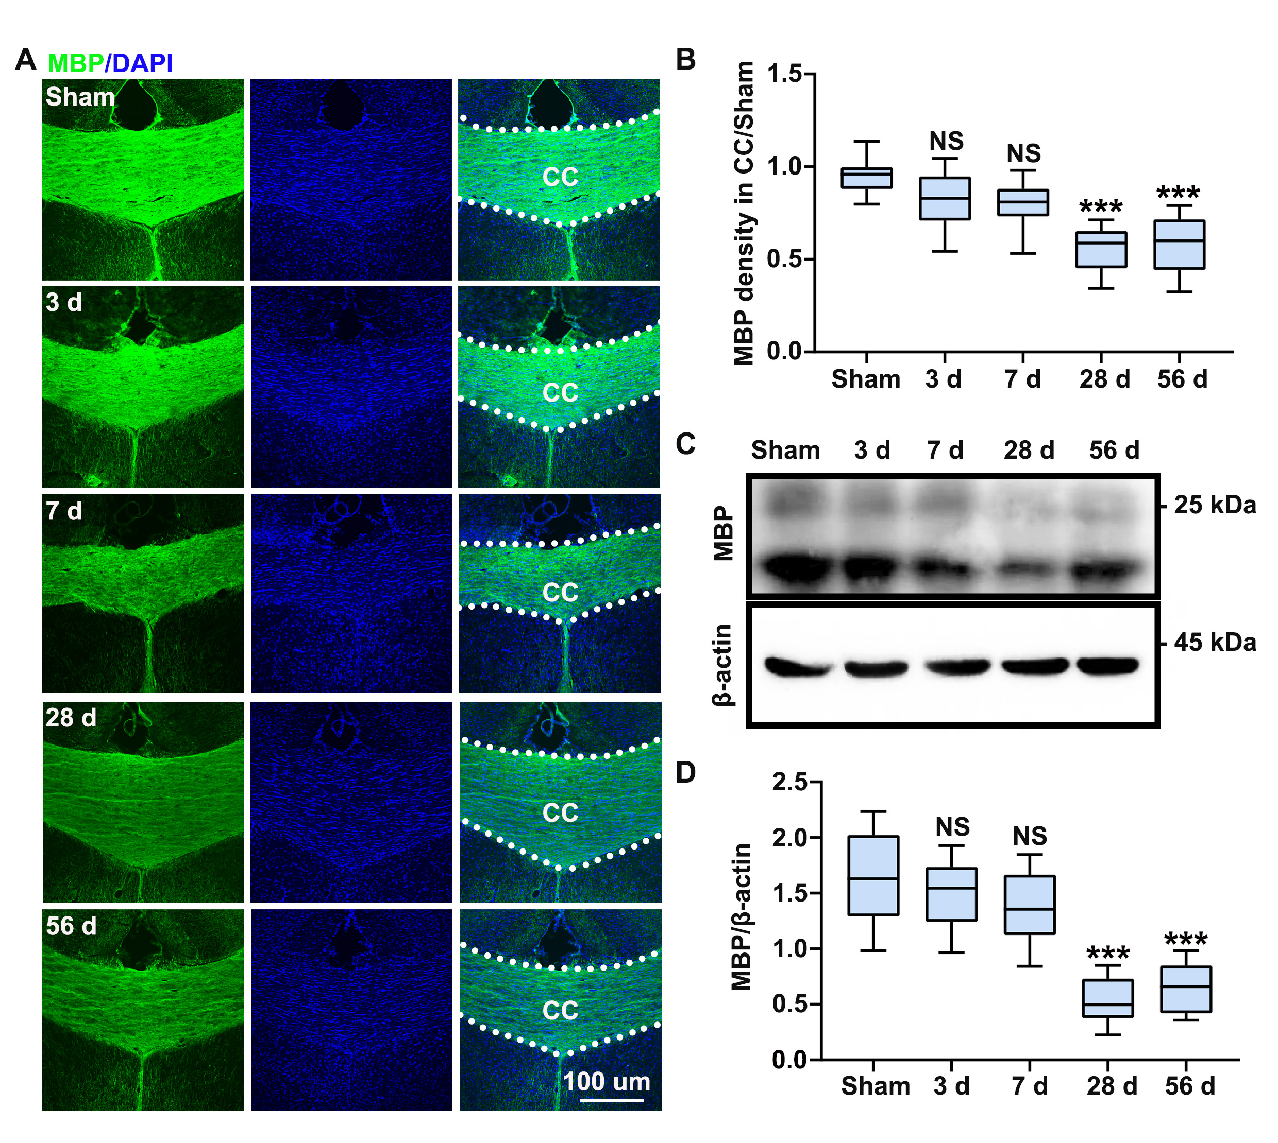
Supplementary Figure 7. Progressively demyelination in CC after CCH. (A and B) Immunofluorescence staining and quantification of MBP density in CC at different time points after operation. (C and D) Western blot and quantification of MBP expression in the CC at different time points after operation. n=5 per group; NS not significant, **p < 0.01, ***p < 0.001 compared to sham group by one-way ANOVA with Dunnett post hoc test.

