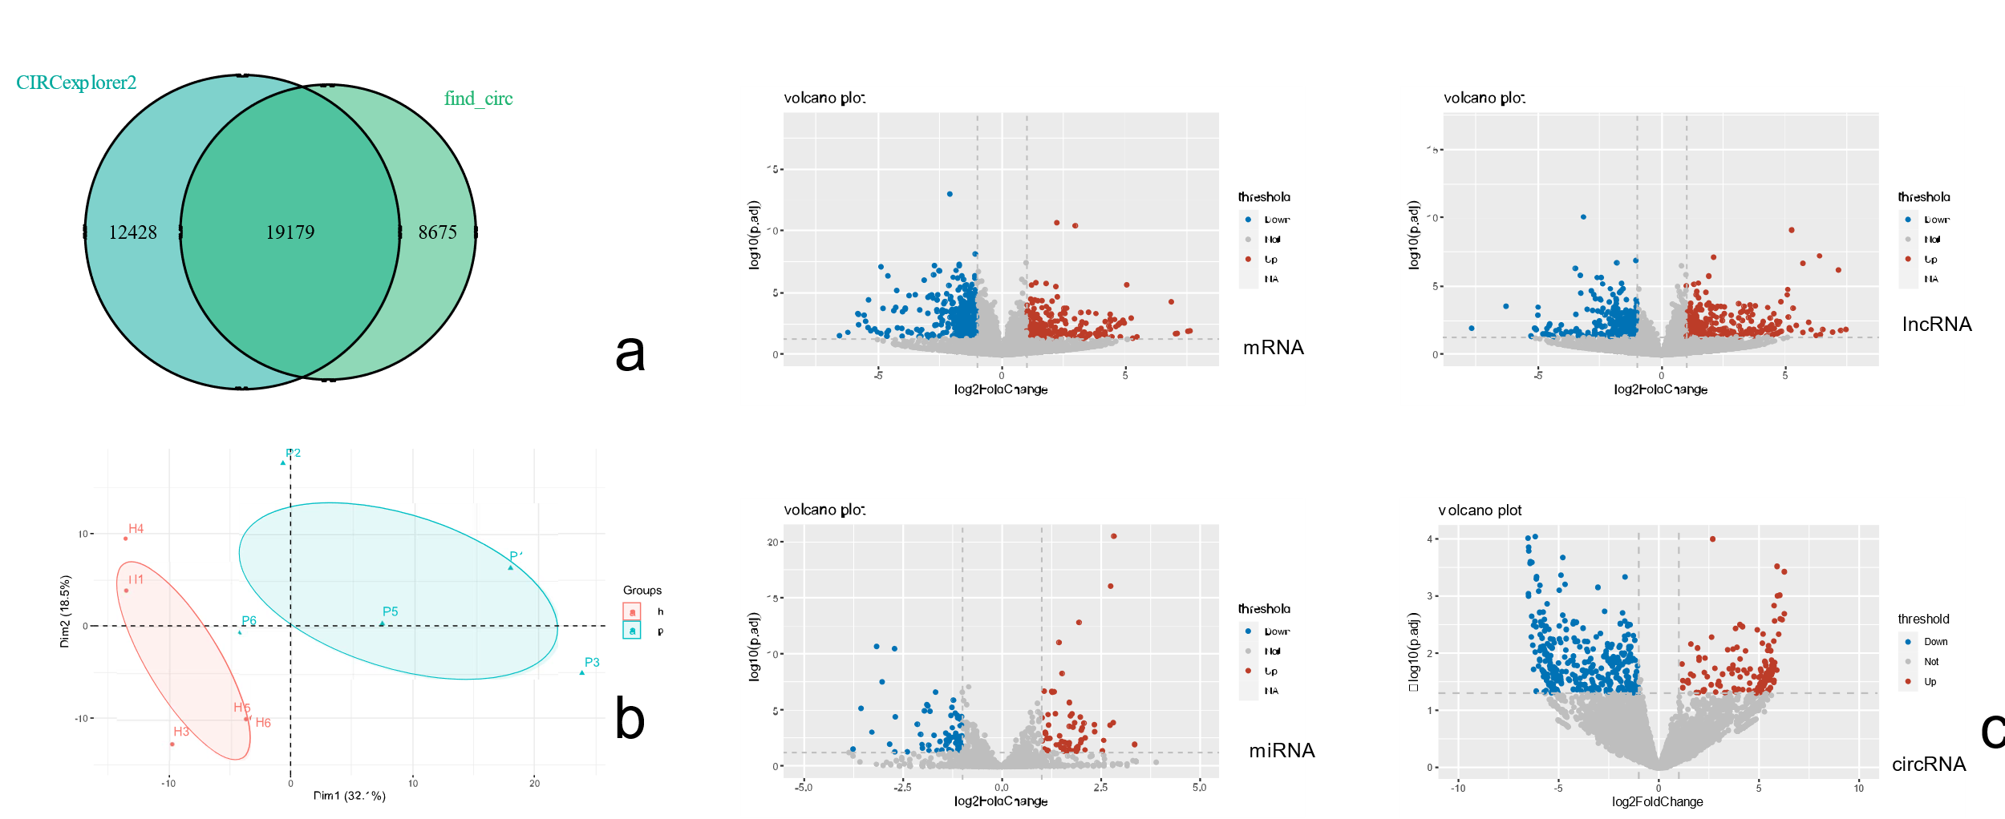
Figure s1 (a) A Venn diagram that shows the number of circRNAs indentified by CIRCexplorer2 and find_circ; (b) Principal component analysis. Red points: healthy group samples; blue points: periodontal granulation tissue group, CI:95% (c) volcano map shows differentially expressed genes The X axis represents log2FoldChange, the Y axis represents -log10(padj). Red dots: upregulated genes, blue dots :down-regulated genes, grey: non-differentially expressed genes.

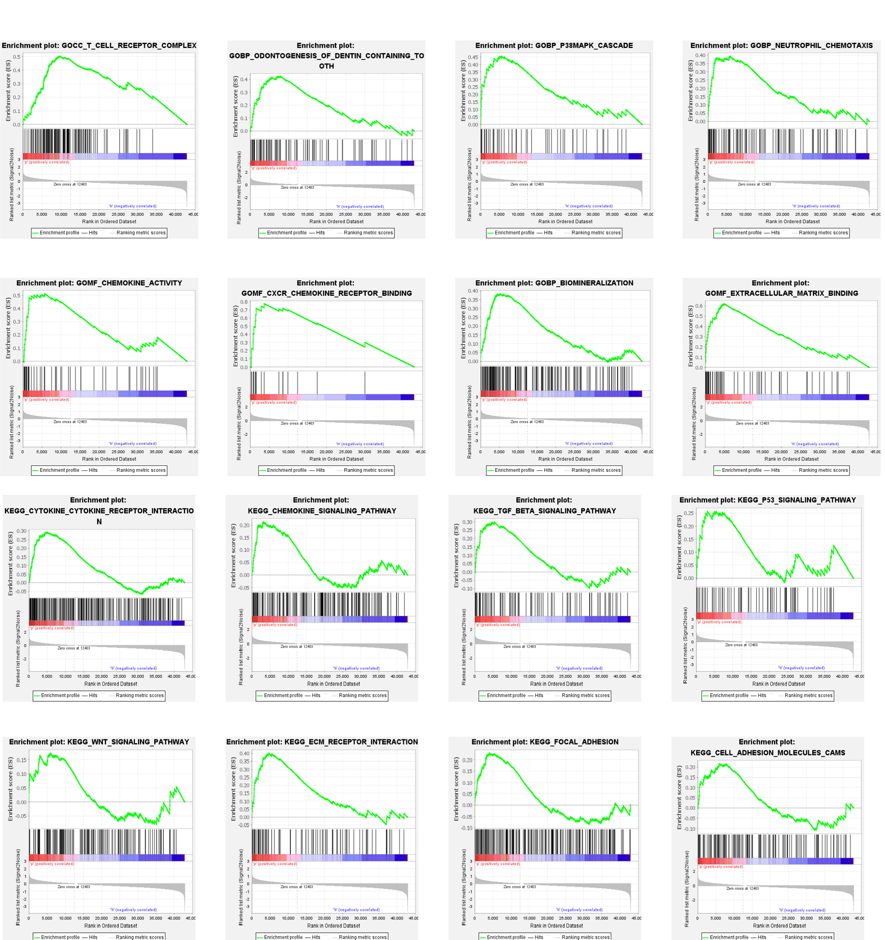
Figure s2 GSEA results

