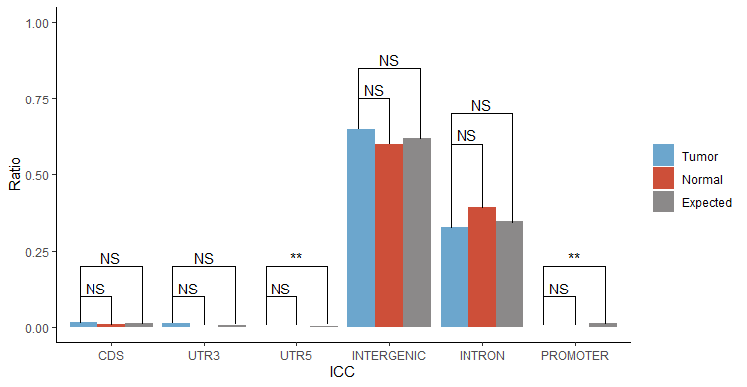
B
A
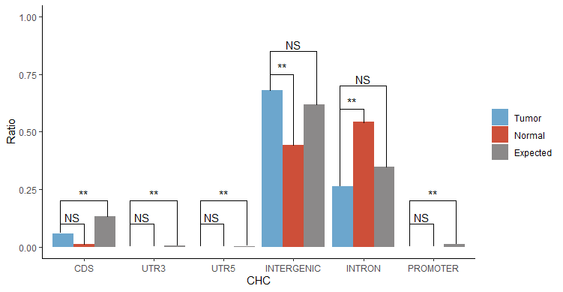
Fig S1. The preference of HBV integration across the host genome elements. (A) ICC; (B) CHC.

A
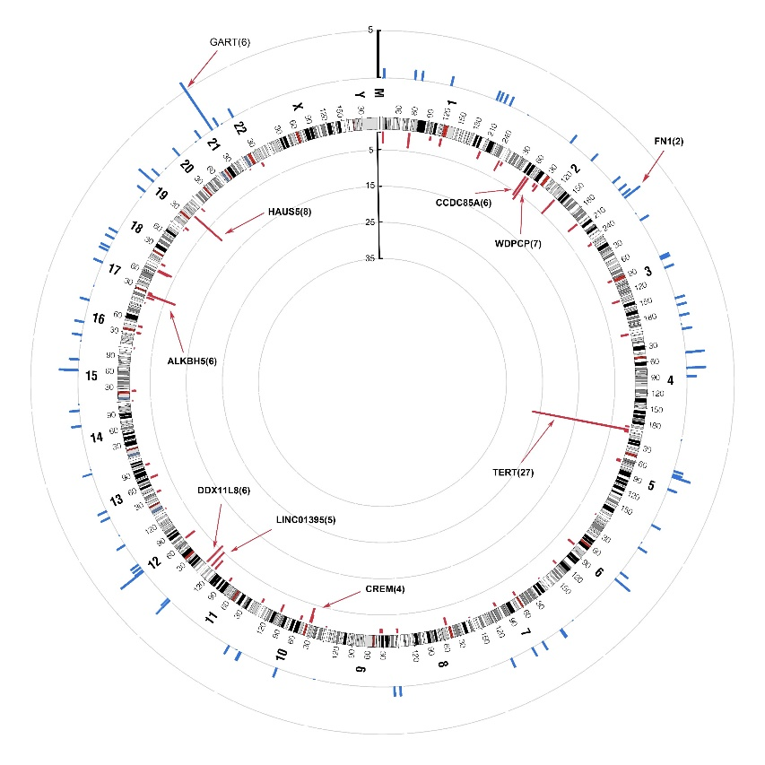
B
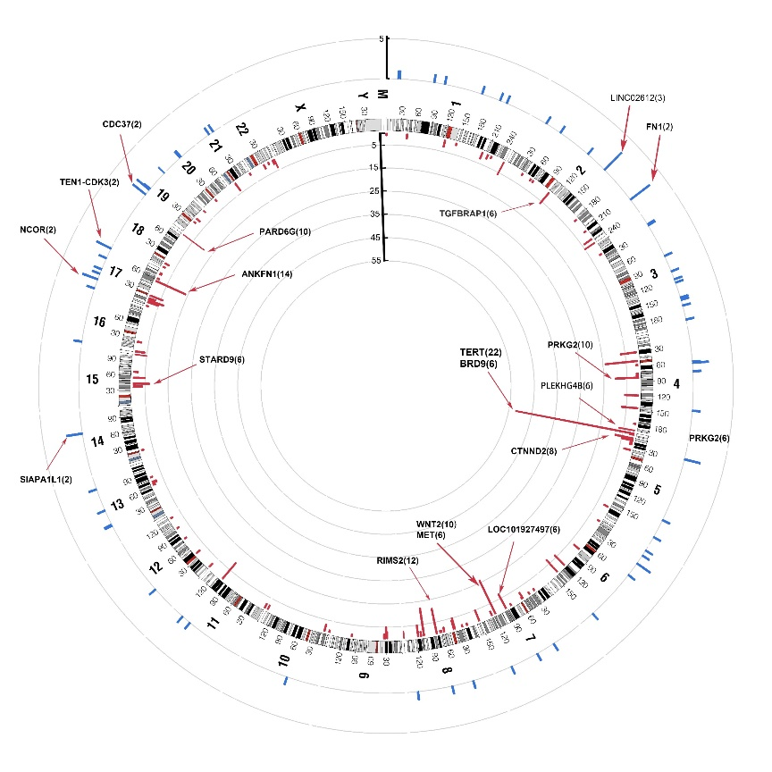
Fig. S2. HBV integration hot spots calculated by the number of breakpoints in sliding windows (1 Mbps). (A) ICC; (B) CHC

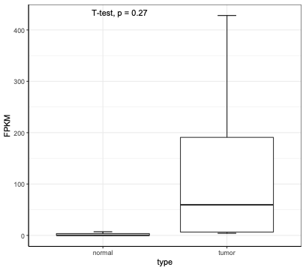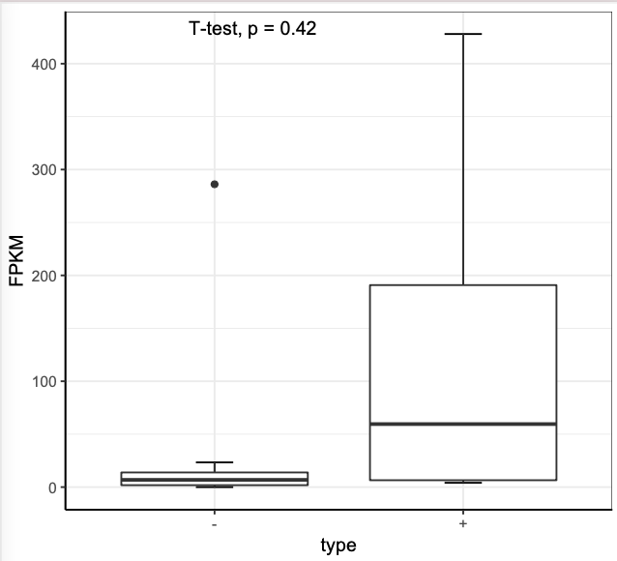
Fig S3. FPKM of MET in ICC samples
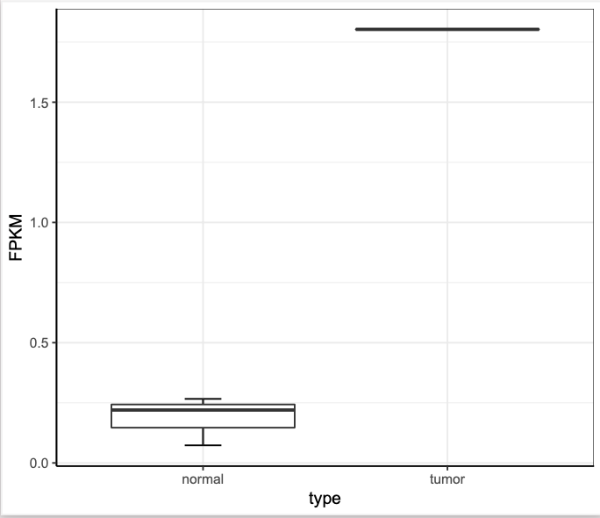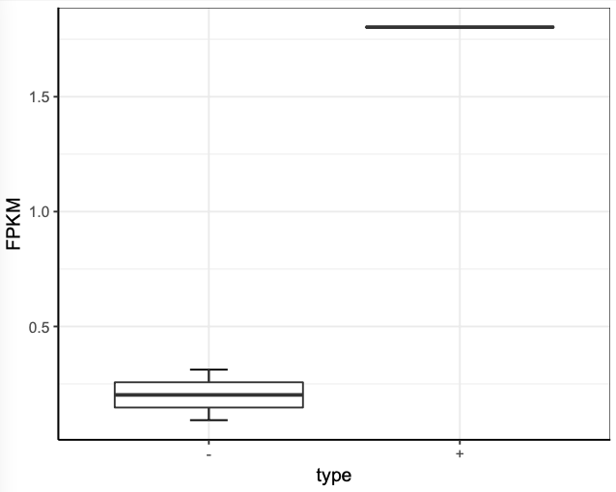
Fig S4. FPKM of WNT2 in ICC samples
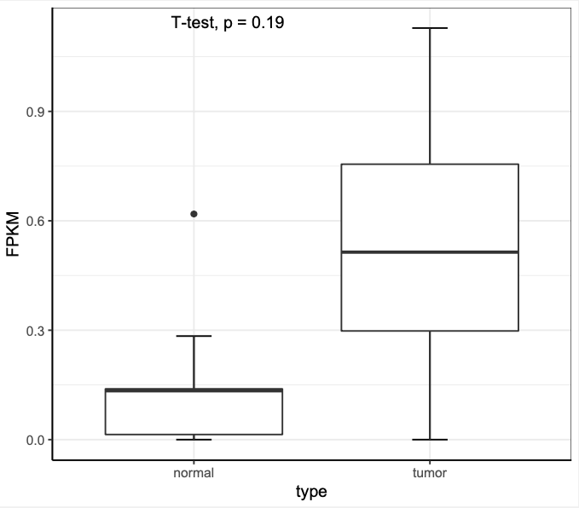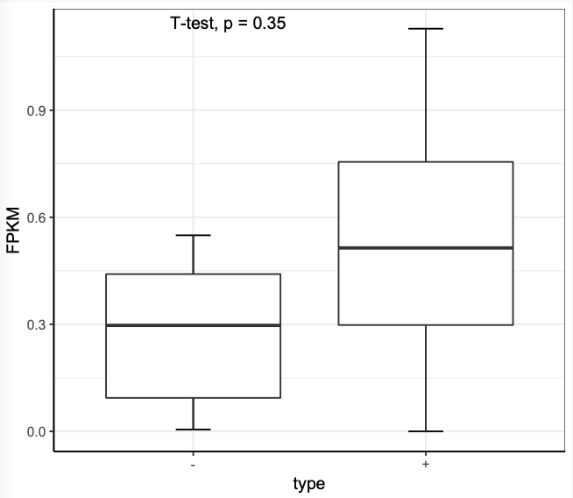
Fig S5. FPKM of BRD9 in ICC samples
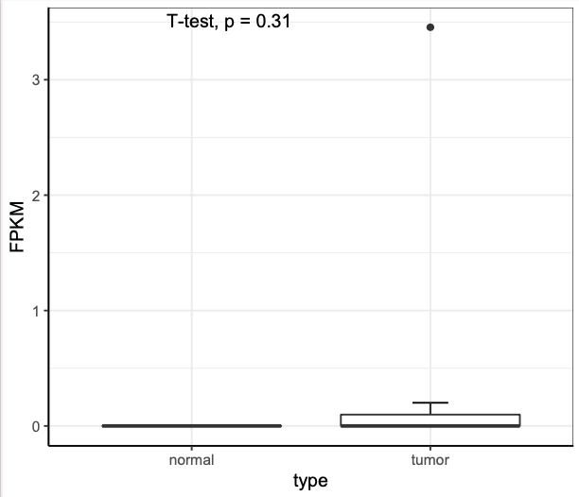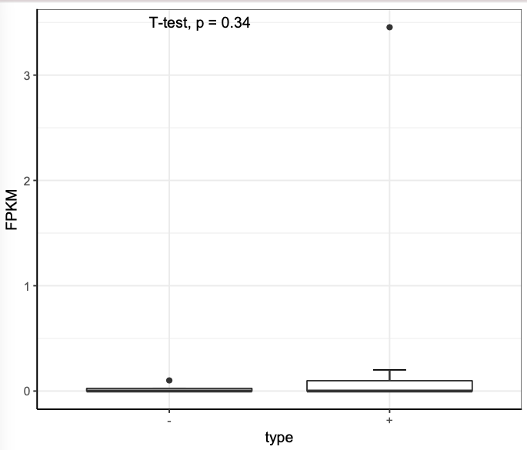
Fig S6. FPKM of TERT in ICC samples

