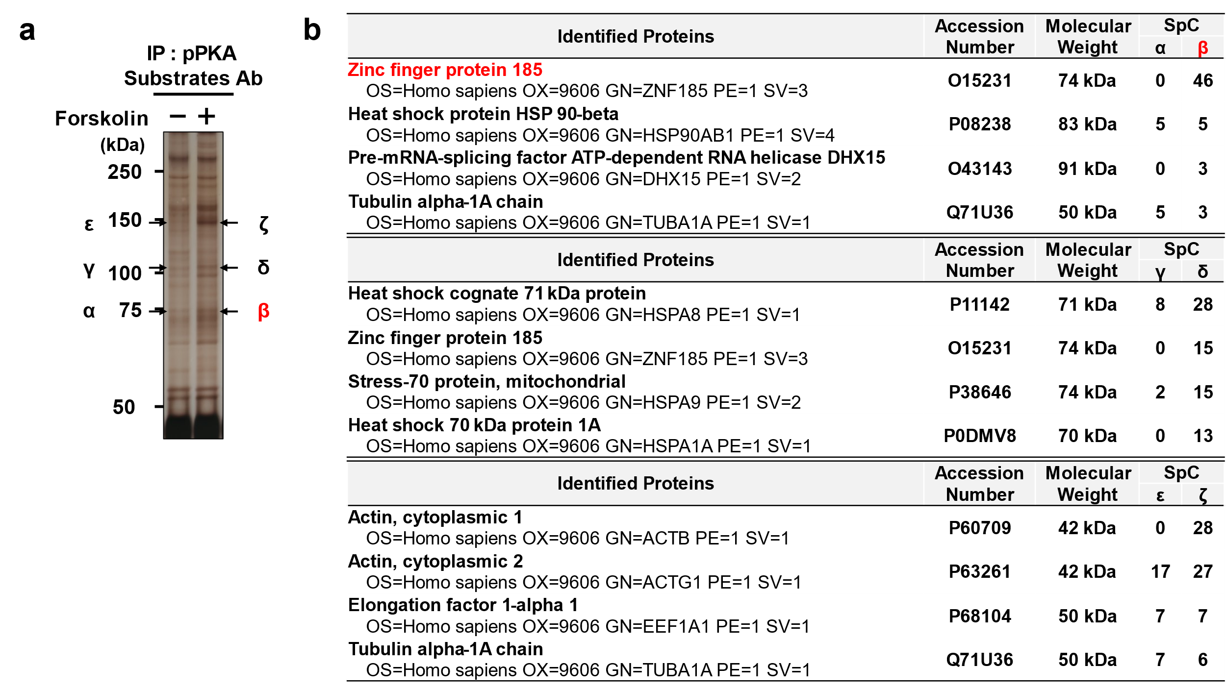
Supplementary Figure 1 Screening for PKA substrates in HUVECs.
a. Representative image of the silver-stained gel is presented in Fig. 1b. Forskolin (10 µM) was added to HUVECs for 1 h. b. Identified proteins by LC-MS/MS. An immunoprecipitated PKA substrate indicated by β was identified as ZNF185. Three bands (β, δ, and ζ) and their control bands (α, γ, and ε) were excised from the gels. SpC: spectral count.

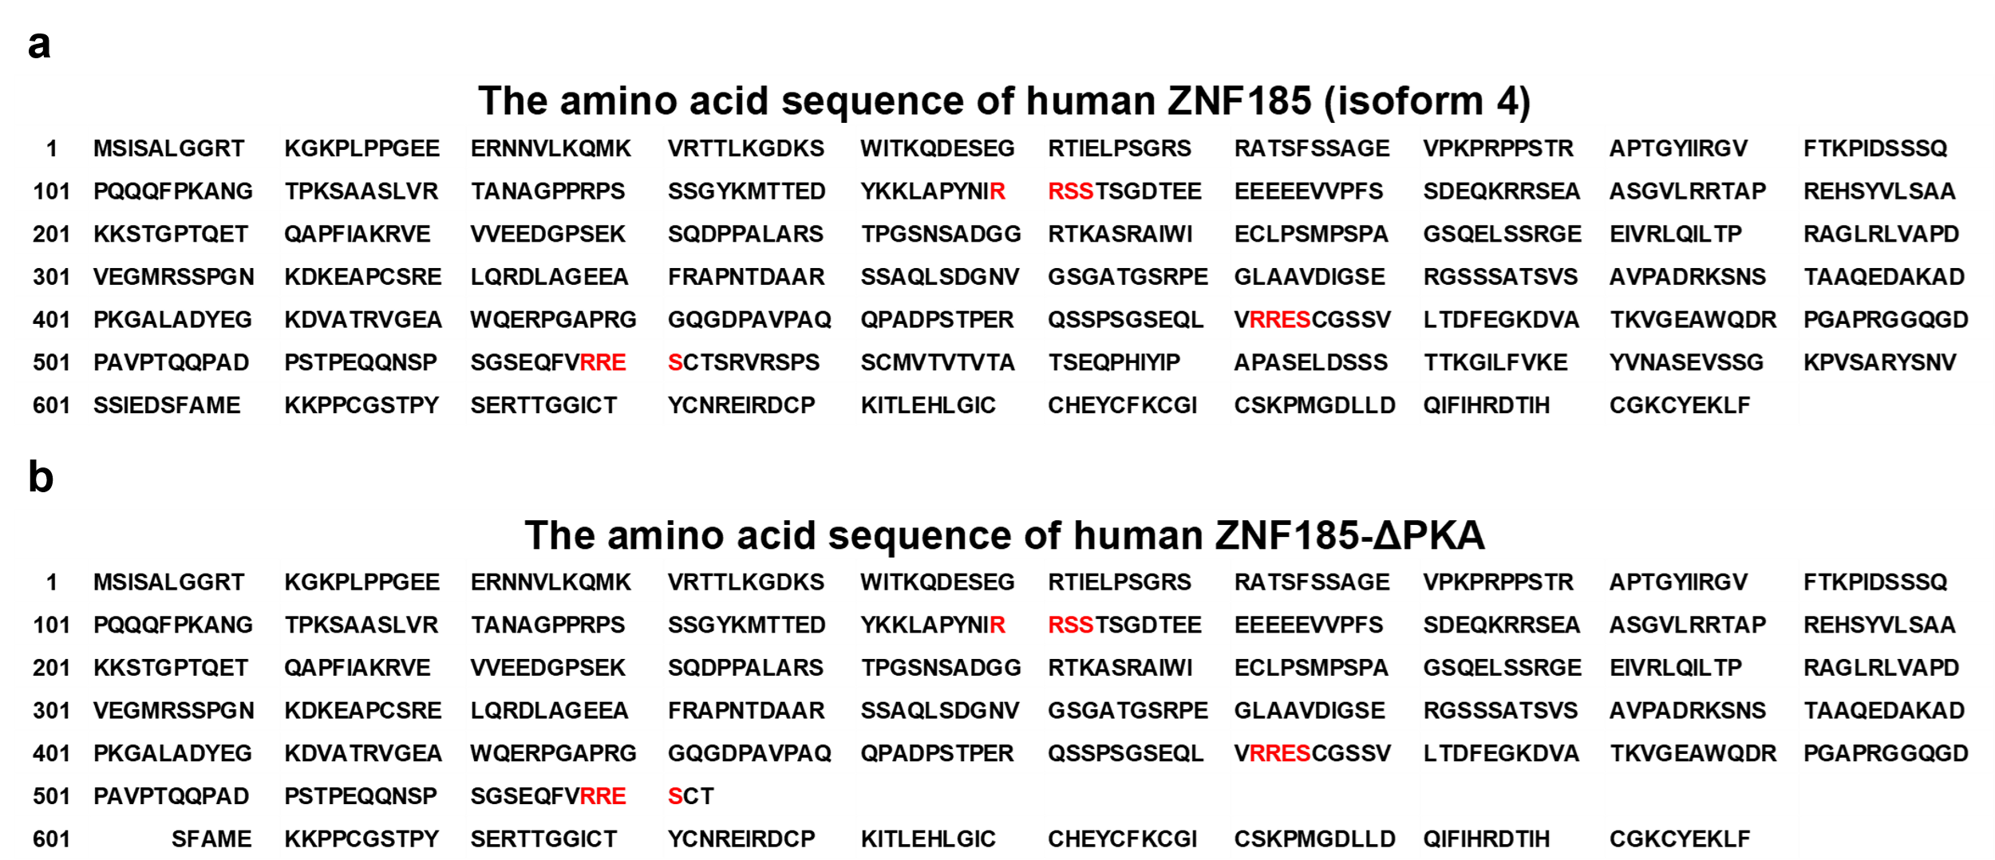
Supplementary Figure 2 The amino acid sequence of ZNF185.
ZNF185 isoform 4 (a) and ZNF185-ΔPKA (b) are shown. Three RRXS motifs are indicated in red.

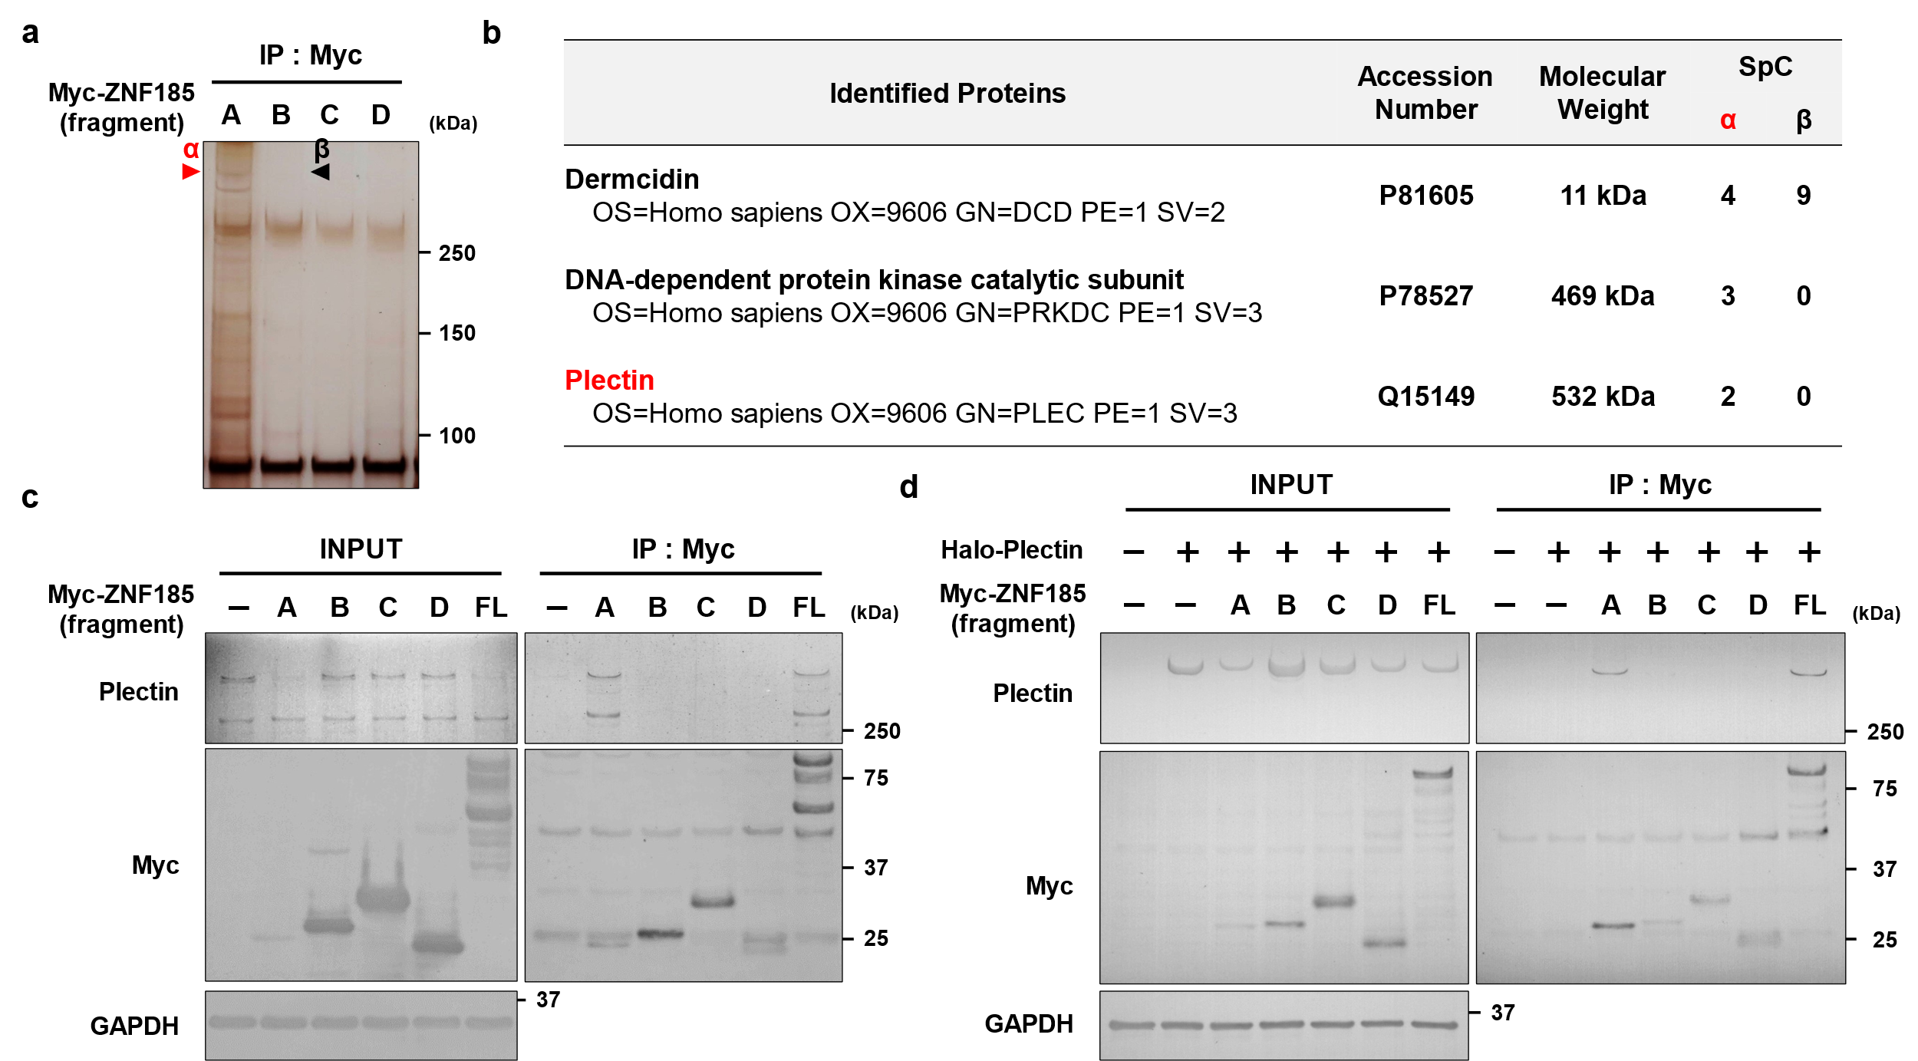
Supplementary Figure 3 Identification of plectin as a ZNF185 interacting protein.
a. Representative silver staining of ZNF185 interacting proteins. The Myc-ZNF185 fragments indicated in Fig. 2c are overexpressed in HEK293T cells. Anti-Myc beads were used for coimmunoprecipitation. ZNF185 fragment A interacts with a protein indicated by α. b Identified proteins by LC-MS/MS. SpC: spectral count. c, d. Plectin interacts with the N-terminal region of ZNF185. (c) Endogenous plectin interacts with ZNF185 fragment A and full-length ZNF185. Anti-Myc beads were used for coimmunoprecipitation. Representative blots are shown (n = 3). (d) Overexpressed plectin interacts with ZNF185 fragment A and full-length ZNF185. Halo-plectin, Myc-ZNF185 fragments, and full-length ZNF185 were overexpressed in HKE293T cells. Anti-Myc beads were used for coimmunoprecipitation. Representative blots are shown (n = 3).

