Supplementary Material

Generation mechanism of surface micro-texture in axial ultrasonic vibration-assisted milling (AUVAM)

Zongbo Zhang *ª, Wengang Liu ª, Xintong Chen ª, Yu Zhang ª, Chunling Xu ª, Kai Wang ª, Wei Wang ª, Xin Jiang ª
ª College of Mechanical and Electrical Engineering, China University of Petroleum (East China), Qingdao 266580, PR China.
* Corresponding authors
Fax: (+86) 0532-86983300
E-mail: zzb001_0@ 163. com (Zongbo Zhang).

Table S1
Conventional tool parameters
Diameter(mm) | Material | Cutter teeth | Helix angle(º) | relief angle (º) | end cutting edge angle (º)
2 | Cemented carbide | 2 | 45 | 10 | 1.5

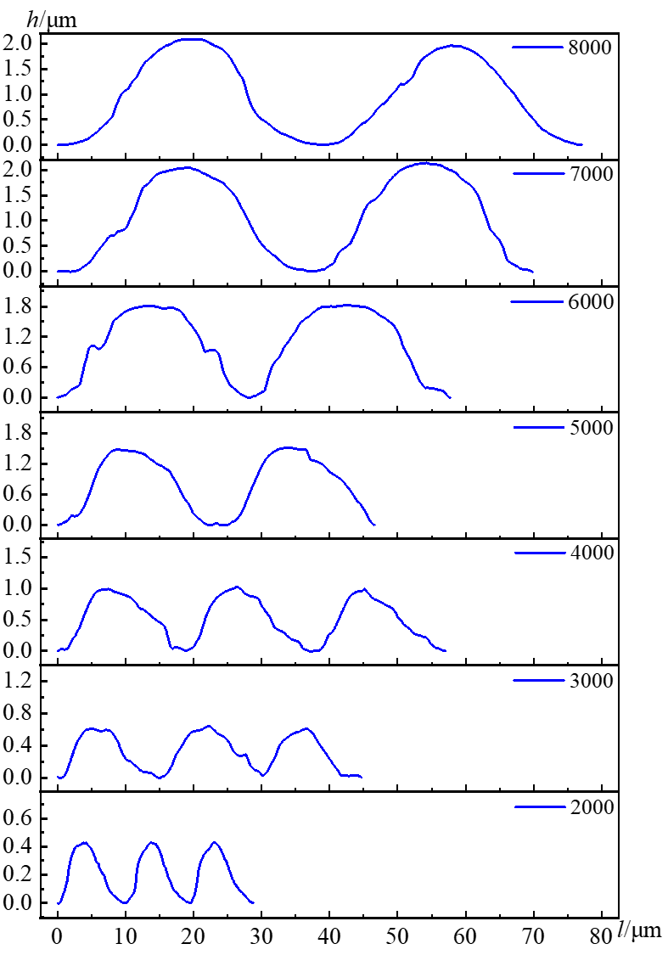 | 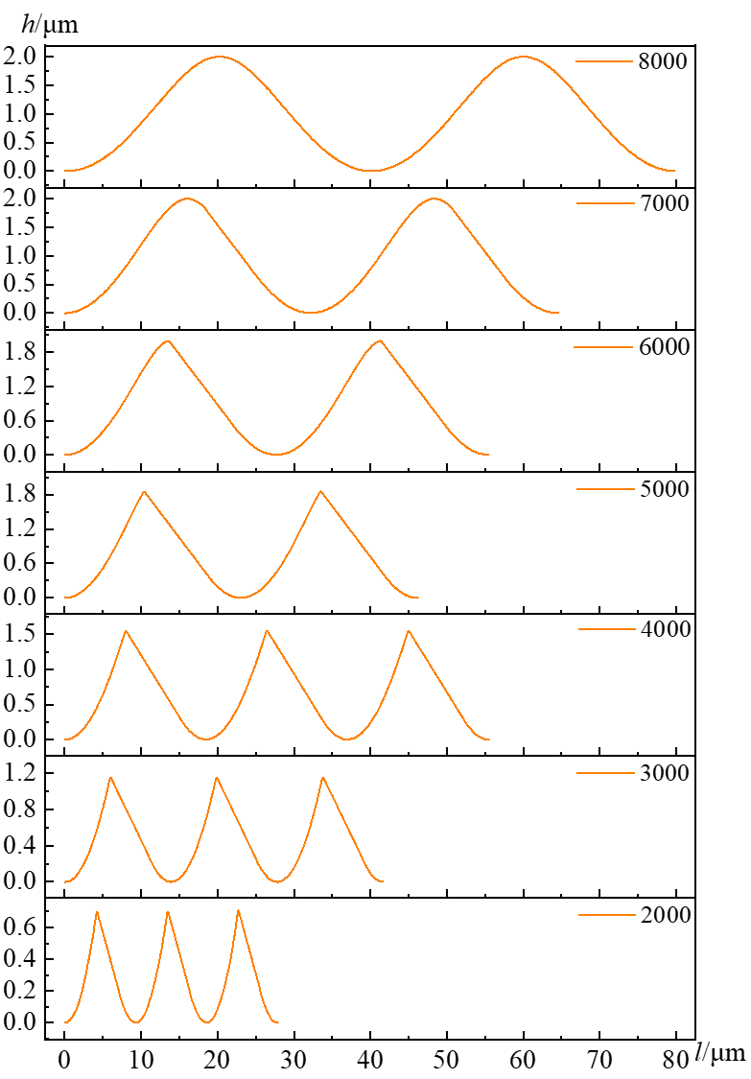
(a) | (b)
Fig. S1. Experiment and simulation results of micro-texture profiles under different spindle speeds (ranged from 2000 rpm to 8000 rpm with interval of 1000 rpm) with the relief angle of 10º: (a) experiment result; (b) simulation results.

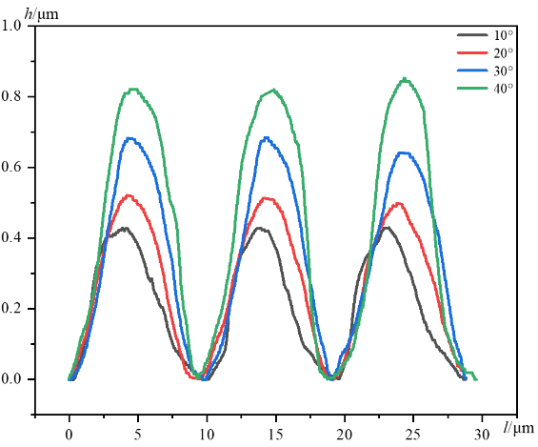 | 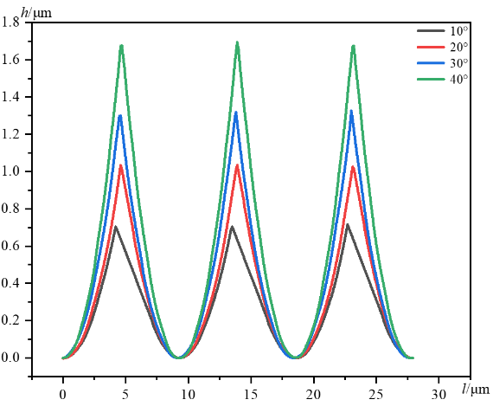
(a) n=2000 rpm | (b) n=2000 rpm
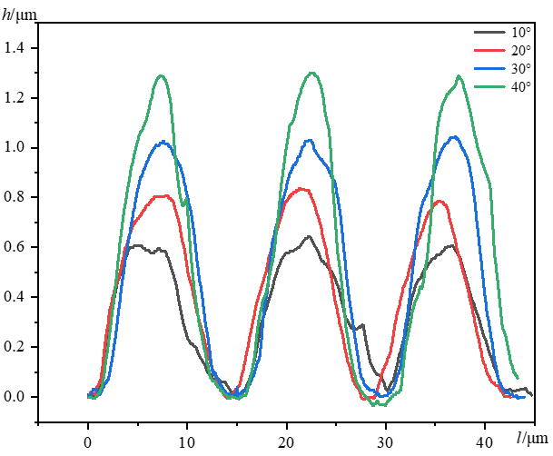 | 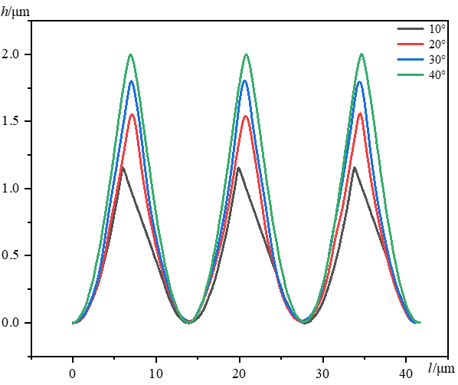
(c) n=3000 rpm | (d) n=3000 rpm
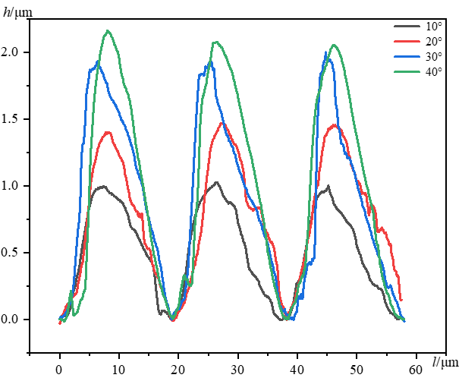 | 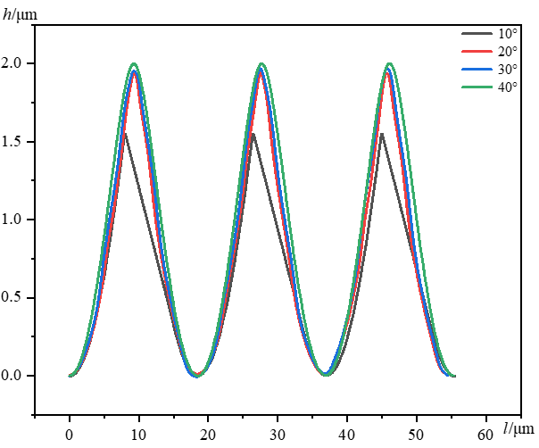
(e) n=4000 rpm | (f) n=4000 rpm
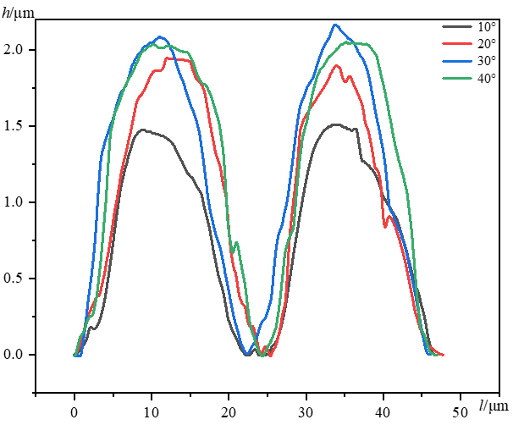 | 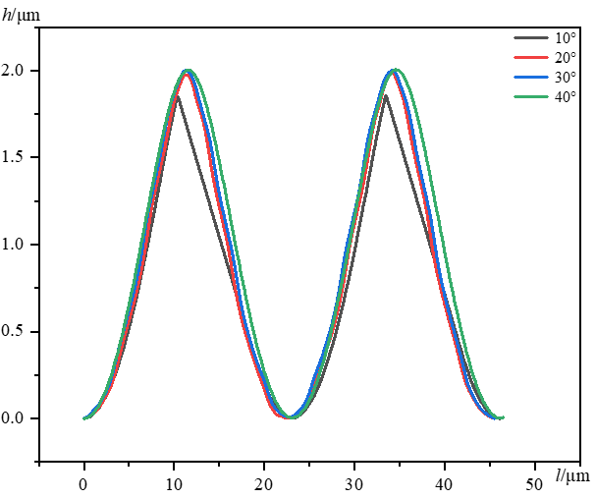
(g) n=5000 rpm | (h) n=5000 rpm

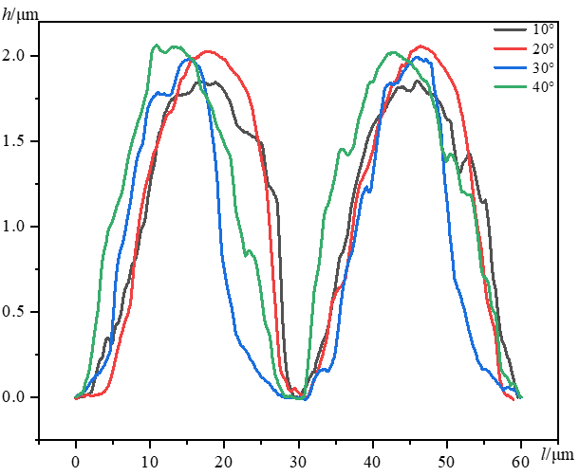 | 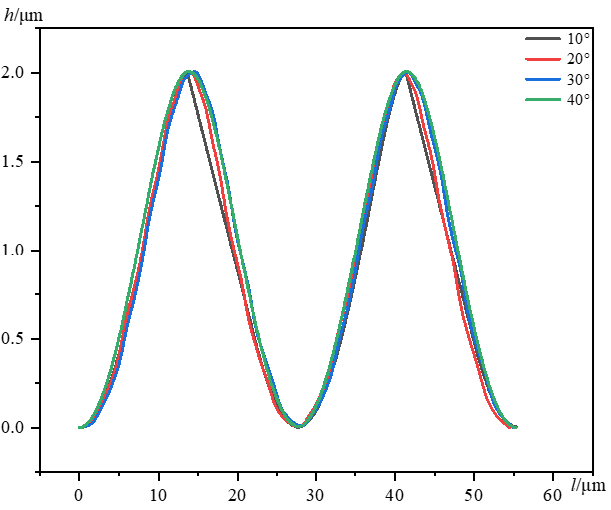
(i) n=6000 rpm | (j) n=6000 rpm
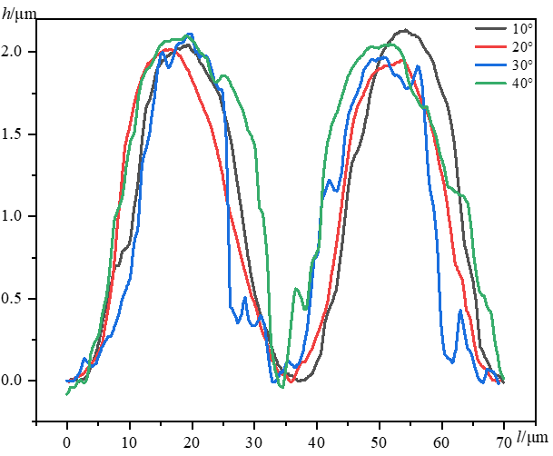 | 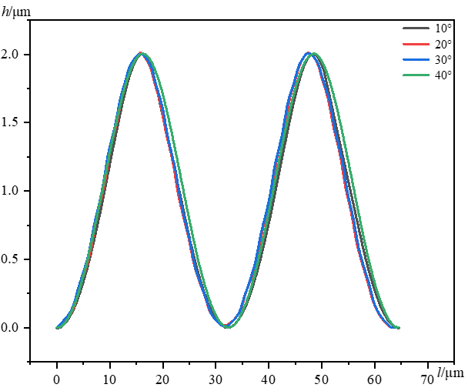
(k) n=7000 rpm | (l) n=7000 rpm
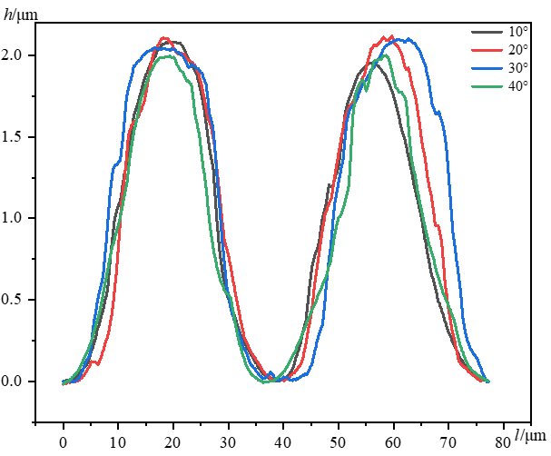 | 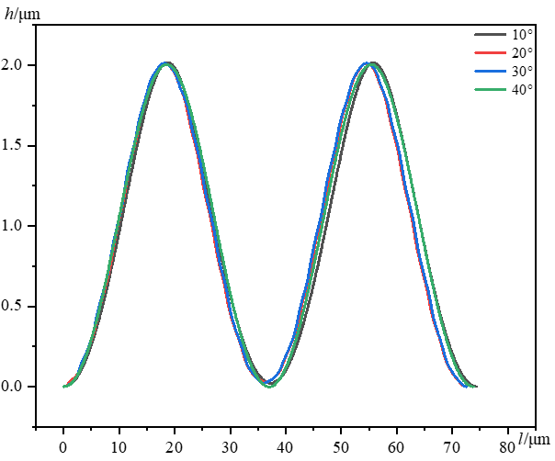
(m) n=8000 rpm | (n) n=8000 rpm
Fig. S2. Profile of the micro-texture with various spindle speeds: (a)(c)(e)(g)(i)(k)(m) are experiments results; (b)(d)(f)(h)(j)(l)(n) are simulation results.

Fig. S3. Topography of microstructures, n=8000 rpm, α=10º.
Two points (E, F) were selected to calculate the inclination angle of the microstructure, as shown in Fig. S3. The distance between the two points was 298.2 μm, and the height difference was 7.2 μm by measurement. The inclination angle of the microstructure can be calculated as 1.38º, which was consistent with the end cutting edge angle of the milling tool (1.5º).
Fig. S4. Micrograph of micro-texture units, n=5000 rpm, α=10º.

