Inferring the diurnal variability of OH radical concentrations over the Amazon from BVOC measurements

A. Ringsdorf¹, A. Edtbauer¹, J. Vilà-Guerau de Arellano^{1,2}, E. Y. Pfannerstill^{1a}, S. Gromov¹, V. Kumar³, A. Pozzer¹, S. Wolff¹, A. Tsokankunku¹, M. Soergel^{1b}, M. O. Sá⁴, A. Araújo⁵, F. Ditas^{6c}, C. Poehlker⁶, J. Lelieveld^{1,7}, J. Williams^{1,7}
¹Department of Atmospheric Chemistry, Max Planck Institute for Chemistry, Mainz, Germany
²Meteorology and Air Quality Section, University of Wageningen, Netherlands
³Satellite remote sensing group, Max Planck Institute for Chemistry, Mainz, Germany
⁴Instituto Nacional de Pesquisas da Amazônia (INPA), CEP 69067-375, Manaus, Brazil
⁵Empresa Brasileira de Pesquisa Agropecuária (Embrapa) Amazonia Oriental, CEP 66095-100, Belém, Brazil
⁶Department of Multiphase Chemistry, Max Planck Institute for Chemistry, Mainz, Germany
⁷Climate and Atmosphere Research Center, The Cyprus Institute, 1645 Nicosia, Cyprus
ªnow at: Department of Environmental Science, Policy, and Management, University of California, Berkeley, 94720, CA, USA
^{b}now at: Friedrich-Alexander-Universität Erlangen-Nürnberg, Sachgebiet Arbeitssicherheit, Erlangen, Germany
^{c}now at: Hessian Agency for Nature Conservation, Environment and Geology, Wiesbaden, Germany

Supplementary
Table S1: Daytime chemical reaction scheme applied in DALES. The reaction rate coefficients for first order reactions [s-1] and second order reactions [cm³ modelcules⁻¹ s⁻¹] are presented in the right column with T representing the air temperature [K]. The rate coefficient of R17 is shown below the table. Species in brackets are chemically inactive. The n is a variable describing the recycling efficiency by giving the number of OH molecules emerging from the reaction R19. R1 and R6 are reactions depending on the photolysis of the respective species.
Number | Chemical equation | Reaction rate constant
R1 | O₃ + (hv) $→$ O^{1D} + O₂ | $$3.83×{10}^{-5}∙e^{-0.575}$$
R2 | O^{1D} + H₂O $→$ 2OH | $$1.63×{10}^{-10}∙e^{\frac{60}{T}}$$
R3 | O^{1D} + N₂ $→$ O₃ | $$2.15×{10}^{-11}∙e^{\frac{110}{T}}$$
R4 | O^{1D} + O₂ $→$ O₃ | $$3.30×{10}^{-11}∙e^{\frac{55}{T}}$$
R5 | NO₂ + (O₂) $→$ NO + O₃ | $$1.67×{10}^{-2}∙e^{-0.575}$$
R6 | CH₂O + (hv) $→$ HO₂ | $$1.47×{10}^{-4}∙e^{-0.575}$$
R7 | OH + CO $→$ HO₂ + (CO₂) | $$2.40×{10}^{-13}$$
R8 | OH + CH₄ $→$ CH₃O₂ | $$2.45×{10}^{-12}∙e^{\frac{-1755}{T}}$$
R9 | OH + ISO $→$ RO₂ | $$1.00×{10}^{-10}$$
R10 | OH + MVK $→$ HO₂ + CH₂O | $$2.40×{10}^{-11}$$
R11 | OH + HO₂ $→$ H₂O + (O₂) | $$4.80×{10}^{-11}∙e^{\frac{250}{T}}$$
R12 | OH + H₂O₂ $→$ H₂O + HO₂ | $$2.90×{10}^{-12}∙e^{\frac{-160}{T}}$$
R13 | HO₂ + NO $→$ OH + NO₂ | $$3.50×{10}^{-12}∙e^{\frac{250}{T}}$$
R14 | CH₃O₂ + NO $→$ HO₂ + NO₂ + CH₂O | $$2.80×{10}^{-12}∙e^{\frac{300}{T}}$$
R15 | RO₂ + NO $→$ HO₂ + NO₂ + MVK + CH₂O | $$1.00×{10}^{-11}$$
R16 | OH + CH₂O $→$ HO₂ | $$5.50×{10}^{-12}∙e^{\frac{125}{T}}$$
R17 | 2HO₂ $→$ H₂O₂ + (O₂) | k*
R18 | CH₃O₂ + HO₂ $→$ Product | $$4.10×{10}^{-13}∙e^{\frac{750}{T}}$$
R19 | RO₂ + HO₂ $→$ nOH + Product | $$1.50×{10}^{-11}$$
R20 | OH + NO₂ $→$ HNO₃ | $$3.50×{10}^{-12}∙e^{\frac{340}{T}}$$
R21 | NO + O₃ $→$ NO₂ + (O₂) | $$3.00×{10}^{-12}∙e^{\frac{-1500}{T}}$$
* k = (k₁ + k₂)k₃, k₁ = $2.2×{10}^{-13}∙e^{\frac{600}{T}}$, k₂ = $1.90×{10}^{-33}∙e^{\frac{980}{T}}∙ c_{air}$, k₃ =$1+1.40×{10}^{-21}∙e^{\frac{2200}{T}}∙c_{H_{2}O}$
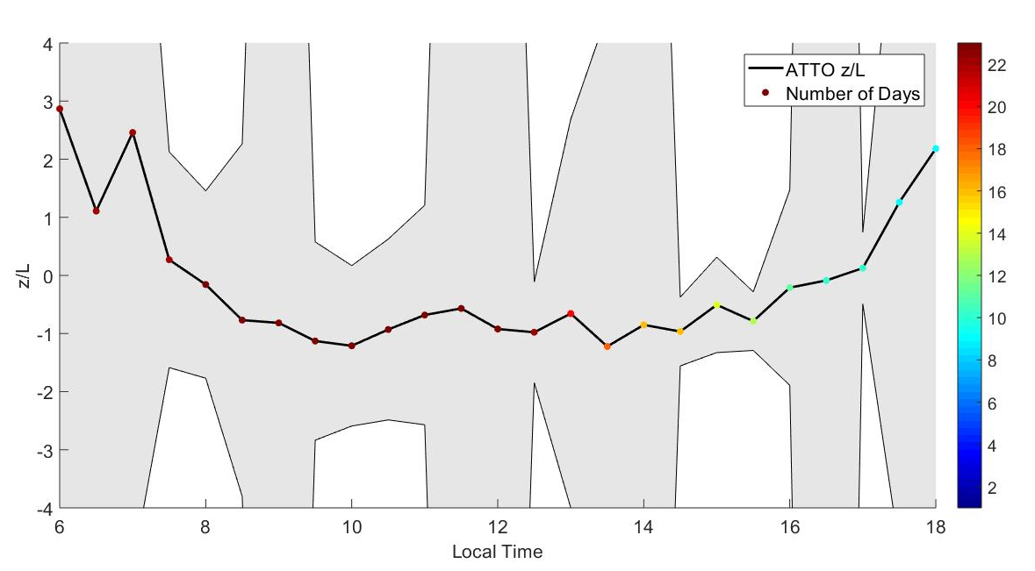
S1: Stability parameter z/L observed at ATTO and median averaged over the 23 days used in this study. Precipitation events are excluded. Shadings indicate 1σ. At certain days single observations give values for z/L of almost 100 leading to the high variability at some daytimes.
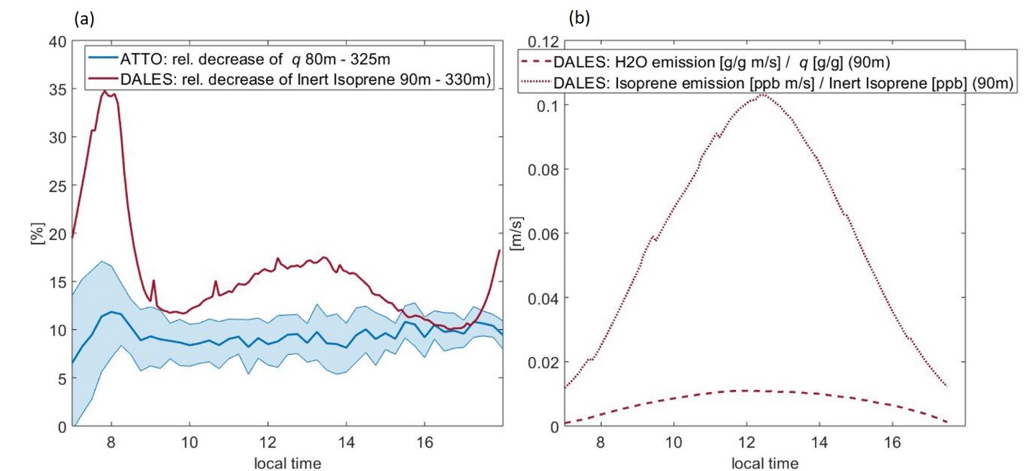
S2: Comparison of the inert isoprene tracer to q, both used to correct for turbulent mixing a) The relative decrease of q measured at ATTO compared to inert isoprene simulated by DALES. b) The emission and dilution velocity for q and inert isoprene both calculated from DALES simulations.
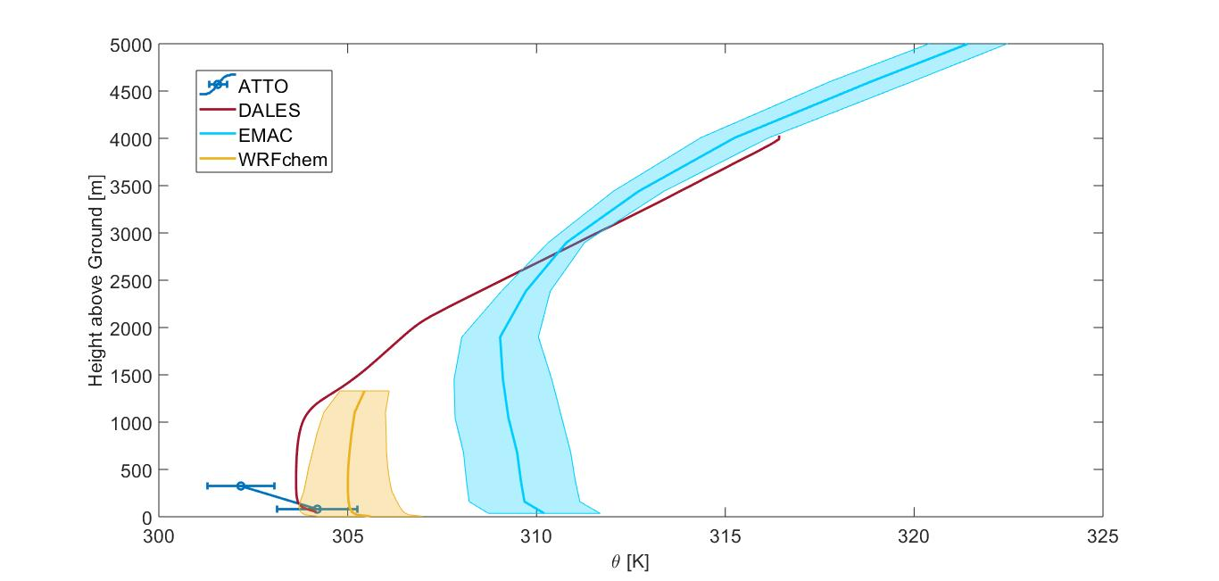
S3: The vertical profile of the potential temperature θ for the numerical models DALES, EMAC and WRF-Chem compared to median averaged observations at ATTO at two heights. Errorbars and Shadings indicate 1σ.

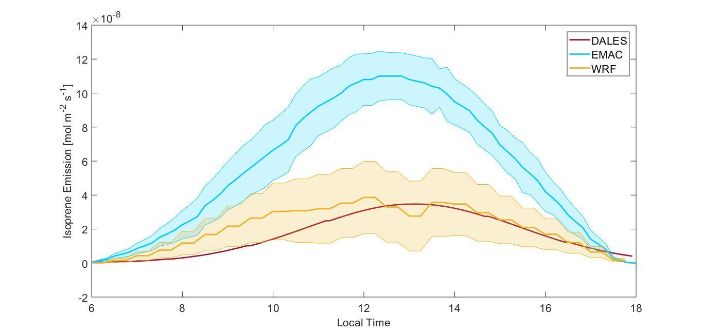
S4: Isoprene emission in the numerical models DALES, EMAC and WRF-Chem. For EMAC only the case with reduces isoprene emission is shown. Shadings indicate 1σ.

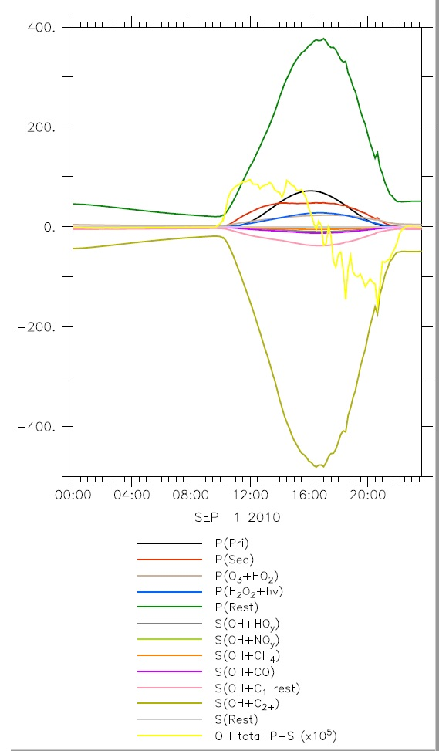
S5: Sources and sinks of OH from the global model EMAC at 80 m height extracted for September, 1st.

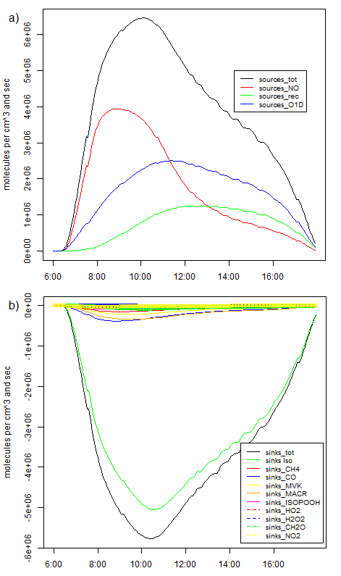
S6: Sources and sinks of OH from DALES over one typical day (local time) of the Amazon dry season at 90 m height. a) sources of OH b) sinks of OH
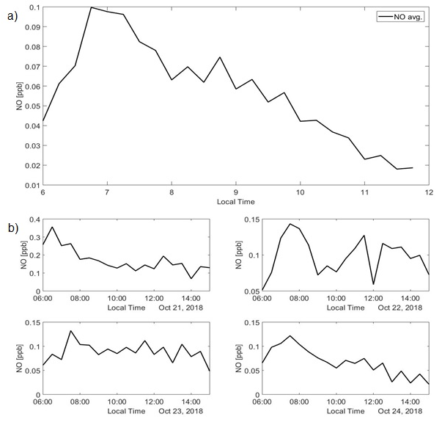
S7: Daily cycles of NO detected at ATTO a) Median averaged mixing ratio of NO measured in the dry season of 2018 (September, October) b) The NO mixing ratio measured at ATTO on four days that are considered for the OH estimation as well. All other days have no overlapping data.

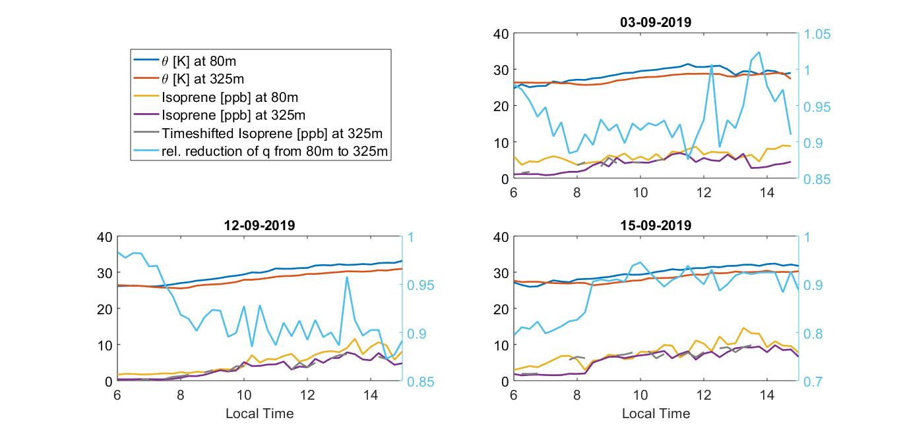
S8: Time series of potential temperature θ and isoprene on the three days that result in an enhanced OH before 8:00 LT. The OH concentration is estimated in the parts of the day when θ at 80 m exceeds θ measured at 325 m, which indicates instable stratification of the boundary layer. The relative reduction of the specific humidity q between 80 m and 325 m is shown as well with values on the right axis.

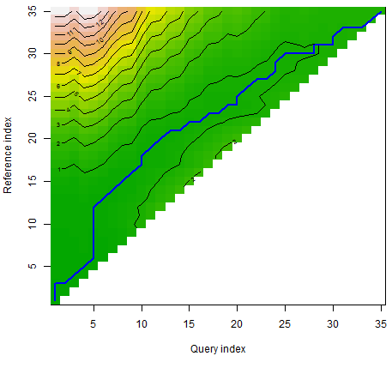
S9: Example of a warping path of the Dynamical Time Warping analysis with the positive window cut off. Reference and Query Indexes are the time steps of potential temperature at 80 m and 325 m.

