Clinicopathological significance of fusion oncogenes in papillary thyroid carcinoma: a meta-analysis of summary and individual patient data
Vuong et al.
(Supplementary data)

Table S1. Clinicopathological features of NTRK1- versus NTRK3-rearranaged PTCs
Variables | NTRK1 | NTRK3 | p-value
Variables | (N=80) | (N=145) | p-value
Age |  |  | 0.139
Mean (SD) | 35.3 (19.1) | 31.0 (16.1)
Median [Min, Max] | 36.0 [4.30, 74.0] | 29.0 [5.20, 74.0]
Gender |  |  | <0.001
Female | 43 (56.6) | 113 (81.3)
Male | 33 (43.4) | 26 (18.7)
Histologic variants |  |  | <0.001
Classic | 30 (56.6) | 29 (24.0)
Follicular variant | 10 (18.9) | 59 (48.8)
Diffuse sclerosing variant | 4 (7.55) | 0 (0)
Solid variant | 1 (1.89) | 10 (8.26)
Other variants | 8 (15.1) | 23 (19.0)
Psammoma |  |  | 0.508
No | 55 (77.5) | 65 (75.6)
Yes | 16 (22.5) | 21 (24.4)
Focality |  |  | 0.011
Multifocal | 26 (78.8) | 50 (53.8)
Unifocal | 7 (21.2) | 43 (46.2)
Vascular invasion |  |  | 0.048
No | 4 (44.4) | 46 (78.0)
Yes | 5 (55.6) | 13 (22.0)
Lymph node metastasis |  |  | 0.065
No | 8 (22.2) | 34 (43.0)
Yes | 28 (77.8) | 45 (57.0)
Extrathyroidal extension |  |  | 0.036
No | 8 (36.4) | 48 (61.5)
Yes | 14 (63.6) | 30 (38.5)
Distant metastasis |  |  | 0.061
No | 13 (48.1) | 27 (71.1)
Yes | 14 (51.9) | 11 (28.9)
Abbreviations: SD, standard deviation
*, bold values indicate a statistically significant value

Table S2. Clinicopathological features of different RET rearrangement variants
Variables | RET/PTC1 | RET/PTC3 | Other RET fusions | p-value
Variables | (N=82) | (N=39) | (N=19) | p-value
Age |  |  |  | 0.231
Mean (SD) | 26.8 (14.8) | 22.6 (15.0) | 24.1 (16.3)
Median [Min, Max] | 24.5 [7.40, 69.0] | 15.0 [6.00, 58.0] | 18.0 [5.10, 66.0]
Gender |  |  |  | 0.357
Female | 64 (78.0) | 26 (66.7) | 13 (68.4)
Male | 18 (22.0) | 13 (33.3) | 6 (31.6)
Histologic pattern |  |  |  | 0.041
Classic | 31 (53.4) | 23 (59.0) | 6 (46.2)
Diffuse sclerosing | 21 (36.2) | 8 (20.5) | 6 (46.2)
Follicular | 1 (1.72) | 7 (17.9) | 1 (7.69)
Solid | 5 (8.62) | 1 (2.56) | 0 (0)
Psammoma |  |  |  | 1.000
No | 1 (20.0) | 0 (0) | NA
Yes | 4 (80.0) | 1 (100) | NA
Focality |  |  |  | 0.063
Multifocal | 31 (77.5) | 18 (78.3) | 3 (37.5)
Unifocal | 9 (22.5) | 5 (21.7) | 5 (62.5)
Vascular invasion |  |  |  | 0.444
No | 3 (42.9) | 2 (100) | NA
Yes | 4 (57.1) | 0 (0) | NA
Lymph node metastasis |  |  |  | 0.141
No | 13 (19.7) | 4 (11.8) | 3 (18.8)
Yes | 53 (80.3) | 30 (88.2) | 13 (81.3)
Extrathyroidal extension |  |  |  | 0.691
No | 9 (27.3) | 2 (14.3) | 3 (30.0)
Yes | 24 (72.7) | 12 (85.7) | 7 (70.0)
Distant metastasis |  |  |  | 0.192
No | 37 (78.7) | 18 (60.0) | 7 (63.6)
Yes | 10 (21.3) | 12 (40.0) | 4 (36.4)
Abbreviations: SD, standard deviation
*, bold values indicate a statistically significant value

Figure S1. Progressive-free survival of NTRK1-positive versus NTRK3-positive PTCs
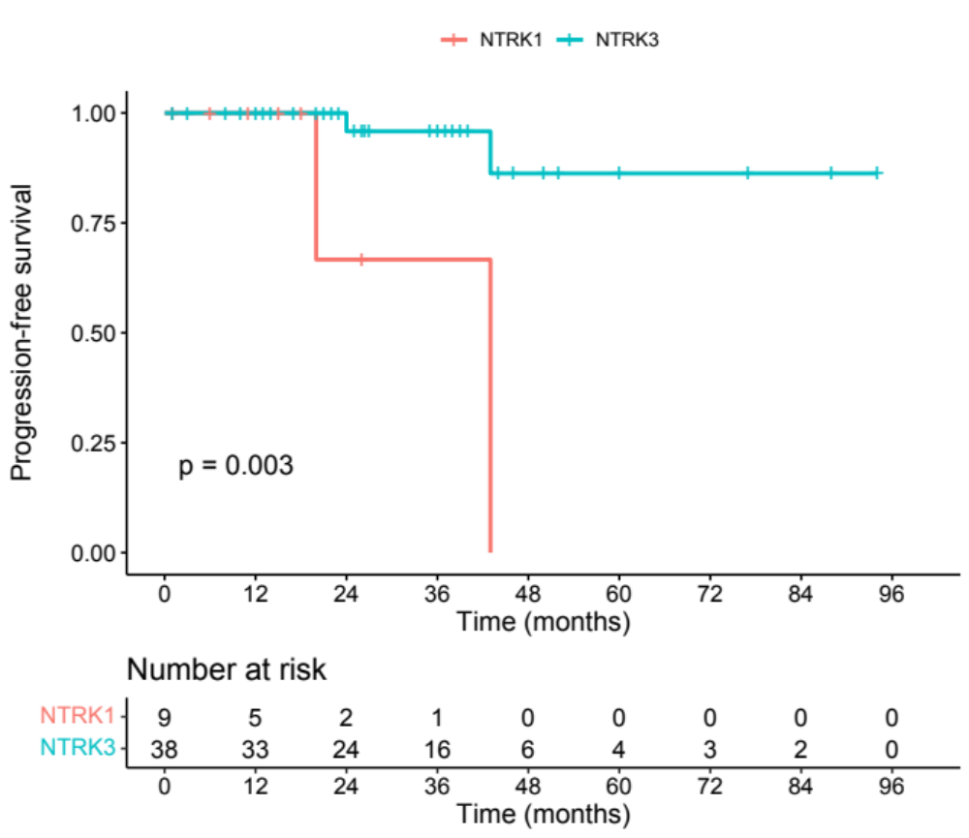
Figure S2. Progression-free survival of PTCs with RET/PTC1, RET/PTC3, or other rare RET variants
