Controlled Electronic and Magnetic Landscape in Self-Assembled Complex Oxide Heterostructures

D.-S. Park, et al.

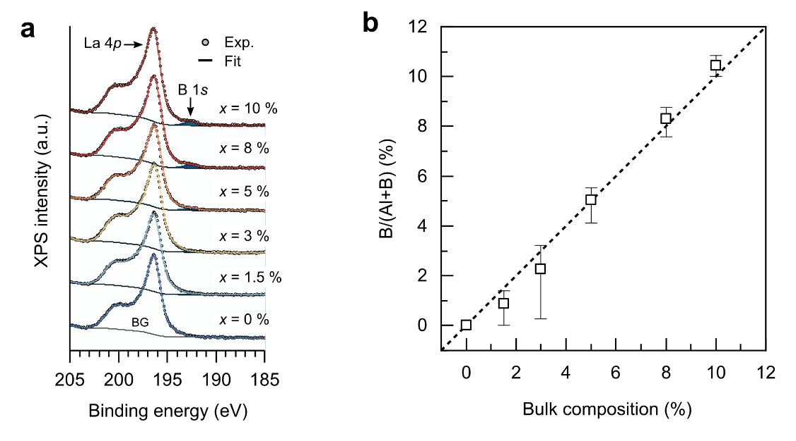
Supplementary figure 1. X-ray photoemission spectroscopy for the LABO(x) samples. (a) XPS La 4p and B 1s core-level spectra for the LABO films as a function of LBO composition (x). (b) Atomic ratios for the B composition of the films, determined by B-site cation ratios as B/(Al+B).

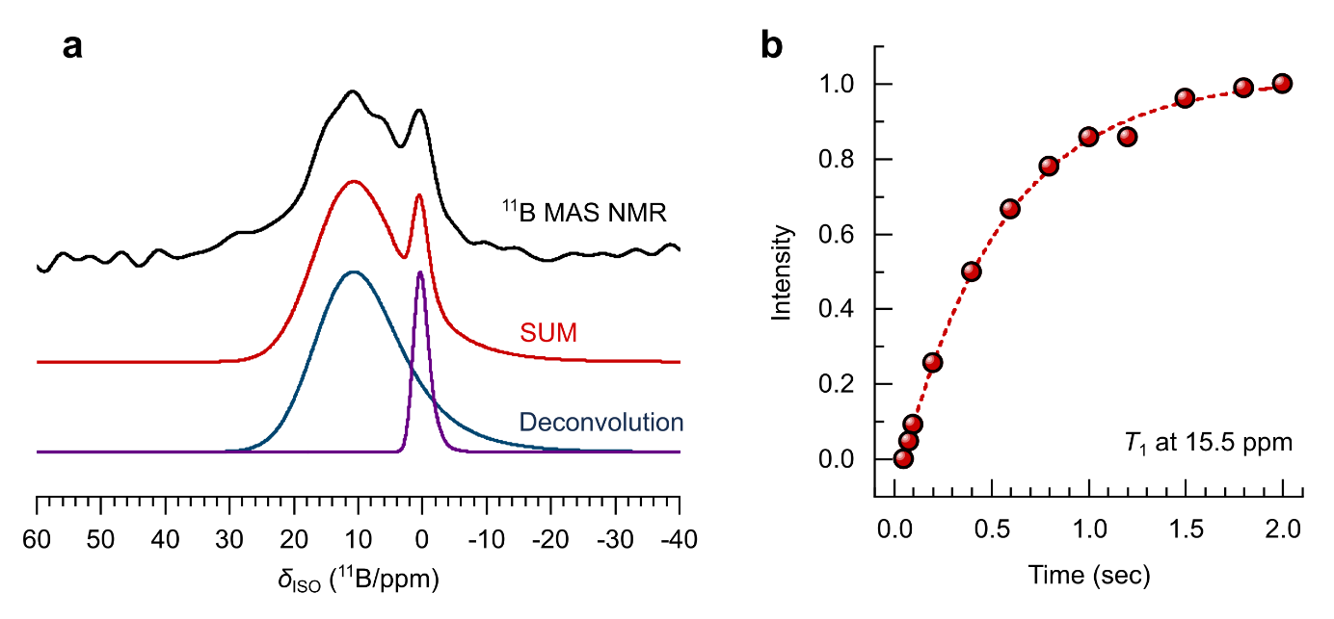
Supplementary figure 2. (a) The ¹¹B MAS NMR spectrum (top) of the LABO-STO thin film, the simulation of the distribution of quadrupole parameters (middle), and the individual peaks which sum to give the simulation (bottom). It is suspected that the purple resonance (δ_{iso} = 1.5 ppm) is a preferential alignment artefact of the major broad resonance. (b) The T₁ determination of the broad resonance with a δ_{iso} at 15.5 ppm. The data is fitted to a single exponential f(t) = I_{o} × [1-exp(-t/T₁)] to give a T₁ of 0.522 seconds for the broad resonance and 0.654 seconds for the narrower resonance.
The majority of the ¹¹B, in the thin film, is present in a broad disordered BO₃ environment (a), with a δ_{iso} = 15.5 ppm, C_{Q} centre of 2.5 MHz and C_{Q} width of 2.4 MHz (all η values were fixed to 0.1 during the simulations). This resonance is contradictory to the previous work on LABO ceramics which showed multiple highly-ordered BO₃ and BO₄ environments. There is evidence of preferential alignment of the ¹¹B environment, resulting in a narrow resonance at δ_{iso} = 1.5 ppm (no C_{Q} distribution is simulated to this resonance), this is expected as the thin films were sliced to be inserted into the rotor causing orientation of the films in the rotor to be likely. The measured T₁ relaxation time for the broad distributed BO₃ resonance is 0.522 seconds (±0.029 seconds), this is significantly quicker than the 240 seconds T₁ measured for bulk LBO and is also faster than the 1.2 second relaxation time measured for LABO ceramics¹. This proposes that the disordered BO₃ environments are in a highly conductive environment, as the local hyperfine field from these conduction electrons will interact with the nuclear site causing a decreased relaxation time. The relaxation of the second ‘aligned’ resonance is similar (0.624 seconds), which advocates its relationship to the broad resonance and not a secondary environment. This suggests the relaxation time is significantly longer and that the boron speciation is in a traditional LBO environment¹.
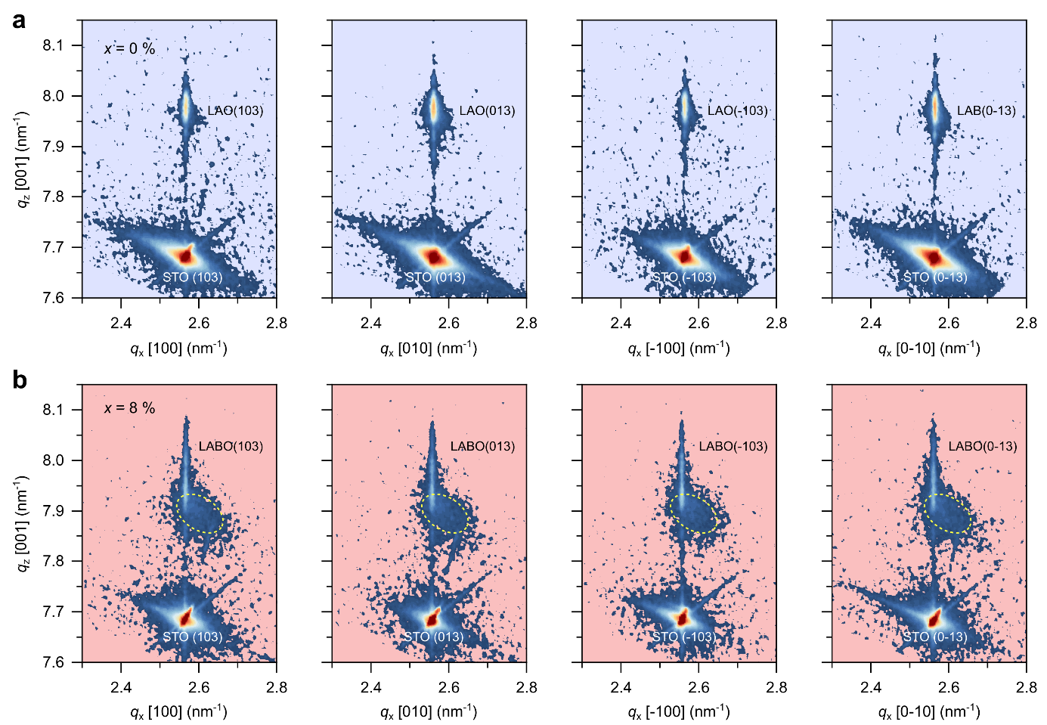
Supplementary figure 3. Reciprocal space maps (RSMs) around STO {103} reflections for the undoped LAO/STO (a) and LABO(x = 8 %)/STO (b) samples.

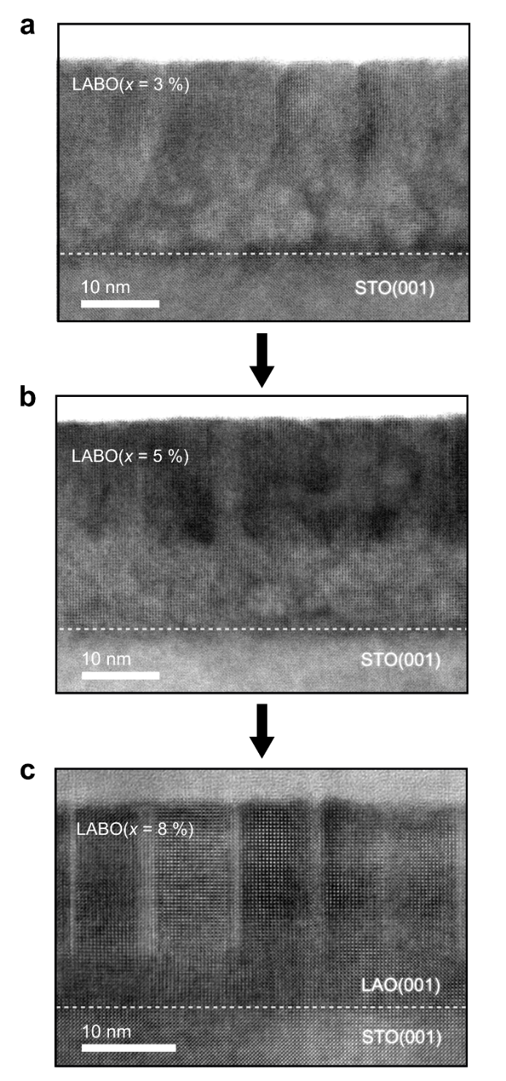

Supplementary figure 4. Cross-sectional STEM images for the LABO(x) films grown on STO(001): (a) LABO(x = 3 %)/STO, (b) LABO(x = 5 %)/STO, and (c) LABO(x = 8 %)/STO.

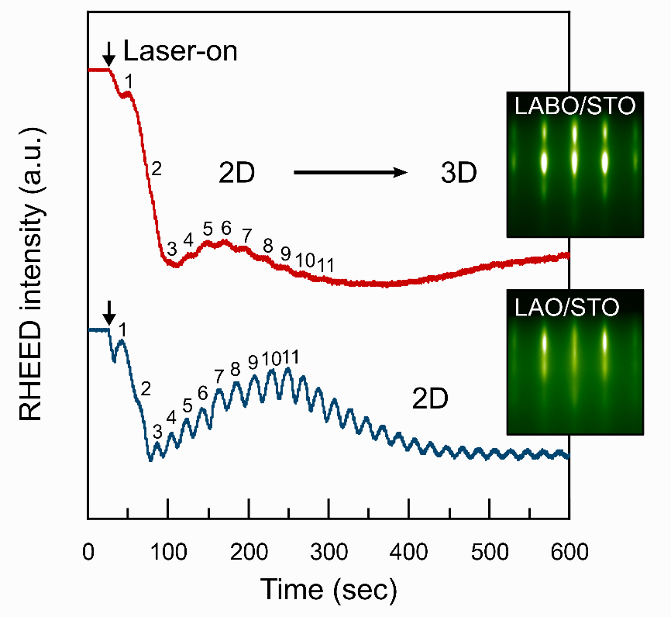
Supplementary figure 5. Reflection high-energy electron diffraction (RHEED) intensity oscillations during the growth of LAO (bottom) and LABO (top) films grown on TiO₂-terminated STO(001). The insets show the RHEED patterns after film growth. For the LAO film on TiO₂-STO, a steady 2D film growth mode was found during film growth, resulting in a streaky RHEED pattern after film growth. While, for the LABO film growth on TiO₂-STO, a transition from 2D to 3D film growth was found after the deposition of 10 – 11 UCs, resulting in a spotty RHEED pattern.

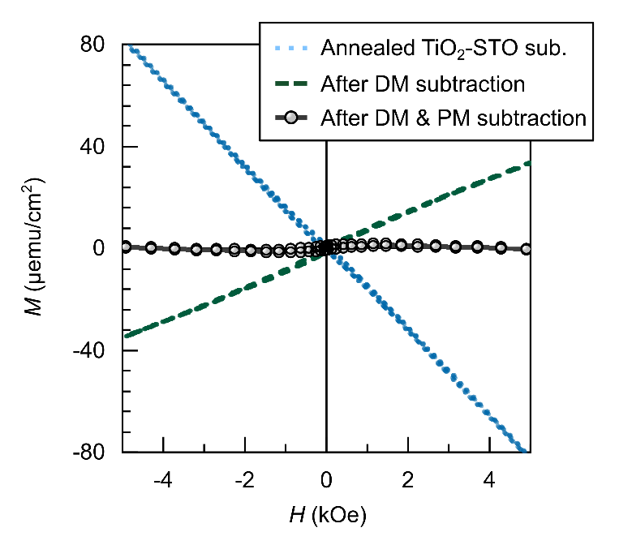
Supplementary figure 6. Magnetic measurement for an annealed TiO₂-terminated SrTiO₃ substrate used for film growth. Before its magnetic measurement, the treated substrate was loaded in the same PLD growth chamber and was annealed by taking the same film growth temperature procedure (heating and cooling processes) in the same growth pressure, P_{O}. This confirms that there is no external magnetic contribution from the vacuum chamber.

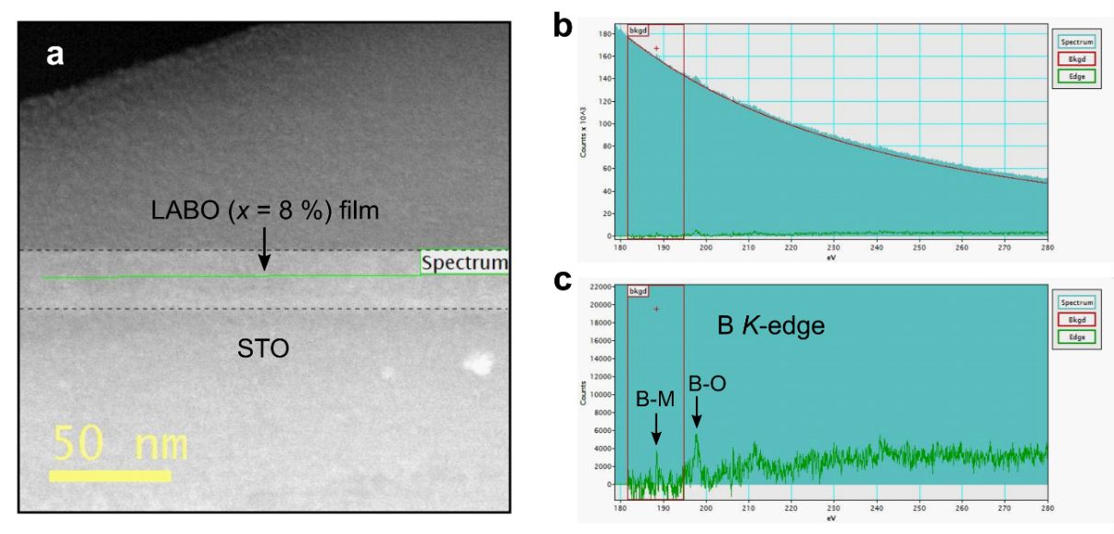
Supplementary figure 7. (a) Cross-sectional STEM image for the LABO(x = 8 %) on STO(001). The horizontal line scan was performed for the B K-edge electron energy loss spectroscopy (EELS) analysis of the LABO film layer. (b,c) The EELS profiles of the B K-edge signals before (b) and after (c) background subtraction. The results show two different chemical states of B in the LABO film layer: metallic B states at ~188 eV and B-O states at ~196 - 197 eV.

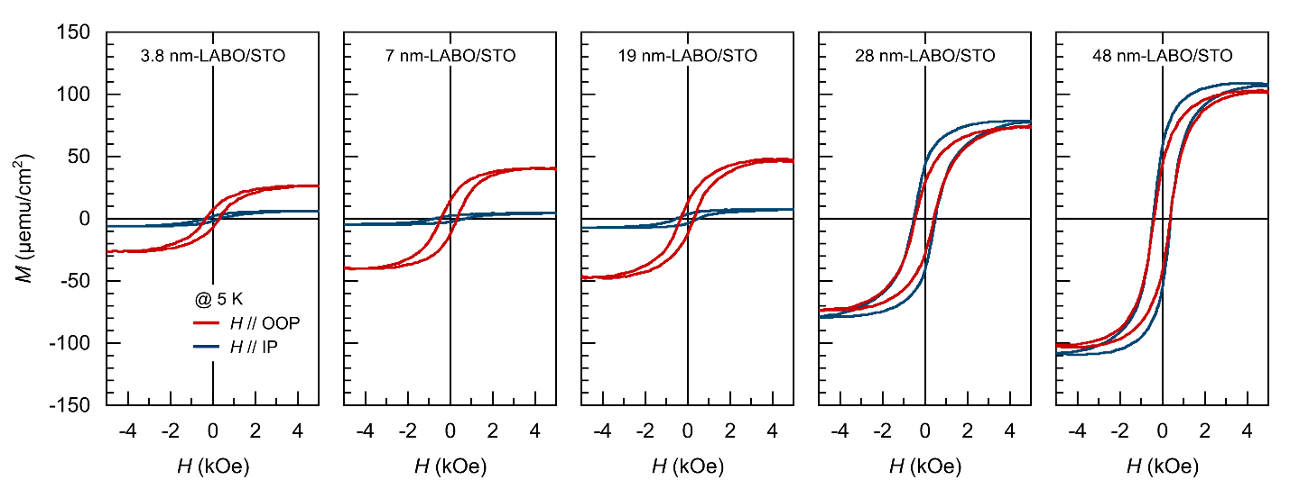
Supplementary figure 8. 5 K magnetic hysteresis loops of the LABO (x = 10 %) films as a function of thicknesses (3.8 nm, 7 nm, 19 nm, 28 nm, and 48 nm). The in-plane (IP) magnetic hysteresis loops of the films were measured by applying external magnetic fields (H) along the IP direction of the samples. The out-of-plane (OOP) hysteresis loops were measured while applying the fields to the OOP direction of the samples.

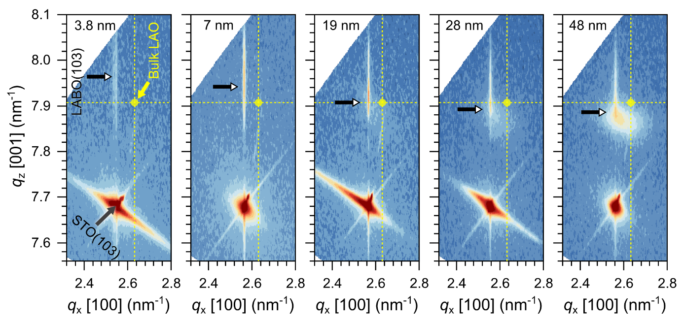
Supplementary figure 9. Reciprocal space maps (RSMs) around STO {103} reflections for the LABO(x = 10 %)/STO samples with different film thicknesses (3.8 nm, 7 nm, 19 nm, 28 nm, and 48 nm).
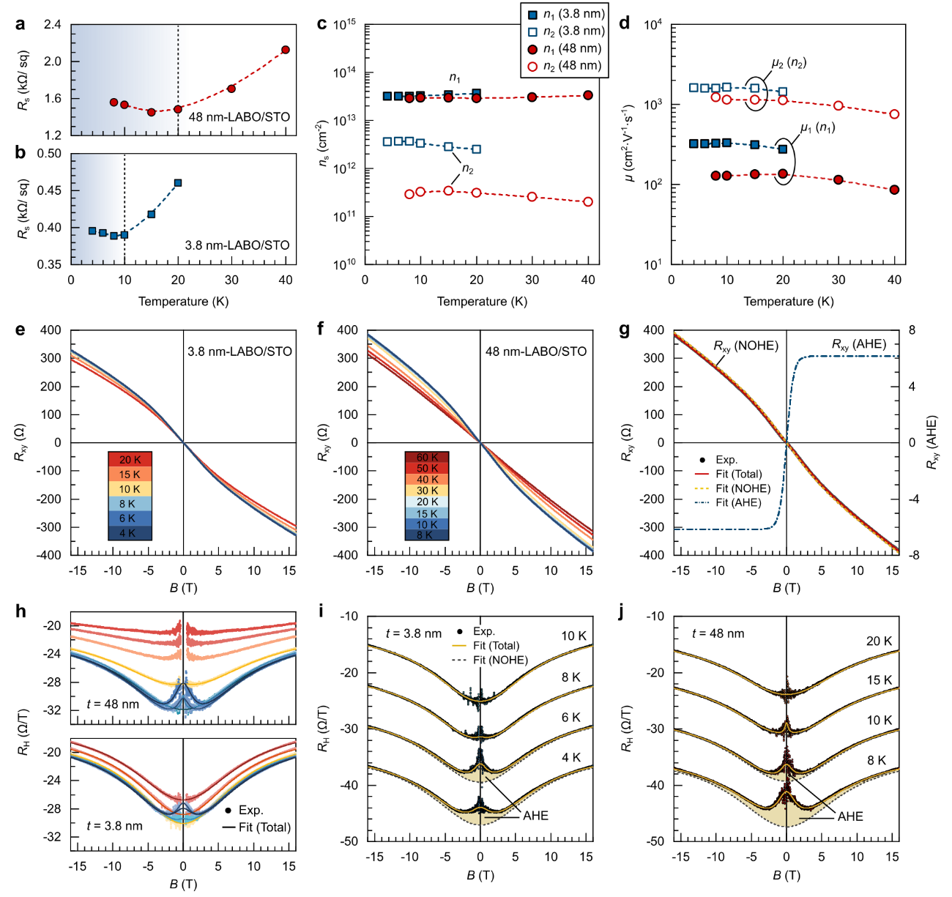
Supplementary figure 10. (a,b) Low-temperature (< 50 K) sheet resistance (R_{s}) of the LABO films, t = 3.8 nm (a) and 48 nm (b). (c,d) Sheet carrier density (c) and mobility (d) of the films. The low-temperature (below 50 K) carrier transport of the samples was determined by nonlinear ordinary Hall effect (NOHE) which describes the multiband conducting parameters: low-mobility (µ₁) carrier density (n₁) and high-mobility (µ₂) carrier density (n₂) of the samples derived by employing a two-band model (see Supplementary text 1). (e,f) Variable temperature Hall resistance, R_{xy}, of the samples, 3.8 nm-LABO/STO (e) and 48 nm-LABO/STO (f). (g) The experimental 8 K R_{xy} of the 48 nm-LABO/STO and its best-fit by deconvoluting NOHE and AHE parts. (h) Experimental R_{H} (= R_{xy}/B) of the samples as a function of temperature, t = 3.8 nm (bottom) and 48 nm (top). (i,j) The repositioned high-field (16 T) R_{H} of the samples with temperatures for visible comparison on the temperature-dependent AHE.

Supplementary Note 1.
Determination of low-temperature two-carrier conduction and anomalous Hall effect.
Determining the sheet resistance, $R_{s}$, of sample in the van der Pauw configuration requires voltage measurements of the sample in two directions.
$R_{s}=\frac{π}{\ln{2}}\frac{R_{12,34}-R_{23,41}}{2}f$, | (1)
where $R$ denotes the measured resistance that should be averaged by switching the current and voltage contacts in the reciprocal theorem, $R_{12,34}=R_{21,43}= R_{34,12}=R_{43,21}$. $f$ represents the van der Pauw correction factor ($0.2<f<1$)². Figure S10a shows low-temerpature (< 50 K) $R_{s}$ of the 10 UC- and 48 nm-LABO/STO samples. The $R_{s}$ of the 3.8 nm-LABO/STO sample is lower (~4 times) than that of the 48 nm-LABO/STO. Both samples show resistance upturns at low temperatures with different crossover temperatures (~ 10 K for t = 3.8 nm and ~20 K for t = 48 nm). Such resistance upturns are usually caused by either a carrier localization with a low carrier density (n) or a carrier scattering with a lower carrier mobility (µ). To further understand this, we performed Hall resistance measurements on the samples. Since the high-field non-linear Hall resistance of the LABO/STO samples at low temperatures below 50 K is typically attributed to both the light d_{xy} and heavy d_{xz/yz} band electrons in STO, two-carrier conduction was considered. For a 2D system, the total conductivity is a result of the sum of conductivities of the different sub-bands, which can be written as the conductivity tensor³:
$σ=\left(\begin{matrix}D_{i} & -A_{i} \\ A_{i} & D_{i}\end{matrix}\right)$, | (2)
where $D_{i}= \frac{n_{i}e^{2}}{m_{i}}\frac{τ_{i}}{1+{ω_{c}}_{i}^{2}τ_{i}^{2}}$, $A_{i}=\frac{n_{i}e^{2}}{m_{i}}\frac{ω_{c_{i}}τ_{i}^{2}}{1+{ω_{c}}_{i}^{2}τ_{i}^{2}}$, and, $m_{i}$ and i are the effective mass and the band number, respectively. The cyclotron frequency denoting the electron in a magnetic field is given by $ω_{c}=\frac{eB}{m^{⋆}}$ and the scattering time is given by $τ=\frac{μ_{i}m_{i}}{e}$. Rewriting eq. (2) we obtain⁴:
$R_{xy}^{2e}=-\frac{1}{e}\frac{\left(\frac{n_{1}μ_{1}^{2}}{1+μ_{1}^{2}B^{2}}+\frac{n_{2}μ_{2}^{2}}{1+μ_{2}^{2}B^{2}}\right)}{{\left(\frac{n_{1}μ_{1}}{1+μ_{1}^{2}B^{2}}+\frac{n_{2}μ_{2}}{1+μ_{2}^{2}B^{2}}\right)}^{2}+{\left(\frac{n_{1}μ_{1}^{2}}{1+μ_{1}^{2}B^{2}}+\frac{n_{2}μ_{2}^{2}}{1+μ_{2}^{2}B^{2}}\right)}^{2}B^{2}}$, | (3)
with the constraint, 𝑅_{𝑥𝑥}(𝐵 = 0) = 𝑒(𝑛₁𝜇₁ + 𝑛₂𝜇₂)⁻¹, where 𝐵, 𝑛_{1,2}, and 𝜇_{1,2} are the applied magnetic field, the carrier density, and the carrier mobility of the two bands, respectively. Supplementary figures 10b,c show the derived carrier density and mobility of the LABO/STO samples (t = 10 UC and 48 nm). This confirms that high- (> 1,000 cm²⸱V⁻¹⸱s⁻¹) and low-mobility (< 350 cm²⸱V⁻¹⸱s⁻¹) carriers exist in both of the samples at low temperatures. However, the results show the mobility of 𝑛₁-carrier and the high-mobility carrier density (𝑛₂) decrease with t. This could indicate that the 48 nm-LABO/STO interface processes more defect centers (e.g. oxygen vacancies) for both of carrier scattering events and carrier localization which occur at low temperatures.
To investigate the magnetoelectric properties of the samples, we performed Hall resistance, $R_{xy}$, measurements by sweeping external magnetic fields (±16 T) which were perpendicular to the surface of the samples. The experimental $R_{xy}$ of the samples was fitted from the sum of both the Hall contribution from the two-band model and the anomalous Hall effect (see Supplementary figure 10g)⁵:
$R_{xy}=R_{xy}^{2e}+R_{xy}^{AHE}=R_{xy}^{2e}+R_{0}^{AHE}M_{z}(B)$, | (4)
where $M_{z}$ is a spontaneous magnetization in the z-direction in the samples and $R_{0}^{AHE}$ is the magnitude of the resistance scaling, proportional to the saturation magnetization ($R_{0}^{AHE}∝M_{0})$, which can be seen as its signal at zero magnetic field. Furthermore, we describe the non-hysteretic anomalous Hall effect signal with a Langevin function⁵:

$R_{xy}^{AHE}=R_{0}^{AHE}\tanh\left(\frac{B}{B_{c}}\right)$, | (5)
where $B_{c}$ is the critical magnetic field for the AHE. To further visualize the AHE feature around zero field, one can divide the Hall resistance by the applied magnetic field $\left(R_{H}=R_{xy}/B\right)$. Figure S10h shows the experimental $R_{H}$ of the LABO/STO samples (t = 3.8 nm and 48 nm) as a function of temperature, fitted by combining the two-band model and anomalous Hall contributions. The results clearly show a gradual upturn of $R_{H}$ near the zero-field (around 1 T) with decreasing temperatures and when it reaches the critical temperature. The increase of resistance in high fields (B > 5 T) is because the magnetic moments of the samples are screened and therefore it appears as a unitary scattering⁶. Therefore, these low-field results show a clear contribution of the anomalous Hall effect to the transport properties of the LABO/STO samples. The AHE is strongly dependent on measurement temperatures and magnetic properties of the LABO/STO samples.

References
- Park, D.-S. et al. Electromagnetic functionalization of wide-bandgap dielectric oxides by boron interstitial doping. Adv. Mater. 30, 1802025 (2018).
- van der. Pauw, L. J. A method of measuring specific resistivity and Hall effect of discs of arbitrary shape. Philips Res. Rep. 13, 1–9 (1958).
- Kane, M. J., Apsley, N., Anderson, D. A., Taylor, L. L. & Kerr, T. Parallel conduction in GaAs/Al_{x}Ga_{1-x}As modulation doped heterojunctions. Semiconductors 18, 5629–5636 (1985).
- Joshua, A., Pecker, S., Ruhman, J., Altman, E. & Ilani, S. A universal critical density underlying the physics of electrons at the LaAlO₃/SrTiO₃ interface. Nat. Commun. 3, 1129 (2012).
- Gunkel, F. et al. Defect control of conventional and anomalous electron transport at complex oxide interfaces. Phys. Rev. X 6, 031035 (2016).
- Joshua, A., Ruhman, J., Pecker, S., Altman, E. & Ilani, S. Gate-tunable polarized phase of two-dimensional electrons at the LaAlO₃/SrTiO₃ interface. Proc. Natl. Acad. Sci. U. S. A 110, 9633–9638 (2013).

