Supplementary Information
Genetic structure and north-south decrease of genetic diversity in the Patagonian maqui berry (Aristotelia chilensis [Molina] Stuntz) determined by SSR marker analysis
Matías Cona¹, Alexandra Chávez^{2,†}, Pedro León-Lobos³, Juan Carlos Marín^{2,*} & Patricio Hinrichsen^{1,*}
¹Laboratorio de Biotecnología, Instituto de Investigaciones Agropecuarias, INIA La Platina, Santa Rosa 11,610, Santiago, CHILE, ²Laboratorio de Genómica y Biodiversidad, Departamento de Ciencias Básicas, Facultad de Ciencias, Universidad del Bio-Bío, Av. Andrés Bello 720, Chillán, CHILE, and ³Laboratorio de Semillas Nativas, Instituto de Investigaciones Agropecuarias, INIA La Platina, Santa Rosa 11,610, Santiago, CHILE.
†Present Address: Darmstadt Universität, Darmstadt, Germany.
*Corresponding authors. Email jcmarin@ubiobio.cl; phinrichsen@inia.cl. ORCID (PH) 0000-0002-1270-3913
Journal name: Conservation Genetics

Table S1 Pairwise F_{ST} matrix of the 14 localities where Aristotelia chilensis was collected.
 | QM | CC | RA | PO | VI | PI | VA | PV | IT | HU | LI | PU | VM
QM | 0
CC | 0.118* | 0
RA | 0.104 *** | 0.040 | 0
PO | 0.210 *** | 0.227*** | 0.167*** | 0
VI | 0.280 ** | 0.228*** | 0.173*** | 0.147*** | 0
PI | 0.259*** | 0.249*** | 0.170*** | 0.152*** | 0.020* | 0
VA | 0.231*** | 0.201*** | 0.133*** | 0.153*** | 0.048 *** | 0.039*** | 0
PV | 0.246*** | 0.326** | 0.256*** | 0.238*** | 0.220 *** | 0.208*** | 0.230 *** | 0
IT | 0.267 *** | 0.318** | 0.244*** | 0.269*** | 0.274 *** | 0.305*** | 0.278 *** | 0.152*** | 0
HU | 0.150 *** | 0.226** | 0.170*** | 0.237*** | 0.241 *** | 0.235*** | 0.206 *** | 0.055 | 0.052 | 0
LI | 0.345 *** | 0.414*** | 0.310*** | 0.313*** | 0.262 *** | 0.305*** | 0.291 *** | 0.234*** | 0.226*** | 0.199 *** | 0
PU | 0.313 *** | 0.388*** | 0.284*** | 0.291*** | 0.260 *** | 0.270*** | 0.264 *** | 0.190*** | 0.164*** | 0.141 *** | 0.040*** | 0
VM | 0.445 *** | 0.568*** | 0.387*** | 0.375*** | 0.351 *** | 0.374*** | 0.374 *** | 0.361*** | 0.309*** | 0.379 *** | 0.249*** | 0.118 *** | 0
CY | 0.414 *** | 0.518*** | 0.369*** | 0.352*** | 0.319 *** | 0.335*** | 0.349 *** | 0.318*** | 0.327*** | 0.339 *** | 0.189*** | 0.112*** | 0.178**
Note: For locality abbreviations see Table 1. Asterisks denote statistical significance (n.s., p > 0.05, *p < 0.05, **p < 0.01, ***p < 0.001), based on 1,000 permutations.

Table S2 Results of the analyses of molecular variance (AMOVAs) of 13 microsatellite data from the 183 samples of Aristotelia chilensis from six regions.
Grouping | Source of variation | Fixation indices | Percentage variance
(1) CCh, SCh | Among groups | Φ_{CT} = 0.16057*** | 16.06
(2) ChP | Among populations within groups | Φ_{SC} = 0.16672*** | 14.00
 | Among individuals within populations | Φ_{ST} = 0.30052*** | 69.95
(1) CCh | Among groups | Φ_{CT} = 0.16260*** | 16.26
(2) SCh | Among populations within groups | Φ_{SC} = 0.13316*** | 11.15
(3) ChP | Among individuals within populations | Φ_{ST} = 0.27411*** | 72.59
(1) QM, RA, CC | Among groups | Φ_{CT} = 0.13730* | 13.73
(2) PO | Among populations within groups | Φ_{SC} = 0.06219*** | 5.37
(3) SCh | Among individuals within populations | Φ_{ST} = 0.19095*** | 80.91
(4) ChP
(1) QM | Among groups | Φ_{CT} = 0.12668 | 12.67
(2) RA, CC | Among populations within groups | Φ_{SC} = 0.04578 | 4.00
(3) PO | Among individuals within populations | Φ_{ST} = 0.16666*** | 83.33
(4) SCh
(5) Chp
(1) QM | Among groups | Φ_{CT} = 0.12668 | 12.67
(2) RA, CC | Among populations within groups | Φ_{SC} = 0.04578 | 4.00
(3) PO | Among individuals within populations | Φ_{ST} = 0.16666*** | 83.33
(4) SCh
(5) PV, IT, HU
(6) LI, PU, VM, CY
Note: Statistical significance (*p < 0.05, **p < 0.01, ***p < 0.001), based on 10,000 permutations. For locality abbreviations see Table 1.

Table S3 Mantel tests of the whole population, the northern region of Aristotelia chilensis distribution, the southern regions of its distribution and the southern region, respectively.
Grouping | Coefficients | Indices
CCh, SCh, ChP | Correlation coefficient | 0.770509 ***
 | Regression coefficient | 0.018729
CCh | Correlation coefficient | 0.777559 *
 | Regression coefficient | 0.044056
CCh, SCh | Correlation coefficient | 0.819847 **
 | Regression coefficient | 0.027393
SCh, ChP | Correlation coefficient | 0.787834 ***
 | Regression coefficient | 0.027893
ChP | Correlation coefficient | 0.816000**
 | Regression coefficient | 0.041941
LI, PU, VM, CY | Correlation coefficient | 0.489856
 | Regression coefficient | 0.037093
Note: Asterisks denote statistical significance (*p < 0.05, **p < 0.01, ***p < 0.001), based on 1,000 permutations. For locality abbreviations see Table 1.

Table S4 Estimation of migration ± standard deviation using BayesAss
 | Central Chile | Araucanía | Chilean Patagonia
Central Chile | - | 0.1195(0.0221) | 0.0066(0.0065)
Araucanía | 0.0052(0.0051) | - | 0.0052(0.0052)
Chilean Patagonia | 0.0047(0.0047) | 0.0050(0.0048) | 0.9903(0.0066)
Note: Columns indicate sources of plants by site, and rows indicate destinations. Values > 0.1 are in bold

Table S5 Prior distributions of the demographic parameters inferred using MSVAR. The demographic parameters are the estimated current effective population size (No), the ancestral effective population size (Nt), the mutation rate (µ) and the time of the bottleneck in years (t).

Priors | No |  |  | Nt |  |  | µ |  |  | t
Scenario | LB | Mean | HB | LB | mean | HB | LB | mean | HB | LB | mean | HB
Bottleneck | 31 | 3,160 | 316,000 | 1,000 | 100,000 | 10,000,000 | 0.00001 | 0.0001 | 0.001 | 158 | 15,850 | 1,585,000
Stable | 31 | 3,160 | 316,000 | 31 | 3,160 | 316,000 | 0.00001 | 0.0001 | 0.001 | 158 | 15,850 | 1,585,000
Expansion | 100 | 10,000 | 1000,000 | 31 | 3,160 | 316,000 | 0.00001 | 0.0001 | 0.001 | 15 | 1,585 | 158,500
Hyperpriors
Scenario | LB | Mean of means | HB | LB | Mean of means | HB | LB | Mean of means | HB | LB | Mean of means | HB
Bottleneck | 316 | 3,160 | 316,00 | 10,000 | 100,000 | 1,000,000 | 0.00001 | 0.0001 | 0.001 | 1,585 | 15,850 | 158,500
Stable | 316 | 3,160 | 316,00 | 316 | 3,160 | 31,600 | 0.00001 | 0.0001 | 0.001 | 1,585 | 15,850 | 158,500
Expansion | 1,000 | 10,000 | 1000,00 | 316 | 3,160 | 31,600 | 0.00001 | 0.0001 | 0.001 | 158 | 1,585 | 15,850
Notes: Prior distributions are log-normal distributions parameterized with the mean and standard deviation (SD) for each parameter and truncated at zero following Storz and Beaumont (2002). The values in the table correspond to the priors of each of the parameters shown and the hyperpriors are the mean of means and variance of means. LB = low boundary (mean – SD), HB = high boundary (mean +SD). The values of the means of variances and variance of variances were left as default

Table S6 Estimated current effective population size (Ne), ancestral effective population size (Nt) and time in years since the bottleneck (Nx) for each sampled group, inferred using MSVAR.
 | Ne |  |  | Nt |  |  | Nx
 | Mode | HPD |  | Mode | HPD |  | Mode | HPD
QM | 209 | 23 | 3388 | 257040 | 36308 | 5011872 | 3236 | 269 | 35481
RA | 209 | 23 | 3388 | 257040 | 36308 | 5011872 | 3236 | 269 | 35481
CC | 209 | 23 | 3388 | 257040 | 36308 | 5011872 | 3236 | 269 | 35481
PO | 355 | 32 | 3981 | 229087 | 18197 | 2511886 | 7762 | 457 | 53703
VA | 263 | 19 | 2951 | 169824 | 27542 | 4265795 | 5370 | 372 | 47863
PI | 263 | 19 | 2951 | 169824 | 27542 | 4265795 | 5370 | 372 | 47863
VR | 263 | 19 | 2951 | 169824 | 27542 | 4265795 | 5370 | 372 | 47863
PV | 148 | 12 | 1549 | 72444 | 11220 | 1584893 | 6310 | 309 | 36308
IT | 148 | 12 | 1549 | 72444 | 11220 | 1584893 | 6310 | 309 | 36308
HU | 148 | 12 | 1549 | 72444 | 11220 | 1584893 | 6310 | 309 | 36308
LJ | 380 | 24 | 3890 | 165959 | 16596 | 2818383 | 6761 | 912 | 131826
PU | 173 | 10 | 1659 | 562341 | 38019 | 7413102 | 6166 | 407 | 56234
VM | 199 | 9 | 2291 | 67608 | 6457 | 2041738 | 12303 | 851 | 177828
CY | 199 | 9 | 2291 | 67608 | 6457 | 2041738 | 12303 | 851 | 177828

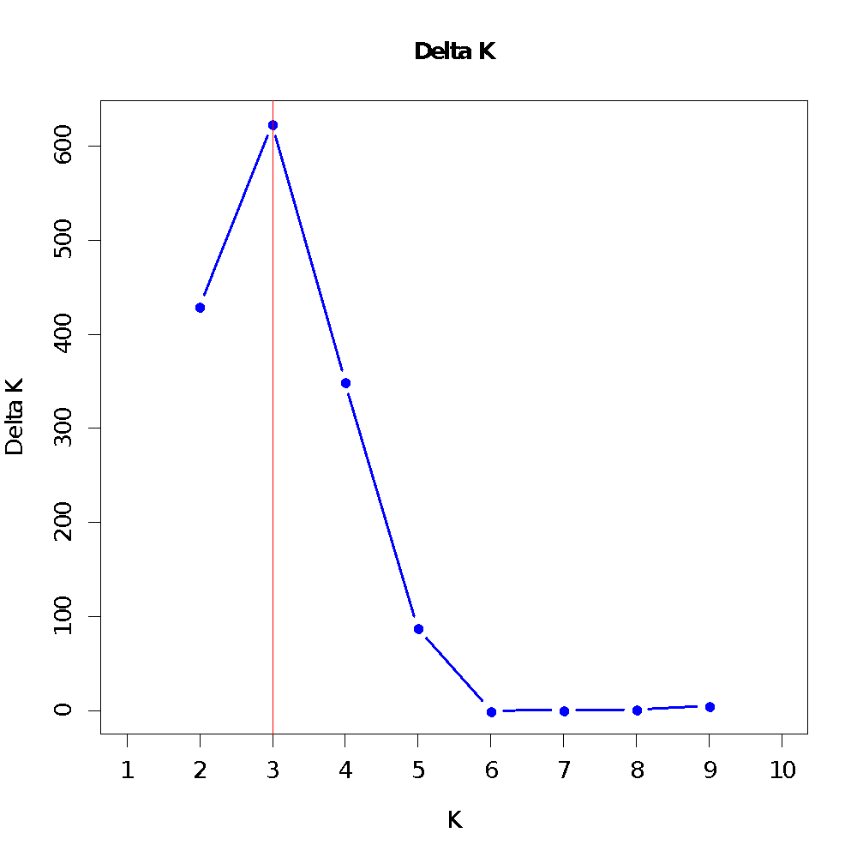
Fig. S1 Support for defining the number of maqui populations based on DK (Delta K = mean (∣L’’(K)∣)/SD(L(K))) following Evanno et al (2005) as a function of K from the microsatellite data set

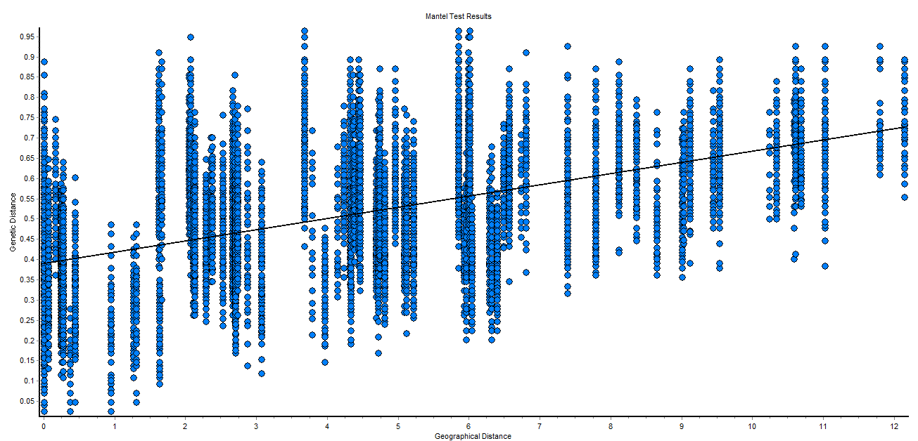

Fig. S2 Correlation of genetic and geographic distances evaluated in the Mantel test. r = 0.5419457187, p < 0.001

