SUPPLEMENTARY INFORMATION

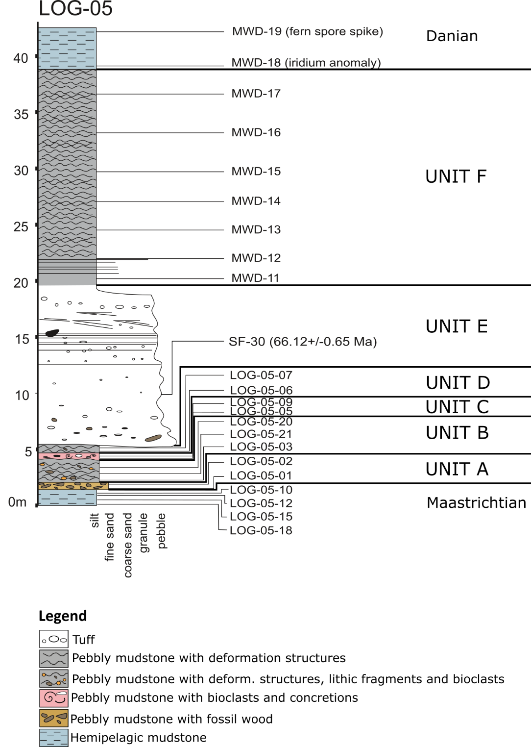
Figure S1. Log of the K-Pg section, showing lithologies, sample locations, tuff age, iridium anomaly and fern spore spike. Units A-F indicated correspond to units described in the manuscript.

Table S1. Palynological slide preparation methods.
10 g samples washed, disaggregated to fragments 1 cm³ in size
37% cold HCl for 2 hours, dilute to neutral with distilled water
48% cold HF for 24 hours, dilute to neutral with distilled water
37% cold HCl for 1 hour, dilute to neutral with distilled water
10% cold KOH for 10 minutes, dilute to neutral with distilled water
10 μm sieve, palynofacies slide mounted with cellosize and entellan glue

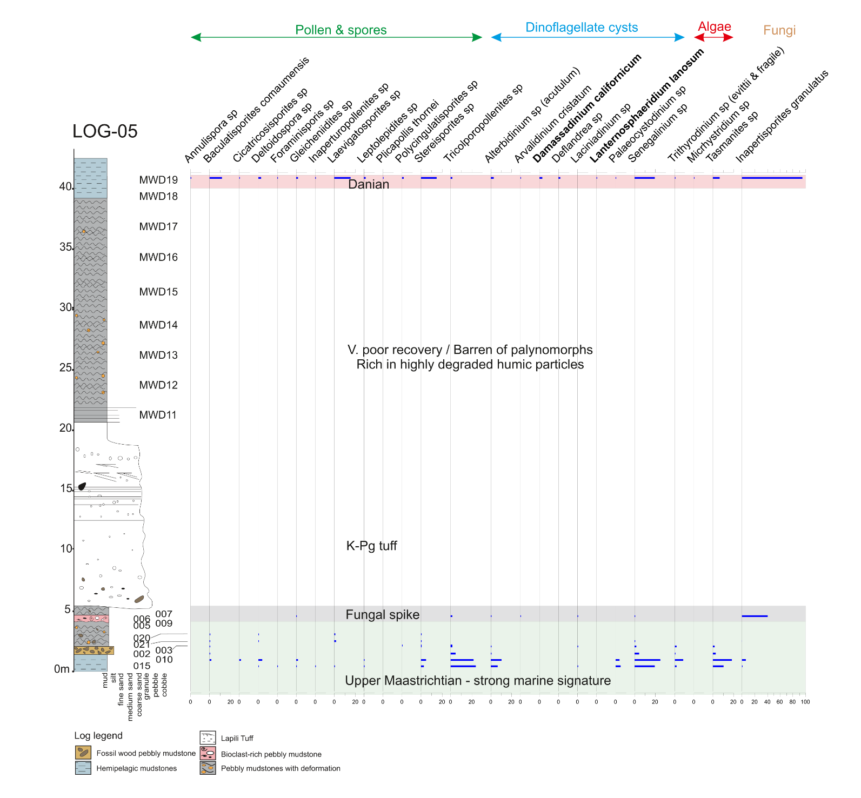
Figure S2. Absolute counts of palynomorphs from the study interval.

Table S2. Palynomorph counts for samples from LOG-05.
Sample name | Angiosperms | Bryophytes | Gymnosperms | Lycopsida | Pteridophytes | Miospore species | Dinocysts | Dinocyst species | Acritarchs | Acritarch sp. | Fungal spores | Total No species
MWD19 | 6 | 39 | 2 | 5 | 70 | 13 | 66 | 8 | 17 | 2 | 197 | 24
MWD18 | 0 | 0 | 0 | 0 | 0 | 0 | 0 | 0 | 0 | 0 | 0 | 0
MWD17 | 0 | 0 | 0 | 0 | 0 | 0 | 0 | 0 | 0 | 0 | 0 | 0
MWD16 | 0 | 0 | 0 | 0 | 0 | 0 | 0 | 0 | 0 | 0 | 0 | 0
MWD15 | 0 | 0 | 0 | 0 | 0 | 0 | 0 | 0 | 0 | 0 | 0 | 0
MWD14 | 0 | 0 | 0 | 0 | 0 | 0 | 0 | 0 | 0 | 0 | 0 | 0
MWD13 | 0 | 0 | 0 | 0 | 0 | 0 | 0 | 0 | 0 | 0 | 0 | 0
MWD12 | 0 | 0 | 0 | 0 | 0 | 0 | 0 | 0 | 0 | 0 | 0 | 0
LOG-05-07 | 16 | 0 | 0 | 0 | 8 | 2 | 33 | 4 | 0 | 0 | 342 | 7
LOG-05-06 | 36 | 37 | 36 | 0 | 145 | 6 | 109 | 2 | 0 | 0 | 36 | 9
LOG-05-20 | 266 | 133 | 0 | 0 | 0 | 5 | 0 | 0 | 0 | 0 | 0 | 0
LOG-05-21 | 89 | 22 | 0 | 0 | 44 | 6 | 200 | 7 | 44 | 1 | 0 | 14
LOG-05-03 | 0 | 0 | 0 | 0 | 0 | 0 | 0 | 0 | 0 | 0 | 0 | 0
LOG-05-02 | 67 | 0 | 0 | 0 | 13 | 2 | 237 | 8 | 80 | 2 | 0 | 12
LOG-05-01 | 16 | 0 | 0 | 0 | 24 | 5 | 194 | 7 | 100 | 2 | 0 | 30
LOG-05-12 | 70 | 10 | 31 | 6 | 31 | 22 | 176 | 18 | 60 | 3 | 14 | 44
LOG-05-18 | 96 | 12 | 14 | 3 | 12 | 15 | 200 | 21 | 58 | 5 | 6 | 42

Table S3. Foraminifera specimens counted and identified on samples from LOG-05.
 |  |  | FAMILY/SUPERFAMILY
 |  |  | Ammodiscidae | Buliminellidae | Cibicidae | Gavelinellidae |  | Haplophragmoididae | Hormosinellidae | Miliolidae |  |  | Nodosariidae |  |  |  |  |  | Recurvoidinae | Reophacidae | Rhabdamminidae | Spiroplectamminidae | Verneuilinidae
 |  |  | SPECIES
Sample | Sediment (g) | Total | Ammodiscus californica | Buliminella obtusa | Cibicides sp | Gavelinella sp. | Gavelinella pertusa | Haplophragmoides suborbicularis | Hormosinelloides guttifer | Miliammina fusca | Silicosigmoilina californica | Quinqueloculina sp. | Dentalina sp. | Reussoolina apiculata | Lagena globosa | Favolagena supracretacea | Nodosaria filiformis | Lagena sp. | Cribrostomoides trinitatensis | Nodulina dentaliniformis | Bathysiphon sp. | Spiroplectammina spectabilis | Migros midwayensis
MWD-19 | 400 | 46 | 3 | 7 | 5 | 0 | 1 | 0 | 0 | 0 | 0 | 3 | 0 | 0 | 0 | 1 | 0 | 0 | 2 | 0 | 24 | 0 | 0
MWD-18 | 400 | 200 | 9 | 10 | 9 | 5 | 8 | 0 | 0 | 9 | 3 | 10 | 0 | 3 | 0 | 34 | 0 | 55 | 8 | 0 | 37 | 0 | 0
MWD-17 | 200 | 0 | 0 | 0 | 0 | 0 | 0 | 0 | 0 | 0 | 0 | 0 | 0 | 0 | 0 | 0 | 0 | 0 | 0 | 0 | 0 | 0 | 0
MWD-16 | 200 | 0 | 0 | 0 | 0 | 0 | 0 | 0 | 0 | 0 | 0 | 0 | 0 | 0 | 0 | 0 | 0 | 0 | 0 | 0 | 0 | 0 | 0
MWD-15 | 200 | 0 | 0 | 0 | 0 | 0 | 0 | 0 | 0 | 0 | 0 | 0 | 0 | 0 | 0 | 0 | 0 | 0 | 0 | 0 | 0 | 0 | 0
MWD-14 | 200 | 3 | 0 | 0 | 0 | 0 | 0 | 0 | 0 | 0 | 0 | 0 | 0 | 0 | 0 | 0 | 0 | 0 | 0 | 0 | 0 | 3 | 0
MWD-13 | 200 | 5 | 3 | 0 | 0 | 0 | 0 | 0 | 0 | 0 | 0 | 0 | 0 | 0 | 0 | 0 | 0 | 0 | 0 | 0 | 0 | 2 | 0
MWD-12 | 200 | 1 | 0 | 0 | 0 | 0 | 0 | 0 | 0 | 1 | 0 | 0 | 0 | 0 | 0 | 0 | 0 | 0 | 0 | 0 | 0 | 0 | 0
LOG-05-07 | 200 | 0 | 0 | 0 | 0 | 0 | 0 | 0 | 0 | 0 | 0 | 0 | 0 | 0 | 0 | 0 | 0 | 0 | 0 | 0 | 0 | 0 | 0
LOG-05-21 | 400 | 200 | 17 | 4 | 12 | 0 | 0 | 0 | 0 | 5 | 36 | 6 | 22 | 8 | 3 | 36 | 1 | 34 | 5 | 0 | 0 | 7 | 4
LOG-05-03 | 400 | 200 | 13 | 3 | 8 | 0 | 0 | 16 | 0 | 6 | 30 | 0 | 8 | 7 | 5 | 32 | 5 | 28 | 28 | 0 | 0 | 6 | 5
LOG-05-02 | 200 | 0 | 0 | 0 | 0 | 0 | 0 | 0 | 0 | 0 | 0 | 0 | 0 | 0 | 0 | 0 | 0 | 0 | 0 | 0 | 0 | 0 | 0
LOG-05-01 | 200 | 0 | 0 | 0 | 0 | 0 | 0 | 0 | 0 | 0 | 0 | 0 | 0 | 0 | 0 | 0 | 0 | 0 | 0 | 0 | 0 | 0 | 0
LOG-05-12 | 400 | 200 | 10 | 4 | 25 | 13 | 0 | 25 | 14 | 7 | 11 | 3 | 4 | 22 | 0 | 16 | 2 | 13 | 17 | 13 | 1 | 0 | 0
LOG-05-18 | 400 | 200 | 9 | 2 | 24 | 19 | 0 | 32 | 12 | 8 | 13 | 4 | 4 | 19 | 0 | 11 | 2 | 14 | 14 | 10 | 3 | 0 | 0

Table S4: LOG-05-02 Paleocharcoal Data (3 s.f.)
Raman Parameter (FWHMRa) Results
FWHMRa | Minimum* | 1.54
FWHMRa | Maximum* | 2.54
FWHMRa | Median | 2.03
FWHMRa | Mean | 2.03
FWHMRa | Standard Deviation | 0.204
FWHMRa | Standard Error | 0.0292
FWHMRa Geothermometry Results
Charring Temperature (°C) | Minimum | 395
Charring Temperature (°C) | Maximum | 1022
Charring Temperature (°C) | Median | 716
Charring Temperature (°C) | Mean | 716
Charring Temperature (°C) | Standard Deviation | 128
Charring Temperature (°C) | Standard Error | 18.2
*Note maximum and minimum FWHMRa values do not correspond to maximum and minimum derived temperatures, given the inverse relationship between temperature and FWHMRa.
A median temperature of 716°C is consistent with moderate-high intensity surface and/or crown fire conditions, whilst a maximum temperature of 1022°C indicates an origin within very intense fire. A minimum value of 395°C concurs with the lower temperatures of charcoal presentation in spectroscopic analysis. Sample spectrum 14 displayed very broad D and G bands, and intense fluorescence that rendered deconvolution inapplicable. Therefore, a temperature below 300°C can be broadly attributed to this spectrum, though it is not possible to discern more specific temperature estimates.
Visual assessment of spectra acquired present a range of notable characteristics that justify the Raman data collected, and temperatures calculated. Within these spectra, D(1) (main D-band, typically located at 1350 cm-1, that has been fit during spectral deconvolution) and G bands are typically clear and distinct, with the exception of spectrum A14, in which the bands are too highly obscured by fluorescence and signal ‘noise’. In those spectra that are not restricted by interference – though presentation is considerably variable – a range of additional band functions are apparent.
These functions present as distortions or shoulders on the main D(1) and G bands, and include bands D3, D4, D5 and D6. They represent additional features of the microstructure, though their study in charcoals is limited. Function D3, within these spectra, is typically seen as a distortion on the left shoulder of the G band, reducing gaussian fit overall. D6 is found on the right flank of the D(1) band, whilst D4 and D5 are typically amalgamated with D(1) to form a broad distorted shoulder. This broad shoulder in the D-band is lost at the highest temperatures. The band function D2, typically observed in thermal maturities seen beyond those experienced by charcoal, may in one instance be visible as a small distortion on the right shoulder of the G-band. Confidence in this observation is, however, limited by the presentation of fluorescence and noise in this spectrum.
Fig. S3 shows these features. The angle of the spectrum, caused by fluorescence, can been seen to reduce with increasing temperature. This is consistent with the association of fluorescence with low maturity material ‘contaminants’. As temperature of formation increases, D and G band widths reduce, particularly as the D band loses the broad left shoulder associated with D4 and D5 functions. The coherent change in width supports our application of FWHMRa. These spectra continue to highlight the inapplicability of intensity ratios in Raman-charcoal geothermometry, given the non-linear change in D-band height. The contrasting direction of shift in both D and G bands with increasing temperature supports established band separation relationships.
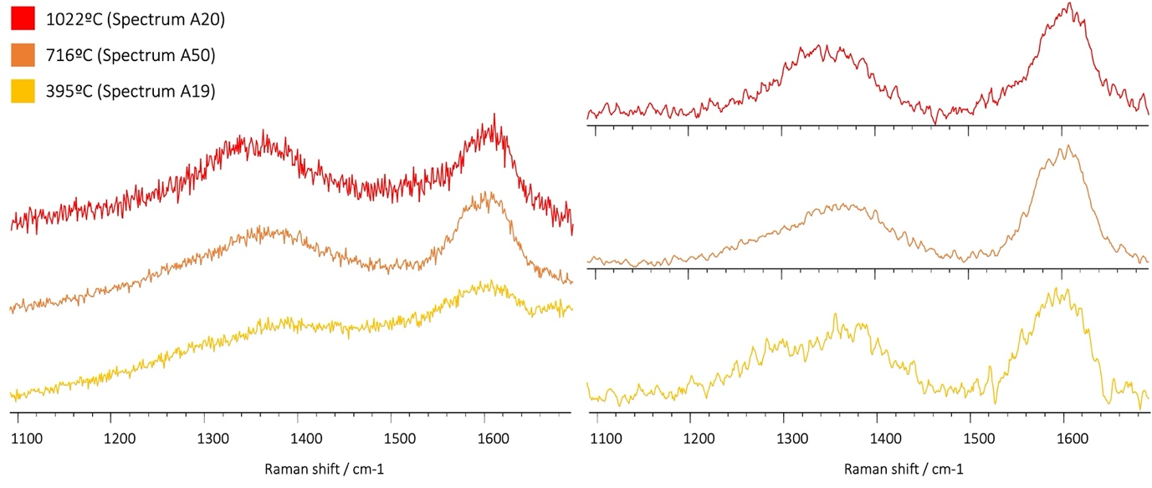
Figure S3: raw (left) and deconvolved (right) spectra associated with highest, median, and lowest calculated temperatures.

Analysis of this geothermometric data via histogram and boxplot presentation (Figs. S4, S5) highlight an apparent normality to this dataset. Outlying values, coinciding with maximum and minimum temperatures, occur at 395°C and 1022°C. The occurrence of normality in this dataset is further supported by ‘informal’ measures, including a standard deviation <50% mean value, and identical median and mean values. Statistical confirmation via the Shapiro-Wilk test (Table S5) indicates no significance, in which case the null hypothesis of assumed normality cannot be rejected. It is worth noting, however, that in this case the population (n = 49) falls below the standard minimum (50) for Shapiro-Wilk testing. Analysis of kurtosis and skew suggest a symmetrical dataset, with mild skew toward higher temperature values, respectively.
Normal distribution and unimodality exhibited by these data may suggest a single ‘population’ of palaeocharcoals, derived from a single fire event. This conclusion, however, is most likely restricted by the small population under analysis (n = 49), and limited understanding of broad temperature presentation within natural fire systems.
Table S5: Shapiro-Wilk test
 | Shapiro-Wilk Test |  |  | Kurtosis | Skewness
 | n | W | p | Kurtosis | Skewness
Log_05_02 Paleocharcoal | 49 | 0.984 | Not Significant | 0.281 | - 0.148

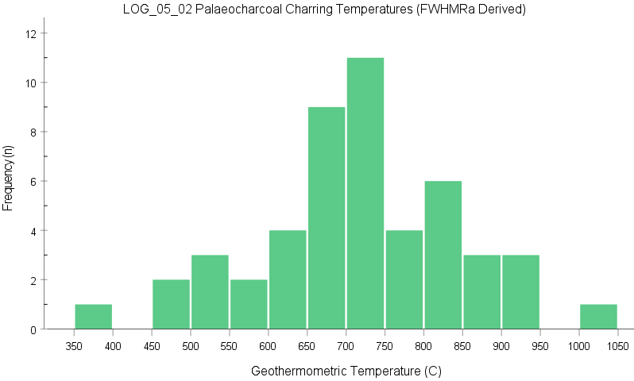
Figure S4: Histogram of paleocharcoal charring temperatures (FWHMRa derived).

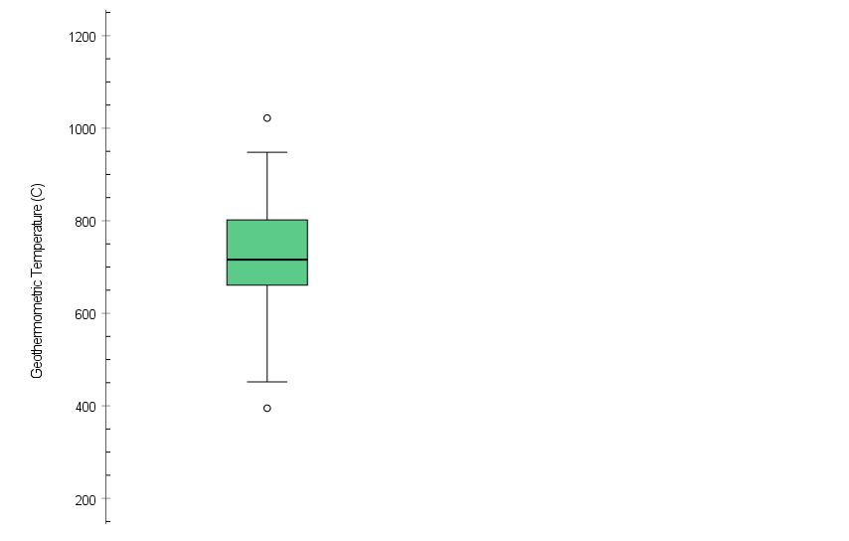
Figure S5: Boxplot of paleocharcoal charring temperatures (FWHMRa derived).

Table S6. Zircon grains from sample SF-30 analyzed. Spots in green are from detrital grains, and in blue from an outlier, and all 4 were excluded from the age calculation.
 |  |  |  |  | 204 corrected
Spot Name | %  comm  206 | ppm  U | ppm  Th | 232Th  /238U | 238U/  206Pb | %  err | 207Pb  /206Pb | %  err | 207Pb  /235U | %  err | 206Pb  /238U | %  err | err  corr | 206Pb  /238U  Age | 1s  err
SF30-1.1 | 0.58 | 281 | 142 | 0.52 | 91.162 | 2.3 | 0.04378 | 4.7 | 0.06622 | 5.3 | 0.01097 | 2.3 | 0.43 | 70.3 | 1.6
SF30-2.1 | 0.09 | 166 | 93 | 0.58 | 93.785 | 2.4 | 0.04734 | 3.5 | 0.06961 | 4.3 | 0.01066 | 2.4 | 0.56 | 68.4 | 1.6
SF30-3.1 | 0.67 | 63 | 22 | 0.36 | 94.854 | 3.6 | 0.04557 | 19.1 | 0.06624 | 19.4 | 0.01054 | 3.6 | 0.19 | 67.6 | 2.4
SF30-4.1 | 1.36 | 132 | 93 | 0.72 | 96.316 | 2.5 | 0.04071 | 10.5 | 0.05827 | 10.7 | 0.01038 | 2.5 | 0.23 | 66.6 | 1.6
SF30-5.1 | 0.24 | 352 | 175 | 0.51 | 97.105 | 2.2 | 0.04836 | 3.5 | 0.06868 | 4.1 | 0.01030 | 2.2 | 0.54 | 66.0 | 1.5
SF30-6.1 | 0.18 | 688 | 484 | 0.73 | 95.225 | 2.2 | 0.04793 | 3.3 | 0.06940 | 3.9 | 0.01050 | 2.2 | 0.55 | 67.3 | 1.4
SF30-7.1 | 0.14 | 494 | 392 | 0.82 | 96.295 | 2.2 | 0.04866 | 2.1 | 0.06968 | 3.0 | 0.01038 | 2.2 | 0.72 | 66.6 | 1.4
SF30-8.1 | 0.49 | 400 | 213 | 0.55 | 97.745 | 2.2 | 0.04683 | 5.6 | 0.06606 | 6.0 | 0.01023 | 2.2 | 0.37 | 65.6 | 1.5
SF30-9.1 | 0.42 | 381 | 216 | 0.59 | 94.950 | 2.3 | 0.05091 | 8.7 | 0.07393 | 9.0 | 0.01053 | 2.3 | 0.25 | 67.5 | 1.5
SF30-10.1 | 0.05 | 151 | 75 | 0.51 | 61.418 | 2.4 | 0.05010 | 5.3 | 0.11248 | 5.8 | 0.01628 | 2.4 | 0.41 | 104.1 | 2.5
SF30-11.1 | 5.01 | 77 | 41 | 0.55 | 99.955 | 2.7 | 0.04623 | 16.1 | 0.06372 | 16.4 | 0.01000 | 2.7 | 0.17 | 64.2 | 1.7
SF30-12.1 | 0.22 | 517 | 333 | 0.67 | 73.535 | 2.2 | 0.04794 | 4.1 | 0.08989 | 4.7 | 0.01360 | 2.2 | 0.46 | 87.1 | 1.9
SF30-13.1 | 0.00 | 315 | 235 | 0.77 | 95.104 | 2.3 | 0.04777 | 2.8 | 0.06925 | 3.6 | 0.01051 | 2.3 | 0.63 | 67.4 | 1.5
SF30-14.1 | 0.55 | 576 | 424 | 0.76 | 94.944 | 2.2 | 0.04776 | 7.0 | 0.06936 | 7.3 | 0.01053 | 2.2 | 0.30 | 67.5 | 1.5
SF30-15.1 | 0.04 | 390 | 69 | 0.18 | 72.084 | 2.2 | 0.04903 | 2.7 | 0.09378 | 3.5 | 0.01387 | 2.2 | 0.63 | 88.8 | 1.9
SF30-16.1 | 0.02 | 223 | 187 | 0.86 | 97.345 | 2.3 | 0.04823 | 3.3 | 0.06831 | 4.0 | 0.01027 | 2.3 | 0.58 | 65.9 | 1.5
SF30-17.1 | 1.35 | 146 | 44 | 0.31 | 97.586 | 2.5 | 0.04446 | 8.7 | 0.06281 | 9.1 | 0.01025 | 2.5 | 0.27 | 65.7 | 1.6
SF30-18.1 | 0.69 | 293 | 226 | 0.80 | 93.687 | 2.3 | 0.04551 | 5.5 | 0.06698 | 6.0 | 0.01067 | 2.3 | 0.38 | 68.4 | 1.6
SF30-19.1 | 0.31 | 211 | 85 | 0.42 | 97.764 | 2.4 | 0.04638 | 7.5 | 0.06540 | 7.9 | 0.01023 | 2.4 | 0.30 | 65.6 | 1.5
SF30-20.1 | 0.55 | 248 | 135 | 0.56 | 98.121 | 2.3 | 0.04710 | 4.3 | 0.06617 | 4.9 | 0.01019 | 2.3 | 0.47 | 65.4 | 1.5
SF30-21.1 | 1.77 | 166 | 72 | 0.45 | 96.404 | 2.4 | 0.04689 | 7.8 | 0.06705 | 8.2 | 0.01037 | 2.4 | 0.29 | 66.5 | 1.6
SF30-22.1 | 0.42 | 216 | 123 | 0.59 | 98.334 | 2.4 | 0.04727 | 9.2 | 0.06627 | 9.5 | 0.01017 | 2.4 | 0.25 | 65.2 | 1.5
SF30-23.1 | 0.00 | 184 | 74 | 0.41 | 98.107 | 2.7 | 0.04727 | 3.6 | 0.06643 | 4.5 | 0.01019 | 2.7 | 0.61 | 65.4 | 1.8
SF30-24.1 | 0.00 | 303 | 138 | 0.47 | 97.514 | 2.3 | 0.04670 | 3.1 | 0.06603 | 3.8 | 0.01025 | 2.3 | 0.59 | 65.8 | 1.5
SF30-25.1 | 0.80 | 194 | 99 | 0.53 | 101.350 | 2.4 | 0.04633 | 7.5 | 0.06303 | 7.9 | 0.00987 | 2.4 | 0.30 | 63.3 | 1.5
SF30-26.1 | 0.00 | 185 | 91 | 0.51 | 96.515 | 2.4 | 0.05277 | 3.3 | 0.07538 | 4.1 | 0.01036 | 2.4 | 0.58 | 66.4 | 1.6
SF30-27.1 | 0.45 | 131 | 43 | 0.34 | 100.288 | 3.0 | 0.04756 | 24.9 | 0.06538 | 25.1 | 0.00997 | 3.0 | 0.12 | 64.0 | 1.9
SF30-28.1 | 0.92 | 180 | 61 | 0.35 | 99.831 | 2.8 | 0.04349 | 8.7 | 0.06006 | 9.1 | 0.01002 | 2.8 | 0.31 | 64.2 | 1.8

Figure S6. Concordia diagrams showing A) age of zircon spots analyzed and B) age (1 sigma error) and C) weighted mean age (2 sigma error).

Table S7. Results of iridium analysis for selected samples of LOG-05.
Analyte Symbol | LOI (%) | Total (%) | Ir (ppb) | Mass (g)
Detection limit |  | 0,01 | 0,1
Analysis method | FUS-ICP | FUS-ICP | NI-FINA | NI-FINA
MWD-18 | 8.96 | 99.81 | 1.2 | 15
LOG-05-07 | 8.94 | 99.13 | 0.5 | 15
LOG-05-21 | 10.18 | 99.07 | 0.3 | 15

References
Arenillas, I., Arz, J.A., and GrajaIes-Nishimura, J.M. et al., 2006, Chicxulub impact event is Cretaceous/Paleogene boundary in age: new micropaleontological evidence: Earth and Planetary Science Letters, v. 249, p. 241-257.
Bamford, M.K., and Philippe, M., 2001, Jurassic-Early Cretaceous Gondwanan homoxylous woods: a nomenclatural revision of the genera with taxonomic notes: Review of Palaeobotany and Palynology, v. 113, p. 287–297.
Barefoot, A.C., and Hankins, F.W., 1982, Identification of Modern and Tertiary Woods: Oxford, Oxford University Press, 189 p.
Black L.P., Kamo S.L., Allen C.M., Aleinikoff J.N., Davis D.W., Korsch R.J., and Foudoulis C., 2003, TEMORA 1: a new zircon standard for Phanerozoic U–Pb geochronology: Chemical Geology, v. 200, p. 155−170.
Claeys P., Kiessling W., and Alvarez, W., 2002, Distribution of Chicxulub ejecta at the Cretaceous/Tertiary boundary, in Koeberl, C., and MacLeod, K.G., eds, Catastrophic events and mass extinctions: impacts and beyond: Boulder, Colorado, Geological Society of America Special Paper 356, p. 55–68.
Dastas, N.R., Chamberlain, J.A., and Garb, M.P., 2014, Cretaceous-Paleogene dinoflagellate biostratigraphy and the age of the Clayton Formation, southeastern Missouri, USA: Geosciences, v. 4, p. 1–29.
Firth, J. V., 1993, Dinoflagellate assemblages and sea-level fluctuations in the Maastrichtian of southwest Georgia: Review of Palaeobotany and Palynology, v. 79, p. 179–204, doi: 10.1016/0034-6667(93)90022-M.
Firth, J. V., 1987, Dinoflagellate biostratigraphy of the Maastrichtian to Danian interval in the U.S. Geological Survey Albany core, Georgia, U.S.A: Palynology, v. 11, p. 199–216.
García Esteban, L., 2002, Anatomía e identificación de maderas de coníferas a nivel de especie: Madrid, Fundacion Conde del Valle de Salazar, 421 p.
García Esteban, L., de Palacios, P., Guindeo Casasús, A., García Fernández, F., 2004, Characterisation of the xylem of 352 conifers: Investigación Agraria: Sistemas y Recursos Forestales, v. 13, p. 452–478.
Gulick, S., Morgan, J., and Mellett, C.L., and the Expedition 364 Scientists, 2017, Expedition 364 Preliminary Report: Chicxulub: Drilling the K-Pg Impact Crater: International Ocean Discovery Program, 38 p.
Greguss, P., 1955, Identification of living gymnosperms on the basis of xylotomy: Budapest, Akadémiai Kiadó, 263 p.
Helenes, J., 1984, Dinoflagellates from Cretaceous to Early Tertiary rocks of the Sebastian Vizcaino Basin, Baja California, Mexico, in Frizzel, A., ed., Geology of the Baja California Peninsula: Pacific Section SEPM, v. 39, p. 89-106.
Helenes, J., and Téllez-Duarte, M.A., 2002, Paleontological evidence of the Campanian to Early Paleocene paleogeography of Baja California: Palaeogeography, Palaeoclimatology, Palaeoecology, v. 186, p. 61-80.
Hoffman, E.L., 1992, Instrumental Neutron Activation in Geoanalysis: Journal of Geochemical Exploration, v. 44, p. 297-319.
Hoffman, E.L., Naldrett, A.J., Van Loon, J.C., Hancock, R.G.V. and Manson, A., 1978, The determination of all the platinum group elements and gold in rocks and ore by neutron activation analysis after preconcentrating by a nickel sulphide fire-assay technique on large samples: Analytica Chimica Acta, v. 102, p. 157-166.
IAWA Softwood Committee, 2004, IAWA list of microscopic features for softwood identification: IAWA J. 25, p. 1–70.
Kräusel, R., 1919, Die fossilen Koniferhölzer (unter Ausschluß von Araucarioxylon Kraus): Palaeontographica Abteilung, v. 62, p. 185–275.
Kring, D.A., Claeys, P., Gulick, S.P.S., Morgan, J.V., Collins, G.S., and the IODP-ICDP Expedition 364 Science Party, 2017, Chicxulub and the exploration of large peak-ring impact craters through scientific drilling: GSA Today, v. 27(10), p. 4–8.
Lucas-Clark, J., 2006, Small peridinioid dinoflagellate cysts from the Paleocene of South Carolina, USA: Palynology, v. 30, p. 183–210.
Ludwig, K.R., 2003, Isoplot 3.00: A geochronological toolkit for Microsoft Excel: Berkeley Geochronologixcal Center, Special Publication 4, 70 p.
Ludwig, K., 2009, SQUID 2: A User’s Manual, rev. 12 Apr. 2009: Berkeley Geochronology Center, Special Publication v. 5, 110 p.
Marshall, J.E.A., 1991, Quantitative spore colour: Journal of the Geological Society, v. 148, p. 223-233.
Metcalfe, C.R., 1987, Anatomy of the Dicotyledons Vol. III. Magnoliales, Illiciales, and Laurales (sensu Armen Takhtajan): Oxford, Clarendon Press.
Molina, E., Alegret, L., Arenillas, I., Arz, J. A., Gallala, N., Hardenbol, J., Von Salis, K., Steurbaut, E., Vandenberghe, N., and Zaghbibturki, D., 2006, The Global Boundary Stratotype Section and Point for the base of the Danian Stage (Paleocene, Paleogene, "Tertiary", Cenozoic) at El Kef, Tunisia: Original definition and revision: Episodes, v. 29 (4), p. 263-273.
Morgan, J.V., Lana, C., Kearsley, A., Coles, B.; Belcher, C., Montanari, S., Díaz-Martínez, E., Barbosa, A., and Neumann, V., 2006, Analyses of shocked quartz at the global K-P boundary indicate an origin from a single, high-angle, oblique impact at Chicxulub: Earth and Planetary Science Letters 251(3-4), p. 264-279.
Norris, R.D., Huber, B.T., and Self-Trail, J.M., 1999, Synchroneity of the K-T oceanic mass extinction and meteorite impact: Blake Nose, Western North Atlantic: Geology, no. 5, p. 419-422.
Osinski, G.R. et al., 2019, Explosive interaction of impact melt and seawater following the Chicxulub impact event: Geology, v. 48, doi: https://doi.org/10.1130/G46783.1.
Philippe, M., and Bamford, M.K., 2008, A key to morphogenera used for Mesozoic conifer-like woods: Review of Palaeobotany and Palynology, v. 148, p. 184–207.
Prauss, M.L., 2009, The K/Pg boundary at Brazos-River, Texas, USA — An approach by marine palynology: Palaeogeography, Palaeoclimatology, Palaeoecology, v. 283, p. 195–215, doi: 10.1016/j.palaeo.2009.09.024.
Pujana, R.R., Ruiz, D.P., Martínez, L.C.A., and Zhang, Y., 2016, Proposal for quantifying two characteristics of tracheid pit arrangement in gymnosperm woods: Revista del Museo Argentino de Ciencias Naturales, v. 18, 117–124.
Richter, H. G., 1987, Lauraceae, in Metcalfe, C.R., ed., Anatomy of the dicotyledons, 2nd ed., vol. III, Magnoliales, Illiciales, and Laurales, Oxford, Clarendon Press, p. 152 – 173.
Sato, K., Tassinari, C.C.G., Basei, M.A.S., Siga Júnior, O., Onoe, A.T., and Souza M.D.D., 2014, Sensitive High Resolution Ion Microprobe (SHRIMP IIe/MC) of the Institute of Geosciences of the University of São Paulo, Brazil: analytical method and first results: Geologia USP. Serie Científica 14, p. 3−18.
Schulte, P., and Kontny, A., 2005, Chicxulub impact ejecta from the Cretaceous-Paleogene (K-P) boundary in northeastern Mexico, in Kenkmann, T., Hörz, F., and Deutsch, A., eds., Large meteorite impacts, III: Geological Society of America Special Paper 384, p. 191–221.
Schulte, P., Deutsch, A., Salge, T., Berndt, J., Kontny, A., MacLeod, K.G., Neuser, R.D., and Krumma S., 2009, A dual-layer Chicxulub ejecta sequence with shocked carbonates from the Cretaceous–Paleogene (K–Pg) boundary, Demerara Rise, western Atlantic: Geochimica et Cosmochimica Acta 73, p. 1180–1204.
Schulte P., et al., 2010, The Chicxulub asteroid impact and mass extinction at the Cretaceous-Paleogene boundary: Science, v. 327(5970), p. 1214-1218, doi: 10.1126/science.1177265.
Smit, J., 1999, The global stratigraphy of the Cretaceous-Tertiary boundary impact ejecta: Annual Review of Earth and Planetary Sciences, v. 27, p. 75–113, doi: https://doi.org/10.1146/annurev.earth.27.1.75.
Smit, J., Roep, B., Grajales-Nishimura, J.M., Bermudez, J., 1996, Coarse-grained, clastic sandstone complex at the K/T boundary around the Gulf of Mexico: Deposition by tsunami waves induced by the Chicxulub impact?, in Ryder, G., Fastovsky, D., and Gartner, S. eds., The Cretaceous-Tertiary event and other catastrophes in Earth history, Geological Society of America Special Paper, v. 307, p. 151–182, doi: 10.1130/0-8137-2307-8.151.
Snyder, S.W., and Huber, B.T., 1996, Preparation techniques for use of foraminifera in the classroom: Paleontological Society Papers, v. 2, p. 231-236, doi: https://doi.org/10.1017/S1089332600003302.
Urrutia-Fucugauchi, J., Marin, L., and Trejo-Garcia, A., 1996, UNAM scientific drilling program of the Chicxulub impact structure: Evidence for a 300-km crater diameter: Geophysical Research Letters, v. 23, p. 1516–1568.
Vaudois, N., and Privé, C., 1971, Révision des bois fossiles de Cupressaceae. Palaeontographica Abteilung B. 134, p. 61–86.
Williams, I.S., 1998, U-Th-Pb geochronology by ion microprobe, in McKibben, M.A., Shanks, W.C., and Ridley, W.I. eds., Applications of Microanalytical Techniques to Understanding Mineralizing Processes: Reviews in Economic Geology, v. 7, p. 1–35.

