Supplementary Information

Seasonal variation and sources of carbonaceous species and elements in PM_{2.5} and PM₁₀ over the eastern Himalaya

Sudhir Kumar Sharma^{1,2*} • Sauryadeep Mukherjee³ • Nikki Choudhary^{1,2} • Akansha Rai^{1,2} • Abhinandan Ghosh³ • Abhijit Chatterjee³ • Narayanswami Vijayan¹ • Tuhin Kumar Mandal^{1,2}

¹CSIR-National Physical Laboratory, Dr. K. S. Krishnan Road, New Delhi-110 012, India.
²Academy of Scientific and Innovative Research (AcSIR), Ghaziabad-201 002, India
³Centre for Astroparticle Physics and Space Sciences, Bose Institute, Darjeeling-734 102, India.

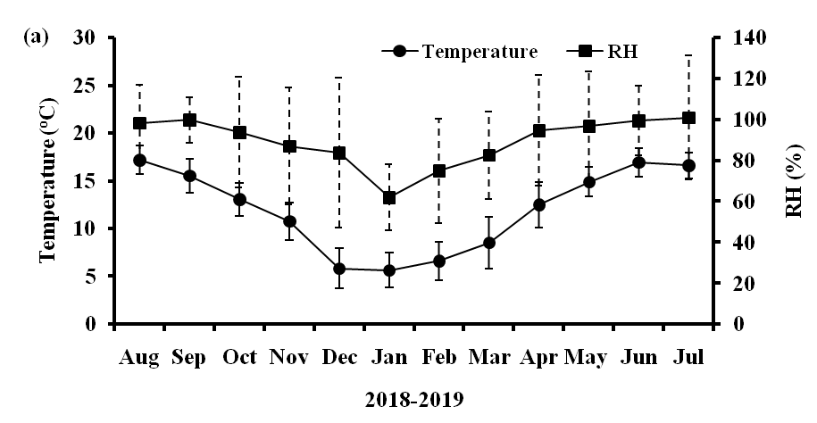

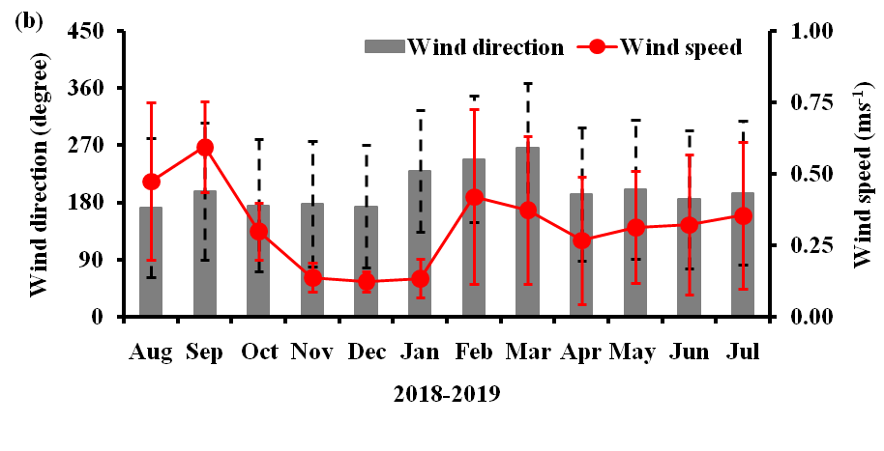

Fig. S1: Monthly average variations in (a) temperature and RH (b) wind direction and wind speed Darjeeling during 2018-2019.

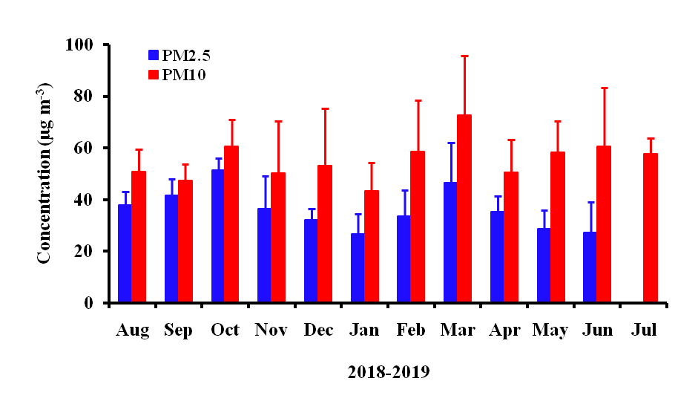

Fig. S2: Monthly variation in mass concentration of PM_{2.5} and PM₁₀ at Darjeeling during 2018-19.

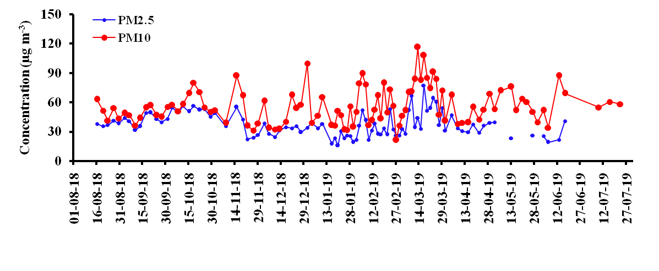
(a).

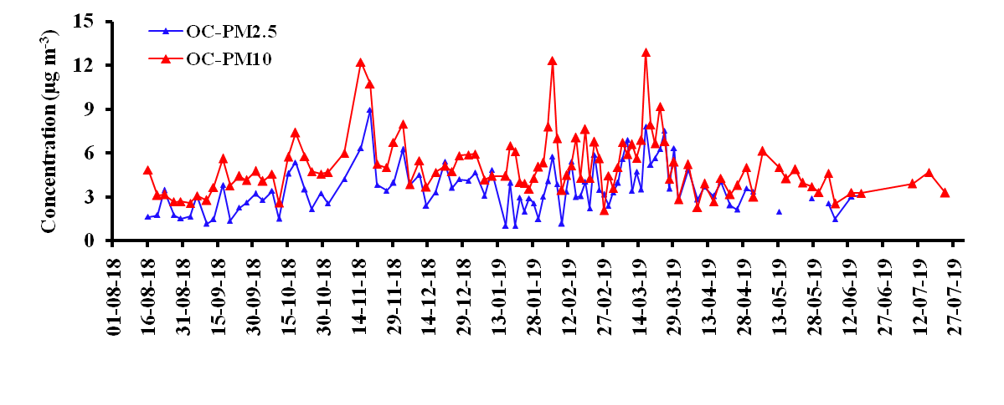
(b).

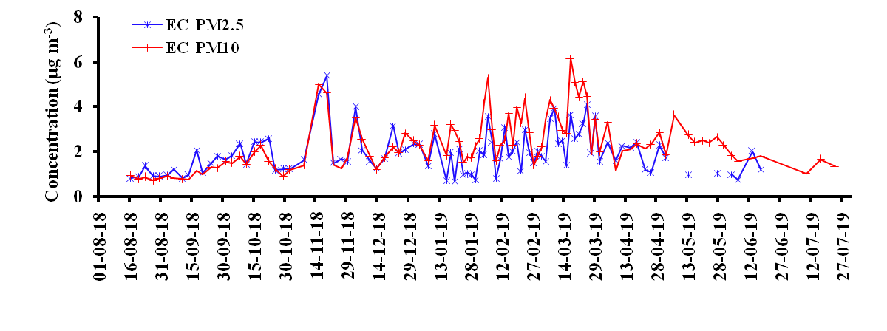
(c).

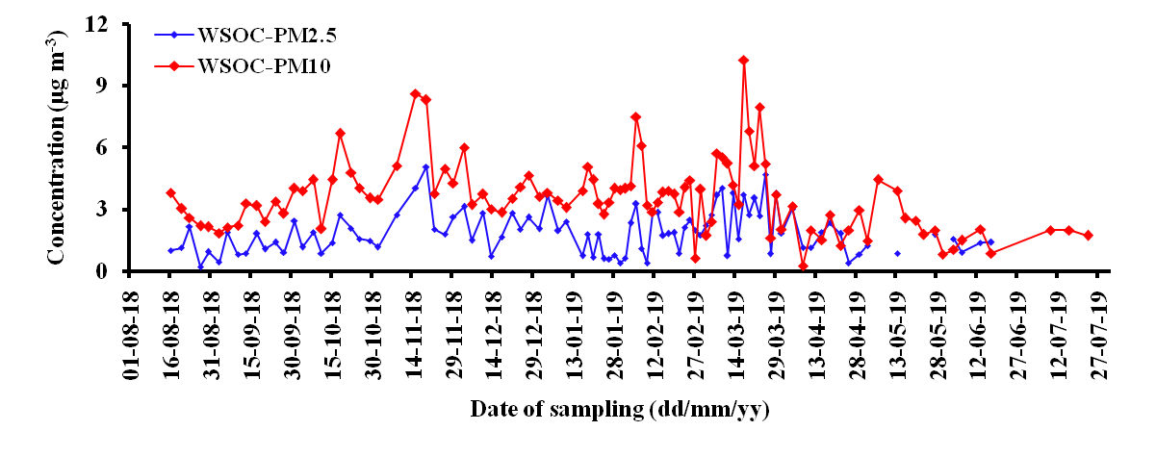
(d).

Fig. S3: Temporal variation in concentrations of (a) PM_{2.5}, PM₁₀ (b) OC (in PM_{2.5}, PM₁₀), (c) EC (in PM_{2.5}, PM₁₀); and (d) WSOC (in PM_{2.5}, PM₁₀) at Darjeeling.

Winter
Summer
Monsoon
Post-monsoon
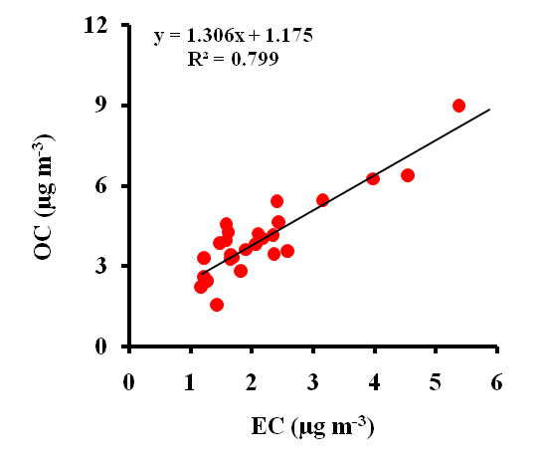
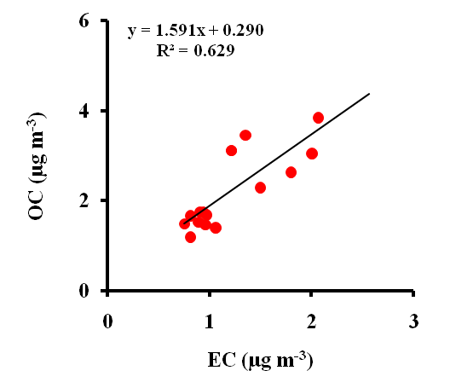
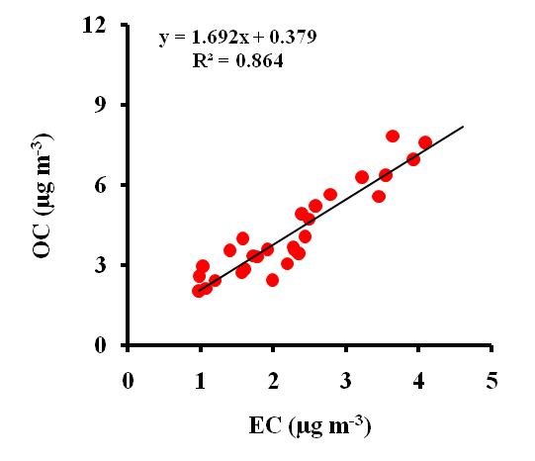
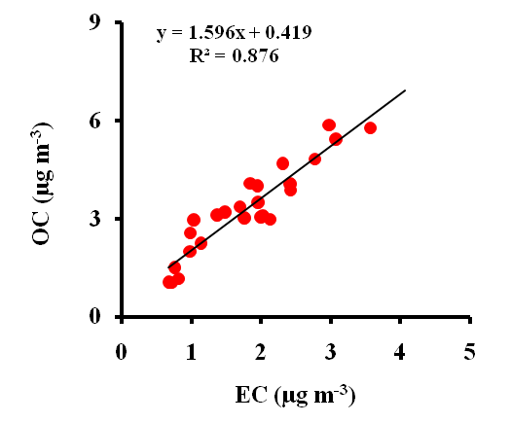
(a).

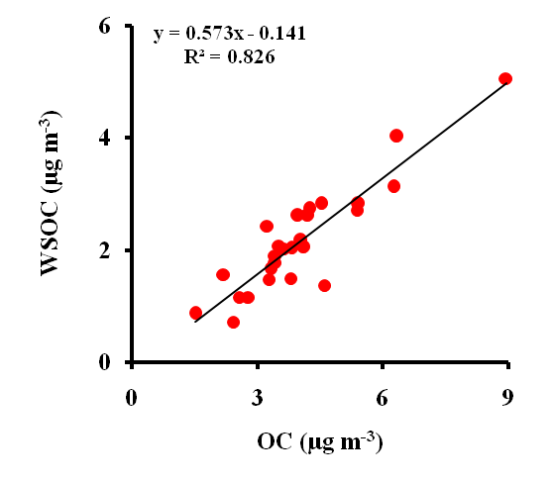
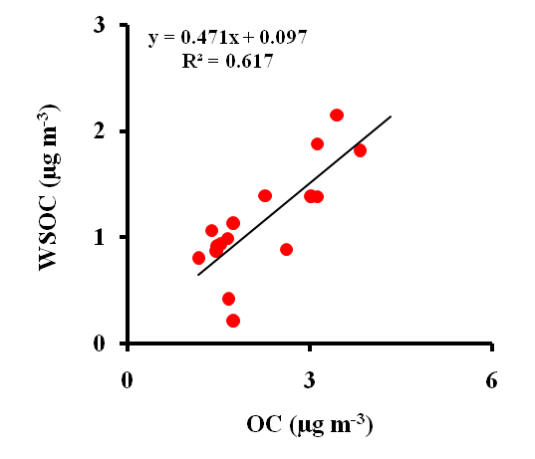
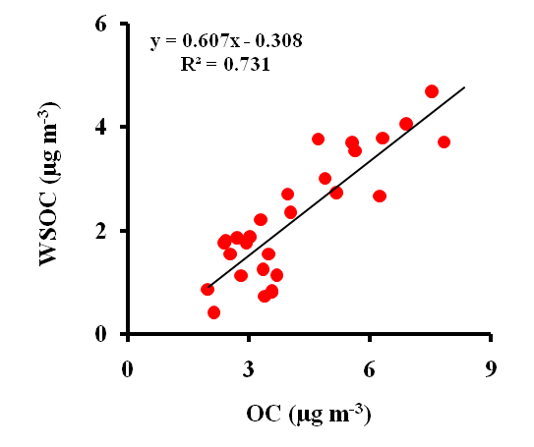
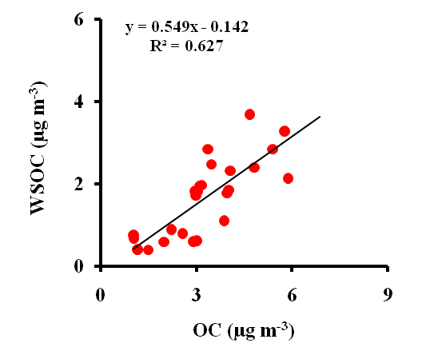
(b).

Fig. S4: Scatter plots between (a) OC and EC; and (b) WSOC and OC of PM_{2.5} during winter, summer, monsoon and post-monsoon seasons at Darjeeling.

Winter
Summer
Monsoon
Post-monsoon
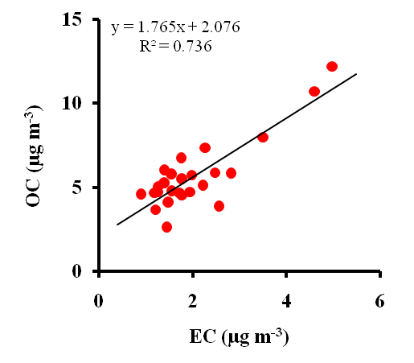
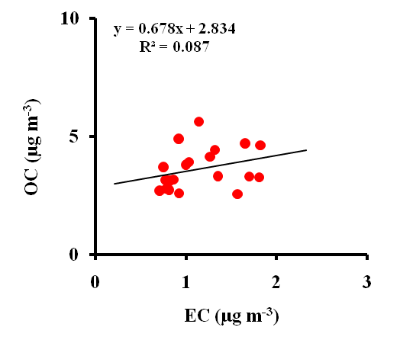
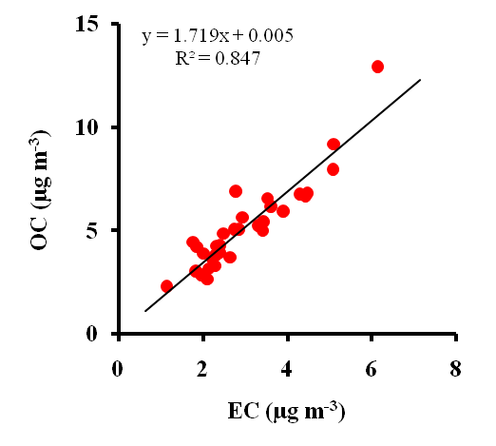
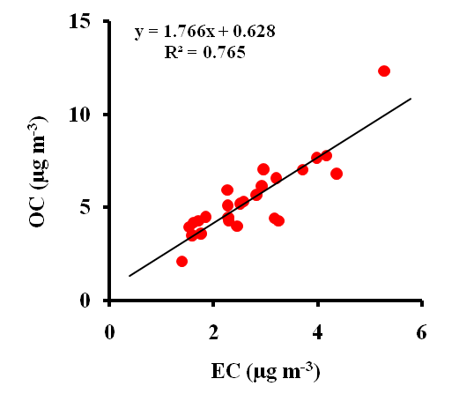
(a).

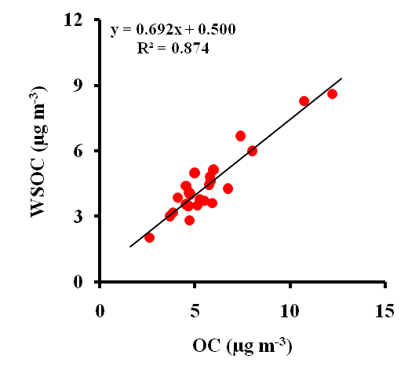
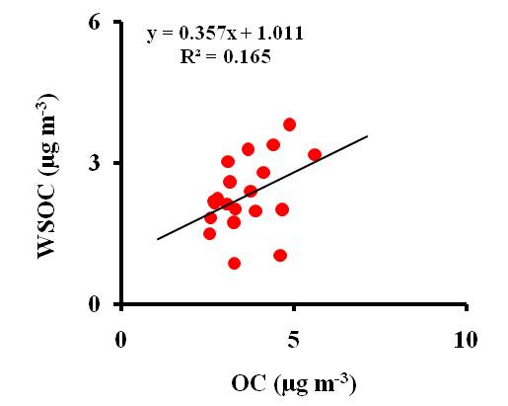
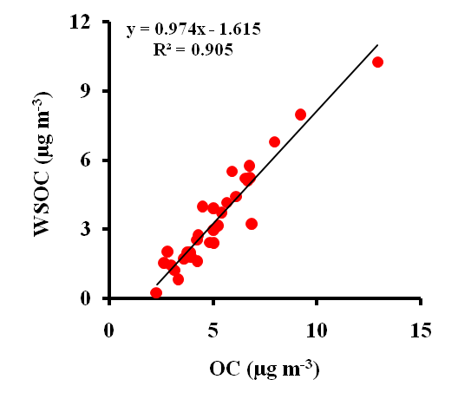
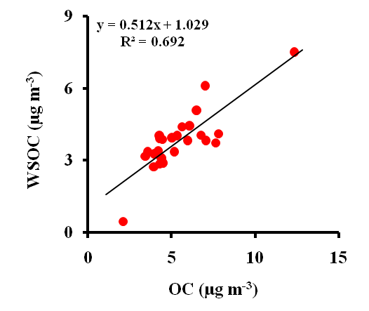
(b).

Fig. S5: Scatter plots between (a) OC and EC; and (b) WSOC and OC of PM₁₀ during winter, summer, monsoon and post-monsoon seasons at Darjeeling.

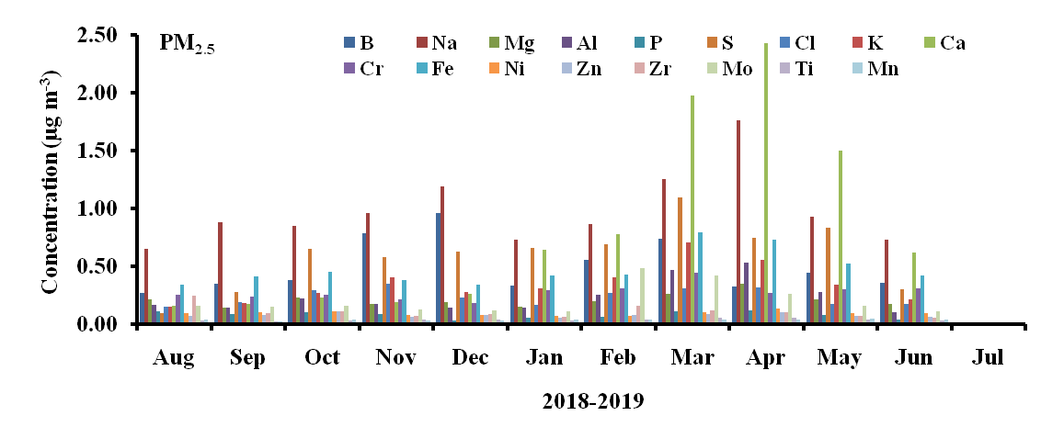

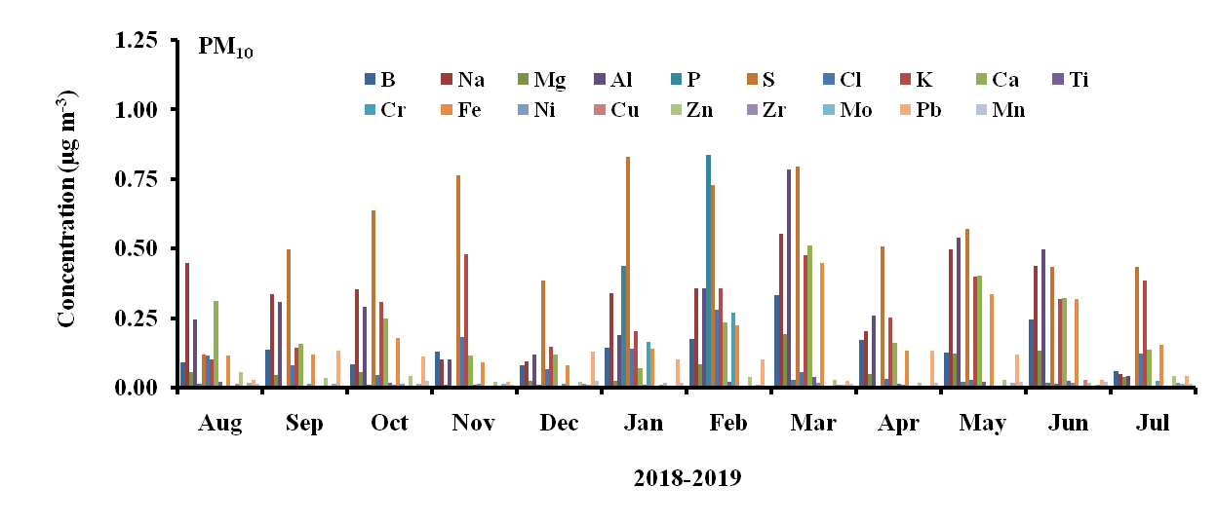

Fig. S6: Monthly average concentrations of major and trace elements in PM_{2.5} and PM₁₀ at Darjeeling.

 | PM_{2.5} | B | Na | Mg | Al | P | S | Cl | K | Ca | Cr | Fe | Ni | Zn | Zr | Mo | Ti | Mn
PM_{2.5} | 1
B | 0.70 | 1
Na | 0.20 | 0.29 | 1
Mg | 0.18 | 0.46 | 0.26 | 1
Al | 0.37 | 0.60 | 0.30 | 0.41 | 1
P | 0.50 | 0.42 | 0.07 | 0.01 | 0.34 | 1
S | 0.43 | 0.24 | -0.15 | -0.09 | 0.36 | 0.29 | 1
Cl | 0.59 | 0.37 | -0.01 | -0.08 | -0.11 | 0.19 | 0.10 | 1
K | 0.69 | 0.60 | 0.03 | 0.16 | 0.70 | 0.40 | 0.58 | 0.36 | 1
Ca | -0.17 | 0.28 | 0.18 | 0.34 | 0.48 | 0.16 | -0.02 | -0.46 | 0.17 | 1
Cr | -0.33 | 0.00 | 0.15 | 0.13 | -0.15 | 0.03 | -0.33 | -0.30 | -0.33 | 0.12 | 1
Fe | 0.14 | 0.32 | 0.09 | 0.26 | 0.44 | 0.30 | 0.02 | 0.02 | 0.25 | 0.24 | -0.37 | 1
Ni | 0.20 | -0.08 | -0.12 | -0.09 | -0.10 | -0.21 | 0.19 | 0.20 | 0.17 | -0.11 | -0.53 | -0.06 | 1
Zn | 0.63 | 0.43 | -0.21 | 0.01 | 0.22 | 0.16 | 0.27 | 0.74 | 0.68 | -0.20 | -0.54 | 0.24 | 0.47 | 1
Zr | 0.31 | 0.20 | -0.17 | -0.18 | 0.24 | -0.04 | 0.30 | 0.33 | 0.46 | -0.02 | -0.34 | -0.21 | 0.31 | 0.53 | 1
Mo | -0.01 | 0.08 | 0.19 | 0.20 | 0.02 | -0.06 | -0.03 | -0.07 | 0.00 | 0.07 | 0.72 | -0.72 | -0.23 | -0.28 | 0.10 | 1
Ti | 0.26 | 0.12 | -0.09 | 0.15 | 0.32 | 0.16 | 0.29 | 0.04 | 0.36 | 0.01 | -0.04 | -0.16 | 0.17 | 0.08 | 0.18 | 0.31 | 1
Mn | -0.25 | -0.06 | 0.20 | 0.12 | 0.02 | -0.44 | 0.17 | -0.26 | -0.21 | 0.19 | -0.04 | -0.04 | -0.08 | -0.22 | 0.01 | -0.03 | -0.20 | 1
Table S1: Correlation matrix of major and trace elements of PM_{2.5} during winter at Darjeeling.
Significant at p < 0.05 (bold black)

Table S2: Correlation matrix of major and trace elements of PM_{2.5} during summer at Darjeeling.
 | PM_{2.5} | B | Na | Mg | Al | P | S | Cl | K | Ca | Cr | Fe | Ni | Zn | Zr | Mo | Ti | Mn
PM_{2.5} | 1
B | 0.85 | 1
Na | 0.17 | -0.14 | 1
Mg | 0.19 | -0.12 | 0.89 | 1
Al | 0.48 | 0.22 | 0.75 | 0.84 | 1
P | 0.64 | 0.36 | 0.68 | 0.68 | 0.74 | 1
S | 0.72 | 0.72 | 0.03 | 0.07 | 0.40 | 0.49 | 1
Cl | 0.34 | 0.16 | 0.43 | 0.30 | 0.33 | 0.38 | 0.27 | 1
K | 0.77 | 0.68 | 0.28 | 0.37 | 0.73 | 0.66 | 0.80 | 0.19 | 1
Ca | 0.19 | -0.01 | 0.86 | 0.82 | 0.81 | 0.57 | 0.01 | 0.23 | 0.38 | 1
Cr | 0.59 | 0.64 | -0.03 | 0.00 | 0.29 | 0.45 | 0.56 | 0.28 | 0.64 | 0.09 | 1
Fe | 0.49 | 0.36 | 0.46 | 0.60 | 0.79 | 0.50 | 0.25 | 0.29 | 0.63 | 0.63 | 0.28 | 1
Ni | 0.02 | -0.24 | 0.80 | 0.80 | 0.73 | 0.59 | -0.11 | 0.22 | 0.23 | 0.82 | -0.03 | 0.49 | 1
Zn | 0.24 | -0.01 | 0.27 | 0.24 | 0.43 | 0.27 | 0.18 | 0.38 | 0.29 | 0.19 | 0.06 | 0.28 | 0.42 | 1
Zr | 0.42 | 0.38 | 0.43 | 0.40 | 0.56 | 0.62 | 0.38 | 0.36 | 0.63 | 0.48 | 0.65 | 0.48 | 0.40 | 0.10 | 1
Mo | 0.51 | 0.50 | 0.19 | 0.17 | 0.40 | 0.54 | 0.50 | 0.36 | 0.62 | 0.25 | 0.94 | 0.24 | 0.15 | 0.13 | 0.72 | 1
Ti | 0.29 | 0.16 | 0.25 | 0.27 | 0.29 | 0.30 | 0.36 | 0.22 | 0.27 | 0.09 | -0.05 | 0.29 | 0.14 | 0.34 | -0.18 | -0.06 | 1
Mn | 0.23 | 0.13 | 0.26 | 0.05 | 0.02 | 0.24 | 0.14 | 0.10 | -0.01 | 0.16 | 0.02 | -0.08 | 0.13 | 0.04 | 0.17 | 0.06 | -0.04 | 1
Significant at p < 0.05 (bold black)

Table S3: Correlation matrix of major and trace elements of PM_{2.5} during monsoon at Darjeeling.
 | PM_{2.5} | B | Na | Mg | Al | P | S | Cl | K | Ca | Cr | Fe | Ni | Zn | Zr | Mo | Ti | Mn
PM_{2.5} | 1
B | 0.01 | 1
Na | 0.08 | 0.38 | 1
Mg | -0.26 | -0.22 | -0.25 | 1
Al | 0.23 | -0.20 | -0.09 | 0.47 | 1
P | 0.61 | -0.25 | 0.11 | -0.15 | 0.12 | 1
S | -0.31 | -0.16 | 0.14 | -0.05 | 0.01 | -0.65 | 1
Cl | 0.12 | 0.22 | 0.10 | 0.20 | 0.24 | -0.43 | 0.31 | 1
K | -0.63 | 0.18 | -0.19 | 0.04 | 0.01 | -0.68 | 0.49 | 0.12 | 1
Ca | -0.78 | 0.14 | -0.19 | 0.33 | -0.01 | -0.86 | 0.48 | 0.13 | 0.72 | 1
Cr | -0.01 | 0.26 | 0.16 | -0.11 | -0.23 | -0.19 | -0.12 | 0.19 | -0.28 | 0.17 | 1
Fe | 0.03 | -0.03 | 0.11 | -0.10 | 0.24 | -0.25 | 0.20 | 0.43 | 0.19 | 0.15 | 0.10 | 1
Ni | 0.38 | -0.05 | 0.24 | -0.63 | -0.05 | 0.52 | -0.23 | -0.20 | -0.31 | -0.54 | 0.00 | 0.39 | 1
Zn | 0.29 | 0.22 | 0.19 | -0.09 | -0.18 | 0.18 | 0.07 | -0.10 | -0.05 | -0.29 | -0.42 | -0.70 | -0.31 | 1
Zr | 0.06 | 0.08 | 0.13 | 0.07 | -0.16 | 0.19 | -0.15 | -0.22 | -0.38 | -0.14 | 0.29 | -0.86 | -0.39 | 0.55 | 1
Mo | 0.25 | 0.00 | 0.09 | 0.17 | 0.47 | 0.28 | -0.13 | 0.17 | -0.17 | -0.42 | -0.51 | -0.30 | -0.05 | 0.45 | 0.22 | 1
Ti | 0.06 | 0.19 | -0.16 | 0.59 | 0.50 | 0.10 | -0.34 | -0.01 | -0.07 | 0.18 | 0.05 | -0.06 | -0.27 | -0.10 | 0.01 | 0.05 | 1
Mn | -0.53 | -0.16 | -0.42 | 0.76 | -0.05 | -0.34 | -0.07 | 0.02 | 0.18 | 0.51 | -0.05 | -0.02 | -0.59 | -0.25 | -0.11 | -0.24 | 0.31 | 1
Significant at p < 0.05 (bold black)

Table S4: Correlation matrix of major and trace elements of PM_{2.5} during post-monsoon at Darjeeling.
 | PM_{2.5} | B | Na | Mg | Al | P | S | Cl | K | Ca | Cr | Fe | Ni | Zn | Zr | Mo | Ti | Mn
PM_{2.5} | 1
B | -0.06 | 1
Na | -0.52 | 0.17 | 1
Mg | 0.23 | -0.18 | -0.30 | 1
Al | 0.50 | -0.08 | -0.37 | 0.75 | 1
P | 0.54 | -0.39 | -0.58 | 0.03 | 0.27 | 1
S | 0.26 | 0.21 | -0.27 | -0.15 | -0.11 | -0.09 | 1
Cl | 0.44 | 0.49 | -0.28 | -0.12 | 0.10 | 0.11 | 0.51 | 1
K | 0.21 | 0.51 | -0.25 | -0.09 | 0.09 | -0.02 | 0.62 | 0.82 | 1
Ca | -0.07 | 0.18 | 0.02 | 0.29 | 0.23 | -0.22 | 0.07 | -0.14 | -0.07 | 1
Cr | 0.34 | -0.20 | -0.14 | 0.12 | 0.11 | 0.20 | 0.09 | 0.25 | 0.00 | -0.19 | 1
Fe | 0.66 | -0.27 | -0.43 | 0.09 | 0.22 | 0.45 | 0.27 | 0.35 | 0.04 | -0.28 | 0.80 | 1
Ni | 0.81 | -0.30 | -0.47 | 0.31 | 0.47 | 0.43 | 0.11 | 0.15 | -0.02 | 0.02 | 0.11 | 0.46 | 1
Zn | 0.70 | -0.16 | -0.44 | 0.26 | 0.29 | 0.23 | 0.34 | 0.25 | 0.18 | -0.21 | 0.09 | 0.41 | 0.75 | 1
Zr | 0.38 | -0.32 | -0.02 | 0.24 | 0.26 | 0.13 | -0.05 | -0.37 | -0.44 | 0.08 | -0.07 | 0.15 | 0.55 | 0.45 | 1
Mo | 0.73 | -0.09 | -0.24 | 0.02 | 0.41 | 0.41 | 0.14 | 0.38 | 0.11 | 0.18 | 0.34 | 0.51 | 0.70 | 0.34 | 0.29 | 1
Ti | -0.21 | 0.42 | 0.15 | -0.12 | -0.10 | -0.25 | -0.19 | -0.08 | 0.14 | -0.03 | -0.19 | -0.26 | -0.22 | -0.10 | -0.13 | -0.18 | 1
Mn | 0.25 | -0.12 | 0.03 | -0.16 | -0.10 | 0.06 | 0.05 | -0.04 | -0.20 | -0.14 | 0.12 | 0.26 | 0.26 | 0.13 | 0.40 | 0.18 | -0.49 | 1
Significant at p < 0.05 (bold black)

Table S5: Correlation matrix of major and trace elements of PM₁₀ during winter at Darjeeling.
 | PM₁₀ | B | Na | Mg | Al | P | S | Cl | K | Ca | Ti | Cr | Fe | Ni | Cu | Zn | Zr | Mo | Pb | Mn
PM₁₀ | 1
B | 0.32 | 1
Na | 0.23 | 0.16 | 1
Mg | 0.54 | 0.23 | 0.68 | 1
Al | 0.66 | 0.14 | 0.41 | 0.79 | 1
P | 0.19 | -0.10 | 0.59 | 0.55 | 0.27 | 1
S | 0.57 | 0.34 | -0.06 | 0.13 | 0.45 | -0.42 | 1
Cl | 0.40 | -0.09 | 0.54 | 0.53 | 0.43 | 0.93 | -0.22 | 1
K | 0.67 | 0.06 | 0.26 | 0.49 | 0.86 | 0.11 | 0.61 | 0.38 | 1
Ca | 0.44 | 0.10 | 0.59 | 0.81 | 0.89 | 0.37 | 0.21 | 0.42 | 0.68 | 1
Ti | 0.58 | 0.09 | 0.31 | 0.69 | 0.92 | 0.17 | 0.38 | 0.35 | 0.79 | 0.83 | 1
Cr | 0.16 | -0.13 | 0.61 | 0.51 | 0.24 | 1.00 | -0.44 | 0.93 | 0.09 | 0.35 | 0.15 | 1
Fe | 0.41 | 0.03 | 0.15 | 0.52 | 0.85 | 0.07 | 0.40 | 0.22 | 0.81 | 0.82 | 0.79 | 0.05 | 1
Ni | -0.01 | 0.14 | 0.06 | -0.13 | -0.15 | 0.04 | -0.24 | 0.04 | -0.16 | -0.14 | -0.06 | 0.06 | -0.30 | 1
Cu | 0.10 | -0.18 | -0.06 | 0.19 | 0.24 | -0.02 | 0.03 | 0.02 | 0.25 | 0.20 | 0.29 | -0.05 | 0.23 | 0.14 | 1
Zn | 0.60 | 0.34 | 0.10 | 0.22 | 0.47 | -0.09 | 0.59 | 0.17 | 0.72 | 0.31 | 0.45 | -0.12 | 0.48 | -0.05 | 0.16 | 1
Zr | 0.39 | 0.13 | 0.11 | 0.21 | 0.06 | 0.20 | 0.05 | 0.23 | 0.10 | 0.10 | 0.25 | 0.16 | -0.01 | 0.09 | 0.21 | 0.32 | 1
Mo | 0.33 | 0.34 | 0.08 | 0.11 | 0.03 | 0.05 | 0.07 | 0.07 | 0.13 | 0.08 | 0.10 | 0.02 | 0.10 | -0.21 | -0.07 | 0.36 | 0.53 | 1
Pb | 0.12 | 0.32 | 0.00 | 0.05 | -0.01 | -0.06 | 0.02 | -0.06 | -0.15 | -0.16 | 0.01 | -0.06 | -0.34 | 0.30 | -0.09 | -0.13 | -0.09 | -0.08 | 1
Mn | -0.11 | -0.09 | 0.04 | -0.12 | -0.15 | 0.11 | 0.15 | 0.08 | -0.15 | -0.06 | -0.17 | 0.13 | -0.12 | -0.11 | -0.04 | -0.20 | -0.10 | -0.32 | -0.30 | 1
Significant at p < 0.05 (bold black)

Table S6: Correlation matrix of major and trace elements of PM₁₀ during summer at Darjeeling.
 | PM₁₀ | B | Na | Mg | Al | P | S | Cl | K | Ca | Ti | Cr | Fe | Ni | Cu | Zn | Zr | Mo | Pb | Mn
PM₁₀ | 1
B | 0.70 | 1
Na | 0.72 | 0.70 | 1
Mg | 0.73 | 0.64 | 0.93 | 1
Al | 0.77 | 0.65 | 0.94 | 0.98 | 1
P | 0.66 | 0.58 | 0.91 | 0.96 | 0.94 | 1
S | 0.87 | 0.75 | 0.72 | 0.67 | 0.71 | 0.69 | 1
Cl | 0.78 | 0.18 | 0.46 | 0.54 | 0.55 | 0.47 | 0.55 | 1
K | 0.84 | 0.61 | 0.81 | 0.79 | 0.87 | 0.77 | 0.82 | 0.64 | 1
Ca | 0.71 | 0.66 | 0.89 | 0.87 | 0.94 | 0.82 | 0.69 | 0.47 | 0.91 | 1
Ti | 0.72 | 0.54 | 0.89 | 0.93 | 0.96 | 0.87 | 0.64 | 0.57 | 0.86 | 0.91 | 1
Cr | 0.06 | 0.17 | 0.26 | 0.27 | 0.21 | 0.31 | 0.06 | 0.07 | 0.00 | 0.04 | 0.18 | 1
Fe | 0.70 | 0.61 | 0.88 | 0.87 | 0.94 | 0.82 | 0.67 | 0.47 | 0.93 | 0.99 | 0.92 | 0.03 | 1
Ni | 0.41 | 0.24 | 0.29 | 0.30 | 0.27 | 0.22 | 0.37 | 0.39 | 0.36 | 0.25 | 0.27 | -0.01 | 0.24 | 1
Cu | -0.03 | 0.07 | -0.01 | 0.00 | 0.03 | 0.02 | 0.11 | -0.18 | 0.06 | 0.06 | 0.03 | 0.00 | 0.09 | -0.21 | 1
Zn | 0.67 | 0.28 | 0.47 | 0.44 | 0.48 | 0.51 | 0.65 | 0.64 | 0.67 | 0.44 | 0.47 | -0.05 | 0.47 | 0.34 | -0.05 | 1
Zr | -0.12 | -0.09 | -0.07 | 0.00 | -0.05 | 0.07 | 0.02 | -0.16 | -0.16 | -0.13 | -0.05 | -0.08 | -0.13 | -0.23 | 0.62 | 0.12 | 1
Mo | 0.23 | 0.37 | 0.16 | 0.18 | 0.15 | 0.07 | 0.25 | 0.07 | 0.13 | 0.15 | 0.15 | 0.11 | 0.13 | 0.24 | 0.27 | 0.05 | 0.15 | 1
Pb | -0.21 | -0.22 | -0.02 | -0.06 | -0.05 | -0.08 | -0.29 | -0.13 | -0.16 | -0.06 | -0.04 | -0.07 | -0.04 | 0.03 | -0.09 | -0.12 | -0.10 | -0.26 | 1
Mn | 0.09 | 0.11 | 0.14 | 0.14 | 0.15 | 0.15 | 0.07 | 0.05 | 0.17 | 0.21 | 0.22 | 0.04 | 0.16 | -0.04 | -0.14 | 0.10 | 0.03 | -0.18 | 0.019 | 1
Significant at p < 0.05 (bold black)

Table S7: Correlation matrix of major and trace elements of PM₁₀ during monsoon at Darjeeling.
 | PM₁₀ | B | Na | Mg | Al | P | S | Cl | K | Ca | Ti | Cr | Fe | Ni | Cu | Zn | Zr | Mo | Pb | Mn
PM₁₀ | 1
B | 0.60 | 1
Na | 0.45 | 0.53 | 1
Mg | 0.43 | 0.45 | 0.84 | 1
Al | -0.08 | -0.39 | 0.19 | 0.30 | 1
P | 0.27 | -0.05 | 0.54 | 0.62 | 0.63 | 1
S | 0.52 | 0.67 | 0.66 | 0.63 | -0.29 | 0.07 | 1
Cl | -0.06 | -0.32 | 0.03 | -0.07 | 0.36 | 0.28 | -0.26 | 1
K | 0.49 | 0.48 | 0.64 | 0.78 | -0.01 | 0.26 | 0.83 | 0.07 | 1
Ca | 0.35 | 0.16 | 0.80 | 0.85 | 0.52 | 0.82 | 0.40 | 0.34 | 0.61 | 1
Ti | 0.25 | 0.12 | 0.79 | 0.84 | 0.37 | 0.68 | 0.34 | 0.25 | 0.61 | 0.89 | 1
Cr | -0.51 | -0.64 | -0.33 | -0.50 | 0.48 | 0.12 | -0.64 | 0.33 | -0.65 | -0.16 | -0.22 | 1
Fe | 0.44 | 0.39 | 0.74 | 0.97 | 0.29 | 0.61 | 0.65 | -0.07 | 0.82 | 0.84 | 0.79 | -0.52 | 1
Ni | -0.11 | -0.50 | 0.01 | 0.07 | 0.79 | 0.57 | -0.49 | 0.41 | -0.27 | 0.39 | 0.32 | 0.60 | 0.07 | 1
Cu | 0.43 | 0.63 | 0.45 | 0.37 | -0.24 | 0.14 | 0.32 | -0.20 | 0.25 | 0.19 | 0.22 | -0.58 | 0.26 | -0.39 | 1
Zn | 0.05 | -0.18 | 0.40 | 0.32 | 0.47 | 0.63 | 0.03 | 0.84 | 0.30 | 0.69 | 0.55 | 0.18 | 0.30 | 0.42 | 0.07 | 1
Zr | 0.34 | 0.65 | 0.29 | 0.39 | -0.45 | 0.03 | 0.54 | -0.26 | 0.54 | 0.07 | 0.14 | -0.72 | 0.35 | -0.63 | 0.72 | -0.05 | 1
Mo | -0.14 | 0.09 | -0.06 | -0.17 | -0.04 | -0.20 | 0.06 | -0.14 | -0.11 | -0.20 | -0.30 | 0.25 | -0.16 | -0.14 | -0.30 | -0.25 | -0.11 | 1
Pb | -0.26 | 0.04 | -0.13 | -0.20 | 0.11 | -0.16 | -0.32 | 0.26 | -0.25 | -0.14 | -0.17 | 0.35 | -0.23 | -0.02 | -0.09 | 0.04 | -0.17 | 0.37 | 1
Mn | 0.32 | 0.17 | 0.33 | 0.38 | 0.35 | 0.14 | 0.03 | -0.02 | 0.15 | 0.35 | 0.34 | -0.28 | 0.33 | 0.27 | 0.31 | 0.04 | -0.08 | -0.08 | -0.018 |  | 1
Significant at p < 0.05 (bold black)

Table S8: Correlation matrix of major and trace elements of PM₁₀ during post-monsoon at Darjeeling.
 | PM₁₀ | B | Na | Mg | Al | P | S | Cl | K | Ca | Ti | Cr | Fe | Ni | Cu | Zn | Zr | Mo | Pb | Mn
PM₁₀ | 1
Na | 0.04 | -0.17 | 1
Mg | -0.04 | -0.16 | 0.72 | 1
Al | 0.16 | 0.00 | 0.55 | 0.74 | 1
P | -0.22 | -0.26 | 0.26 | 0.38 | 0.44 | 1
S | 0.44 | 0.40 | 0.09 | 0.00 | 0.40 | -0.08 | 1
Cl | 0.27 | 0.06 | 0.26 | 0.21 | 0.17 | -0.08 | 0.30 | 1
K | 0.46 | 0.17 | 0.35 | 0.29 | 0.52 | -0.13 | 0.76 | 0.74 | 1
Ca | 0.06 | -0.17 | 0.55 | 0.71 | 0.92 | 0.58 | 0.23 | 0.07 | 0.34 | 1
Ti | 0.02 | -0.27 | 0.46 | 0.57 | 0.84 | 0.62 | 0.19 | 0.00 | 0.28 | 0.87 | 1
Cr | -0.07 | 0.47 | 0.30 | 0.27 | 0.49 | 0.02 | 0.32 | -0.05 | 0.30 | 0.40 | 0.24 | 1
Fe | 0.11 | -0.07 | 0.50 | 0.64 | 0.96 | 0.40 | 0.33 | 0.12 | 0.48 | 0.93 | 0.85 | 0.53 | 1
Ni | 0.16 | 0.31 | 0.25 | 0.26 | 0.39 | 0.18 | 0.31 | -0.26 | 0.04 | 0.32 | 0.37 | 0.24 | 0.28 | 1
Cu | 0.42 | -0.25 | 0.02 | -0.05 | -0.08 | 0.09 | 0.04 | -0.29 | -0.17 | -0.02 | 0.09 | -0.37 | -0.13 | 0.18 | 1
Zn | 0.45 | 0.44 | 0.16 | 0.11 | 0.55 | 0.00 | 0.80 | 0.11 | 0.58 | 0.45 | 0.37 | 0.38 | 0.52 | 0.38 | -0.02 | 1
Zr | -0.11 | 0.01 | -0.43 | -0.42 | -0.48 | -0.43 | -0.15 | 0.00 | -0.16 | -0.47 | -0.31 | -0.48 | -0.47 | -0.23 | -0.08 | 0.00 | 1
Mo | -0.24 | 0.00 | -0.38 | -0.34 | -0.32 | 0.01 | -0.16 | -0.57 | -0.55 | -0.18 | -0.12 | -0.13 | -0.28 | 0.11 | 0.31 | 0.05 | 0.38 | 1
Pb | -0.18 | -0.25 | 0.04 | -0.27 | -0.27 | 0.27 | 0.05 | -0.09 | -0.13 | -0.09 | -0.15 | -0.10 | -0.23 | -0.02 | 0.05 | -0.09 | -0.10 | 0.03 | 1
Mn | 0.26 | 0.27 | 0.14 | 0.07 | -0.06 | -0.08 | 0.09 | -0.03 | -0.02 | -0.18 | -0.30 | 0.03 | -0.16 | 0.04 | 0.20 | 0.17 | -0.09 | 0.15 | -0.09 | 1
Significant at p < 0.05 (bold black)

