12/10/21, 11:55 AM stratgenGWAS tsetse X chromosome
stratgenGWAS tsetse X chromosome Norah Saarman
5/4/2021
GWAS following statgenGWAS vignette
https://cran.r-project.org/web/packages/statgenGWAS/vignettes/GWAS.html (https://cran.r project.org/web/packages/statgenGWAS/vignettes/GWAS.html)
Bring in data
########################################
#Make any transformations etc to the data
#######################################
#load and name the dataframe
indinfoDF <- as.data.frame(read.table("../individual_info.txt",sep="\t",header=T)) t(table(indinfoDF[,c("Sex","SiteID")]))
## Sex
## SiteID F M UNK
## 02-GAN 4 4 0
## 03-DUK 7 4 0
## 09-ORB 8 4 0
## 15-NGO 7 5 0
## 18-BOL 6 4 0
## 19-KTC 5 5 0
## 20-TUM 6 5 0
## 25-CHU 6 7 0
## 27-OCA 12 12 0
## 27-OD 15 8 0
## 28-AKA 12 6 0
## 31-ACA 19 9 0
## 32-APU 5 5 0
## 34-AMI 6 5 0
## 37-OT 6 0 0
## 38-OCU 20 17 0
## 43-OS 0 2 0
## 44-MK 0 3 0
## 48-BN 14 13 0
## 49-KK 2 3 10
## 51-MF 6 5 0
## 53-UWA 7 8 0
## 55-KAF 111 81 0
## 58-SS 7 7 0
## 67-WAM 8 4 0
## 69-BV 2 3 0
## 69-NAN 7 4 0
## 72-JN 9 8 0
## 77-NB 7 9 0
## 78-OK 5 4 0
## 81-BUD 11 9 0
## 86-SUB 6 5 0
## 99-BUG 0 0 4
t(table(indinfoDF[,c("Sex","Cluster")]))
## Sex
## Cluster F M UNK
## North 163 125 0
## Outgroup 2 3 10
## South 62 53 4
## West 119 87 0
t(table(indinfoDF[,c("Sex","TrypPhenotype")]))

## Sex
## TrypPhenotype F M UNK
## negative 89 90 0
## positive 120 54 0
t(table(indinfoDF[,c("SiteID","TrypPhenotype")]))
## SiteID
## TrypPhenotype 02-GAN 03-DUK 09-ORB 15-NGO 18-BOL 19-KTC 20-TUM 25-CHU 27-OCA ## negative 0 0 0 0 0 0 0 0 9 ## positive 0 0 0 0 0 0 0 0 14 ## SiteID
## TrypPhenotype 27-OD 28-AKA 31-ACA 32-APU 34-AMI 37-OT 38-OCU 43-OS 44-MK 48-BN ## negative 10 10 10 9 10 0 9 0 0 0 ## positive 13 8 18 1 1 0 21 0 0 0 ## SiteID
## TrypPhenotype 49-KK 51-MF 53-UWA 55-KAF 58-SS 67-WAM 69-BV 69-NAN 72-JN 77-NB ## negative 0 0 12 91 0 3 0 3 0 3 ## positive 0 0 0 89 0 4 0 2 0 3 ## SiteID
## TrypPhenotype 78-OK 81-BUD 86-SUB 99-BUG
## negative 0 0 0 0
## positive 0 0 0 0
t(table(indinfoDF[,c("Cluster","TrypPhenotype")]))
## Cluster
## TrypPhenotype North Outgroup South West
## negative 79 0 9 91
## positive 76 0 9 89
GWAS_info <- indinfoDF[indinfoDF$SiteID %in% c("27-OCA","27-OD","28-AKA","31-ACA","32-AP U","34-AMI","38-OCU","53-UWA","55-KAF","67-WAM","69-NAN","77-NB"),] GWAS_info$IndivID <- as.character(GWAS_info$IndivID)
#dealing with a duplicate individual name KAF_15_080, should it be removed? GWAS_info$IndivID[GWAS_info$IndivID == "KAF_15_080" & GWAS_info$library == "pool12"] <- "KAF_15_080p12"
GWAS_info$IndivID[GWAS_info$IndivID == "KAF_15_080" & GWAS_info$library == "pool6"] <- "KAF_15_080p06"
rownames(GWAS_info) <- GWAS_info$IndivID # replace rownames with individual id GWAS_info$IndivID[GWAS_info$IndivID == "KAF_15_080p12"] <- "KAF_15_080" GWAS_info$IndivID[GWAS_info$IndivID == "KAF_15_080p06"] <- "KAF_15_080" GWAS_info[GWAS_info$IndivID == "KAF_15_080",]

## IndivID library index barcode Year Site SiteID Village ## KAF_15_080p12 KAF_15_080 pool12 index_3 barcode_TCCGG 2015 KAF 55-KAF Kafu ## KAF_15_080p06 KAF_15_080 pool6 index_1 barcode_CTGAT 2015 KAF 55-KAF Kafu ## Cluster Sex Longitude Latitude TotalReads NoRadTag LowQuality
## KAF_15_080p12 West M 32.04063 1.54218 21314612 110531 481907 ## KAF_15_080p06 West M 32.04063 1.54218 13795178 104026 134977 ## Retained retianed_reads lowqual_reads no_radtag_reads ## KAF_15_080p12 20722174 0.9722051 0.022609232 0.005185691 ## KAF_15_080p06 13556175 0.9826749 0.009784361 0.007540751 ## propAvg_reads TrypPhenotype
## KAF_15_080p12 1.600934 negative
## KAF_15_080p06 1.047310 negative
#There is only one KAF_15_080 in the gData, so I think I will need to remove this sample as I don't see which it is. This will be achieved when I select only matching rownames.
# remove any columns without trypanosome phenotype
GWAS_info <- GWAS_info[!is.na(GWAS_info$TrypPhenotype),]
Subset of the data: females only
# select only females
GWAS_info <- GWAS_info[GWAS_info$Sex == "F",]
Create a gData object
The next step is to create a gData object from the raw data that can be used for the GWAS analysis. For this the raw data has to be converted to a suitable format for a gData object. When creating a gData object, the markers should be input as a matrix or data.frame with genotypes in the row names and markers in the column names. The latter is already satisfied so only the row names should be added and the Ind column used for that should be dropped.
The map used as input when creating a gData object, should at least have the columns “chr” and “pos” and the row names should be the names of the SNPs. Other columns are ignored when creating a gData object, so they can be left as they are.
Glossina fuscipes fuscipes genome
X = Muller elements A, D, F L1 = Muller elements B, C L2 = Muller element E
Import and combine marker matrices from different muller elements and create a gData object:

# load markers info and create gMarkers object and remove any individuals that we don't have pheno data for
genA <- as.matrix(BEDMatrix("../RDA/stacks2_overlap_popgen_all_meA.bed",simple_names=TRU E)) #uses BEDMatrix
## Extracting number of samples and rownames from stacks2_overlap_popgen_all_meA.fam... ## Extracting number of variants and colnames from stacks2_overlap_popgen_all_meA.bim...
genD <- as.matrix(BEDMatrix("../RDA/stacks2_overlap_popgen_all_meD.bed",simple_names=TRU E))
## Extracting number of samples and rownames from stacks2_overlap_popgen_all_meD.fam... ## Extracting number of variants and colnames from stacks2_overlap_popgen_all_meD.bim...
genF <- as.matrix(BEDMatrix("../RDA/stacks2_overlap_popgen_all_meF.bed",simple_names=TRU E))
## Extracting number of samples and rownames from stacks2_overlap_popgen_all_meF.fam... ## Extracting number of variants and colnames from stacks2_overlap_popgen_all_meF.bim... identical(rownames(genA),rownames(genD)) #TRUE
## [1] TRUE
identical(rownames(genA),rownames(genF)) #TRUE
## [1] TRUE
gen <- cbind(genA,genD,genF)
gen.imp <- apply(gen, 2, function(x) replace(x, is.na(x), as.numeric(names(which.max(tab le(x)))))) #impute genotypes to remove very small amount of missing data gMarkers <- gen.imp
#reciprocally check they are the same samples as the phenotype info gMarkers <- gMarkers[rownames(gMarkers) %in% rownames(GWAS_info),]
gMarkers <- gMarkers[match(rownames(GWAS_info), rownames(gMarkers)),] #check order matc hes gMarkers
GWAS_info <- GWAS_info[rownames(GWAS_info) %in% rownames(gMarkers),] identical(rownames(gMarkers), rownames(GWAS_info))

## [1] TRUE
n <- dim(gMarkers)[1]
loci <- dim(gMarkers)[2]
paste("Total ",n," samples, ",loci," loci, with ",round((sum(is.na(gen))/(n*loci))/100,4 ),"% missing data that was replaced with imputed data")
## [1] "Total 209 samples, 29069 loci, with 0.0038 % missing data that was replaced with imputed data"
# load map file and make sure all relevant info is available and create gMap object ME <- read.delim(file="../scaff_coord_len_Gfus_new_10x.tsv",header=T) colnames(ME) <- c("scaffold_no","ME","max_count","total_count","fraction","scaffold","on e","length")
bimA <- read.delim(file="../RDA/stacks2_overlap_popgen_all_meA.bim",header=F); colnames (bimA) <- c("scaffold","snp","foo","scaffpos","major","minor"); bimA <- left_join(bimA,M E,by="scaffold") #keep all rows in bim with ME info
bimD <- read.delim(file="../RDA/stacks2_overlap_popgen_all_meD.bim",header=F); colnames (bimD) <- c("scaffold","snp","foo","scaffpos","major","minor"); bimD <- left_join(bimD,M E,by="scaffold") #keep all rows in bim with ME info
bimF <- read.delim(file="../RDA/stacks2_overlap_popgen_all_meF.bim",header=F); colnames (bimF) <- c("scaffold","snp","foo","scaffpos","major","minor"); bimF <- left_join(bimF,M E,by="scaffold") #keep all rows in bim with ME info
#find Muller element position based on length of scaffold and position on scaffold bimA$end <- as.factor(bimA$length)
bimA$start <- mapvalues(bimA$length, from = levels(bimA$end), to = as.integer(cumsum(lev els(bimA$end)))-as.integer(levels(bimA$end))) #uses plyr
bimA$position <- as.integer(bimA$scaffpos + bimA$start)
bimA$element <- 1 #Muller element A assigned 1 (X)
identical(length(bimA$element),length(bimA$snp))
## [1] TRUE
bimD$end <- as.factor(bimD$length)
bimD$start <- mapvalues(bimD$length, from = levels(bimD$end), to = as.integer(cumsum(lev els(bimD$end)))-as.integer(levels(bimD$end))) #uses plyr
bimD$position <- as.integer(bimD$scaffpos + bimD$start)
bimD$element <- 2 #Muller element D assigned 2 (X)
identical(length(bimD$element),length(bimD$snp))
## [1] TRUE

bimF$end <- as.factor(bimF$length)
bimF$start <- mapvalues(bimF$length, from = levels(bimF$end), to = as.integer(cumsum(lev els(bimF$end)))-as.integer(levels(bimF$end))) #uses plyr
bimF$position <- as.integer(bimF$scaffpos + bimF$start)
bimF$element <- 3 #Muller element F assigned 3 (X)
identical(length(bimF$element),length(bimF$snp))
## [1] TRUE
#create combined gMap
bim <- rbind(bimA,bimD,bimF)
bim <- bim[match(colnames(gMarkers), bim$snp),] #check order matches gMarkers bim$snp <- as.character(bim$snp) #check SNP names are characters
identical(colnames(gMarkers), bim$snp) #check that loci are identical ## [1] TRUE
#assign gMap
gMap <- bim # position is against the muller element
rownames(gMap) <- gMap[["snp"]]
colnames(gMap)[match(c("element", "position"), colnames(gMap))] <- c("chr", "pos") #rela bel colnames element to chr and position on element to pos
## Now a gData object containing only map and marker info:
gData <- createGData(geno = gMarkers, map = gMap)
Adding phenotypic data to the gData object just created.
The object dropsPheno contains genotypic means for 28 trials. To be able to run a GWAS analysis per trial the data has to be added as a list of 28 data.frames. These data.frames should have “genotype” as their first column and may only contain traits after that. Other columns need to be dropped.
The phenotypic data can be added to gDataDrops using the same function that was used for creating the object. Adding an argument gData to the function call will add new data to an existing gData object. If gDataDrops would have been non-empty, the phenotypic data already present would be overwritten.
Note that if the phenotypic data consists of only one trial/experiment, it can be added as a single data.frame without first converting it to a list. In this case createGData will convert the input to a list with one item.
To get an idea of the contents of the data a summary of the gData object can be made. This will give an overview of the content of the map and markers and also print a summary per trait per trial. Since there are 28 trials and 8 traits in gDataDrops giving a very large summary, the output is restricted here to one trial, Mur13W, using the trials parameter of the summary function.

## Rename Variety_ID to genotype:
colnames(GWAS_info)[colnames(GWAS_info) == "IndivID"] <- "genotype"
## Select relevant columns
pheno <- GWAS_info[,c("genotype", "TrypPhenotype")]
pheno$TrypPhenotype <- sub("negative",0, pheno$TrypPhenotype)
pheno$TrypPhenotype <- sub("positive",1, pheno$TrypPhenotype)
pheno$TrypPhenotype <- as.numeric(pheno$TrypPhenotype)
## Add phenotypic data to gDataDrops.
gData <- createGData(gData = gData, pheno = pheno)
## The genotype here is the same as the Ind from dropsMarkers, let me just check that list1 <- as.character(pheno$genotype); list2 <- rownames(gMarkers); list1 <- list1[order (match(list1,list2))] #reorder
identical(list1,list2) #check that identical...
## [1] TRUE
## Get summary of a single trial (or all data as is the case)
summary(gData)

## map
## Number of markers: 29069
## Number of chromosomes: 3
##
## markers
## Number of markers: 29069
## Number of genotypes: 209
## Content:
## 0 1 2 NA
## 0.82 0.11 0.07 0
##
## pheno
## Number of trials: 1
##
## pheno:
## Number of traits: 209
## Number of genotypes: 209
##
## [,1] [,2] [,3] [,4] [,5] [,6] [,7] [,8] [,9] [,10] [,11] [,12] [,13] ## Min. 1 1 1 1 1 0 1 0 0 0 0 0 1 ## 1st Qu. 1 1 1 1 1 0 1 0 0 0 0 0 1 ## Median 1 1 1 1 1 0 1 0 0 0 0 0 1 ## Mean 1 1 1 1 1 0 1 0 0 0 0 0 1 ## 3rd Qu. 1 1 1 1 1 0 1 0 0 0 0 0 1 ## Max. 1 1 1 1 1 0 1 0 0 0 0 0 1 ## NA's 0 0 0 0 0 0 0 0 0 0 0 0 0 ## [,14] [,15] [,16] [,17] [,18] [,19] [,20] [,21] [,22] [,23] [,24] [,25]
## Min. 0 1 0 1 0 1 1 0 1 1 1 1 ## 1st Qu. 0 1 0 1 0 1 1 0 1 1 1 1 ## Median 0 1 0 1 0 1 1 0 1 1 1 1 ## Mean 0 1 0 1 0 1 1 0 1 1 1 1 ## 3rd Qu. 0 1 0 1 0 1 1 0 1 1 1 1 ## Max. 0 1 0 1 0 1 1 0 1 1 1 1 ## NA's 0 0 0 0 0 0 0 0 0 0 0 0 ## [,26] [,27] [,28] [,29] [,30] [,31] [,32] [,33] [,34] [,35] [,36] [,37] ## Min. 1 1 0 0 1 0 1 1 1 0 0 0 ## 1st Qu. 1 1 0 0 1 0 1 1 1 0 0 0 ## Median 1 1 0 0 1 0 1 1 1 0 0 0 ## Mean 1 1 0 0 1 0 1 1 1 0 0 0 ## 3rd Qu. 1 1 0 0 1 0 1 1 1 0 0 0 ## Max. 1 1 0 0 1 0 1 1 1 0 0 0 ## NA's 0 0 0 0 0 0 0 0 0 0 0 0 ## [,38] [,39] [,40] [,41] [,42] [,43] [,44] [,45] [,46] [,47] [,48] [,49] ## Min. 1 1 1 0 0 0 0 1 0 1 1 1 ## 1st Qu. 1 1 1 0 0 0 0 1 0 1 1 1 ## Median 1 1 1 0 0 0 0 1 0 1 1 1 ## Mean 1 1 1 0 0 0 0 1 0 1 1 1 ## 3rd Qu. 1 1 1 0 0 0 0 1 0 1 1 1 ## Max. 1 1 1 0 0 0 0 1 0 1 1 1 ## NA's 0 0 0 0 0 0 0 0 0 0 0 0 ## [,50] [,51] [,52] [,53] [,54] [,55] [,56] [,57] [,58] [,59] [,60] [,61] ## Min. 1 1 1 1 1 1 1 1 0 0 0 0 ## 1st Qu. 1 1 1 1 1 1 1 1 0 0 0 0

## Median 1 1 1 1 1 1 1 1 0 0 0 0 ## Mean 1 1 1 1 1 1 1 1 0 0 0 0 ## 3rd Qu. 1 1 1 1 1 1 1 1 0 0 0 0 ## Max. 1 1 1 1 1 1 1 1 0 0 0 0 ## NA's 0 0 0 0 0 0 0 0 0 0 0 0 ## [,62] [,63] [,64] [,65] [,66] [,67] [,68] [,69] [,70] [,71] [,72] [,73] ## Min. 1 0 1 0 0 0 0 1 1 0 1 0 ## 1st Qu. 1 0 1 0 0 0 0 1 1 0 1 0 ## Median 1 0 1 0 0 0 0 1 1 0 1 0 ## Mean 1 0 1 0 0 0 0 1 1 0 1 0 ## 3rd Qu. 1 0 1 0 0 0 0 1 1 0 1 0 ## Max. 1 0 1 0 0 0 0 1 1 0 1 0 ## NA's 0 0 0 0 0 0 0 0 0 0 0 0 ## [,74] [,75] [,76] [,77] [,78] [,79] [,80] [,81] [,82] [,83] [,84] [,85] ## Min. 1 1 1 1 1 0 0 0 1 1 0 0 ## 1st Qu. 1 1 1 1 1 0 0 0 1 1 0 0 ## Median 1 1 1 1 1 0 0 0 1 1 0 0 ## Mean 1 1 1 1 1 0 0 0 1 1 0 0 ## 3rd Qu. 1 1 1 1 1 0 0 0 1 1 0 0 ## Max. 1 1 1 1 1 0 0 0 1 1 0 0 ## NA's 0 0 0 0 0 0 0 0 0 0 0 0 ## [,86] [,87] [,88] [,89] [,90] [,91] [,92] [,93] [,94] [,95] [,96] [,97] ## Min. 0 0 0 0 0 0 0 0 1 0 1 1 ## 1st Qu. 0 0 0 0 0 0 0 0 1 0 1 1 ## Median 0 0 0 0 0 0 0 0 1 0 1 1 ## Mean 0 0 0 0 0 0 0 0 1 0 1 1 ## 3rd Qu. 0 0 0 0 0 0 0 0 1 0 1 1 ## Max. 0 0 0 0 0 0 0 0 1 0 1 1 ## NA's 0 0 0 0 0 0 0 0 0 0 0 0 ## [,98] [,99] [,100] [,101] [,102] [,103] [,104] [,105] [,106] [,107]
## Min. 0 0 1 0 0 1 0 0 1 1 ## 1st Qu. 0 0 1 0 0 1 0 0 1 1 ## Median 0 0 1 0 0 1 0 0 1 1 ## Mean 0 0 1 0 0 1 0 0 1 1 ## 3rd Qu. 0 0 1 0 0 1 0 0 1 1 ## Max. 0 0 1 0 0 1 0 0 1 1 ## NA's 0 0 0 0 0 0 0 0 0 0 ## [,108] [,109] [,110] [,111] [,112] [,113] [,114] [,115] [,116] [,117]
## Min. 1 0 1 0 0 1 0 0 1 0 ## 1st Qu. 1 0 1 0 0 1 0 0 1 0 ## Median 1 0 1 0 0 1 0 0 1 0 ## Mean 1 0 1 0 0 1 0 0 1 0 ## 3rd Qu. 1 0 1 0 0 1 0 0 1 0 ## Max. 1 0 1 0 0 1 0 0 1 0 ## NA's 0 0 0 0 0 0 0 0 0 0 ## [,118] [,119] [,120] [,121] [,122] [,123] [,124] [,125] [,126] [,127] ## Min. 1 1 0 0 0 1 1 0 1 1 ## 1st Qu. 1 1 0 0 0 1 1 0 1 1 ## Median 1 1 0 0 0 1 1 0 1 1 ## Mean 1 1 0 0 0 1 1 0 1 1 ## 3rd Qu. 1 1 0 0 0 1 1 0 1 1 ## Max. 1 1 0 0 0 1 1 0 1 1 ## NA's 0 0 0 0 0 0 0 0 0 0 ## [,128] [,129] [,130] [,131] [,132] [,133] [,134] [,135] [,136] [,137]

## Min. 1 0 1 1 1 0 1 0 1 0 ## 1st Qu. 1 0 1 1 1 0 1 0 1 0 ## Median 1 0 1 1 1 0 1 0 1 0 ## Mean 1 0 1 1 1 0 1 0 1 0 ## 3rd Qu. 1 0 1 1 1 0 1 0 1 0 ## Max. 1 0 1 1 1 0 1 0 1 0 ## NA's 0 0 0 0 0 0 0 0 0 0 ## [,138] [,139] [,140] [,141] [,142] [,143] [,144] [,145] [,146] [,147] ## Min. 0 0 1 1 1 0 0 1 0 0 ## 1st Qu. 0 0 1 1 1 0 0 1 0 0 ## Median 0 0 1 1 1 0 0 1 0 0 ## Mean 0 0 1 1 1 0 0 1 0 0 ## 3rd Qu. 0 0 1 1 1 0 0 1 0 0 ## Max. 0 0 1 1 1 0 0 1 0 0 ## NA's 0 0 0 0 0 0 0 0 0 0 ## [,148] [,149] [,150] [,151] [,152] [,153] [,154] [,155] [,156] [,157] ## Min. 0 1 1 1 1 1 1 1 1 1 ## 1st Qu. 0 1 1 1 1 1 1 1 1 1 ## Median 0 1 1 1 1 1 1 1 1 1 ## Mean 0 1 1 1 1 1 1 1 1 1 ## 3rd Qu. 0 1 1 1 1 1 1 1 1 1 ## Max. 0 1 1 1 1 1 1 1 1 1 ## NA's 0 0 0 0 0 0 0 0 0 0 ## [,158] [,159] [,160] [,161] [,162] [,163] [,164] [,165] [,166] [,167] ## Min. 1 1 0 1 1 1 1 1 1 1 ## 1st Qu. 1 1 0 1 1 1 1 1 1 1 ## Median 1 1 0 1 1 1 1 1 1 1 ## Mean 1 1 0 1 1 1 1 1 1 1 ## 3rd Qu. 1 1 0 1 1 1 1 1 1 1 ## Max. 1 1 0 1 1 1 1 1 1 1 ## NA's 0 0 0 0 0 0 0 0 0 0 ## [,168] [,169] [,170] [,171] [,172] [,173] [,174] [,175] [,176] [,177] ## Min. 1 1 1 0 1 1 1 0 1 1 ## 1st Qu. 1 1 1 0 1 1 1 0 1 1 ## Median 1 1 1 0 1 1 1 0 1 1 ## Mean 1 1 1 0 1 1 1 0 1 1 ## 3rd Qu. 1 1 1 0 1 1 1 0 1 1 ## Max. 1 1 1 0 1 1 1 0 1 1 ## NA's 0 0 0 0 0 0 0 0 0 0 ## [,178] [,179] [,180] [,181] [,182] [,183] [,184] [,185] [,186] [,187] ## Min. 0 1 1 1 1 1 1 1 1 1 ## 1st Qu. 0 1 1 1 1 1 1 1 1 1 ## Median 0 1 1 1 1 1 1 1 1 1 ## Mean 0 1 1 1 1 1 1 1 1 1 ## 3rd Qu. 0 1 1 1 1 1 1 1 1 1 ## Max. 0 1 1 1 1 1 1 1 1 1 ## NA's 0 0 0 0 0 0 0 0 0 0 ## [,188] [,189] [,190] [,191] [,192] [,193] [,194] [,195] [,196] [,197] ## Min. 1 1 0 0 0 1 0 1 0 1 ## 1st Qu. 1 1 0 0 0 1 0 1 0 1 ## Median 1 1 0 0 0 1 0 1 0 1 ## Mean 1 1 0 0 0 1 0 1 0 1 ## 3rd Qu. 1 1 0 0 0 1 0 1 0 1 ## Max. 1 1 0 0 0 1 0 1 0 1

## NA's 0 0 0 0 0 0 0 0 0 0 ## [,198] [,199] [,200] [,201] [,202] [,203] [,204] [,205] [,206] [,207] ## Min. 1 0 0 0 1 1 0 1 0 0 ## 1st Qu. 1 0 0 0 1 1 0 1 0 0 ## Median 1 0 0 0 1 1 0 1 0 0 ## Mean 1 0 0 0 1 1 0 1 0 0 ## 3rd Qu. 1 0 0 0 1 1 0 1 0 0 ## Max. 1 0 0 0 1 1 0 1 0 0 ## NA's 0 0 0 0 0 0 0 0 0 0 ## [,208] [,209]
## Min. 0 1
## 1st Qu. 0 1
## Median 0 1
## Mean 0 1
## 3rd Qu. 0 1
## Max. 0 1
## NA's 0 0
gDataDedup <- codeMarkers(gData, impute = FALSE, verbose = TRUE)
## Input contains 29069 SNPs for 209 genotypes.
## 0 genotypes removed because proportion of missing values larger than or equal to 1. ## 0 SNPs removed because proportion of missing values larger than or equal to 1. ## 9646 duplicate SNPs removed.
## Output contains 19423 SNPs for 209 genotypes.
#what are the duplicates? Same location but different SNP name?
gData$map[duplicated(gData$map$pos[gData$map$chr==1]),]
## [1] chr pos
## <0 rows> (or 0-length row.names)
gData$map[duplicated(gData$map$pos[gData$map$chr==2]),]
## [1] chr pos
## <0 rows> (or 0-length row.names)
gData$map[duplicated(gData$map$pos[gData$map$chr==3]),]
## [1] chr pos
## <0 rows> (or 0-length row.names)
gData$map[duplicated(gData$map$pos),]

## chr pos
## 312810:7:- 2 24833030
## 351290:16:+ 2 32430007
## 415275:80:- 2 44931411
## 431954:74:- 2 48149840
gData$map[duplicated(rownames(gData$map)[gData$map$chr==1]),]
## [1] chr pos
## <0 rows> (or 0-length row.names)
gData$map[duplicated(rownames(gData$map)[gData$map$chr==2]),]
## [1] chr pos
## <0 rows> (or 0-length row.names)
gData$map[duplicated(rownames(gData$map)[gData$map$chr==3]),]
## [1] chr pos
## <0 rows> (or 0-length row.names)
gData$map[duplicated(rownames(gData$map)),]
## [1] chr pos
## <0 rows> (or 0-length row.names)
## Use chromosome specific kinship matrices computed using method of van Raden. GWASChrSpec <- runSingleTraitGwas(gData = gDataDedup,
traits = "TrypPhenotype", thrType = "fdr",
kinshipMethod = "vanRaden", genomicControl = TRUE)
summary(GWASChrSpec)

## pheno:
## Traits analysed: TrypPhenotype
##
## Data are available for 19423 SNPs.
## 0 of them were not analyzed because their minor allele frequency is below 0.01 ##
## Trait: TrypPhenotype
##
## Mixed model with only polygenic effects, and no marker effects: ## Genetic variance: 0.2186223
## Residual variance: 0.1295075
##
## LOD-threshold: NA
## Number of significant SNPs: 3
## Smallest p-value among the significant SNPs: 2.749315e-11 ## Largest p-value among the significant SNPs: 7.104326e-06 (LOD-score: 5.148477) ##
## Genomic control correction was applied
## Genomic control inflation-factor: 0.888
#print tables of significant snps
print(GWASChrSpec$signSnp, row.names = FALSE)

## $pheno
## trait snp chr pos allFreq pValue effect ## TrypPhenotype 1013638:53:+ 1 1306135 0.007177033 1.678301e-02 -0.1691866 ## TrypPhenotype 1022619:47:+ 1 3006866 0.009569378 1.422399e-02 0.2047902 ## TrypPhenotype 1023646:43:- 1 3210474 0.150717703 3.109892e-04 -0.5509740 ## TrypPhenotype 1028674:36:+ 1 4173414 0.011961722 2.790202e-02 0.1516284 ## TrypPhenotype 1039473:73:- 1 6247640 0.002392344 1.532550e-02 0.1832916 ## TrypPhenotype 1049741:23:+ 1 8221123 0.019138756 4.764789e-02 0.2510151 ## TrypPhenotype 1052423:23:+ 1 8740268 0.222488038 1.529511e-02 0.3460746 ## TrypPhenotype 1063873:85:- 1 10994335 0.014354067 2.235574e-02 0.2693985 ## TrypPhenotype 1067224:70:- 1 11668054 0.177033493 3.773849e-02 0.1724522 ## TrypPhenotype 1073581:44:+ 1 12972647 0.480861244 1.371828e-03 0.2283988 ## TrypPhenotype 1090170:77:+ 1 16366881 0.205741627 4.000680e-02 0.1387528 ## TrypPhenotype 1091843:78:- 1 16741300 0.009569378 2.186457e-02 0.1915443 ## TrypPhenotype 3999:70:- 1 20104926 0.222488038 8.978806e-03 0.3035066 ## TrypPhenotype 49716:74:- 1 29236519 0.272727273 3.517845e-02 0.2333651 ## TrypPhenotype 80317:41:+ 1 35313491 0.129186603 1.293700e-02 0.2498543 ## TrypPhenotype 81484:73:- 1 35546247 0.308612440 3.058077e-02 0.2143490 ## TrypPhenotype 83215:96:- 1 35905808 0.098086124 2.166501e-02 0.1634550 ## TrypPhenotype 88431:30:+ 1 36853877 0.143540670 3.468638e-02 0.1145884 ## TrypPhenotype 119546:91:- 1 42755155 0.442583732 1.877448e-02 0.2460187 ## TrypPhenotype 122796:12:+ 1 43410856 0.009569378 2.414620e-02 0.2391890 ## TrypPhenotype 124699:45:- 1 43825439 0.102870813 5.161521e-06 -0.3543922 ## TrypPhenotype 132986:43:+ 1 45505052 0.119617225 3.094506e-02 0.1758743 ## TrypPhenotype 146647:34:- 1 48194522 0.019138756 2.810289e-02 0.2808520 ## TrypPhenotype 194921:42:- 1 57821378 0.035885167 4.906136e-02 0.4168252 ## TrypPhenotype 202384:62:- 1 59335329 0.473684211 3.235053e-02 0.3937055 ## TrypPhenotype 214261:34:- 1 61647440 0.167464115 8.253104e-05 -0.2277886 ## TrypPhenotype 214394:73:+ 1 61675150 0.009569378 1.589725e-04 0.2306792 ## TrypPhenotype 219057:52:+ 1 62606269 0.392344498 1.376102e-02 -0.1679239 ## TrypPhenotype 223152:53:- 1 63395907 0.301435407 1.887663e-03 0.2010851 ## TrypPhenotype 1610905:22:+ 2 379803 0.031100478 3.554324e-04 -0.4084513 ## TrypPhenotype 1103556:9:+ 2 1192079 0.071770335 4.669931e-04 -0.4465817 ## TrypPhenotype 1105858:34:- 2 1652722 0.124401914 4.551596e-06 0.3061188 ## TrypPhenotype 1114223:28:- 2 3319728 0.200956938 2.697750e-02 0.1512800 ## TrypPhenotype 1118901:77:- 2 4175467 0.148325359 1.185943e-02 0.2401346 ## TrypPhenotype 1120452:26:+ 2 4485673 0.007177033 2.749315e-11 -0.3969879 ## TrypPhenotype 1121870:74:- 2 4766675 0.377990431 3.189636e-02 0.1684609 ## TrypPhenotype 1126710:47:+ 2 5768054 0.126794258 5.789404e-03 -0.1399885 ## TrypPhenotype 236878:40:+ 2 9818059 0.160287081 1.877835e-02 0.2237210 ## TrypPhenotype 249134:78:- 2 12157639 0.244019139 2.947399e-02 0.1557457 ## TrypPhenotype 268407:33:+ 2 15843990 0.102870813 8.928252e-07 -0.5230423 ## TrypPhenotype 279425:61:- 2 17998529 0.119617225 6.180744e-06 -0.2716108 ## TrypPhenotype 292792:80:- 2 20681956 0.205741627 9.403795e-03 0.2037278 ## TrypPhenotype 293655:99:- 2 20868021 0.019138756 4.947109e-02 0.1136740 ## TrypPhenotype 304703:61:- 2 23192101 0.016746411 2.939018e-04 -0.1840819 ## TrypPhenotype 308368:48:- 2 23967932 0.224880383 2.925846e-02 0.3025845 ## TrypPhenotype 312231:62:- 2 24704067 0.074162679 5.388032e-10 -0.3936459 ## TrypPhenotype 315646:85:+ 2 25426606 0.141148325 3.605056e-02 0.1606263 ## TrypPhenotype 317279:90:- 2 25733841 0.026315789 7.104326e-06 0.2287330 ## TrypPhenotype 323719:77:- 2 27013977 0.133971292 9.217863e-04 0.1846458 ## TrypPhenotype 331072:80:- 2 28491884 0.222488038 3.909540e-02 0.1855661 ## TrypPhenotype 359223:85:- 2 33959558 0.284688995 2.925881e-02 0.1524231

## TrypPhenotype 366668:8:+ 2 35456925 0.188995215 8.101494e-07 -0.3453048 ## TrypPhenotype 388231:15:+ 2 39691256 0.241626794 3.598238e-02 0.1590363 ## TrypPhenotype 401970:73:- 2 42339597 0.074162679 2.206264e-02 0.1738654 ## TrypPhenotype 407838:91:- 2 43480386 0.009569378 7.972963e-03 0.2445635 ## TrypPhenotype 413756:63:- 2 44646457 0.078947368 4.603087e-02 -0.1299477 ## TrypPhenotype 414703:25:- 2 44831146 0.339712919 5.298255e-08 -0.4041452 ## TrypPhenotype 418764:19:- 2 45592967 0.447368421 1.645784e-02 0.1826467 ## TrypPhenotype 436204:66:- 2 49012378 0.246411483 1.603321e-03 0.1967605 ## TrypPhenotype 443301:72:- 2 50571951 0.208133971 1.045018e-02 0.2202607 ## TrypPhenotype 461211:86:- 2 54262310 0.291866029 3.078189e-02 0.1174851 ## TrypPhenotype 472343:9:+ 2 56487692 0.114832536 1.785606e-02 0.2055731 ## TrypPhenotype 474828:61:- 2 56965053 0.157894737 4.040399e-02 0.2586430 ## TrypPhenotype 475136:54:+ 2 57024989 0.007177033 2.250971e-02 0.1323233 ## TrypPhenotype 1857829:87:- 3 2417061 0.416267943 1.182086e-04 0.2090939 ## TrypPhenotype 1866906:53:- 3 3535301 0.423444976 1.769997e-02 -0.1218106 ## TrypPhenotype 1793349:13:+ 3 4844823 0.076555024 1.533321e-02 0.2120249 ## trait snp chr pos allFreq pValue effect ## effectSe RLR2 LOD snpStatus propSnpVar
## 0.07521915 0.02391569 1.775130 within LD of significant SNP 0.07623978 ## 0.08883946 0.02510446 1.846979 within LD of significant SNP 0.08435713 ## 0.16357060 0.05284090 3.507255 within LD of significant SNP 0.06719523 ## 0.07326233 0.02028666 1.554364 within LD of significant SNP 0.05973832 ## 0.08038750 0.02456810 1.814585 within LD of significant SNP 0.08383858 ## 0.13452782 0.01652026 1.321956 within LD of significant SNP 0.10138006 ## 0.15173578 0.02458237 1.815447 within LD of significant SNP 0.15740249 ## 0.12533233 0.02186384 1.650611 within LD of significant SNP 0.13236205 ## 0.08813256 0.01815291 1.423215 within LD of significant SNP 0.05484589 ## 0.07619775 0.04207803 2.862700 within LD of significant SNP 0.10252474 ## 0.07173250 0.01774286 1.397866 within LD of significant SNP 0.05393539 ## 0.08878726 0.02202239 1.660259 within LD of significant SNP 0.10747747 ## 0.12363011 0.02842462 2.046781 within LD of significant SNP 0.13498307 ## 0.11765546 0.01864748 1.453723 within LD of significant SNP 0.04675950 ## 0.10692528 0.02578730 1.888166 within LD of significant SNP 0.18197406 ## 0.10528396 0.01963689 1.514552 within LD of significant SNP 0.13405069 ## 0.07565327 0.02208785 1.664241 within LD of significant SNP 0.04140717 ## 0.05761724 0.01874680 1.459841 within LD of significant SNP 0.03557530 ## 0.11128680 0.02311187 1.726432 within LD of significant SNP 0.06910528 ## 0.11271836 0.02131458 1.617151 within LD of significant SNP 0.16915926 ## 0.08384460 0.08192982 5.287222 within LD of significant SNP 0.10202737 ## 0.08657274 0.01955308 1.509409 within LD of significant SNP 0.07699344 ## 0.13587164 0.02023576 1.551249 within LD of significant SNP 0.10127089 ## 0.22479267 0.01631661 1.309260 within LD of significant SNP 0.19446876 ## 0.19538971 0.01923897 1.490119 within LD of significant SNP 0.15326242 ## 0.06208568 0.06237692 4.083383 within LD of significant SNP 0.15678032 ## 0.06546615 0.05767676 3.798678 within LD of significant SNP 0.11436788 ## 0.07249911 0.02534261 1.861349 within LD of significant SNP 0.04359140 ## 0.06905835 0.03975589 2.724076 within LD of significant SNP 0.11345330 ## 0.12241300 0.05187560 3.449243 within LD of significant SNP 0.05570454 ## 0.13653423 0.04990045 3.330690 within LD of significant SNP 0.06995171 ## 0.07202385 0.08280325 5.341836 significant SNP 0.21049360 ## 0.07266232 0.02052591 1.568998 within LD of significant SNP 0.04676982 ## 0.10152255 0.02641426 1.925936 within LD of significant SNP 0.20452592 ## 0.06573138 0.16014591 10.560776 significant SNP 0.23740257 ## 0.08338599 0.01933891 1.496259 within LD of significant SNP 0.08352692

## 0.05403309 0.03160558 2.237366 within LD of significant SNP 0.06444187 ## 0.10120370 0.02311039 1.726343 within LD of significant SNP 0.15509280 ## 0.07599061 0.01989798 1.530561 within LD of significant SNP 0.06467552 ## 0.11515055 0.09400162 6.049234 within LD of significant SNP 0.11122239 ## 0.06477879 0.08067601 5.208959 within LD of significant SNP 0.20239059 ## 0.08348616 0.02809008 2.026697 within LD of significant SNP 0.05797488 ## 0.06141404 0.01625872 1.305649 within LD of significant SNP 0.03647380 ## 0.05443374 0.05324904 3.531798 within LD of significant SNP 0.08281803 ## 0.14744089 0.01994999 1.533749 within LD of significant SNP 0.08521354 ## 0.06954183 0.14213703 9.268570 within LD of significant SNP 0.22837312 ## 0.08136366 0.01847494 1.443088 within LD of significant SNP 0.05768461 ## 0.05489795 0.07970531 5.148477 significant SNP 0.14748210 ## 0.05954399 0.04496804 3.035370 within LD of significant SNP 0.09077066 ## 0.09549572 0.01790465 1.407874 within LD of significant SNP 0.09744915 ## 0.07427161 0.01994991 1.533743 within LD of significant SNP 0.06438616 ## 0.07574113 0.09466282 6.091435 within LD of significant SNP 0.13613823 ## 0.08052896 0.01848827 1.443910 within LD of significant SNP 0.07765383 ## 0.08071186 0.02195802 1.656342 within LD of significant SNP 0.05204628 ## 0.09812479 0.02928475 2.098380 within LD of significant SNP 0.09135227 ## 0.06913716 0.01676109 1.336951 within LD of significant SNP 0.04622256 ## 0.08076983 0.11289562 7.275867 within LD of significant SNP 0.18248062 ## 0.08096320 0.02405611 1.783627 within LD of significant SNP 0.08428041 ## 0.06656526 0.04094377 2.794980 within LD of significant SNP 0.11213484 ## 0.09152988 0.02732746 1.980876 within LD of significant SNP 0.08084891 ## 0.05777535 0.01959049 1.511705 within LD of significant SNP 0.03589235 ## 0.09226817 0.02347120 1.748214 within LD of significant SNP 0.11808354 ## 0.13397774 0.01767355 1.393576 within LD of significant SNP 0.19348542 ## 0.06163063 0.02181487 1.647630 within LD of significant SNP 0.05631226 ## 0.05824270 0.05980416 3.927351 within LD of significant SNP 0.15124423 ## 0.05459870 0.02353414 1.752027 within LD of significant SNP 0.04536931 ## 0.09299620 0.02456449 1.814367 within LD of significant SNP 0.13153002 ## effectSe RLR2 LOD snpStatus propSnpVar
print(GWASChrSpec$signSnp$pheno[GWASChrSpec$signSnp$pheno$snpStatus == "significant SNP" ,], row.names = FALSE)
## trait snp chr pos allFreq pValue effect ## TrypPhenotype 1105858:34:- 2 1652722 0.124401914 4.551596e-06 0.3061188 ## TrypPhenotype 1120452:26:+ 2 4485673 0.007177033 2.749315e-11 -0.3969879 ## TrypPhenotype 317279:90:- 2 25733841 0.026315789 7.104326e-06 0.2287330 ## effectSe RLR2 LOD snpStatus propSnpVar
## 0.07202385 0.08280325 5.341836 significant SNP 0.2104936
## 0.06573138 0.16014591 10.560776 significant SNP 0.2374026
## 0.05489795 0.07970531 5.148477 significant SNP 0.1474821
#add in Muller element and scaffold info and write to file:
results <- left_join(GWASChrSpec$GWAResult$pheno,gMap, by = "snp")
write.csv(results,"GWASChrSpec_X_results_binom.csv",sep=",",quote = FALSE)
## Warning in write.csv(results, "GWASChrSpec_X_results_binom.csv", sep = ",", : ## attempt to set 'sep' ignored

## Plot a QQ-plot of GWAS
plot(GWASChrSpec, plotType = "qq", trait = "TrypPhenotype")
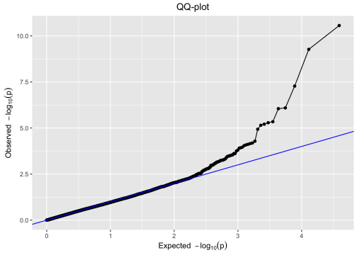
## Plot a manhattan plot by Muller element
plot(GWASChrSpec, plotType = "manhattan", trait = "TrypPhenotype")

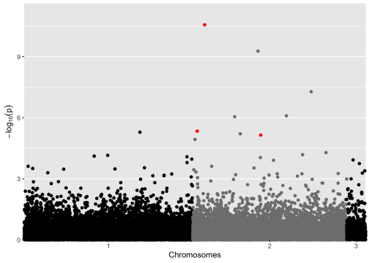
## Plot a qtl plot of GWAS... this seems useless to me. plot(GWASChrSpec, plotType = "qtl")
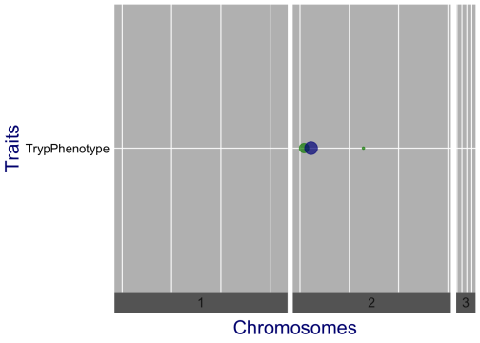
## Plot a manhattan plot by Scaffold number in ME order
chr.order <- c(1:length(unique(ordered(results$scaffold_no))))
names(chr.order) <- c(rev(as.character(unique(results$scaffold_no[results$ME=="A"]))),re v(as.character(unique(results$scaffold_no[results$ME=="D"]))),rev(as.character(unique(re sults$scaffold_no[results$ME=="F"]))))
chr.string <- c() # empty vector
for (x in as.character(results$scaffold_no)) {
chr.string <- c(chr.string, chr.order[[x]])
}
results$scaffold_ord <- chr.string
manplot <- manhattan(results, chr="scaffold_ord", bp="scaffpos", snp="snp", p="pValue", logp=TRUE, suggestiveline=FALSE,genomewideline = FALSE, highlight = GWASChrSpec$signSnp $pheno$snp[GWASChrSpec$signSnp$pheno$snpStatus == "significant SNP"], chrlabs = names(ch r.order))

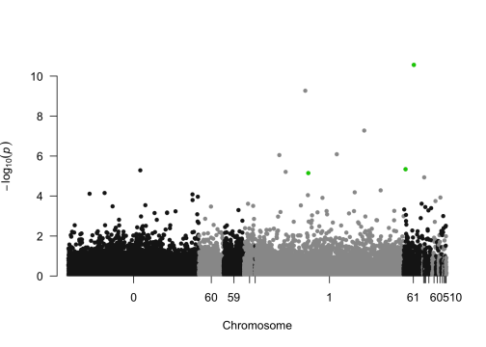
EMMA <- runSingleTraitGwas(gData = gDataDedup,
traits = "TrypPhenotype", remlAlgo = "EMMA", thrType = "fdr", genomicControl = TRUE)
summary(EMMA)
## pheno:
## Traits analysed: TrypPhenotype
##
## Data are available for 19423 SNPs.
## 0 of them were not analyzed because their minor allele frequency is below 0.01 ##
## Trait: TrypPhenotype
##
## Mixed model with only polygenic effects, and no marker effects: ## Genetic variance: 0.07706461
## Residual variance: 0.1851261
##
## LOD-threshold: NA
## Number of significant SNPs: 4
## Smallest p-value among the significant SNPs: 8.3931e-13 ## Largest p-value among the significant SNPs: 5.939636e-06 (LOD-score: 5.22624) ##
## Genomic control correction was applied
## Genomic control inflation-factor: 0.881
print(EMMA$signSnp, row.names = FALSE)

## $pheno
## trait snp chr pos allFreq pValue effect ## TrypPhenotype 1013638:53:+ 1 1306135 0.007177033 2.948226e-02 -0.1438738 ## TrypPhenotype 1022619:47:+ 1 3006866 0.009569378 1.201686e-02 0.1876783 ## TrypPhenotype 1023646:43:- 1 3210474 0.150717703 3.739569e-05 -0.6011315 ## TrypPhenotype 1039473:73:- 1 6247640 0.002392344 8.356727e-03 0.1856192 ## TrypPhenotype 1052423:23:+ 1 8740268 0.222488038 1.667789e-02 0.2926295 ## TrypPhenotype 1063873:85:- 1 10994335 0.014354067 3.201545e-02 0.2205525 ## TrypPhenotype 1065860:74:- 1 11389411 0.459330144 4.955956e-02 0.1092018 ## TrypPhenotype 1067224:70:- 1 11668054 0.177033493 1.758191e-02 0.1828887 ## TrypPhenotype 1073581:44:+ 1 12972647 0.480861244 5.426024e-04 0.2335214 ## TrypPhenotype 1089662:33:+ 1 16273341 0.334928230 3.862076e-02 0.1513212 ## TrypPhenotype 1090170:77:+ 1 16366881 0.205741627 4.300735e-02 0.1272339 ## TrypPhenotype 1091843:78:- 1 16741300 0.009569378 3.142191e-02 0.1613310 ## TrypPhenotype 3999:70:- 1 20104926 0.222488038 5.413162e-03 0.2885801 ## TrypPhenotype 39618:76:- 1 27142696 0.033492823 4.281396e-02 0.1438780 ## TrypPhenotype 42345:83:- 1 27774589 0.399521531 3.741754e-02 0.2360447 ## TrypPhenotype 49716:74:- 1 29236519 0.272727273 3.134525e-02 0.2294274 ## TrypPhenotype 74474:76:- 1 34140174 0.081339713 2.246148e-02 0.1804244 ## TrypPhenotype 75578:25:- 1 34356950 0.004784689 6.489304e-03 -0.1779878 ## TrypPhenotype 80317:41:+ 1 35313491 0.129186603 9.271455e-03 0.2185283 ## TrypPhenotype 81484:73:- 1 35546247 0.308612440 4.552788e-02 0.1685776 ## TrypPhenotype 83215:96:- 1 35905808 0.098086124 8.387743e-03 0.1797667 ## TrypPhenotype 88431:30:+ 1 36853877 0.143540670 1.740259e-02 0.1238493 ## TrypPhenotype 97648:26:+ 1 38634851 0.330143541 4.498397e-02 0.1365967 ## TrypPhenotype 119546:91:- 1 42755155 0.442583732 9.662846e-03 0.2480617 ## TrypPhenotype 122796:12:+ 1 43410856 0.009569378 2.499654e-02 0.1965020 ## TrypPhenotype 124699:45:- 1 43825439 0.102870813 3.596162e-07 -0.3939461 ## TrypPhenotype 132986:43:+ 1 45505052 0.119617225 3.327322e-02 0.1575742 ## TrypPhenotype 146647:34:- 1 48194522 0.019138756 2.618836e-02 0.2604288 ## TrypPhenotype 202384:62:- 1 59335329 0.473684211 3.575425e-02 0.3175096 ## TrypPhenotype 209355:8:+ 1 60636153 0.009569378 4.759025e-02 0.2837627 ## TrypPhenotype 214261:34:- 1 61647440 0.167464115 2.449810e-05 -0.2256563 ## TrypPhenotype 214394:73:+ 1 61675150 0.009569378 1.043676e-04 0.2300589 ## TrypPhenotype 219057:52:+ 1 62606269 0.392344498 3.290200e-03 -0.1928318 ## TrypPhenotype 223152:53:- 1 63395907 0.301435407 1.118483e-03 0.1991550 ## TrypPhenotype 1610905:22:+ 2 379803 0.031100478 7.420736e-05 -0.4623167 ## TrypPhenotype 1103556:9:+ 2 1192079 0.071770335 7.072715e-05 -0.4912942 ## TrypPhenotype 1105858:34:- 2 1652722 0.124401914 1.320127e-06 0.3031050 ## TrypPhenotype 1114223:28:- 2 3319728 0.200956938 2.725290e-02 0.1421759 ## TrypPhenotype 1118901:77:- 2 4175467 0.148325359 1.765716e-02 0.1936439 ## TrypPhenotype 1120452:26:+ 2 4485673 0.007177033 8.393100e-13 -0.4131839 ## TrypPhenotype 1121870:74:- 2 4766675 0.377990431 1.571935e-02 0.1716640 ## TrypPhenotype 1126710:47:+ 2 5768054 0.126794258 3.502940e-03 -0.1411338 ## TrypPhenotype 236878:40:+ 2 9818059 0.160287081 2.419648e-02 0.1871157 ## TrypPhenotype 238967:47:+ 2 10234068 0.236842105 3.030462e-02 -0.1679673 ## TrypPhenotype 244151:8:+ 2 11234267 0.315789474 3.675848e-02 -0.1128591 ## TrypPhenotype 249134:78:- 2 12157639 0.244019139 4.985964e-02 0.1288194 ## TrypPhenotype 264501:45:- 2 15100301 0.107655502 5.210846e-03 -0.1890949 ## TrypPhenotype 268407:33:+ 2 15843990 0.102870813 2.864078e-07 -0.5619357 ## TrypPhenotype 269356:30:- 2 16034479 0.100478469 2.469927e-02 -0.1203205 ## TrypPhenotype 279425:61:- 2 17998529 0.119617225 4.403818e-06 -0.2595754 ## TrypPhenotype 292792:80:- 2 20681956 0.205741627 6.558120e-03 0.2045716
## TrypPhenotype 293655:99:- 2 20868021 0.019138756 3.735694e-02 0.1159026 ## TrypPhenotype 304703:61:- 2 23192101 0.016746411 5.993533e-05 -0.2006718 ## TrypPhenotype 308368:48:- 2 23967932 0.224880383 3.740795e-02 0.2717346 ## TrypPhenotype 312231:62:- 2 24704067 0.074162679 2.029545e-11 -0.4105941 ## TrypPhenotype 315646:85:+ 2 25426606 0.141148325 3.304761e-02 0.1514462 ## TrypPhenotype 317279:90:- 2 25733841 0.026315789 1.392018e-06 0.2338950 ## TrypPhenotype 323719:77:- 2 27013977 0.133971292 8.382108e-04 0.1789165 ## TrypPhenotype 331072:80:- 2 28491884 0.222488038 3.103512e-02 0.1731695 ## TrypPhenotype 349114:51:+ 2 31979519 0.019138756 1.165471e-04 -0.2237783 ## TrypPhenotype 351016:17:+ 2 32376065 0.059808612 3.037458e-02 -0.1412694 ## TrypPhenotype 359223:85:- 2 33959558 0.284688995 1.085886e-02 0.1658252 ## TrypPhenotype 366668:8:+ 2 35456925 0.188995215 6.387813e-08 -0.3751558 ## TrypPhenotype 388231:15:+ 2 39691256 0.241626794 3.588054e-02 0.1437625 ## TrypPhenotype 396411:48:+ 2 41335408 0.334928230 2.232519e-04 -0.1922109 ## TrypPhenotype 397623:26:- 2 41585762 0.495215311 5.078242e-05 -0.2119876 ## TrypPhenotype 401970:73:- 2 42339597 0.074162679 2.074899e-02 0.1682838 ## TrypPhenotype 407838:91:- 2 43480386 0.009569378 8.657799e-03 0.2261068 ## TrypPhenotype 413756:63:- 2 44646457 0.078947368 2.761540e-02 -0.1342957 ## TrypPhenotype 414703:25:- 2 44831146 0.339712919 2.525299e-09 -0.4255701 ## TrypPhenotype 418764:19:- 2 45592967 0.447368421 7.790820e-03 0.1880780 ## TrypPhenotype 436204:66:- 2 49012378 0.246411483 3.649162e-04 0.2084481 ## TrypPhenotype 442653:7:+ 2 50440343 0.327751196 5.939636e-06 -0.2232777 ## TrypPhenotype 443301:72:- 2 50571951 0.208133971 7.998846e-03 0.2193647 ## TrypPhenotype 461211:86:- 2 54262310 0.291866029 2.046299e-02 0.1211401 ## TrypPhenotype 472343:9:+ 2 56487692 0.114832536 1.664627e-02 0.1857498 ## TrypPhenotype 475136:54:+ 2 57024989 0.007177033 9.942726e-03 0.1415934 ## TrypPhenotype 1857829:87:- 3 2417061 0.416267943 7.728286e-05 0.2041803 ## TrypPhenotype 1866906:53:- 3 3535301 0.423444976 4.533641e-03 -0.1409514 ## TrypPhenotype 1793349:13:+ 3 4844823 0.076555024 1.805350e-02 0.1783791 ## trait snp chr pos allFreq pValue effect ## effectSe RLR2 LOD snpStatus propSnpVar
## 0.07044647 0.01975934 1.530439 within LD of significant SNP 0.05513323 ## 0.07976588 0.02614017 1.920209 within LD of significant SNP 0.07084866 ## 0.15718812 0.06758441 4.427178 within LD of significant SNP 0.07998621 ## 0.07517689 0.02874829 2.077964 within LD of significant SNP 0.08598136 ## 0.13042832 0.02379724 1.777859 within LD of significant SNP 0.11254036 ## 0.10962702 0.01917980 1.494640 within LD of significant SNP 0.08871501 ## 0.05922721 0.01613407 1.304873 within LD of significant SNP 0.02961162 ## 0.08217549 0.02342108 1.754934 within LD of significant SNP 0.06168515 ## 0.07245006 0.04849314 3.265518 within LD of significant SNP 0.10717528 ## 0.07795646 0.01786653 1.413179 within LD of significant SNP 0.04489573 ## 0.06697958 0.01711712 1.366457 within LD of significant SNP 0.04535195 ## 0.07991453 0.01931124 1.502767 within LD of significant SNP 0.07624550 ## 0.11090347 0.03187723 2.266549 within LD of significant SNP 0.12203263 ## 0.07567171 0.01714846 1.368415 within LD of significant SNP 0.05067842 ## 0.12085159 0.01808756 1.426925 within LD of significant SNP 0.07220271 ## 0.11359479 0.01932840 1.503828 within LD of significant SNP 0.04519481 ## 0.08429663 0.02168068 1.648562 within LD of significant SNP 0.04622033 ## 0.06987322 0.03056953 2.187802 within LD of significant SNP 0.04823141 ## 0.08969498 0.02800144 2.032852 within LD of significant SNP 0.13920386 ## 0.08979648 0.01672161 1.341723 within LD of significant SNP 0.08291361 ## 0.07284088 0.02872164 2.076355 within LD of significant SNP 0.05008388 ## 0.05556032 0.02349410 1.759386 within LD of significant SNP 0.04155796 ## 0.07257891 0.01680500 1.346942 within LD of significant SNP 0.04656282
## 0.10236917 0.02770436 2.014895 within LD of significant SNP 0.07025775 ## 0.09347221 0.02092372 1.602120 within LD of significant SNP 0.11416873 ## 0.08414766 0.09955669 6.444161 within LD of significant SNP 0.12607296 ## 0.07888678 0.01890936 1.477905 within LD of significant SNP 0.06180441 ## 0.12487729 0.02059462 1.581892 within LD of significant SNP 0.08707782 ## 0.16113722 0.01840552 1.446672 within LD of significant SNP 0.09967962 ## 0.15257129 0.01641458 1.322482 within LD of significant SNP 0.08563302 ## 0.05770158 0.07056347 4.610868 within LD of significant SNP 0.15385886 ## 0.06380665 0.06030638 3.981434 within LD of significant SNP 0.11375366 ## 0.07018480 0.03547363 2.482778 within LD of significant SNP 0.05748218 ## 0.06549641 0.04327434 2.951371 within LD of significant SNP 0.11128588 ## 0.12563917 0.06273220 4.129553 within LD of significant SNP 0.07136564 ## 0.13314062 0.06307327 4.150414 within LD of significant SNP 0.08466028 ## 0.06796510 0.09077523 5.879384 significant SNP 0.20636928 ## 0.06864943 0.02031341 1.564587 within LD of significant SNP 0.04130995 ## 0.08706523 0.02339066 1.753079 within LD of significant SNP 0.13299841 ## 0.06427307 0.17941232 12.076078 significant SNP 0.25716840 ## 0.07583458 0.02421945 1.803565 within LD of significant SNP 0.08673345 ## 0.05170545 0.03502074 2.455567 within LD of significant SNP 0.06550064 ## 0.08851684 0.02115379 1.616248 within LD of significant SNP 0.10849224 ## 0.08265354 0.01956576 1.518491 within LD of significant SNP 0.08444886 ## 0.05758309 0.01821176 1.434642 within LD of significant SNP 0.03120609 ## 0.06995833 0.01609235 1.302251 within LD of significant SNP 0.04424562 ## 0.07235412 0.03215212 2.283092 within LD of significant SNP 0.09438741 ## 0.11907353 0.10107941 6.543015 within LD of significant SNP 0.12837837 ## 0.05711755 0.02100831 1.607316 within LD of significant SNP 0.03566930 ## 0.06118319 0.08251814 5.356171 within LD of significant SNP 0.18485163 ## 0.08041090 0.03049349 2.183221 within LD of significant SNP 0.05845611 ## 0.05932177 0.01809889 1.427629 within LD of significant SNP 0.03791795 ## 0.05386594 0.06424779 4.222317 within LD of significant SNP 0.09841816 ## 0.13911736 0.01808935 1.427036 within LD of significant SNP 0.06872347 ## 0.06776893 0.16107815 10.692601 within LD of significant SNP 0.24846135 ## 0.07572249 0.01895708 1.480860 within LD of significant SNP 0.05127948 ## 0.05255590 0.09041423 5.856355 significant SNP 0.15421390 ## 0.05744253 0.04535728 3.076647 within LD of significant SNP 0.08522512 ## 0.08558416 0.01939828 1.508147 within LD of significant SNP 0.08486404 ## 0.06248640 0.05951982 3.933499 within LD of significant SNP 0.11306648 ## 0.06954510 0.01954954 1.517490 within LD of significant SNP 0.06889288 ## 0.06950571 0.02686665 1.964216 within LD of significant SNP 0.07620655 ## 0.07565011 0.11100871 7.194648 within LD of significant SNP 0.16069346 ## 0.07300935 0.01838084 1.445141 within LD of significant SNP 0.06345431 ## 0.05596582 0.05487398 3.651205 within LD of significant SNP 0.09010713 ## 0.05637312 0.06542163 4.294287 within LD of significant SNP 0.10473929 ## 0.07761267 0.02224323 1.683003 within LD of significant SNP 0.04875825 ## 0.09198878 0.02849373 2.062592 within LD of significant SNP 0.07808422 ## 0.06499530 0.02022021 1.558849 within LD of significant SNP 0.04936750 ## 0.07832046 0.13174391 8.597687 within LD of significant SNP 0.20234117 ## 0.07550317 0.02925286 2.108417 within LD of significant SNP 0.08936737 ## 0.06280091 0.05134775 3.437807 within LD of significant SNP 0.12585214 ## 0.05332940 0.08044998 5.226240 significant SNP 0.11697699 ## 0.08835423 0.02906321 2.096973 within LD of significant SNP 0.08019241 ## 0.05574515 0.02234178 1.689031 within LD of significant SNP 0.03816027 ## 0.08276702 0.02381077 1.778683 within LD of significant SNP 0.09640809 ## 0.05865281 0.02749929 2.002495 within LD of significant SNP 0.06447874
## 0.05562030 0.06244373 4.111917 within LD of significant SNP 0.14421952 ## 0.05309534 0.03315721 2.343553 within LD of significant SNP 0.06074778 ## 0.08047755 0.02323259 1.743439 within LD of significant SNP 0.09309767 ## effectSe RLR2 LOD snpStatus propSnpVar
print(EMMA$signSnp$pheno[EMMA$signSnp$pheno$snpStatus == "significant SNP",], row.names = FALSE)
## trait snp chr pos allFreq pValue effect ## TrypPhenotype 1105858:34:- 2 1652722 0.124401914 1.320127e-06 0.3031050 ## TrypPhenotype 1120452:26:+ 2 4485673 0.007177033 8.393100e-13 -0.4131839 ## TrypPhenotype 317279:90:- 2 25733841 0.026315789 1.392018e-06 0.2338950 ## TrypPhenotype 442653:7:+ 2 50440343 0.327751196 5.939636e-06 -0.2232777 ## effectSe RLR2 LOD snpStatus propSnpVar
## 0.06796510 0.09077523 5.879384 significant SNP 0.2063693
## 0.06427307 0.17941232 12.076078 significant SNP 0.2571684
## 0.05255590 0.09041423 5.856355 significant SNP 0.1542139
## 0.05332940 0.08044998 5.226240 significant SNP 0.1169770
#add in Muller element and scaffold info and write to file:
results2 <- left_join(EMMA$GWAResult$pheno,gMap, by = "snp")
write.csv(results2,"GWASEMMA_X_results_binom.csv",sep=",",quote = FALSE)
## Warning in write.csv(results2, "GWASEMMA_X_results_binom.csv", sep = ",", : ## attempt to set 'sep' ignored
## Plot a QQ-plot of GWAS
plot(EMMA, plotType = "qq", trait = "TrypPhenotype")

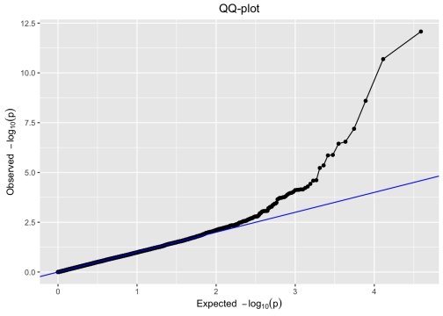
## Plot a manhattan plot by Muller element
plot(EMMA, plotType = "manhattan", trait = "TrypPhenotype",xlab="Scaffold")

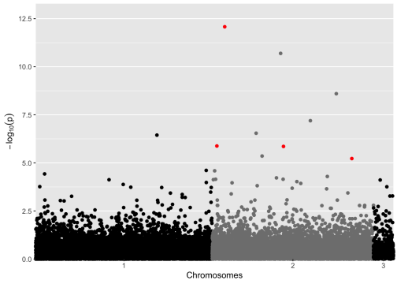
## Plot a manhattan plot by Scaffold number in ME order
chr.order <- c(1:length(unique(ordered(results2$scaffold_no))))
names(chr.order) <- c(rev(as.character(unique(results2$scaffold_no[results2$ME=="A"]))), rev(as.character(unique(results2$scaffold_no[results2$ME=="D"]))),rev(as.character(uniqu e(results2$scaffold_no[results2$ME=="F"]))))
chr.string <- c() # empty vector
for (x in as.character(results2$scaffold_no)) {
chr.string <- c(chr.string, chr.order[[x]])
}
results2$scaffold_ord <- chr.string
manplot <- manhattan(results2, chr="scaffold_ord", bp="scaffpos", snp="snp", p="pValue", logp=TRUE, suggestiveline=FALSE,genomewideline = FALSE, highlight = EMMA$signSnp$pheno$s np[EMMA$signSnp$pheno$snpStatus == "significant SNP"], chrlabs = names(chr.order))

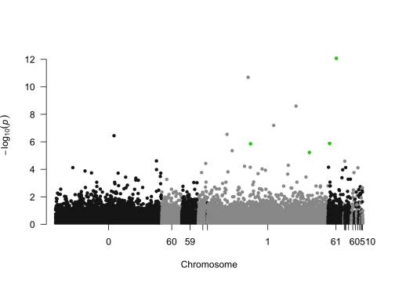## Explore top SNPs
#create vector of genotype012
Markers <- GWASChrSpec$signSnp$pheno$snp[GWASChrSpec$signSnp$pheno$snpStatus == "signifi cant SNP"]
Genotype012 <- gDataDedup$markers[,colnames(gDataDedup$markers) == Markers[1]]
#create vector of phenotypes
Infected <- gDataDedup$pheno$pheno$TrypPhenotype[match(rownames(gDataDedup$markers),gDat aDedup$pheno$pheno$genotype)]
names(Infected) <- gDataDedup$pheno$pheno$genotype[match(rownames(gDataDedup$markers),gD ataDedup$pheno$pheno$genotype)]
Infected <- as.factor(Infected[names(Infected) %in% names(Genotype012)]) identical(names(Genotype012),names(Infected))
## [1] TRUE
#print major and minor alleles
print(paste("Marker = ", Markers[1], ", Major = ",gMap$major[gMap$snp == Markers[1]],", Minor = ",gMap$minor[gMap$snp == Markers[1]]))
## [1] "Marker = 1105858:34:- , Major = C , Minor = T"

#replace 0, 1, 2 with actual alleles
geno <- as.character(Genotype012)
summary(geno)
## Length Class Mode
## 209 character character
names(geno) <- NULL
geno_table <- list("0" = "CC", "1" = "CT","2" = "TT")
Genotype <- c() # empty vector
for (x in geno) {
Genotype <- c(Genotype, geno_table[[x]])
}
#create a data frame and tabulate the labels
top_snp <- data.frame(Genotype,Infected)
#bar plot with proportion infected
tab <- table(top_snp)
df <- data.frame(Genotype = c("AA","AT","TT"), Infection = c(tab[1,2]/sum(tab[1,1:2]), t ab[2,2]/sum(tab[2,1:2]),tab[3,2]/sum(tab[3,1:2])), Count = c(sum(tab[1,1:2]),sum(tab[2,1 :2]),sum(tab[3,1:2])), Labels = c(paste0("Infected: ",tab[1,2],"/",sum(tab[1,1:2])), pas te0("Infected: ",tab[2,2],"/",sum(tab[2,1:2])),paste0("Infected: ",tab[3,2],"/",sum(tab[ 3,1:2]))))
ggplot(df, aes(x =Genotype, y = Infection)) +
geom_col() +
ylab("Infection Rate") +
ggtitle(paste("Marker: ",Markers[1])) +
geom_text(aes(label = Count), vjust = -0.2)

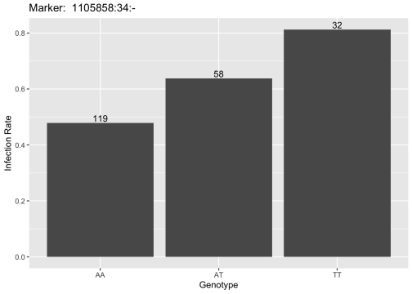
#density plot
ggplot(data=top_snp, aes(x=Genotype, group=Infected, fill=Infected)) + geom_density(adjust=1.5, alpha=.6) +
xlab("Genotype") +
ylab("Density") +
ggtitle(paste("Marker: ",Markers[1])) +
scale_fill_manual(values=c("#E69F00", "#56B4E9"), name="Status",
labels=c("Control","Infected"))

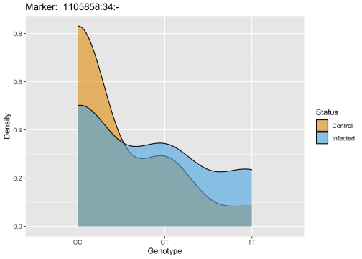
#bar plot with counts, showing infection status by fill
ggplot(data=top_snp, aes(x=Genotype, group=Infected, fill=Infected)) + geom_bar(alpha=.6) +
xlab("Genotype") +
ylab("Count") +
ggtitle(paste("Marker: ",Markers[1])) +
annotate(geom="text", x = c(1,2,3), y = df$Count + 5, label= df$Labels) + scale_fill_manual(values=c("#E69F00", "#56B4E9"), name="Status", labels=c("Control", "Infected"))

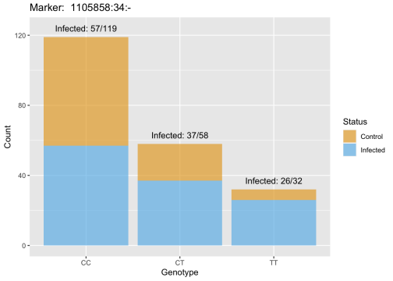
#create vector of genotype012
Markers <- GWASChrSpec$signSnp$pheno$snp[GWASChrSpec$signSnp$pheno$snpStatus == "signifi cant SNP"]
Genotype012 <- gDataDedup$markers[,colnames(gDataDedup$markers) == Markers[2]]
#create vector of phenotypes
Infected <- gDataDedup$pheno$pheno$TrypPhenotype[match(rownames(gDataDedup$markers),gDat aDedup$pheno$pheno$genotype)]
names(Infected) <- gDataDedup$pheno$pheno$genotype[match(rownames(gDataDedup$markers),gD ataDedup$pheno$pheno$genotype)]
Infected <- as.factor(Infected[names(Infected) %in% names(Genotype012)]) identical(names(Genotype012),names(Infected))
## [1] TRUE
#print major and minor alleles
print(paste("Marker = ", Markers[2], ", Major = ",gMap$major[gMap$snp == Markers[2]],", Minor = ",gMap$minor[gMap$snp == Markers[2]]))
## [1] "Marker = 1120452:26:+ , Major = C , Minor = T"

#replace 0, 1, 2 with actual alleles
geno <- as.character(Genotype012)
summary(geno)
## Length Class Mode
## 209 character character
names(geno) <- NULL
geno_table <- list("0" = "AA", "1" = "AT","2" = "TT")
Genotype <- c() # empty vector
for (x in geno) {
Genotype <- c(Genotype, geno_table[[x]])
}
#create a data frame and tabulate the labels
top_snp <- data.frame(Genotype,Infected)
#bar plot with proportion infected
tab <- table(top_snp)
df <- data.frame(Genotype = c("CC","CT","TT"), Infection = c(tab[1,2]/sum(tab[1,1:2]), t ab[2,2]/sum(tab[2,1:2]),tab[3,2]/sum(tab[3,1:2])), Count = c(sum(tab[1,1:2]),sum(tab[2,1 :2]),sum(tab[3,1:2])), Labels = c(paste0("Infected: ",tab[1,2],"/",sum(tab[1,1:2])), pas te0("Infected: ",tab[2,2],"/",sum(tab[2,1:2])),paste0("Infected: ",tab[3,2],"/",sum(tab[ 3,1:2]))))
ggplot(df, aes(x =Genotype, y = Infection)) +
geom_col() +
ylab("Infection Rate") +
ggtitle(paste("Marker: ",Markers[2])) +
geom_text(aes(label = Count), vjust = -0.2)

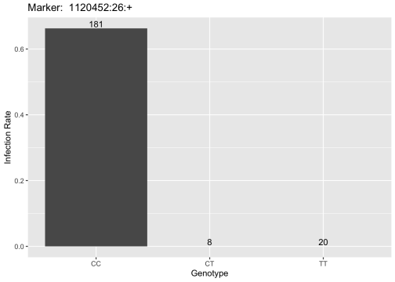
#density plot
ggplot(data=top_snp, aes(x=Genotype, group=Infected, fill=Infected)) + geom_density(adjust=1.5, alpha=.6) +
xlab("Genotype") +
ylab("Density") +
ggtitle(paste("Marker: ",Markers[2])) +
scale_fill_manual(values=c("#E69F00", "#56B4E9"), name="Status",
labels=c("Control","Infected"))

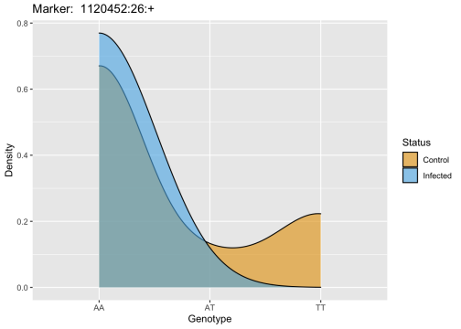
#bar plot with counts, showing infection status by fill
ggplot(data=top_snp, aes(x=Genotype, group=Infected, fill=Infected)) + geom_bar(alpha=.6) +
xlab("Genotype") +
ylab("Count") +
ggtitle(paste("Marker: ",Markers[2])) +
annotate(geom="text", x = c(1,2,3), y = df$Count + 5, label= df$Labels) + scale_fill_manual(values=c("#E69F00", "#56B4E9"), name="Status", labels=c("Control", "Infected"))

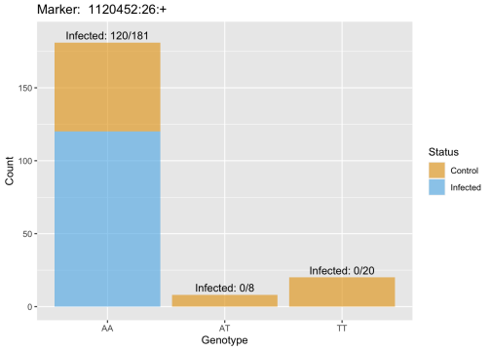
#create vector of genotype012
Markers <- GWASChrSpec$signSnp$pheno$snp[GWASChrSpec$signSnp$pheno$snpStatus == "signifi cant SNP"]
Genotype012 <- gDataDedup$markers[,colnames(gDataDedup$markers) == Markers[3]]
#create vector of phenotypes
Infected <- gDataDedup$pheno$pheno$TrypPhenotype[match(rownames(gDataDedup$markers),gDat aDedup$pheno$pheno$genotype)]
names(Infected) <- gDataDedup$pheno$pheno$genotype[match(rownames(gDataDedup$markers),gD ataDedup$pheno$pheno$genotype)]
Infected <- as.factor(Infected[names(Infected) %in% names(Genotype012)]) identical(names(Genotype012),names(Infected))
## [1] TRUE
#print major and minor alleles
print(paste("Marker = ", Markers[3], ", Major = ",gMap$major[gMap$snp == Markers[3]],", Minor = ",gMap$minor[gMap$snp == Markers[3]]))
## [1] "Marker = 317279:90:- , Major = G , Minor = A"

#replace 0, 1, 2 with actual alleles
geno <- as.character(Genotype012)
summary(geno)
## Length Class Mode
## 209 character character
names(geno) <- NULL
geno_table <- list("0" = "GG", "1" = "GA","2" = "AA")
Genotype <- c() # empty vector
for (x in geno) {
Genotype <- c(Genotype, geno_table[[x]])
}
#create a data frame and tabulate the labels
top_snp <- data.frame(Genotype,Infected)
#bar plot with proportion infected
tab <- table(top_snp)
df <- data.frame(Genotype = c("AA","AT","TT"), Infection = c(tab[1,2]/sum(tab[1,1:2]), t ab[2,2]/sum(tab[2,1:2]),tab[3,2]/sum(tab[3,1:2])), Count = c(sum(tab[1,1:2]),sum(tab[2,1 :2]),sum(tab[3,1:2])), Labels = c(paste0("Infected: ",tab[1,2],"/",sum(tab[1,1:2])), pas te0("Infected: ",tab[2,2],"/",sum(tab[2,1:2])),paste0("Infected: ",tab[3,2],"/",sum(tab[ 3,1:2]))))
ggplot(df, aes(x =Genotype, y = Infection)) +
geom_col() +
ylab("Infection Rate") +
ggtitle(paste("Marker: ",Markers[3])) +
geom_text(aes(label = Count), vjust = -0.2)

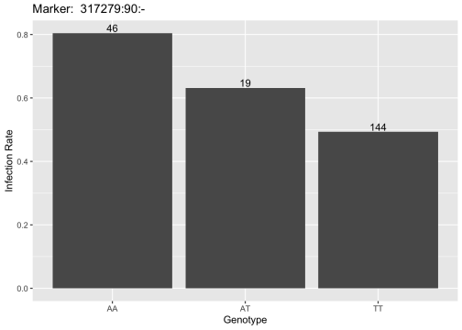
#density plot
ggplot(data=top_snp, aes(x=Genotype, group=Infected, fill=Infected)) + geom_density(adjust=1.5, alpha=.6) +
xlab("Genotype") +
ylab("Density") +
ggtitle(paste("Marker: ",Markers[3])) +
scale_fill_manual(values=c("#E69F00", "#56B4E9"), name="Status",
labels=c("Control","Infected"))

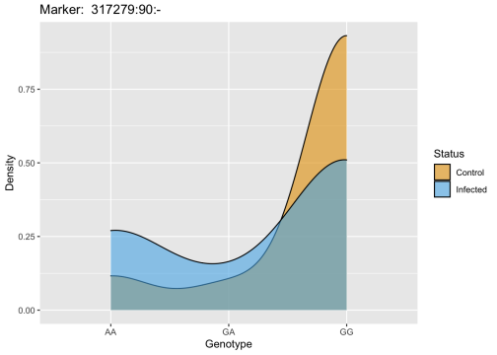
#bar plot with counts, showing infection status by fill
ggplot(data=top_snp, aes(x=Genotype, group=Infected, fill=Infected)) + geom_bar(alpha=.6) +
xlab("Genotype") +
ylab("Count") +
ggtitle(paste("Marker: ",Markers[3])) +
annotate(geom="text", x = c(1,2,3), y = df$Count + 5, label= df$Labels) + scale_fill_manual(values=c("#E69F00", "#56B4E9"), name="Status", labels=c("Control", "Infected"))

