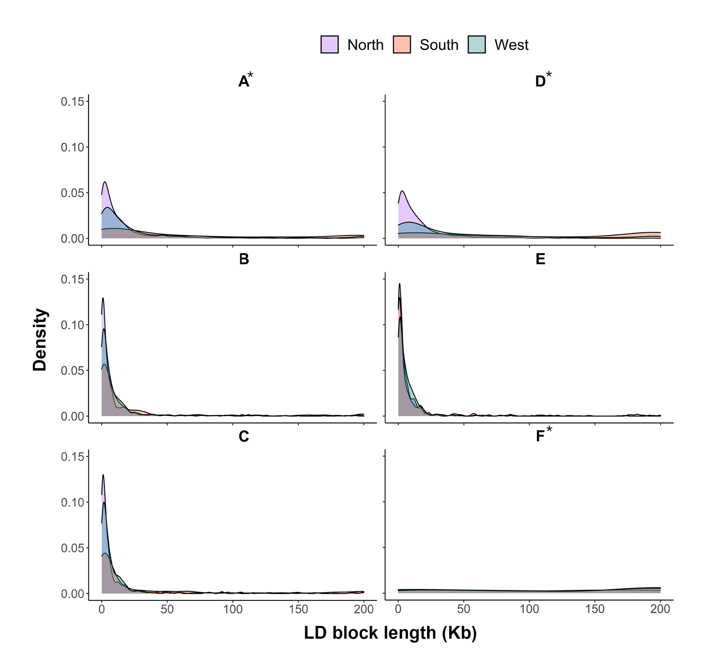
Figure S1. Linkage blocks length distribution for each Muller element and genetic unit (purple = north, orange = south, green = west). Muller elements associated with the sex chromosomes in Glossina fuscipes fuscipes are marked *.
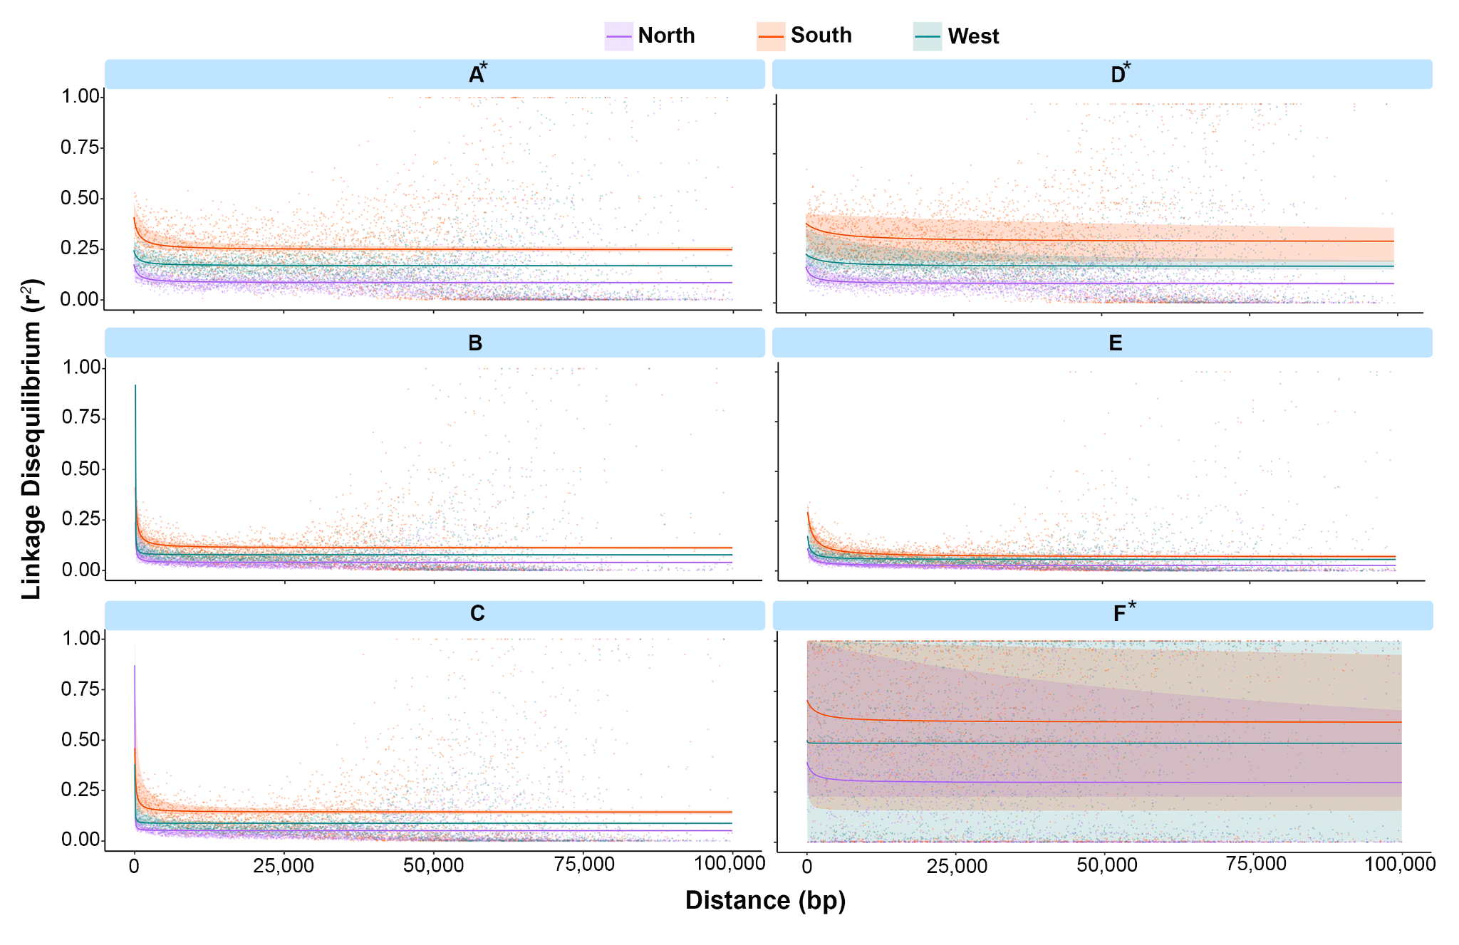Figure S2. Linkage disequilibrium (r²) decay for each Muller element and genetic unit (purple = north, orange = south, green = west). Results indicate relatively fast decay in the north and autosomal Muller elements, and relatively slow decay in the south and sex chromosome associated Muller elements (marked *).
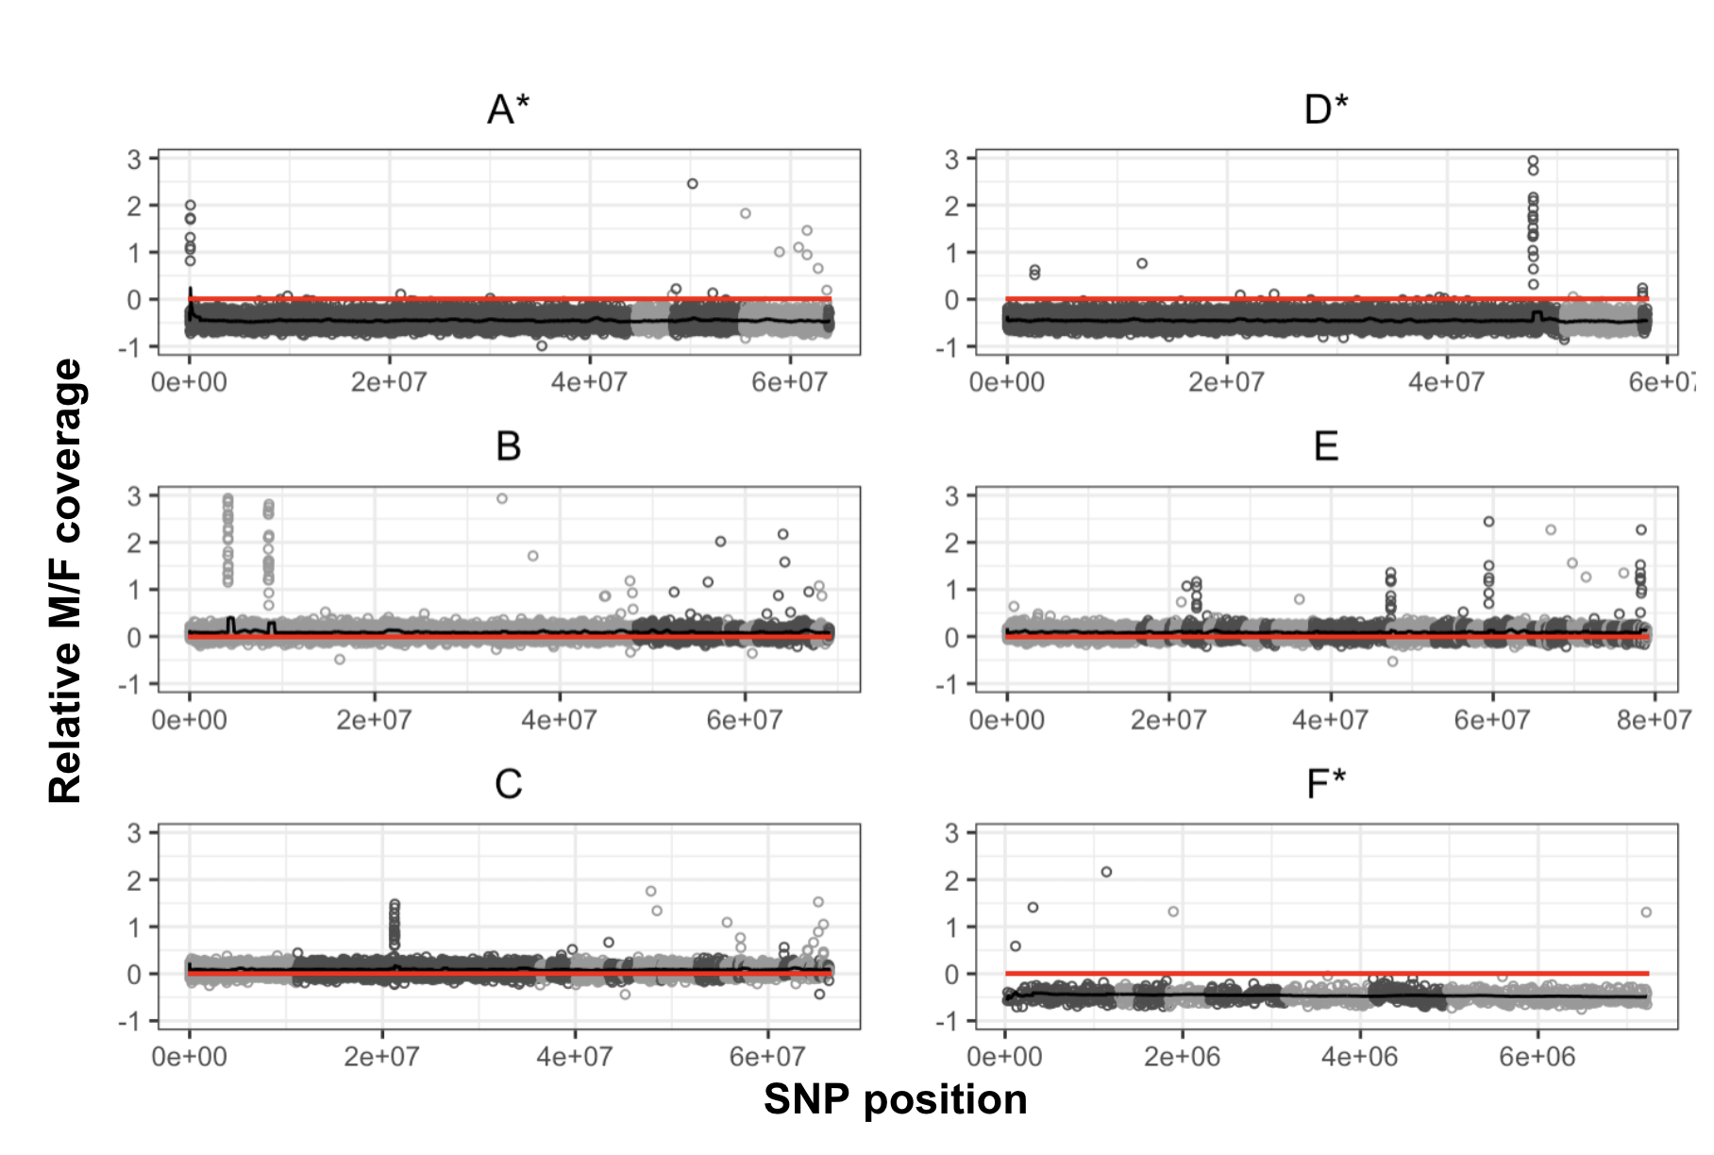
Figure S3. Relative male/female (M/F) read depth of coverage (log2(M)-log2(F) coverage) for each Muller element (ME). Scaffolds within each ME are indicated with alternating shades of grey. Black line indicates the moving average along the ME. Red line indicates the expectation for autosomes (equal read depth in males relative to females). MEs associated with the sex chromosomes are marked*.
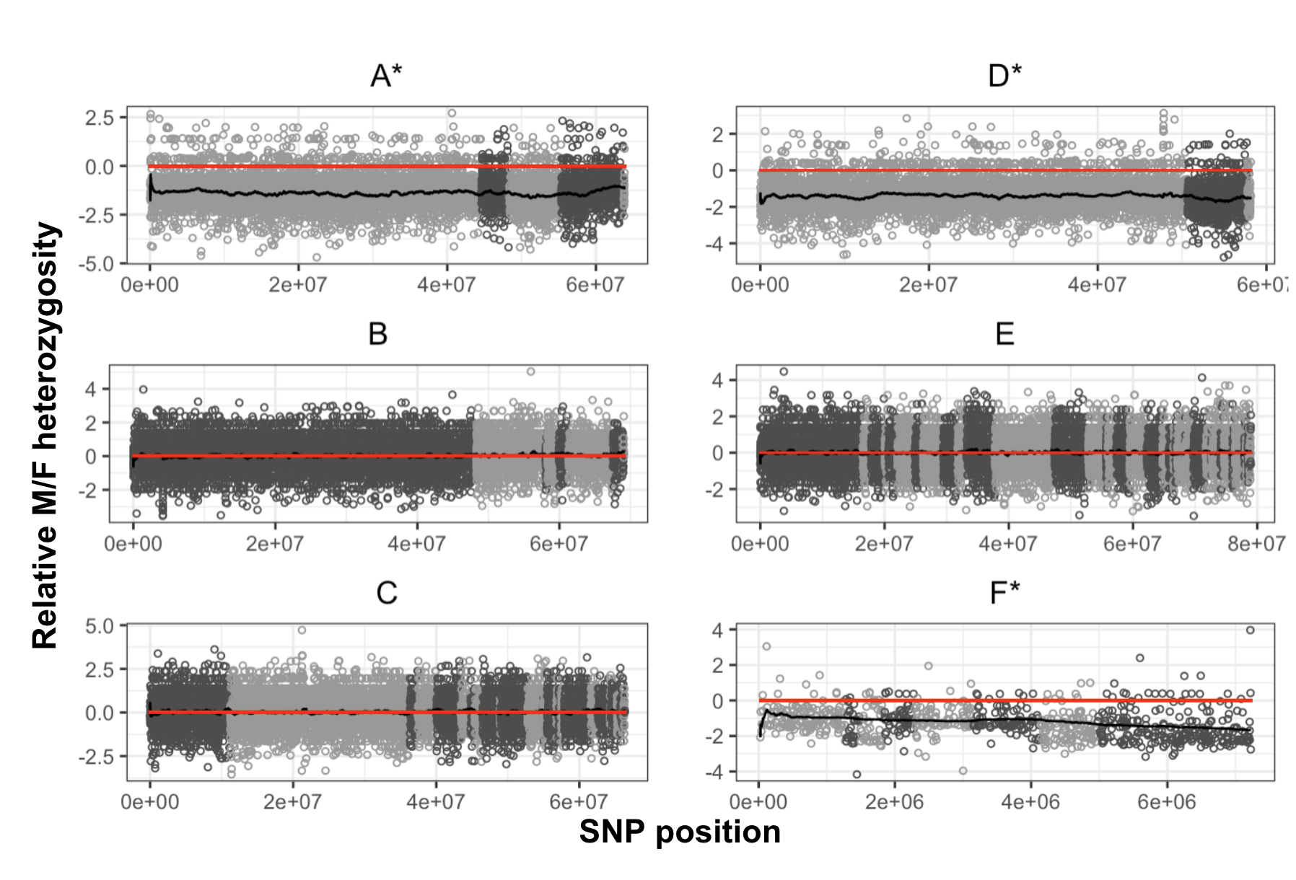
Figure S4. Relative male/female (M/F) heterozygosity (log2(M)-log2(F) heterozygosity) for each Muller element (ME). Scaffolds within each ME are organized from longest to shortest and indicated with alternating shades of grey. Black line indicates the moving average along the ME. Red line indicates the expectation for autosomes (equal heterozygosity in males relative to females). ME associated with the sex chromosomes are marked*.

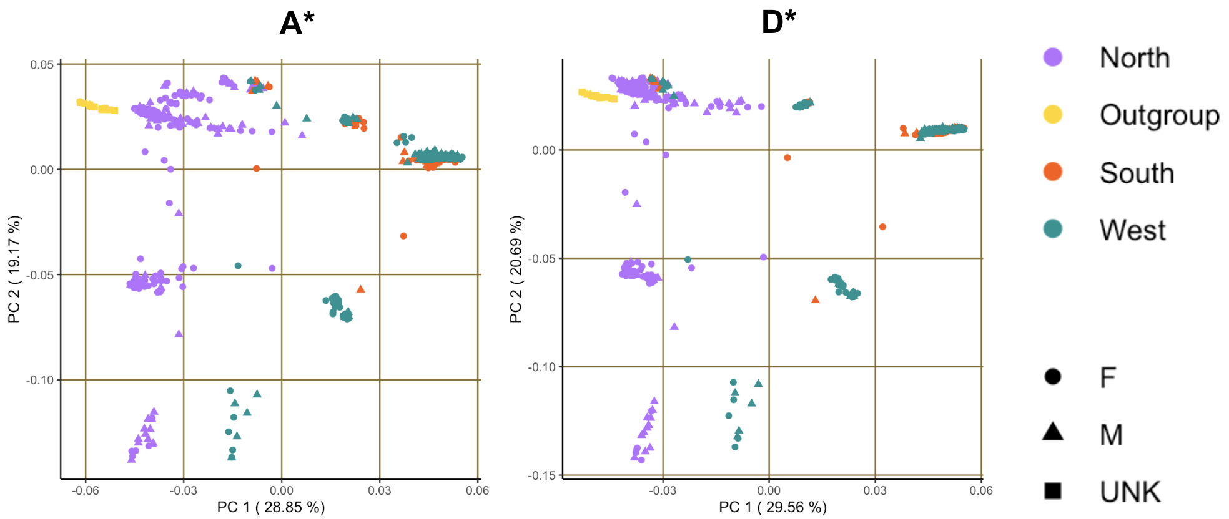
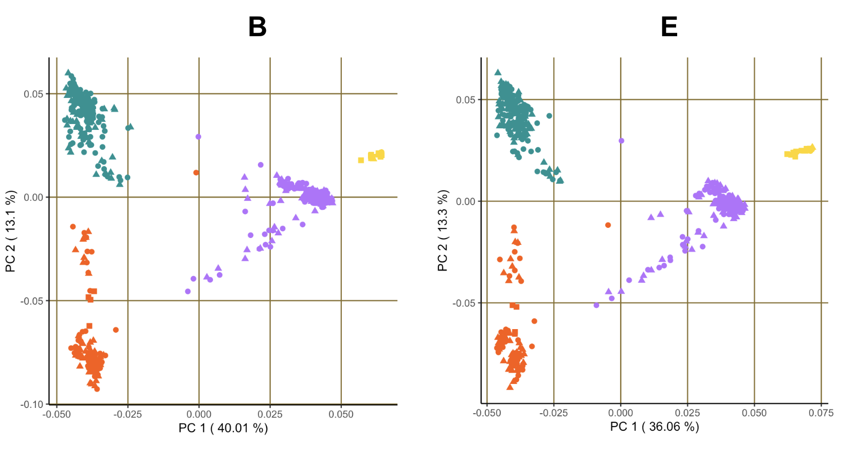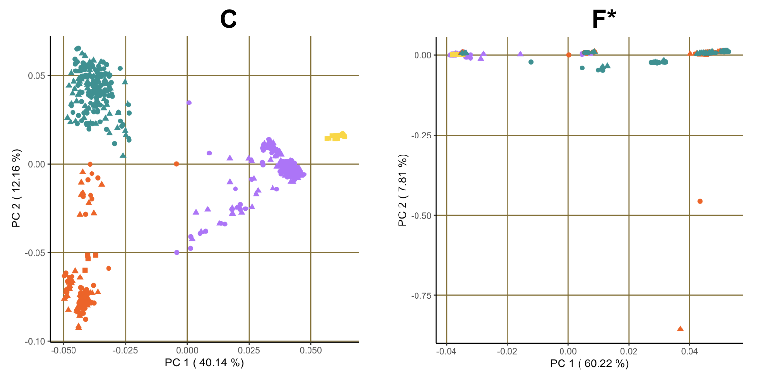
Figure S5. Principal components analysis of genomic variation of all individuals in the population genomics dataset for Muller elements (ME) A-F. Shape indicates sex (female = circle, male = triangle, unknown = square), and color indicates the common genetic cluster of the sample’s place of origin (north = blue, west = purple, south = orange, outgroup = yellow). ME associated with the sex chromosomes are marked*.

