Implications of Parkinson’s disease-associated alterations in the oral and gut microbiome on vitamin B12 biosynthesis and levodopa bioavailability
Sebastiaan van Kessel¹, Markus Schwalbe¹, Phillip A Engen⁴, Robin M Voigt^{3, 4}, Maliha Shaikh⁴, Gabriella Sanzo³, Patrick Mcnamara², Alex M Yerkan⁴, Leo Verhagen Metman², Ali Keshavarzian^{3, 4}, Sahar El Aidy¹
¹ Host-microbe interactions, Groningen Biomolecular Sciences and Biotechnology Institute (GBB), University of Groningen, Groningen, The Netherlands
² Department of Neurological Sciences, Section of Movement Disorders Rush University Medical Center, Chicago, IL, USA
³ Division of Digestive Disease and Nutrition, Section of Gastroenterology, Department of Internal Medicine, Rush University Medical Center, Chicago, IL, USA
⁴ Rush Center for Integrated Microbiome and Chronobiology Research, Rush University Medical Center, Chicago, IL, USA
Corresponding Author: Sahar El Aidy, e mail: sahar.elaidy@rug.nl
Supplementary Figures
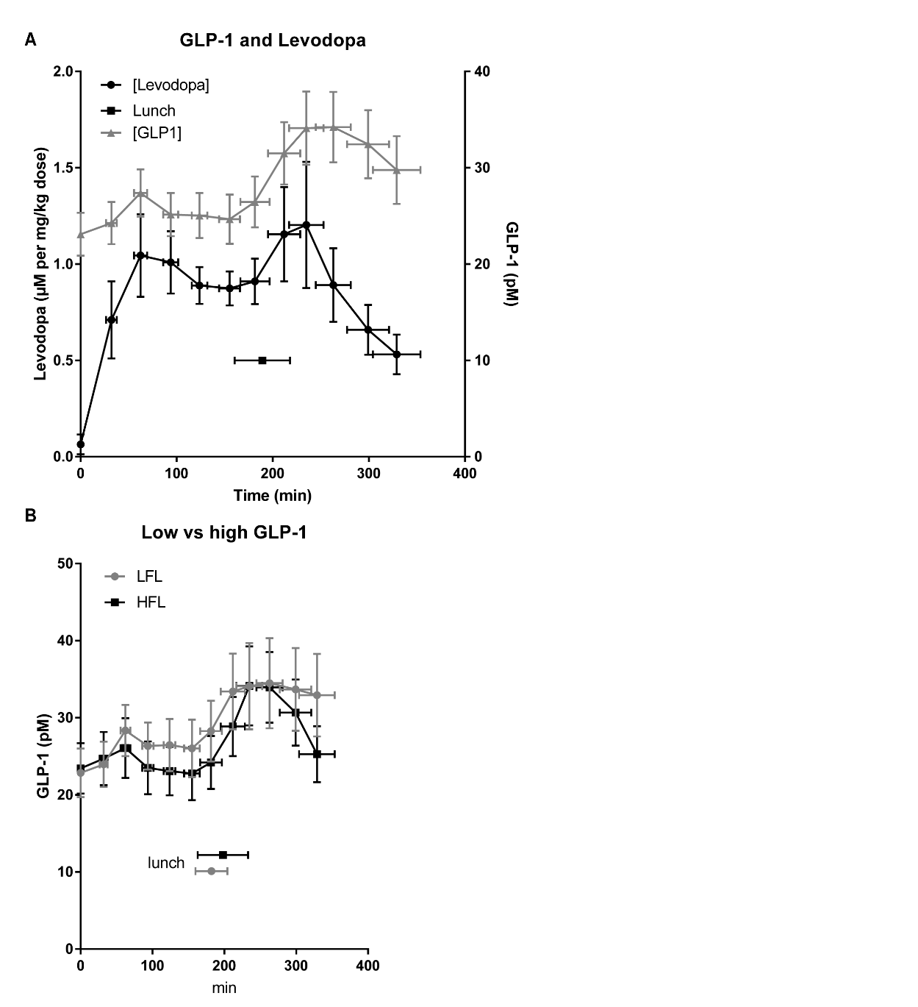
Supplementary Figure 1. GLP-1 plasma levels. (A) depict the GLP-1 (nM) and levodopa (µM per mg/kg) plasma concentrations for PD patients. The horizontal error bars depict the standard deviation and the vertical error bars depict the standard error. (B) depict the plasma GLP-1 concentrations grouped for high frequency levodopa (HFL) and low frequency levodopa (LFL) patients. The horizontal error bars depict the standard deviation and the vertical error bars depict the standard error.

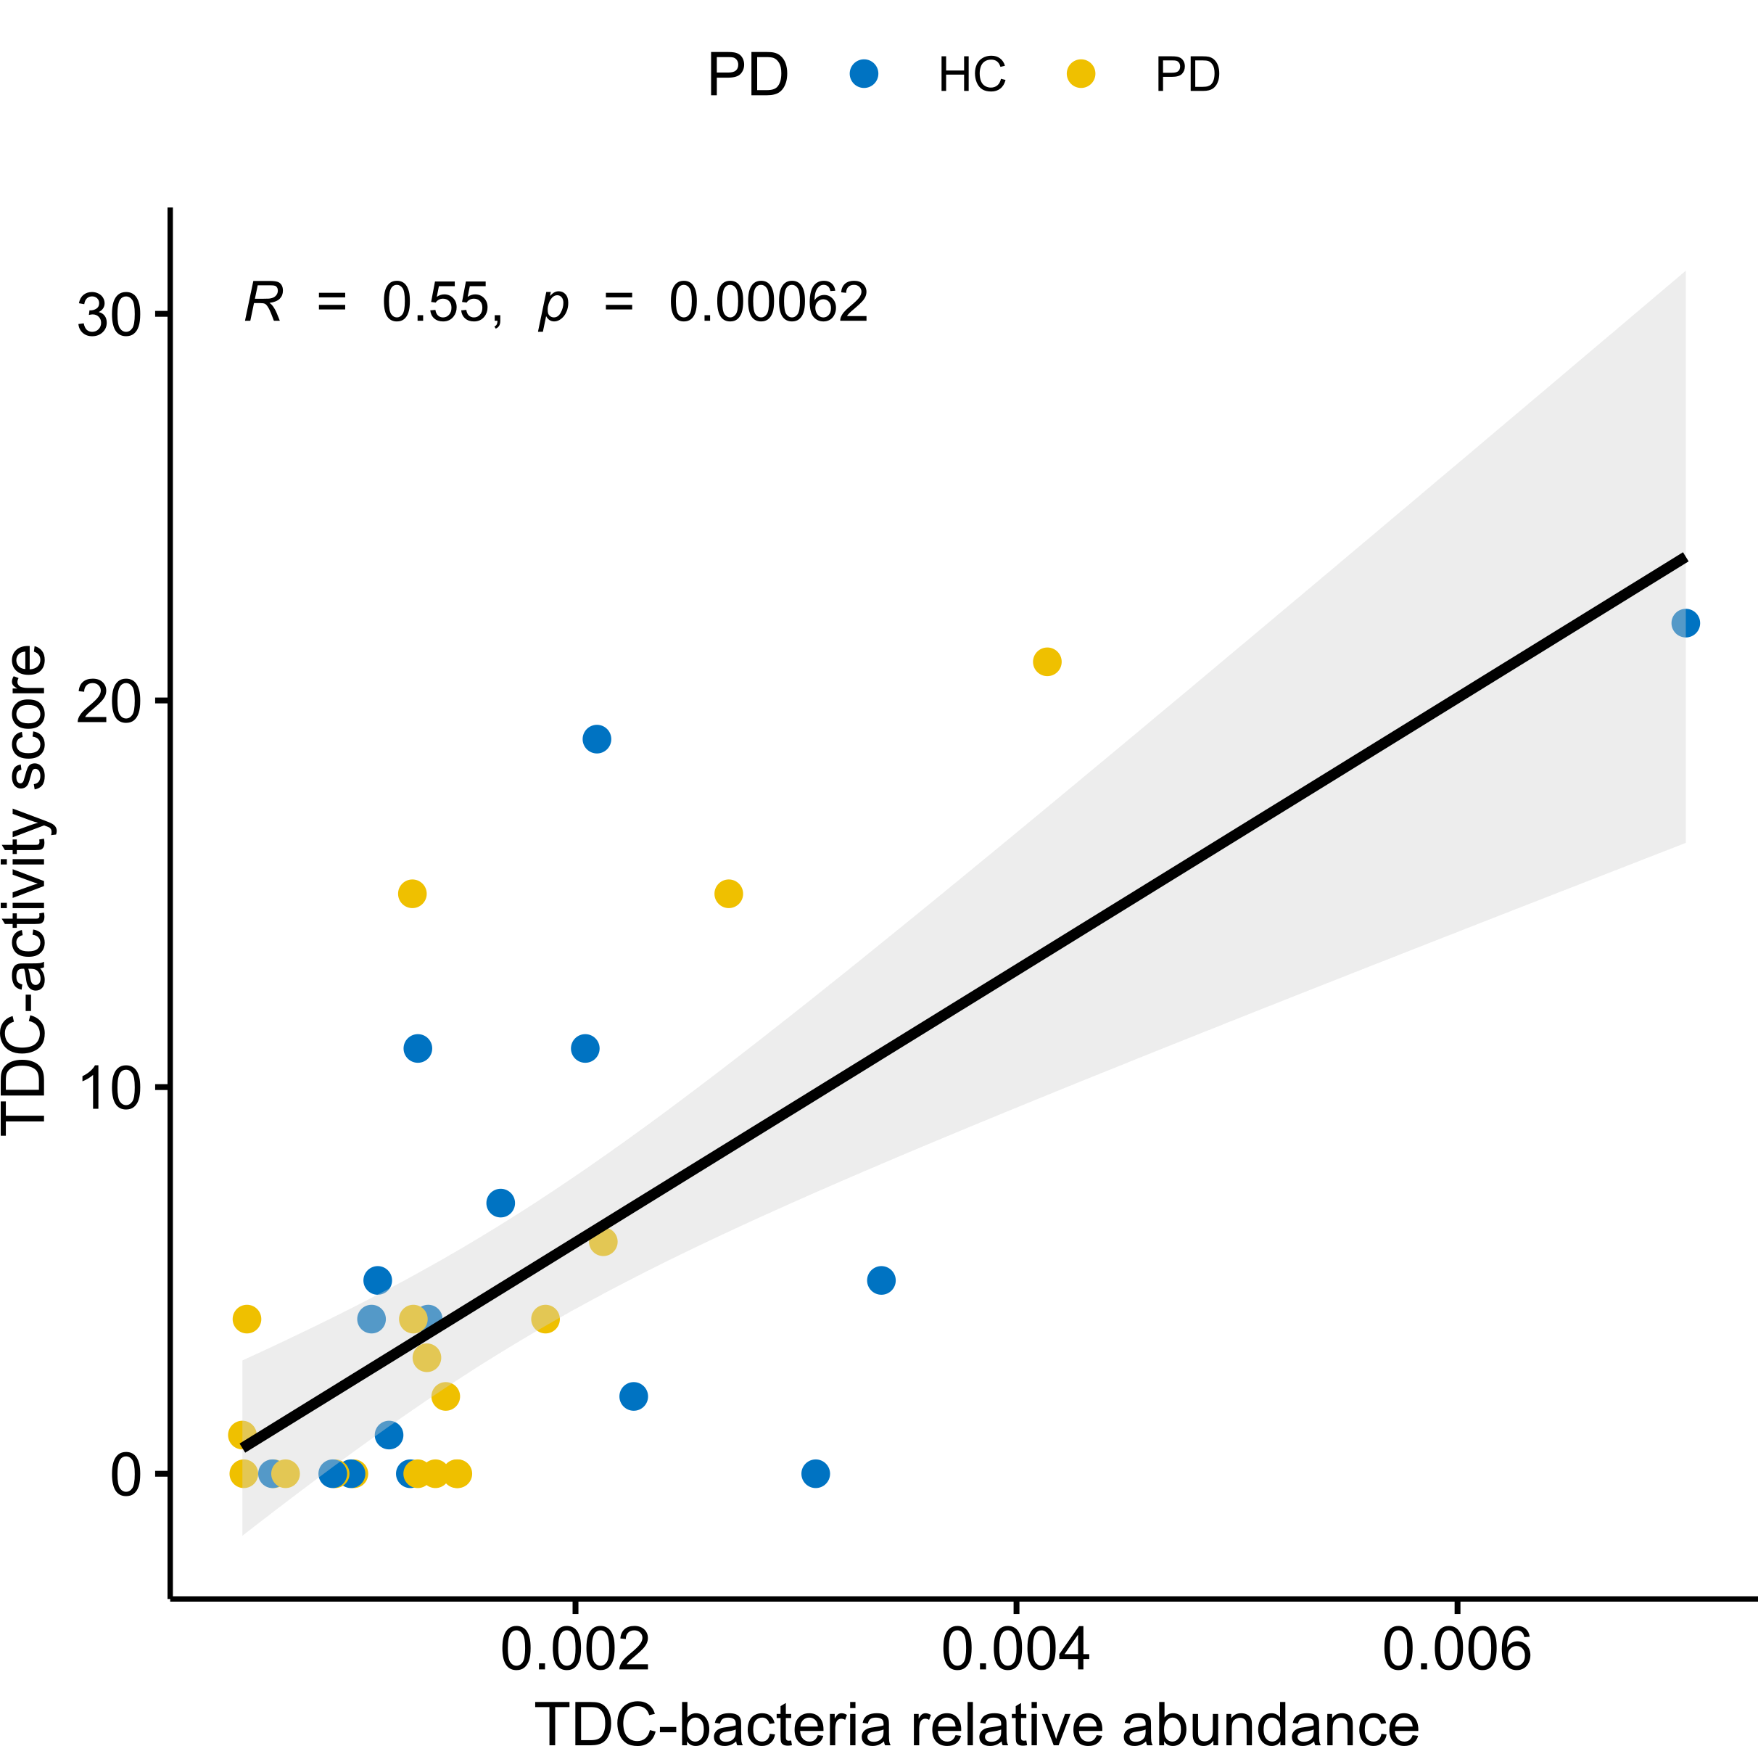
Supplementary Figure 2. TDC-bacteria relative abundance correlates with TDC-activity. Scatter plot showing positive correlation between TDC-activity score determined by plating (see methods) and summed relative abundance of tdc-harboring bacterial species. A linear regression line and the corresponding 95% confidence intervals are indicated in black. Correlation was determined by Spearman’s ρ.

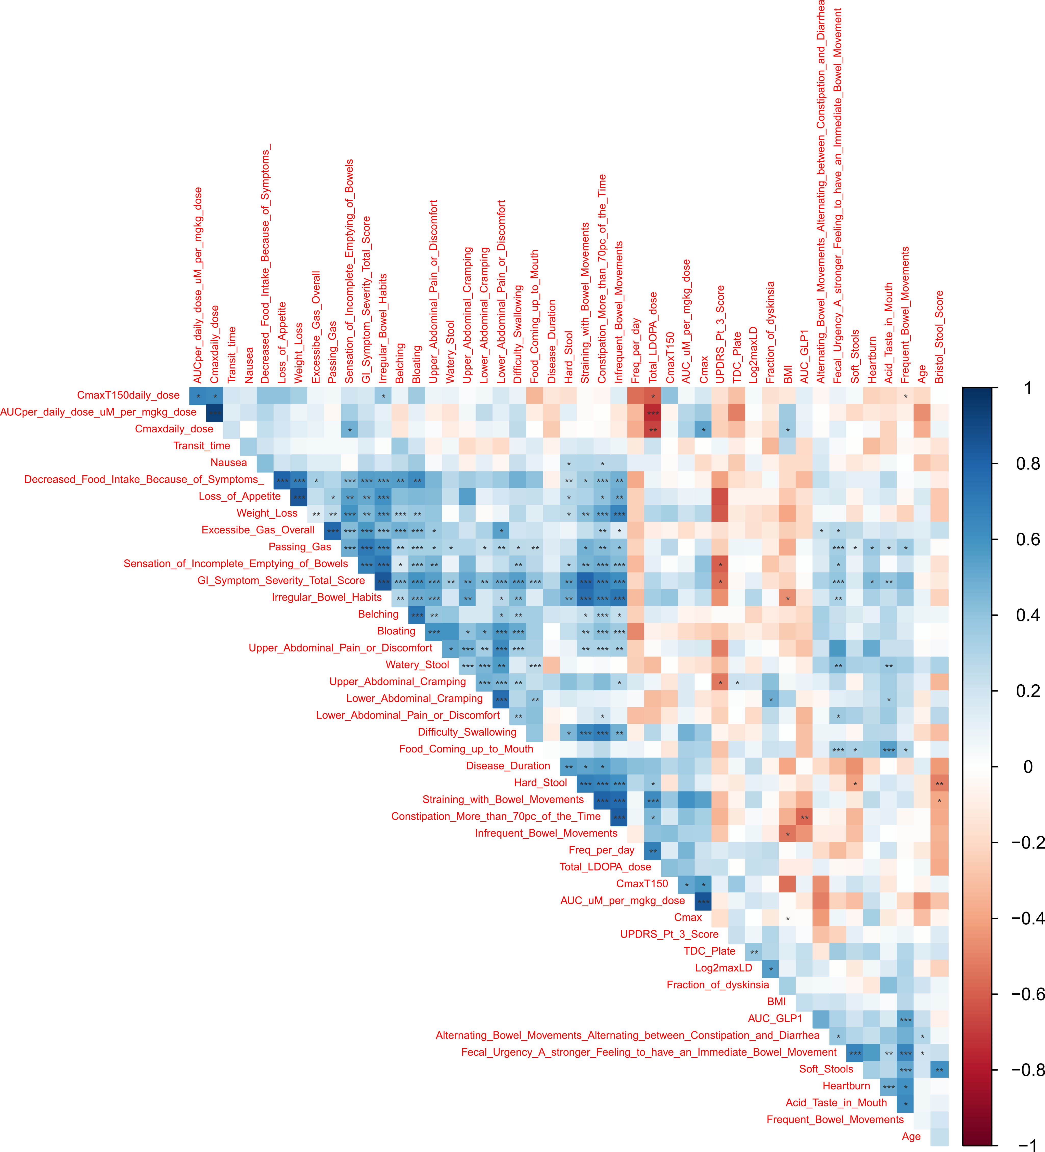
Supplementary Figure 3. Clinical variables correlate with each other. Correlation matrix showing Spearman correlations between clinical data. Significance was determined by using the cor.mtest function from the corrplot R package. Shown significance values are not corrected for multiple comparisons.
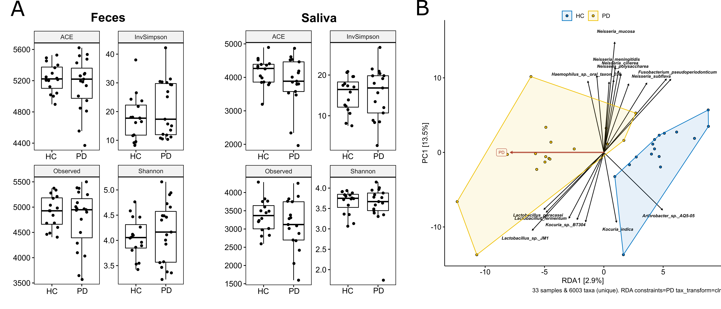
Supplementary Figure 4. Differences in microbiota composition between HC and PD. (A) Box plots showing different alpha diversity measures for fecal and saliva samples. None were found to be significantly different between HC and PD (assessed by unpaired Wilcoxon test) (B) RDA on clr-transformed OTU abundances of saliva samples, constrained to PD status (RDA1). Associations of taxa with either group are depicted as black arrows, while the length of the arrow indicates the strength of the association. The separation of the PD and HC group was found to be significant (p=0.577).

Supplementary Figure 5. KEGG orthologue presence of differentially abundant orthologues is not traceable to specific genera. The left panel shows a heatmap representing KEGG orthologue presence (black) or absence for a certain genus. The right panel depicts a heatmap showing z-score normalized abundances of the 68 significant features per sample.

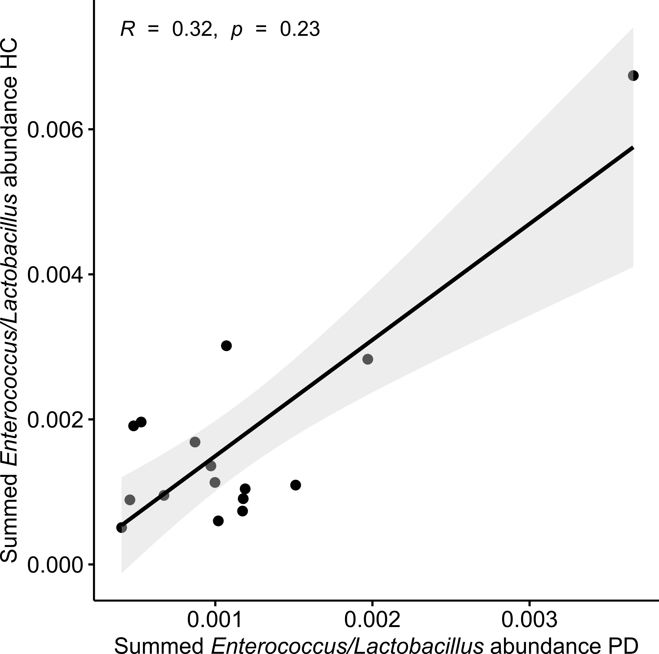
Supplementary Figure 6. Summed relative abundance of Tdc-harboring Enterococcus/Lactobacillus species correlates between PD and HC for the same household. Scatter plot showing Summed relative abundance of Tdc-harboring Enterococcus/Lactobacillus species in feces for either the PD subject (x-axis) or the healthy control subject living in the same household (y-axis). Correlation was assessed by Spearman’s ρ.

