Supplementary data Table 1: Description of pediatric systemic lupus patients.
Delay to diagnosis is in months, steroids dose in mg per day, time between 2 flares is in months, HC: hydroxychloroquine, MMF: mycophenolate mofetil, MTX: methotrexate, CY: cyclophosphamide pulse, AZ: azathioprin

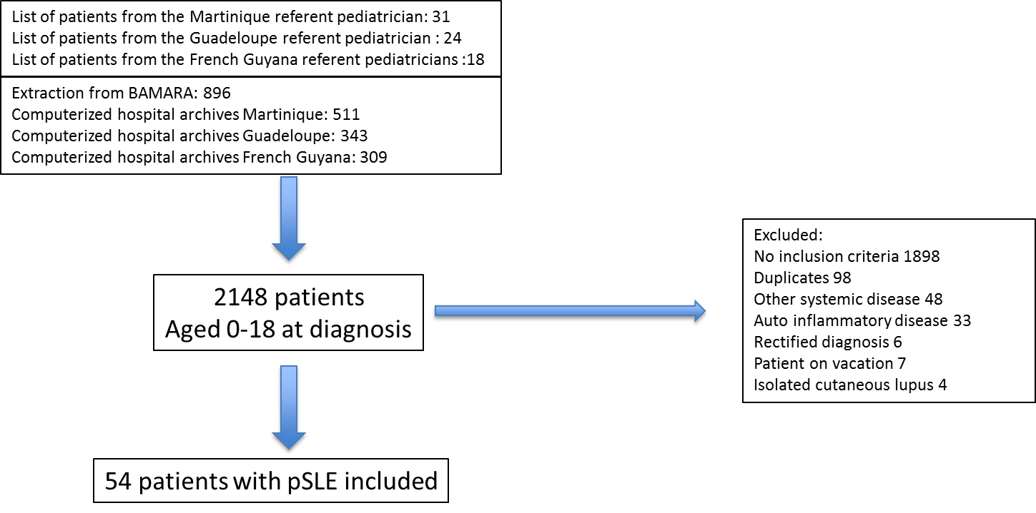
Figure 1 supplementary data: Flowchart of the study.
BAMARA is the French national database for rare diseases.
Table 2 supplementary data: Renal involvement at onset and during childhood
Lupus-related renal impairment was defined according to the international classification

