Dissolved organic matter modulates the toxicity of persistent free radicals on the nematode Caenorhabditis elegans

Xuchao Zhang¹, Nadine Saul^{2,3}, Thora Lieke^{4,5}, Yi Chen¹, Min Wu^{1*}, Bo Pan¹, Christian E.W. Steinberg^{1,2}

¹ Yunnan Provincial Key Lab of Soil Carbon Sequestration and Pollution Control, Faculty of Environmental Science and Engineering, Kunming University of Science and Technology, 650500 Kunming, China
² Faculty of Life Sciences, Freshwater and Stress Ecology, Humboldt University of Berlin, 12437 Berlin, Germany
³ Faculty of Life Sciences, Molecular Genetics Group, Humboldt University of Berlin, 10115 Berlin, Germany
⁴ University of South Bohemia in Ceske Budejovice, Faculty of Fisheries and Protection of Waters, South Bohemian Research Center of Aquaculture and Biodiversity of Hydrocenoses, Institute of Aquaculture and Protection of Waters, Na Sádkách 1780, 370 05 České Budějovice, Czech Republic
⁵ Institute of Parasitology, Biology Centre of the Czech Academy of Sciences, Ceske Budejovice, Czech Republic

*Corresponding authors: Min Wu, phone: 86-871-65102829, E-mail address: minwup@hotmail.com

Text S1. Media and buffer. In order to maintain pH balance, the exposure medium was prepared by adding M9 buffer to K-medium, then mixed well with OP50 just before the exposure experiments, with a volume ratio of K medium: M9 Buffer: OP50 = 3:3:1. K-medium: 2.36 g potassium chloride (KCl), 3 g sodium chloride (NaCl), in 1 L double-distilled H₂O (ddH₂O). M9 buffer: 3 g potassium dihydrogen phosphate (KH₂PO₄), 7.5 g disodium phosphate (Na₂HPO₄), 5 g NaCl, in 1 L ddH₂O.

Test S2. 96 mm-chemotaxis-assay plates. To test the attraction of NaCl, chemotaxis agars were prepared without adding NaCl. Add 10 g agar and 2.3 mL of 1 M potassium phosphate buffer in the bottle, fill up to 500 mL with the ddH₂O. After sterilization, mix 0.5 mL of 1 M calcium chloride (CaCl₂) and 0.5 mL of 1 M magnesium sulfate (MgSO₄), then distribute in 96 mm Petri dishes.
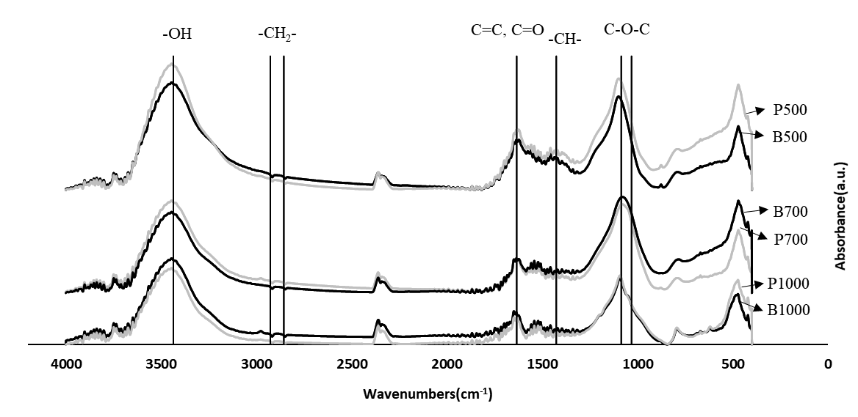
Fig. S1. Fourier transform infrared (FTIR) spectra of unwashed biochar and washed biochar. Samples were prepared with potassium bromide (mass ratio =1:1500) and detected by ThermoFisher spectrometer (NICOLET iS50 FT-IR, USA). The dark line means unwashed biochar, the grey line means washed biochar particles.

Table S1. Total of carbon concentration in the supernatant
TOC | S500 | S700 | S1000
mg·L⁻¹ | 143.76 | 66.80 | 10.67
Note: 40 mg of biochar was added in 15 mL sterile water and shaken for 24 h at 20°C. The total carbon in the liquid phases was detected by TOC Analyzer (vario TOC cube, Elementar Analysensystem, Germany).

Table S2. The elemental composition in unwashed biochar and washed biochar
% | C | H | O | N | S | H/C | O/C | （N+O）/C
biomass | 37.42 | 5.58 | 34.82 | 0.65 | 0.00 | 1.79 | 0.70 | 0.71
B500 | 33.53 | 1.89 | 16.37 | 0.83 | 0.75 | 0.68 | 0.37 | 0.39
B700 | 24.33 | 1.20 | 13.95 | 0.50 | 0.88 | 0.59 | 0.43 | 0.45
B1000 | 0.44 | 0.21 | 5.47 | 0.01 | 0.96 | 5.74 | 9.39 | 9.41
P500 | 36.66 | 2.13 | 20.61 | 0.92 | 0.00 | 0.70 | 0.42 | 0.44
P700 | 27.37 | 1.39 | 16.62 | 0.57 | 0.09 | 0.61 | 0.46 | 0.47
P1000 | 0.39 | 0.06 | 3.10 | 0.00 | 0.03 | 1.73 | 6.03 | 6.03
Note: The elemental composition was determined by CHNOS Elemental Analyzer (vario MICRO, Elementar Analysensystem, Germany).

