Supplementary Information for
Preclinical development of carrier-free prodrug nanoparticles for enhanced antitumor therapeutic potential with less toxicity
Man Kyu Shim^{1,#}, Suah Yang^{1,2,#}, Jooho Park¹, Jun Sik Yoon¹, Jinseong Kim^{1,2}, Yujeong Moon^{1,3}, Nayeon Shim^{1,2}, Mihee Jo¹, Yongwhan Choi¹, Kwangmeyung Kim^{1,2,*}
¹Center for Theragnosis, Biomedical Research Institute, Korea Institute of Science and Technology, Seoul, 02792, Republic of Korea.
²KU-KIST Graduate School of Converging Science and Technology, Korea University, Seoul, 02841, Republic of Korea.
³Department of Bioengineering, Korea University, Seoul, 02841, Republic of Korea.
#These authors contributed equally to this work.
*Correspondence and requests for materials should be addressed to K. Kim (E-mail: kim@kist.re.kr; address: Biomedical Research Institute, Korea Institute of Science and Technology (KIST), Seoul, 02792, Republic of Korea).
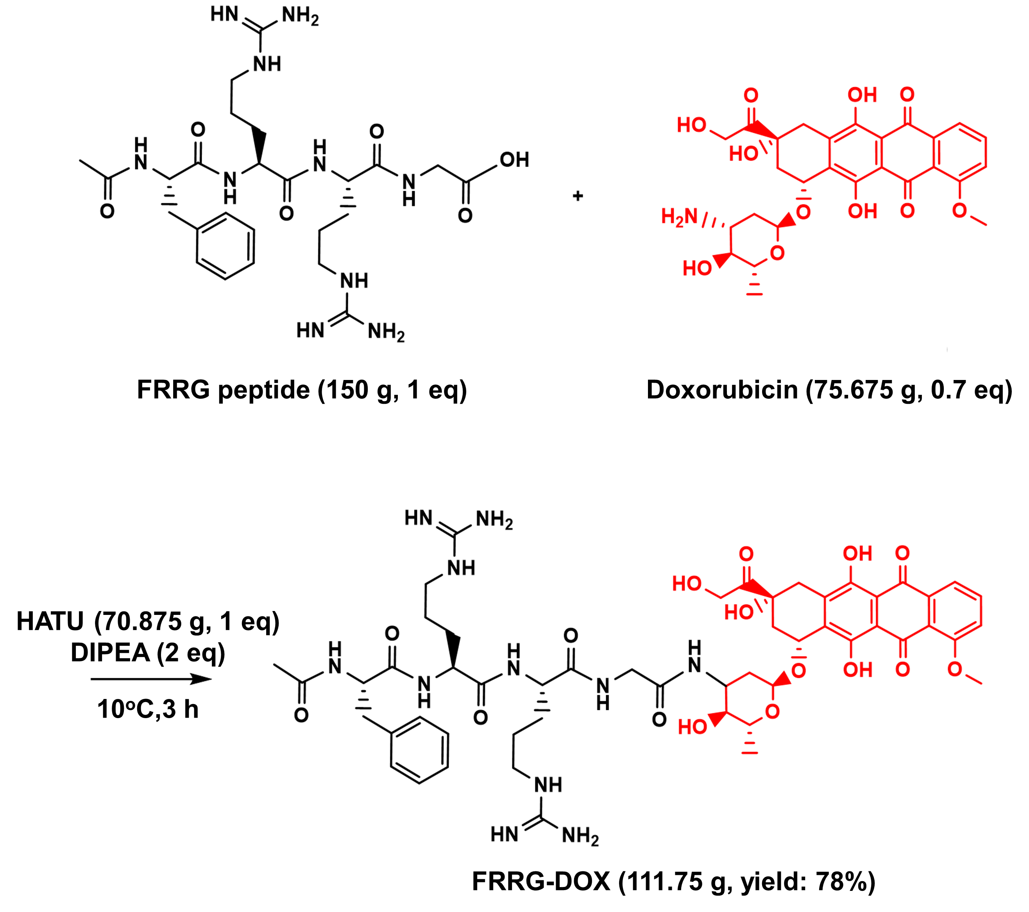
Figure S1. Synthetic route to prepare the cancer-specific prodrug FRRG-DOX.
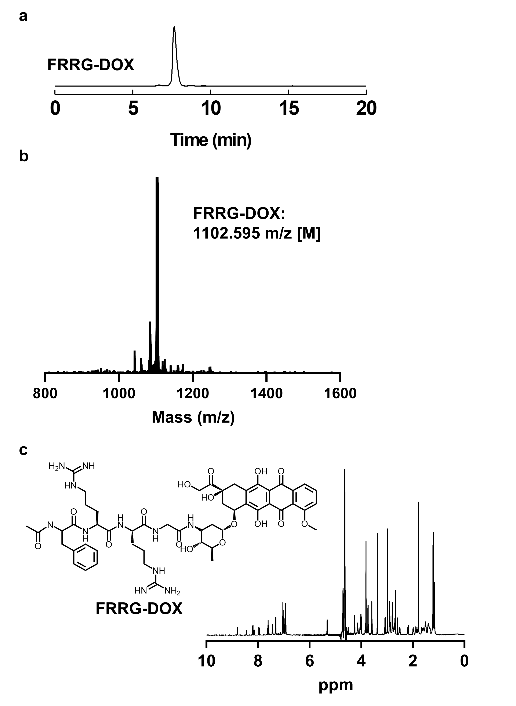
Figure S2. The (a) purity, (b) exact mass and (c) chemical structure of FRRG-DOX, as confirmed via HPLC, MALDI-TOF and ¹H-NMR, respectively.

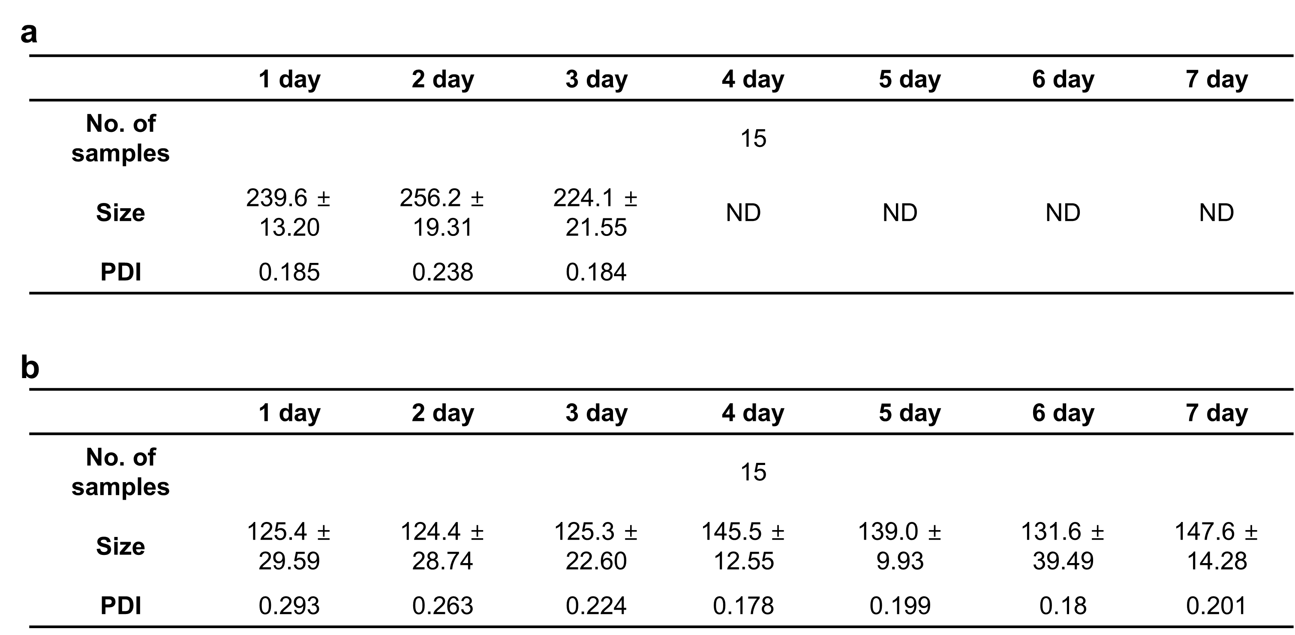
Figure S3. Detail information of the particle stability analysis of (a) FRRG-DOX and (b) F68-FDOX nanoparticles in mouse serum.

Figure S4. Cumulative release of G-DOX from F68-FDOX after incubation with cathepsin B.
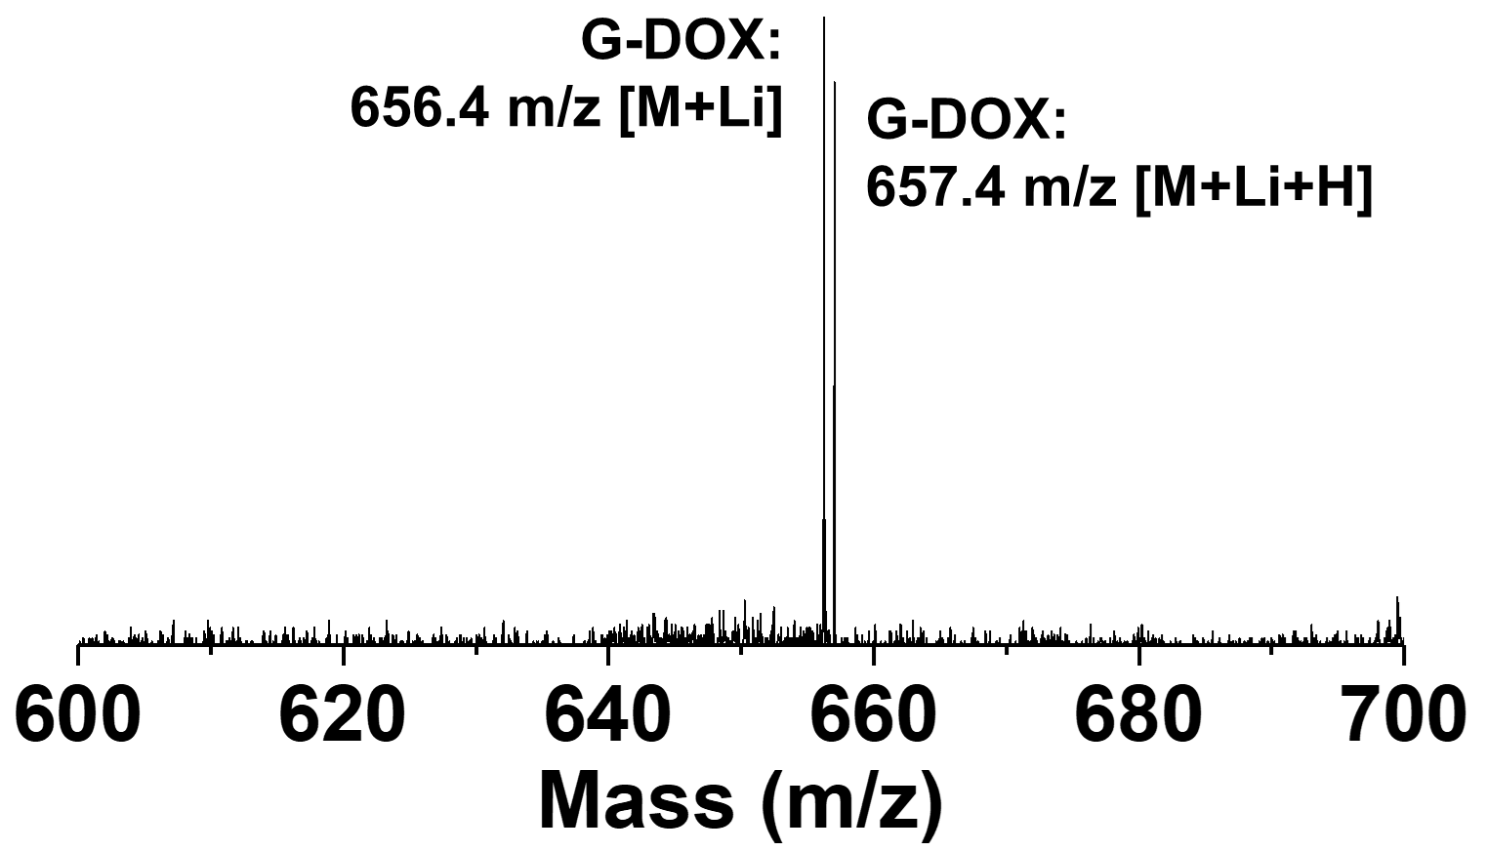
Figure S5. The mass analysis of the newly appeared peak (13 min; Figure 1f) in the HPLC spectrum after incubation of F68-FDOX with cathepsin B.

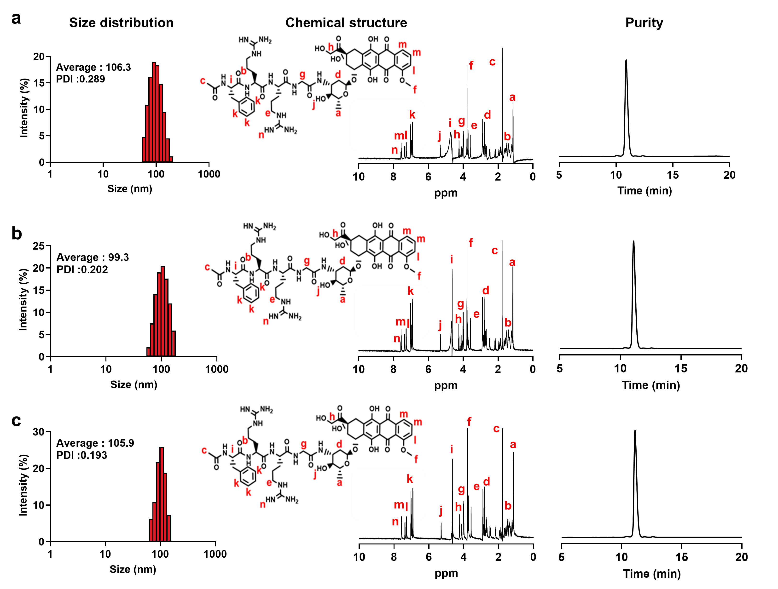
Figure S6. Long-term storage stability of lyophilized F68-FDOX powder stored for (a) 3, (b) 6, (c) 12 months in the low (-4ºC) condition.

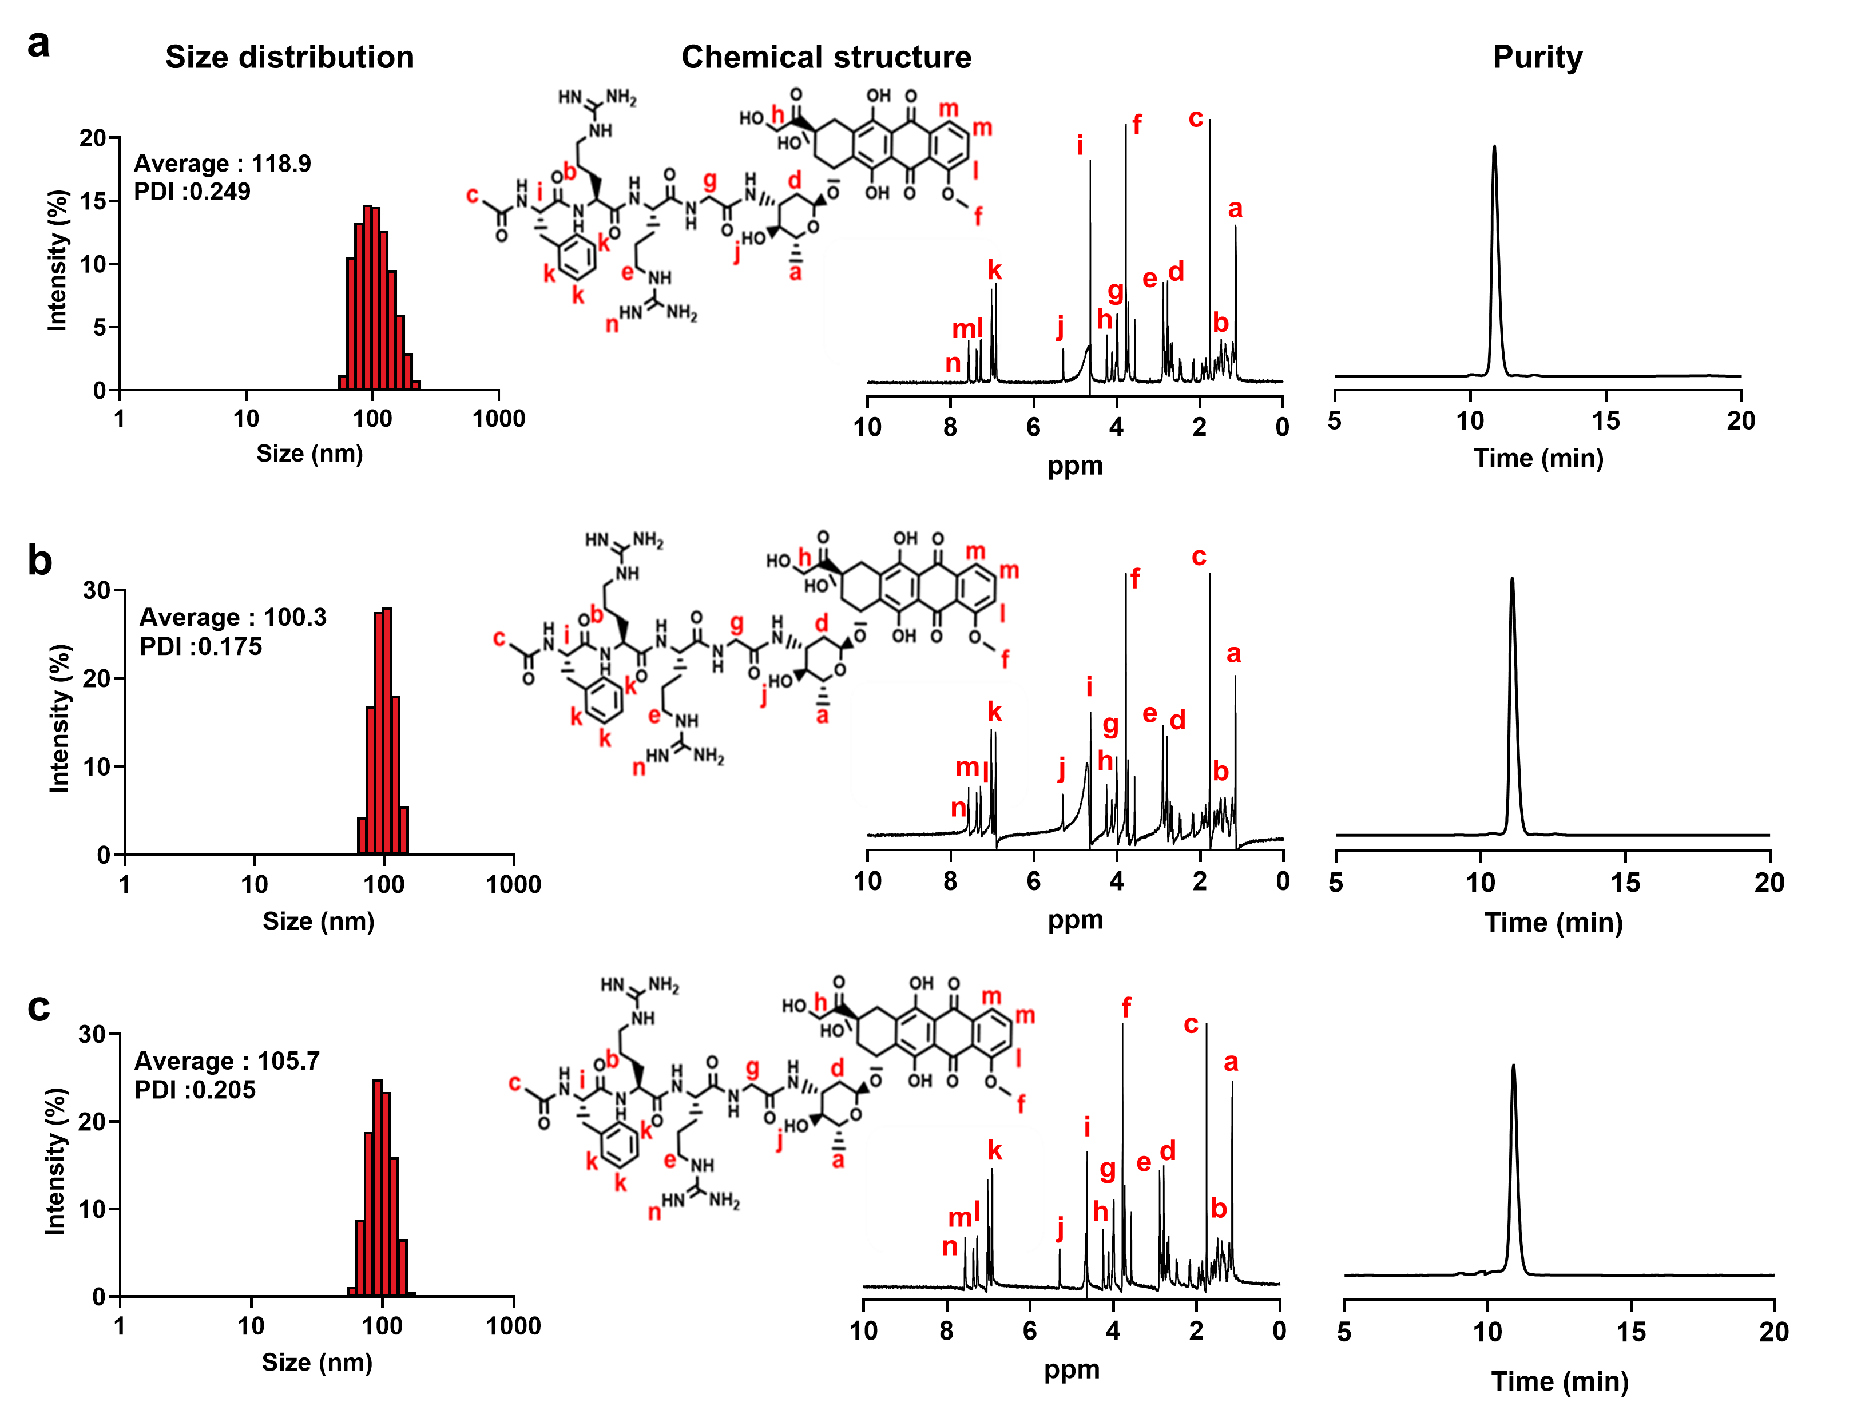
Figure S7. Long-term storage stability of lyophilized F68-FDOX powder stored for (a) 3, (b) 6, (c) 12 months in the room (37ºC) condition.

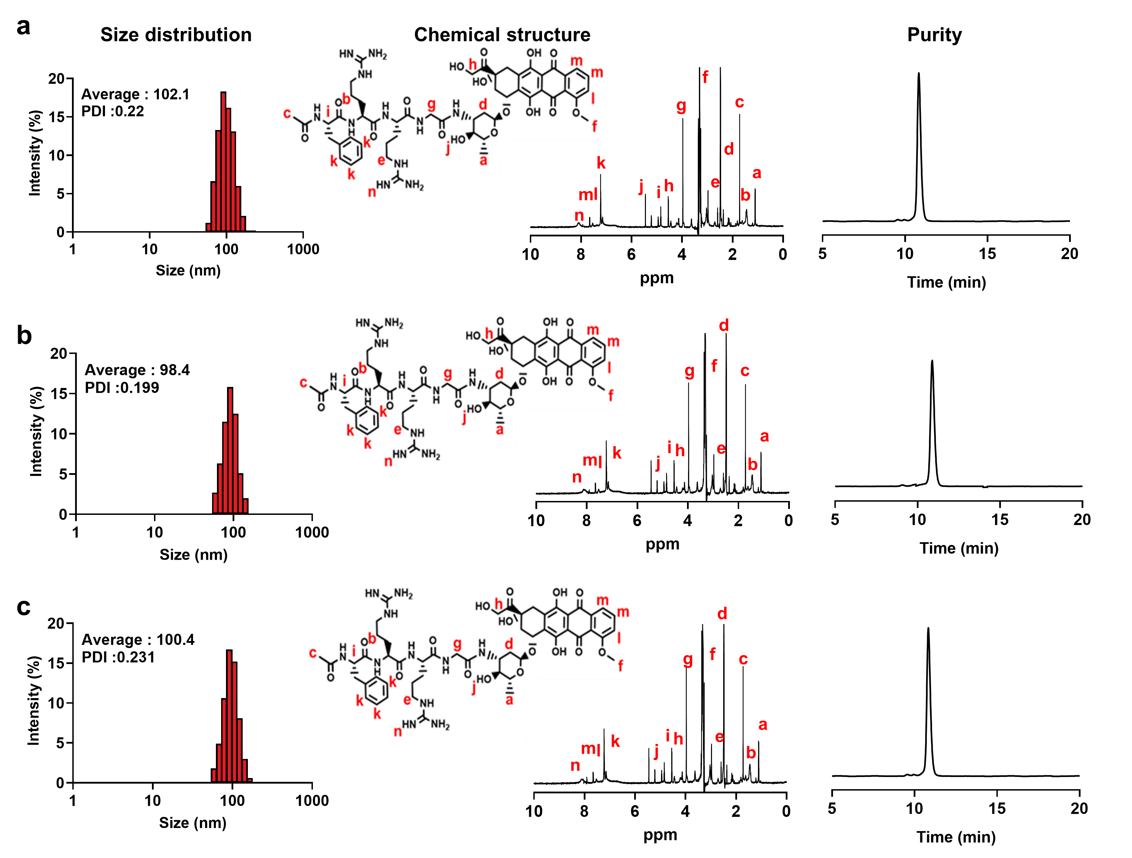
Figure S8. Long-term storage stability of lyophilized F68-FDOX powder stored for (a) 3, (b) 6, (c) 12 months in the accelerated (60ºC) condition.
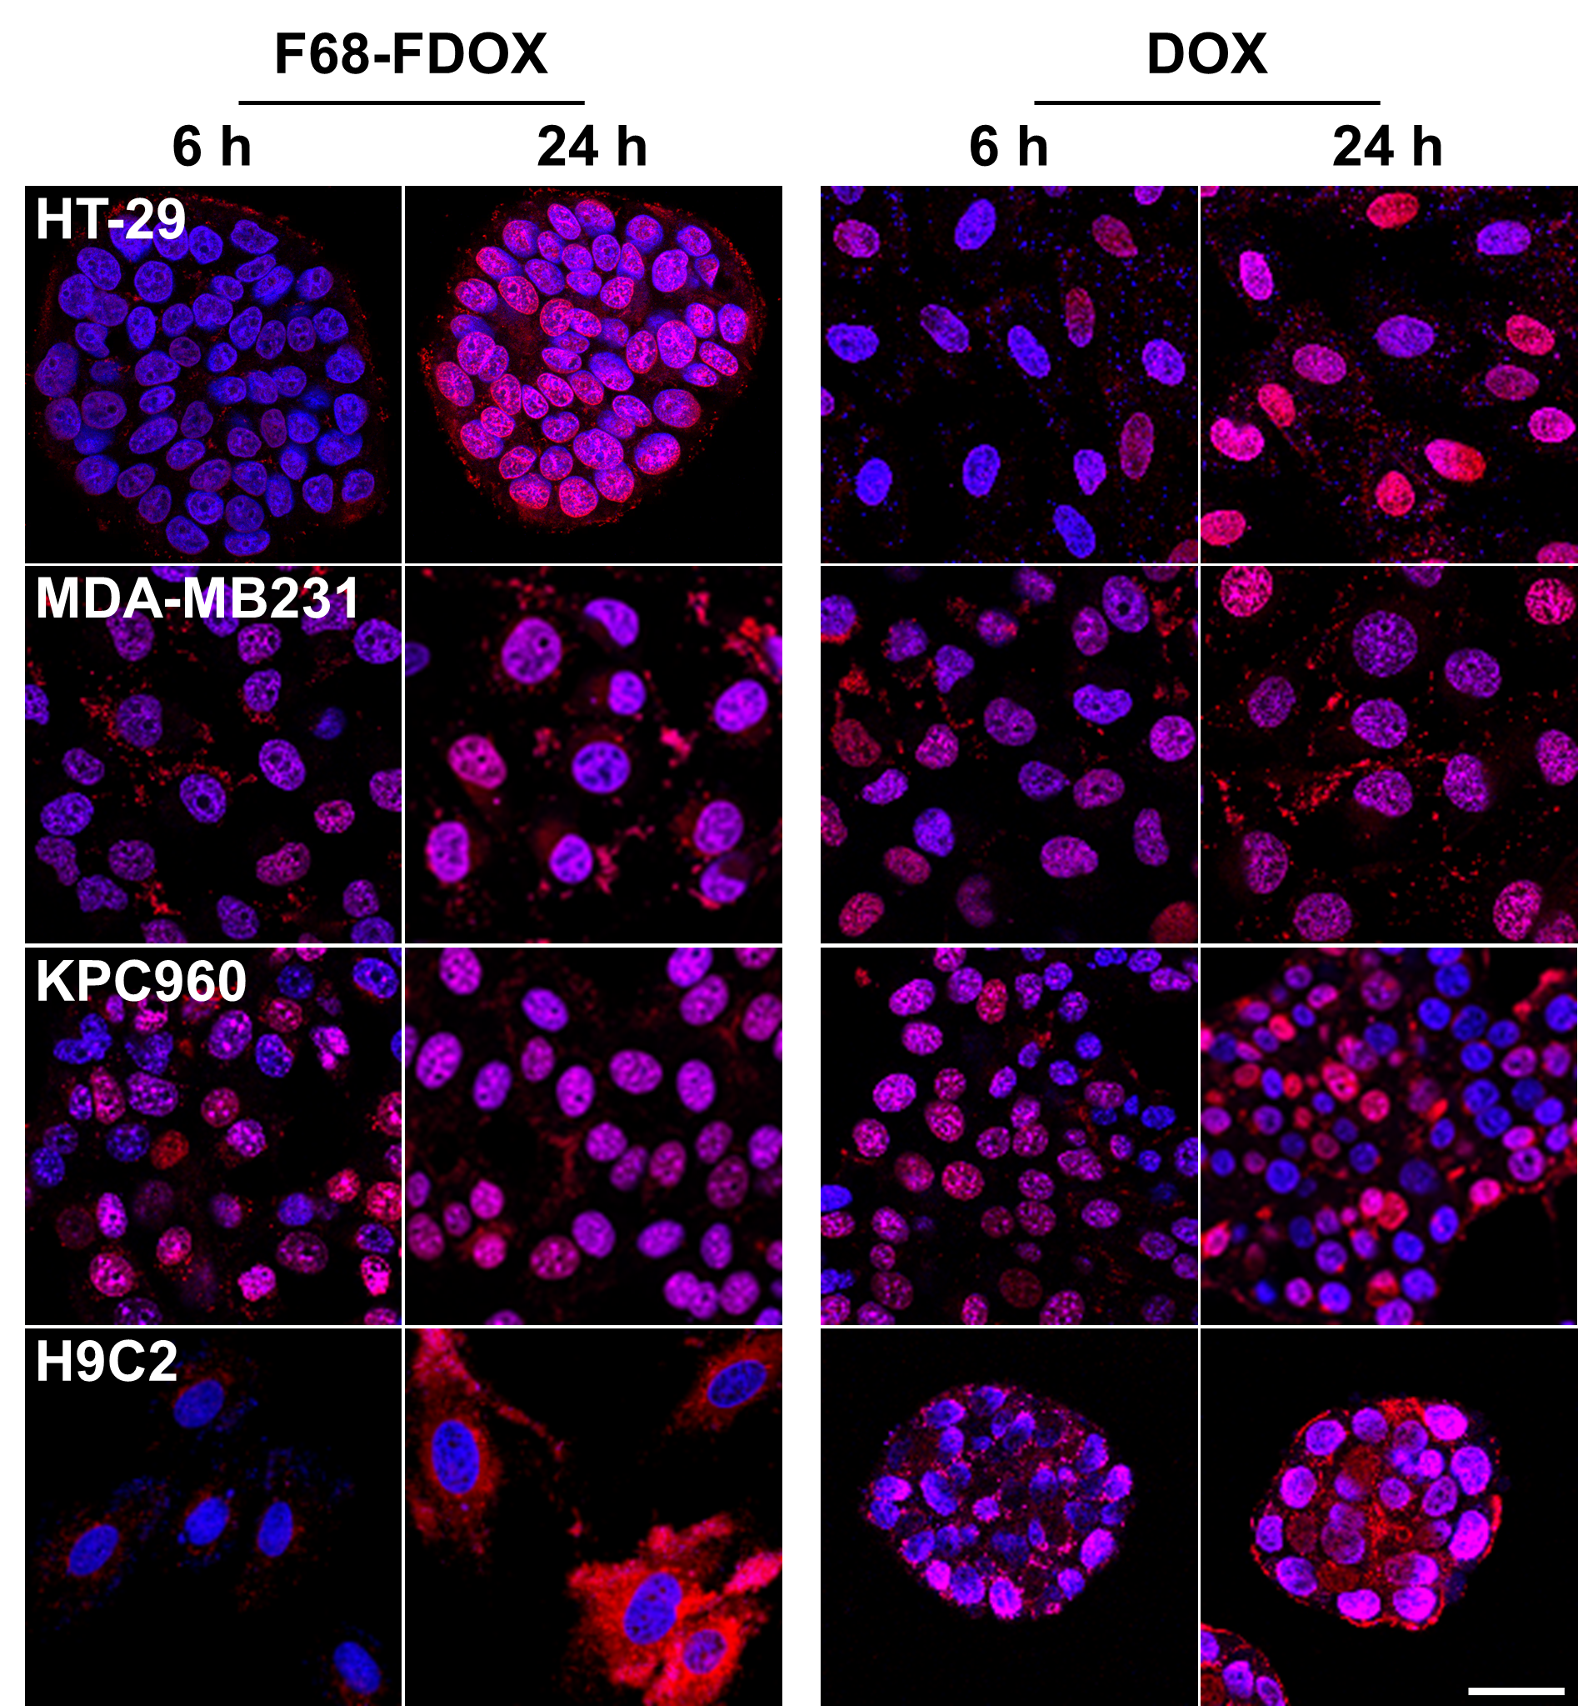
Figure S9. The cellular uptake of F68-FDOX and DOX in the HT29, MDA-MB231, KPC960 and H9C2 cells after 6 or 24 h of incubation.

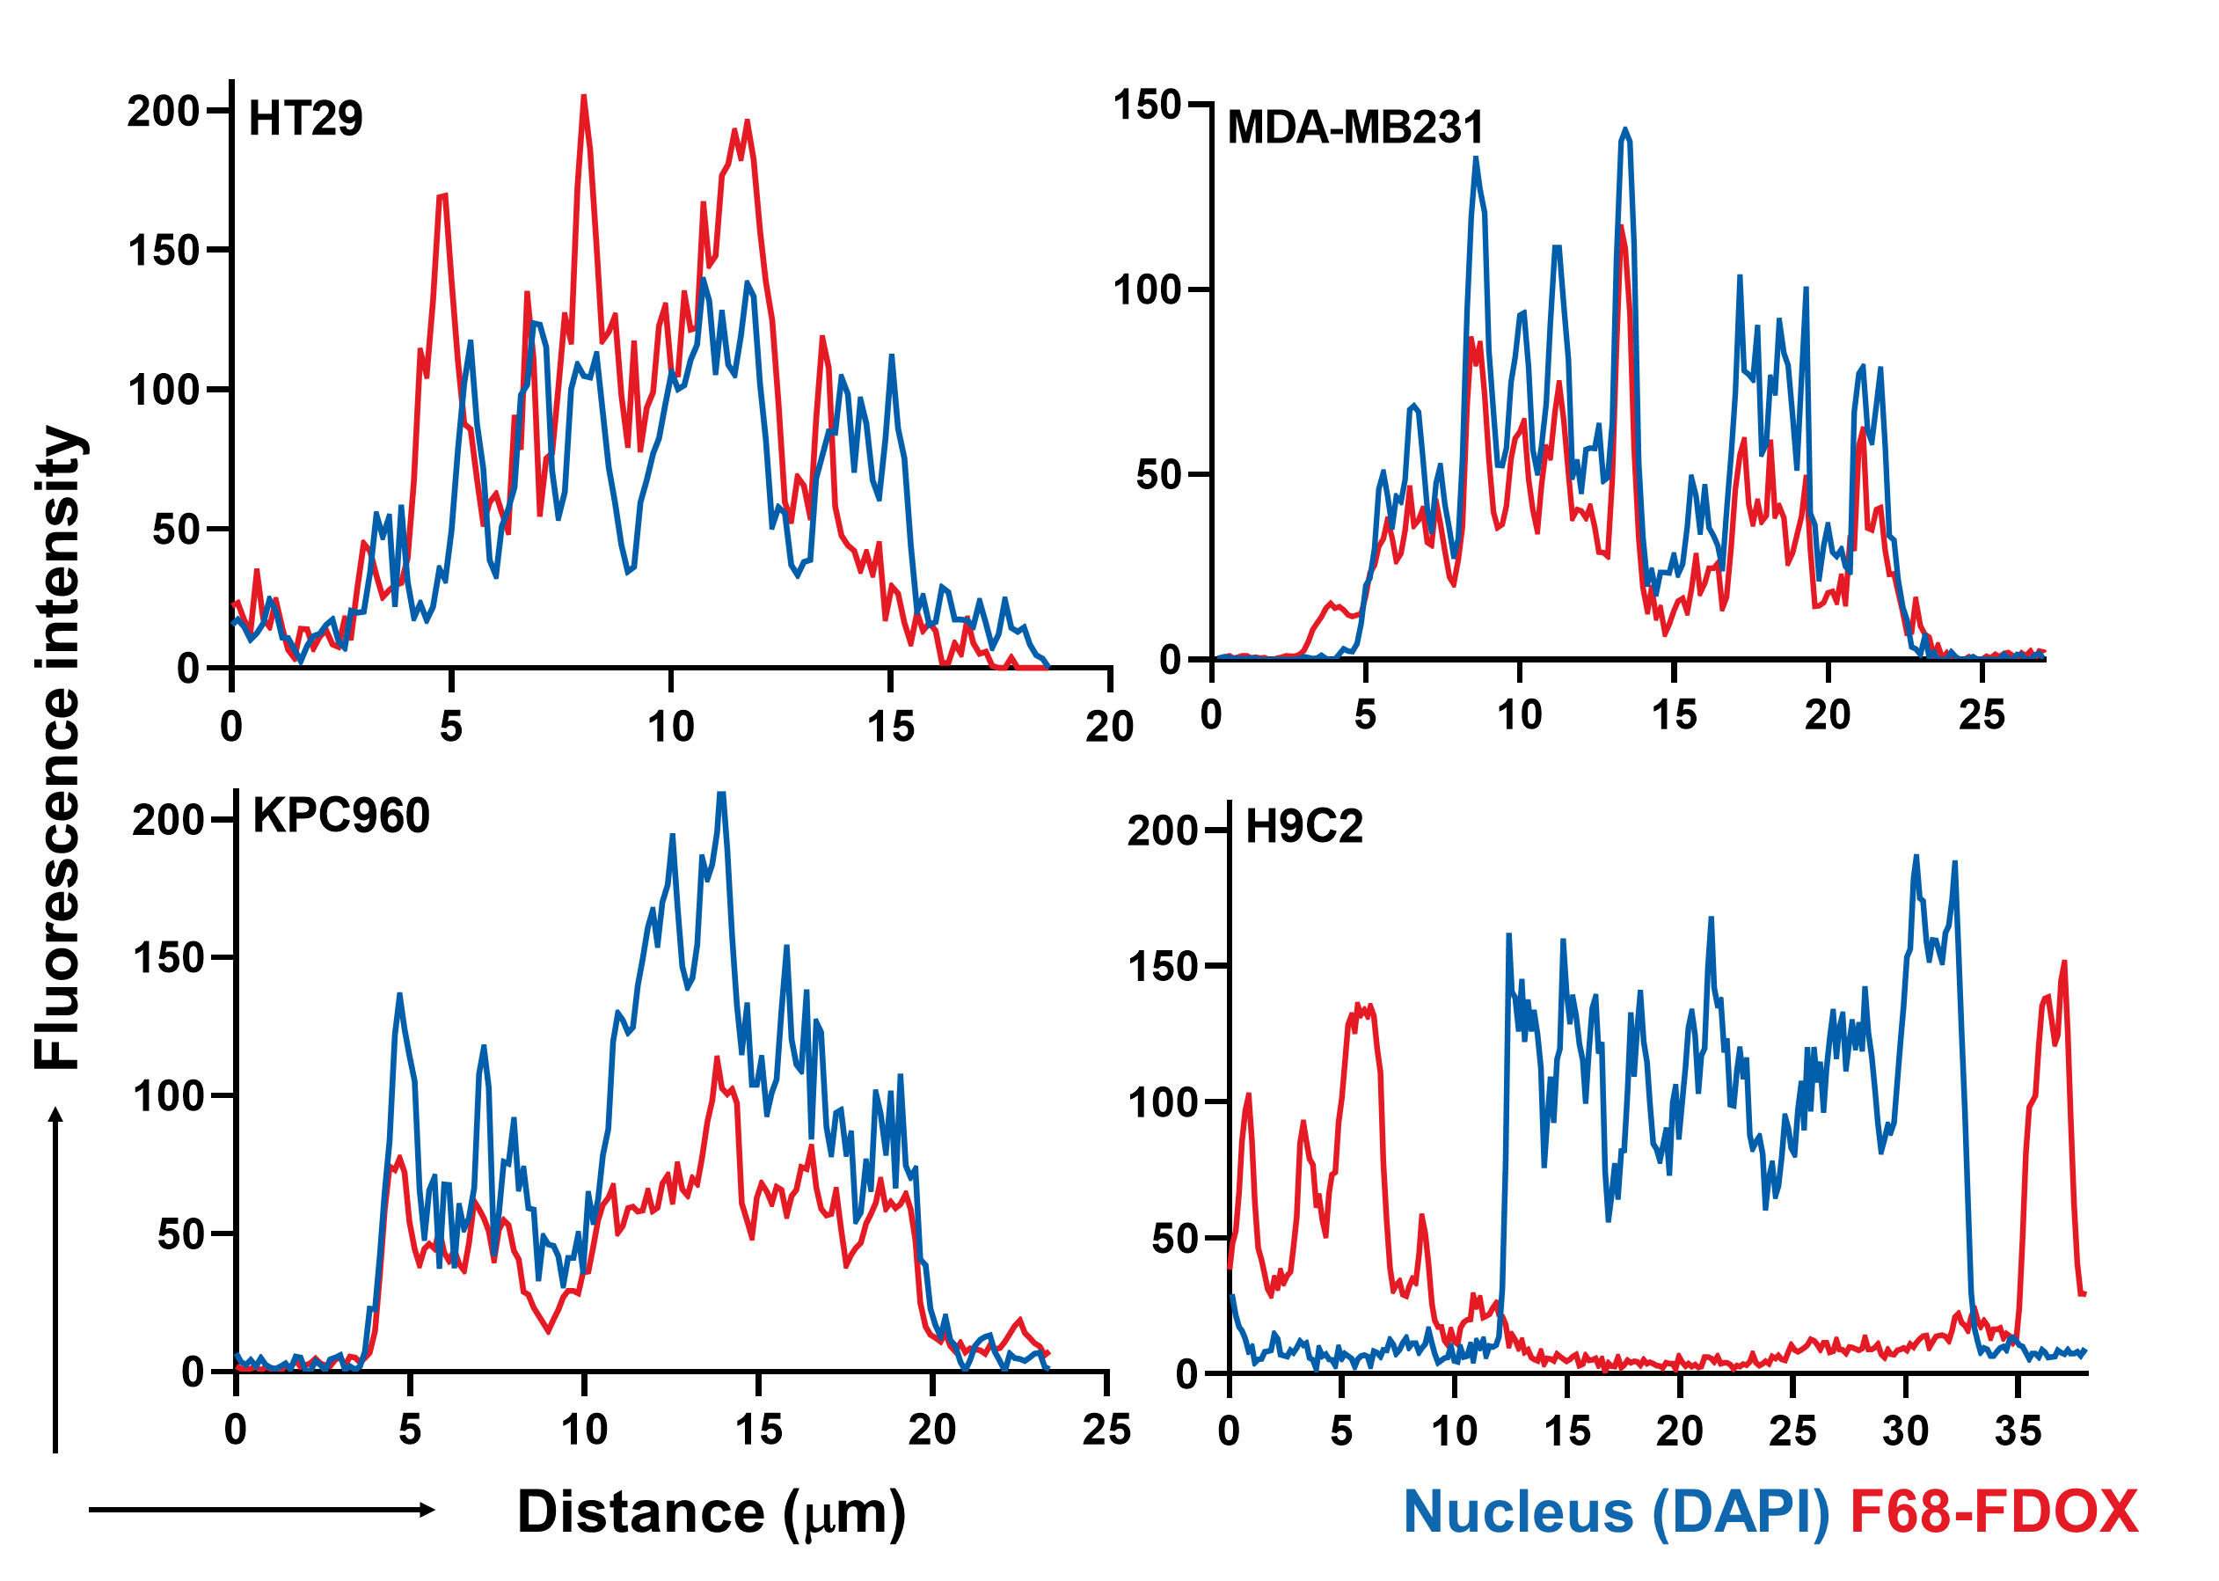
Figure S10. The fluorescence intensity profile was measured from the line-scans through cells of white lines in the fluorescence imaging results in Figure 2b.

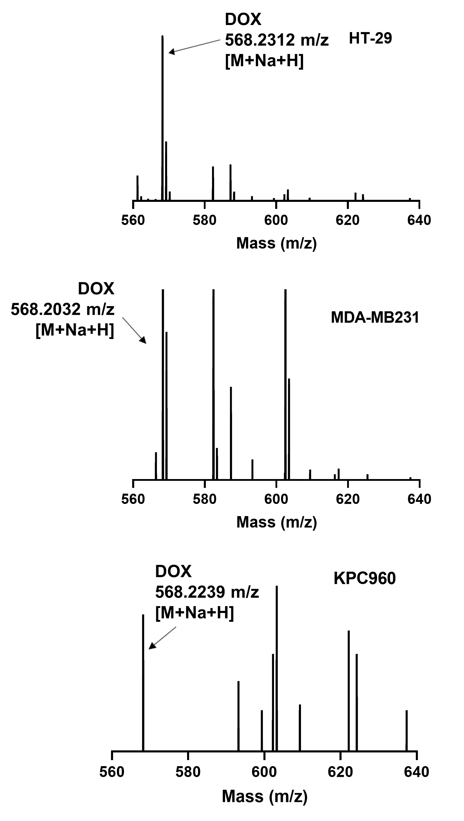
Figure S11. The mass analysis of the DOX released from F68-FDOX in the HT29, MDA-MB231 and KPC960 cells after 48 h of treatment.

Figure S12. Quantitative analysis for the fluorescence intensity in major organs and tumor tissues of HT29-tumor bearing mice after 9 h of treatment with DOX, FRRG-DOX or F68-FDOX.

Figure S13. Quantitative analysis for the apoptosis region of tumor tissues stained with TUNEL.

Figure S14. Mice survival after single-dosage with DOX, FRRG-DOX or F68-FDOX.

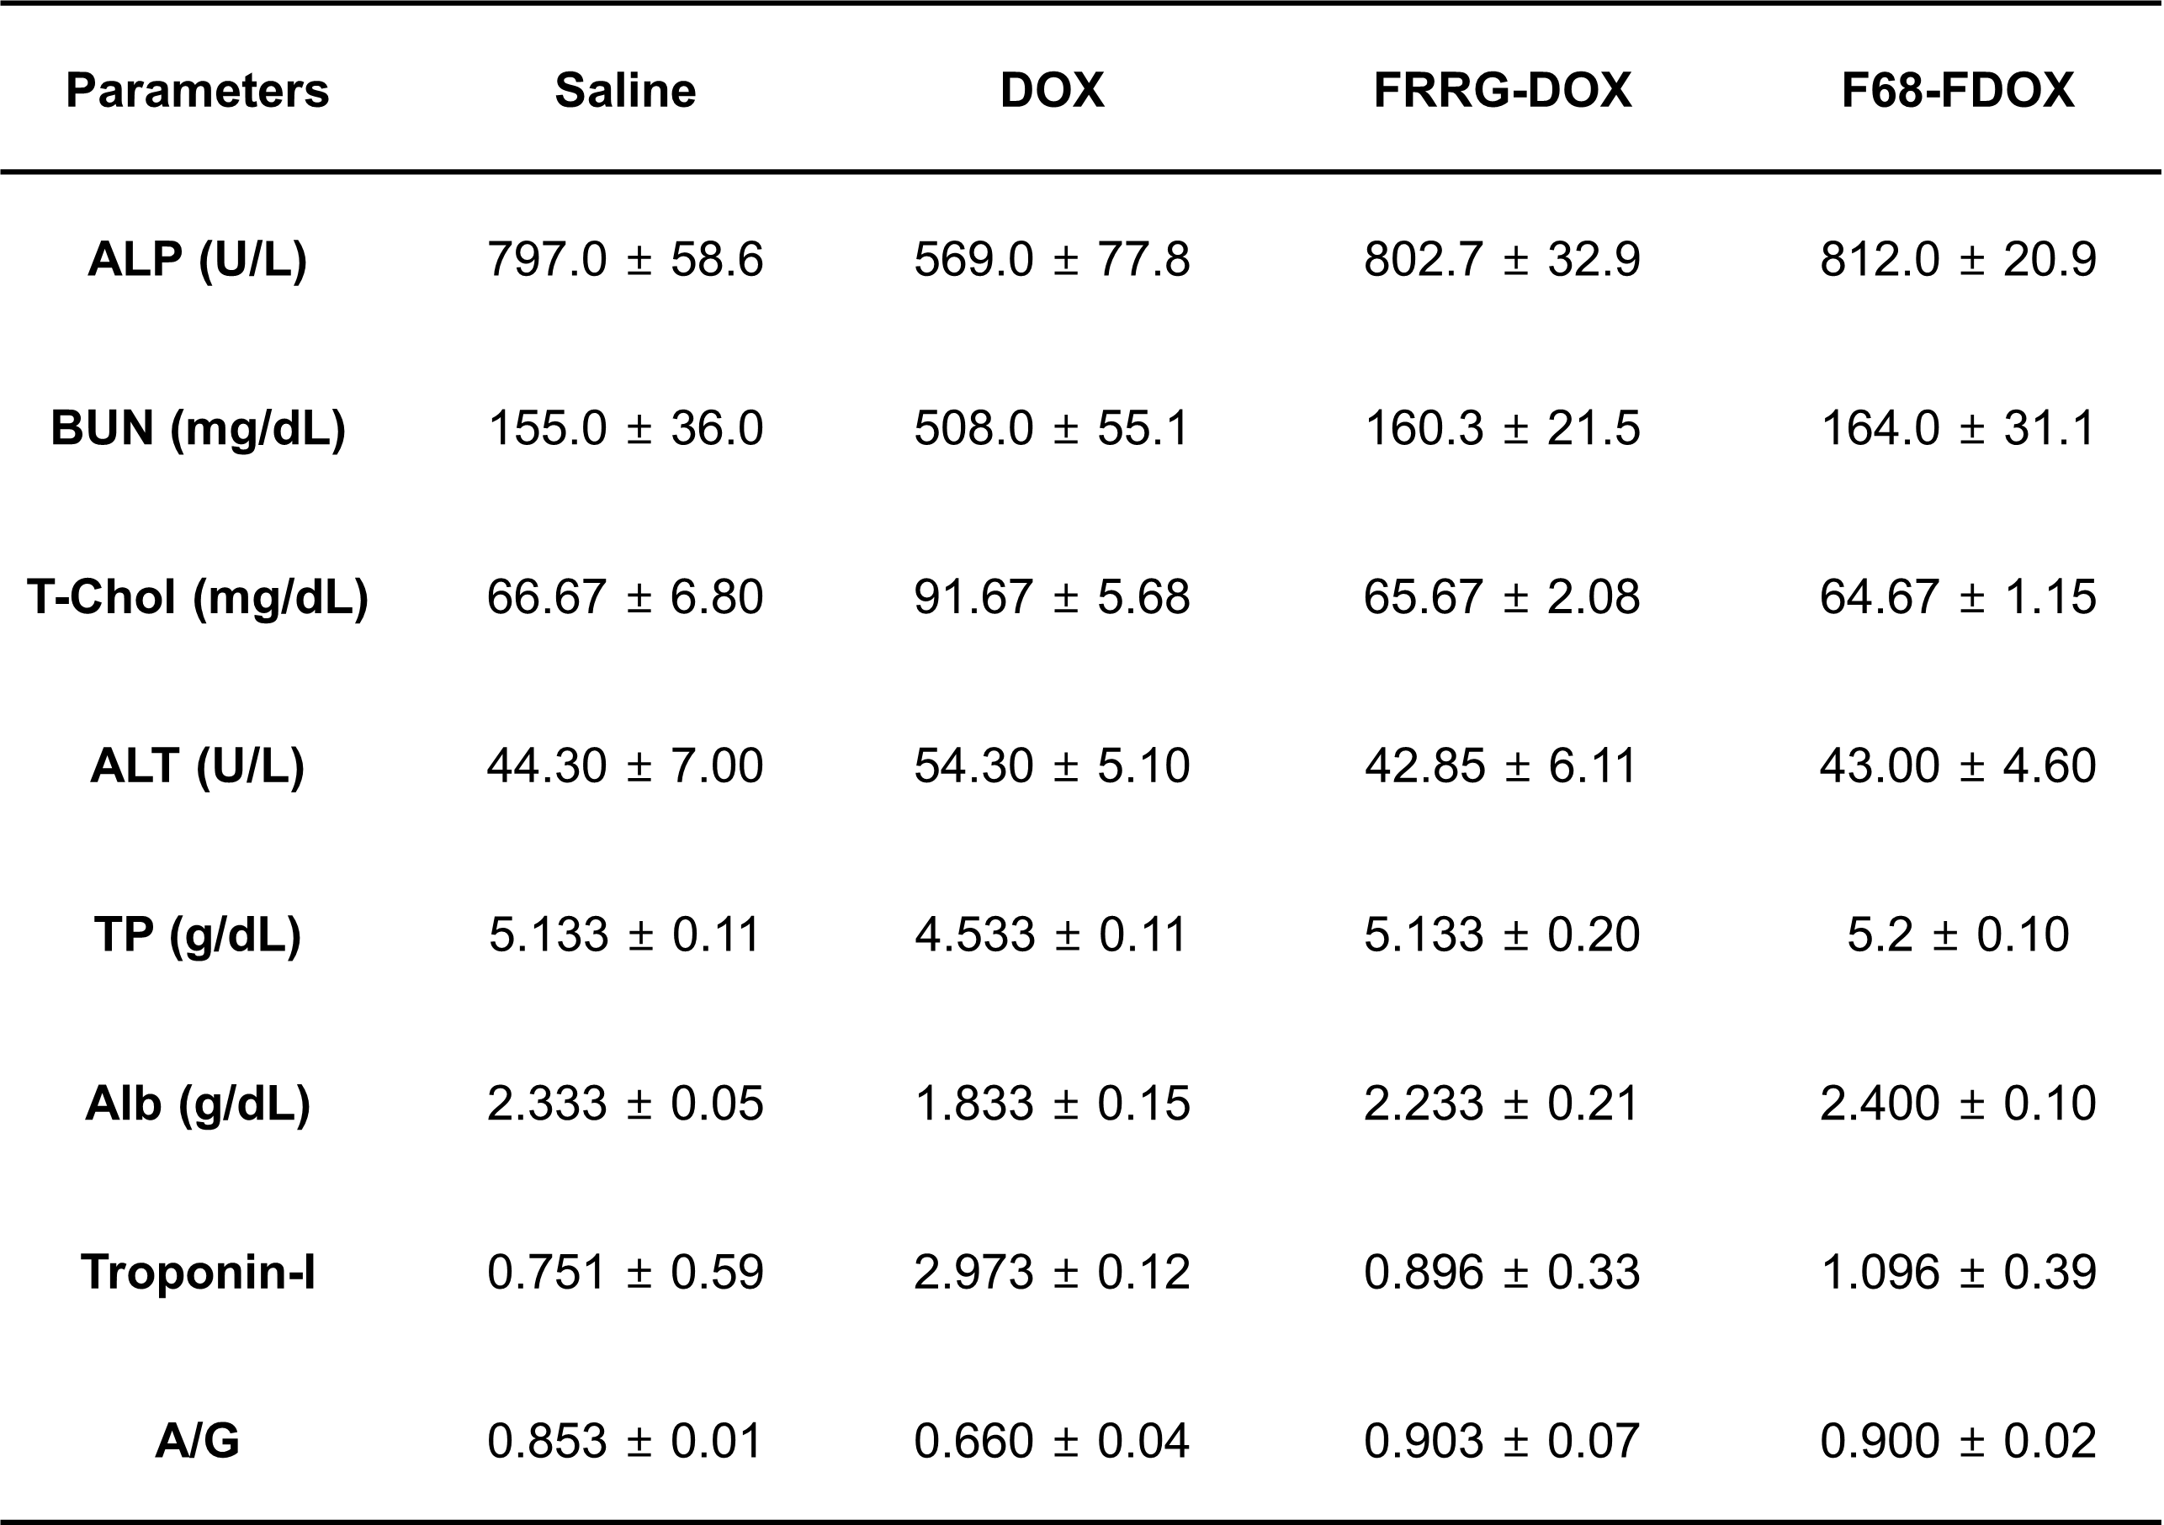
Figure S15. Detail information of the serological examination on day 9 after single-dosage with DOX, FRRG-DOX or F68-FDOX.

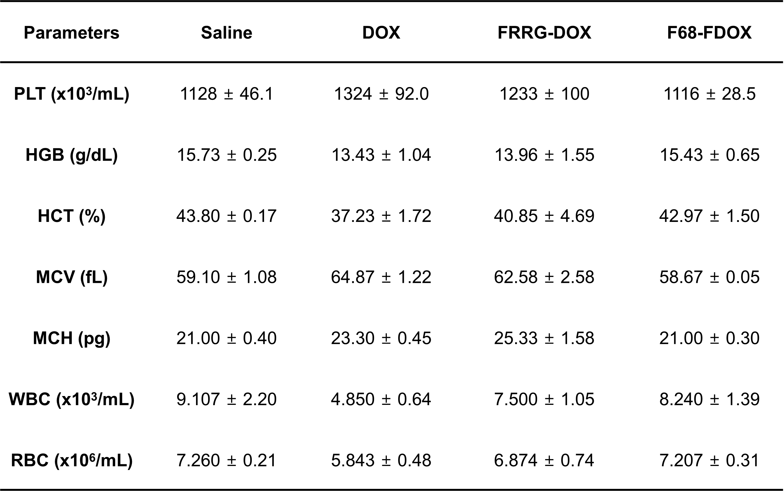
Figure S16. Detail information of the complete blood count (CBC) analyses on day 9 after single-dosage with DOX, FRRG-DOX or F68-FDOX.

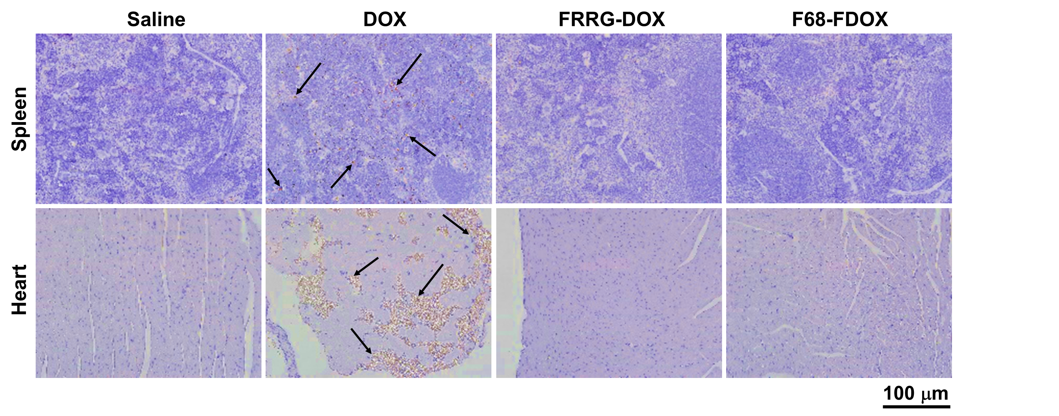
Figure S17. Major organ tissues stained with TUNEL on day 9 after single-dosage with DOX, FRRG-DOX or F68-FDOX.

Figure S18. Mice survival after multi-dosage with DOX, FRRG-DOX or F68-FDOX.

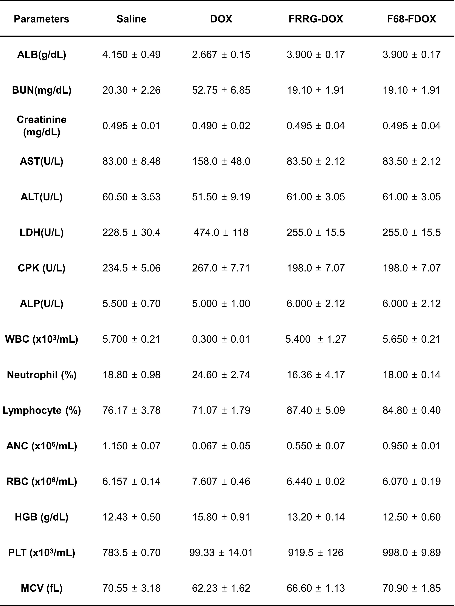
Figure S19. Detail information of the hematological analyses on day 7 after multi-dosage with DOX, FRRG-DOX or F68-FDOX.

