Supplementary file for the paper

Development of long-covid, or prevalent complaints in general?

By Magnusson et al., 2022

Table of contents (brief titles):

S-Figure 1. Flow chart. | p. 2
S-Table 1. The overlap between long-covid definitions. | p. 3
S-Table 2. Group differences (positive vs negative and positive vs untested), adjusted for previous prevalent complaints | p. 4

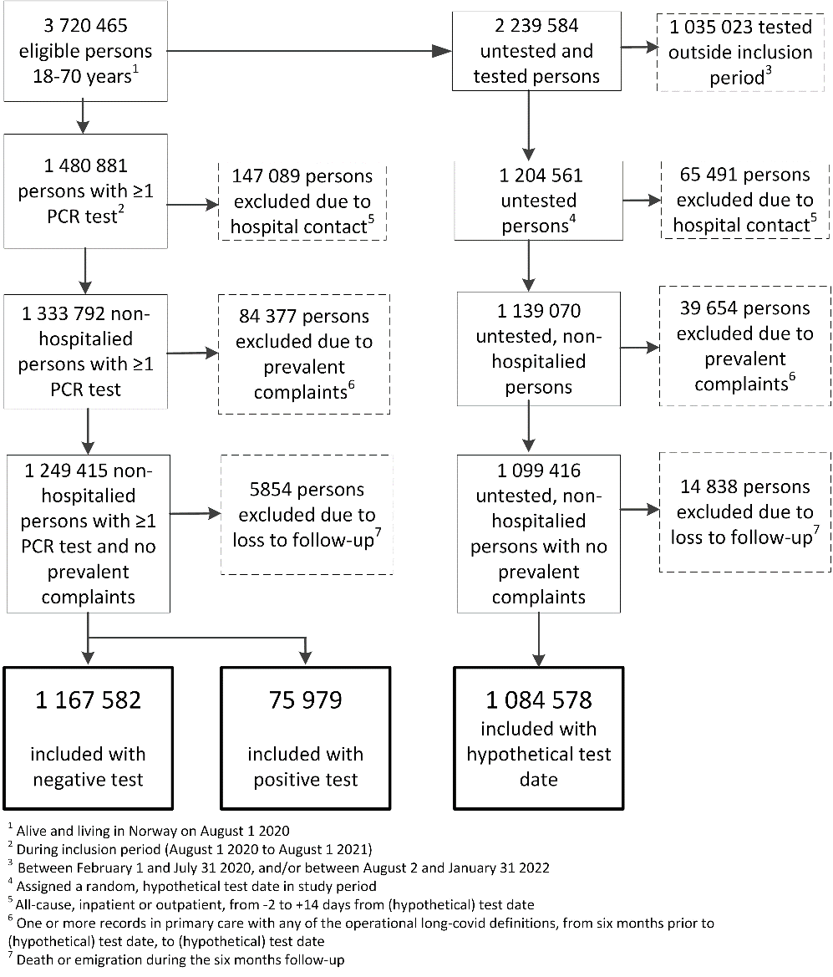

Supplementary Figure 1. Flow chart showing eligible, excluded and included persons.

Supplementary Table 1. The overlap between the prevalence of seven long-covid definitions at baseline, 2, 4 and 6 months.
 | Pulmonary | Neurological | General | Pulmonary + neurological | Pulmonary + general | Neurological + general | All
Baseline
Testing positive | 186 (0.2) | <5 (0.007) | 602 (0.8) | <5 (0.007) | 27 (0.04) | <5 (0.007) | <5 (0.007)
Testing negative | 2937 (0.3) | 39 (0.003) | 1610 (0.1) | <5 (0.0004) | 81 (0.007) | 8 (0.0007) | <5 (0.0004)
Untested | 148 (0.01) | 32 (0.003) | 414 (0.04) | <5 (0.0005) | 8 (0.0007) | <5 (0.0005) | <5 (0.0005)
2 months
Testing positive | 1850 (2.4) | 69 (0.09) | 3939 (5.2) | <5 (0.007) | 419 (0.6) | 12 (0.02) | <5 (0.007)
Testing negative | 11061 (0.9) | 748 (0.06) | 15329 (1.3) | 13 (0.001) | 465 (0.04) | 54 (0.005) | <5 (0.0004)
Untested | 2203 (0.2) | 510 (0.05) | 6754 (0.6) | <5 (0.0005) | 66 (0.006) | 37 (0.003) | <5 (0.0005)
4 months
Testing positive | 976 (1.3) | 102 (0.13) | 2565 (3.4) | <5 (0.007) | 183 (0.2) | 19 (0.03) | <5 (0.007)
Testing negative | 6467 (0.6) | 1029 (0.09) | 15770 (1.4) | 11 (0.0009) | 323 (0.03) | 93 (0.008) | <5 (0.0004)
Untested | 2764 (0.3) | 592 (0.05) | 7611 (0.7) | <5 (0.0005) | 102 (0.009) | 45 (0.004) | <5 (0.0005)
6 months
Testing positive | 812 (1.1) | 105 (0.1) | 2265 (3.0) | <5 (0.007) | 109 (0.1) | 23 (0.03) | <5 (0.007)
Testing negative | 6744 (0.6) | 1063 (0.09) | 15799 (1.4) | 26 (0.002) | 374 (0.03) | 84 (0.007) | <5 (0.0004)
Untested | 3159 (0.3) | 683 (0.06) | 7960 (0.7) | 6 (0.0006) | 88 (0.008) | 57 (0.005) | <5 (0.0005)
Data are numbers with percentages for the group testing positive (n=75 979), the group testing negative (n=1 167 582) and the untested group (n=1 084 578).

Supplementary Table 2. The differences between the group testing positive and the comparison groups in prevalence of different post-covid complaints over time, adjusted for prevalent pulmonary, neurological and/or general complaints during 2017-19.
 | Test positive vs test negative |  |  |  | Test positive vs untested
 | Baseline | 2 months | 4 months | 6 months | Baseline | 2 months | 4 months | 6 months
One complaint
Pulmonary | 3 | 180 | 90 | 65 | 30 | 290 | 140 | 110
Pulmonary | -2 to 8 | 167 to 193 | 80 to 99 | 56 to 74 | 24 to 35 | 274 to 306 | 128 to 152 | 100 to 121
Neurological | NE | 3 | 5 | 6 | NE | 5 | 8 | 8
Neurological | NE | 1 to 5 | 2 to 8 | 2 to 9 | NE | 2 to 7 | 5 to 11 | 5 to 11
General | 65 | 387 | 203 | 169 | 63 | 386 | 221 | 189
General | 57 to 73 | 370 to 404 | 189 to 216 | 155 to 182 | 56 to 70 | 370 to 402 | 208 to 233 | 176 to 201
Combinations of two complaints
Pulmonary | 3 | 52 | 22 | 12 | 4 | 64 | 27 | 16
+ general | 0 to 6 | 46 to 59 | 17 to 26 | 8 to 15 | 1 to 7 | 54 to 73 | 22 to 33 | 12 to 20
Neurological | NE | 1 | 2 | 3 | NE | 1 | 2 | 2
+ general | NE | 0 to 2 | 0 to 3 | 1 to 4 | NE | 0 to 2 | 1 to 3 | 1 to 4
Estimates are group differences in prevalence per 10 000 persons in the respective groups, with 95% confidence intervals, representing the group testing positive minus the group testing negative and the untested group, in separate analyses. Group differences for pulmunoary+neurological and for all three combinations (pulmonary+neurological+general) could not be estimated due to too few observations for test positive.

